Supplemental Information

Table S-1. All large language models tested.
Model (API Name) | Context Tokens | Cost | Ranked Time | Release Date
Claude models are from Anthropic; GPT from OpenAI | 1 token is approx. 3.5 characters | Input $/million tokens |  Output $/million tokens | On average for scoring, fastest = 1 | Date of first public API release, not including future iterations
claude-3-haiku-20240307 | 200k | $0.25 | $1.25 | 1 | Mar 13 2024
claude-3-sonnet-20240229 | 200k | $3 | $15 | 3 | Mar 4 2024
claude-3-opus-20240229 | 200k | $15 | $75 | 4 | Mar 4 2024
gpt-4-turbo-2024-04-09 | 128k | $10 | $30 | 3 | Nov 6 2023
gpt-3.5-turbo-0125 | 16k | $0.50 | $1.50 | 2 | Mar 1 2023

Table S-2. Variables for content relevance scoring.
variable | type | description
article_letter | str | The letter of the article (A, B, C, etc.)
grade | int | The grade of the article (1-5) based on this research question: "What is the narrative surrounding the development of this renewable energy project in this location, and what evidence of opposition or support for the project can be identified?" Score each search result with a number between 1-5, with 1 being the least relevant and 5 being the most relevant. Here are examples of what might receive the following scores:  1 - an article that does not mention renewable energy or the project in question ({plant_info}), but may have info about a different project or ordinance  2 - an article that might be related to renewable energy near the location in question but does not mention the specific project ({plant_info})  3 - an article that mentions the specific project and location in question ({plant_info}), but only provides basic information about the project and no information on opposition or support  n4 - an article that you are EXTREMELY CONFIDENT mentions the exact project and location in question ({plant_info})  5 - an article that you are EXTREMELY CONFIDENT describes the narrative of the specific project development ({plant_info}), including mentions of opposition and support.
justification | str | The justification for the grade. Use no more than 8 words.

Table S-3. Variables for public perception scoring and their definitions.
variable | type | description
mention_support | int | 1 if any mention of support (e.g., an individual or organization mentioned in support of the project), 0 if not
mention_opp | int | 1 if any mention of opposition (e.g., an individual or organization mentioned in opposition of the project), 0 if not
physical_opp | int | 1 if evidence of physical opposition involving at least one person (e.g., protests, marches, picketing, mass presence at governmental meetings), 0 if not
policy_opp | int | 1 if evidence of the use or attempted use of legislation (like ordinances or moratoria) or permitting to block projects, 0 if not
legal_opp | int | 1 if evidence of legal challenges and the use of courts to block projects, 0 if not
opinion_opp | int | 1 if any opinion-editorials or other media explicitly opposing a project exist, 0 if not
environmental_opp | int | 1 if evidence of environmental concerns, like water, soil, wildlife, and ecological impacts, 0 if not
participation_opp | int | 1 if evidence of opposition stemming from a perceived or real lack of participation of fairness in the project, 0 if not
tribal_opp | int | 1 if evidence of Tribal opposition, 0 if not
health_opp | int | 1 if evidence of opposition from real or perceived health and safety risks from the project, 0 if not
intergov_opp | int | 1 if any evidence of disagreement between local, regional, and federal government about the project, 0 if not
property_opp | int | 1 if evidence of opposition from real or perceived property value impacts, 0 if not
compensation | int | 1 if evidence of support or opposition from real or perceived lack of additional non-required compensation or benefits from the project, 0 if not
delay | int | 1 if evidence of a substantial delay (months or years) in project development because of opposition, 0 if not
co_land_use | int | 1 if evidence of project co-existing with other land uses, such as agriculture, recreation, and grazing, 0 if not
narrative | str | A one-paragraph narrative summary of the public perceptions of the specified renewable energy project, including the project name, location, and developer, when it was proposed, the public response, and details on any evidence of opposition or support.

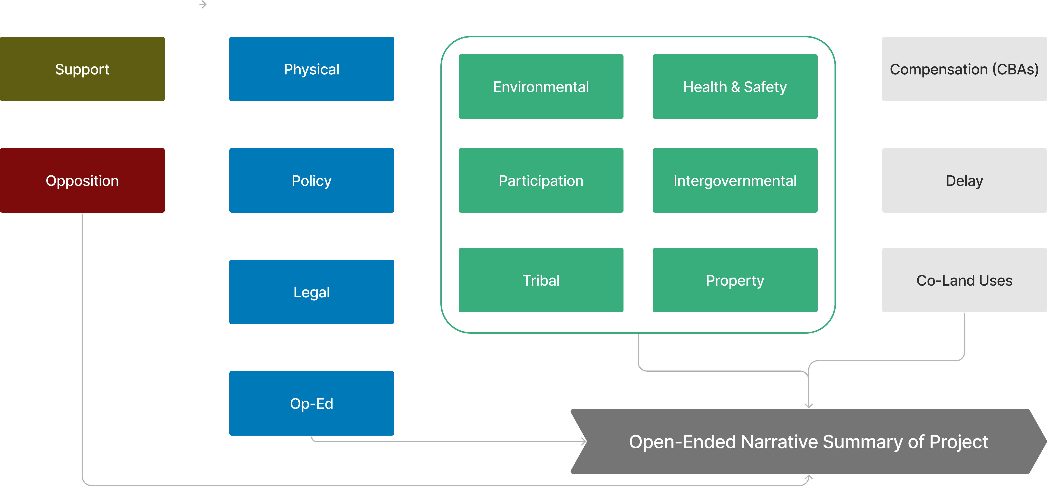
Figure S-1. Diagrammatic representation of variables used in scoring step. variables used in scoring step.

