Supporting Information

Concentration-dependent modes of melittin-induced membrane destabilization: an integration of experimental and computational tools

Andrea Chacón Calderón¹, Pavel Zelenovskii², Marcio Soares¹, Ellen C. Wrobel³, Osvaldo N. Oliveira Jr.³, Daniel Pereira¹, Luís Mafra¹, Mariana Sardo¹, Ildefonso Marín-Montesinos¹, Ana Barros-Timmons¹

¹Department of Chemistry & CICECO−Aveiro Institute of Materials, University of Aveiro, 3810-193 Aveiro, Portugal.
²Department of Physics & CICECO−Aveiro Institute of Materials, University of Aveiro, Aveiro 3810-193, Portugal.
³ Sao Carlos Institute of Physics, University of Sao Paulo, CP 369, 13560-970 São Carlos, SP, Brazil

Contents

Table S1. PM-IRRAS frequencies of the pure lipids, DOPE:DPPG and (DOPE:DPPG):MLT monolayers on 5 mM HEPES buffer subphase at a surface pressure of 30 mN m⁻¹.
Table S2. Size and size distribution by intensity obtained by dynamic light scattering for MLVs of DOPE:DPPG, (DOPE:DPPG):MLT 30:1 and 10:1 ratio.
Table S3. ¹H and ¹³C chemical shifts changes for MLVs of DOPE:DPPG, (DOPE:DPPG):MLT 30:1 and 10:1 ratio.
Table S4. ³¹P chemical shifts for the deconvoluted spectra and T₁ relaxation times for MLVs of DOPE:DPPG, (DOPE:DPPG):MLT 30:1 and 10:1 ratio.

Figure S1. Effect of melittin on Langmuir monolayers observed by Brewster angle microscopy.
Figure S2. Interaction of melittin with thin lipid films observed by AFM topographical and phase images of the lipid films.
Figure S3. Size distribution changes induced in MLVs by melittin.
Figure S4. Snapshots from the top view of the initial step (1 ns) of the MD runs for systems I, II, and III.
Figure S5. Density profiles for systems I, II and III averaged over 200 ns of sampling.

Table S1. PM-IRRAS frequencies of the pure lipids, DOPE:DPPG and (DOPE:DPPG):MLT monolayers on 5 mM HEPES buffer subphase at a surface pressure of 30 mN m⁻¹.
Subphase | Composition | PM-IRRAS signal wavenumber (cm⁻¹)
Subphase | Composition | v_{as}(CH₂) | v_{s}(CH₂) | v(C=O) | v_{sci}(CH₂) | v_{as}(PO₂⁻) | v_{s}(PO₂⁻)
Buffer | DOPE | 2918 | 2856 | 1740 | 1470 | 1218 | 1076
Buffer | DPPG | 2918 | 2849 | 1732 | 1468 | 1220 | 1094
Buffer | DOPE:DPPG 8:2 | 2928 | 2851 | 1739 | 1458 | 1227 | 1065
Buffer | (DOPE:DPPG):  MLT 30:1 | 2917 | 2847 | 1740 | - | 1227 | 1080
Buffer | (DOPE:DPPG):  MLT 10:1 | 2928 | - | 1738  1714 | 1477 | 1224 | 1060

Table S2. Size and size distribution by intensity obtained by dynamic light scattering for MLVs of DOPE:DPPG, (DOPE:DPPG):MLT 30:1 and 10:1 ratio. The intensity percentage of each population is shown inside the parenthesis.

Peak (in descending order of intensity) | DOPE:DPPG | (DOPE:DPPG):MLT 30:1 | (DOPE:DPPG):MLT 10:1
Peak 1 (%) | 890.9 ± 498.7 nm (73.9) | 687.1 ± 311.8 nm (85.6) | 333.1 ± 105.1 nm(79.3)
Peak 2 (%) | 126.4 ± 43.11 nm (19.8) | 103.6 ± 37.05 nm (12.2) | 63.12 ± 16.01 nm (12.5)
Peak 3 (%) | 4706 ± 824.3 nm (6.3) | 5047 ± 584.3 nm (1.9) | 4677 ± 880.3 nm (8.2)

Table S3. ¹H and ¹³C chemical shifts changes for DOPE:DPPG 8:2 MLVs in the presence of melittin at lipid:peptide ratios of 30:1 and 10:1.

Signal | ¹H chemical shift (ppm) |  |  | Signal | ¹³C chemical shift (ppm)
Signal | DOPE:DPPG | (DOPE:DPPG):  MLT 30:1 | (DOPE:DPPG):  MLT 10:1 | Signal | DOPE:DPPG | (DOPE:DPPG):  MLT 30:1 | (DOPE:DPPG):  MLT 10:1
ω | 0,95 | 0,96 | 0,96 | ω | 14,53 | 14,4 | 14,41
(CH₂)_{n} | 1,36 | 1,37 | 1,36 | ω-1 | 23,33 | 23,21 | 23,18
C8, 11 | 2,10 | 2,10 | 2,09 | ω-2 | 32,68 | 32,57 | 32,51
C9, 10 | 5,38 | 5,40 | 5,39 | (CH₂)_{n} | 30,14 | 30,08 | 30,05
C3 | 1,68 | 1,65 | 1,63 | C8, 11 | 27,99 | 27,95 | 27,9
C2 | 2,40 | 2,33 | 2,30 | C3 | 25,71 | 25,89 | 25,98
C2 | 2,45 | 2,42 | 2,39 | C2 | 34,85 | 35,43 | 35,76
g1 | 4,53 | 4,50 | - | g1 | 62,93 | 62,94 | 62,95
g2 | - | 5,08 | 5,08 | g2 | 71,7 | 71,96 | 71,97
g3-PE | 4,30 | 4,36 | - | g3 | 67,53 | 67,69 | 67,72
g3-PG | 4,10 | 4,12 | 4,11 | α_{PE} | 63,47 | 63,56 | 63,62
α_{PE} | 4,17 | 4,20 | 4,19 | β_{PE} | 41,34 | 41,53 | 41,58
β_{PE} | 2,99 | 3,05 | 3,07 | α_{PG} | 69,4 | 69,53 | 69,64
α_{PG} | 3,93 | 3,96 | 3,96 | ß_{PG} | 64,61 | 66,02 | 66,08
ß_{PG} | 3,68 | 3,70 | 3,69 | y_{PG} | 63,81 | 64,58 | 64,74
y_{PG} | 3,34 | 3,36 | 3,35

Table S4. ³¹P chemical shifts for the deconvoluted spectra and T₁ relaxation times for the DOPE:DPPG liposomes with and without melittin.
Signal | |∆| ³¹P chemical shift (ppm) |  | ³¹P relaxation time T₁ (s)
Signal | (DOPE:DPPG):MLT 30:1 | (DOPE:DPPG):MLT  10:1 | DOPE:DPPG | (DOPE:DPPG):MLT 30:1 | DOPE:DPPG):MLT  10:1
DOPE | 0.35 | 0.32 | 0.42 | 0.14 | 0.18
DPPG | 0.56 | 0.53 | 0.04 | 1.82 | 1.40

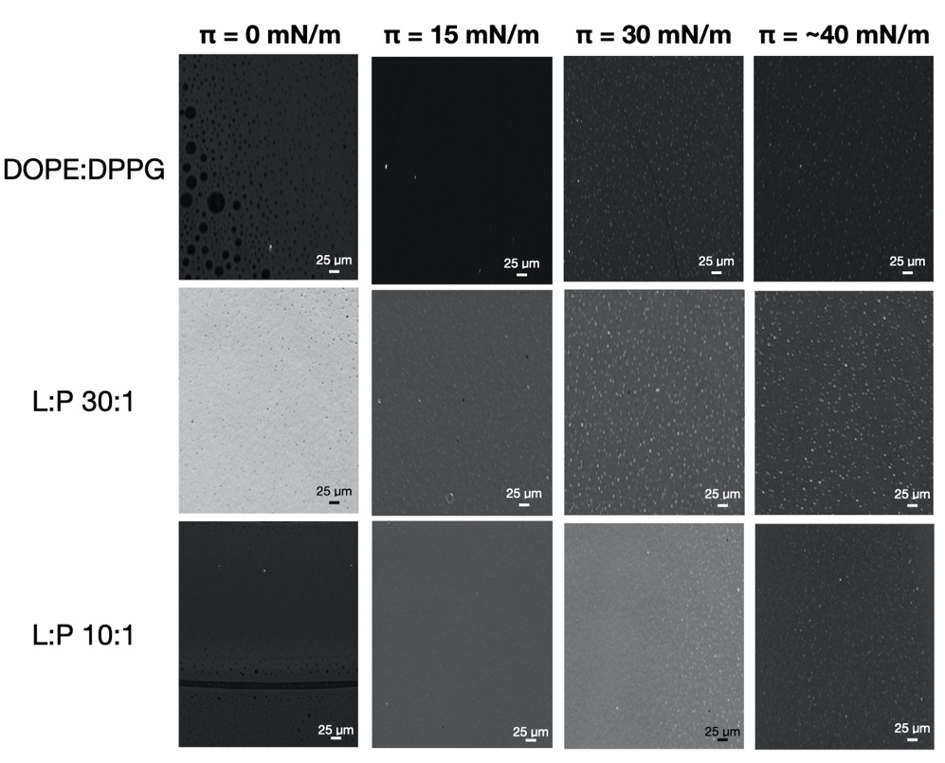
Figure S1. Effect of melittin on Langmuir monolayers. Images obtained by Brewster angle microscopy of Langmuir monolayers of DOPE:DPPG, (DOPE:DPPG):MLT 30:1 and 10:1 ratio, at different surface pressure of the compression isotherms (see Figure 1).

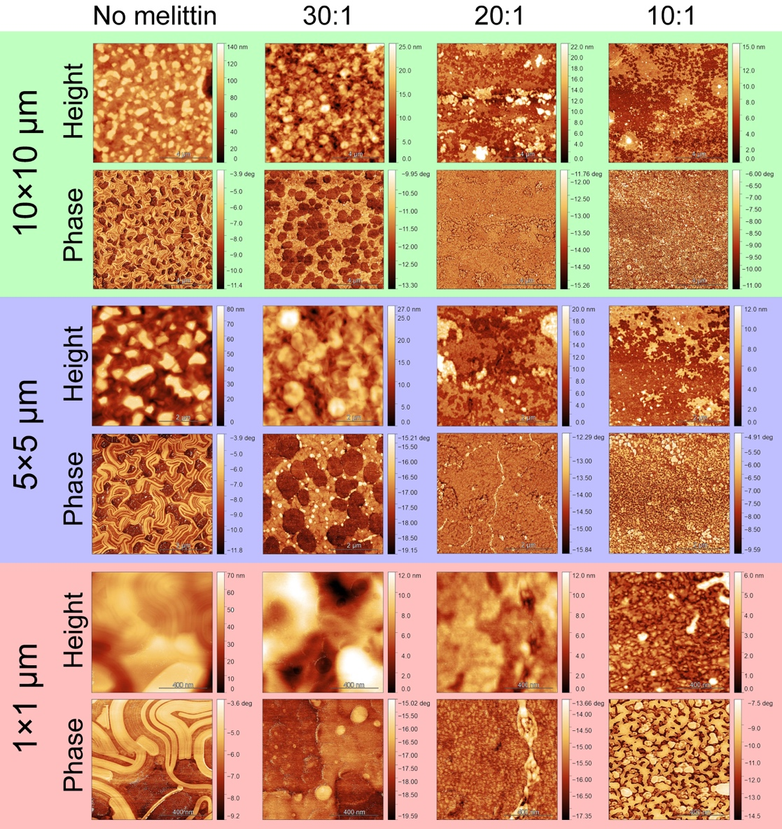

Figure S2. Interaction of melittin with thin lipid films. AFM topographical and phase images of the lipid films of (from left to right) DOPE:DPPG, (DOPE:DPPG):MLT 30:1, 20:1 and 10:1 ratio.

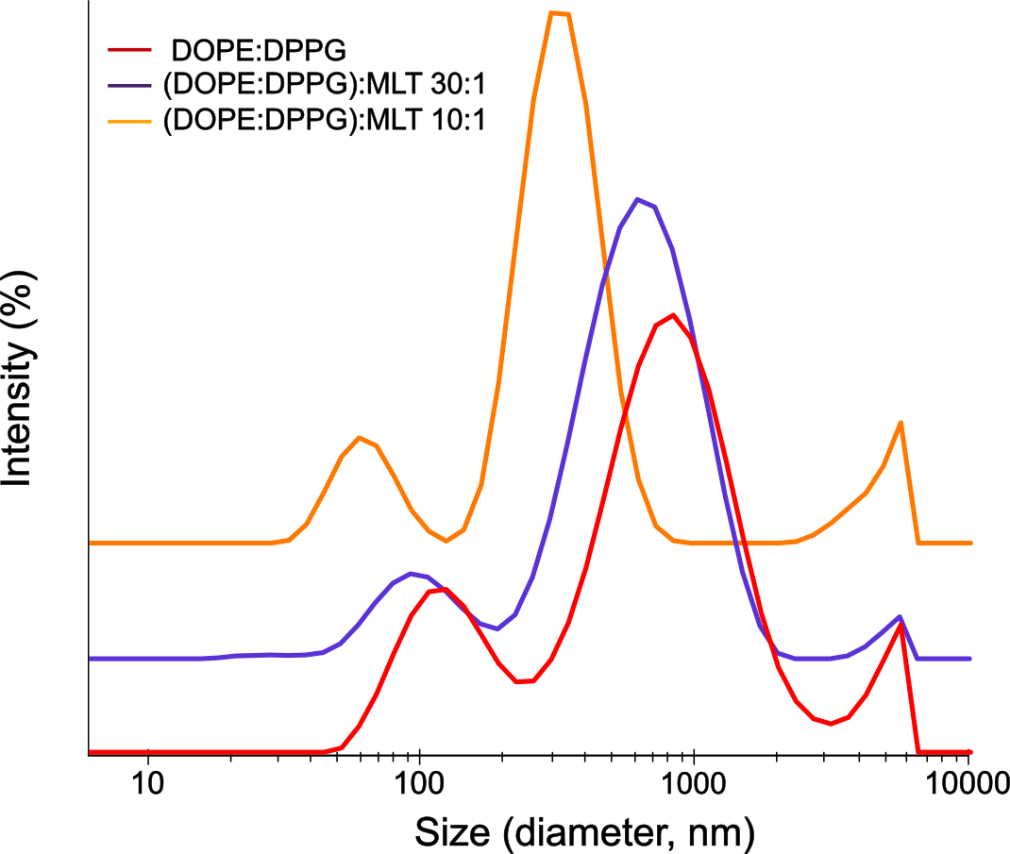

Figure S3. Size distribution changes induced in MLVs by melittin. Size distribution by intensity fraction of DOPE:DPPG, (DOPE:DPPG):MLT 30:1 and 10:1 ratio MLVs suspensions.

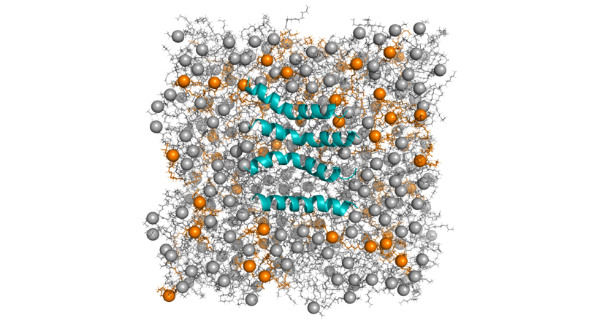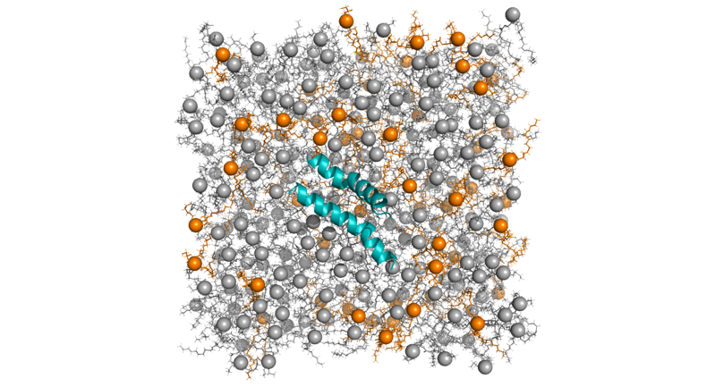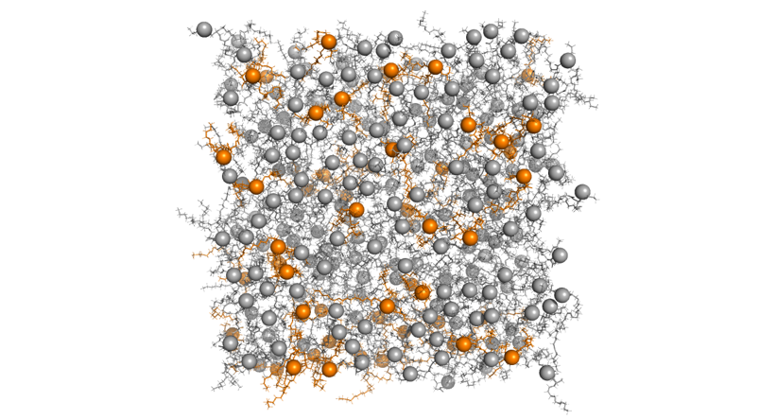
I
II
III
Figure S4. Snapshots from the top view of the initial step (1 ns) of the MD runs for systems I, II, and III. DOPE and DPPG phospholipid are shown in grey and orange, respectively. The P atoms are shown as spheres. Water molecules and ions are omitted for clarity.

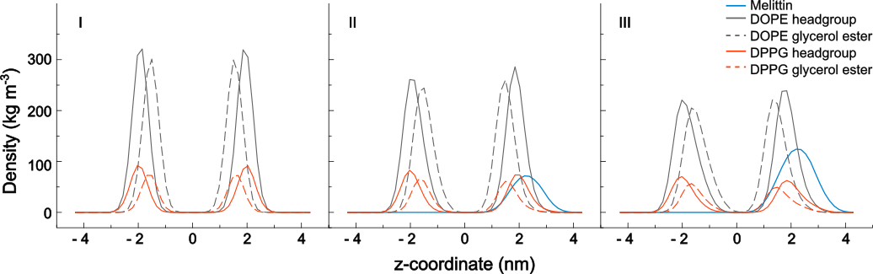

Figure S5. Density profiles for systems I, II and III showing the DOPE (grey) and DPPG (orange) corresponding headgroups (solid line) and glycerol ester groups (dashed line), and the protein (blue). The densities were averaged over 200 ns of sampling.

