DART: A Daily Monitoring Framework for Distinguishing Withdrawal from Relapse During Antipsychotic Tapering
Authors: S. H. Richter, S. B. Carol, M.D.
Date: 3/5/2026
Author contacts:
SHRichter@tuta.com
SBCarol.MD@tuta.com

ABSTRACT
Background: When symptoms re-emerge during antipsychotic dose reduction, standard practice typically interprets this as relapse and responds with dose reinstatement. This assumption is rarely testable: a single-timepoint assessment cannot distinguish genuine relapse from withdrawal—a time-limited response that resolves without intervention—or from unmasking of iatrogenic receptor upregulation, whether as the primary driver or superimposed on underlying illness (dopamine supersensitivity psychosis, DSP). These possibilities require fundamentally different responses, and misidentification carries consequences: dose reinstatement for unmasked supersensitivity treats the immediate presentation while potentially deepening the receptor changes driving it. The frequency of this misclassification is uncertain but may be clinically significant: when Fallon and colleagues [2012] systematically assessed treatment-compliant patients experiencing relapse, 39% met criteria for supersensitivity psychosis. Tapering methodologies and frameworks for identifying discontinuation syndromes exist and have shown promise—but their appropriate use depends on trajectory characterization that current practice cannot provide. A systematic review identified only five antipsychotic discontinuation studies with daily clinical assessment—the frequency necessary to detect short-lasting withdrawal symptoms. No published protocol links observed symptom trajectories to tapering decisions through daily monitoring.
Methods: From trajectory patterns observed during daily monitoring of occupancy-guided antipsychotic tapering, we derived DART (Daily Adaptive Response Tapering), a decision framework linking tapering progression to observed recovery trajectories.
Results: Daily monitoring detected withdrawal features invisible to standard assessment intervals: repeated oscillations between apparent recovery (0–1/10) and symptom re-emergence (10/10) extending 53 days, with a tertiary elevation at days 32–39 that resolved without intervention but would register as "relapse" at most any single assessment timepoint. Withdrawal dyskinesia covaried temporally with psychotic symptoms, suggesting a common dopaminergic mechanism. Peak severity reached 10/10 during each of eight sequential reductions before amplitude narrowing emerged after months—consistent with receptor normalization timescales but detectable only through sustained daily monitoring. These features informed DART's core elements: confirmation holds, step-size calibration based on prior response, and trajectory-based criteria for distinguishing withdrawal from relapse.
Conclusions: Daily monitoring revealed withdrawal trajectory complexity that could be misclassified as relapse under standard assessment intervals. DART proposes a transferable, low-resource framework applicable across populations where standard assessment tools are less reliable, including those at elevated risk for supersensitivity. Whether multiphasic withdrawal patterns generalize requires prospective evaluation. But the clinical stakes of the withdrawal-relapse distinction are immediate: for the individual patient, misclassification determines whether the appropriate response is dose reinstatement or continued observation—and current assessment infrastructure cannot reliably make that call.
Keywords: antipsychotic withdrawal, antipsychotic discontinuation, antipsychotic tapering, DART protocol, hyperbolic tapering, receptor occupancy, multiphasic withdrawal, withdrawal dyskinesia, relapse distinction, dopamine supersensitivity psychosis, daily monitoring

Ethics and Conflicts of Interest
Conflicts of Interest: We declare no conflicts of interest.
Ethics: This case report documents retrospective caregiver observation and was determined not to constitute human subjects research requiring institutional ethics committee review. Informed consent for publication was provided by the patient's legal guardians, who hold decision-making authority for all medical care. Reporting follows CARE guidelines. All identifying information has been anonymized.
Data Availability: Deidentified participant data are available from the corresponding authors upon reasonable request.
Funding: This research received no grant from any funding agency in the public, commercial, or not-for-profit sectors.

Abbreviations
ASD, autism spectrum disorder; ASL, acceptable symptom level; CPZ, chlorpromazine; D₂, dopamine D₂ receptor; D₂^{High}, high-affinity state of D₂ receptor; DART, daily adaptive response tapering; DSP, dopamine supersensitivity psychosis; EPS, extrapyramidal symptoms; K, dose achieving 50% receptor occupancy; PET, positron emission tomography; TD, tardive dyskinesia.

Introduction

The Withdrawal-Relapse Distinction in Current Practice
When symptoms re-emerge during antipsychotic dose reduction, the standard response is to reinstate or increase the dose [Taylor 2022; Emsley 2013; Leucht 2012]. This response assumes that symptom re-emergence indicates relapse—recurrence of the underlying illness requiring continued pharmacological intervention. But symptom re-emergence during dose reduction has three clinically distinct possible etiologies, not one: relapse, withdrawal—a time-limited response to reduced receptor blockade that resolves with continued observation rather than dose reinstatement [Brandt 2020; Horowitz 2021; Moncrieff 2006]—and unmasking of iatrogenic receptor upregulation that sustained treatment had been compensating for [Chouinard 2017; Samaha 2007].
The frequency of this misclassification is unknown, but may not be negligible: when Fallon and colleagues [2012] systematically assessed treatment-compliant patients experiencing relapse, 39% met criteria for supersensitivity psychosis. Occupancy-guided tapering methodologies [Horowitz 2021; Costardi 2021] and structured frameworks for identifying discontinuation syndromes [Cosci 2022; Chouinard 2017, 2023] have been developed—but their appropriate use depends on a distinction that current practice rarely makes: whether re-emerging symptoms represent the underlying disease or a response to treating it. A single-timepoint assessment showing elevated symptoms is ambiguous: it could represent the peak of a self-limiting withdrawal curve, a secondary elevation within an oscillating pattern, or the beginning of a sustained relapse. Only trajectory characterization can distinguish these possibilities.
Yet the infrastructure to capture these trajectories does not exist—in routine clinical practice or in most discontinuation research [Brandt 2020; Récalt 2019; Horowitz 2021]. Our review of antipsychotic withdrawal studies identified only five with daily clinical assessment—the frequency the authors deemed necessary because "short lasting withdrawal symptoms... otherwise may be missed" [Brandt 2020]. Among these, observation periods ranged from 7 days to 7 months, meaning shorter studies could not have detected phenomena emerging in the third week regardless of assessment frequency. Studies measuring "relapse" at weekly or monthly intervals cannot distinguish withdrawal from disease recurrence, because both register as equivalent treatment failures [Récalt 2019; Cohen 2019]. This has consequences beyond individual patient care. Long-term antipsychotic maintenance is standard care for schizophrenia [NICE 2014; Leucht 2012], yet efficacy beyond two years remains uncertain [Harrow 2012, 2014; Murray 2016]. Despite this uncertainty, international guidelines provide no standardized procedures for dose reduction or discontinuation when it is attempted [Horowitz 2021; NICE 2014]—leaving clinicians without a framework for distinguishing withdrawal from relapse when they do reduce doses. If withdrawal is commonly misclassified as relapse, maintenance treatment may systematically overestimate relapse risk during discontinuation attempts.
Recent work on antidepressant discontinuation illustrates what intensive monitoring can reveal: a prospective cohort study with daily ratings during hyperbolic tapering found complex temporal patterns—which the authors characterized as "wave-like" and "delayed"—invisible to weekly or monthly assessment [van Os 2023]. Whether similar patterns characterize antipsychotic withdrawal is unknown, but the pharmacological basis for expecting them is strong: antipsychotics produce receptor neuroadaptations at least as extensive as those underlying antidepressant withdrawal, and potentially more complex given the multiple neurotransmitter systems involved [Chouinard 2017; Cosci 2020; Samaha 2007]. For antipsychotics, structured tools for identifying withdrawal syndromes exist [Cosci 2022; Chouinard 2017] but are rarely employed in routine practice [Crellin 2022]. To our knowledge, no published protocol provides a framework for daily monitoring during antipsychotic tapering with explicit decision rules linking observed trajectories to dose adjustments [Brandt 2020; Horowitz 2021].
A reasonable objection is that psychotic illness itself fluctuates—that oscillating symptoms during dose reduction need not indicate withdrawal. While correct—symptom variability is a recognized feature of schizophrenia, typically driven by environmental stressors, sleep disruption, or substance use [Zubin 1977; Nuechterlein 1984]—withdrawal generates specific predictions that disease fluctuation does not. First, temporal coupling: withdrawal symptoms characteristically emerge within 48 hours of dose reduction [Dilsaver 1988; Chouinard 2017], whereas schizophrenic relapse characteristically presents as an abrupt transition from remission to full symptom recurrence—Emsley et al. [2013] found that patients remained in remission right up until the visit prior to relapse—not as repeated oscillation between recovery and re-emergence across weeks. Second, covariation of motor and psychotic symptoms: if withdrawal dyskinesia and psychotic symptoms emerge together, peak together, and resolve together following dose reductions, this parallel time course implicates a shared pharmacological mechanism rather than independent disease processes [Miller 1993; Chouinard 2008, 2017; Gardos 1978]. Third, progressive amplitude narrowing over months—consistent with receptor normalization timescales [Seeman 2005; Horowitz 2021; Servonnet 2020]—is not predicted by the natural course of untreated psychotic illness, which does not systematically attenuate in response to cumulative dose reduction. Although no single feature is pathognomonic, and none of these predictions has been formally validated as a diagnostic criterion, testing whether they reliably distinguish withdrawal from disease fluctuation requires the trajectory data that current assessment intervals do not capture.

Author Perspective & Methodological Context
We are family caregivers and legal guardians of an adult patient (John, a pseudonym) with autism spectrum disorder (ASD)—not psychiatrists. Our contribution is the daily observation, systematic documentation, and quantitative analysis that standard clinical practice rarely affords. Our backgrounds—Emergency Medicine/Occupational Medicine and physics/software engineering—enabled this integration of clinical observation with quantitative methodology. John received ongoing care from board-certified psychiatrists throughout; when conventional tapering approaches failed repeatedly, we began daily monitoring to characterize what was happening between appointments.
Our engagement with dopamine supersensitivity literature began in 2018 when John received his first antipsychotic, risperidone, and soon developed tardive dyskinesia (TD). Surveys document limited training on antipsychotic discontinuation among mental health professionals [Cooper 2019; Roed 2023; Speyer 2023, 2025; Rakofsky 2021], and existing diagnostic frameworks for medication-induced syndromes are rarely applied in routine practice [Crellin 2022]. When we raised concerns—first about early TD, later about possible supersensitivity psychosis when he developed psychosis after years on olanzapine—the unfamiliarity we encountered was consistent with this pattern. Whether DSP fully explains John’s course is not something we can establish definitively—but the DSP framework and the research it has generated [Chouinard 1978, 1991, 2017; Horowitz 2021; Samaha 2007; Seeman 2011] both inspired and guided our approach: the occupancy-guided tapering calculations, the expectation of withdrawal phenomena distinct from relapse, and the recognition that detecting such phenomena would require both patience and monitoring far more intensive than standard practice permits.
Family-based observation carries inherent limitations: observer bias, emotional investment, and absence of clinical experience across diverse presentations. The patterns we document may also reflect individual idiosyncrasies rather than generalizable phenomena. But what family observation lacks in clinical breadth, it offers in temporal depth: the ability to detect patterns unfolding between standard appointments. The daily assessment protocol described here emerged from this sustained engagement—made possible by circumstances (family structure, professional flexibility, medical and scientific backgrounds) that most caregivers lack and that clinical systems do not provide.

This Paper’s Contributions
We conducted daily monitoring during occupancy-guided chlorpromazine tapering in a patient whose course was consistent with the DSP framework [Chouinard 1991, 2017; Samaha 2007, 2021; Seeman 2005, 2011; Suzuki 2015; Yin 2017]. From trajectory patterns observed across twelve sequential dose reductions over 193 days, we derived DART (Daily Adaptive Response Tapering), a decision framework linking tapering progression to observed recovery trajectories. We report what daily monitoring revealed—withdrawal patterns that would be indistinguishable from relapse under any standard assessment interval—and identify the infrastructure gap—clinical, research, and educational—that prevents such detection. We also address an initiation dilemma: if stability is required before tapering, patients whose therapeutic window has closed may be precisely those excluded from dose reduction. The barriers sustaining this gap are examined in Supplement C. This contribution assumes trajectory information would change clinical decisions; whether the field is prepared to act on such information depends on frameworks for differential response that largely do not yet exist [Blackman 2021; Horowitz 2021].
This paper does not argue against maintenance antipsychotic treatment, which remains appropriate for many patients; rather, it addresses the monitoring infrastructure needed when dose reduction is attempted. Supplemental materials (A-G) provide clinical history, tapering methodology, barrier analysis, clinical scenarios, supportive treatments, objections to DSP, receptor pharmacology, and receptor-occupancy considerations; given that the framework derives from a single case, we opted for comprehensive documentation to support independent evaluation and adaptation.

Rationale for Tapering
A note on mechanism. Whether dopamine dysfunction is a primary cause of psychosis remains debated. Glutamatergic, serotonergic, and immune-mediated mechanisms have all been implicated, and substantial evidence supports models in which dopamine dysregulation represents a final common pathway rather than an originating cause [Howes 2009, 2012; McCutcheon 2020; Javitt 2012]. This paper does not depend on resolving that debate. It addresses a narrower pharmacological question: what happens when chronic D₂ receptor blockade is reduced?
Chronic receptor blockade produces compensatory upregulation across well-characterized drug classes: beta-adrenergic receptors upregulate during propranolol treatment [Frishman 1987; Aarons 1980], benzodiazepine receptors adapt to sustained GABAergic modulation [Ashton 2005], and the hypothalamic-pituitary-adrenal axis suppresses endogenous cortisol during exogenous corticosteroid administration [Beuschlein 2024]. In each case, abrupt removal unmasks the compensatory state—producing tachycardia, seizures, or adrenal crisis—and gradual withdrawal is standard practice. In each case, these rebound phenomena are understood as expected consequences of homeostatic adaptation, not as evidence that the underlying disease has worsened.
Chronic D₂ receptor blockade produces analogous compensatory responses, demonstrated directly through human PET imaging [Silvestri 2000; Thompson 2020; de Beer 2025] and quantified in animal models [Burt 1977; Samaha 2007]. This is consistent with the homeostatic principle that predicts it—its absence would be the finding requiring explanation. The compensatory cascade follows a predictable escalation: when receptor blockade is sustained, the system first increases receptor density (20–40% in animal models [Samaha 2007]); when this proves insufficient, it converts existing receptors to high-affinity D₂^{High} states that bind dopamine more readily—amplifying functional sensitivity 2- to 3-fold beyond what density changes alone would predict [Seeman 2005, 2011]. Each step represents a progressively stronger homeostatic response to a sustained perturbation.
The same principle that predicts this compensatory escalation also predicts its resolution: when the perturbation is removed, the system should normalize—not instantaneously, but on the timescale of receptor turnover and circuit-level remodeling rather than drug elimination [Samaha 2007; Chouinard 2017]. This asymmetry between the speed of pharmacological change and the pace of biological recovery is the central challenge for any tapering approach, and the primary reason daily monitoring may be necessary to characterize withdrawal trajectories that unfold over weeks to months rather than days [Brandt 2020; Récalt 2019]. The clinical consequences of reducing chronic blockade—withdrawal phenomena, rebound symptoms, and the monitoring required to distinguish them from relapse—follow from this pharmacology, not from any particular theory of disease etiology [Carlsson 1963; Seeman 1976; Kapur 2000a].
Two bodies of literature informed our approach. Occupancy-guided tapering addresses the hyperbolic relationship between dose and receptor occupancy: equivalent milligram reductions produce vastly larger blockade changes at lower doses [Kapur 2000a; Uchida 2009; Horowitz 2021; Costardi 2021], explaining why conventional linear tapers fail disproportionately at final stages. A recent dose-response meta-analysis confirmed that both therapeutic effects and extrapyramidal side effects follow this non-linear occupancy relationship [Siafis 2023], reinforcing the rationale for occupancy-guided rather than milligram-based dose adjustments. For antidepressants, hyperbolic tapering has achieved approximately 70% discontinuation success [Horowitz 2019; Groot 2020a, 2021; van Os 2023]. Extending these principles to antipsychotics requires consideration of receptor neuroadaptations—specifically D₂ upregulation—that may complicate withdrawal [Samaha 2007; Chouinard 2017; Cosci 2020; Kruyer 2021; Neill 2023].
The DSP framework describes the clinical consequences of this upregulation: as receptor density increases, the therapeutic window progressively narrows until no dose achieves efficacy without intolerable side effects [Chouinard 1991, 2017]. Figure 1 illustrates this transformation. As upregulation progresses, the dose required for efficacy increasingly overlaps with the dose producing intolerable motor effects—eventually eliminating any acceptable therapeutic dose. This was the clinical signature that prompted our investigation: persistent symptoms alongside excessive sedation and extrapyramidal symptoms (EPS) at near-maximal occupancy, with no dose offering an acceptable balance.
Whether DSP explains any individual patient's course cannot be established definitively. But the framework generates a specific prediction relevant to monitoring design: if withdrawal involves reversal of extensive receptor adaptations rather than simple drug elimination, it may be prolonged and multiphasic, with different transmitter systems recovering on different timescales [Chouinard 2017; Cosci 2022], requiring assessment granularity far exceeding standard practice. This prediction—not the DSP diagnosis itself—motivated our approach. A detailed review of DSP mechanisms and the scientific foundation underlying occupancy-guided approaches is provided in Supplement G.

METHODS

Study Design
This study employed intensive longitudinal monitoring during antipsychotic tapering, with daily outcome assessment enabling trajectory characterization not possible with standard clinical follow-up intervals. A prior occupancy-guided olanzapine taper had succeeded where conventional approaches had repeatedly failed, encouraging us to apply the same principles to chlorpromazine. The rationale for applying the DSP framework is described in the Introduction; specific clinical features supporting this application are detailed in Supplement A, Table A-2. The specific decision framework (DART) emerged iteratively from observed patterns rather than preceding observation.

Observational Approach

Daily Symptom Rating
Hallucinations served as the primary outcome measure, rated daily on a 0–10 scale with behavioral anchors enabling consistent comparison across days. The anchors were developed during the early tapering period and calibrated to observable behaviors—such as vocalization patterns, agitation, and response to external stimuli—rather than patient self-report, given the patient's psychotic symptoms and autism-related communication challenges.
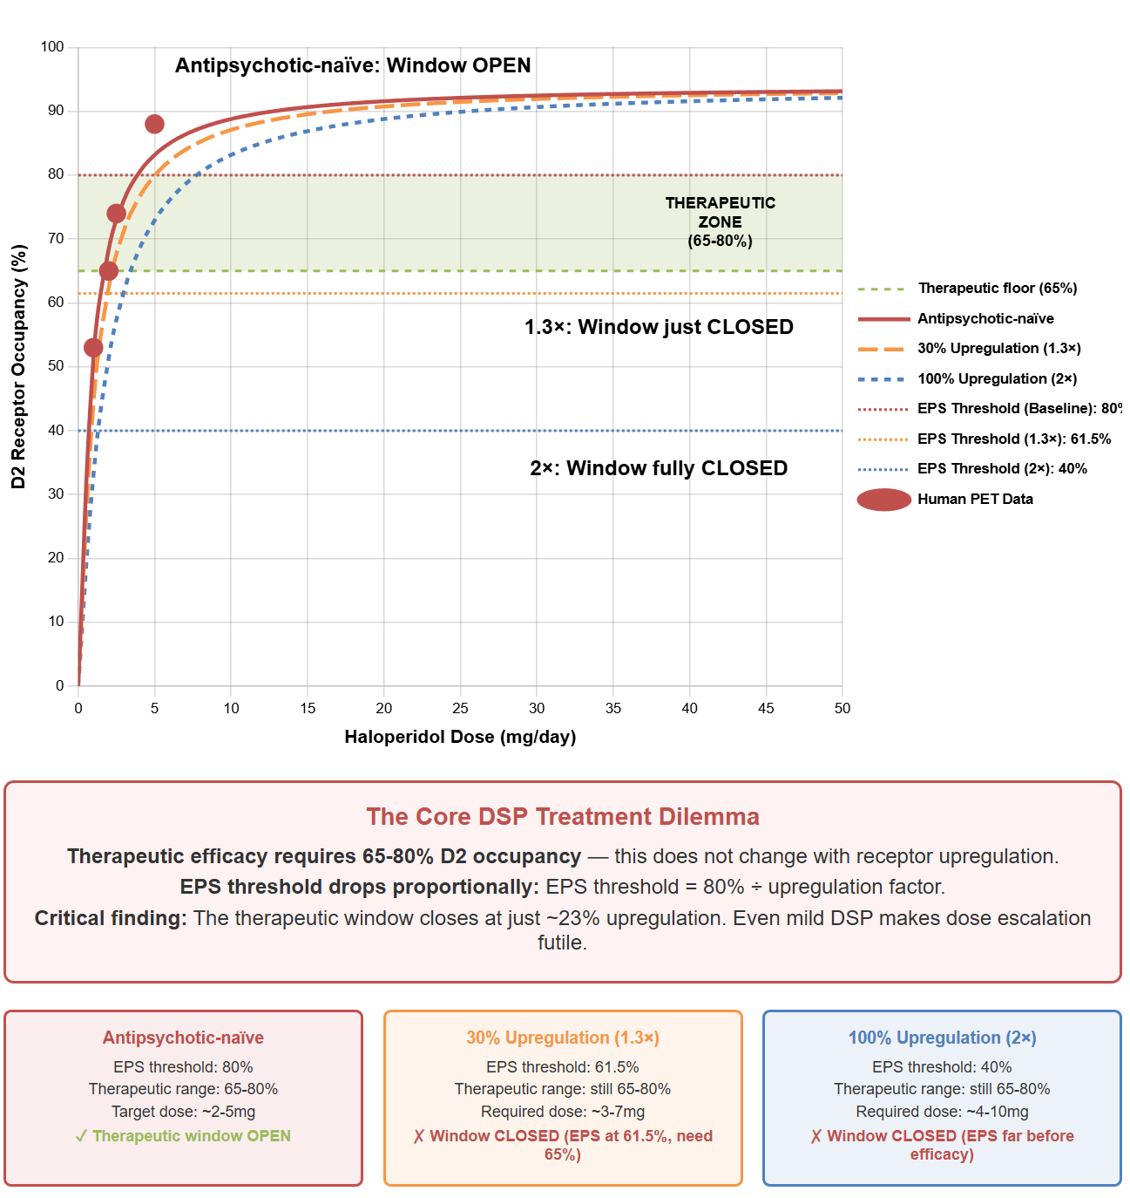
Figure 1. The vanishing therapeutic window in dopamine supersensitivity. D₂ receptor occupancy curves for antipsychotic-naive (red) and upregulated states (orange: 1.3×; blue: 2×). Red circles: human PET data. Green band: therapeutic zone (65–80%), established in antipsychotic-naive populations; whether this threshold shifts with upregulation remains unstudied. Horizontal lines: EPS thresholds, modeled as dropping proportionally with upregulation (80% → 61.5% → 40%). Even mild DSP (30% upregulation) creates an impossible situation: EPS emerges at 61.5%, but efficacy requires 65%+, explaining why dose escalation fails. See Supplement B for modeling.
Two distinct effects converge here. The first is pharmacological: the dose-occupancy relationship saturates early, with ~80% occupancy reached around 5 mg haloperidol equivalent and negligible additional blockade above that dose [Kapur 2000a; Siafis 2023]. The second is neuroadaptive: upregulation raises the efficacy threshold while the EPS threshold drops—progressively eliminating any acceptable dose. High doses in treatment-resistant patients are a rational response to apparent non-response, but if that non-response is upregulation-driven, dose escalation deepens the receptor changes producing it [Samaha 2007; Chouinard 2017].
Low severity (1-2): Mouth movements suggesting subvocal response to voices; patient able to redirect attention when prompted; daily activities maintained with minimal disruption.
Moderate severity (3-5): Observable silent or whispered talking to voices; difficulty obtaining or maintaining attention; partial engagement with environment; reduced spontaneous communication.
High severity (6-7): Extended periods of blank staring with frequent audible responses to voices; inability to attend to surrounding environment; frequent pacing; minimal functional communication requiring repeated prompting for basic needs.
Severe (8-10): Complete apparent disconnection from external reality; no response to verbal prompts; continuous dialogue with hallucinations; extensive pacing, eyes tracking unseen stimuli. Choreiform movements and catatonic episodes were also observed at this level.
Functional capacity correlated with these ratings: at 1-2/10, the patient engaged in board games, television, and video games and conversed with ease; at 3-5/10, basic self-care was possible but participation in activities was impaired and reciprocal communication was rare; at 6/10 and above, there was minimal functional activity, no verbal communication, and a lack of interest in eating and drinking. Ratings were recorded daily throughout the tapering period.
The rationale for daily assessment is diagnostic, not merely descriptive. As outlined in the Introduction, the differential among withdrawal, unmasking, and relapse depends on trajectory features—temporal coupling to dose changes, oscillation versus sustained elevation, and amplitude change over time—that are invisible at standard assessment intervals. Daily monitoring was the minimum frequency capable of capturing these features.
This rating approach was developed for within-patient tracking to guide tapering decisions, not as a generalizable assessment instrument. It has not been independently validated. The behavioral anchors enabled consistent day-to-day comparison but should not be interpreted as equivalent to validated measures of hallucination severity.

Tapering Decision-Making
The general principle was that each reduction should be calibrated to the response from the preceding one, with a stability target at or below the established baseline before proceeding—initially 5/10, improving to 0–2/10 as the taper progressed and receptor normalization permitted lower achievable baselines. Complete remission was not required; if the therapeutic window had narrowed or closed as the DSP framework suggests (see Introduction, Figure 1), full symptom relief would be unlikely at any dose while receptor upregulation persisted. Specific decision rules—including how long to wait after apparent recovery before proceeding—emerged from observing trajectory patterns and are reported in Results alongside the observations that shaped them.

Occupancy Guided Dose Calculations
Dose reductions were guided by recognizing that receptor blockade changes follow a hyperbolic function, such that equivalent milligram reductions produce increasingly large occupancy changes at lower doses [Kapur 2000a; Uchida 2009]. We initially targeted 5-10% reductions in D₂ occupancy per step, building on methodological work by Horowitz [2021, 2024], O'Neill [2023], and Costardi [2021].
Occupancy was calculated using the hyperbolic model: Occupancy = Dose / (Dose + K), where K represents the dose achieving 50% occupancy. For chlorpromazine, K ≈ 82mg, estimated indirectly from chlorpromazine-haloperidol equivalency data and haloperidol's PET-derived dose-occupancy parameters [Lako 2013]. For polypharmacy, combined occupancy was calculated as: 1 − (1 − Occ₁)(1 − Occ₂) [Uchida 2011].
These calculations are approximations; the model guided direction while clinical response determined pace. Progressive dose reductions were determined by clinical response, with step size adjustments described in Results. An example tapering schedule, comparison of tapering methods, and discussion of D₂^{High} receptor dynamics during tapering are provided in Supplement B.

Application Context

Patient Characteristics & Background
The patient (John, a pseudonym) is an adult diagnosed with autism spectrum disorder (ASD) level 2, ADHD, and generalized anxiety disorder. He had no psychotic symptoms prior to antipsychotic exposure; a 2018 psychiatric hospitalization—self-initiated during a severe anxiety crisis following multiple sleepless nights, with nocturnal panic leading him to express the belief that his heart had stopped [Tunnell 2024; Petrovsky 2014; Waters 2018]—was attributed to acute decompensation secondary to sleep deprivation rather than an emerging primary psychotic disorder, and he was discharged with a diagnosis of Major Depressive Disorder. Risperidone was initiated during the hospitalization at 0.5mg for ASD-related irritability rather than psychosis [Accordino 2016], and subsequently increased to 3mg. He developed tardive dyskinesia within months of risperidone initiation—the strongest predictor of subsequent DSP in long-term follow-up [Chouinard 1991, 2017; Ward 2018]—and progressed from this non-psychotic presentation to treatment-unresponsive psychosis over the following years. His course included eleven agents over seven years, three at maximum FDA-approved doses, with dose-dependent paradoxical worsening on both aripiprazole and cariprazine [Takase 2015; Iyo 2013] and preserved response to low-affinity clozapine (discontinued after 3 weeks due to myocarditis) [Chouinard 2017; Samaha 2007]. This cumulative pattern was consistent with the DSP framework [Chouinard 1991, 2017]; chronological DSP indicators and the detailed medication history are provided in Supplement A, Tables A-1 and A-2.

Clinical Context at Protocol Initiation
At the time of protocol development, John's regimen was lumateperone 42mg and chlorpromazine (CPZ) 175mg daily, with sertraline 100mg, clonazepam PRN, and propranolol 10mg. At an estimated 82–85% combined D₂ receptor occupancy [Kapur 2000a; Uchida 2011; Davis 2015], he experienced persistent hallucinations alongside excessive sedation, akathisia, and irritability: pharmacological effect without adequate therapeutic response. This illustrates the closed therapeutic window described in the Introduction (Figure 1) [Chouinard 2017; Samaha 2007].
CPZ tapering was initiated on 16 June 2025 using the approach described above; lumateperone, sertraline, clonazepam, and propranolol were maintained at stable doses throughout the observation period described in Results. Compounded formulations enabled precise dose titration [Horowitz 2022a]. For at least 5 days prior to the initial reduction, daily ratings documented no akathisia or cholinergic rebound symptoms, though hallucinations remained at moderate severity (5–7/10). Within the DSP framework, this persistent symptom burden at near-maximal occupancy supported dose reduction rather than escalation [Chouinard 2017; Samaha 2007].

RESULTS

Observation Period
Daily monitoring was maintained for 193 days (June 11 – December 21, 2025), beginning with a 5-day baseline period before the first dose reduction on June 16 and encompassing twelve sequential reductions from CPZ 175mg to 34mg. Ratings were recorded every evening by the same caregiver throughout; no days were missed. During the first 60 days, only CPZ dose was changed—all other medications and doses remained constant.
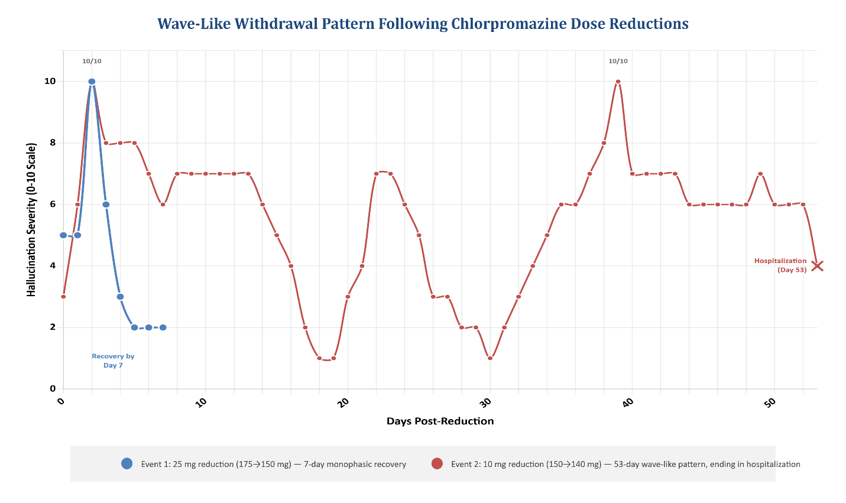
Figure 2 presents the complete daily symptom trajectory across the observation period. The results below focus on two sequential reductions during this initial 60-day period that produced markedly different patterns—not as a controlled comparison (they differ in baseline dose, absolute reduction, and position on the occupancy curve), but as demonstration of the trajectory features daily monitoring can capture.
Figure 2. Multiphasic withdrawal patterns following CPZ dose reductions. Event 1 (blue): 25mg reduction (175→150mg) produced a monophasic pattern with peak symptoms at day 2 and recovery by day 7. Event 2 (red): 10mg reduction (150→140mg) produced a prolonged multiphasic pattern characterized by repeated oscillations between apparent recovery and symptom re-emergence over 53 days. Hospitalization occurred at day 53 following the patient acting on a delusion; for the purposes of this report, we present Event 2 data until this interruption.
Event 1: 25mg reduction, 175→150mg; ~3% occupancy change.
Hallucination ratings followed a pattern consistent with standard descriptions of antipsychotic withdrawal [Moncrieff 2006; Cerovecki 2013; Brandt 2020]—rapid emergence, peak at 48–72 hours, and recovery to baseline by day 7—accompanied by broader withdrawal features including choreiform movements and catatonic episodes [Wilson 2025], that were observed but not formally rated. At weekly assessment intervals, this event would appear as: elevated symptoms at week 1, resolution by week 2.
Event 2: 10mg reduction, 150→140mg; ~2% occupancy change.
Symptoms followed a fundamentally different trajectory. Rather than resolving within two weeks, they followed a prolonged pattern characterized by repeated oscillations over 53 days, at which point hospitalization interrupted observation. Daily monitoring documented: initial emergence to 10/10 (days 1–3); first apparent recovery to 1/10 (day 19); secondary elevation to 7/10 (days 20–23); second apparent recovery to 1/10 (days 24–30); tertiary elevation peaking at 10/10 (days 32–39); and oscillating decline toward resolution (days 40–53).
Throughout this 53-day trajectory, symptoms dropped below 4/10 during only two brief periods, with trough values of 1/10 lasting no more than a single day. This trajectory illustrates the diagnostic problem outlined in the Introduction: three clinically distinct possibilities—withdrawal, unmasking, and relapse—present identically at any single timepoint. A clinical assessment at virtually any timepoint during Event 2 would register as "relapse requiring intervention." The tertiary elevation at days 32-39 illustrates the point most sharply: a clinic visit after a month would encounter severe symptoms that had been elevated for over a week—a presentation indistinguishable from relapse at a single timepoint. Daily monitoring revealed this as a peak within an oscillating trajectory that included 10/10 severity yet ultimately resolved without dose change. Hospitalization occurred at day 53 following the patient acting on a delusion. We present Event 2 data to this point.
This pattern is consistent with van Os and Groot's characterization of antidepressant withdrawal phenomena as "wave-like" and "delayed" [van Os 2023]. Had we proceeded with further reductions after the initial apparent recovery, we would have compounded withdrawal burden before the secondary and tertiary elevations had run their course—a direct observation of the latent accumulation concern raised in the Introduction. The DART framework that emerged from these observations is described below.

Within-Subject Replication
Subsequent dose reductions provided within-subject replication of the core observations: withdrawal trajectories extended beyond typical monitoring windows and included oscillations between apparent recovery and symptom re-emergence.
Figure 3 displays the peak and trough severity for each dose reduction period across the full monitoring course.
Several features warrant attention:
Consistent trajectory complexity. Most dose reductions produced multiphasic patterns with at least one secondary elevation following initial apparent recovery.
Extreme symptom volatility. During most dose reduction periods, severity oscillated between 10/10 peaks and 0–2/10 troughs—volatility not captured by mean severity or single assessments.
Persistent peak severity. Peak severity remained at 10/10 through the first eight tapering periods despite progressively lower doses, indicating that each reduction continued to provoke severe withdrawal regardless of absolute dose level.
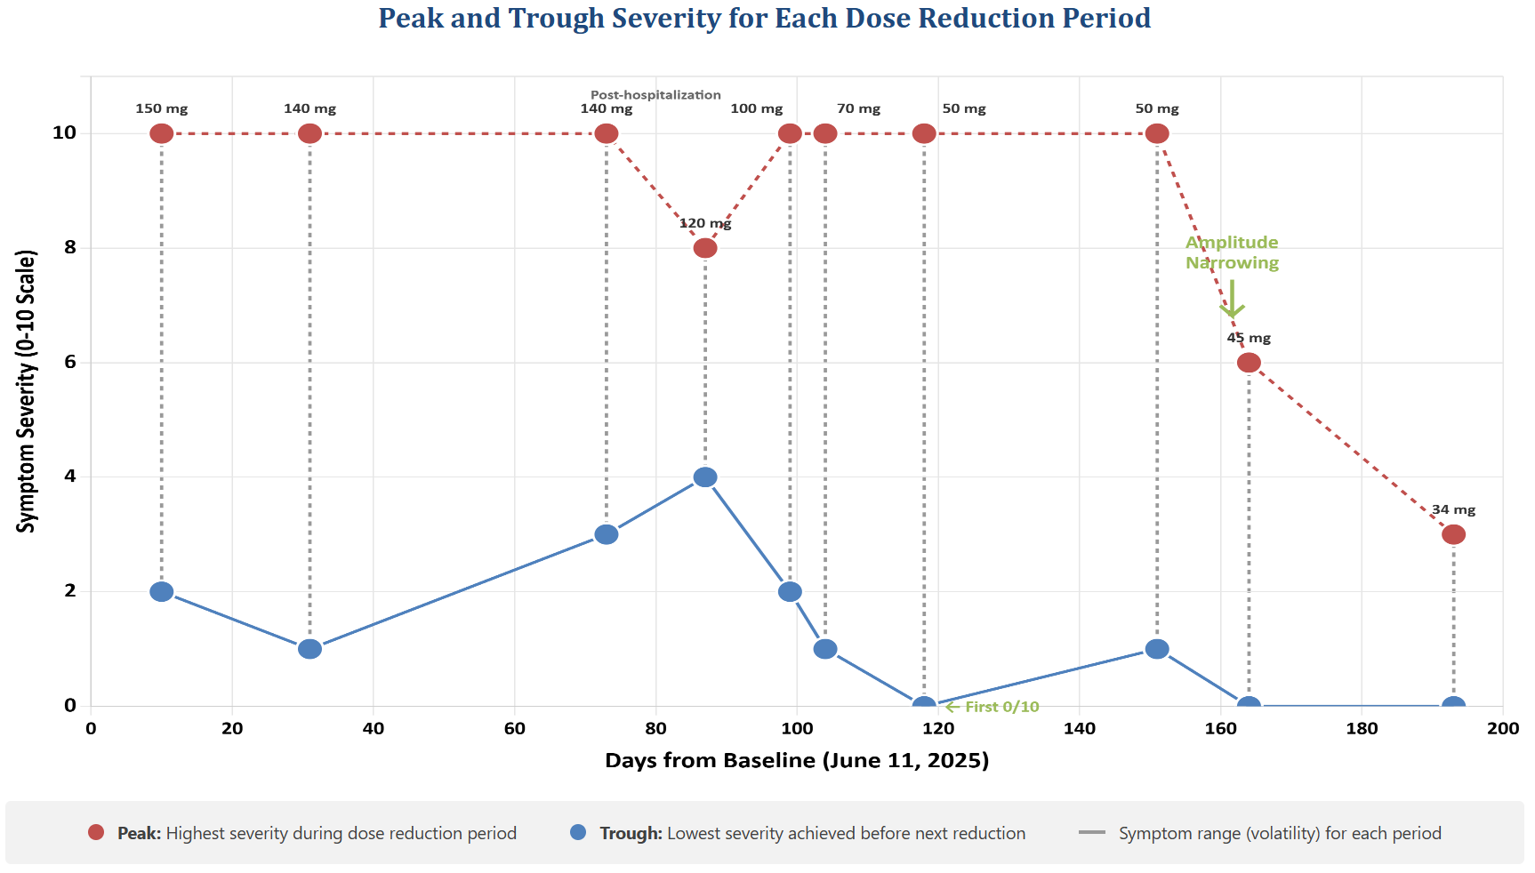
Late amplitude narrowing. Only after months of gradual reduction did peak severity diminish: from 10/10 to 6/10 at 45mg (day 164), and to 3/10 at 34mg (day 193). This suggests possible receptor normalization occurring on a timescale of months—consistent with estimates from the supersensitivity literature [Seeman 2005; Horowitz 2021]—but a pattern detectable only through sustained longitudinal monitoring. Supplement B, Figure B-1, illustrates this temporal dissociation between occupancy normalization and D₂^{High} state recovery.
Figure 3. Peak and trough symptom severity for each dose reduction period during occupancy-guided tapering. Each vertical pair represents one tapering interval during the 193-day recording period: the red point shows the highest severity reached following a dose reduction (peak), and the blue point shows the lowest severity achieved before the next reduction (trough). The dashed vertical line connecting each pair illustrates the symptom range—the volatility experienced during that period. Dose at each interval is annotated above the peak. The post-hospitalization period (days 73-87, following involuntary administration of high-dose haloperidol) is marked. Xanomeline-trospium (X/T) was initiated on September 13 (day 94); sertraline was switched to escitalopram on October 10 (day 121) to avoid CYP2D6 interactions with xanomeline. The first recorded 0/10 day occurred at day 118 (50 mg). Amplitude narrowing emerged only late in the taper, with peak severity dropping from 10/10 to 6/10 at 45 mg (day 164) and to 3/10 at 34 mg (day 193).

Temporal coupling to dose changes. Symptom emergence occurred within 1–3 days of each dose reduction, replicating across all 12 sequential reductions. This consistent temporal relationship is predicted by withdrawal but not by disease fluctuation, which—as the vulnerability-stress model describes [Zubin 1977; Nuechterlein 1984]—is driven by environmental stressors rather than pharmacological events. The within-subject replication across 12 reductions strengthens the inference that these trajectories reflect a pharmacological response rather than coincidental disease fluctuation.
First “asymptomatic” day. Daily monitoring recorded the first 0/10 day at day 118 (50mg). Prior to this, trough severities had not reached apparent symptom absence (0/10 reflects absence of observable behavioral indicators, not confirmed absence of hallucinations).
External disruption effects. The post-hospitalization period (days 73-87) showed elevated troughs following involuntary administration of high-dose haloperidol during a 3-day admission. Daily monitoring documented the temporal relationship, enabling the question of whether this elevation reflected the intervention, ongoing withdrawal, or both to be asked.

Temporal Covariation of Motor and Psychotic Symptoms
During withdrawal episodes, widespread dyskinesia (orofacial, limb, trunk) paralleled psychotic symptoms temporally—emerging together, peaking together, resolving together. During acute withdrawal phases (within 48 hours of a dose reduction), peak psychotic symptoms were also accompanied by brief catatonic features at dose-trough: stupor, mutism, rigid posturing, refusal to eat or drink, and fixed staring. Catatonia is a recognized complication of antipsychotic treatment [Wilson 2025; Caroff 2011], and withdrawal catatonia has been documented following discontinuation of clozapine and benzodiazepines [Lander 2018], with at least one report following non-clozapine antipsychotic withdrawal in a patient with autism spectrum disorder [Faisal 2021]. Whether these transient catatonic features represent a withdrawal phenomenon in the context of dopamine supersensitivity warrants further investigation.
These motor observations were documented through daily behavioral notes (pacing, tremors, tongue movements, rigid posturing) rather than systematic rating scales; daily monitoring was not designed to formally assess movement disorders.
This covariation is consistent with a common dopaminergic mechanism: D₂ receptor upregulation that produces motor symptoms in the nigrostriatal pathway may simultaneously produce psychotic symptoms in the mesolimbic pathway [Miller 1993; Gardos 1978; Chouinard 2008, 2017; Yin 2017]. Similar temporal coupling has been documented in case reports [Karaş 2016]. While causation cannot be established from observational data alone, the repeated detection of parallel time courses across multiple dose reductions strengthens the inference that both phenomena reflect a shared underlying process—and illustrates how daily monitoring can reveal relationships invisible to less frequent assessment.
This motor-psychotic covariation addresses the second of the three trajectory predictions outlined in the Introduction: if withdrawal dyskinesia and psychotic symptoms share a common pharmacological mechanism—D₂ receptor upregulation expressed across nigrostriatal and mesolimbic pathways [Miller 1993; Chouinard 2008, 2017; Yin 2017]—their temporal coupling during dose reduction is expected. Disease-driven psychotic fluctuation, typically attributed to environmental stressors rather than pharmacological changes [Zubin 1977; Nuechterlein 1984], would not predict parallel motor involvement.

What Standard Assessment Would Show
To illustrate what daily monitoring contributed, Table 1 compares what daily monitoring revealed against what standard assessment intervals might capture for Event 2 (the 53-day trajectory). The conventional interpretations shown reflect both standard clinical practice—in which symptom re-emergence during or after dose reduction is typically attributed to relapse and managed with dose reinstatement [Taylor 2022; Emsley 2013]—and discontinuation research methodology, in which "relapse" measured at weekly or monthly intervals cannot distinguish withdrawal from disease recurrence [Récalt 2019; Cohen 2019]. Under any standard assessment interval, the self-limiting nature of this withdrawal would not be detected. The clinical response—dose reinstatement—would relieve symptoms while precluding discovery that they would have resolved without intervention. Supplement C examines the clinical culture and institutional factors that perpetuate this assessment gap.

Table 1. Symptom Interpretation by Assessment Interval
Assessment Interval | What Would Be Observed | Conventional Interpretation*
Daily (this protocol) | Oscillating trajectory with three peaks and eventual resolution | Multiphasic withdrawal; continue observation
Weekly | Week 1: elevated; Week 2: improved; Week 3: severely elevated; Week 4: improved | Would typically be classified as relapse; dose reinstatement would be the standard response
Biweekly | Day 14: elevated (8/10); Day 28: moderately elevated (5/10) | Persistent symptoms; dose reinstatement or escalation
Monthly | Day 30: elevated (6/10) | "Relapse" at one month; return to prior dose
*Based on standard clinical response to symptom re-emergence during dose reduction, in which return of psychotic symptoms is typically classified as relapse warranting dose reinstatement [Leucht 2012; Cerovecki 2013; Brandt 2020; Cooper 2019; Récalt 2019].

DART: The Framework that Emerged
The trajectory patterns documented above—particularly the multiphasic character of Event 2 and its replication across subsequent reductions—shaped DART (Daily Adaptive Response Tapering), the monitoring framework presented in Figures 4 and 5. DART represents our attempt to codify what we learned, not what we started with. We present it not as a protocol ready for clinical implementation, but as a structured hypothesis—a framework intended to illustrate the complexity of occupancy-guided tapering decisions and to help generate interest in the systematic research needed to validate, refine, or replace its components. Several observations directly informed specific framework elements:
Baseline Establishment. Before entering the adaptive cycle, a 1–2 week observation period at the current stable dose establishes the patient's baseline symptom severity and documents DSP indicators (see Supplement G, Table G-5). This baseline becomes the individualized Stability Target (ST) for initial progression decisions—the symptom level the patient must return to before proceeding with the next reduction. When baseline exceeds 2/10—as it did in this case—explicit documentation of the rationale for initiation is made: this might be evidence of a closed therapeutic window, failed dose escalation, or presence of multiple DSP features (see Supplements A and G). As the taper proceeds, the achievable baseline may improve, allowing the stability target to be adjusted accordingly. While hallucination severity served as the primary metric in this application, DART accommodates composite measures depending on patient presentation.
Symptom Assessment Timing. A practical question arising from daily monitoring is when within the dosing cycle to assess symptoms. DART specifies assessment at ligand trough—the point of minimum D₂ occupancy—rather than at peak blockade. The trough represents maximum receptor exposure to endogenous dopamine, and therefore greatest symptom expression from any upregulated D₂^{High} population; assessing at peak blockade would mask the signal the protocol is designed to detect. The goal is not to eliminate trough symptoms but to ensure they remain tolerable, with partial resolution expected upon the next dose. This trough window may also be therapeutically significant. Preclinical evidence demonstrates that D₂ upregulation depends not merely on the degree of blockade but on its temporal continuity: continuously high occupancy (>80% for 24 h/day) produces robust upregulation, whereas transiently high occupancy—with equivalent peak levels but intervening reduced blockade—does not [Ginovart 2009; Samaha 2008; Turrone 2003]. The principle that "less is more"—that intermittent receptor exposure may preserve antipsychotic efficacy while reducing neuroadaptive pressure toward supersensitivity—has direct implications for tapering [Samaha 2008; Bedard 2011; Servonnet 2020]. Each dosing interval inherently produces this intermittent pattern, and the trough is the period during which D₂^{High} populations encounter endogenous dopamine—a condition that may facilitate receptor normalization. The effective trough duration will vary by antipsychotic half-life, a consideration when selecting or adjusting agents during tapering.
The Confirmation Hold. Event 2 demonstrated that brief periods at the stability target could not be trusted (see Figure 2 and accompanying narrative). This led to the 4–7 day confirmation hold: a required observation period at the stability target prior to the next dose reduction. If symptoms reappear during this period, the patient returns to active monitoring rather than advancing. This precaution was further reinforced when successive small reductions implemented every 3–4 days—while symptoms appeared stable—were followed by sustained elevation to 5-6/10 after approximately 10 days, consistent with accumulated withdrawal burden from stacked reductions (though concurrent medication changes preclude definitive attribution).
Step Size Calibration. Early in the monitoring period, we observed that reductions producing extended recovery periods (3+ weeks) were followed by similar or worse responses if the subsequent step was not reduced proportionally. This led to abandoning any fixed schedule in favor of continuous recalibration: a reduction requiring 3 weeks to stabilize prompted a substantially smaller next step than one stabilizing in 4 days. Our initial 5–10% occupancy targets may have been too aggressive for this patient, so later reductions targeted 1–5% changes.
The Reversion Threshold and Post-Revert Pathway. When symptoms exceeded 5–6/10 and persisted beyond 2 weeks without evidence of oscillation toward recovery, we reverted to the last stable dose. This threshold emerged from observing which symptom levels were sustainable (with reduced but retained functional engagement) versus which indicated the reduction had exceeded tolerance. Figure 5 illustrates the post-revert decision pathway, which begins with a critical assessment: whether an acceptable symptom level (ASL) is achieved following reversion. The ASL is determined by the treatment and support team based on the patient's clinical context, tolerance, and functional capacity—it is a clinical judgment, not a predetermined threshold.

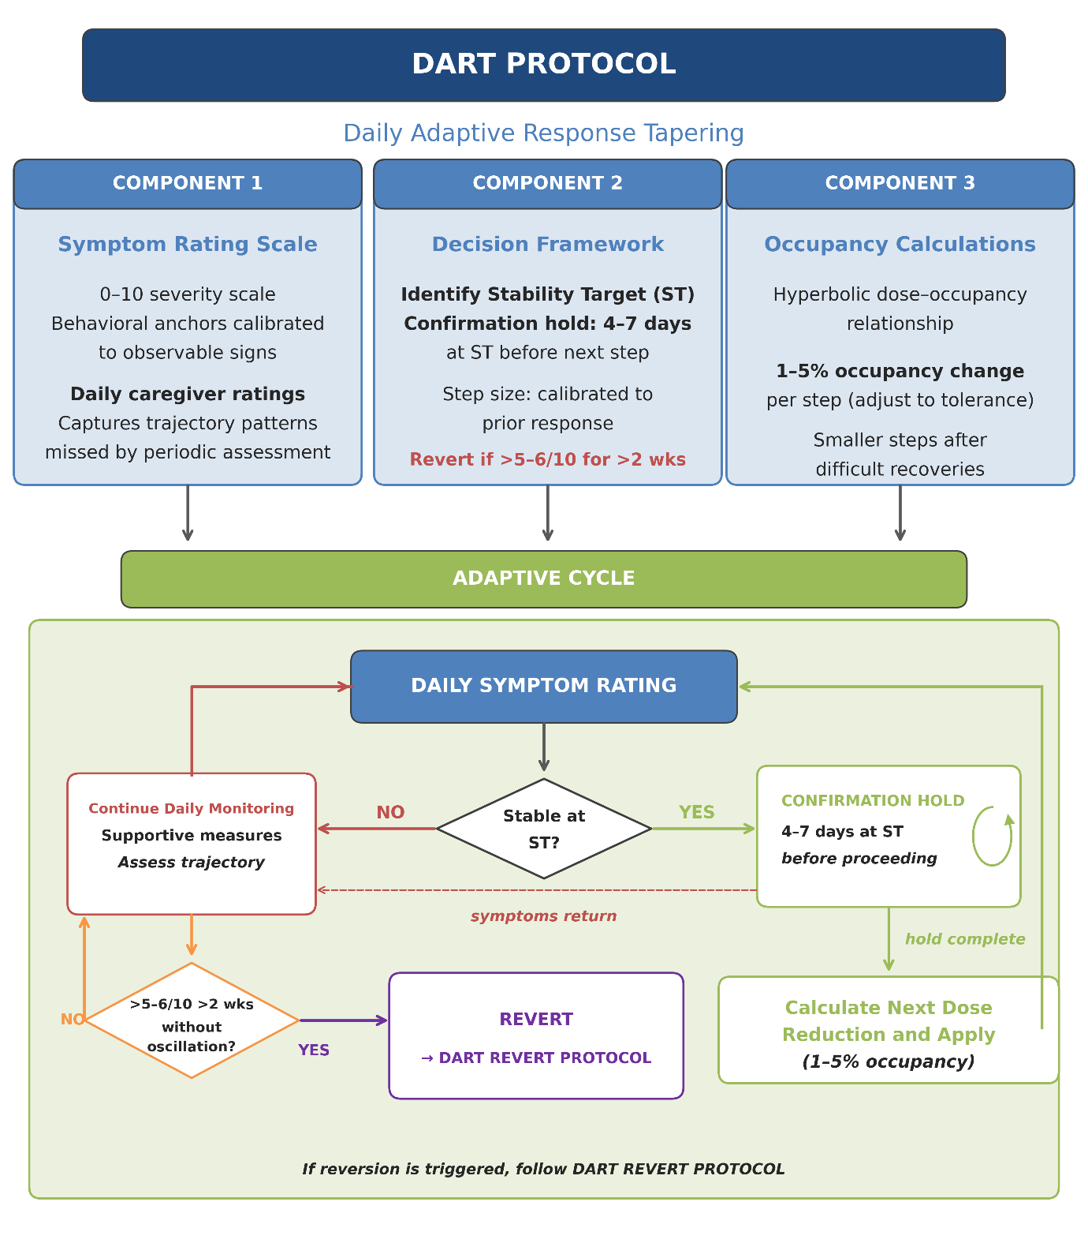
Figure 4. DART Protocol Schematic: A Framework Derived from Observation. The DART (Daily Adaptive Response Tapering) protocol comprises three integrated components: a symptom rating scale with behavioral anchors, a decision framework governing progression and reversion, and occupancy-guided dose calculations. The pre-protocol baseline establishment phase (1–2 weeks) determines the individualized stability target. See text for derivation of protocol elements from observed trajectory patterns; see Supplement B for tapering considerations, Supplement E for supportive treatments, and Supplement G for mechanisms.
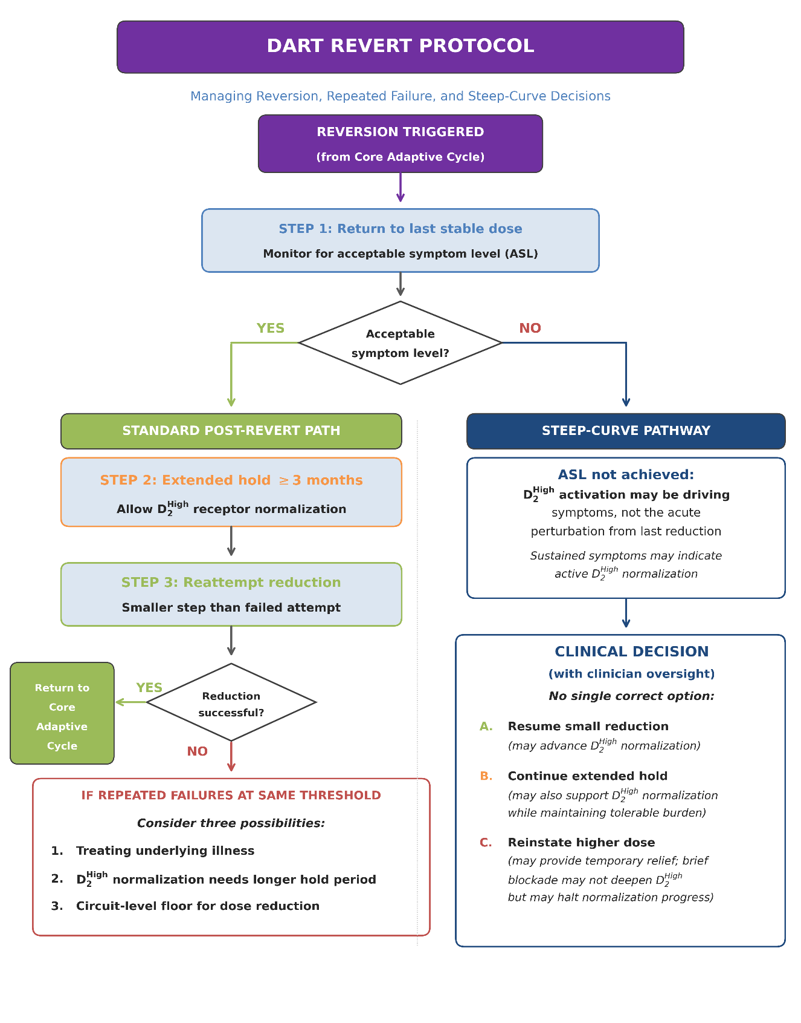
Figure 5. DART Revert Protocol: Managing Reversion and Steep-Curve Decisions. Following reversion to the last stable dose, the treatment team monitors for an acceptable symptom level (ASL)—a clinical judgment based on patient context, tolerance, and functional capacity. If ASL is achieved, the standard post-revert path applies: an extended hold (≥3 months) allows D₂^{High} receptor normalization before reattempting reduction with a smaller step. Successful reduction returns the patient to the Core Adaptive Cycle (Figure 4); repeated failures at the same threshold prompt consideration of alternative explanations (see text). If ASL is not achieved, this may indicate the taper has entered the steep-curve phase, where D₂^{High} activation rather than the acute perturbation may be driving symptoms. The steep-curve pathway presents a clinical decision requiring clinician oversight: resume small reduction, continue an extended hold, or temporarily reinstate a higher dose—each with different implications for receptor normalization (see Supplement H).

When the reverted dose restores an acceptable symptom level, DART follows a standard post-revert path: an extended hold of at least 3 months before reattempting reduction—consistent with Horowitz et al.'s recommendation of 3–6 month intervals between reductions, titrated to individual tolerance [Horowitz 2021]—using a smaller step size than the failed attempt. If repeated attempts at the same dose threshold fail despite extended holds and reduced step sizes, clinicians might consider three possibilities: that the current dose is treating an underlying disease state rather than suppressing withdrawal; that D₂^{High} receptor normalization requires longer than the hold period [Seeman 2005; Servonnet 2020]; or that circuit-level neuroadaptations have created a temporary or permanent floor for dose reduction [Kruyer 2021].
When the reverted dose does not restore an acceptable symptom level, this may signal that the taper has entered the steep-curve phase—where small dose changes produce large occupancy shifts and the primary symptom driver may have shifted from acute withdrawal to sustained D₂^{High} receptor activation. In this scenario, reversion may be insufficient because the occupancy difference between the current and reverted dose is too small to re-mask an exposed D₂^{High} receptor population. The steep-curve pathway presents a clinical decision requiring clinician oversight: resuming small reductions, continuing an extended hold, or temporarily reinstating a higher dose—each with different implications for receptor normalization (see Supplement G).

DISCUSSION

What Daily Monitoring Reveals
The trajectory features documented in Results—prolonged duration exceeding standard monophasic descriptions [Moncrieff 2006; Cerovecki 2013; Brandt 2020], oscillating rather than monotonic resolution, and amplitude narrowing emerging only after months (see also Figure 3)—each have implications extending beyond this individual case. The oscillating pattern is particularly consequential: how many "relapses" in the discontinuation literature represent similar self-limiting phenomena cannot be known, because the assessment methodology that would answer this question has rarely been implemented [Brandt 2020; Récalt 2019; Cohen 2019]. The months-long timescale before amplitude narrowing suggests neuroadaptive processes requiring extended normalization periods—consistent with estimates of D₂^{High} receptor state recovery [Seeman 2005; Horowitz 2021; Samaha 2007] but incompatible with typical research protocols or clinical expectations [Brandt 2020; Chouinard 2017].
The Introduction outlined three trajectory features that would distinguish withdrawal from disease fluctuation: temporal coupling to dose changes, motor-psychotic covariation, and progressive amplitude narrowing. The observed data are consistent with all three—symptom onset reliably followed each reduction within days across 12 sequential events, motor and psychotic symptoms tracked in parallel, and peak severity diminished only after months of cumulative dose reduction. While no single feature is diagnostic, and this case cannot validate these as formal criteria, the convergence of all three predictions in a single longitudinal dataset suggests that the withdrawal-relapse distinction is not merely theoretical—it generates testable, observable signatures when assessment is sufficiently granular to detect them.
The trajectory for patients with suspected DSP undertaking antipsychotic discontinuation remains uncertain, though emerging evidence suggests that sufficiently gradual tapering may permit receptor normalization in some individuals [Horowitz 2021; Groot 2020a; van Os 2023]. Critically, most discontinuation trials have employed tapers lasting weeks to a few months—timescales adequate for drug washout but far too brief to permit resolution of receptor adaptations that may require years to normalize [Samaha 2007; Chouinard 2017].
This mismatch may contribute to the elevated relapse rates observed in discontinuation arms and the consistent finding that these rates converge with maintenance cohorts at approximately three years [Tiihonen 2018; Moncrieff 2025; Horowitz 2025]—suggesting that much of the early excess "relapse" represents withdrawal-mediated supersensitivity psychosis rather than recurrence of underlying illness. Consistent with this interpretation, tardive dyskinesia—another manifestation of dopaminergic upregulation—can require years to remit following antipsychotic withdrawal, with remission rates of only 12–33% reported over follow-up periods extending to nearly 7 years [Glazer 1993; Waln 2013]. These timescales reinforce the case for tapering calibrated to receptor normalization rather than drug elimination [Horowitz 2021].

The Initiation Paradox
This apparent paradox reflects what Chouinard and colleagues have termed the closed therapeutic window in DSP [Chouinard 1991, 2017]: no dose achieves low symptom levels, because doses high enough to suppress symptoms produce intolerable side effects or paradoxical worsening, while lower doses permit withdrawal emergence (Figure 1). If stability is required before initiating a taper in the presence of significant receptor upregulation, the patients for whom dose reduction is most indicated may be precisely those excluded.
The established baseline then becomes the individualized stability target for progression decisions. As the taper proceeds and receptor normalization occurs, achievable baseline typically improves—as it did in this case, eventually reaching 0/10 by day 118. The stability target adjusts accordingly: what begins as "return to 5/10" may become "return to 2/10" and eventually "return to 0/10" as the taper progresses. This dynamic threshold accommodates the biological reality that supersensitivity resolves gradually rather than instantaneously [Seeman 2005; Samaha 2007].

Potential Clinical Applications
The trajectory patterns that necessitated these solutions to the initiation paradox—multiphasic withdrawal, oscillating recovery, months-long normalization—are the same features that give DART potential utility beyond this single application. If validated in prospective studies, DART's daily monitoring infrastructure has applications beyond withdrawal characterization. Daily trajectory data may help clinicians identify DSP—oscillating withdrawal signatures, motor-psychotic covariation, paradoxical worsening with dose increases—providing longitudinal evidence that cross-sectional assessment cannot capture. For patients labeled treatment-resistant, DART could help determine whether resistance reflects disease severity or iatrogenic complication. The trajectory patterns described under the reversion criterion—oscillating withdrawal versus stable persistent symptoms—provide information for distinguishing iatrogenic from underlying illness that no single assessment can capture. Where these conditions coexist, iterative reduction with extended observation may identify the dose below which symptoms become stable rather than oscillating—suggesting medication is treating illness rather than suppressing withdrawal.
Importantly, DART requires no specialized equipment or imaging. The daily rating methodology can be implemented by trained caregivers, with treating clinicians interpreting trajectory patterns, assessing for withdrawal signatures such as motor-psychotic covariation, and making dose-adjustment decisions. This division—daily observational data from caregivers, clinical interpretation from prescribers—bridges the infrastructure gap between appointments without displacing clinical authority.

Distinguishing Withdrawal from Relapse: What DART Enables
When symptoms emerge during tapering, three possibilities have been described: withdrawal, unmasking of supersensitivity, and relapse. Withdrawal is a time-limited response to reduced blockade that resolves with observation [Brandt 2020; Cerovecki 2013; Horowitz 2021; Moncrieff 2023]—though daily monitoring revealed that duration may substantially exceed "days to weeks" and include secondary elevations. Unmasking of supersensitivity occurs due to iatrogenic receptor changes from sustained treatment; dose reinstatement in this context may deepen the underlying upregulation rather than resolve it [Chouinard 2017; Samaha 2007]. Relapse occurs from recurrence of primary illness and is typically persistent or progressive rather than oscillating [Taylor 2022; Emsley 2013].
Several trajectory features help distinguish these processes in practice. Withdrawal typically shows a predictable temporal relationship to dose reduction (onset within days), may include non-psychotic features such as insomnia, anxiety, and movement abnormalities, and resolves with time [Brandt 2020; Cosci 2020; Cerovecki 2013; Blackman 2021]. Dilsaver and Alessi [1988] characterized withdrawal symptom onset as occurring within 48 hours of discontinuation—in contrast to primary psychosis relapse, which typically emerges over a week or longer [Taylor 2022; Horowitz 2021]. The DART framework permitted detection of oscillating withdrawal patterns with eventual resolution—distinct from sustained or progressive symptoms—supporting the interpretation of withdrawal rather than relapse in this application.
Nonetheless, validated criteria for differentiation do not exist in formal psychiatric nosology [Chouinard 2017; Crellin 2022]. Chouinard's operational framework [Chouinard 2017], while not formally adopted, provides the most systematically developed criteria currently available and has been applied consistently across multiple independent cohort studies [Fallon 2012; Kimura 2014; Suzuki 2015; Takase 2015]. The full diagnostic criteria and their chronological application to this case are detailed in Supplement A. DART was designed to capture the trajectory information these heuristics require, though whether it would prove useful in other contexts remains to be seen. Supplement D provides hypothetical clinical vignettes illustrating how these distinctions might inform reasoning across various scenarios.

Infrastructure Implications
The observations reported here were possible only because of circumstances described in Author Perspective and Methods—continuous caregiver availability, professional backgrounds, compounded formulations [Horowitz 2022a], and tolerance for sustained symptom elevation without dose reinstatement. These conditions are unavailable in routine practice, creating barriers at multiple levels.
At the knowledge level, DSP and withdrawal phenomena remain unfamiliar to many practitioners [Cooper 2023], and clinical guidance on antipsychotic withdrawal management remains largely absent [Blackman 2021]. At the structural level, even clinicians who suspect withdrawal cannot observe symptom trajectories between appointments (Table 1). Supplement C examines how these knowledge and structural barriers interact to perpetuate the assessment gap.
Research implications follow directly: if multiphasic patterns are common, the evidence base for maintenance treatment—built on discontinuation trials that cannot distinguish withdrawal from recurrence (Table 1)—may systematically overestimate relapse risk.
These structural barriers compound a more fundamental issue: even where intensive monitoring were feasible, the clinical framework for differential response is largely absent. Current guidelines provide procedures for maintenance but not for interpreting or managing discontinuation-emergent symptoms [Blackman 2021; Horowitz 2021]—in part because the monitoring infrastructure needed to characterize symptom trajectories has not been available [Brandt 2020; Récalt 2019]. Without trajectory data, the distinction between withdrawal and relapse cannot branch to different clinical actions [Taylor 2022; Emsley 2013]; the absence of that framework and the absence of that data are mutually reinforcing.
DART's development path—methodology emerging from clinical necessity rather than prospective research design—parallels a trajectory documented for hyperbolic tapering in the Netherlands, where patient-developed solutions eventually formalized into clinical tools now integrated into prescribing practice [Groot 2020a, 2020b; van Os 2023]. DART similarly emerged from practice rather than preceding it, raising questions about generalizability that only prospective application can answer. However, its monitoring architecture—daily ratings with behavioral anchors, stability-based progression criteria, occupancy-guided dose calculations—represents a transferable framework whose specific parameters require calibration to individual circumstances.

Possible Mechanisms
The trajectory complexity observed may reflect multiple neuroadaptive processes operating on different timescales [Cosci 2020]. D₂ receptor upregulation and D₂^{High} states may account for acute withdrawal [Samaha 2007, 2021; Seeman 2011], while differential recovery across neurotransmitter systems—histaminergic, serotonergic, cholinergic, glutamatergic—could contribute to oscillating patterns [Chouinard 2017; Cosci 2020]. Circuit-level dysfunction may also develop independently of receptor density changes: Kruyer et al. [2021] demonstrated behavioral supersensitivity arising from synaptic remodeling rather than receptor upregulation per se. Regional heterogeneity within the dopaminergic system—where striatal, mesolimbic, and mesocortical pathways show distinct adaptive responses—may produce asynchronous recovery during tapering (Supplement G).
Pharmacokinetic factors may also contribute independently of receptor-level neuroadaptation, producing agent-specific withdrawal signatures modified by metabolic genotype, body composition, and concurrent medications. Chlorpromazine illustrates this complexity: multiphasic elimination, deep tissue reservoirs [Bickel 1983], active metabolites with a metabolic recycling pathway [Jaworski 1990], and autoinduction of its own metabolism [Dahl 1977]. In this case, the complexity may have been compounded by polypharmacy history—four pharmacologically distinct antipsychotics (aripiprazole, haloperidol, clozapine, cariprazine) within six months of the monitored taper—potentially creating heterogeneous receptor populations recovering on different timelines. Supplement G reviews biological mechanisms, and Supplement B discusses pharmacokinetic factors.

LIMITATIONS
This single-application proof-of-concept cannot establish causality, population prevalence, or generalizability [Carey 2012]. Several specific limitations must be considered.
Generalizability unknown. Whether the trajectory patterns documented represent a common phenomenon, a rare occurrence, or an idiosyncratic response to this patient's specific circumstances cannot be determined. The pattern may be underreported rather than rare—given that few studies have used assessment methodology capable of detecting it—but replication is needed.
Unvalidated rating scale. The 0-10 severity scale with behavioral anchors was developed for this application. It has not been validated against established instruments, and the behavioral indicators used to infer hallucination severity in a patient with autism-related communication challenges may not generalize to other populations. Accordingly, a rating of 0/10 indicated that no behavioral response to voices was observed, not that hallucinations were necessarily absent.
Caregiver-administered assessment. Observer bias, emotional investment, and absence of clinical experience across diverse presentations are inherent limitations of family-based observation. The patterns documented may have been influenced by observer effects.
Diagnostic uncertainty. Primary schizophrenia with complex medication interactions cannot be excluded. The 2018 hospitalization involved an acute presentation; while treating clinicians concluded this reflected sleep-deprivation-related decompensation rather than emerging psychosis—supported by self-sought hospitalization, absence of documented hallucinations at discharge, Major Depressive Disorder discharge diagnosis, and risperidone initiation for ASD-related irritability rather than psychosis (Supplement A)—retrospective exclusion of a primary psychotic episode cannot be absolute. We cannot exclude primary schizophrenia with concomitant medication-induced supersensitivity—a combination that may be common [Chouinard 2017; Yin 2017; Fallon 2012; Nakata 2017]. Supplement F addresses objections to the DSP framework and specifies what evidence would weaken the hypothesis.
Anchoring bias. Having identified dopamine supersensitivity as a possible explanation for symptoms and medication responses early in this patient's course, we may have interpreted subsequent events through a confirmatory lens [Croskerry 2003; Saposnik 2016].
Concurrent medications. Lumateperone, sertraline, clonazepam, and propranolol were maintained throughout. We cannot exclude contributions from these agents, though CPZ was the only variable changed during the observations reported.
ASD as confounding variable. Possible constitutional dopaminergic differences in autism make it difficult to distinguish medication-induced from developmental receptor changes [Pavăl 2021, 2023; Kosillo 2021; Chhabra 2023; Blum 2024; Zurcher 2021]. This represents a double-edged limitation: ASD may confer heightened vulnerability to DSP (Supplement A), potentially making this case representative of a clinically important at-risk population—but the same neurobiological differences that increase vulnerability may also limit generalizability to neurotypical populations.
Measurement limitations. We infer receptor changes from clinical response patterns; quantification would require PET imaging unavailable in this context. Supplement A reviews the evidence for heightened DSP vulnerability in ASD populations.
Despite these limitations, several features strengthen the inference that the observed symptom fluctuations represent withdrawal phenomena rather than random variation or measurement artifact: temporal consistency (symptoms emerged 1-3 days post-reduction across events), dose-response relationship (larger reductions produced more severe and prolonged responses), within-subject replication across twelve sequential reductions, and temporal covariation of withdrawal dyskinesia with psychotic symptoms suggesting a common dopaminergic mechanism.

Future Directions
Whether the approach described here—or adaptations of it—would have applications in other contexts requires prospective evaluation. Several directions seem warranted.
Discontinuation research. Prospective trials incorporating daily or near-daily assessment could characterize trajectory patterns currently invisible to standard protocols, enabling distinction between withdrawal and relapse as separate outcomes rather than equivalent "treatment failures." Digital phenotyping approaches—smartphone-based ecological momentary assessment, wearable sensors, or caregiver-reported daily ratings—might achieve adequate temporal resolution without the intensive in-person observation this protocol required, though electronic health record integration presents its own challenges [Desai 2020].
Clinical decision support. Simplified versions of daily tracking might be incorporated into clinical care—for example, caregiver-reported daily ratings transmitted to clinicians between appointments.
Protocol validation. The rating scale would require validation against established measures, and DART's decision rules would require testing across diverse patients and clinical settings.
Identifying candidates for intensive monitoring. Not all patients attempting antipsychotic tapering would require daily assessment. Clinical features predictive of trajectory complexity—such as DSP indicators (Supplement A, Table A-2), duration of antipsychotic exposure, or prior withdrawal history—might identify patients for whom intensive monitoring is warranted.
Broader implementation would require institutional support, clinical oversight, and safety infrastructure beyond what family-based monitoring can provide.

CONCLUSIONS
This paper reports findings from daily monitoring during antipsychotic tapering in a clinical context consistent with the dopamine supersensitivity psychosis framework, and presents DART (Daily Adaptive Response Tapering), the monitoring protocol that emerged from these observations.
Daily monitoring detected trajectory complexity invisible to standard assessment intervals: withdrawal extending 53 days, with oscillating patterns including secondary elevations that would register as "relapse" at most any single timepoint (Table 1; Figures 2–3).
Whether these patterns generalize cannot be determined from a single case; prospective research with comparable assessment granularity is needed. But current infrastructure—clinical and research—lacks the capacity to answer this question, and the clinical framework for responding differently to withdrawal versus relapse remains underdeveloped [Cooper 2019, 2023; Roed 2023; Speyer 2025]. DART's low-resource monitoring architecture—daily caregiver ratings reported to treating clinicians—may offer a starting point for bridging both gaps.
Without trajectory-level monitoring, the possibility that some patients diagnosed with treatment-resistant schizophrenia may be experiencing iatrogenic worsening rather than disease progression cannot be evaluated. DART cannot resolve questions of prevalence, but it may offer clinicians a tool for a distinction that, for the individual patient, determines whether the appropriate response is dose increase or gradual reduction.
Although this report describes a single case, several features may generalize beyond the specific diagnosis and drug involved. The multiphasic temporal course—withdrawal emerging, resolving, and re-emerging across weeks to months rather than following a single predictable arc—is consistent with homeostatic recovery from any prolonged receptor perturbation and has been described across other drug classes [Horowitz 2021; Cosci 2020; Stockmann 2018]. The practical demands may likewise generalize: successful tapering required not only an occupancy-informed dose schedule but sustained care infrastructure—daily monitoring, a stable caregiving environment, compounded doses at non-standard strengths, and alignment among all treatment team members regarding goals, expected course, and decision rules. This infrastructure proved as essential as the pharmacological strategy itself. A taper of this complexity is fragile: any disruption—a prescriber unable or unwilling to maintain the protocol, a provider change, loss of compounding access, breakdown in the caregiving relationship, or misinterpretation of withdrawal as relapse—could derail the process entirely, potentially leading to dose reinstatement that deepens the receptor adaptations the taper sought to resolve.
We welcome correspondence from those working with similar cases.

References
Aarons RD, Nies AS, Gal J, Hegstrand LR, Molinoff PB. Elevation of beta-adrenergic receptor density in human lymphocytes after propranolol administration. J Clin Invest. 1980;65(5):949-957.
Accordino RE, Kidd C, Politte LC, Henry CA, McDougle CJ. Psychopharmacological interventions in autism spectrum disorder. Expert Opin Pharmacother. 2016;17(7):937-952. https://doi.org/10.1517/14656566.2016.1154536
Ashton H. The diagnosis and management of benzodiazepine dependence. Curr Opin Psychiatry. 2005;18(3):249-255. https://doi.org/10.1097/01.yco.0000165594.60434.84
Bedard AM, Maheux J, Levesque D, Samaha AN. (2011). Continuous, but not intermittent, antipsychotic drug delivery intensifies the pursuit of reward cues. Neuropsychopharmacology, 36(6), 1248-1259. https://doi.org/10.1038/npp.2011.10
Beuschlein F, Else T, Bancos I, Engel J, Gurnell M, Gadelha M, et al. European Society of Endocrinology and Endocrine Society joint clinical guideline: diagnosis and therapy of glucocorticoid-induced adrenal insufficiency. J Clin Endocrinol Metab. 2024;109(7):1657-1683. https://doi.org/10.1210/clinem/dgae250
Bickel MH, Graber BE, Moor M. Distribution of chlorpromazine and imipramine in adipose and other tissues of rats. Life Sci. 1983;33(20):2025-2031. https://doi.org/10.1016/0024-3205(83)90742-7
Blackman G, Oloyede E. (2021) Clozapine discontinuation withdrawal symptoms in schizophrenia. Ther Adv Psychopharmacol 11:20451253211032053. https://doi.org/10.1177/20451253211032053
Blum K, Bowirrat A, Sunder K, Thanos PK, Hanna C, Gold MS, Dennen CA, Elman I, Murphy KT, Makale MT. Dopamine Dysregulation in Reward and Autism Spectrum Disorder. Brain Sci. 2024 Jul 22;14(7):733. https://doi.org/10.3390/brainsci14070733
Brandt L, Bschor T, Henssler J, Müller M, Hasan A, Heinz A, Gutwinski S. (2020). Antipsychotic withdrawal symptoms: a systematic review and meta-analysis. Frontiers in Psychiatry, 11, 569912. https://doi.org/10.3389/fpsyt.2020.569912
Burt DR, Creese I, Snyder SH. Antischizophrenic drugs: chronic treatment elevates dopamine receptor binding in brain. Science. 1977;196(4287):326-328. https://doi.org/10.1126/science.847477
Carey TS, Sanders GD, Viswanathan M, Trikalinos TA, Kato E, Chang S, Brasure M, Hasselblad V, Kane RL. (2012). Framework for considering study designs for future research needs. In Methods Guide for Effectiveness and Comparative Effectiveness Reviews. Agency for Healthcare Research and Quality (US).
Carlsson A, Lindqvist M. Effect of chlorpromazine or haloperidol on formation of 3-methoxytyramine and normetanephrine in mouse brain. Acta Pharmacol Toxicol. 1963;20:140-144. https://doi.org/10.1111/j.1600-0773.1963.tb01730.x
Caroff SN, Hurford I, Lybrand J, Campbell EC. Movement disorders induced by antipsychotic drugs: implications of the CATIE schizophrenia trial. Neurol Clin. 2011;29(1):127-148. https://doi.org/10.1016/j.ncl.2010.10.002
Cerovecki A, Musil R, Klimke A, Seemüller F, Haen E, Schennach R, Kühn KU, Volz HP, Riedel M. (2013). Withdrawal symptoms and rebound syndromes associated with switching and discontinuing atypical antipsychotics: theoretical background and practical recommendations. CNS Drugs, 27(7), 545-572. https://doi.org/10.1007/s40263-013-0079-5
Chhabra S, Nardi L, Leukel P, Sommer CJ, Schmeisser MJ. Striatal increase of dopamine receptor 2 density in idiopathic and syndromic mouse models of autism spectrum disorder. Front Psychiatry. 2023 Mar 8;14:1110525. https://doi.org/10.3389/fpsyt.2023.1110525
Chouinard G, Chouinard VA. (2008). Atypical antipsychotics: CATIE study, drug-induced movement disorder and resulting iatrogenic psychiatric-like symptoms, supersensitivity rebound psychosis and withdrawal discontinuation syndromes. Psychotherapy and Psychosomatics, 77(2), 69-77. https://doi.org/10.1159/000112883
Chouinard G, Cosci F, Chouinard VA, Alphs L. (2023). The Extrapyramidal Symptom Rating Scale and Its Abbreviated Version: A Critical Review of Clinimetric Properties. Psychotherapy and Psychosomatics, 92(6), 359-366. https://doi.org/10.1159/000535113
Chouinard G, Jones BD, Annable L. Neuroleptic-induced supersensitivity psychosis. Am J Psychiatry. 1978;135(11):1409-1410. https://doi.org/10.1176/ajp.135.11.1409
Chouinard G, Margolese HC. Manual for the Extrapyramidal Symptom Rating Scale (ESRS). Schizophr Res. 2005;76(2-3):247-265. https://doi.org/10.1016/j.schres.2005.02.013
Chouinard G, Samaha AN, Chouinard VA, Peretti CS, Kanahara N, Takase M, Iyo M. (2017). Antipsychotic-induced dopamine supersensitivity psychosis: pharmacology, criteria, and therapy. Psychotherapy and Psychosomatics, 86(4), 189-219. https://doi.org/10.1159/000477313
Chouinard G. (1991). Severe cases of neuroleptic-induced supersensitivity psychosis: diagnostic criteria for the disorder and its treatment. Schizophrenia Research, 5(1), 21-33. https://doi.org/10.1016/0920-9964(91)90050-2
Cohen D, Recalt A. (2019). Discontinuing psychotropic drugs from participants in randomized controlled trials: a systematic review. Psychotherapy and Psychosomatics, 88(2), 96-104. https://doi.org/10.1159/000496733
Cooper RE, Hanratty E, Morant N, Moncrieff J. (2023). Tapering interventions for antipsychotic reduction and discontinuation in adults with schizophrenia and other psychotic disorders. The Lancet Psychiatry, 10(9), 720-732. https://doi.org/10.1016/S2215-0366(23)00197-1
Cooper RE, Hanratty É, Morant N, Moncrieff J. (2019). Mental health professionals' views and experiences of antipsychotic reduction and discontinuation. PLoS One, 14(6), e0218711. https://doi.org/10.1371/journal.pone.0218711
Cosci F, Chouinard G. (2020). Acute and persistent withdrawal syndromes following discontinuation of psychotropic medications. Psychotherapy and Psychosomatics, 89(5), 283-306. https://doi.org/10.1159/000506868
Cosci F, Romanazzo S, Mansueto G, Rontani P, Levitan MN, Cunha Dias da Rocha D, Halkjœr-Lassen RD, Quagliato LA, Nakamura T, Uematsu K, Nardi AE, Oe M, Chouinard VA, Chouinard G. (2022). Clinical Utility of Semistructured Interview and Scales to Assess Withdrawal Syndromes With Dose Reduction or Discontinuation of Selective Serotonin Reuptake Inhibitors or Serotonin Norepinephrine Reuptake Inhibitors. Journal of Clinical Psychopharmacology, 42(1), 17-22. https://doi.org/10.1097/JCP.0000000000001491
Costardi CG, Gadelha A, Bressan RA. (2021). Individualizing tapering antipsychotic schemes considering D₂ blockade dynamics. Journal of Psychopharmacology, 35(9), 1161-1162. https://doi.org/10.1177/02698811211031202
Crellin NE, Priebe S, Morant N, Lewis G, Freemantle N, Johnson S, Horne R, Pinfold V, Kent L, Smith R, Darton K, Cooper RE, Long M, Thompson J, Gruenwald L, Freudenthal R, Stansfeld JL, Moncrieff J. (2022). An analysis of views about supported reduction or discontinuation of antipsychotic treatment among people with schizophrenia and other psychotic disorders. BMC Psychiatry, 22(1), 185. https://doi.org/10.1186/s12888-022-03822-5
Croskerry P. (2003). The importance of cognitive errors in diagnosis and strategies to minimize them. Academic Medicine, 78(8), 775-780. https://doi.org/10.1097/00001888-200308000-00003
Dahl SG, Strandjord RE. Pharmacokinetics of chlorpromazine after single and chronic dosage. Clin Pharmacol Ther. 1977;21(4):437-448. https://doi.org/10.1002/cpt1977214437
Davis RE, Vanover KE, Zhou Y, Brašić JR, Guevara M, Bisuna B, Ye W, Raymont V, Willis W, Kumar A, Gapasin L, Goldwater DR, Mates S, Wong DF. ITI-007 demonstrates brain occupancy at serotonin 5-HT_(2A) and dopamine D₂ receptors and serotonin transporters using positron emission tomography in healthy volunteers. Psychopharmacology. 2015;232(15):2863-2872. https://doi.org/10.1007/s00213-015-3922-1
de Beer F, de Vries E, Wijnen B, Begemann MJH, van Beveren N, Boonstra N, Gangadin SS, de Haan L, Hamers IMH, Veling W, Koops S, Sommer IEC. Dopamine D₂/3R availability after discontinuation of antipsychotic treatment: a [11C]raclopride PET study in remitted first-episode psychosis patients. Psychol Med. 2025;55:e264. https://doi.org/10.1017/S003329172510161X
Desai SB, Vyas R, Patel N. Electronic health record barriers and facilitators: an update. Healthc Inform Res. 2020;26(4):317-323. https://doi.org/10.4258/hir.2020.26.4.317
Dilsaver SC, Alessi NE. Antipsychotic withdrawal symptoms: phenomenology and pathophysiology. Acta Psychiatr Scand. 1988;77(3):241-6. https://doi.org/10.1111/j.1600-0447.1988.tb05116.x
Emsley R, Chiliza B, Asmal L, Harvey BH. The nature of relapse in schizophrenia. BMC Psychiatry. 2013;13:50. https://doi.org/10.1186/1471-244X-13-50
Faisal M, Pradeep V, O\'Hanrahan S. Case of paediatric catatonia precipitated by antipsychotic withdrawal in a child with autism spectrum disorder. BMJ Case Rep. 2021;14(4):e240785. https://doi.org/10.1136/bcr-2020-240785
Fallon P, Dursun S, Deakin B. Drug-induced supersensitivity psychosis revisited: characteristics of relapse in treatment-compliant patients. Ther Adv Psychopharmacol. 2012;2(1):13-22. https://doi.org/10.1177/2045125311431105
Frishman WH. Beta-adrenergic blocker withdrawal. Am J Cardiol. 1987;59(13):26F-32F. https://doi.org/10.1016/0002-9149(87)90075-3
Gardos G, Cole JO, Tarsy D. Withdrawal syndromes associated with antipsychotic drugs. Am J Psychiatry. 1978;135(11):1321-1324. https://doi.org/10.1176/ajp.135.11.1321
Ginovart N, Wilson AA, Hussey D, Houle S, Kapur S. (2009). D₂-receptor upregulation is dependent upon temporal course of D₂-occupancy: a longitudinal [¹¹C]-raclopride PET study in cats. Neuropsychopharmacology, 34(3), 662-671. https://doi.org/10.1038/npp.2008.116
Glazer WM, Morgenstern H, Doucette JT. Predicting the long-term risk of tardive dyskinesia in outpatients maintained on neuroleptic medications. J Clin Psychiatry. 1993;54(4):133-9. PMID: 8098030
Groot PC, van Os J. (2020a). Antidepressant tapering tips to help people come off medication more safely. Psychosis, 12(2), 142-145. https://doi.org/10.1080/17522439.2019.1687520
Groot PC, van Os J. (2020b). Outcome of antidepressant drug discontinuation with taperingstrips after 1-5 years. Therapeutic Advances in Psychopharmacology, 10, 2045125320954609. https://doi.org/10.1177/2045125320954609
Groot PC, van Os J. (2021). Successful use of tapering strips for hyperbolic reduction of antidepressant dose: a cohort study. Therapeutic Advances in Psychopharmacology, 11, 20451253211039327. https://doi.org/10.1177/20451253211039327
Harrow M, Jobe TH, Faull RN. (2014). Does treatment of schizophrenia with antipsychotic medications eliminate or reduce psychosis? A 20-year multi-follow-up study. Psychological Medicine, 44(14), 3007-3016. https://doi.org/10.1017/S0033291714000610
Harrow M, Jobe TH, Faull RN. Do all schizophrenia patients need antipsychotic treatment continuously throughout their lifetime? A 20-year longitudinal study. Psychol Med. 2012 Oct;42(10):2145-55. https://doi.org/10.1017/S0033291712000220
Horowitz MA, Jauhar S, Natesan S, Murray RM, Taylor D. (2021). A method for tapering antipsychotic treatment that may minimize the risk of relapse. Schizophrenia Bulletin, 47(4), 1116-1129. https://doi.org/10.1093/schbul/sbab017
Horowitz MA, Moncrieff J, de Haan L, Bogers JPAM. Tapering antipsychotic medication: practical considerations. Psychol Med. 2022a;52(1):32-35. https://doi.org/10.1017/S0033291721004116
Horowitz MA, Moncrieff J. (2024). Gradually tapering off antipsychotics: lessons for practice from case studies and neurobiological principles. Current Opinion in Psychiatry, 37(4), 320-330. https://doi.org/10.1097/YCO.0000000000000938
Horowitz MA, O'Neill J, Berna F, Taylor D. Not so hasty: the effect of tapering speed on relapse may still be important. Schizophr Bull. 2025;sbaf163. https://doi.org/10.1093/schbul/sbaf163
Horowitz MA, Taylor D. Tapering of SSRI treatment to mitigate withdrawal symptoms. Lancet Psychiatry. 2019;6(6):538-546. https://doi.org/10.1016/S2215-0366(19)30032-X
Howes OD, Kambeitz J, Kim E, Stahl D, Slifstein M, Abi-Dargham A, et al. The nature of dopamine dysfunction in schizophrenia and what this means for treatment. Arch Gen Psychiatry. 2012;69(8):776-86. https://doi.org/10.1001/archgenpsychiatry.2012.169
Howes OD, Kapur S. The dopamine hypothesis of schizophrenia: version III—the final common pathway. Schizophr Bull. 2009;35(3):549-562. https://doi.org/10.1093/schbul/sbp006
Iyo M, Tadokoro S, Kanahara N, Hashimoto T, Niitsu T, Watanabe H, Hashimoto K. (2013). Optimal extent of dopamine D2 receptor occupancy by antipsychotics for treatment of dopamine supersensitivity psychosis and late-onset psychosis. Journal of Clinical Psychopharmacology, 33(3), 398-404. https://doi.org/10.1097/JCP.0b013e31828ea95c
Javitt DC. Twenty-five years of glutamate in schizophrenia: are we there yet? Schizophr Bull. 2012;38(5):911-913. https://doi.org/10.1093/schbul/sbs100
Jaworski TJ, Hawes EM, McKay G, Midha KK. The metabolism of chlorpromazine N-oxide in man and dog. Xenobiotica. 1990;20(1):107-115. https://doi.org/10.3109/00498259009046817
Kapur S, Zipursky R, Jones C, Remington G, Houle S. (2000a). Relationship between dopamine D₂ occupancy, clinical response, and side effects: a double-blind PET study of first-episode schizophrenia. American Journal of Psychiatry, 157(4), 514-520. https://doi.org/10.1176/appi.ajp.157.4.514
Karaş H, Güdük M, Saatcioğlu Ö. (2016). Withdrawal-emergent dyskinesia and supersensitivity psychosis due to olanzapine use. Archives of Neuropsychiatry, 53(2), 178-180. https://doi.org/10.5152/npa.2015.10122
Kazdin AE. Single-case experimental designs. Evaluating interventions in research and clinical practice. Behav Res Ther. 2019;117:3-17. https://doi.org/10.1016/j.brat.2018.11.015
Kimura H, Kanahara N, Komatsu N, Ishige M, Muneoka K, Yoshimura M, et al. A prospective comparative study of risperidone long-acting injectable for treatment-resistant schizophrenia with dopamine supersensitivity psychosis. Schizophr Res. 2014;155(1-3):52-58. https://doi.org/10.1016/j.schres.2014.02.022
Kosillo P, Bhardwaj SK. (2021). Dopaminergic dysregulation in syndromic autism spectrum disorders: Insights from genetic mouse models. Frontiers in Neural Circuits, 15, 700968. https://doi.org/10.3389/fncir.2021.700968
Kruyer A, Parrilla-Carrero J, Powell C, Brandt L, Gutwinski S, Angelis A, Chalhoub RM, Jhou TC, Kalivas PW, Amato D. (2021). Accumbens D₂-MSN hyperactivity drives antipsychotic-induced behavioral supersensitivity. Molecular Psychiatry, 26(11), 6159-6169. https://doi.org/10.1038/s41380-021-01235-6
Lako IM, van den Heuvel ER, Knegtering H, Bruggeman R, Taxis K. Estimating dopamine D₂ receptor occupancy for doses of 8 antipsychotics: a meta-analysis. J Clin Psychopharmacol. 2013;33(5):675-681. https://doi.org/10.1097/JCP.0b013e3182983ffa
Lander M, Bhardwaj SK, Bhardwaj T, Sareen J. (2018). Review of withdrawal catatonia: what does this reveal about clozapine? Translational Psychiatry, 8(1), 139. https://doi.org/10.1038/s41398-018-0192-9
Leucht S, Tardy M, Komossa K, Heres S, Kissling W, Salanti G, et al. Antipsychotic drugs versus placebo for relapse prevention in schizophrenia: a systematic review and meta-analysis. Lancet. 2012;379(9831):2063-71. https://doi.org/10.1016/S0140-6736(12)60239-6
McCutcheon RA, Krystal JH, Howes OD. Dopamine and glutamate in schizophrenia: biology, symptoms and treatment. World Psychiatry. 2020;19(1):15-33. https://doi.org/10.1002/wps.20693
Miller R, Chouinard G. Loss of striatal cholinergic neurons as a basis for tardive and L-dopa-induced dyskinesias, neuroleptic-induced supersensitivity psychosis and refractory schizophrenia. Biol Psychiatry. 1993;34(10):713-738. https://doi.org/10.1016/0006-3223(93)90044-E
Moncrieff J, Horowitz MA. Helping people to discontinue antipsychotics: if, when and how. Schizophrenia. 2025;11(1):5. https://doi.org/10.1038/s41537-025-00695-x
Moncrieff J, Lewis G, Freemantle N, Johnson S, Barnes TRE, Jakobsen JC, Larsen JT, Hróbjartsson A. (2023). Randomised controlled trial of gradual tapering of antipsychotics in people with a diagnosis of schizophrenia, schizoaffective disorder or delusional disorder: the RADAR trial. BMJ Open, 13(5), e069101. https://doi.org/10.1136/bmjopen-2022-069101
Moncrieff J. (2006). Does antipsychotic withdrawal provoke psychosis? Review of the literature on rapid onset psychosis (supersensitivity psychosis) and withdrawal-related relapse. Acta Psychiatrica Scandinavica, 114(1), 3-13. https://doi.org/10.1111/j.1600-0447.2006.00787.x
Murray RM, Quattrone D, Natesan S, van Os J, Nordentoft M, Howes O, Di Forti M, Taylor D. Should psychiatrists be more cautious about the long-term prophylactic use of antipsychotics? Br J Psychiatry. 2016 Nov;209(5):361-365. https://doi.org/10.1192/bjp.bp.116.182683
Nakata Y, Kanahara N, Kimura H, Niitsu T, Komatsu N, Oda Y, Kubota-Isozaki M, Omori Y, Tadokoro S, Hashimoto T, Iyo M. (2017). Dopamine supersensitivity psychosis in schizophrenia: concepts and implications in clinical practice. Journal of Psychopharmacology, 31(12), 1511-1518. https://doi.org/10.1177/0269881117728428
National Institute for Health and Care Excellence (NICE). Psychosis and schizophrenia in adults: prevention and management. NICE Clinical Guideline CG178. London: NICE; 2014. Available from: https://www.nice.org.uk/guidance/cg178
Neill JC, Grayson B, Kiss B, Gyertyán I, Ferguson P, Adham N. Advances in animal models of dopamine supersensitivity and treatment resistance: translational implications for schizophrenia. Neuropharmacology. 2023;222:109345. https://doi.org/10.1016/j.neuropharm.2022.109345
Nuechterlein KH, Dawson ME. A heuristic vulnerability/stress model of schizophrenic episodes. Schizophr Bull. 1984;10(2):300-312. https://doi.org/10.1093/schbul/10.2.300
O'Neill JR, Taylor DM, Horowitz MA. (2023). Implementing gradual, hyperbolic tapering of long-acting injectable antipsychotics by prolonging the inter-dose interval: an in silico modelling study. Therapeutic Advances in Psychopharmacology, 13, 20451253231198463. https://doi.org/10.1177/20451253231198463
Pavăl D, Micluția IV. (2021). The Dopamine Hypothesis of Autism Spectrum Disorder Revisited: Current Status and Future Prospects. Developmental Neuroscience, 43(2), 73-83. https://doi.org/10.1159/000515751
Pavăl D. The dopamine hypothesis of autism spectrum disorder: A comprehensive analysis of the evidence. Int Rev Neurobiol. 2023;173:1-42. https://doi.org/10.1016/bs.irn.2023.08.009
Petrovsky N, Ettinger U, Hill A, Frenzel L, Meyhöfer I, Wagner M, Backhaus J, Kumari V. Sleep deprivation disrupts prepulse inhibition and induces psychosis-like symptoms in healthy humans. Journal of Neuroscience. 2014;34(27):9134–9140. https://doi.org/10.1523/JNEUROSCI.0904-14.2014
Rakofsky JJ, Dunlop BW. Innovations in psychopharmacology education in U.S. psychiatric residency programs. Acad Psychiatry. 2021;45(4):503-510. Available from: https://doi.org/10.1007/s40596-020-01386-0
Roed K, Buus N, Nielsen J, Christensen PS, Midtgaard J. (2023). Mental health staff's perspectives on tapering of antipsychotic medication: a focus group study. Qualitative Health Research, 33(13), 1165-1176. https://doi.org/10.1177/10497323231195821
Récalt AM, Cohen D. (2019). Withdrawal confounding in randomized controlled trials of antipsychotic, antidepressant, and stimulant drugs, 2000-2017. Psychotherapy and Psychosomatics, 88(2), 105-113. https://doi.org/10.1159/000496734
Samaha AN, Reckless GE, Seeman P, Diwan M, Nobrega JN, Kapur S. (2008). Less is more: antipsychotic drug effects are greater with transient rather than continuous delivery. Biological Psychiatry, 64(2), 145-152. https://doi.org/10.1016/j.biopsych.2008.01.010
Samaha AN, Seeman P, Stewart J, Rajabi H, Kapur S. (2007). "Breakthrough" dopamine supersensitivity during ongoing antipsychotic treatment leads to treatment failure over time. Journal of Neuroscience, 27(11), 2979-2986. https://doi.org/10.1523/JNEUROSCI.5416-06.2007
Samaha AN, Seeman P. (2021). Dopamine supersensitivity psychosis: history, mechanisms and opportunities for prevention. Neuropharmacology, 195, 108655. https://doi.org/10.1016/j.neuropharm.2021.108655
Saposnik G, Redelmeier D, Ruff CC, Tobler PN. (2016). Cognitive biases associated with medical decisions: a systematic review. BMC Medical Informatics and Decision Making, 16(1), 138. https://doi.org/10.1186/s12911-016-0377-1
Seeman P, Lee T, Chau-Wong M, Wong K. Antipsychotic drug doses and neuroleptic/dopamine receptors. Nature. 1976;261(5562):717-719. https://doi.org/10.1038/261717a0
Seeman P, Weinshenker D, Quirion R, Srivastava LK, Bhardwaj SK, Grandy DK, Premont RT, Sotnikova TD, Boksa P, El-Ghundi M, O'Dowd BF, George SR, Perreault ML, Männistö PT, Robinson S, Palmiter RD, Tallerico T. Dopamine supersensitivity correlates with D₂High states, implying many paths to psychosis. Proc Natl Acad Sci U S A. 2005;102(9):3513-3518. https://doi.org/10.1073/pnas.0409766102
Seeman P. (2011). All roads to schizophrenia lead to dopamine supersensitivity and elevated dopamine D₂High receptors. CNS Neuroscience & Therapeutics, 17(2), 118-132. https://doi.org/10.1111/j.1755-5949.2010.00162.x
Servonnet A, Bhardwaj SK, Samaha AN. (2020). Antipsychotic-evoked dopamine supersensitivity: functional imaging evidence and clinical relevance. Frontiers in Pharmacology, 11, 1303. https://doi.org/10.3389/fphar.2020.01303
Siafis S, Wu H, Wang D, Burschinski A, Nomura N, Takeuchi H, Schneider-Thoma J, Davis JM, Leucht S. Antipsychotic dose, dopamine D₂ receptor occupancy and extrapyramidal side-effects: a systematic review and dose-response meta-analysis. Mol Psychiatry. 2023;28:3267--3277. https://doi.org/10.1038/s41380-023-02203-y
Silvestri S, Seeman MV, Negrete JC, Houle S, Shammi CM, Remington GJ, Kapur S, Zipursky RB, Wilson AA, Christensen BK, Seeman P. (2000). Increased dopamine D₂ receptor binding after long-term treatment with antipsychotics in humans: a clinical PET study. Psychopharmacology, 152(2), 174-180. https://doi.org/10.1007/s002130000532
Speyer H, Eplov LF, Roe D. (2025). Antipsychotic discontinuation through the lens of epistemic injustice. Community Mental Health Journal, 61(2), 244-247. https://doi.org/10.1007/s10597-024-01274-7
Speyer H, Jakobsen JC, Westergaard C, Nørgaard HCB, Pisinger C, Krogh J, Hjorthøj C, Christensen AN, Helles R, Jørgensen TSH, Lindschou J, Correll CU, Gluud C, Fink-Jensen A. (2023). Antipsychotic dose reduction compared to continued treatment in people with schizophrenia. Cochrane Database of Systematic Reviews, 2023(3), CD014383. https://doi.org/10.1002/14651858.CD014383.pub2
Stockmann T, Odegbaro D, Timimi S, Moncrieff J. SSRI and SNRI withdrawal symptoms reported on an internet forum. Int J Risk Saf Med. 2018;29(3-4):175-180. https://doi.org/10.3233/JRS-180018
Suzuki T, Kanahara N, Yamanaka H, Takase M, Kimura H, Watanabe H, Iyo M. (2015). Dopamine supersensitivity psychosis as a pivotal factor in treatment-resistant schizophrenia. Psychiatry Research, 227(2-3), 278-282. https://doi.org/10.1016/j.psychres.2015.02.021
Takase M, Kanahara N, Oda Y, Kimura H, Watanabe H, Iyo M. (2015). Dopamine supersensitivity psychosis and dopamine partial agonist: a retrospective survey of failure of switching to aripiprazole in schizophrenia. Journal of Psychopharmacology, 29(4), 383-389. https://doi.org/10.1177/0269881115570085
Taylor D, Horowitz MA. Distinguishing relapse from antipsychotic withdrawal in schizophrenia. Lancet Psychiatry. 2022;9(11):847-849. https://doi.org/10.1016/S2215-0366(22)00328-5
Thompson IA, de Vries EFJ, Sommer IEC. Dopamine D₂ receptor up-regulation after antipsychotic drug treatment: evidence and relevance for treatment. Transl Psychiatry. 2020;10(1):191. https://doi.org/10.1038/s41398-020-00868-4
Tiihonen J, Tanskanen A, Taipale H. 20-year nationwide follow-up study on discontinuation of antipsychotic treatment in first-episode schizophrenia. Am J Psychiatry. 2018;175(8):765-773. https://doi.org/10.1176/appi.ajp.2018.17091001
Tunnell NC, Corner SE, Roque AD, Kroll JL, Meuret AE. Biobehavioral approach to distinguishing panic symptoms from medical illness. Frontiers in Psychiatry. 2024;15:1296569. https://doi.org/10.3389/fpsyt.2024.1296569
Turrone P, Remington G, Kapur S, Nobrega JN. (2003). Differential effects of within-day continuous vs transient dopamine D₂ receptor occupancy in the development of vacuous chewing movements (VCMs) in rats. Neuropsychopharmacology, 28(8), 1433-1439. https://doi.org/10.1038/sj.npp.1300233
Uchida H, Kapur S, Mulsant BH, Graff-Guerrero A, Pollock BG, Mamo DC. (2009). Sensitivity of older patients to antipsychotic motor side effects: a PET study examining potential mechanisms. American Journal of Geriatric Psychiatry, 17(3), 255-263. https://doi.org/10.1097/JGP.0b013e318198776d
Uchida H, Takeuchi H, Graff-Guerrero A, Suzuki T, Watanabe K, Mamo DC. (2011). Predicting dopamine D₂ receptor occupancy from plasma levels of antipsychotic drugs: a systematic review and pooled analysis. Journal of Clinical Psychopharmacology, 31(3), 318-325. https://doi.org/10.1097/JCP.0b013e318218d339
van Os J, Groot PC. Outcomes of hyperbolic tapering of antidepressants. Ther Adv Psychopharmacol. 2023;13:20451253231171518. https://doi.org/10.1177/20451253231171518
Waln O, Jankovic J. An update on tardive dyskinesia: from phenomenology to treatment. Tremor and Other Hyperkinetic Movements. 2013;3:tre-03-161-4138-1. https://doi.org/10.7916/D88P5Z71
Ward KM, Citrome L. (2018). Antipsychotic-related movement disorders: drug-induced parkinsonism vs. tardive dyskinesia—key differences in pathophysiology and clinical management. Neurology and Therapy, 7(2), 233-248. https://doi.org/10.1007/s40120-018-0105-0
Waters F, Chiu V, Atkinson A, Blom JD. Severe sleep deprivation causes hallucinations and a gradual progression toward psychosis with increasing time awake. Frontiers in Psychiatry. 2018;9:303. https://doi.org/10.3389/fpsyt.2018.00303
Wilson JE, Oldham MA, Francis A, Perkey D, Kramer E, Jiang S, Yoon J, Beach S, Fricchione G, Gunther M, Ha J, Luccarelli J, Rosen J, Hamlin D, Dragonetti JD, Gerstenblith A, Stewart AL, Sole J, Bourgeois JA. Catatonia: American Psychiatric Association resource document. J Acad Consult Liaison Psychiatry. 2025;66(4):277-299. https://doi.org/10.1016/j.jaclp.2025.05.001
Yin J, Barr AM, Ramos-Miguel A, Procyshyn RM. (2017). Antipsychotic induced dopamine supersensitivity psychosis: a comprehensive review. Current Neuropharmacology, 15(1), 174-183. https://doi.org/10.2174/1570159X14666160606093602
Zubin J, Spring B. Vulnerability: a new view of schizophrenia. J Abnorm Psychol. 1977;86(2):103-126. https://doi.org/10.1037/0021-843X.86.2.103
Zurcher NR, Walsh EC, Phillips RD, Cernasov PM, Tseng CJ, Dharanikota A, et al. A simultaneous [¹¹C]raclopride positron emission tomography and functional magnetic resonance imaging investigation of striatal dopamine binding in autism. Transl Psychiatry. 2021;11(1):33. https://doi.org/10.1038/s41398-020-01170-0

