Table S1. Robustness checks for the association between the systemic inflammation response index (SIRI) and overall survival.
Analysis methods | HR (95% CI) | p-value
Primary Cox multivariate model | 2.02 (1.53–2.67) | <0.001
Time-varying albumin coefficient model | 2.03 (1.55–2.66) | <0.001
3-month Landmark analysis | 2.11 (0.60–7.40) | 0.243
The table presents the hazard ratios for log-transformed SIRI across different statistical models to verify the consistency of the results. The Primary Cox multivariate model was adjusted for age, ECOG performance status, line of therapy, and albumin. The Time-varying albumin coefficient model was applied to address the violation of the proportional hazards assumption for albumin. The 3-month Landmark analysis excluded patients who died or were censored within 3 months of treatment initiation (n=19) to minimize guarantee-time bias.
Abbreviations: HR, hazard ratio; CI, confidence interval; SIRI, systemic inflammation response index.

Table S2. Sensitivity analysis: Multivariable Cox proportional hazards model adjusted for PD-L1 expression status.
Variable | PFS HR (95% CI) | p-value | OS HR (95% CI) | p-value
log-SIRI | 1.37 (1.07–1.75) | 0.012 | 2.01 (1.52–2.66) | <0.001
Age | 0.99 (0.97–1.01) | 0.544 | 0.98 (0.96–1.00) | 0.125
ECOG ≥2 | 1.62 (0.91–2.91) | 0.104 | 1.26 (0.68–2.32) | 0.463
Treatment line | 0.91 (0.80–1.04) | 0.172 | 0.87 (0.76–1.00) | 0.045
Albumin | 0.84 (0.56–1.27) | 0.416 | 0.40 (0.27–0.61) | <0.001
PD-L1 positive (vs negative) | 0.92 (0.40–2.12) | 0.848 | 1.84 (0.78–4.33) | 0.164
This sensitivity analysis was performed to assess whether the prognostic value of the Systemic Inflammation Response Index (SIRI) remains significant after adjusting for PD-L1 expression, a known predictive biomarker for pembrolizumab. The multivariable model included log-transformed SIRI, age, ECOG performance status, line of therapy, serum albumin, and PD-L1 status (Positive vs. Negative).
Abbreviations: PFS, progression-free survival; OS, overall survival; HR, hazard ratio; CI, confidence interval; SIRI, systemic inflammation response index; ECOG, Eastern Cooperative Oncology Group; PD-L1, programmed death-ligand 1.

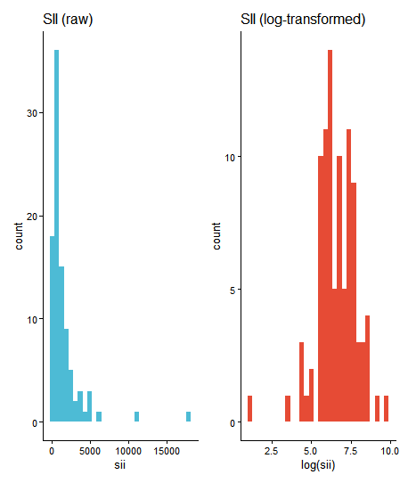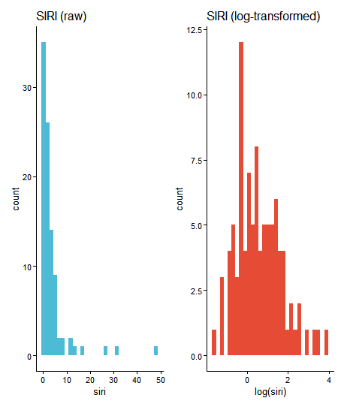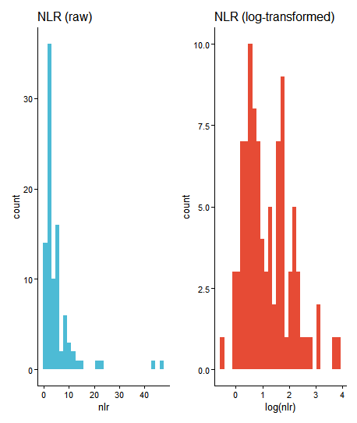
Fig. S1. Distribution of peripheral blood inflammatory markers before and after natural log transformation.
The histograms illustrate the frequency distribution of the Systemic Immune-Inflammation Index (SII), Systemic Inflammation Response Index (SIRI), and Neutrophil-to-Lymphocyte Ratio (NLR).
The left panels (blue) display the raw values, exhibiting a distinct right-skewed distribution.
The right panels (red) display the values after natural logarithmic transformation, demonstrating a reduction in skewness and an approximation to a normal distribution, which justified the use of log-transformed variables in the subsequent regression analyses.

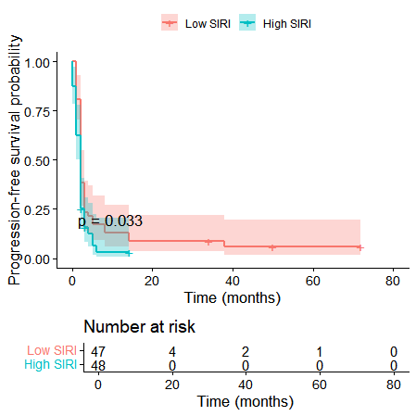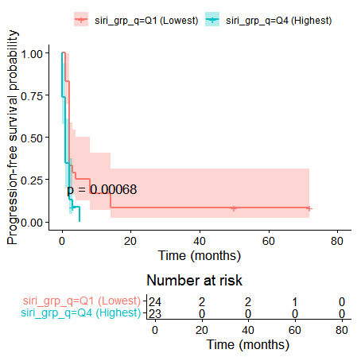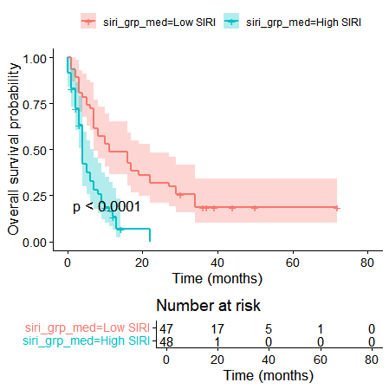
Fig. S2. Kaplan-Meier estimates of survival outcomes stratified by the Systemic Inflammation Response Index (SIRI) over the full follow-up period.
Survival curves are plotted over the entire follow-up period (up to 80 months) to illustrate the long-term clinical course. Survival probabilities were estimated using the Kaplan–Meier method and compared using the log-rank test. Shaded regions represent 95% confidence intervals.
(A) Progression-free survival (PFS) stratified by median SIRI
(B) PFS comparison between extreme quartiles (Q1 vs. Q4)
(C) Overall Survival (OS) stratified by median SIRI

