Supplementary Materials for

Silver coated textile for versatile personal thermal management via multi-order reflections

Xiaoyu Xie, Yang Liu, Zhao Xu, Dengteng Ge, Lili Yang*

*Corresponding author: Lili Yang (liliyang@dhu.edu.cn)

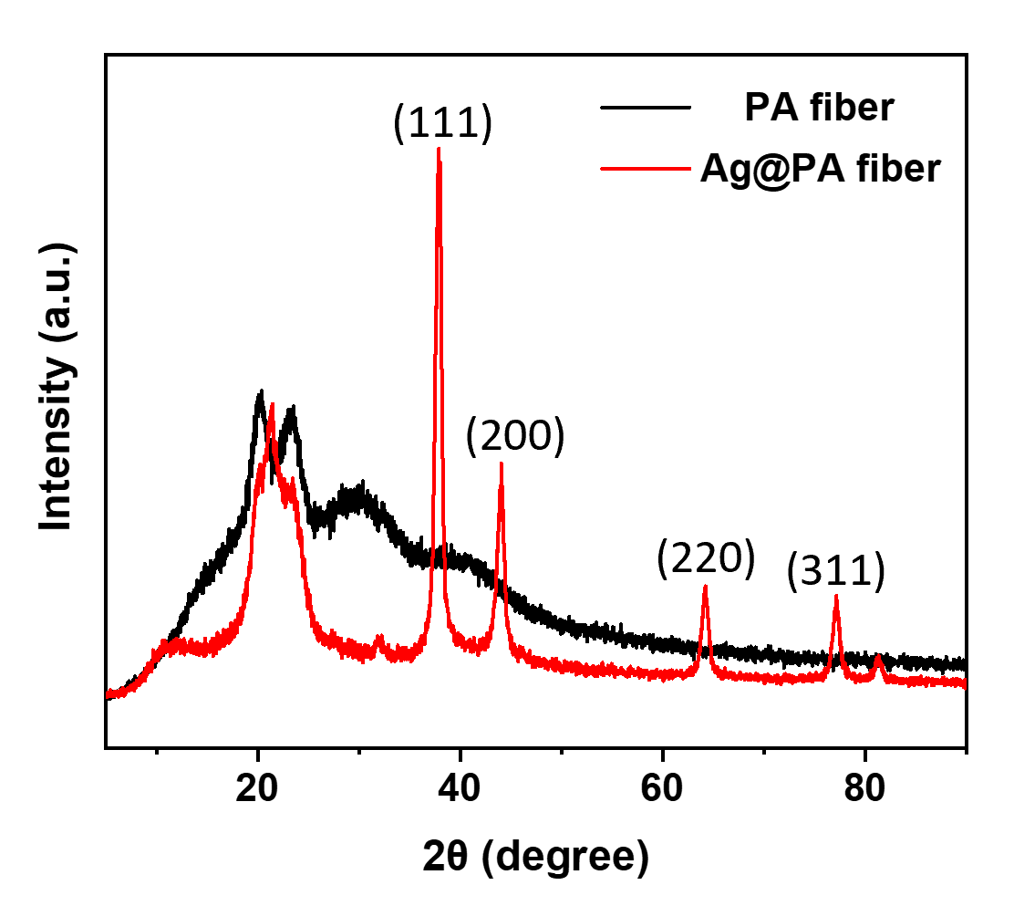
Fig. S1 XRD patterns of PA fiber and Ag@PA fiber

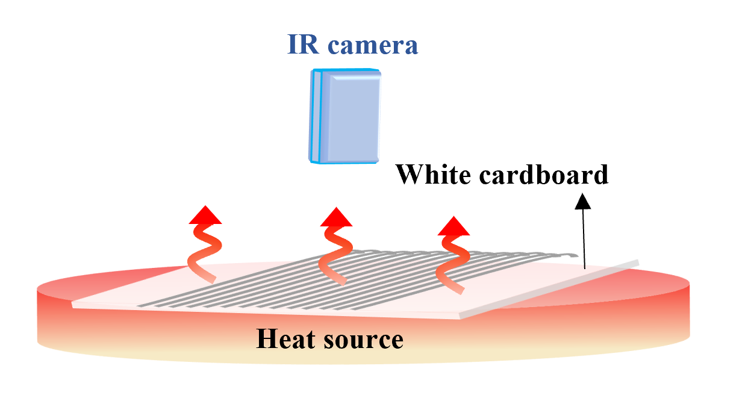
Fig. S2 Schematic diagram for fiber bundle emissivity measurement

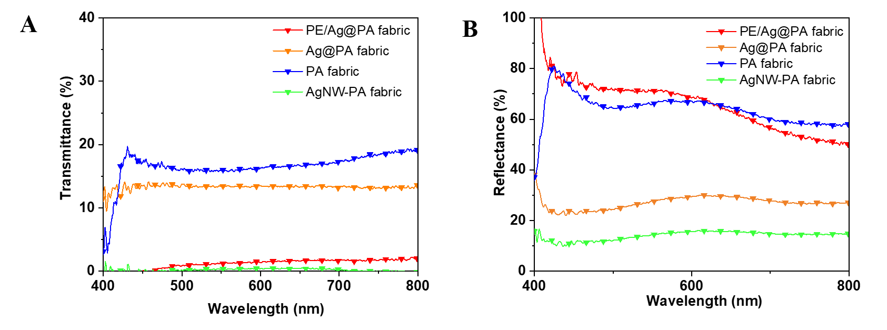
Fig. S3 Visible transmittance and reflection of different fabrics

