Table 2a The optimized cis- and trans- structures of ABOHs
ID | Trans- | Cis-
ABOH^{Cl} | 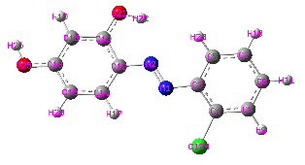 | 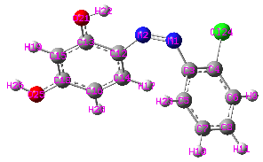
ABOH^{CN} | 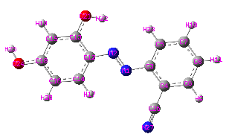 | 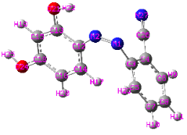
ABOH^{NO}₂ | 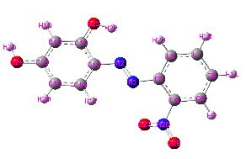 | 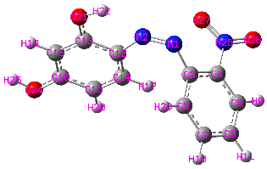

Table 2b The optimized trans- hydrazone geometry of ABOHs.
ABOH^{Cl} | ABOH^{CN} | ABOH^{NO}₂
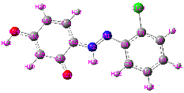 | 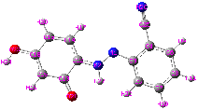 | 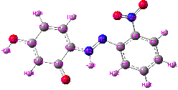

Table 3 DFT calculated electronic energy at 298 K.
Sample | Electronic energy (E), hartree | ΔE_{trans -̶ cis}, Kcal/mol | ΔE_{(trans-hydrazone) ̶ trans}, Kcal/mol
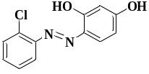 | -1182.942145 | -13.04, | -53.25
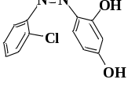 | -1182.921370 | -13.04, | -53.25
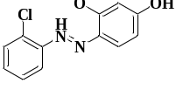 | -1183.027008 | -13.04, | -53.25
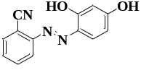 | -815.593106 | -16.52 | -52.46
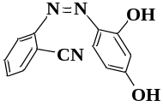 | -815.566784 | -16.52 | -52.46
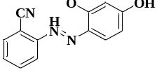 | -815.676710 | -16.52 | -52.46
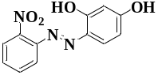 | -927.881975 | -11.07 | -52.59
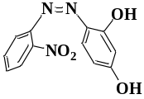 | -927.864338 | -11.07 | -52.59
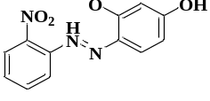 | -927.965786 | -11.07 | -52.59

Table 4 QTAIM analysis of the compounds
ID | Interactions | ρ_{c} (at BCP) (e Å⁻³) | $∇$²(ρ_{c}) (at BCP) (e Å⁻⁵) | ρ_{c} (at RCP) (e Å⁻³) | $∇$²(ρ_{c}) (at RCP) (e Å⁻⁵) | B.E. (kcal/mol)
ABOH^{Cl} | O21-H22···N2 | +0.022556 | +0.082530 | +0.021191 | +0.116810 | -4.29
ABOH^{CN} | O21-H22···N2 | +0.022073 | +0.081569 | +0.020894 | +0.114302 | -4.18
ABOH^{NO}₂ | O21-H22···N2 | +0.022324 | +0.082548 | +0.021062 | +0.116038 | -4.24
ABOH^{NO}₂ | O27···N1 | +0.014985 | +0.057499 | +0.013716 | +0.070483 | -2.6
Table 5a HOMOs of ABOHs
ID | HOMO (H)
ID | Trans- | Cis-
ABOH^{Cl} | H  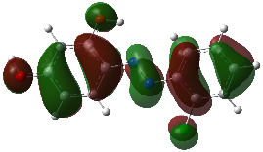  H-1  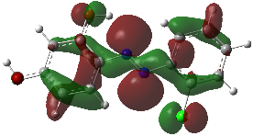  H-2  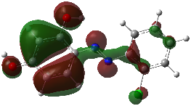  H-4  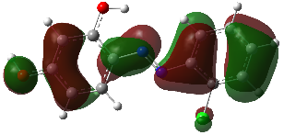 | H  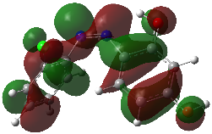  H-1  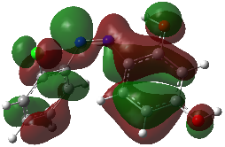  H-2  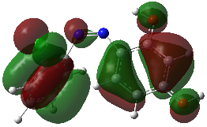  H-3  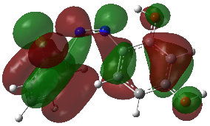  H-4  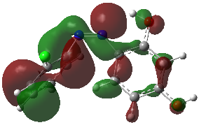
ABOH^{CN} | H  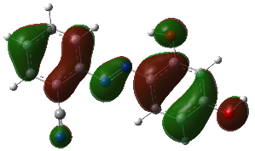  H-1  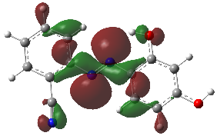  H-2  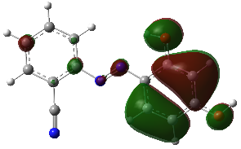  H-4  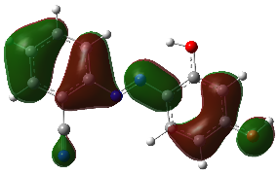 | H  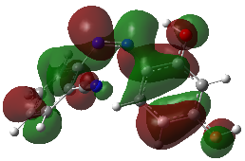  H-1  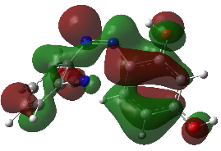  H-2  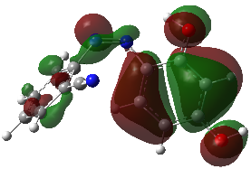  H-3  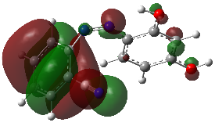  H-4  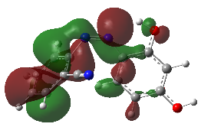
ABOH^{NO}₂ | H  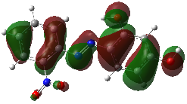  H-1  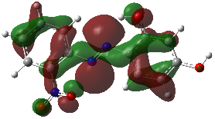  H-2  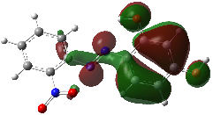 | H  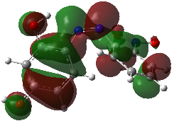  H-1  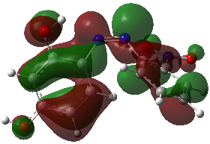  H-2  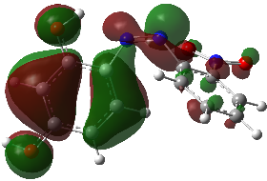  H-3  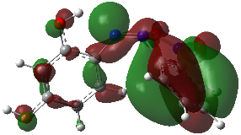  H-5  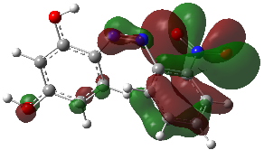
Table 5b LUMOs of ABOHs
ID | LUMO (L)
ID | Trans- | Cis-
ABOH^{Cl} | L  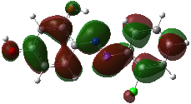  L+2  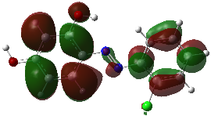  L+3  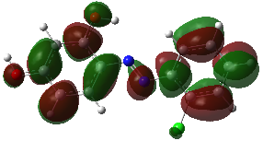  L+8  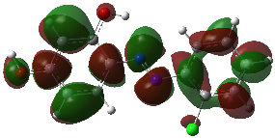 | L  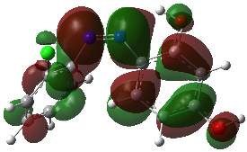  L+1  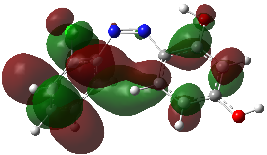  L+2  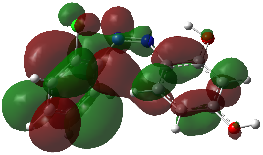
ABOH^{CN} | L  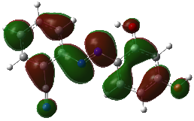  L+1  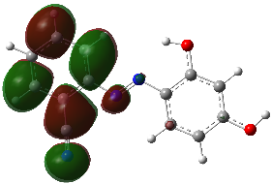  L+2  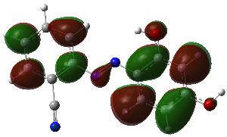  L+3  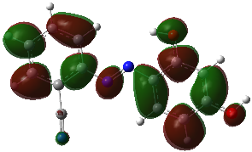 | L  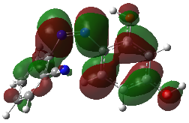  L+1  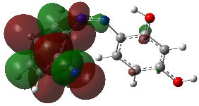  L+2  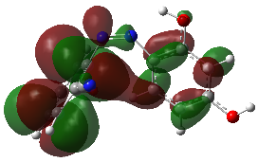
ABOH^{NO}₂ | L  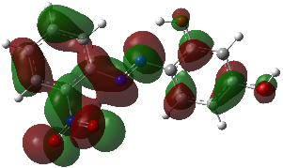  L+1  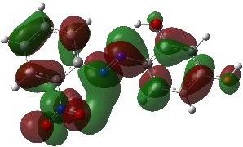 | L  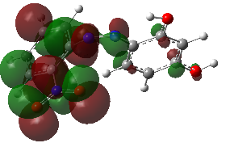  L+1  