APPENDIX

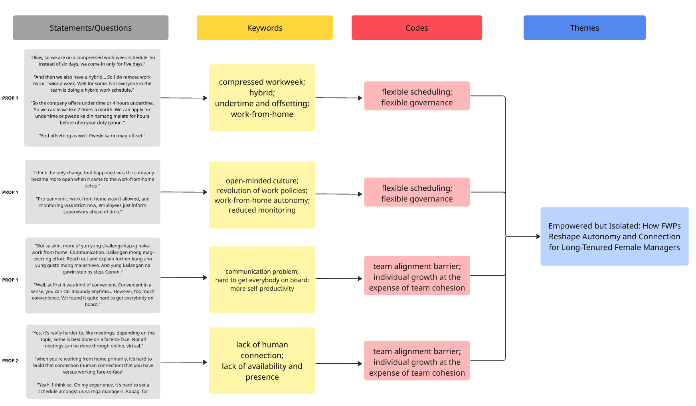

Appendix A. Thematic Analysis: Theme 1
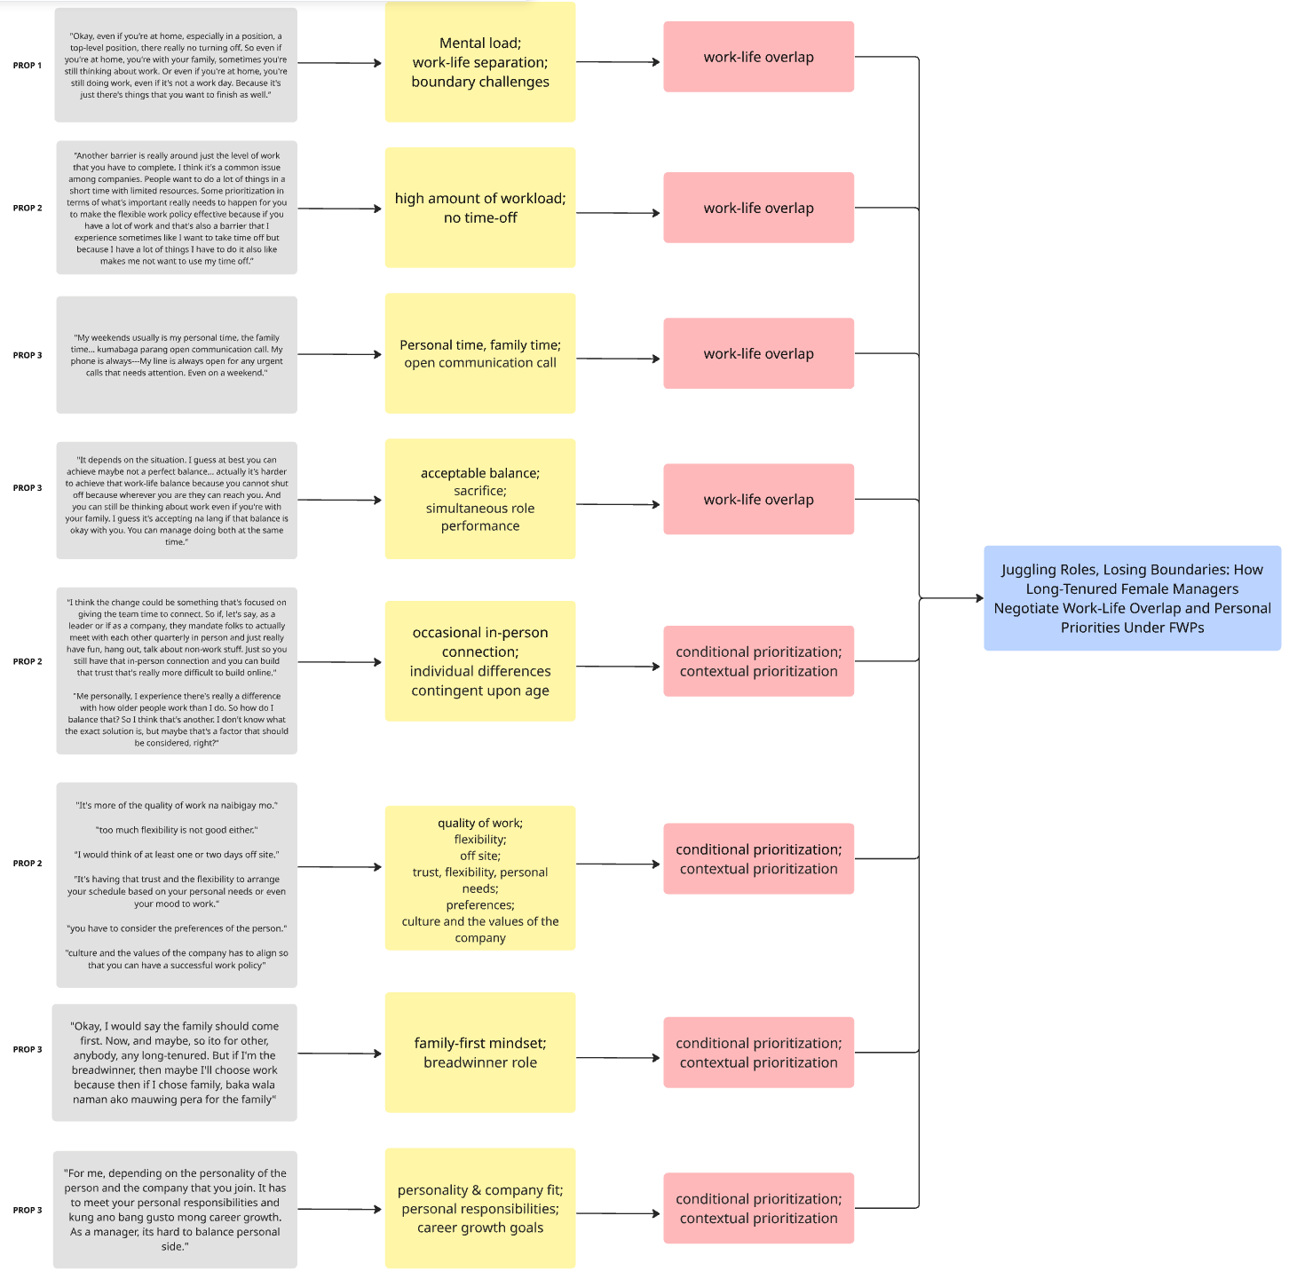

Appendix B. Thematic Analysis: Theme 2
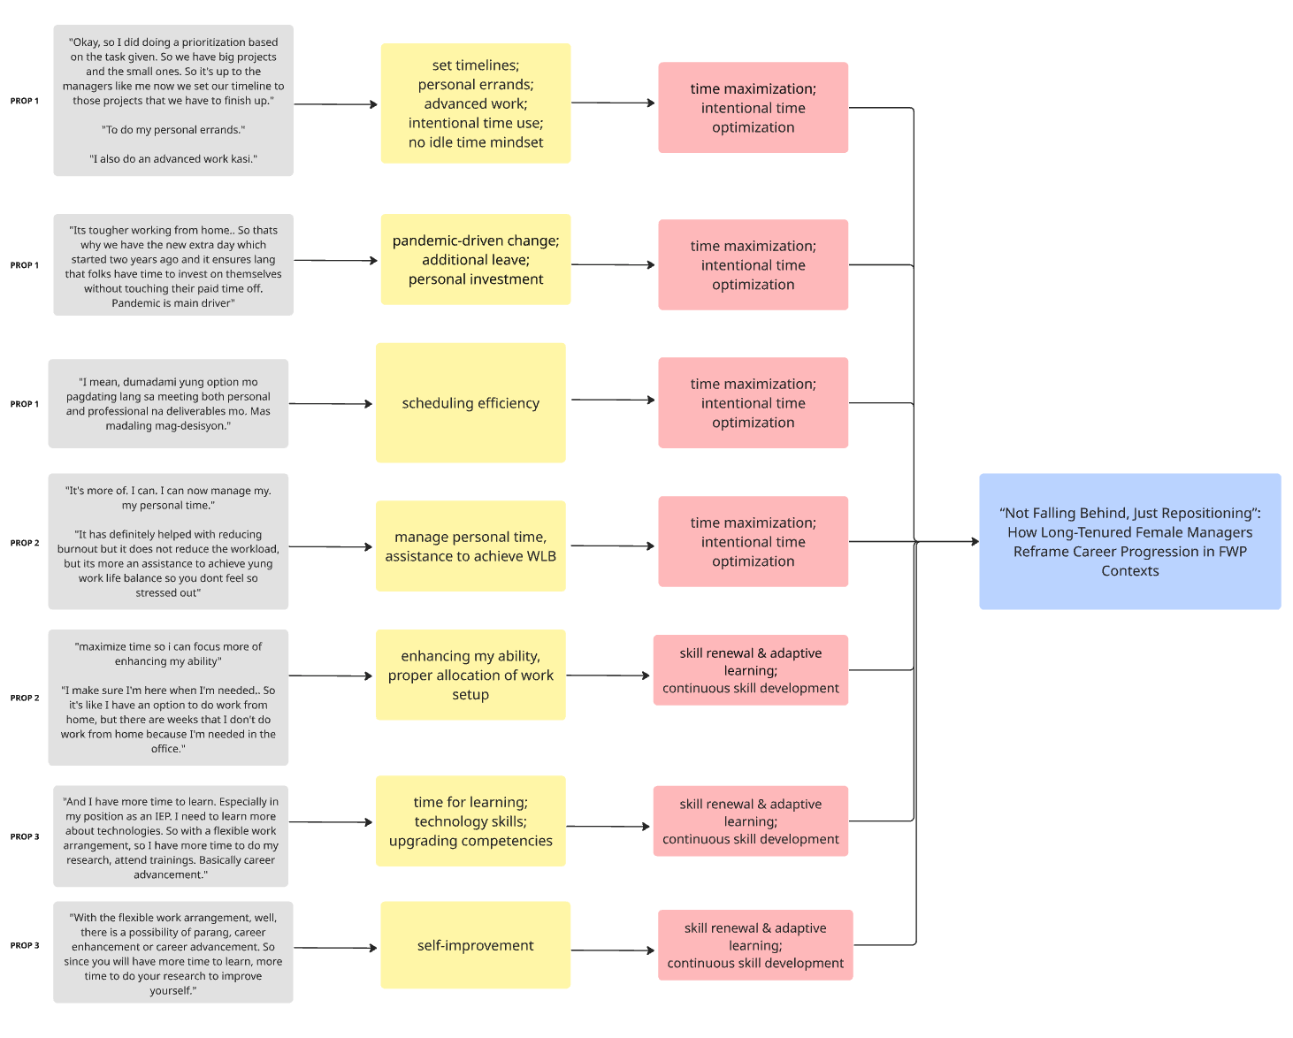
Appendix C. Thematic Analysis: Theme 3

ACCESS TO CONSOLIDATED GOOGLE DRIVE

Appendix D. Consolidated Google Drive, Including Interview Transcripts, Among Others

ACCESS TO MIRO BOARD

Appendix E. Miro Board, Including Completed Thematic Analysis and Conceptual Framework

ACCESS TO RESEARCH DESIGN TABLE

Appendix F. Research Design Table

