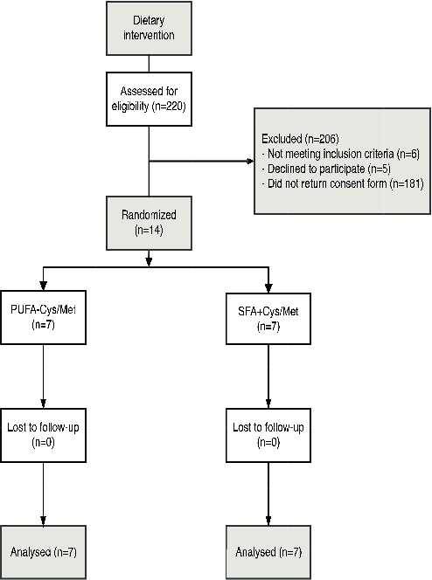Additional File 2 Figure 1: Participant flow

