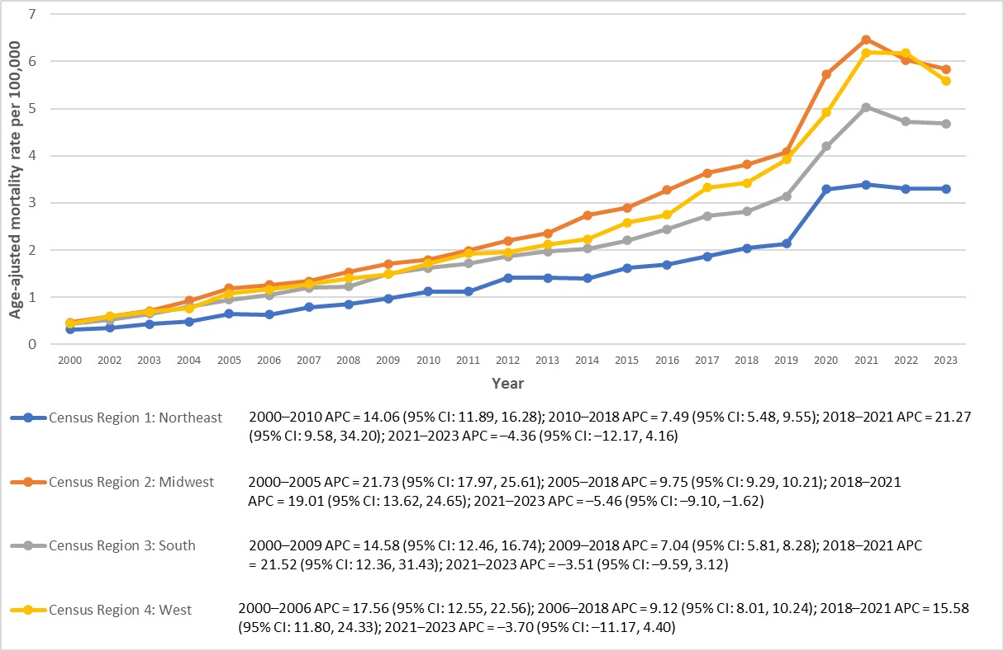
Supplementary Figure 1. Sleep apnea-related mortality in patients with hypertension per 100,000 stratified by census region in the United States from 2000 to 2023.
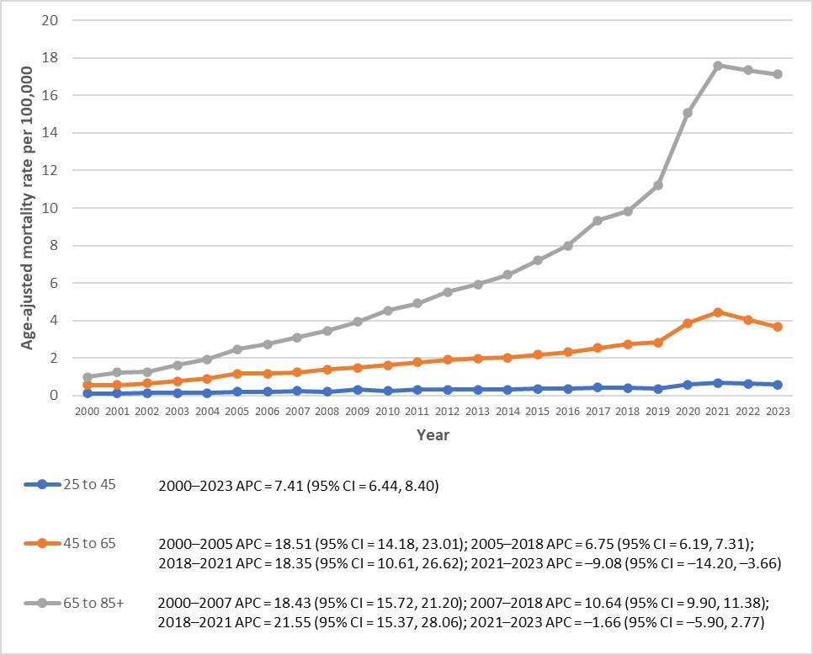
Supplementary Figure 2. Trends in Sleep apnea-related mortality in patients with Hypertention per 100,000 stratified by age group in the United States from 2000 to 2023.
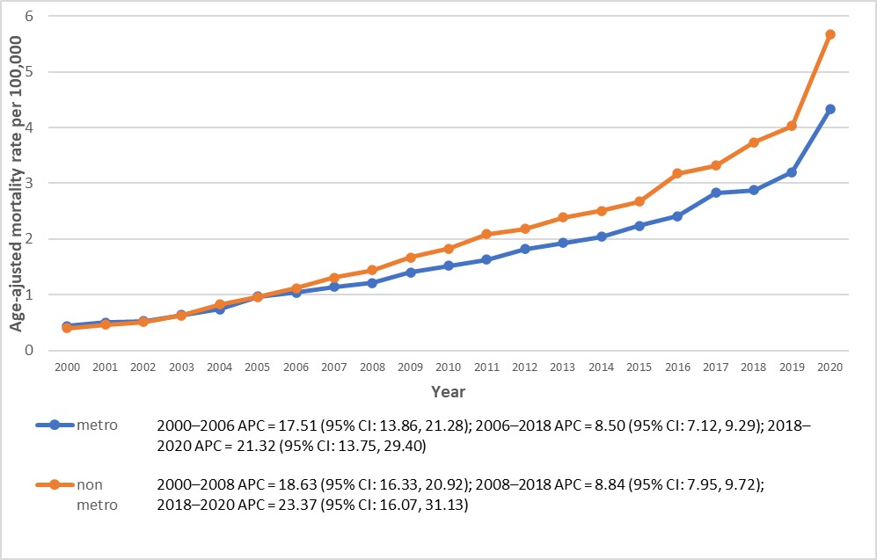

Supplementary Figure 3. Trends in Sleep apnea-related mortality in patients with Hypertension per 100,000, stratified by urban-rural classification in the United States from 2000 to 2023.

Year | Overall | Female | Male | Hispanic or Latino | NH American Indian | NH Asian | NH Black | NH White
2000 | 766 | 275 | 491 | 26 | N/A | N/A | 164 | 561
2001 | 893 | 324 | 569 | 35 | N/A | N/A | 193 | 650
2002 | 966 | 327 | 639 | 47 | N/A | N/A | 185 | 718
2003 | 1224 | 451 | 773 | 63 | 12 | 12 | 240 | 900
2004 | 1477 | 516 | 961 | 59 | 16 | 16 | 299 | 1091
2005 | 1929 | 673 | 1256 | 83 | 16 | 20 | 355 | 1452
2006 | 2102 | 808 | 1294 | 106 | 12 | 21 | 379 | 1579
2007 | 2381 | 869 | 1512 | 139 | 15 | 29 | 410 | 1785
2008 | 2651 | 953 | 1698 | 122 | 17 | 27 | 449 | 2028
2009 | 3072 | 1101 | 1971 | 156 | 21 | 30 | 557 | 2302
2010 | 3410 | 1203 | 2207 | 170 | 14 | 39 | 563 | 2622
2011 | 3787 | 1366 | 2421 | 191 | 29 | 50 | 619 | 2897
2012 | 4248 | 1507 | 2741 | 211 | 31 | 53 | 667 | 3273
2013 | 4608 | 1591 | 3017 | 251 | 37 | 50 | 699 | 3562
2014 | 5008 | 1760 | 3248 | 265 | 35 | 62 | 729 | 3906
2015 | 5607 | 1942 | 3665 | 327 | 37 | 67 | 801 | 4357
2016 | 6253 | 2203 | 4050 | 352 | 39 | 86 | 933 | 4831
2017 | 7330 | 2550 | 4780 | 415 | 66 | 112 | 995 | 5728
2018 | 7830 | 2693 | 5137 | 407 | 59 | 88 | 1061 | 6199
2019 | 8786 | 2939 | 5847 | 478 | 67 | 128 | 1134 | 6973
2020 | 12081 | 4055 | 8026 | 828 | 96 | 190 | 1766 | 9186
2021 | 14001 | 4785 | 9216 | 844 | 111 | 167 | 1872 | 10867
2022 | 13812 | 4949 | 8863 | 762 | 89 | 174 | 1779 | 10869
2023 | 13446 | 4673 | 8773 | 730 | 87 | 148 | 1673 | 10679
Total | 127668 | 44413 | 83255 | 7067 | 911 | 1403 | 19422 | 99015

Supplementary Table 1. Overall and sex stratified Sleep apnea-related mortality in patients with Hypertention in the United States from 2000 to 2023

Year | Medical Facility | Nursing Home/Long Term Care | Hospices | Home | Other
2000 | 399 | 64 | 0 | 272 | 24
2001 | 477 | 70 | 0 | 321 | 19
2002 | 510 | 69 | 0 | 356 | 23
2003 | 636 | 98 | 0 | 452 | 32
2004 | 736 | 137 | 0 | 551 | 49
2005 | 974 | 166 | 11 | 702 | 71
2006 | 1025 | 185 | 11 | 803 | 72
2007 | 1146 | 205 | 26 | 906 | 89
2008 | 1222 | 246 | 25 | 1027 | 95
2009 | 1392 | 275 | 51 | 1184 | 94
2010 | 1536 | 327 | 72 | 1343 | 130
2011 | 1608 | 429 | 90 | 1514 | 144
2012 | 1826 | 426 | 106 | 1713 | 176
2013 | 1838 | 483 | 112 | 1985 | 189
2014 | 1936 | 564 | 125 | 2186 | 194
2015 | 2108 | 653 | 150 | 2478 | 216
2016 | 2315 | 732 | 260 | 2717 | 229
2017 | 2557 | 832 | 358 | 3281 | 301
2018 | 2673 | 941 | 337 | 3560 | 317
2019 | 2854 | 1107 | 444 | 4020 | 360
2020 | 4351 | 1328 | 457 | 5463 | 478
2021 | 5441 | 1314 | 496 | 6175 | 575
2022 | 4635 | 1509 | 610 | 6435 | 622
2023 | 4176 | 1599 | 594 | 6402 | 675
Total | 57351 | 15913 | 4805 | 66585 | 5655

Supplementary Table 2. Sleep apnea-related mortality in patients with Hypertention stratified by place of death in the United States from 2000 to 2023
Crude Rate (95% CI)
 | 25 to 45 | 45 to 65 | 65 to 85+
2000 | 0.09 (0.07 - 0.11) | 0.56 (0.50 - 0.62) | 0.98 (0.88 - 1.08)
2001 | 0.10 (0.08 - 0.13) | 0.56 (0.50 - 0.62) | 1.26 (1.15 - 1.38)
2002 | 0.12 (0.10 - 0.15) | 0.64 (0.58 - 0.70) | 1.24 (1.12 - 1.35)
2003 | 0.14 (0.12 - 0.17) | 0.78 (0.71 - 0.84) | 1.59 (1.46 - 1.72)
2004 | 0.16 (0.13 - 0.19) | 0.90 (0.83 - 0.97) | 1.94 (1.80 - 2.09)
2005 | 0.19 (0.16 - 0.22) | 1.18 (1.10 - 1.26) | 2.47 (2.31 - 2.63)
2006 | 0.21 (0.18 - 0.24) | 1.19 (1.11 - 1.27) | 2.77 (2.60 - 2.94)
2007 | 0.26 (0.22 - 0.29) | 1.29 (1.21 - 1.37) | 3.10 (2.93 - 3.28)
2008 | 0.23 (0.20 - 0.26) | 1.44 (1.36 - 1.53) | 3.42 (3.24 - 3.60)
2009 | 0.30 (0.26 - 0.34) | 1.57 (1.48 - 1.65) | 3.95 (3.76 - 4.15)
2010 | 0.28 (0.24 - 0.31) | 1.67 (1.58 - 1.75) | 4.53 (4.32 - 4.74)
2011 | 0.30 (0.26 - 0.33) | 1.84 (1.75 - 1.93) | 4.88 (4.66 - 5.09)
2012 | 0.31 (0.27 - 0.34) | 1.99 (1.89 - 2.08) | 5.44 (5.22 - 5.66)
2013 | 0.30 (0.26 - 0.34) | 2.11 (2.01 - 2.21) | 5.83 (5.61 - 6.05)
2014 | 0.34 (0.30 - 0.37) | 2.16 (2.06 - 2.26) | 6.31 (6.09 - 6.54)
2015 | 0.34 (0.31 - 0.38) | 2.31 (2.21 - 2.42) | 7.06 (6.82 - 7.30)
2016 | 0.36 (0.32 - 0.40) | 2.49 (2.39 - 2.60) | 7.80 (7.56 - 8.05)
2017 | 0.40 (0.36 - 0.44) | 2.77 (2.66 - 2.88) | 9.14 (8.87 - 9.40)
2018 | 0.35 (0.31 - 0.39) | 2.97 (2.85 - 3.09) | 9.60 (9.34 - 9.87)
2019 | 0.35 (0.31 - 0.39) | 3.13 (3.01 - 3.25) | 10.87 (10.59 - 11.15)
2020 | 0.54 (0.49 - 0.59) | 4.21 (4.07 - 4.35) | 14.59 (14.27 - 14.91)
2021 | 0.65 (0.59 - 0.70) | 4.89 (4.74 - 5.04) | 16.73 (16.39 - 17.06)
2022 | 0.60 (0.54 - 0.65) | 4.46 (4.31 - 4.60) | 16.62 (16.28 - 16.95)
2023 | 0.53 (0.48 - 0.58) | 4.03 (3.90 - 4.17) | 16.28 (15.96 - 16.61)
Total | 0.27 (0.26 - 0.28) | 1.87 (1.85 - 1.89) | 5.72 (5.67 - 5.77)

Supplementary Table 3 Sleep apnea-related mortality in patients with Hypertention Crude Rate per 100,000 stratified by Age Group in the United States from 2000 to 2023.

Year | Overall (95% CI) | Female (95% CI) | Male (95% CI)
2000 | 0.44 (0.41 - 0.47) | 0.28 (0.24 - 0.31) | 0.60 (0.55 - 0.65)
2001 | 0.48 (0.45 - 0.51) | 0.31 (0.27 - 0.34) | 0.71 (0.65 - 0.76)
2002 | 0.54 (0.51 - 0.58) | 0.31 (0.28 - 0.35) | 0.73 (0.67 - 0.78)
2003 | 0.65 (0.61 - 0.68) | 0.43 (0.39 - 0.47) | 0.90 (0.83 - 0.96)
2004 | 0.76 (0.72 - 0.80) | 0.48 (0.44 - 0.53) | 1.11 (1.04 - 1.18)
2005 | 0.99 (0.94 - 1.03) | 0.62 (0.57 - 0.67) | 1.40 (1.32 - 1.48)
2006 | 1.04 (0.99 - 1.08) | 0.75 (0.69 - 0.80) | 1.41 (1.33 - 1.49)
2007 | 1.16 (1.11 - 1.21) | 0.77 (0.72 - 0.82) | 1.62 (1.54 - 1.71)
2008 | 1.25 (1.20 - 1.30) | 0.82 (0.76 - 0.87) | 1.79 (1.70 - 1.87)
2009 | 1.43 (1.38 - 1.48) | 0.95 (0.89 - 1.01) | 2.02 (1.93 - 2.11)
2010 | 1.57 (1.52 - 1.62) | 1.02 (0.96 - 1.08) | 2.23 (2.14 - 2.32)
2011 | 1.71 (1.66 - 1.77) | 1.12 (1.06 - 1.18) | 2.42 (2.33 - 2.52)
2012 | 1.88 (1.82 - 1.94) | 1.20 (1.14 - 1.26) | 2.67 (2.57 - 2.77)
2013 | 1.99 (1.93 - 2.05) | 1.25 (1.19 - 1.31) | 2.88 (2.78 - 2.98)
2014 | 2.10 (2.04 - 2.16) | 1.35 (1.29 - 1.41) | 3.04 (2.93 - 3.14)
2015 | 2.33 (2.27 - 2.39) | 1.47 (1.40 - 1.54) | 3.38 (3.27 - 3.49)
2016 | 2.53 (2.46 - 2.59) | 1.64 (1.57 - 1.71) | 3.63 (3.52 - 3.75)
2017 | 2.89 (2.82 - 2.96) | 1.86 (1.78 - 1.93) | 4.20 (4.07 - 4.32)
2018 | 3.06 (2.99 - 3.13) | 1.90 (1.83 - 1.97) | 4.41 (4.28 - 4.53)
2019 | 3.34 (3.27 - 3.41) | 2.01 (1.94 - 2.09) | 4.95 (4.82 - 5.08)
2020 | 4.54 (4.46 - 4.62) | 2.76 (2.67 - 2.84) | 6.66 (6.51 - 6.81)
2021 | 5.29 (5.20 - 5.38) | 3.32 (3.22 - 3.41) | 7.65 (7.49 - 7.81)
2022 | 5.07 (4.98 - 5.16) | 3.31 (3.21 - 3.40) | 7.21 (7.06 - 7.36)
2023 | 4.87 (4.79 - 4.96) | 3.05 (2.96 - 3.14) | 7.05 (6.90 - 7.20)
Total | 1.86 (1.85 - 1.87) | 1.18 (1.17 - 1.20) | 2.71 (2.69 - 2.74)

Supplementary Table 4 Sleep apnea-related mortality in patients with Hypertention AMMR per 100,000 stratified by race in the United States from 2000 to 2023.

Year | Hispanic (95% CI) | NH American Indian (95% CI) | NH Asian (95% CI) | NH Black (95% CI) | NH White (95% CI)
2000 | 0.21 (0.14 - 0.31) | N/A | N/A | 0.91 (0.77 - 1.05) | 0.37 (0.34 - 0.41)
2001 | 0.29 (0.20 - 0.41) | N/A | N/A | 1.09 (0.93 - 1.24) | 0.43 (0.39 - 0.46)
2002 | 0.34 (0.24 - 0.46) | N/A | N/A | 0.98 (0.83 - 1.12) | 0.45 (0.42 - 0.49)
2003 | 0.48 (0.36 - 0.62) | Unreliable (0.71 - 2.17) | 0.30 (0.09 - 0.31) | 1.24 (1.08 - 1.40) | 0.60 (0.56 - 0.64)
2004 | 0.43 (0.32 - 0.56) | Unreliable (0.46 - 1.66) | 0.30 (0.16 - 0.47) | 1.51 (1.33 - 1.68) | 0.72 (0.67 - 0.76)
2005 | 0.52 (0.40 - 0.66) | Unreliable (0.46 - 1.66) | 0.30 (0.18 - 0.47) | 1.75 (1.57 - 1.94) | 0.93 (0.88 - 0.98)
2006 | 0.66 (0.53 - 0.80) | Unreliable (0.46 - 1.66) | 0.30 (0.18 - 0.47) | 1.85 (1.66 - 2.04) | 0.99 (0.94 - 1.04)
2007 | 0.78 (0.64 - 0.92) | Unreliable (0.58 - 1.88) | 0.39 (0.26 - 0.57) | 1.94 (1.74 - 2.13) | 1.12 (1.07 - 1.17)
2008 | 0.71 (0.57 - 0.84) | Unreliable (0.69 - 1.97) | 0.29 (0.19 - 0.43) | 2.07 (1.87 - 2.26) | 1.27 (1.21 - 1.32)
2009 | 0.82 (0.69 - 0.96) | 1.77 (1.05 - 2.80) | 0.34 (0.23 - 0.50) | 2.58 (2.36 - 2.80) | 1.44 (1.38 - 1.50)
2010 | 0.92 (0.77 - 1.07) | Unreliable (0.54 - 1.81) | 0.39 (0.28 - 0.54) | 2.51 (2.30 - 2.73) | 1.56 (1.50 - 1.62)
2011 | 0.94 (0.80 - 1.08) | 1.94 (1.26 - 2.87) | 0.51 (0.37 - 0.68) | 2.73 (2.51 - 2.95) | 1.71 (1.65 - 1.78)
2012 | 1.00 (0.86 - 1.14) | 2.13 (1.41 - 3.08) | 0.48 (0.36 - 0.64) | 2.85 (2.63 - 3.07) | 1.91 (1.84 - 1.97)
2013 | 1.17 (1.01 - 1.32) | 2.30 (1.60 - 3.22) | 0.44 (0.32 - 0.59) | 2.91 (2.68 - 3.13) | 2.05 (1.98 - 2.12)
2014 | 1.15 (1.01 - 1.30) | 2.20 (1.52 - 3.09) | 0.57 (0.43 - 0.73) | 2.95 (2.73 - 3.17) | 2.20 (2.13 - 2.27)
2015 | 1.39 (1.24 - 1.55) | 2.34 (1.62 - 3.26) | 0.57 (0.44 - 0.72) | 3.22 (2.99 - 3.45) | 2.41 (2.34 - 2.48)
2016 | 1.40 (1.25 - 1.55) | 2.42 (1.69 - 3.35) | 0.72 (0.58 - 0.90) | 3.61 (3.37 - 3.85) | 2.63 (2.55 - 2.70)
2017 | 1.63 (1.47 - 1.80) | 3.98 (3.05 - 5.12) | 0.89 (0.72 - 1.06) | 3.83 (3.58 - 4.07) | 3.07 (2.99 - 3.15)
2018 | 1.57 (1.41 - 1.73) | 3.49 (2.64 - 4.53) | 0.67 (0.54 - 0.83) | 3.92 (3.67 - 4.16) | 3.23 (3.15 - 3.31)
2019 | 1.72 (1.56 - 1.88) | 3.73 (2.86 - 4.77) | 0.95 (0.79 - 1.12) | 4.11 (3.86 - 4.35) | 3.55 (3.46 - 3.63)
2020 | 2.83 (2.63 - 3.03) | 5.46 (4.40 - 6.71) | 1.33 (1.14 - 1.52) | 6.23 (5.93 - 6.53) | 4.70 (4.60 - 4.80)
2021 | 2.81 (2.61 - 3.01) | 6.56 (5.30 - 7.81) | 1.22 (1.03 - 1.40) | 6.75 (6.43 - 7.06) | 5.65 (5.54 - 5.76)
2022 | 2.53 (2.34 - 2.72) | 5.49 (4.39 - 6.79) | 1.22 (1.04 - 1.41) | 6.31 (6.01 - 6.61) | 5.52 (5.41 - 5.63)
2023 | 2.33 (2.16 - 2.51) | 4.97 (3.96 - 6.16) | 1.01 (0.84 - 1.17) | 5.77 (5.48 - 6.05) | 5.38 (5.27 - 5.48)
Total | 1.16 (1.12 - 1.19) | 2.15 (1.97 - 2.33) | 0.55 (0.52 - 0.58) | 2.79 (2.74 - 2.84) | 1.87 (1.85 - 1.88)

Supplementary Table 5. Overall and sex-stratified Sleep apnea-related mortality in patients with Hypertention per 100,000 in the United States from 2000 to 2023.

Age-Adjusted Rate (95% CI)
Year | Metropolitan | Nonmetropolitan
2000 | 0.44 (0.40 - 0.47) | 0.40 (0.33 - 0.47)
2001 | 0.50 (0.46 - 0.53) | 0.46 (0.38 - 0.53)
2002 | 0.53 (0.49 - 0.56) | 0.51 (0.43 - 0.59)
2003 | 0.64 (0.60 - 0.68) | 0.63 (0.55 - 0.72)
2004 | 0.74 (0.70 - 0.78) | 0.83 (0.73 - 0.92)
2005 | 0.97 (0.92 - 1.01) | 0.96 (0.85 - 1.06)
2006 | 1.04 (0.99 - 1.09) | 1.12 (1.01 - 1.24)
2007 | 1.14 (1.09 - 1.19) | 1.31 (1.19 - 1.43)
2008 | 1.21 (1.15 - 1.26) | 1.44 (1.31 - 1.56)
2009 | 1.40 (1.34 - 1.46) | 1.67 (1.54 - 1.81)
2010 | 1.52 (1.46 - 1.57) | 1.83 (1.69 - 1.97)
2011 | 1.63 (1.57 - 1.69) | 2.09 (1.94 - 2.23)
2012 | 1.82 (1.75 - 1.88) | 2.18 (2.03 - 2.34)
2013 | 1.93 (1.87 - 2.00) | 2.39 (2.23 - 2.55)
2014 | 2.04 (1.97 - 2.10) | 2.51 (2.35 - 2.67)
2015 | 2.24 (2.18 - 2.31) | 2.67 (2.51 - 2.83)
2016 | 2.41 (2.34 - 2.48) | 3.18 (2.99 - 3.36)
2017 | 2.83 (2.75 - 2.90) | 3.32 (3.13 - 3.50)
2018 | 2.88 (2.81 - 2.95) | 3.74 (3.55 - 3.93)
2019 | 3.20 (3.12 - 3.27) | 4.03 (3.83 - 4.23)
2020 | 4.33 (4.24 - 4.41) | 5.67 (5.44 - 5.90)

Supplementary Table 6. Sleep apnea-related mortality in patients with Hypertention AAMR per 100,000 stratified by urban-rural classification in the United States from 2000 to 2020.

 | Age-Adjusted Rate (95% CI)
Alabama | 1.29 (1.20-1.37)
Alaska | 2.27 (1.91-2.63)
Arizona | 1.35 (1.27-1.42)
Arkansas | 1.58 (1.47-1.70)
California | 1.73 (1.70-1.77)
Colorado | 3.16 (3.03-3.30)
Connecticut | 0.98 (0.89-1.06)
Delaware | 2.57 (2.30-2.83)
District of Columbia | 1.97 (1.67-2.28)
Florida | 1.38 (1.34-1.42)
Georgia | 1.27 (1.21-1.34)
Hawaii | 1.93 (1.74-2.11)
Idaho | 2.69 (2.47-2.90)
Illinois | 1.51 (1.46-1.57)
Indiana | 2.34 (2.24-2.44)
Iowa | 3.02 (2.87-3.18)
Kansas | 1.81 (1.68-1.94)
Kentucky | 1.91 (1.80-2.02)
Louisiana | 1.38 (1.29-1.48)
Maine | 1.79 (1.62-1.96)
Maryland | 2.03 (1.93-2.13)
Massachusetts | 0.89 (0.84-0.95)
Michigan | 1.44 (1.38-1.50)
Minnesota | 3.50 (3.37-3.63)
Mississippi | 1.56 (1.44-1.68)
Missouri | 1.99 (1.90-2.08)
Montana | 3.19 (2.91-3.46)
Nebraska | 3.09 (2.89-3.30)
Nevada | 1.11 (1.00-1.22)
New Hampshire | 1.69 (1.51-1.86)
New Jersey | 1.40 (1.33-1.46)
New Mexico | 1.49 (1.36-1.63)
New York | 0.80 (0.76-0.83)
North Carolina | 2.49 (2.41-2.57)
North Dakota | 2.11 (1.83-2.39)
Ohio | 2.86 (2.79-2.94)
Oklahoma | 2.82 (2.68-2.96)
Oregon | 3.95 (3.79-4.11)
Pennsylvania | 1.79 (1.73-1.84)
Rhode Island | 2.05 (1.83-2.27)
South Carolina | 2.31 (2.20-2.42)
South Dakota | 3.49 (3.16-3.81)
Tennessee | 2.53 (2.43-2.63)
Texas | 1.99 (1.94-2.04)
Utah | 2.45 (2.27-2.63)
Vermont | 2.44 (2.14-2.74)
Virginia | 1.74 (1.66-1.82)
Washington | 3.02 (2.91-3.13)
West Virginia | 1.96 (1.80-2.11)
Wisconsin | 2.23 (2.13-2.33)
Wyoming | 3.83 (3.40-4.26)

Supplementary Table 7. Sleep apnea-related mortality in patients with Hypertention per 100,000 stratified by state in the United States from 2000 to 2020.

Census Region | Year | Age-Adjusted Rate (95% CI)
Census Region 1: Northeast | 2000 | 0.32 (0.26-0.38)
Census Region 1: Northeast | 2001 | 0.34 (0.28-0.40)
Census Region 1: Northeast | 2002 | 0.35 (0.29-0.41)
Census Region 1: Northeast | 2003 | 0.43 (0.36-0.49)
Census Region 1: Northeast | 2004 | 0.48 (0.41-0.55)
Census Region 1: Northeast | 2005 | 0.65 (0.57-0.73)
Census Region 1: Northeast | 2006 | 0.63 (0.55-0.71)
Census Region 1: Northeast | 2007 | 0.79 (0.70-0.87)
Census Region 1: Northeast | 2008 | 0.85 (0.76-0.94)
Census Region 1: Northeast | 2009 | 0.97 (0.88-1.07)
Census Region 1: Northeast | 2010 | 1.12 (1.01-1.22)
Census Region 1: Northeast | 2011 | 1.12 (1.02-1.22)
Census Region 1: Northeast | 2012 | 1.41 (1.29-1.52)
Census Region 1: Northeast | 2013 | 1.41 (1.30-1.53)
Census Region 1: Northeast | 2014 | 1.40 (1.29-1.51)
Census Region 1: Northeast | 2015 | 1.62 (1.50-1.74)
Census Region 1: Northeast | 2016 | 1.69 (1.56-1.81)
Census Region 1: Northeast | 2017 | 1.87 (1.74-2.00)
Census Region 1: Northeast | 2018 | 2.04 (1.91-2.17)
Census Region 1: Northeast | 2019 | 2.14 (2.01-2.28)
Census Region 1: Northeast | 2020 | 3.29 (3.13-3.46)
Census Region 1: Northeast | 2021 | 3.39 (3.23-3.56)
Census Region 1: Northeast | 2022 | 3.30 (3.14-3.46)
Census Region 1: Northeast | 2023 | 3.30 (3.14-3.46)
Total (2000-2023) |  | 1.87 (1.84-1.90)
Census Region 2: Midwest | 2000 | 0.47 (0.40-0.53)
Census Region 2: Midwest | 2001 | 0.52 (0.45-0.59)
Census Region 2: Midwest | 2002 | 0.59 (0.52-0.67)
Census Region 2: Midwest | 2003 | 0.71 (0.63-0.78)
Census Region 2: Midwest | 2004 | 0.93 (0.84-1.02)
Census Region 2: Midwest | 2005 | 1.19 (1.08-1.29)
Census Region 2: Midwest | 2006 | 1.26 (1.16-1.37)
Census Region 2: Midwest | 2007 | 1.34 (1.23-1.44)
Census Region 2: Midwest | 2008 | 1.53 (1.42-1.65)
Census Region 2: Midwest | 2009 | 1.71 (1.59-1.83)
Census Region 2: Midwest | 2010 | 1.80 (1.68-1.92)
Census Region 2: Midwest | 2011 | 1.99 (1.87-2.12)
Census Region 2: Midwest | 2012 | 2.20 (2.07-2.33)
Census Region 2: Midwest | 2013 | 2.36 (2.23-2.50)
Census Region 2: Midwest | 2014 | 2.74 (2.59-2.88)
Census Region 2: Midwest | 2015 | 2.90 (2.75-3.05)
Census Region 2: Midwest | 2016 | 3.27 (3.11-3.43)
Census Region 2: Midwest | 2017 | 3.63 (3.46-3.79)
Census Region 2: Midwest | 2018 | 3.82 (3.65-3.99)
Census Region 2: Midwest | 2019 | 4.08 (3.91-4.25)
Census Region 2: Midwest | 2020 | 5.73 (5.53-5.93)
Census Region 2: Midwest | 2021 | 6.47 (6.26-6.69)
Census Region 2: Midwest | 2022 | 6.03 (5.82-6.23)
Census Region 2: Midwest | 2023 | 5.84 (5.64-6.04)
Total (2000-2023) |  | 3.23 (3.18-3.27)
Census Region 3: South | 2000 | 0.44 (0.38-0.49)
Census Region 3: South | 2001 | 0.47 (0.42-0.52)
Census Region 3: South | 2002 | 0.52 (0.47-0.58)
Census Region 3: South | 2003 | 0.65 (0.59-0.71)
Census Region 3: South | 2004 | 0.80 (0.74-0.87)
Census Region 3: South | 2005 | 0.95 (0.88-1.02)
Census Region 3: South | 2006 | 1.04 (0.97-1.12)
Census Region 3: South | 2007 | 1.20 (1.12-1.28)
Census Region 3: South | 2008 | 1.23 (1.15-1.31)
Census Region 3: South | 2009 | 1.50 (1.41-1.58)
Census Region 3: South | 2010 | 1.62 (1.53-1.71)
Census Region 3: South | 2011 | 1.72 (1.63-1.81)
Census Region 3: South | 2012 | 1.87 (1.77-1.96)
Census Region 3: South | 2013 | 1.97 (1.88-2.07)
Census Region 3: South | 2014 | 2.03 (1.93-2.12)
Census Region 3: South | 2015 | 2.21 (2.11-2.31)
Census Region 3: South | 2016 | 2.44 (2.34-2.55)
Census Region 3: South | 2017 | 2.72 (2.62-2.83)
Census Region 3: South | 2018 | 2.82 (2.71-2.93)
Census Region 3: South | 2019 | 3.14 (3.03-3.26)
Census Region 3: South | 2020 | 4.20 (4.08-4.33)
Census Region 3: South | 2021 | 5.03 (4.89-5.18)
Census Region 3: South | 2022 | 4.73 (4.60-4.87)
Census Region 3: South | 2023 | 4.68 (4.55-4.81)
Total (2000-2023) |  | 2.67 (2.63-2.70)
Census Region 4: West | 2000 | 0.44 (0.37-0.51)
Census Region 4: West | 2001 | 0.59 (0.52-0.67)
Census Region 4: West | 2002 | 0.60 (0.52-0.67)
Census Region 4: West | 2003 | 0.69 (0.61-0.77)
Census Region 4: West | 2004 | 0.76 (0.68-0.85)
Census Region 4: West | 2005 | 1.08 (0.98-1.18)
Census Region 4: West | 2006 | 1.17 (1.06-1.27)
Census Region 4: West | 2007 | 1.28 (1.18-1.39)
Census Region 4: West | 2008 | 1.40 (1.29-1.51)
Census Region 4: West | 2009 | 1.49 (1.38-1.60)
Census Region 4: West | 2010 | 1.72 (1.60-1.84)
Census Region 4: West | 2011 | 1.93 (1.80-2.05)
Census Region 4: West | 2012 | 1.95 (1.83-2.07)
Census Region 4: West | 2013 | 2.12 (1.99-2.25)
Census Region 4: West | 2014 | 2.23 (2.10-2.35)
Census Region 4: West | 2015 | 2.58 (2.44-2.71)
Census Region 4: West | 2016 | 2.75 (2.61-2.89)
Census Region 4: West | 2017 | 3.33 (3.18-3.48)
Census Region 4: West | 2018 | 3.42 (3.27-3.58)
Census Region 4: West | 2019 | 3.92 (3.75-4.08)
Census Region 4: West | 2020 | 4.92 (4.74-5.10)
Census Region 4: West | 2021 | 6.19 (5.99-6.39)
Census Region 4: West | 2022 | 6.18 (5.98-6.38)
Census Region 4: West | 2023 | 5.59 (5.41-5.78)
Total (2000-2023) |  | 3.24 (3.19-3.29)
Supplementary Table 8. Sleep apnea-related mortality in patients with Hypertention AAMR per 100,000 stratified by census region in the United States from 2000 to 2023.

UCD - 15 Leading Causes of Death | Total Deaths (2000-2023)
Diseases of heart (I00-I09, I11, I13, I20-I51) | 31,299
Diabetes mellitus (E10-E14) | 9,710
Chronic lower respiratory diseases (J40-J47) | 8,563
Malignant neoplasms (C00-C97) | 6,372
Essential hypertension and hypertensive renal disease (I10, I12, I15) | 4,339

Supplementary Table 9. Sleep apnea-related mortality in patients with Hypertention per 100,000 stratified by top 3 underlying causes of death in the United States from 2000 to 2020.

Category | Interval of Years | APC (95% CI)
Overall | 1999–2018 | 9.15 (8.70 to 9.60)
 | 2018–2020 | 20.20 (14.28 to 26.43)
Male | 1999–2018 | 9.45 (8.87 to 10.02)
 | 2018–2020 | 19.93 (13.20 to 27.07)
Female | 1999–2018 | 8.10 (7.27 to 8.93)
 | 2018–2020 | 20.93 (12.77 to 29.69)
Black or African American | 1999–2018 | 11.71 (8.36 to 15.24)
 | 2018–2020 | -5.60 (-16.61 to -2.97)
White | 1999–2018 | 9.47 (8.82 to 10.13)
 | 2018–2020 | 20.35 (14.33 to 26.90)
Hispanic or Latino | 1999–2018 | 18.97 (4.09 to 36.38)
 | 2018–2020 | -11.80 (-29.37 to 0.20)
Metropolitan | 1999–2018 | 18.63 (16.13 to 20.67)
 | 2018–2020 | 21.32 (13.75 to 29.40)
Non-Metropolitan | 1999–2018 | 8.84 (7.95 to 9.72)
 | 2018–2020 | 23.37 (16.07 to 31.11)
Northeast | 1999–2018 | 21.21 (9.58 to 34.20)
 | 2018–2020 | -4.34 (-21.02 to 16.17)
Midwest | 1999–2018 | 21.73 (17.37 to 26.61)
 | 2018–2020 | -8.75 (6.29 to 10.24)
South | 1999–2018 | 14.57 (12.42 to 16.75)
 | 2018–2020 | 7.04 (3.43 to 5.84)
West | 1999–2018 | 9.12 (6.02 to 10.24)
 | 2018–2020 | 12.59 (11.80 to 34.32)
Age 25–45 | 1999–2018 | 7.41 (6.44 to 8.40)
 | 2018–2020 | Data not available
Age 45–65 | 1999–2018 | 6.75 (6.19 to 7.31)
 | 2018–2020 | 18.35 (10.61 to 26.62)
Age 65–85+ | 1999–2018 | 10.64 (9.90 to 11.38)
 | 2018–2020 | 21.55 (15.37 to 28.06)
Supplementary Table 10. Summary APCs of per 100,000 in the United States from 2000 to 2023 of people with Sleep apnea-related mortality in patients with Hypertention

