Supplementary figures

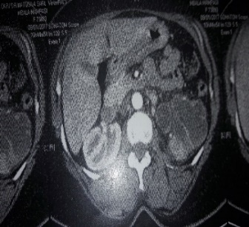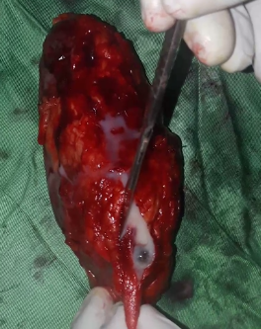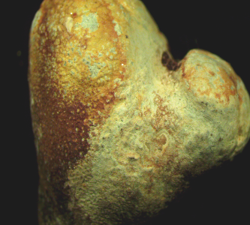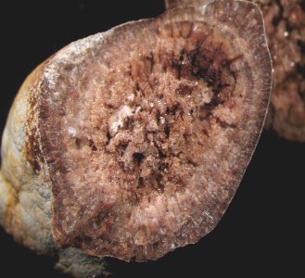
Left pyonephrosis on pyelic calculus in a 49-year-old female patient who underwent nephrectomy. It was an irregularly shaped stone 19 mm in large diameter, with a heterogeneous, bumpy, rough surface with the presence of confluent deposits in layers of beige color. Heterogeneous section, crystalline, concentric and radial at the periphery and without detectable organization in depth, dark yellow-brown to dark brown. Majority composed of 79% whewellite.
Figure S 1. Left pyonephrosis on pyelic calculus

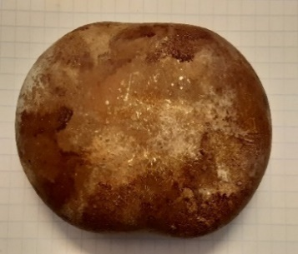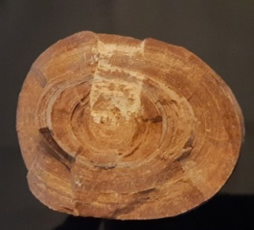  - 81X58X37 mm diameter oval calculus, surgically extracted from the bladder of a 47-year-old patient with benign prostatic hyperplasia. Stone predominantly composed of 86% uric acid. | 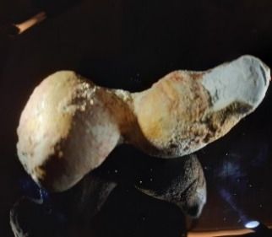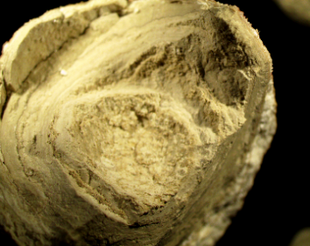  - Irregular stone of 65X30X26 mm, extracted from the urethra of a 12-year-old patient followed for posterior urethral valves. Stone predominantly composed of ammonium acid urate.
Figure S 2. Illustrations of the two stones removed from the lower urinary tract.

