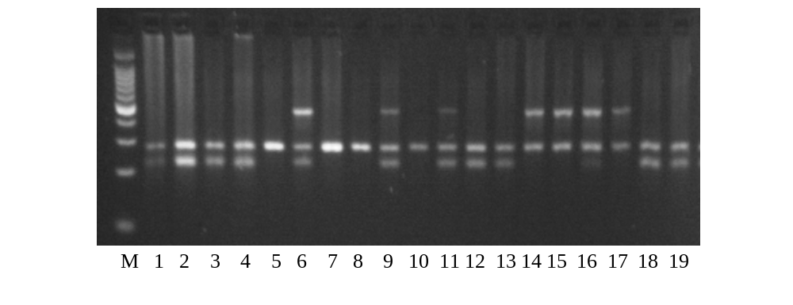
480 bp (GSTT1)
268 bp (β-globin)
219 bp (GSTM1)

M= Molecular weight marker (100bp); GSTM1-active/GSTT1-active= 6, 9, 11; GSTM1-active/GSTT1-null= 1, 2, 3, 4, 12, 13; GSTM1-null/GSTT1-active= 14; GSTM1-null/GSTT1 null= 5, 7, 8, 10.
Figure S1: GSTM1, GSTT1, β-globin genes and corresponding bands in electrophoresis gel.

