Table S1. Primer data statistics for Nicotiana benthamiana.
Gene ID | Primer F（5’→3’) | Primer R（5’→3’)
Peroxidas 10 | cctgacccgacactggattc | ggggcaaggttggaatctga
Kunitz-type | ccaagattccccgaagtgct | aggttaagtatacgccgccg
Denfensin | gccttaccaaaccaccatgc | gctgcagccaaagtttttgc
Cyclin-D3-2 | gctgctgtggcttgtctttc | tcttgcatcagcgacttgga
Terpenoid | gggtgctaccgaagaagagg | agttctccctttgagccgtg
Ans | gcccagaaagcaatcatggc | tggcctaaccataccaggga
NbWRKY40 | cttgctgcagccatttcagg | ctggtgtgcaggacttttgc
Ethylene | taaccccaagaagcgagcag | tagccgccatttctgcagaa
Inner | tcccctctgatgtcggaact | agtcctgttgcggaaaccaa
Actin | aagggatgcgaggatgga | caaggaaatcaccgctttgg
PVY-CP | gatgaatgggcttatggtttggtg | gatttgcctaagggttggtttcg
WRKYGFP | tatcggatccgaattcatggaattcacaagttttgttga | ccgcaagcttgtcgaccttgtacagctcgtccatgcc

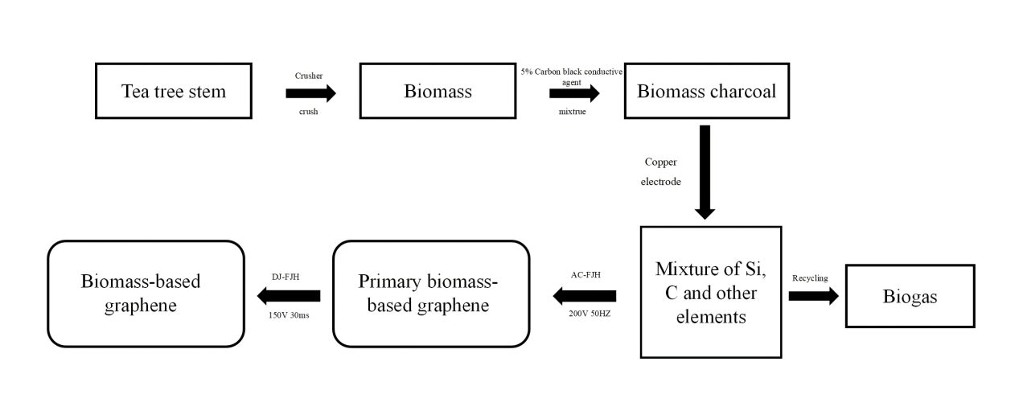
Fig. S1 The preparation method of FG.

