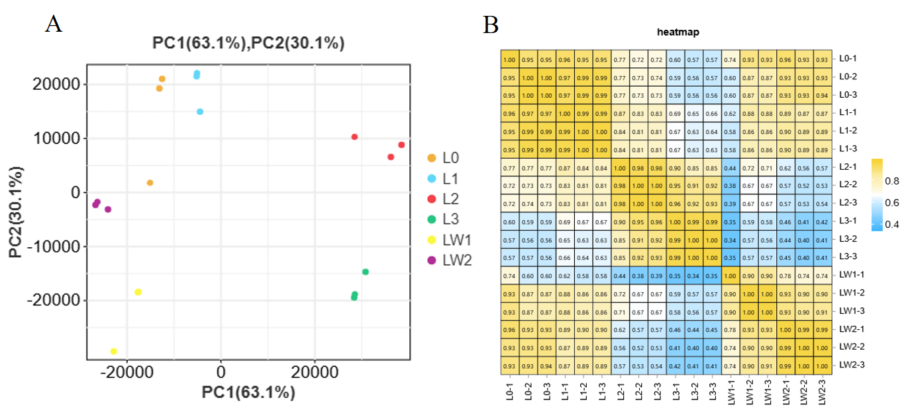
Fig. S1 Principal component analysis （PCA） （A）and correlation heatmap （B） of different Rosa persica transcriptome samples

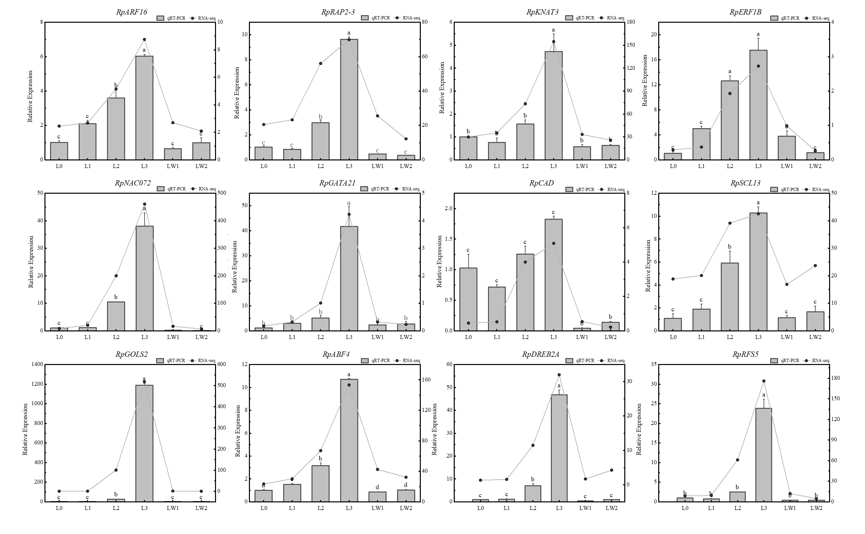
Fig. S2 Validation of qRT-PCR
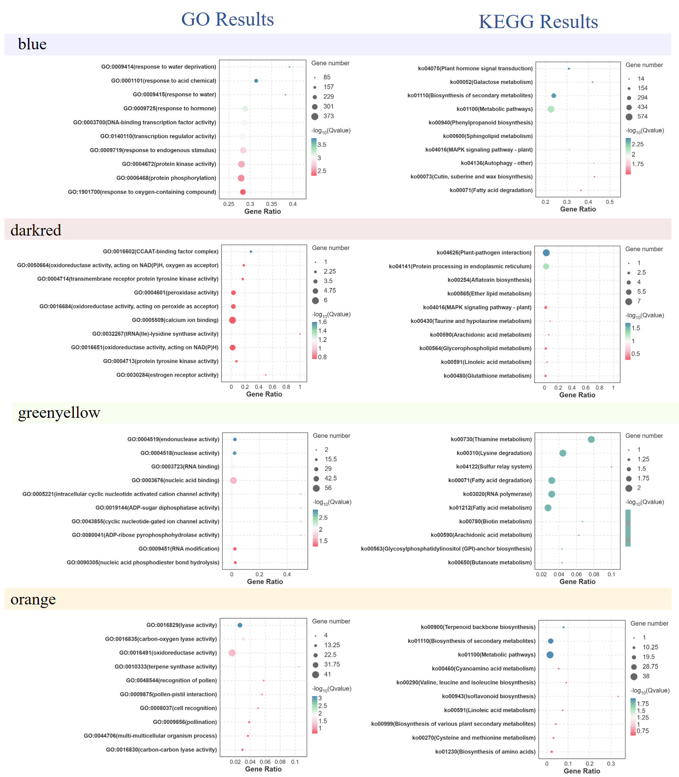
Fig. S3 GO and KEGG significant enrichment of key modules

Fig. S4 Screening of Arabidopsis lines with overexpression

