Chart 1. Mean best-corrected visual acuity (BCVA), expressed in logarithm of the minimum angle of resolution (logMAR), at baseline and 3 months postoperatively. Error bars represent 95% confidence intervals.

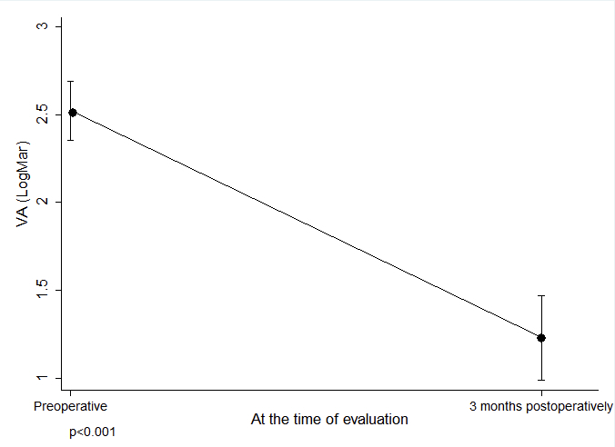

Chart 2. Mean best-corrected visual acuity (BCVA), expressed in logMAR, at baseline and 3 months postoperatively, stratified by diagnosis (PVR grade C, recurrent retinal detachment due to PVR, and penetrating ocular trauma). Error bars represent 95% confidence intervals.

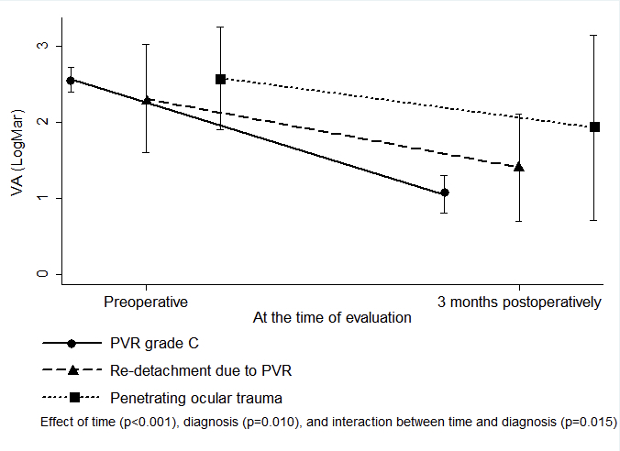

Chart 3. Mean best-corrected visual acuity (BCVA), expressed in logMAR, at baseline and 3 months postoperatively, according to intraoperative retinectomy status. Error bars represent 95% confidence intervals.

