Supplementary data
Antibacterial Activities of Depsidones from Timorese Endophytic Fungus Corynespora cassiicola against Methicilin and Multidrug-Resistant Bacteria

Contents
1. General experimental procedures 3
2. Isolation and Identification of Endophytic Fungi 3
3. Cultivation 3
4. Extraction and Fractionation 3
5. Antibacterial Assay 4
Figure S1. ¹H NMR spectrum of compound 1 (Recorded in Aceton) 5
Figure S2 Mass spectrum of compound 1 6
Figure S3. HPLC Chromatogram of compound 1 6
Figure S4. ¹H NMR spectrum of compound 2 (Recorded in Aceton) 7
Figure S5 Mass spectrum of compound 2 8
Figure S6. HPLC Chromatogram of compound 2 8
Figure S7. ¹H NMR spectrum of compound 3 (Recorded in Aceton) 9
Figure S8. Mass spectrum of compound 3 11
Figure S9. HPLC Chromatogram of compound 3 ……………………11.
Figure S10. ¹H NMR spectrum of compound 4 (Recorded in DMSO) 12
Figure S11. Mass spectrum of compound 4 13
Figure S12. HPLC Chromatogram of compound 4 13

Experimental Section
1. General Experimental Procedures
1D and 2D NMR data were obtained from Avance DMX 600 NMR spectrometer using acetone-d₆ and DMSO as solvents while Mass spectral data were measured with a LCMS HP1100 Agilent Finnigan LCQ Deca XP. Analytical HPLC with routine monitoring at 235, 254, 280 and 340 nm was conducted with a Dionex P580 and PDA detector system using Eurosphere-10 C-18 (125 × 4 mm) column.
2. Isolation and Identification of Endophytic Fungi
Healthy and fresh leaves of Annona squamosa was collected in Timor Island, Indonesia. The endophytic fungus was isolated from inner tissues of fresh and healthy leaves of A. squamosa according to the methods as previously described [1, 2].
Identification of fungal cultures
The isolated fungus was identified following the protocol including DNA amplification and sequencing of the Internal transcribed spacer (ITS) region.² Searching in BLAST showed 99-100% similarity to Corynespora cassiicola (AL5).
3. Cultivation
Rice (100 g) was put into an Erlenmeyer (1 L) and 110 mL of water was added into the Erlenmeyer. The Erlenmeyer flasks (1L) were then autoclaved and cooled down. Several small pieces of fungus from a Petri dish were transferred to the autoclaved Erlenmeyer ﬂasks containing rice. The cultures were incubated for 21 days at 22 °C under static conditions.
4. Extraction and Fractionation
After reaching their stationary growth, the cultures were exhaustively extracted with EtOAc yielding 1 g of crude extract. The crude extract of C.cassiicola (1 g) was subjected to fractionation with vacuum liquid chromatography (VLC) using mixtures of n-hexane/EtOAc followed by CH₂Cl₂/MeOH as the eluting solvent. Fraction 3, eluted with n-hexane/ EtOAc (6:4), containing 3 (6 mg) while fraction 4 from the elution of n-hexane/ EtOAc (4:6) yielding compound 1 (9 mg). Fraction 7 from the eluents CH₂Cl₂/MeOH (8:2) was further purified with Sephadex LH-20 to afford compound 2 (1.5 mg) and 4 (2 mg).
5. Assessment of Antibacterial Activity
Broth microdilution method was used in order to determine MIC values of each compounds following the protocol from CLSI guidelines. The direct colony suspension was applied in the preparation of the inoculum of 5 × 10⁵ cfu/mL after final dilution. Compounds were prepared from stock solution (10 mg/mL in DMSO), resulting in a final DMSO amount of 0.64% at the highest antibiotic concentration tested (64 μg/mL). Serial 2-fold dilutions of antibiotics were prepared with DMSO being diluted along with the compounds.
Several strains were used including S. aureus ATCC 29213, Streptococcus pneumoniae ATCC 49619, E. coli ATCC 25922, (multi) drug-resistant S. aureus 25697 and Enterococcus faecalis UW 2689.

Compound 1: browon solid; C₁₅H₁₂O₅; UV (MeOH) λ_{max}: 212.5, 267.5 nm); ESIMS m/z [M + H]⁺ 273.1; ESIMS m/z [M-H]⁺ 271.2. ¹H NMR (500 MHz, Aceton-d6) data: δ_{H} 6.66 (br s, H-2), 6.66 (br s, H-4), 6.53(dd, J = 2.8, 0.7 Hz, H-7), 6.52 (d , J = 2.8, H-9), 2.39 (s, H-12), 2.37 (s, H-13); ¹³C NMR (125 MHz, Aceton-d6) data: δ_{C} 145.1 (C-1), 115.5 (C-2), 162.4 (C-3), 104.7 (C-4), 161.5 (C-4a), 142.1 (C-5a), 131.3 (C-6), 113.5 (C-7), 154.5 (C-8), 104.9 (C-9), 144.9 (C-9a), 163.3 (C-11), 112.8 (C-11a), 20.2 (C-12), 15.0 (C-13) (Table 1).
Compound 2: orange brown solid; C₁₆H₁₂O₈; UV (MeOH) λ_{max}: 209.7, 257.0, 299.0 nm); ESIMS m/z [M + H]⁺ 333.1; ESIMS m/z [M-H]⁺ 331.2. ¹H NMR (500 MHz, Aceton-d6) data: δ_{H} 6.78 (s, H-4), 6.64 (s, H-9), 2.31 (s, H-12), 2.70 (s, H-13); ¹³C NMR (125 MHz, Aceton-d6) data: δ_{C} 128.1 (C-1), 141.6 (C-2), 149.3 (C-3), 104.1 (C-4), 155.5 (C-4a), 142.8 (C-5a), 133.5 (C-6), 110.0 (C-7), 160.3 (C-8), 106.3 (C-9), 149.4 (C-9a), 161.6 (C-11), 112.9 (C-11a), 12.5 (C-12), 14.1 (C-13), 172.0 (C-14) (Table 1).
Compound 3: orange brown solid; C₁₅H₁₂O₆; UV (MeOH) λ_{max}: 220.3, 289.0 nm); ESIMS m/z [M + H]⁺ 289.1; ESIMS m/z [M-H]⁺ 287.3. ¹H NMR (500 MHz, Aceton-d6) data: δ_{H} 6.73 (s, H-4), 6.52 (d, J = 2.1,Hz, H-7), 6.52 (d , J = 2.1, H-9), 2.35 (s, H-12), 2.33 (s, H-13); ¹³C NMR (125 MHz, Aceton-d6) data: δ_{C} 129.4 (C-1), 142.6 (C-2), 150.4 (C-3), 105.4 (C-4), 156.9 (C-4a), 144.2 (C-5a), 132.3 (C-6), 114.6 (C-7), 155.6 (C-8), 106.2 (C-9), 146.4 (C-9a), 164.0 (C-11), 114.6 (C-11a), 14.1 (C-12), 16.4 (C-13) (Table 1).
Compound 4: Violet black solid; C₁₆H₁₂O₇; UV (MeOH) λ_{max}: 209.8, 254.7 nm); ESIMS m/z [M + H]⁺ 317.2; ESIMS m/z [M-H]⁺ 315.2. ¹H NMR (500 MHz, DMSO) data: δ_{H} 6.59 (d J = 1.75, H-2), 6.59 (d J = 1.75, H-4), 6.36 (s, H-9), 2.33 (s, H-12), 2.70 (s, H-13); ¹³C NMR (125 MHz, DMSO) data: δ_{C} 144.5 (C-1), 115.5 (C-2), 162.9 (C-3), 104.5 (C-4), 161.9 (C-4a), 139.5 (C-5a), 132.9 (C-6), 115.5 (C-7), 162.6 (C-8), 104.9 (C-9), 145.5 (C-9a), 162.2 (C-11), 112.7 (C-11a), 20.5 (C-12), 13.9 (C-13) (C-14) (Table 1).

Figure S1. ¹H NMR spectrum of compound 1 (Recorded in Aceton-d6)

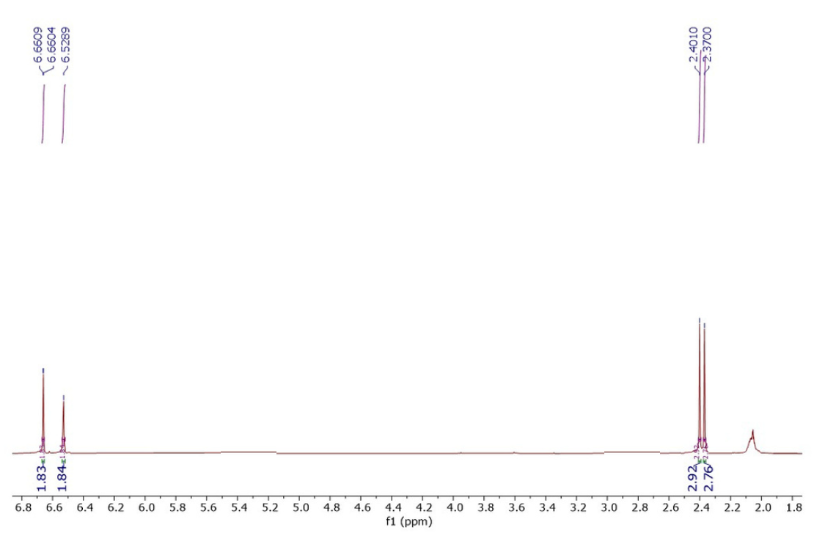

Figure S2 Mass spectrum of compound 1

Figure S3. HPLC Chromatogram of compound 1

Figure S4. ¹H NMR spectrum of compound 2 (Recorded in Aceton-d6)

Figure S5. Mass spectrum of compound 2

Figure S6. HPLC Chromatogram of compound 2

Figure S7 ¹H NMR spectrum of compound 3 (Recorded in Aceton-d6)

Figure S8. Mass Spectra of compound 3

Figure S9. HPLC Chromatogram of compound 3

Figure S10. Figure S7 ¹H NMR spectrum of compound 4 (Recorded in DMSO)

Figure S11. Mass spectrum of compound 4

Figure S12. HPLC Chromatogram of compound 4

