Supplementary Materials
Contents
Supplementary Results 2
Model determination process and Feasibility validation experiment on microbiome data 2
One-vs-Rest experiment. 3
GANBase can achieve the depletion of human host sequences at different mixing ratios with a suitable threshold 4
Interpretability verification of host and target case tests 5
Resource consumption comparison between GANBase and Minimap2 6
Adaptive Sequencing in wet lab for depleting the host from the human-microbiome mixture 6
Adaptive Sequencing result in wet lab for comparison 7
Supplementary Methods 8
Detailed architecture of model Neural Networks 8
Model training process 9
Dataset description 10
Metrics 10
Statistical Analysis and Significance Test 11
Supplementary Figures 13
Supplementary Tables 26

Supplementary Results

Model determination process and Feasibility validation experiment on microbiome data
As we determined the GAN architecture tailored for sequence tasks, we then investigated the neural networks suitable for the discriminator and generator. Considering that once the discriminator is fixed, the generator can be designed accordingly, we first evaluated various neural networks (CNN, LSTM, and Transformer Encoder-based) and hyperparameters through supervised classification of reads identifying S. aureus in ZymoBIOMICS HMW DNA sequencing data (Supplementary Figure 1a, Supplementary Table 1).
Furthermore, we set the neural networks as the discriminator and evaluated the performance of the discriminator through unsupervised classification. In the unsupervised training process, we trained three GAN-based models with different discriminators on the reference genomes of S. aureus and P. aeruginosa, respectively. We chose S. aureus (a typical Gram-positive bacterium) and Pseudomonas aeruginosa (P. aeruginosa, a typical Gram-negative bacterium, NCBI RefSeq GCF_000006765.1) as target species and, for each species, build three models using the best-performing discriminator from each of the three frameworks respectively. To validate the performance of these models, we then utilized sequencing data from the Zymo mock community as simulated test sets. For S. aureus (Supplementary Figure 2b), the performance of the Transformer-based model(red) outperformed the LSTM-based (blue) and CNN-based (green) models. Transformer-based model (red) achieved a higher accuracy score of 81.29%, a ROC-AUC of 84.59%, and a PR-AUC value of 87.02% compared with the LSTM model (accuracy: 71.72%, ROC-AUC: 77.98%, PR-AUC: 73.71%) and the CNN model (accuracy: 59.63%, ROC-AUC: 63.50%, PR-AUC: 60.01%). Regarding P. aeruginosa (Supplementary Figure 2c), the Transformer-based discriminator also achieved the best identification performance (Accuracy: 91.68%, ROC-AUC: 97.10%, and PR-AUC: 97.13%), compared with the LSTM model (accuracy: 90.72%, ROC-AUC: 96.74%, PR-AUC:96.76%) and the CNN model (accuracy: 67.66%, ROC-AUC: 86.35%, PR-AUC: 85.96%).
Moreover, enrichment ratio plays the key criterion to assess the model for adaptive sequencing. Thus, we also compared the performance of models in terms of in silico enrichment ratio using a ratio of 50%:50% data (Supplementary Figure 1d and e). The red dotted lines mean that when the in silico enrichment ratio reaches 2, there are no false-positive reads. As for the result, the Transformer-based model outperforms other models in all metrics.
In this process, we also trained different generators. In our opinion, we tend to make the model with the ability to tolerate small variations in target sequences. Compared to the models with self-attention, LSTM is weak to learn the global information and therefore generates less precise sequences for the discriminator to distinguish, thereby making the discriminator more robust. Although the result of the generator used transformer encoder is more than that used RNN (we used LSTM), due to its higher time cost and more false positive samples, we chose RNN for the generator. (see Supplementary Table 2).
We also compared the capabilities of the GANBase model when the generator is a Transformer and LSTM (Supplementary Table 3 shows the confusion matrix), as well as the sequence generation capabilities of different generators (Supplementary Table 4).
Analysis of data processing parameter selection
For the input data processing, we analyzed the impact of input feature length and sliding window step size on model performance. We applied the windows interception to the S. aureus reference genome with lengths of 400 bp, 200 bp, 100 bp, and 50 bp, using corresponding step sizes (Supplementary Table 5) to construct 16 datasets with coverage levels of 1x, 2x, 4x, and 8x. After training, we evaluated the performance of these 16 models. The results indicate that an input length of 200 bp and a sliding window step size of 100 bp provide a good balance of speed and accuracy, which was shown in Supplementary Figure2. Consequently, we selected these parameters to construct the data preprocessing flow for training and evaluation of GANBase on various downstream tasks.

One-vs-Rest experiment.
To quantify the similarity between different microbial genomes, we used the Average Nucleotide Identity (ANI) score as the main metric. The ANI score is a widely used metric in microbial genomics to measure the nucleotide similarity between two genome sequences. It is calculated by comparing the nucleotide identity between genome fragments and can effectively reflect the evolutionary relationship between genomes. We calculated the ANI scores for microbial genomes in Zymo and compiled the results into a table (see Supplementary Table S6). The table lists the query genome, reference genome, ANI score, number of aligned fragments, total number of fragments, and the proportion of aligned fragments. The higher the ANI score, the higher the nucleotide similarity between the two genomes. For example, when the ANI score is close to 100, it indicates that the two genomes are almost completely identical at the nucleotide level, while a lower ANI score indicates that the genomes are more different.
To assess whether GANBase exhibits varying classification performance across different bacterial groups, we conducted experiments using the One-vs-Rest method on 8 species from the Zymo Standard. In each experiment, the training set consisted of samples from only one species, while the test set included samples from all other species except the one used for training. For the training set, we truncated the sequences to a length of 200 bp with a sliding window of 100bp (providing 2x coverage). We then tested the model on the sequencing results of the remaining species. The results are displayed in Supplementary Figure S2, where the horizontal axis represents the training species, and the vertical axis shows the prediction results for sequences from other species, also cut into 200bp segments. The darker the color, the better the classification performance.
We observed that the model’s discriminative ability weakens when species are closer in the species classification tree. These results, based on the One-vs-Rest method and species taxonomy tree, suggest that species similarity affects the classification accuracy of GANBase (Supplementary Figure 3).

GANBase can achieve the depletion of human host sequences at different mixing ratios with a suitable threshold
In order to deplete host (human) sequences and achieve the purpose of enriching non-host sequences in practical applications, we built the host-depleting model based on the human reference genome. After training the model on the large-scale training dataset containing 14m reads, we evaluated the model's performance on the different simulated testing sets (see the Methods section and Supplementary Table 22 for details on the specific dataset construction and mixing ratio). We used the classification results from GANBase to deplete host sequences, thereby achieving the enrichment of non-host sequences.
Further, we found that the threshold has a great impact on the classification effect of imbalanced samples. In order to improve the classification ability of the discriminator in imbalanced samples, we conducted multiple tests for different thresholds, evaluated the impact of different thresholds on classification accuracy, recall, and other indicators, and optimized the performance of the classifier to make it more suitable for imbalanced samples. We plotted the classification results under different imbalanced conditions, with the human to yeast sample ratios of 1:1, 10:1, 100:1, 1000:1, and 10000:1 (as shown in Supplementary Figure 4). In these tests, we focused on the proportion of predicted humans as 1 and others as 0. The study found that when the samples were balanced (1:1), the prediction results were roughly evenly distributed. However, in the case of unbalanced sample ratios (non-1:1), as the sample ratio gap increased, the misjudgment of the prediction results (including false positives and false negatives) increased significantly. Usually, the default threshold of the classifier is 0.5. However, in classification task evaluations, relying solely on a fixed threshold of 0.5 may not fully reflect its actual classification ability. Therefore, we evaluated model performance across various thresholds on the testing set containing human and Zymo reads mixed at a ratio of 10 to 1 (Supplementary Figure 5). The results show that even at lower thresholds, all metrics, except for Precision, demonstrating improved performance, such as Accuracy and Recall. This phenomenon illustrates that lower thresholds can more effectively deplete host sequences, but may lead to more False Positives, resulting in lower accuracy. Consequently, to achieve higher enrichment factors and more effective host depletion in real-time applications, threshold selection should be balanced and optimized according to specific application needs.
In order to optimize the classification effect, we empirically tested the threshold from 0.1 to 0.9 with a step size of 0.1. As shown in Figure S4, when the threshold is set to 0.1, the classification effect of the classifier under unbalanced samples is relatively accurate, and the enrichment rate can reach more than 10 times. Under more unbalanced ratios, we further refined the threshold selection and tested the thresholds of 0.01 to 0.09 with a step size of 0.01. For the extreme imbalance of 10000:1 human to yeast sample ratio, when the threshold is set to 0.01, although 99.9% of the human genome is filtered out, the enrichment rate is significantly increased to 65 times, this high enrichment rate is at the cost of increased false positives.
Specially, we evaluated the impact of the threshold on classification results under 11 different mixing ratios of hosts and pathogens to select an appropriate classification threshold. These ratios ranged from moderately imbalanced (5:1 to 10k:1) to extremely imbalanced (100k:1). Analysis of the Matthews correlation coefficient (MCC) and F1-score curves under different thresholds revealed that for host removal tasks, the model exhibits stronger performance in the lower threshold range (Supplementary Figure 6h-j). Moreover, in highly unbalanced scenarios, overly aggressive threshold settings can be counterproductive, as maintaining recall is crucial for preserving rare target sequences (Supplementary Figure 5). Considering both the in silico enrichment ratio heatmap and the changes in various classification metrics with the threshold, we found that when the threshold is set to 0.1, the model maintains optimal overall performance across different mixing ratios. At this threshold, even under extreme dilution conditions of 100k:1, the model can still balance the detection limit and false positive rate (Supplementary Figure 4j-l), thus ensuring the reliability of subsequent analyses.
Considering that in actual scenarios, the proportion of target sequences to be detected may be as low as 0.001%, to further evaluate whether GANBase can maintain normal classification capabilities under imbalanced data, we tested the test sets with different mixing ratios of human hosts and different microorganisms (1:1, 10:1, 100:1, 1000:1, 10,000:1, and extreme 100,000:1). The results show that the model exhibits excellent classification performance under various mixing ratios. It is worth noting that even at the extreme ratio of 100,000 to 1, the model can accurately classify sequences and achieve a high in silico enrichment ratio (Supplementary Figure 6). This shows that GANBase can still maintain efficient classification and enrichment capabilities under extremely low target sequence ratios.

Interpretability verification of host and target case tests
We show the specific values of the host&target cases in the supplementary. For these results, we also considered that the choice of threshold would affect the results, so we tested the classification results when the threshold was 0.9. Supplementary Table 16 shows that it may be possible to adapt to different problems by modifying the threshold.
In addition, in order to prove the interpretability of the sequence, we visualized the sequence attention weights on the human model. We selected the sequences of Human (NA24385), E. coli, S. aureus, and P. aeruginosa, and calculated the attention weights of the top 10 single bases (Supplementary Figure 8), the attention weights of the top 10 5mers and 10mers (Supplementary Figure 9). In addition, we also calculated the attention weights of 20mers in NA24385, and selected the top 1 and top 30 short sequences to NCBI BLAST for comparison. The result of the 20-mer sequence alignment in NCBI Blast shows that the sequence attention weights extracted by the GANBase model adhere to sequence category rules. For the top weight sequence (CCTGTCATTTCTCCTTAGGG), only Homo sapiens can be matched with 100% accuracy, and very few other species can be matched. For the 30th top sequence (TGATAATTTTAGTACTAACT), many short sequences can be matched approximately, and the species they represent are more diverse.

Resource consumption comparison between GANBase and Minimap2
To evaluate the performance of GANBase, a deep learning-based host removal method, we conducted host removal processing tests on a hardware platform equipped with an AMD EPYC 7763 64-Core processor (128 threads, 256 MiB L3 cache) and an NVIDIA GeForce RTX 3090 GPU (24 GB VRAM) for both the human and Zymo reference genomes (total size approximately 3.2 GB). Experimental results show that GANBase exhibits a significant speedup in processing efficiency, with an average single-sequence processing time of only 0.47 ms/seq. In contrast, even under a high-concurrency configuration with all 64 threads running, the traditional alignment-based algorithm Minimap2 still requires 24.14 ms/seq, meaning GANBase achieves approximately a 51-fold speedup.
Regarding resource consumption, Minimap2 maintained a system memory usage of around 12 GB when processing the 3.2 GB reference genome. GANBase exhibits extremely lightweight characteristics, with only 2.6 M model parameters and a static GPU memory footprint of only 1.4 GB during inference. By transforming traditional alignment tasks into deep learning inference tasks, GANBase not only achieves a leap in throughput but also demonstrates superior computational resource utilization under high-performance computing architectures.

Adaptive Sequencing in wet lab for depleting the host from the human-microbiome mixture
Our adaptive sequencing process first extracts nucleic acids (such as DNA or RNA) from biological samples and performs quantification and quality testing to ensure the effectiveness of downstream operations. The Supplementary Figure Shown is a workflow diagram for adaptive sequencing.
During the adaptive sequencing process of the wet experiment, the real-time data generated by the nanopore sequencer is output in the form of electrical signals. These signals must go through the base recognition step before they can be sent to the model for analysis and judgment. However, the base recognition process integrated in the existing selective sequencing relies on the Guppy server, which is slow and time-consuming, thus affecting the throughput of the experiment and the final enrichment effect. In order to improve the efficiency and accuracy of the experiment, we optimized the existing base recognition method in the script file provided by ONT. Specifically, we replaced the base recognition method that originally relied on the Guppy Server with the more efficient bonito method and implemented it as a local function, avoiding the need to call additional processes.
Supplementary Figure 10a shows the trend of the cumulative growth of sequencing reads over time (minutes) during the experiment, indicating that the sequencing platform maintains a stable data output capacity throughout the entire operation cycle. Supplementary Figure 10b further depicts the cumulative change of the estimated number of base pairs over the experimental time. Its growth curve is consistent with the reading trend, reflecting that the data output is also consistent and predictable at the base level. Supplementary Figure 10c shows the dynamic change of active fragment quality over time. The curve reveals that during the sequencing process, the fragment quality fluctuates to a certain extent, which may be related to the change of channel state, sequencing enzyme activity, or sample complexity, suggesting that the interference factors of the time dimension need to be considered in real-time quality control. Supplementary Figure 10d shows the distribution of sequencing reads under different state channels. Finally, Supplementary Figure 10e presents the data reduction classified by channel state. The bar graph shows that there are obvious differences in the amount of data reduction under different channel states, indicating that the channel state plays a key role in data retention. This shows that during the sequencing process, data output and quality are affected by both time and experimental conditions.

Adaptive Sequencing result in wet lab for comparison
To evaluate the performance of GANBase in real-time adaptive sequencing, we conducted a wet-lab experiment. For comparison purposes, we included the supervised model SquiggleNet as the baseline. Considering the limitations of supervised models in classifying unseen species, we selected Zymo mock (D6322) as the pathogen and NA12878 standard as the host. The host and pathogen were mixed at ratios of 1:1 (barcode 01), 4:1 (barcode 02), and 9:1 (barcode 03) for library preparation, according to the manufacturer's instructions (see Methods). Sequencing experiments were performed using the MinKNOW Read Until API on FLO-MIN106 (R9.4.1) and FLO-MIN114 (R10.4.1) flow cells (Figure 5a). For the experimental setup, nanopore channels 1–256 were designated as the experimental group (with adaptive sequencing), while channels 257–512 served as the control group (without adaptive sequencing).
The sequencing process on the R9 flowcell was conducted in two consecutive stages, with SquiggleNet applied for host depletion in the first stage (3h 58min) and GANBase in the second stage (3h 8min), for a total runtime of 7 h 6 min. The sequencing conditions changed between significantly the two stages, the number of active pores decreased from 256 at the beginning of the first stage to approximately 150 during the second stage, corresponding to a 41.41% reduction (Figure 5a). Consistent with this decrease, the second stage exhibited reduced overall sequencing throughput, with lower base yield and read counts compared to the first stage (Figure 5b and Supplementary Metrials). These indicate that GANBase was evaluated under reduced pore activity and sequencing throughput on the R9 flowcell. Experiments on the R10 flowcell were conducted for 3 hours, with an independent flow cell used for each method.
In the R9 flowcell sequencing experiment, GANBase consistently achieved higher in silico enrichment ratios for Zymo mock reads than SquiggleNet across all three barcodes. GANBase achieved 1.79-fold (barcode 01), 3.69-fold (barcode 02), and 5.45-fold (barcode 03) values, whereas SquiggleNet achieved 1.75-fold, 3.20-fold, and 4.58-fold (Figure 5d). Furthermore, Figure 5f showed that GANBase achieved significantly higher precision than SquiggleNet across all mixture ratios (82.45% vs. 51.87%; 67.25% vs. 45.52%; 47.45% vs. 36.43%). Correspondingly, GANBase achieved higher recall than SquiggleNet (68.35% vs. 52.18%; 65.75% vs. 50.71%; 64.03% vs. 47.97%). Notably, precision and recall declined as the target proportions decreased in both methods, suggesting that in the case of unbalanced samples, the identification performance of the model on the target genome will be weakened.
In the R10 flowcell sequencing experiment, GANBase achieved 3.37-fold, 4.31-fold,4.67-fold enrich for GANBase respectively, whereas SquiggleNet achieved 2.97-fold,4.01-fold,4.30-fold (Figure 5e). And similar improvements in both precision and recall were observed in the R10 experiments (Figure 5g). It is worth noting that because SquiggleNet was only trained on R9 data, it exhibited a large number of misclassifications in R10 tests. However, GANBase uses bonito for basecalling, eliminating the need to adapt to flowcell version updates.

Supplementary Methods

Detailed architecture of model Neural Networks
The GAN network mainly includes a generator and a discriminator.
In GANBase, the main model used by the generator is the long short-term memory network model, LSTM. Input the encoded gene sequence, convert it into the expression form of a word vector, and then input it into each unit in the neural network, and then combine it with the output of the Fully Connected hidden layer to get the next result. The process of generating a simulation sequence is in the generator. After initialization, the encoded word embedding vector is connected to the LSTM network, and the dimensionality is reduced to output the Fully Connected layer. The probability of each position is calculated through softmax. Finally, the simulation is generated through a multinomial sampling distribution.
The generator takes the encoded sequence as input and uses a 5-layer LSTM to extract features. Subsequently, the features are passed through a Fully Connected layer and a log softmax activation function to obtain the distribution probability of the corresponding base at each position. Finally, the generator generates the sequence by selecting the base with the highest probability at each position.
In the discriminator, in order to extract the global information of the sequence, we use the transformer Encoder. To focus on the internal features of the sequence, a convolutional neural network CNN is added. This network structure is used to compare real sequences and generated Sequences are identified and classified.
For the discriminator, the sequence is encoded, and the position encoding processed by sin/cos is input into a feature extraction module consisting of a 6-layer Transformer Encoder and a 3-layer Conv1d. The normalized features are passed through a Fully Connected layer and a log softmax activation function to obtain the classification probability to determine whether it is the target sequence.
The training of the model mainly includes three parts: pretraining of G, pretraining of D, and Adversarial neural networks, and in each part, training and evaluation are done. In the Adversarial neural networks section, in each training, when training one of G and D, fix the other one and perform step-by-step training.
In the training and evaluation process, we use NLLloss(Negative Log Likelihood Loss) as a loss function to measure the gap between the output of the model and the label. The formula is as follows:
$$NLLloss (p,q)=-\sum_{i=1}{q_{i}{logp}_{i}}$$
After gradual updates, a model with stronger generation ability and higher resolution ability is obtained.
In the adversarial training process, the calculated method of total loss is described as follows: First, the reward of the generative model on the sequence is obtained by MCTS sampling. The reward is a matrix of size (batch size, sequence length) obtained by the discriminator. Then, the output of the generator on the synthetic input data (inputs) is compared with the real target data (targets), and the loss is calculated using the policy gradient loss function (PGLoss). The loss function first converts the predicted value (pred) into a one-hot encoding, then calculates the loss part that matches the target value (targets), and weights the loss according to the reward (reward). Finally, the parameters of the generative model are updated through backpropagation to optimize the strategy of the generative model so that it can obtain higher rewards when generating data.

Model training process
We conducted the GANBase training process following the training steps of seqGAN. The entire network training process was divided into three steps: the pretrain process of the generator, the pretrain process of the discriminator, and the adversarial training of the generator and the discriminator.
First, in the pretraining process of the generator, we used a 5-layer LSTM network as the generator, took the real reference genome sequence as input, and iterated for 15 steps. LSTM mapped the input sequence embedding representation to a hidden state sequence. The hidden state was mapped to the distribution of the output token through the softmax layer. The Adam optimizer was used to gradually update the network weights to reduce the loss. After each round of pretraining, we calculated the results of the NCBI BLAST+ (v2.15.0) alignment, considering how close the sequences generated by the generator are to the real ones, which is shown in the Supplementary Table 5. We used the maximum likelihood estimation method (MLE) according to the standard training method of RNN, calculating the loss of each position through the Negative Log Likelihood Loss function, then summing up the losses of all positions to get the total loss, and then updating the model parameters through backpropagation.
The second step was to pretrain the discriminator. The data input to the discriminator is the real sequence with label 1 and the sequence generated by the generator with label 0, which is iterated through the discriminator for 5 steps. After the embedding layer and position encoding, we input the data into the Transformer Encoder with a multi-head attention mechanism. This encoder consists of multiple self-attention mechanisms and feedforward networks. Then we used the CNN network to aggregate the features and classify the normalized features using the Fully Connected layer and activation function. The loss function of the discriminator used NLL loss to calculate the gap between the model's prediction result and the actual label.
In the third step, we trained the pretrained generator and discriminator alternately. We used the pre-trained generator to generate sequences starting from random probability and used the probability that the sequence provided by the pretrained discriminator was the real sequence to calculate the loss. After that, we fixed the generator and trained the discriminator in the same way as the discriminator pretraining step.

Dataset description
For all trained models related to Zymo standard D6322, we conducted different training and testing datasets as supplementary Table 5.
For test sets, after sequencing and data preprocessing, we got the test data of the Zymo test. The Supplementary Table 21 displays the sequence counts and base counts of them.
For the depletion of human host DNA, we used GRCh38 to conduct the one-class classification model. We mainly performed sliding window processing on the autosomal and sex chromosome sequences to obtain a training set with a coverage of 1-fold. Sequences such as Scalfolds were removed. And we conducted different volume training datasets and showed the training sets below in Supplementary Table 21.
For test sets, we conducted the mixtures with different mixing ratios, including NA24385 & Zymo mock, NA24385 & SARS-CoV-2 standard from TWIST, NA24385 & S. cerevisiae, NA12878 & Zymo, NA12878 & SARS-CoV-2, NA12878 & S.cerevisiae. The test sets are indicated in the Supplementary Table 22.

Metrics
Accuracy is the ratio of the number of correctly predicted samples to the total number of samples, expressed as $Accuracy=\frac{TP+TN}{TP+FN+FP+TN}$. ROC-AUC is the area under the curve with the false positive rate (FPR) and the true positive rate (TPR) as the axes, where the calculation methods of TPR and FPR are: $TPR =\frac{TP}{TP+FN}$，$FPR =\frac{FP}{TN+FP}$. Precision is the proportion of samples predicted by the model as positive examples that are actually positive examples, expressed as $Precision =\frac{TP}{TP+FP}$. Recall is the proportion of samples predicted by the model as positive examples that are actually positive examples, expressed as$Recall =\frac{TP}{TP+FN}$. The F1 score is the harmonic mean of Precision and Recall, expressed as $F1 Score=\frac{2 × (Precision× Recall)}{Precision + Recall}$. MCC comprehensively considers TP, TN, FP, and FN, and is suitable for the evaluation of data sets with class imbalance. The calculation method is$MCC =\frac{TP×TN-FP×FN}{\sqrt{(TP+FP)(FP+FN)(TN+FP)(TN+FN)}}$

Statistical Analysis and Significance Test
To evaluate the performance consistency between GANBase and Minimap2, we implemented a non-parametric permutation test for statistical inference. We defined the null hypothesis as the absence of a significant difference in classification recall between the two methods. This test constructs a null distribution of the mean difference by merging the two sets of recall values and randomly reassigning them to two new sets over 1000 iterations. The empirical p-value was then calculated as the proportion of permutations where the absolute mean difference exceeded the observed difference by 0.051. The obtained p-value was 0.0589 (p > 0.05), indicating that the observed recall difference was not statistically significant, thus validating that GANBase performs comparably to the alignment-based benchmark method.
To evaluate the accuracy of the predicted base compositions (for the proportion of AT base of human or non-human sequences), we compared the AT content distributions between the predicted and reference groups using the independent two-sample t-test (via scipy.stats.ttest). Given the large sample size, the statistical significance was determined at a threshold of p < 0.05. Additionally, effect sizes (e.g., mean difference ΔAT) and Kullback-Leibler (KL) divergence were calculated to quantify the magnitude of distributional shifts and information disparity between groups.
Retraining process of the comparison method
This section aims to validate the performance of four different adaptive sequencing models (supervised model: NanoDeep, SquiggleNet, DeepSelectNet, and the unsupervised: GANBase). We generated three simulated test datasets, each containing a mixture of host and target DNA reads at a 4:1 ratio, with a total of 100,000 reads per dataset. The datasets were constructed through random sampling from publicly available sequencing data and in-house datasets, including: NA12878 & Zymo mock, NA12878 & Yeast, and NA12878 & SARS-CoV-2.
We first assessed the performance of supervised learning models with default weights. The result showed that supervised learning models lose accuracy when encountering unseen data (Supplementary Figure 13 and Supplementary Table 11). This indicated the supervised models require retraining on the new datasets.
To mitigate the potential biases of these models training data (Human and Zymo), we retrained the all three models using the corresponding public nanopore sequencing data. We collected publicly available sequencing data and constructed the input data at a 1:1 ratio. We then labeled the data accordingly for use in supervised learning training.
Drawing interpretable motifs
To further elucidate the discrimination logic of the GANBase model in distinguishing between human genome and Zymo microbial community sequences, we constructed an interpretability analysis workflow based on weights and motifs. First, we calculated the partial derivative of the target classification prediction with respect to the input layer embedding vector through backpropagation, and then performed a weighted summation based on input features to quantify the contribution of each base position in the input sequence to the model's final classification decision. After obtaining position-specific weight mappings, we further employed a weighted k-mer statistical strategy for feature extraction: by traversing the sequence through a sliding window, we calculated the average base weight within each sub-fragment of length k, thus characterizing the significance of that fragment as a classification feature. For samples correctly classified in the test set, we systematically selected the top 30 significant motifs in terms of global contribution, and combined this with the logomaker library to perform multiple sequence alignment and information content calculation on high-scoring motifs, generating sequence logos to visually represent the base distribution preferences captured by the model, such as specific GC enrichment or highly conserved repetitive sequence patterns. To verify the scientific validity of the model's judgment, a control group based on the actual distribution of the reference genome was constructed simultaneously in the experiment. By comparing the similarities and differences between the predicted sequence and the reference sequence in terms of motif frequency and site conservation, the model's learned features were verified to conform to the actual biological properties of the genome.

Supplementary Figures
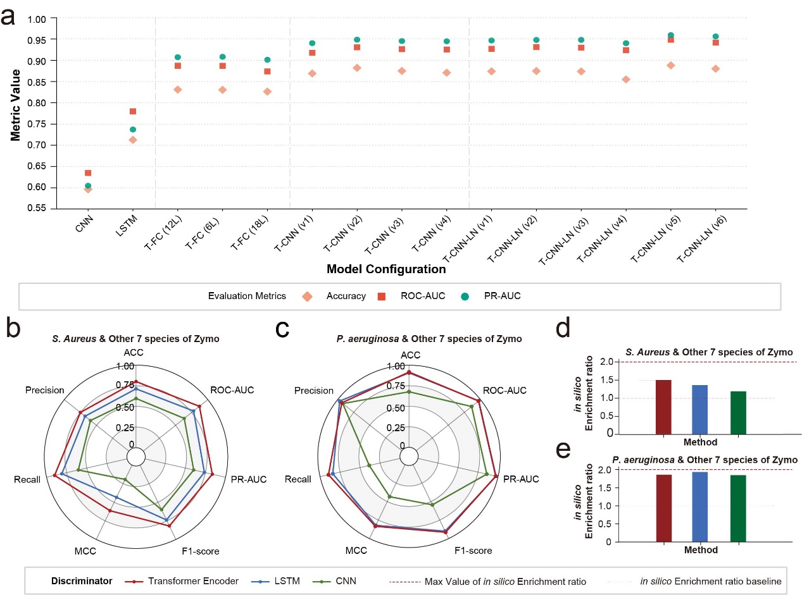
Supplementary Figure 1. Performance evaluation of zymo enrichment analysis of GANBase.
(a) Comparison of model configurations: This panel displays the performance metrics (Accuracy, ROC-AUC, and PR-AUC) across various discriminator architectures, including CNN, LSTM, and different Transformer-based variants (see detail in Supplementary Table 1). (b–c) Radar plots of discriminator performance: These plots compare three discriminator types—Transformer Encoder (red), LSTM (blue), and CNN (green)—across seven evaluation metrics (ACC, ROC-AUC, PR-AUC, F1-score, MCC, Recall, and Precision) for S. aureus (b) and P. aeruginosa (c).(d–e) In silico enrichment efficiency: These bar charts illustrate the in silico enrichment ratio for S. aureus (d) and P. aeruginosa (e) using different methods. The red dotted line indicates the "Max Value of in silico Enrichment ratio," while the light grey dashed line represents the baseline. The red, blue, and green bars correspond to the Transformer Encoder, LSTM, and CNN discriminators, respectively.
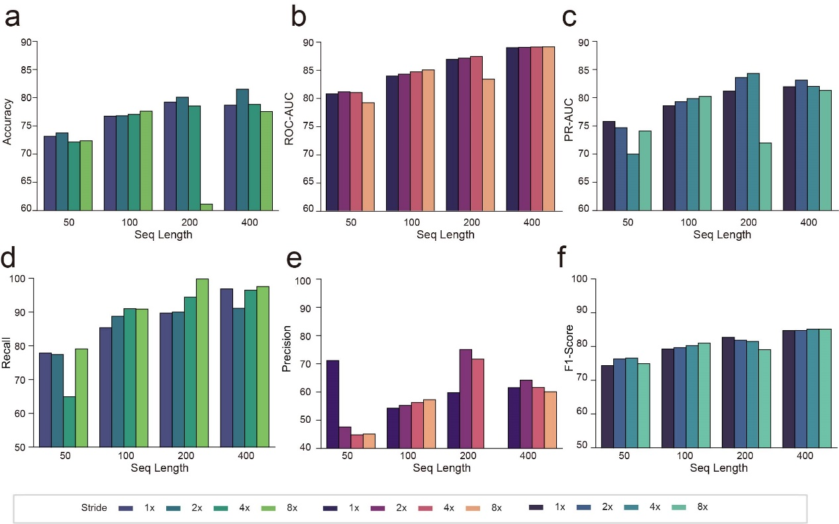
Supplementary Figure 2. Impact of sequence length and sliding window stride on model performance.
This figure illustrates the performance metrics of the GANBase classification model across various combinations of sequence lengths (50, 100, 200, and 400 bp) and sliding window strides (1x, 2x, 4x, and 8x coverage). (a–f) Comprehensive evaluation metrics: The bar charts display the results for (a) Accuracy, (b) ROC-AUC, (c) PR-AUC, (d) Recall, (e) Precision, and (f) F1-Score. In each panel, the horizontal axis represents the sequence length, while the different colored bars (ranging from dark blue to light green/orange) represent different stride settings (1x, 2x, 4x, and 8x). The vertical axis indicates the corresponding metric value (0–100%).

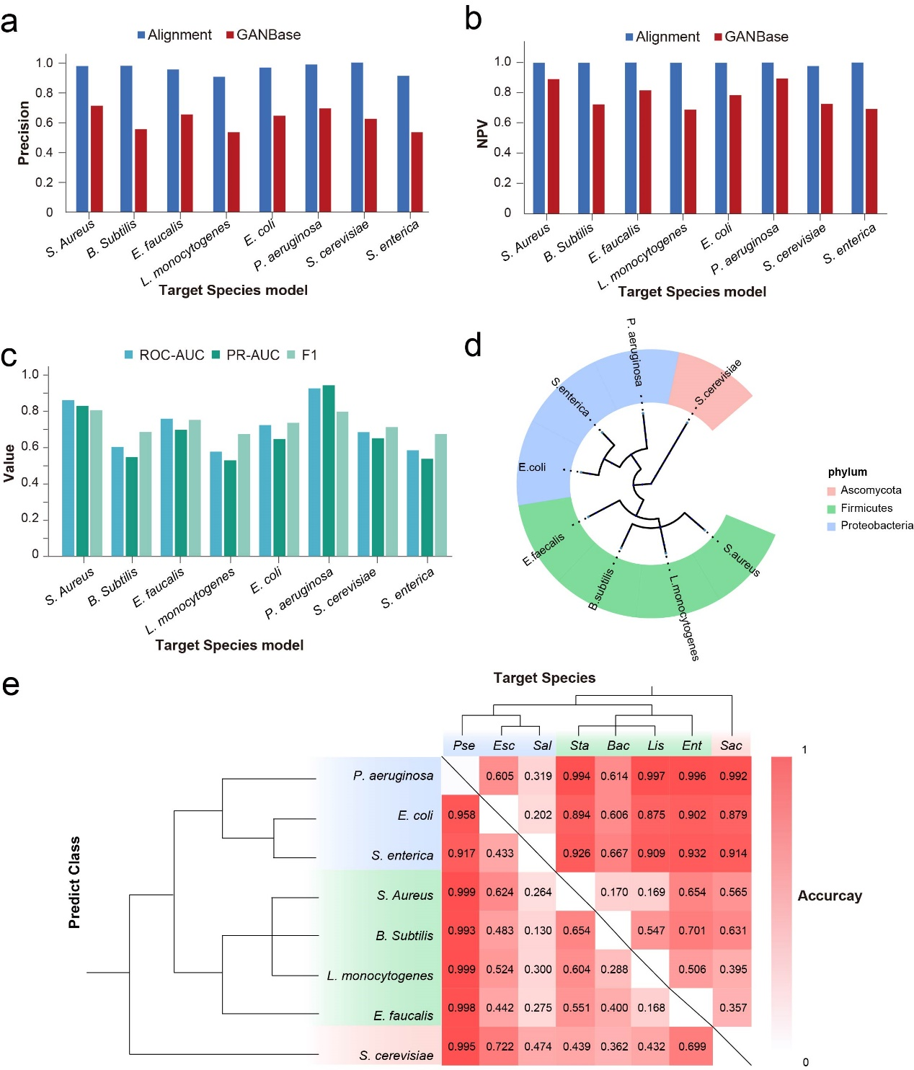Supplementary Figure 3. Comparison with alignment methods and cross-species classification performance.
(a–b) Comparison between GANBase and Alignment (minimap2): These bar charts compare the (a) Precision and (b) Negative Predictive Value (NPV) of GANBase (red) versus the traditional sequence alignment method (blue) across eight target species. (c) Performance across diverse species: The multi-color bar chart illustrates three key evaluation metrics—ROC-AUC, PR-AUC, and F1-score—for GANBase models individually trained and tested on eight distinct species from the Zymo mock community. (d) Phylogenetic distribution of target species: A circular taxonomic tree displays the evolutionary relationships of the eight tested species, categorized by phylum: Ascomycota (pink), Firmicutes (green), and Proteobacteria (blue).(e) shows the Accuracy of GANBase when applied to different target species in a "One-vs-Rest" classification task. The heat map's intensity (red scale) represents the accuracy value, with the hierarchical clustering (left and top) reflecting the similarity in model prediction patterns between species. The diagonal elements are omitted to highlight cross-species discrimination performance.
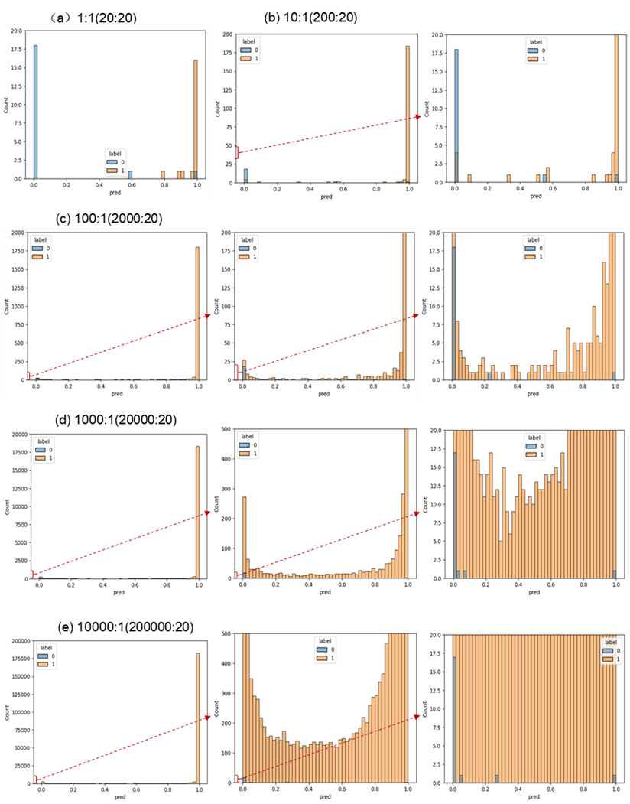
Supplementary Figure 4. Classification results of humans and yeast.
(a) Results at a 1:1 ratio. (b) Results at a 10:1 ratio. (c) Results at a 100:1 ratio. (d) Results at a 1000:1 ratio. (e) Results at a 10000:1 ratio.
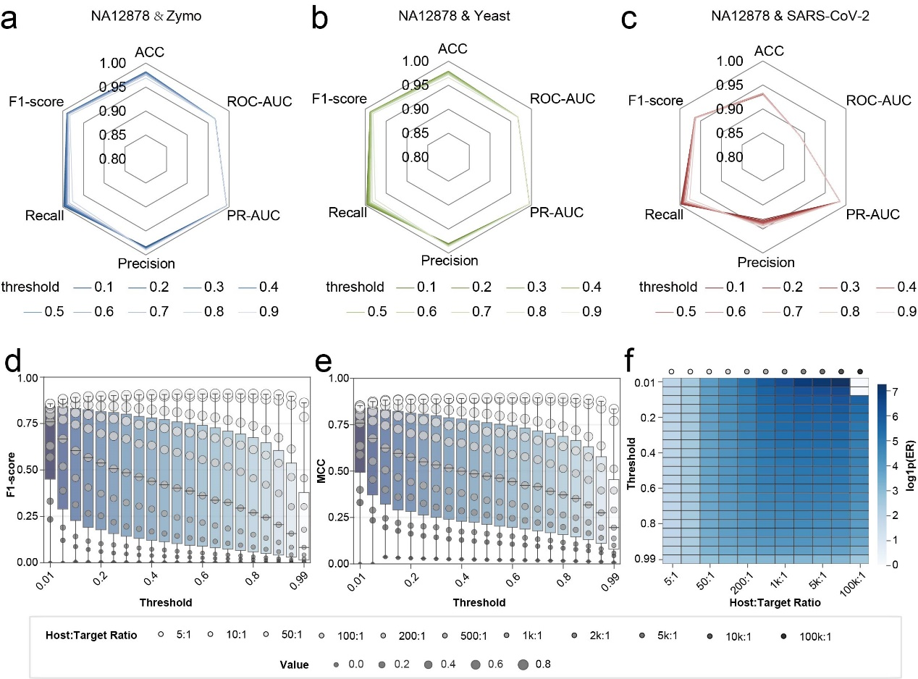
Supplementary Figure 5. Model performance across varying classification thresholds and host-to-target ratios.
(a–c) Performance metrics at different thresholds: Radar charts illustrate model performance—including ACC, ROC-AUC, PR-AUC, Precision, Recall, and F1-score—across classification thresholds ranging from 0.1 to 0.9. Results are shown for NA12878 human samples mixed with (a) Zymo community, (b) Yeast, and (c) SARS-CoV-2. Lines with varying transparency/shades represent the different threshold settings.(d–e) Impact of threshold on classification stability: Box-and-whisker plots display the distribution of (d) F1-score and (e) MCC (Matthews Correlation Coefficient) as the threshold increases from 0.01 to 0.99. Individual data points represent different Host:Target ratios (from 5:1 to 100k:1), with the size and grayscale intensity of the points corresponding to the ratio and specific value, respectively.(f) Enrichment efficiency under extreme dilution: The heat map shows the log value of in silico Enrichment Ratio across a grid of classification thresholds (vertical axis) and Host:Target ratios (horizontal axis). The color gradient (light to dark blue) represents the magnitude of enrichment, highlighting the model's ability to maintain high enrichment factors even at an extreme host-to-target ratio of 100,000:1.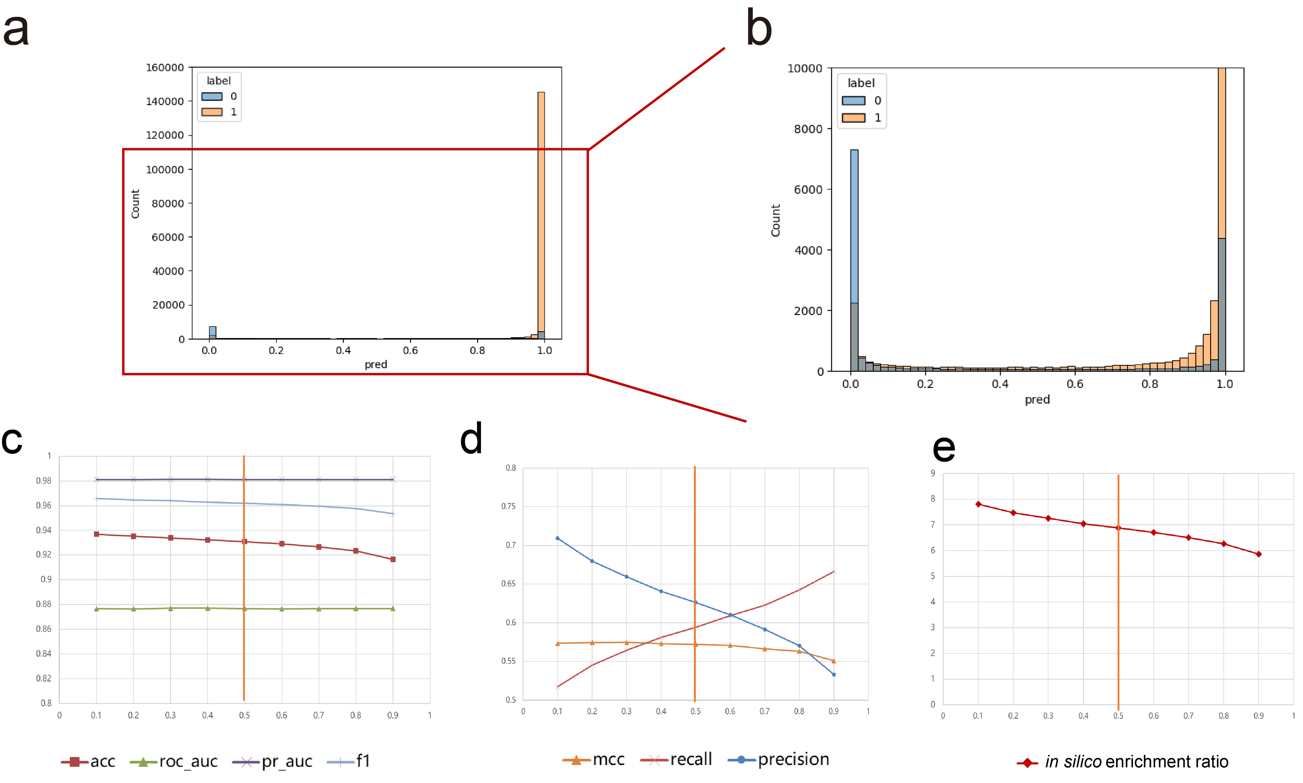
Supplementary Figure 6
(a) Taking human-zymo as an example, the distribution of its predicted value (pred) and the true label (label). The blue bar graph represents the number of samples with the label 0 (zymo), and the orange bar graph represents the number of samples with the label 1 (human). (b) The distribution of the number of samples at different predicted values after zooming in on figure a. (c) Changes in the ACC, ROC-AUC, PR-AUC, and F1 score (f1) of the model at different thresholds. (d) Changes in the MCC, Recall, and Precision of the model at different thresholds. (e) Changes in the in silico enrichment ratio at different thresholds.

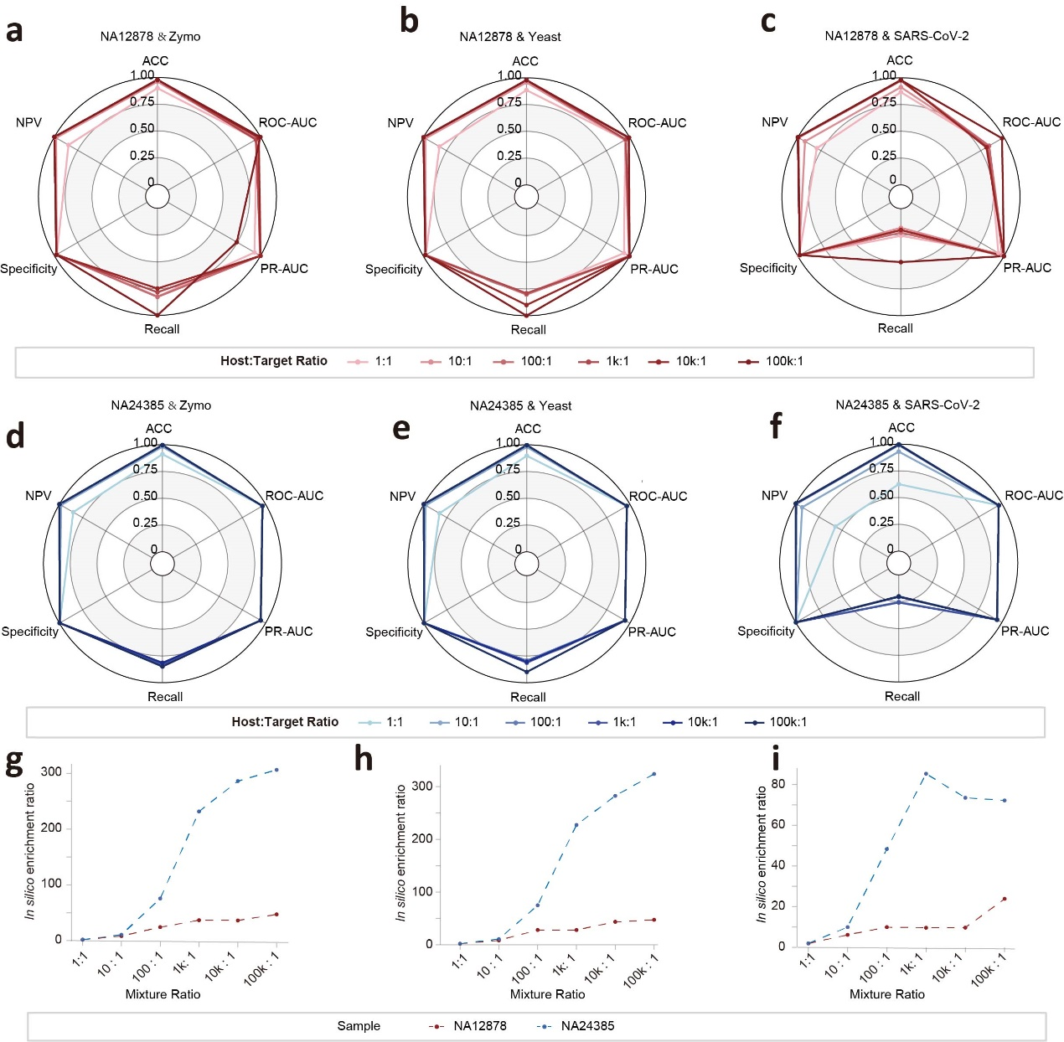
Supplementary Figure 7
(a) Radar chart of performance indicators of the NA12878 sample and Zymo at different mixing ratios. (b) Radar chart of performance indicators of the NA12878 sample and Yeast at different mixing ratios. (c) Radar chart of performance indicators of the NA12878 sample and SARS-CoV-2 at different mixing ratios. (d) Radar chart of performance indicators of the NA24385 sample and Zymo at different mixing ratios. (e) Radar chart of performance indicators of the NA24385 sample and Yeast at different mixing ratios. (f) Radar chart of performance indicators of the NA24385 sample and SARS-CoV-2 at different mixing ratios. (g) Line chart of in silico enrichment ratio of NA12878 and NA24385 with Zymo at different mixing ratios. (h) Line chart of in silico enrichment ratio of NA12878 and NA24385 with Yeast at different mixing ratios. (i) Line graph of in silico enrichment ratio of NA12878 and NA24385 with SARS-CoV-2 at different mixing ratios.

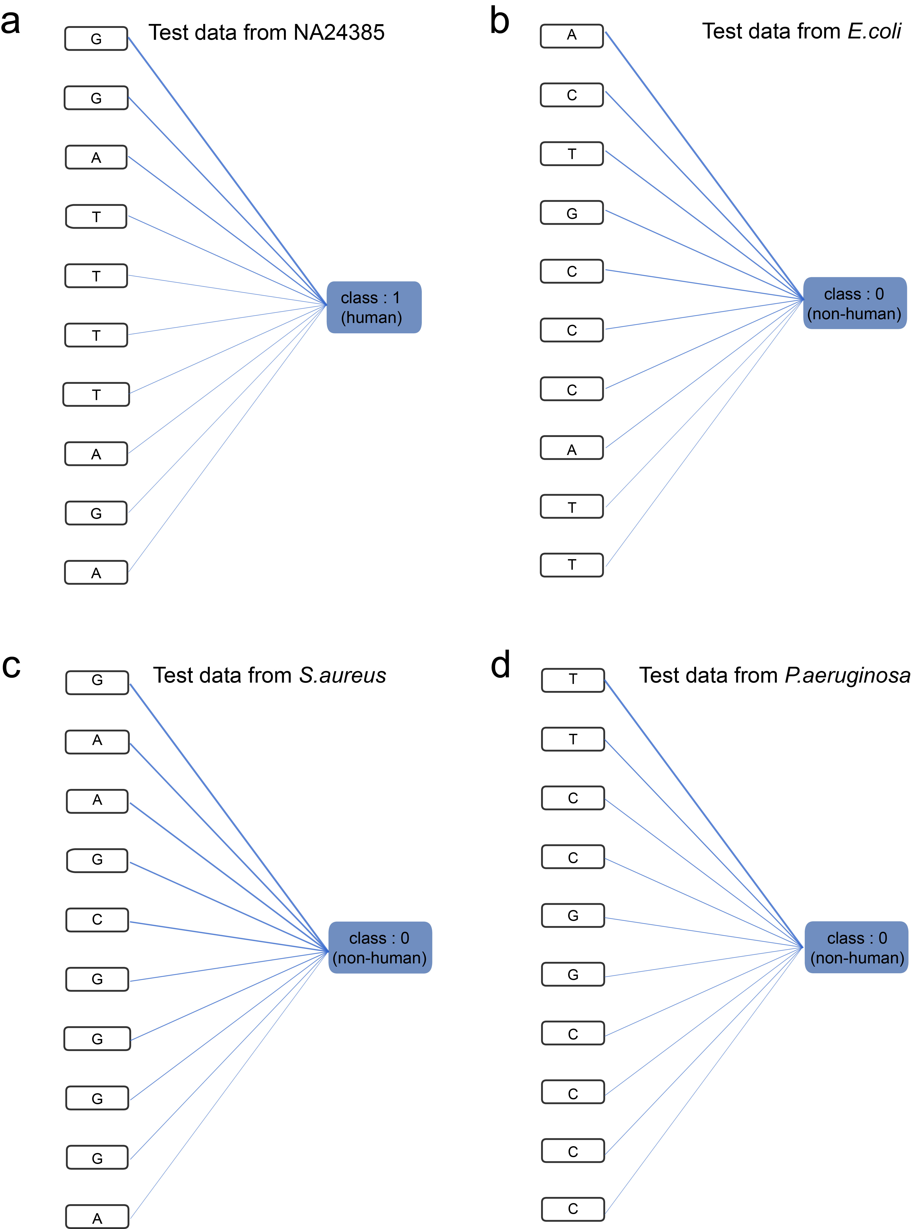
Supplementary Figure 8
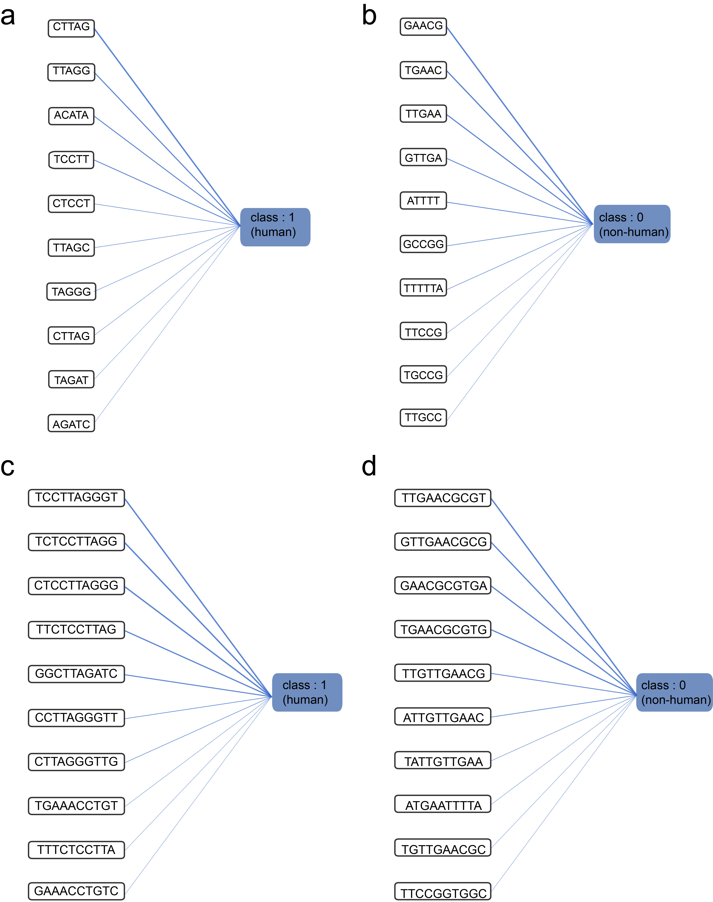
Supplementary Figure 9

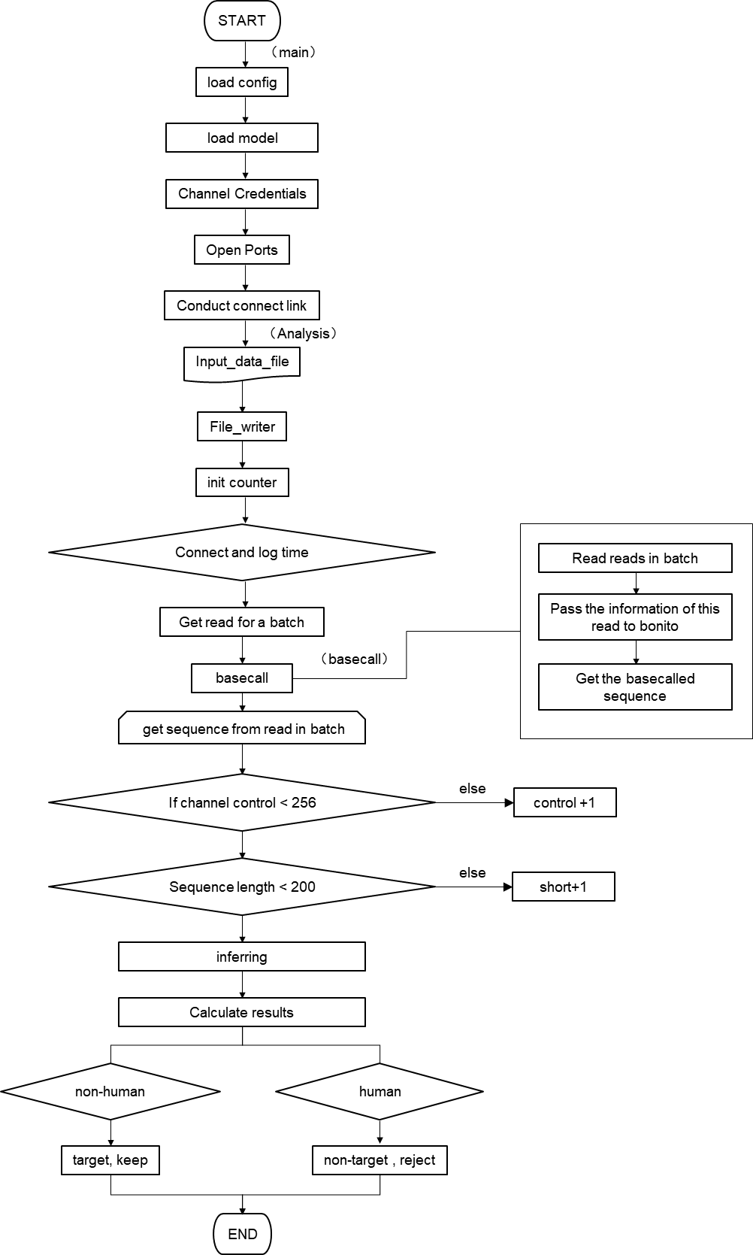
Supplementary Figure 10. the pipeline in Read Until API block.
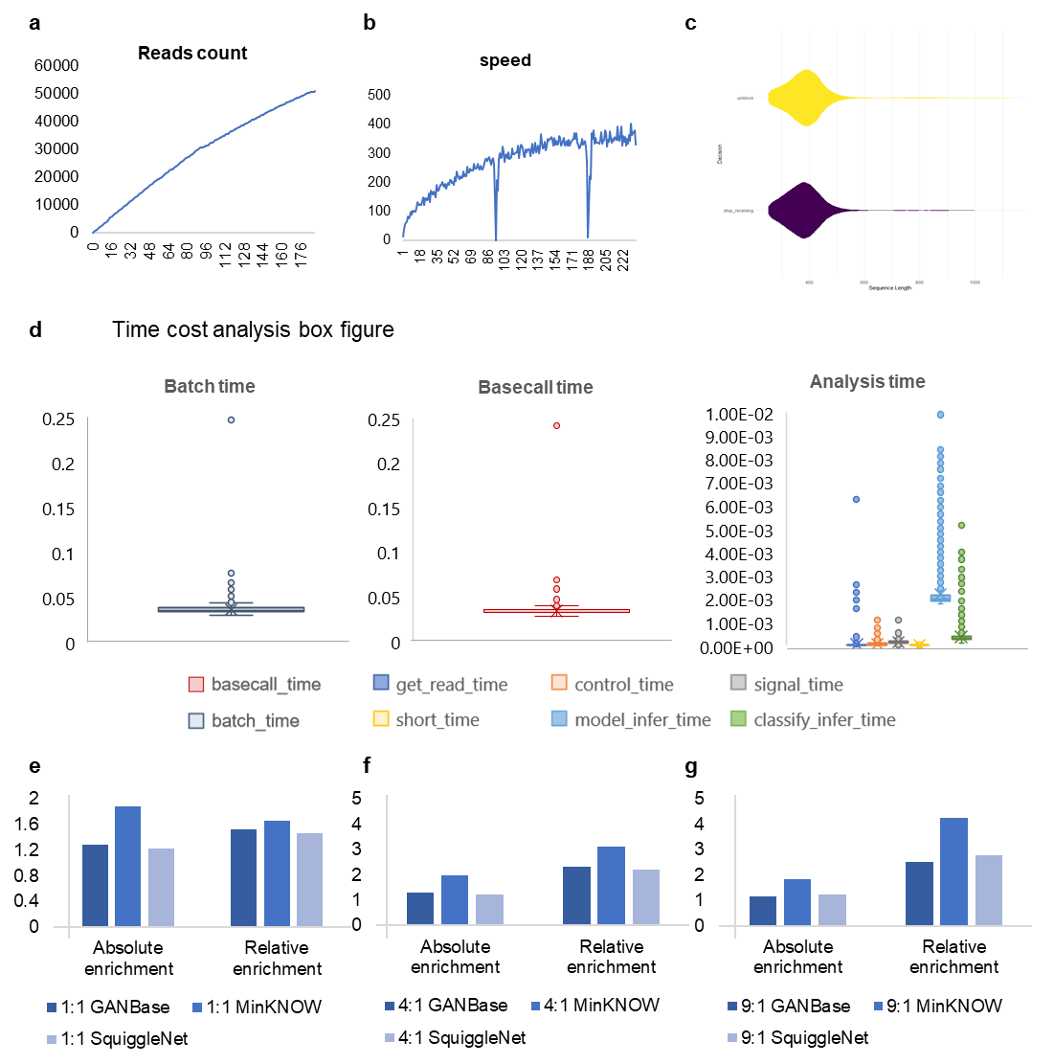
Supplementary Figure 11. R9 Wet lab analysis. (a) Sequencing reads over time; (b) Estimated base pairs over time; (c) Active fragment quality over time;(d) Sequencing reads distribution under different experimental conditions; (e) Data reduction by channel status.

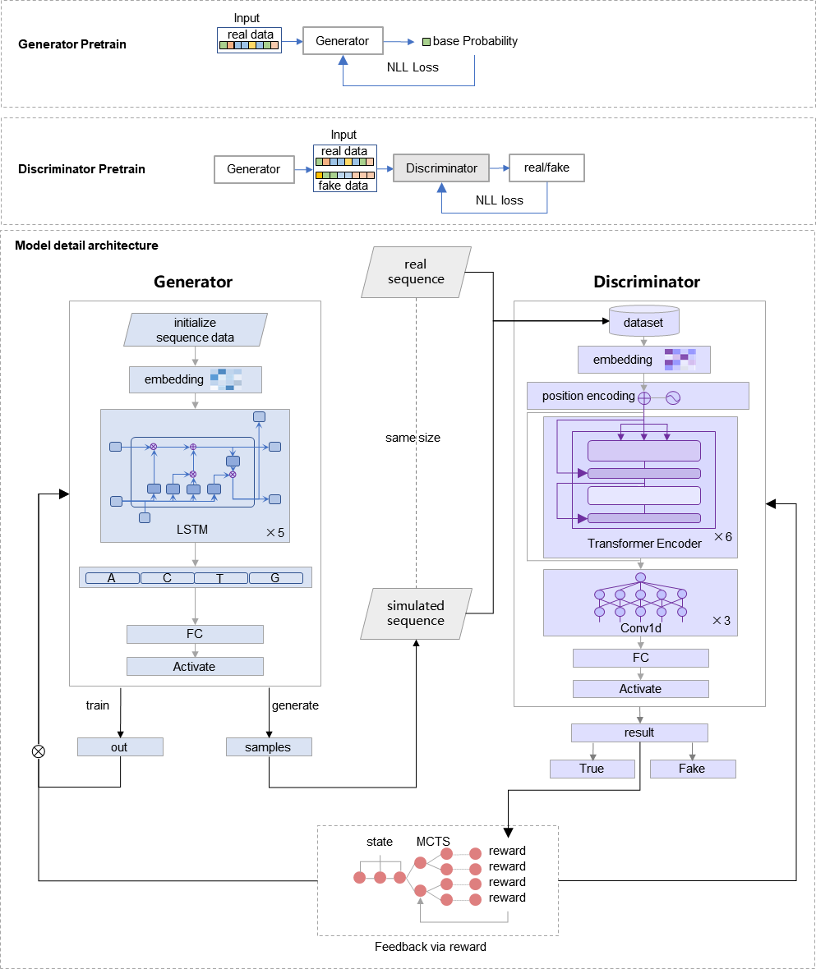
Supplementary Figure 12. Model pretraining process and model detail architecture.

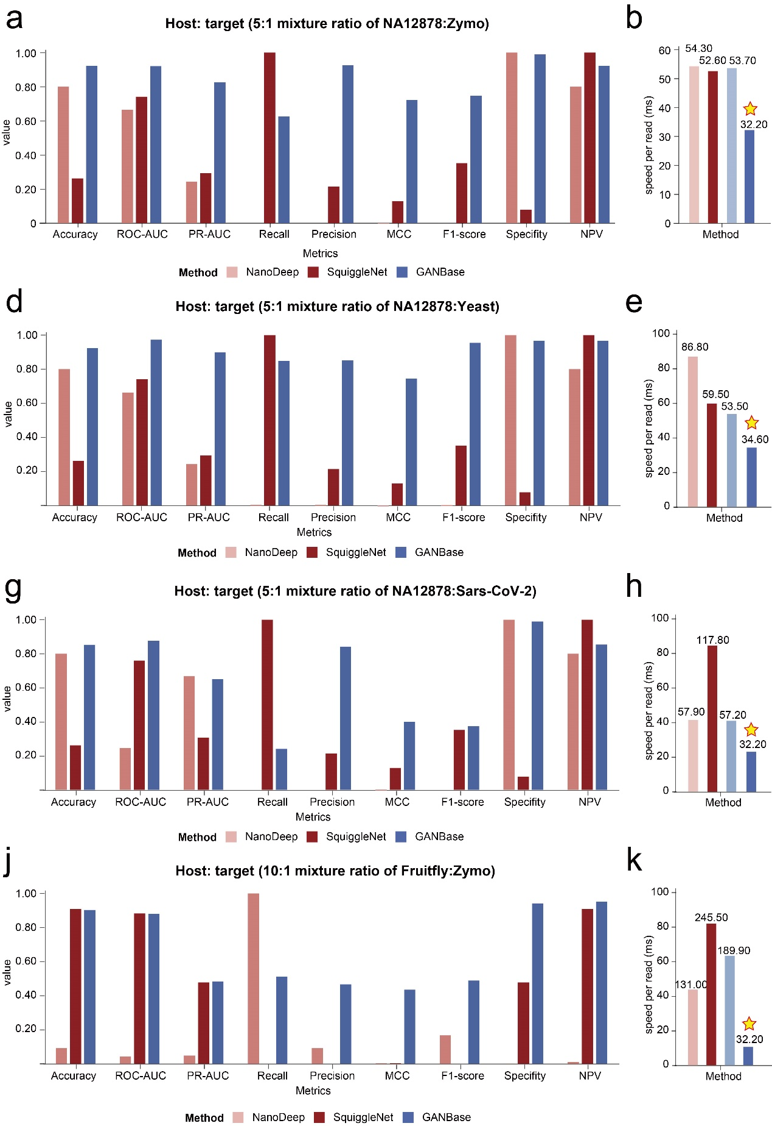
Supplementary Figure 13. Classification results when other methods use the initial weights before retention

Supplementary Tables

Supplementary Table 1: Classification results with supervised different discriminators
network structure | encoder layer | Embedding  dim | head number | hidden dim | channel | kernel | stride | padding | ACC | ROC AUC | PR AUC
CNN | -- | 4 | -- | -- | [(4,16), (16,32), (32,64)] | 3,3,3 | 1,1,1 | 1,1,1 | 0.5963 | 0.6349 | 0.6047
LSTM | -- | 4 | -- | 32 | -- | -- | -- | -- | 0.7128 | 0.7798 | 0.7371
Transformer + Fully Connect | 12 | 4 | 2 | 4 | -- | -- | -- | -- | 0.831 | 0.8871 | 0.9073
Transformer + Fully Connect | 6 | 4 | 2 | 4 | -- | -- | -- | -- | 0.8305 | 0.8869 | 0.9082
Transformer + Fully Connect | 18 | 4 | 2 | 4 | -- | -- | -- | -- | 0.8263 | 0.8738 | 0.9012
Transformer + CNN + Fully Connect | 1 | 4 | 2 | 4 | [(4,16), (16,32), (32,64)] | 3,3,3 | 1,1,1 | 1,1,1 | 0.869 | 0.9176 | 0.9403
Transformer + CNN + Fully Connect | 1 | 4 | 2 | 64 | [(64,128), (128,256), (256,256)] | 3,3,3 | 1,1,1 | 1,1,1 | 0.8822 | 0.9306 | 0.9485
Transformer + CNN + Fully Connect | 1 | 2 | 1 | 64 | [(64,128), (128,256), (256,256)] | 3,3,3 | 1,1,1 | 1,1,1 | 0.875 | 0.9262 | 0.9453
Transformer + CNN + Fully Connect | 1 | 2 | 1 | 4 | [(4,16), (16,32), (32,64)] | 5,3,3 | 1,1,1 | 2,1,1 | 0.8708 | 0.9253 | 0.9448
Transformer+CNN+Layer Norm+ Fully Connect | 1 | 4 | 2 | 4 | [(4,16), (16,32), (32,64)] | 3,3,3 | 1,1,1 | 1,1,1 | 0.874 | 0.9269 | 0.9466
Transformer+CNN+Layer Norm+ Fully Connect | 1 | 2 | 1 | 4 | [(16,16), (16,32), (32,64)] | 5,5,5 | 1,1,1 | 2,2,2 | 0.8748 | 0.9312 | 0.9479
Transformer+CNN+Layer Norm+ Fully Connect | 12 | 4 | 2 | 4 | [(4,16), (16,32), (32,64)] | 3,3,3 | 1,1,1 | 1,1,1 | 0.8738 | 0.9297 | 0.948
Transformer+CNN+Layer Norm+ Fully Connect | 12 | 4 | 2 | 4 | [(4,16), (16,32), (32,1)] | 3,3,3 | 1,1,1 | 1,1,1 | 0.855 | 0.9239 | 0.9402
Transformer+CNN+Layer Norm+ Fully Connect | 12 | 2 | 1 | 64 | [(64,128), (128,256), (256,256)] | 5,5,5 | 1,1,1 | 2,2,2 | 0.888 | 0.9482 | 0.9593
Transformer+CNN+Layer Norm+ Fully Connect | 8 | 4 | 2 | 32 | [(32,64), (64,128), (128,128)] | 5,3,3 | 1,1,1 | 2,1,1 | 0.8802 | 0.9417 | 0.956

Supplementary Table 2: classification results with different generators
Generator model: | TP | TN | FP | FN | ACC | ROC AUC | PR AUC | F1 | MCC | Recall | Precision | Enrichment Ratio
LSTM(3layer) | 142619 | 5187 | 1945 | 23567 | 0.8528 | 0.8740 | 0.9931 | 0.9179 | 0.31263 | 0.8582 | 0.9866 | 4.38
Transformer | 153313 | 4007 | 3125 | 12873 | 0.9076 | 0.8224 | 0.9885 | 0.9504 | 0.3245 | 0.9225 | 0.9800 | 5.76
Supplementary Table 3: Classification results with different discriminators
target species | discriminator | generator | ACC | ROC-AUC | PR-AUC | F1-score | MCC | Recall | Precision
S. aureus | Transformer Encoder | LSTM | 80.09% | 87.02% | 83.59% | 81.88% | 61.39% | 90.01% | 75.10%
S. aureus | LSTM | LSTM | 71.29% | 77.98% | 73.71% | 73.84% | 43.40% | 81.04% | 67.81%
S. aureus | CNN | LSTM | 59.64% | 63.50% | 60.47% | 60.01% | 19.27% | 60.58% | 59.46%
P.aeruginosa | Transformer Encoder | LSTM | 91.68% | 97.10% | 97.13% | 91.50% | 83.44% | 89.51% | 93.57%
P.aeruginosa | LSTM | LSTM | 90.72% | 96.74% | 96.76% | 90.05% | 82.16% | 84.06% | 96.97%
P.aeruginosa | CNN | LSTM | 67.66% | 86.35% | 85.96% | 54.41% | 43.40% | 38.59% | 92.17%

Supplementary Table 4: The number of sequences that were aligned after the pre-training of different generators was compared with the nt library by Blast
model | layer | embedding  dim | hidden dim | The number of sequences aligned to the real sequence
LSTM | 1 | 32 | 32 | 3
LSTM | 3 | 32 | 32 | 10
LSTM | 4 | 32 | 32 | 13
LSTM | 4 | 32 | 64 | 14
LSTM | 5 | 2 | 32 | 8
LSTM | 5 | 2 | 4 | 4
LSTM | 5 | 4 | 64 | 13
LSTM | 5 | 32 | 32 | 18
LSTM | 5 | 32 | 64 | 21
LSTM | 5 | 32 | 128 | 20
LSTM | 5 | 32 | 256 | 20
LSTM | 5 | 64 | 64 | 14
LSTM | 6 | 32 | 32 | 15
LSTM | 7 | 32 | 32 | 15
LSTM | 7 | 32 | 256 | 4
LSTM | 9 | 32 | 32 | 7
BiLSTM | 5 | 32 | 32 | 4
BiLSTM | 5 | 4 | 4 | 2
BiLSTM | 5 | 4 | 4 | 2
Transformer | 1 | 4 | -- | 0
Transformer | 2 | 4 | -- | 0

Supplementary Table 5: Training data volume of Zymo sequences at different sequence lengths and coverages (with number of sequences, total number of bases)
 | Sequence length(bp) | Sequence coverage | slide window stride (bp) | Sequence counts | Base counts (Mbp)
Staphylococcus aureus | 400 | 1x | 400 | 6823 | 2.729
Staphylococcus aureus | 400 | 2x | 200 | 13645 | 5.458
Staphylococcus aureus | 400 | 4x | 100 | 27289 | 10.916
Staphylococcus aureus | 400 | 8x | 50 | 54576 | 21.830
Staphylococcus aureus | 200 | 1x | 200 | 13649 | 2.730
Staphylococcus aureus | 200 | 2x | 100 | 27297 | 5.459
Staphylococcus aureus | 200 | 4x | 50 | 54579 | 10.916
Staphylococcus aureus | 200 | 8x | 25 | 109183 | 21.837
Staphylococcus aureus | 100 | 1x | 100 | 27301 | 2.730
Staphylococcus aureus | 100 | 2x | 50 | 54600 | 5.460
Staphylococcus aureus | 100 | 4x | 25 | 109199 | 10.920
Staphylococcus aureus | 100 | 8x | 12 | 227496 | 22.750
Staphylococcus aureus | 50 | 1x | 50 | 54604 | 2.730
Staphylococcus aureus | 50 | 2x | 25 | 109207 | 5.460
Staphylococcus aureus | 50 | 4x | 12 | 227512 | 11.376
Staphylococcus aureus | 50 | 8x | 6 | 455023 | 22.751
Saccharomyces cerevisiae | 200 | 0.5x | 400 | 32108 | 6.4216
Saccharomyces cerevisiae | 200 | 1x | 200 | 64190 | 12.838
Saccharomyces cerevisiae | 200 | 2x | 100 | 128357 | 25.671
Saccharomyces cerevisiae | 200 | 4x | 50 | 256690 | 51.338
Saccharomyces cerevisiae | 200 | 8x | 25 | 513356 | 102.671
Bacillus subtilis | 200 | 2x | 100 | 40455 | 8.091
Escherichia coli | 200 | 2x | 100 | 48752 | 9.750
Listeria monocytogenes | 200 | 2x | 100 | 29922 | 5.984
Pseudomonas aeruginosa | 200 | 2x | 100 | 67922 | 13.584
Salmonella enterica | 200 | 2x | 100 | 47596 | 9.519
Enterococcus faecalis | 200 | 2x | 100 | 28448 | 5.690

Supplementary Table 6: ANI scores corresponding to 8 species in Zymo
Query Sequence | Reference Sequence | ANI score | Number of Aligned Fragments | Total Number of Fragments | Fragment Alignment Percentage
B.subtilis | B.subtilis | 100 | 1345 | 1348 | 99.78%
B.subtilis | E.faecalis | 84.56 | 11 | 1348 | 0.82%
B.subtilis | L.monocytogenes | 81.55 | 26 | 1348 | 1.93%
B.subtilis | S.aureus | 81.03 | 31 | 1348 | 2.30%
B.subtilis | P.aeruginosa | 78.5 | 9 | 1348 | 0.67%
B.subtilis | E.coli | 77.88 | 11 | 1348 | 0.82%
B.subtilis | S.enterica | 77.3 | 10 | 1348 | 0.74%
B.subtilis | S.cerevisiae | 74.54 | 9 | 1348 | 0.67%
E.faecalis | E.faecalis | 100 | 948 | 948 | 100.00%
E.faecalis | L.monocytogenes | 84.76 | 43 | 948 | 4.54%
E.faecalis | B.subtilis | 83.1 | 19 | 948 | 2.01%
E.faecalis | E.coli | 79.23 | 7 | 948 | 0.74%
E.faecalis | S.aureus | 79.22 | 29 | 948 | 3.06%
E.faecalis | S.enterica | 78.74 | 5 | 948 | 0.53%
E.faecalis | P.aeruginosa | 78.59 | 5 | 948 | 0.53%
E.faecalis | S.cerevisiae | 74.61 | 16 | 948 | 1.69%
E.coli | E.coli | 100 | 1621 | 1624 | 99.82%
E.coli | S.enterica | 82.13 | 918 | 1624 | 56.53%
E.coli | L.monocytogenes | 81.42 | 4 | 1624 | 0.25%
E.coli | S.aureus | 80.07 | 9 | 1624 | 0.55%
E.coli | E.faecalis | 78.9 | 4 | 1624 | 0.25%
E.coli | B.subtilis | 78.54 | 12 | 1624 | 0.74%
E.coli | P.aeruginosa | 76.92 | 50 | 1624 | 3.08%
E.coli | S.cerevisiae | 74.52 | 9 | 1624 | 0.55%
P.aeruginosa | P.aeruginosa | 100 | 2261 | 2264 | 99.87%
P.aeruginosa | L.monocytogenes | 82.53 | 4 | 2264 | 0.18%
P.aeruginosa | S.aureus | 81.48 | 6 | 2264 | 0.26%
P.aeruginosa | E.faecalis | 80.25 | 4 | 2264 | 0.18%
P.aeruginosa | B.subtilis | 80.16 | 9 | 2264 | 0.40%
P.aeruginosa | S.enterica | 77.21 | 57 | 2264 | 2.52%
P.aeruginosa | E.coli | 76.39 | 59 | 2264 | 2.61%
P.aeruginosa | S.cerevisiae | 74.52 | 3 | 2264 | 0.13%
S.enterica | S.enterica | 100 | 1585 | 1586 | 99.94%
S.enterica | E.coli | 82.35 | 887 | 1586 | 55.92%
S.enterica | S.aureus | 80.38 | 7 | 1586 | 0.44%
S.enterica | B.subtilis | 79.59 | 9 | 1586 | 0.57%
S.enterica | L.monocytogenes | 79.58 | 5 | 1586 | 0.32%
S.enterica | E.faecalis | 79.4 | 4 | 1586 | 0.25%
S.enterica | P.aeruginosa | 76.86 | 58 | 1586 | 3.66%
S.enterica | S.cerevisiae | 74.51 | 12 | 1586 | 0.76%
S.aureus | S.aureus | 100 | 907 | 908 | 99.89%
S.aureus | B.subtilis | 81.61 | 21 | 908 | 2.31%
S.aureus | P.aeruginosa | 80.14 | 6 | 908 | 0.66%
S.aureus | L.monocytogenes | 79.26 | 34 | 908 | 3.75%
S.aureus | S.enterica | 79.22 | 7 | 908 | 0.77%
S.aureus | E.faecalis | 78.84 | 30 | 908 | 3.30%
S.aureus | E.coli | 78.55 | 10 | 908 | 1.10%
S.aureus | S.cerevisiae | 74.55 | 9 | 908 | 0.99%
S.cerevisiae | S.cerevisiae | 100 | 4233 | 4256 | 99.46%
S.cerevisiae | E.faecalis | 74.7 | 15 | 4256 | 0.35%
S.cerevisiae | E.coli | 74.54 | 6 | 4256 | 0.14%
S.cerevisiae | S.aureus | 74.52 | 11 | 4256 | 0.26%
S.cerevisiae | L.monocytogenes | 74.52 | 15 | 4256 | 0.35%
S.cerevisiae | S.enterica | 74.5 | 11 | 4256 | 0.26%
S.cerevisiae | B.subtilis | 74.48 | 8 | 4256 | 0.19%
L.monocytogenes | L.monocytogenes | 100 | 996 | 997 | 99.90%
L.monocytogenes | E.faecalis | 83.91 | 50 | 997 | 5.02%
L.monocytogenes | P.aeruginosa | 82.78 | 3 | 997 | 0.30%
L.monocytogenes | B.subtilis | 82.07 | 26 | 997 | 2.61%
L.monocytogenes | S.aureus | 78.66 | 36 | 997 | 3.61%
L.monocytogenes | S.enterica | 78.59 | 5 | 997 | 0.50%
L.monocytogenes | E.coli | 77.55 | 8 | 997 | 0.80%
L.monocytogenes | S.cerevisiae | 74.52 | 10 | 997 | 1.00%

Supplementary Table 7: Training species reference genome RefSeq and volume
Training species | NCBI RefSeq | Reference genome size (Mbp)
Bacillus subtilis | GCF_000009045.1 | 4.046
Escherichia coli | GCF_000005845.2 | 4.845
Listeria monocytogenes | GCF_000196035.1 | 2.992
Pseudomonas aeruginosa | GCF_000006765.1 | 6.792
Saccharomyces cerevisiae | GCF_000146045.2 | 12.843
Salmonella enterica | GCF_000006945.2 | 4.760
Enterococcus faecalis | GCF_000393015.1 | 2.800
Staphylococcus aureus | GCF_000013425.1 | 2.730

Supplementary Table 8: The result of the balanced Zymo dataset
(target: nontarget = 1:1)
species | ACC | AUC | PR-AUC | F1-score | MCC | Recall | Precision | Specificity
Staphylococcus aureus | 77.41% | 85.89% | 82.73% | 80.34% | 57.43% | 92.33% | 71.11% | 62.48%
Bacillus subtilis | 58.74% | 60.13% | 54.47% | 68.34% | 21.97% | 89.06% | 55.44% | 28.41%
Enterococcus faecalis | 70.56% | 75.64% | 69.55% | 74.93% | 43.88% | 87.99% | 65.25% | 53.13%
Escherichia coli | 55.62% | 57.52% | 52.75% | 67.15% | 15.78% | 90.71% | 53.30% | 20.53%
Listeria monocytogenes | 69.10% | 72.13% | 64.48% | 73.44% | 40.42% | 85.46% | 64.39% | 52.73%
Pseudomonas aeruginosa | 75.93% | 92.40% | 94.07% | 79.44% | 55.19% | 93.03% | 69.32% | 58.82%
Saccharomyces cerevisiae | 65.56% | 68.28% | 64.89% | 71.12% | 32.44% | 82.81% | 62.32% | 47.45%
Salmonella enterica | 55.77% | 58.25% | 53.55% | 67.23% | 16.15% | 90.75% | 53.39% | 20.79%

Supplementary Table 9: The result of the imbalanced Zymo dataset
(target: nontarget = 1:7)
species | ACC | AUC | PR-AUC | F1-score | MCC | Recall | Precision | Specificity
Staphylococcus aureus | 64.53% | 86.77% | 40.60% | 40.17% | 36.73% | 95.28% | 25.45% | 60.14%
Bacillus subtilis | 36.54% | 61.17% | 14.99% | 26.14% | 14.03% | 89.81% | 15.29% | 28.93%
Enterococcus faecalis | 57.72% | 76.21% | 24.13% | 34.80% | 28.69% | 90.25% | 21.55% | 53.07%
Escherichia coli | 31.09% | 57.12% | 13.90% | 24.34% | 9.31% | 88.69% | 14.11% | 22.87%
Listeria monocytogenes | 55.94% | 72.41% | 20.22% | 33.65% | 26.91% | 89.40% | 20.73% | 51.15%
Pseudomonas aeruginosa | 63.45% | 90.32% | 75.32% | 38.36% | 33.47% | 90.98% | 24.30% | 59.52%
Saccharomyces cerevisiae | 47.63% | 66.47% | 19.06% | 29.17% | 19.29% | 86.29% | 17.55% | 42.10%
Salmonella enterica | 23.00% | 51.87% | 12.19% | 22.98% | 5.06% | 91.91% | 13.13% | 13.16%
Supplementary Table 10: The comparison Recall result of the Zymo dataset
species | Alignment | GANBase(balance) | GANBase (imbalance)
Staphylococcus aureus | 96.97% | 92.33% | 95.28%
Bacillus subtilis | 95.68% | 89.06% | 89.81%
Enterococcus faecalis | 96.67% | 87.99% | 90.25%
Escherichia coli | 98.61% | 90.71% | 88.69%
Listeria monocytogenes | 94.29% | 85.46% | 89.40%
Pseudomonas aeruginosa | 98.82% | 93.03% | 90.98%
Saccharomyces cerevisiae | 82.67% | 82.81% | 86.29%
Salmonella enterica | 89.55% | 90.75% | 91.91%
Supplementary Table 11: The comparison Precision result of the Zymo dataset
species | Alignment | GANBase(balance)
Staphylococcus aureus | 97.76% | 71.11%
Bacillus subtilis | 97.80% | 55.44%
Enterococcus faecalis | 95.46% | 65.25%
Escherichia coli | 90.58% | 53.30%
Listeria monocytogenes | 96.65% | 64.39%
Pseudomonas aeruginosa | 98.74% | 69.32%
Saccharomyces cerevisiae | 99.99% | 62.32%
Salmonella enterica | 91.16% | 53.39%

Supplementary Table 12: GANBase and Minimap2 infer time( calculate per single read)
method | Batch size | Avg min infer time (ms) | Avg max infer time (ms) | Avg mean infer time (ms) | Avg time per single seq (ms)
GANBase | 1 | 6.7 | 12.1 | 7.2 | 7.2
GANBase | 10 | 7.2 | 12.4 | 7.3 | 0.73
GANBase | 20 | 7.3 | 18.1 | 7.7 | 0.39
GANBase | 50 | 7.9 | 12.3 | 10 | 0.2
GANBase | 100 | 9.5 | 22 | 18.4 | 0.18
GANBase | 200 | 8.2 | 36.1 | 32.3 | 0.16
GANBase | 300 | 8.2 | 62.2 | 47.8 | 0.16
GANBase | 400 | 8.3 | 71.3 | 56.2 | 0.14
GANBase | 500 | 8.1 | 117.8 | 72.5 | 0.15
Minimap2  (t=3) | 1 | 276.11 | 311.32 | 295.09 | 295.09
Minimap2  (t=3) | 10 | 278.68 | 334.04 | 291.14 | 29.11
Minimap2  (t=3) | 20 | 283.93 | 347.46 | 297.04 | 14.85
Minimap2  (t=3) | 50 | 305.19 | 646.79 | 411.57 | 8.23
Minimap2  (t=3) | 100 | 311.68 | 1477.79 | 637.22 | 6.37
Minimap2  (t=3) | 200 | 308.89 | 3452.26 | 854.79 | 4.27
Minimap2  (t=3) | 300 | 309.86 | 6607.28 | 1355.71 | 4.52
Minimap2  (t=3) | 400 | 308.06 | 7802.68 | 1520.81 | 3.8
Minimap2  (t=3) | 500 | 307.4 | 13234.36 | 2461.34 | 4.92
Minimap2  (t=32) | 1 | 255.45 | 1377.15 | 275.09 | 275.09
Minimap2  (t=32) | 10 | 264.21 | 515.17 | 291.2 | 29.12
Minimap2  (t=32) | 20 | 280.99 | 542.48 | 323.11 | 16.16
Minimap2  (t=32) | 50 | 286.99 | 795.32 | 433.64 | 8.67
Minimap2  (t=32) | 100 | 297.83 | 1415.33 | 570.68 | 5.71
Minimap2  (t=32) | 200 | 295.62 | 3163.62 | 745.08 | 3.73
Minimap2  (t=32) | 300 | 296.08 | 5372.55 | 1107.39 | 3.69
Minimap2  (t=32) | 400 | 295.78 | 9195.43 | 1575.59 | 3.94
Minimap2  (t=32) | 500 | 286.01 | 10663.81 | 1607.3 | 3.21

Supplementary Table 13: The metrics results of the methods comparison
Dataset | model | Accuracy | ROC-AUC | PR-AUC | Recall | Precision | MCC | F1-score | Specificity | NPV
NA12878&Zymo | SquiggleNet | 82.80% | 91.96% | 66.19% | 92.38% | 54.09% | 61.39% | 68.23% | 80.40% | 97.68%
NA12878&Zymo | NanoDeep | 81.78% | 98.16% | 93.50% | 99.17% | 52.35% | 63.17% | 68.53% | 77.44% | 99.73%
NA12878&Zymo | DeepSelectNet | 82.88% | 95.33% | 81.56% | 97.44% | 53.99% | 63.86% | 69.48% | 79.24% | 99.20%
NA12878&Zymo | GANBase | 92.24% | 92.04% | 82.68% | 62.55% | 92.58% | 72.16% | 74.66% | 98.88% | 92.19%
NA12878&Yeast | SquiggleNet | 78.66% | 84.55% | 44.11% | 71.71% | 47.77% | 45.47% | 57.34% | 80.40% | 91.91%
NA12878&Yeast | NanoDeep | 80.89% | 93.55% | 76.02% | 94.62% | 51.20% | 59.72% | 66.44% | 77.45% | 98.29%
NA12878&Yeast | DeepSelectNet | 79.73% | 87.25% | 52.11% | 81.71% | 49.60% | 51.87% | 61.73% | 79.24% | 94.54%
NA12878&Yeast | GANBase | 92.40% | 97.29% | 89.87% | 84.80% | 85.15% | 74.43% | 95.36% | 96.69% | 96.60%
NA12878&SARS-CoV-2 | SquiggleNet | 78.43% | 84.52% | 43.87% | 70.54% | 47.36% | 44.56% | 56.67% | 80.40% | 91.61%
NA12878&SARS-CoV-2 | NanoDeep | 81.15% | 93.80% | 75.10% | 96.03% | 51.55% | 60.78% | 67.08% | 77.43% | 98.73%
NA12878&SARS-CoV-2 | DeepSelectNet | 80.21% | 87.71% | 52.38% | 84.06% | 50.31% | 53.68% | 62.94% | 79.24% | 95.21%
NA12878&SARS-CoV-2 | GANBase | 85.28% | 87.60% | 65.04% | 23.98% | 84.20% | 39.96% | 37.32% | 98.99% | 85.34%
Fruitfly&Zymo | SquiggleNet | 33.21% | 71.60% | 47.95% | 92.38% | 22.06% | 11.70% | 35.62% | 18.42% | 90.62%
Fruitfly&Zymo | NanoDeep | 27.52% | 88.40% | 77.93% | 99.18% | 21.53% | 13.07% | 35.37% | 9.61% | 97.91%
Fruitfly&Zymo | DeepSelectNet | 31.85% | 62.87% | 81.03% | 97.44% | 22.37% | 15.39% | 36.38% | 15.45% | 96.02%
Fruitfly&Zymo | GANBase | 87.59% | 90.63% | 74.37% | 50.74% | 79.87% | 57.10% | 62.06% | 96.80% | 88.71%

Supplementary Table 14: In silico enrichment comparasion
 | NanoDeep | SquiggleNet | DeepSelectNet | GANBase
NA12878&Zymo | 2.62 | 2.7 | 2.7 | 4.33
NA12878&Yeast | 2.56 | 2.39 | 2.48 | 4.52
NA12878&SARS-CoV-2 | 2.58 | 2.37 | 2.52 | 4.61
Fruitfly&Zymo | 1.00 | 1.10 | 1.08 | 3.99

Supplementary Table 15: Result of human & SARS-CoV-1 host-depletion
Metrics | NA12878 | NA24385 | Mean ± SD | CV | range
ACC | 57.45% | 58.00% | 57.73%±0.27% | 0.48% | 0.55%
ROC AUC | 89.62% | 92.80% | 91.21%±1.59% | 1.74% | 3.18%
PR AUC | 87.04% | 92.23% | 89.64%±2.60% | 2.90% | 5.19%
F1-score | 27.70% | 27.96% | 27.83%±0.13% | 0.47% | 0.26%
MCC | 26.23% | 29.00% | 27.62%±1.39% | 5.03% | 2.77%
Recall | 16.30% | 16.30% | 16.30%±0.00% | 0.00% | 0.00%
Precision | 92.09% | 98.19% | 95.14%±3.05% | 3.21% | 6.10%
Specificity | 98.60% | 99.70% | 99.15%±0.55% | 0.55% | 1.10%
NPV | 54.09% | 54.36% | 54.23%±0.14% | 0.25% | 0.27%
In silico  enrichment ratio | 1.84 | 1.96 | - | - | -

Supplementary Table 16: Result of human & Ebola host-depletion
Metrics | NA12878 | NA24385 | Mean ± SD | CV | range
ACC | 64.25% | 64.75% | 64.50%±0.25% | 0.39% | 0.50%
ROC AUC | 88.99% | 91.59% | 90.29%±1.30% | 1.44% | 2.60%
PR AUC | 87.94% | 92.46% | 90.20%±2.26% | 2.51% | 4.52%
F1-score | 45.63% | 45.98% | 45.81%±0.18% | 0.39% | 0.35%
MCC | 39.12% | 41.03% | 40.08%±0.96% | 2.39% | 1.91%
Recall | 30.00% | 30.00% | 30.00%±0.00% | 0.00% | 0.00%
Precision | 95.24% | 98.36% | 96.80%±1.56% | 1.61% | 3.12%
Specificity | 98.50% | 99.50% | 99.00%±0.50% | 0.51% | 1.00%
NPV | 58.46% | 58.70% | 58.58%±0.12% | 0.21% | 0.24%
In silico  enrichment ratio | 1.90 | 1.97 | - | - | -

Supplementary Table 17: Result of human & Phage host-depletion
Metrics | NA12878 | NA24385 | Mean ± SD | CV | range
ACC | 88.85% | 89.58% | 89.22%±0.37% | 0.41% | 0.73%
ROC AUC | 98.03% | 99.01% | 98.52%±0.49% | 0.50% | 0.98%
PR AUC | 98.10% | 99.20% | 98.65%±0.55% | 0.56% | 1.10%
F1-score | 87.68% | 88.39% | 88.04%±0.36% | 0.41% | 0.71%
MCC | 79.14% | 80.86% | 80.00%±0.86% | 1.08% | 1.72%
Recall | 79.35% | 79.35% | 79.35%±0.00% | 0.00% | 0.00%
Precision | 97.96% | 99.75% | 98.86%±0.90% | 0.91% | 1.79%
Specificity | 98.35% | 99.80% | 99.08%±0.73% | 0.73% | 1.45%
NPV | 82.65% | 82.86% | 82.76%±0.11% | 0.13% | 0.21%
In silico  enrichment ratio | 1.95 | 1.99 | - | - | -

Supplementary Table 18: human host & target result with threshold=0.9

Host & Target Dataset | Accuracy | ROC-AUC | PR-AUC | Recall | Precision | MCC | F1-score | Specificity | NPV | In silico enrichment ratio
NA12878&  SARS-CoV-1 | 74.95% | 89.69% | 87.09% | 70.13% | 52.73% | 58.80% | 86.85% | 91.10% | 68.86% | 1.74
NA24385&  SARS-CoV-1 | 77.20% | 92.86% | 92.18% | 72.06% | 58.51% | 58.80% | 93.04% | 95.60% | 69.88% | 1.86
NA12878&Phage | 94.00% | 98.03% | 98.10% | 93.92% | 88.03% | 92.65% | 95.22% | 95.35% | 92.84% | 1.90
NA24385&Phage | 95.65% | 99.01% | 99.20% | 95.52% | 91.46% | 92.65% | 98.56% | 98.65% | 93.07% | 1.97
NA12878&Ebola | 77.50% | 88.67% | 87.09% | 74.72% | 56.38% | 66.50% | 85.26% | 88.50% | 72.54% | 1.71
NA24385&Ebola | 80.75% | 91.74% | 92.62% | 77.55% | 64.16% | 66.50% | 93.01% | 95.00% | 73.93% | 1.86
Supplementary Table 19: Result of other host & target with threshold=0.1
Host & Target Dataset | Accuracy | ROC-AUC | PR-AUC | Recall | Precision | MCC | F1-score | Specificity | NPV | In silico enrichment ratio
Mosquito&Zika | 67.49% | 92.71% | 92.26% | 52.64% | 44.89% | 36.14% | 96.86% | 98.83% | 60.75% | 1.94
Mosquito&WNV | 85.88% | 94.91% | 96.07% | 83.78% | 74.31% | 72.92% | 98.45% | 98.85% | 78.49% | 1.01
Mouse&Zymo | 65.97% | 73.20% | 79.23% | 49.59% | 42.03% | 33.47% | 95.63% | 98.47% | 59.68% | 1.97
Mouse&Pluage | 92.54% | 98.38% | 98.50% | 92.04% | 85.76% | 86.26% | 98.65% | 98.82% | 87.79% | 1.97
Tick&Zymo | 58.04% | 69.49% | 65.24% | 40.31% | 19.99% | 28.34% | 69.80% | 87.74% | 55.04% | 1.56
Tick&CCHFV | 77.77% | 87.57% | 90.55% | 71.91% | 61.12% | 56.90% | 97.67% | 98.64% | 69.59% | 1.96

Supplementary Table 20: Discriminator neural network and dimension
network layer | Input dim | Output dim
Embedding | (batch size, seqlen=200) | (batch size, seqlen=200, vocab_size=4)
PositionalEncoding | (batch size, seqlen=200,  vocab size=4) | (batch size, seqlen=200, embedding dim=4)
Linear | (batch size, seqlen=200, embedding dim=4) | (batch size, seqlen=200, hidden dim=64)
Transformer encoder | (batch size, seqlen=200, hidden dim=64) | (batch size, seqlen=200, hidden dim=64)
Conv1d | (batch size, seqlen=200, hidden dim=64) | (batch size, seqlen=200, 128)
Relu | (batch size, seqlen=200,128) | (batch size, seqlen=200, 128)
Conv1d | (batch size, seqlen=200,128) | (batch size, seqlen=200, 256)
Relu | (batch size, seqlen=200, 256) | (batch size, seqlen=200, 256)
Conv1d | (batch size, seqlen=200, 256) | (batch size, seqlen=200, 256)
Relu | (batch size, seqlen=200, 256) | (batch size, seqlen=200, 256)
Layernorm | (batch size, seqlen=200, 256) | (batch size, seqlen=200, 256)
Linear | (batch size, seqlen=200, 256) | (batch size, seqlen=200, class num=2)

Supplementary Table 21: Generator neural network and dimension
network layer | Input dim | Output dim
Embedding | (batch size, seqlen=200) | (batch size, seqlen=200,embedding_dim=4)
LSTM | (batch size, seqlen=200,embedding_dim=4) | (batch size, seqlen=200,hidden_dim=32)
Linear | (batch size, seqlen=200,hidden_dim=32) | (batch size, seqlen=200,vocab_size=4)

Supplementary Table 22: Parameters and hyperparameter of Neural Networks
parameters
Vocabulary size | 4
Generator pretrain step | 15
Linear | 1
Generator Hyperparameters
Hidden dimension |  | 5
Discriminator Hyperparameters
Embedding dimension |  | 4
Hidden dimension |  | 64
Transformer Encoder nhead |  | 2
Transformer Encoder layer |  | 6
Dropout |  | 0.2
Class number |  | 2
CNN Layer |  | 3
CNN Kernels_size |  | 5
CNN Stride |  | 1
CNN padding |  | 2

Supplementary Table 23: sequence counts and base counts of test data
species | Sequence counts | Base counts(Mbp)
Bacillus subtilis | 1952897 | 390.579
Escherichia coli | 5263392 | 1052.678
Listeria monocytogenes | 2429777 | 485.955
Pseudomonas aeruginosa | 2076272 | 415.254
Saccharomyces cerevisiae | 1475110 | 295.022
Salmonella enterica | 6823682 | 1364.736
Enterococcus faecalis | 3172156 | 634.431
Staphylococcus aureus | 2824635 | 564.927

Supplementary Table 24: mixing ratio and volume of human depletion test data
Mixing ratio (host: target) | Host sequence counts | Target sequence counts
1: 1 | 2000000 | 2000000
10:1 | 2000000 | 200000
100:1 | 2000000 | 20000
1000:1 | 2000000 | 2000
10000:1 | 2000000 | 200
100000:1 | 2000000 | 20

Supplementary Table 25: In the method comparison section, the number of each of the eight species included in Zymo(20000 reads)
species | count
Enterococcus faecalis | 2431
Pseudomonas aeruginosa | 2491
Saccharomyces cerevisiae | 2534
Salmonella enterica | 2496
Staphylococcus aureus | 2468
Listeria monocytogenes | 2495
Bacillus subtilis | 2548
Escherichia coli | 2537

Supplementary Table26: GANBase training time
Species and training,with epoch | refseq size (Mbp) | Generator pre-train (s) | Discriminator pre-train (s) | Adversarial train (s) | Adversarial train (h)
S. aureus, 100 epochs | 2.73 | 21.04 | 26.47 | 60739.21 | 16.87
E. faecalis, 100 epochs | 2.80 | 24.86 | 53.60 | 63060.75 | 17.52
L. monocytogenes, 100 epochs | 2.99 | 26.63 | 47.01 | 56895.17 | 15.80
B. subtilis, 100 epochs | 4.05 | 21.06 | 61.86 | 59034.50 | 16.40
S. enterica, 100 epochs | 4.76 | 31.55 | 73.34 | 58296.63 | 16.19
E. coli, 100 epochs | 4.85 | 32.24 | 76.51 | 58716.47 | 16.31
P. aeruginosa, 100 epochs | 6.79 | 37.81 | 104.84 | 61635.04 | 17.12
S. cerevisiae, 100 epochs | 12.84 | 55.03 | 241.99 | 140317.63 | 38.98
fruit fly, 15 epochs (early stop) | 142.18 | 302.85 | 2312.16 | 27530.09 | 7.65
Human(HG38), 15 epochs(early stop) | 3200.00 | 202.28 | 23011.45 | 234109.27 | 65.03
Human(HG38), 20epochs | 3200.00 | 358.69 | 20904.13 | 467067.05 | 129.74

Supplementary Table 27 the wet-lab result detail value
 | method | Mean | Median | Population std | sample std | t-statistic | p-value
absolute enrichment | GANBase | 1.257 | 1.29 | 0.062 | 0.076 | 0.832 | 0.491
absolute enrichment | Squigglenet | 1.22 | 1.22 | 0.008 | 0.01 | 0.832 | 0.491
relative enrichment | GANBase | 2.123 | 2.31 | 0.429 | 0.525 | -0.048 | 0.964
relative enrichment | Squigglenet | 2.147 | 2.22 | 0.533 | 0.653 | -0.048 | 0.964

Supplementary Table 28 the R10 version wet-lab result detail value
barcode | method | total reads | zymo reads | zymo reads ratio | all total | all zymo | baseratio | ratio
barcode01 | GANBase | 23421 | 11341 | 48.42% | 65173292 | 62629682 | 96.10% | 1.98
barcode01 | SquiggleNet | 28960 | 13767 | 47.54% | 88168444 | 31580227 | 35.82% | 0.75
barcode02 | GANBase | 21855 | 4280 | 19.58% | 28008646 | 23969776 | 85.58% | 4.37
barcode02 | SquiggleNet | 26518 | 5039 | 19.00% | 88944528 | 11317411 | 12.72% | 0.67
barcode03 | GANBase | 13525 | 1504 | 11.12% | 10675665 | 8279016 | 77.55% | 6.97
barcode03 | SquiggleNet | 17845 | 1948 | 10.92% | 62115347 | 4390233 | 7.07% | 0.65
Supplementary Table 29 the wet-lab result detail value
barcode | method | TP | FN | TN | FP | zymo accuracy | non-zymo accuracy
barcode01 | GANBase | 7302 | 4039 | 11757 | 323 | 64.39% | 97.33%
barcode01 | SquiggleNet | 3676 | 10091 | 7738 | 7455 | 26.70% | 50.93%
barcode02 | GANBase | 2802 | 1478 | 17044 | 531 | 65.47% | 96.98%
barcode02 | SquiggleNet | 1318 | 3721 | 11210 | 10269 | 26.16% | 52.19%
barcode03 | GANBase | 974 | 530 | 11708 | 313 | 64.76% | 97.40%
barcode03 | SquiggleNet | 517 | 1431 | 8210 | 7687 | 26.54% | 51.64%

barcode | method | Accuracy | Recall | Precision | Specificity | NPV | F1-score | MCC
barcode01 | GANBase | 81.38% | 64.39% | 95.76% | 97.33% | 74.43% | 77.00% | 65.82%
barcode01 | SquiggleNet | 39.41% | 26.70% | 33.02% | 50.93% | 43.40% | 29.53% | -22.96%
barcode02 | GANBase | 90.81% | 65.47% | 84.07% | 96.98% | 92.02% | 73.61% | 68.93%
barcode02 | SquiggleNet | 47.24% | 26.16% | 11.37% | 52.19% | 75.08% | 15.85% | -17.13%
barcode03 | GANBase | 93.77% | 64.76% | 75.68% | 97.40% | 95.67% | 69.80% | 66.59%
barcode03 | SquiggleNet | 48.90% | 26.54% | 6.30% | 51.64% | 85.16% | 10.19% | -13.65%

Supplementary Table 30 the wet-lab result comparison with MinKNOW
barcode | method | zymo accuracy | non-zymo accuracy
barcode01 | MinKNOW | 99.79% | 97.76%
barcode02 | MinKNOW | 99.58% | 97.65%
barcode03 | MinKNOW | 99.16% | 97.83%

barcode | method | Accuracy | Recall | Precision | Specificity | NPV | F1-score | MCC
barcode01 | GANBase | 81.38% | 64.39% | 95.76% | 97.33% | 74.43% | 77.00% | 65.82%
barcode01 | MinKNOW | 98.11% | 99.79% | 90.14% | 97.76% | 99.96% | 94.72% | 93.75%
barcode02 | GANBase | 90.81% | 65.47% | 84.07% | 96.98% | 92.02% | 73.61% | 68.93%
barcode02 | MinKNOW | 97.75% | 99.58% | 70.33% | 97.65% | 99.98% | 82.44% | 82.68%
barcode03 | GANBase | 93.77% | 64.76% | 75.68% | 97.40% | 95.67% | 69.80% | 66.59%
barcode03 | MinKNOW | 97.86% | 99.16% | 54.48% | 97.83% | 99.98% | 70.32% | 72.67%

