Table S1. Characteristics of 6 different psychiatric disorders in primary analysis.
Characteristic | Depression  (N = 20,857) | Anxiety  (N = 17,634) | Stress-related disorders  (N = 798) | Substance misuse  (N = 20,746) | Psychotic disorder  (N = 1154) | Dementia  (N = 5242)
Age (years) | 56.7±8.1 | 57.5±8.0 | 53.7±8.2 | 56.5±8.1 | 55.5±8.4 | 64.5±4.5
Age group
60 and above | 9161 (43.9%) | 8538 (48.4%) | 228 (28.6%) | 8912 (43.0%) | 421 (36.5%) | 4639 (88.5%)
Under 60 | 11696 (56.1%) | 9096 (51.6%) | 570 (71.4%) | 11834 (57.0%) | 733 (63.5%) | 603 (11.5%)
Sex
Female | 13143 (63.0%) | 11664 (66.1%) | 398 (49.9%) | 8280 (39.9%) | 535 (46.4%) | 2503 (47.7%)
Male | 7714 (37.0%) | 5970 (33.9%) | 400 (50.1%) | 12466 (60.1%) | 619 (53.6%) | 2739 (52.3%)
Ethnicity
White | 19903 (95.4%) | 16879 (95.7%) | 736 (92.2%) | 19611 (94.5%) | 1013 (87.8%) | 5023 (95.8%)
Other | 954 (4.6%) | 755 (4.3%) | 62 (7.8%) | 1135 (5.5%) | 141 (12.2%) | 219 (4.2%)
Education
Degree | 5037 (24.2%) | 4377 (24.8%) | 217 (27.2%) | 4159 (20.0%) | 291 (25.2%) | 1114 (21.3%)
Professional qualification | 1110 (5.3%) | 929 (5.3%) | 33 (4.1%) | 983 (4.7%) | 49 (4.2%) | 324 (6.2%)
Secondary school | 9523 (45.7%) | 7948 (45.1%) | 372 (46.6%) | 9557 (46.1%) | 497 (43.1%) | 1890 (36.1%)
Other | 5187 (24.9%) | 4380 (24.8%) | 176 (22.1%) | 6047 (29.1%) | 317 (27.5%) | 1914 (36.5%)
TDI
1 | 6618 (31.7%) | 6040 (34.3%) | 207 (25.9%) | 5363 (25.9%) | 218 (18.9%) | 1984 (37.8%)
2 | 7394 (35.5%) | 6316 (35.8%) | 251 (31.5%) | 6865 (33.1%) | 308 (26.7%) | 1852 (35.3%)
3 | 4348 (20.8%) | 3443 (19.5%) | 198 (24.8%) | 4992 (24.1%) | 339 (29.4%) | 923 (17.6%)
4 | 2242 (10.7%) | 1645 (9.3%) | 129 (16.2%) | 3091 (14.9%) | 244 (21.1%) | 432 (8.2%)
5 | 228 (1.1%) | 163 (0.9%) | 12 (1.5%) | 409 (2.0%) | 41 (3.6%) | 44 (0.8%)
Missing | 27 (0.1%) | 27 (0.2%) | 1 (0.1%) | 26 (0.1%) | 4 (0.3%) | 7 (0.1%)
Smoking status
Current | 3453 (16.6%) | 2423 (13.7%) | 180 (22.6%) | 12146 (58.5%) | 287 (24.9%) | 495 (9.4%)
Previous | 7584 (36.4%) | 6328 (35.9%) | 241 (30.2%) | 5659 (27.3%) | 332 (28.8%) | 2192 (41.8%)
Never | 9681 (46.4%) | 8771 (49.7%) | 370 (46.4%) | 2797 (13.5%) | 516 (44.7%) | 2497 (47.6%)
Missing | 139 (0.7%) | 112 (0.6%) | 7 (0.9%) | 144 (0.7%) | 19 (1.6%) | 58 (1.1%)
Alcohol status
Current | 18086 (86.7%) | 15514 (88.0%) | 670 (84%) | 18815 (90.7%) | 917 (79.5%) | 4532 (86.5%)
Previous | 1536 (7.4%) | 1098 (6.2%) | 75 (9.4%) | 1288 (6.2%) | 143 (12.4%) | 334 (6.4%)
Never | 1128 (5.4%) | 948 (5.4%) | 48 (6.0%) | 517 (2.5%) | 80 (6.9%) | 349 (6.7%)
Missing | 107 (0.5%) | 74 (0.4%) | 5 (0.6%) | 126 (0.6%) | 14 (1.2%) | 27 (0.5%)
BMI
<25.0 | 5284 (25.3%) | 5176 (29.4%) | 214 (26.8%) | 5980 (28.8%) | 306 (26.5%) | 1553 (29.6%)
25.0-29.9 | 8331 (39.9%) | 7239 (41.1%) | 293 (36.7%) | 8749 (42.2%) | 457 (39.6%) | 2294 (43.8%)
≥30 | 7117 (34.1%) | 5138 (29.1%) | 281 (35.2%) | 5896 (28.4%) | 377 (32.7%) | 1372 (26.2%)
Missing | 125 (0.6%) | 81 (0.5%) | 10 (1.3%) | 121 (0.6%) | 14 (1.2%) | 23 (0.4%)
Physical activity
Low | 3481 (16.7%) | 2678 (15.2%) | 137 (17.2%) | 3206 (15.5%) | 196 (17.0%) | 641 (12.2%)
Medium | 7017 (33.6%) | 6087 (34.5%) | 268 (33.6%) | 6744 (32.5%) | 415 (36.0%) | 1781 (34.0%)
High | 4600 (22.1%) | 4005 (22.7%) | 185 (23.2%) | 5089 (24.5%) | 217 (18.8%) | 1217 (23.2%)
Missing | 5759 (27.6%) | 4864 (27.6%) | 208 (26.1%) | 5707 (27.5%) | 326 (28.2%) | 1603 (30.6%)
Cardiovascular disease
Yes | 1879 (9.0%) | 1470 (8.3%) | 90 (11.3%) | 2191 (10.6%) | 100 (8.7%) | 806 (15.4%)
No | 18978 (91.0%) | 16164 (91.7%) | 708 (88.7%) | 18555 (89.4%) | 1054 (91.3%) | 4436 (84.6%)
Hypertension
Yes | 11682 (56.0%) | 10089 (57.2%) | 460 (57.6%) | 11583 (55.8%) | 604 (52.3%) | 3435 (65.5%)
No | 9175 (44.0%) | 7545 (42.8%) | 338 (42.4%) | 9163 (44.2%) | 550 (47.7%) | 1807 (34.5%)
Diabetes
Yes | 3435 (16.5%) | 2538 (14.4%) | 151 (18.9%) | 3432 (16.5%) | 247 (21.4%) | 1081 (20.6%)
No | 17422 (83.5%) | 15096 (85.6%) | 647 (81.1%) | 17314 (83.5%) | 907 (78.6%) | 4161 (79.4%)
Albumin (g/dl) | 45.0±2.4 | 45.0±2.4 | 45.2±2.4 | 45.1±2.4 | 45.0±2.5 | 44.9±2.4
Lymphocyte (%) | 28.7±6.7 | 28.9±6.7 | 28.3±6.7 | 28.5±6.7 | 27.6±7.0 | 27.9±6.8
Mean cell volume (fl) | 91.3±4.0 | 91.2±3.9 | 91.7±3.9 | 92.7±4.0 | 91.2±4.1 | 91.8±4.0
Serum glucose (mg/dl) | 5.1±0.8 | 5.1±0.8 | 5.0±0.8 | 5.1±0.8 | 5.2±0.9 | 5.2±0.9
Red cell distribution width (%) | 13.5±0.7 | 13.4±0.7 | 13.5±0.8 | 13.5±0.7 | 13.6±0.7 | 13.5±0.7
Creatinine (mg/dl) | 70.3±13.2 | 69.8±13.2 | 72.0±14.0 | 72.4±13.2 | 73.1±14.3 | 73.4±14.0
C-reactive protein (mg/dl) | 2.8±3.0 | 2.6±2.9 | 2.8±3.0 | 2.9±3.1 | 3.0±3.3 | 2.3±2.7
Alkaline phosphatase (U/liter) | 85.6±21.8 | 85.1±21.7 | 85.1±21.2 | 86.3±21.5 | 87.1±22.0 | 85.6±21.0
White blood cell count (1000 cells/μl) | 7.1±1.6 | 7.0±1.6 | 7.2±1.7 | 7.6±1.7 | 7.4±1.7 | 7.0±1.6
Note: BMI: body mass index; TDI: Townsend deprivation index.

Table S2. Association between psoriasis-PRS and incident psoriasis.
 | Model 1 |  | Model 2 |  | Model 3
 | HR (95%CI) | P value | HR (95%CI) | P value | HR (95%CI) | P value
PRS
Low risk | Reference | Reference | Reference | Reference | Reference | Reference
Middle risk | 1.41 (1.27, 1.56) | <0.001 | 1.39 (1.26, 1.55) | <0.001 | 1.39 (1.25, 1.54) | <0.001
High risk | 2.26 (2.02, 2.53) | <0.001 | 2.23 (1.99, 2.49) | <0.001 | 2.23 (1.99, 2.49) | <0.001
P for trend | <0.001 |  | <0.001 |  | <0.001
Notes: HR: hazard ratio; CI: confidence interval; PRS: polygenic risk score.
Model 1: adjusted for age, sex, education, and ethnicity.
Model 2: adjusted for age, sex, ethnicity, education, BMI, TDI, alcohol status, smoking status, and physical activity.
Model 3: adjusted for age, sex, ethnicity, education, BMI, TDI, alcohol status, smoking status, physical activity, hypertension, diabetes, and cardiovascular disease.

Table S3. Incidence rate of psoriasis by psychiatric disorders and age.
 | Under 60 |  |  |  |  |  | 60 and above
 | Model 1 |  | Model 2 |  | Model 3 |  | Model 1 |  | Model 2 |  | Model3
 | HR (95%CI) | P value | HR (95%CI) | P value | HR (95%CI) | P value | HR (95%CI) | P value | HR (95%CI) | P value | HR (95%CI) | P value
Any psychiatric disorder
No | Reference | Reference | Reference | Reference | Reference | Reference | Reference | Reference | Reference | Reference | Reference | Reference
Yes | 2.19 (1.97, 2.44) | <0.001 | 1.86 (1.65, 2.08) | <0.001 | 1.73 (1.54, 1.94) | <0.001 | 1.68 (1.50, 1.88) | <0.001 | 1.52 (1.35, 1.71) | <0.001 | 1.42 (1.26, 1.60) | <0.001
Depression
No | Reference | Reference | Reference | Reference | Reference | Reference | Reference | Reference | Reference | Reference | Reference | Reference
Yes | 2.17 (1.88, 2.50) | <0.001 | 1.52 (1.35, 1.71) | <0.001 | 1.72 (1.48, 1.99) | <0.001 | 1.71 (1.45, 2.02) | <0.001 | 1.57 (1.33, 1.86) | <0.001 | 1.48 (1.25, 1.76) | <0.001
Anxiety
No | Reference | Reference | Reference | Reference | Reference | Reference | Reference | Reference | Reference | Reference | Reference | Reference
Yes | 2.15 (1.83, 2.51) | <0.001 | 1.94 (1.65, 2.27) | <0.001 | 1.77 (1.50, 2.08) | <0.001 | 1.41 (1.17, 1.70) | <0.001 | 1.35 (1.12, 1.63) | 0.002 | 1.27 (1.05, 1.53) | 0.012
Stress-related disorders
No | Reference | Reference | Reference | Reference | Reference | Reference | Reference | Reference | Reference | Reference | Reference | Reference
Yes | 3.23 (2.00, 5.21) | <0.001 | 2.69 (1.67, 4.35) | <0.001 | 2.42 (1.50, 3.92) | <0.001 | 1.25 (0.40, 3.87) | 0.702 | 1.18 (0.38, 3.67) | 0.733 | 1.08 (0.35, 3.34) | 0.898
Substance misuse
No | Reference | Reference | Reference | Reference | Reference | Reference | Reference | Reference | Reference | Reference | Reference | Reference
Yes | 2.22 (1.93, 2.55) | <0.001 | 1.71 (1.46, 2.01) | <0.001 | 1.56 (1.32, 1.84) | <0.001 | 1.87 (1.59, 2.20) | <0.001 | 1.53 (1.27, 1.84) | <0.001 | 1.43 (1.19, 1.73) | <0.001
Psychotic disorder
No | Reference | Reference | Reference | Reference | Reference | Reference | Reference | Reference | Reference | Reference | Reference | Reference
Yes | 2.69 (1.69, 4.28) | <0.001 | 2.24 (1.40, 3.58) | <0.001 | 2.05 (1.28, 3.27) | 0.003 | 1.68 (0.80, 3.54) | 0.169 | 1.66 (0.79, 3.49) | 0.181 | 1.39 (0.66, 2.92) | 0.388
Dementia
No | Reference | Reference | Reference | Reference | Reference | Reference | Reference | Reference | Reference | Reference | Reference | Reference
Yes | 2.49 (1.47, 4.22) | <0.001 | 2.36 (1.39, 4.00) | 0.001 | 2.03 (1.20, 3.44) | 0.009 | 1.48 (1.16, 1.88) | 0.002 | 1.44 (1.13, 1.84) | 0.003 | 1.34 (1.05, 1.71) | 0.019
Number of special psychiatric disorders at baseline
0 | Reference | Reference | Reference | Reference | Reference | Reference | Reference | Reference | Reference | Reference | Reference | Reference
1 | 2.05 (1.81, 2.32) | <0.001 | 1.77 (1.56, 2.02) | <0.001 | 1.65 (1.45, 1.89) | <0.001 | 1.53 (1.34, 1.75) | <0.001 | 1.38 (1.20, 1.59) | <0.001 | 1.31 (1.14, 1.50) | <0.001
2 | 2.39 (1.95, 2.92) | <0.001 | 2.04 (1.66, 2.50) | <0.001 | 1.85 (1.51, 2.27) | <0.001 | 2.05 (1.66, 2.54) | <0.001 | 1.84 (1.48, 2.29) | <0.001 | 1.71 (1.38, 2.13) | <0.001
3 | 3.83 (2.79, 5.25) | <0.001 | 3.02 (2.18, 4.17) | <0.001 | 2.63 (1.90, 3.64) | <0.001 | 1.88 (1.18, 2.99) | 0.008 | 1.58 (0.99, 2.53) | 0.055 | 1.43 (0.90, 2.29) | 0.134
>3 | 6.16 (3.19, 11.87) | <0.001 | 4.76 (2.46, 9.23) | <0.001 | 3.95 (2.03, 7.66) | <0.001 | 3.25 (1.22, 8.67) | 0.019 | 2.69 (1.00, 7.20) | 0.049 | 2.33 (0.87, 6.24) | 0.093
P for trend | <0.001 |  | <0.001 |  | <0.001 |  | <0.001 |  | <0.001 |  | <0.001
Notes: HR: hazard ratio; CI: confidence interval; PRS: polygenic risk score.
Model 1: adjusted for age, sex, education, and ethnicity.
Model 2: adjusted for age, sex, ethnicity, education, BMI, TDI, alcohol status, smoking status, and physical activity.
Model 3: adjusted for age, sex, ethnicity, education, BMI, TDI, alcohol status, smoking status, physical activity, hypertension, diabetes, and cardiovascular disease.

Table S4. Incidence rate of psoriasis by psychiatric disorders and sex.
 | Female |  |  |  |  |  | Male
 | Model 1 |  | Model 2 |  | Model 3 |  | Model 1 |  | Model 2 |  | Model3
 | HR (95%CI) | P value | HR (95%CI) | P value | HR (95%CI) | P value | HR (95%CI) | P value | HR (95%CI) | P value | HR (95%CI) | P value
Any psychiatric disorder
No | Reference | Reference | Reference | Reference | Reference | Reference | Reference | Reference | Reference | Reference | Reference | Reference
Yes | 1.95 (1.75, 2.17) | <0.001 | 1.69 (1.51, 1.9) | <0.001 | 1.57 (1.4, 1.76) | <0.001 | 1.91 (1.71, 2.13) | <0.001 | 1.7 (1.51, 1.91) | <0.001 | 1.57 (1.4, 1.77) | <0.001
Depression
No | Reference | Reference | Reference | Reference | Reference | Reference | Reference | Reference | Reference | Reference | Reference | Reference
Yes | 2 (1.74, 2.3) | <0.001 | 1.77 (1.54, 2.04) | <0.001 | 1.65 (1.43, 1.91) | <0.001 | 1.89 (1.59, 2.24) | <0.001 | 1.7 (1.43, 2.02) | <0.001 | 1.57 (1.32, 1.86) | <0.001
Anxiety
No | Reference | Reference | Reference | Reference | Reference | Reference | Reference | Reference | Reference | Reference | Reference | Reference
Yes | 1.84 (1.58, 2.14) | <0.001 | 1.71 (1.47, 1.99) | <0.001 | 1.58 (1.36, 1.84) | <0.001 | 1.66 (1.36, 2.03) | <0.001 | 1.55 (1.27, 1.9) | <0.001 | 1.43 (1.17, 1.75) | <0.001
Stress-related disorders
No | Reference | Reference | Reference | Reference | Reference | Reference | Reference | Reference | Reference | Reference | Reference | Reference
Yes | 1.67 (0.75, 3.71) | 0.212 | 1.44 (0.65, 3.22) | 0.371 | 1.32 (0.59, 2.94) | 0.499 | 3.5 (2.07, 5.93) | <0.001 | 3.05 (1.8, 5.18) | <0.001 | 2.76 (1.63, 4.69) | <0.001
Substance misuse
No | Reference | Reference | Reference | Reference | Reference | Reference | Reference | Reference | Reference | Reference | Reference | Reference
Yes | 2.22 (1.88, 2.61) | <0.001 | 1.62 (1.33, 1.96) | <0.001 | 1.49 (1.23, 1.81) | <0.001 | 1.97 (1.71, 2.26) | <0.001 | 1.63 (1.39, 1.91) | <0.001 | 1.51 (1.29, 1.78) | <0.001
Psychotic
No | Reference | Reference | Reference | Reference | Reference | Reference | Reference | Reference | Reference | Reference | Reference | Reference
Yes | 1.84 (1.58, 2.14) | <0.001 | 1.71 (1.47, 1.99) | <0.001 | 1.58 (1.36, 1.84) | <0.001 | 1.66 (1.36, 2.03) | <0.001 | 1.55 (1.27, 1.9) | <0.001 | 1.43 (1.17, 1.75) | <0.001
Dementia
No | Reference | Reference | Reference | Reference | Reference | Reference | Reference | Reference | Reference | Reference | Reference | Reference
Yes | 1.39 (0.98, 1.97) | 0.062 | 1.35 (0.95, 1.91) | 0.092 | 1.22 (0.86, 1.73) | 0.26 | 1.74 (1.31, 2.31) | <0.001 | 1.7 (1.28, 2.26) | <0.001 | 1.57 (1.18, 2.08) | 0.002
Number of special psychiatric disorders at baseline
0 | Reference | Reference | Reference | Reference | Reference | Reference | Reference | Reference | Reference | Reference | Reference | Reference
1 | 1.75 (1.54, 1.99) | <0.001 | 1.54 (1.34, 1.76) | <0.001 | 1.44 (1.26, 1.65) | <0.001 | 1.81 (1.59, 2.06) | <0.001 | 1.61 (1.41, 1.84) | <0.001 | 1.51 (1.32, 1.74) | <0.001
2 | 2.3 (1.9, 2.78) | <0.001 | 1.99 (1.64, 2.42) | <0.001 | 1.82 (1.5, 2.22) | <0.001 | 2.13 (1.7, 2.68) | <0.001 | 1.88 (1.49, 2.37) | <0.001 | 1.72 (1.36, 2.17) | <0.001
3 | 3.1 (2.18, 4.41) | <0.001 | 2.39 (1.67, 3.42) | <0.001 | 2.13 (1.49, 3.06) | <0.001 | 2.68 (1.82, 3.96) | <0.001 | 2.27 (1.53, 3.36) | <0.001 | 1.99 (1.34, 2.96) | <0.001
>3 | 4.9 (2.2, 10.94) | <0.001 | 3.72 (1.66, 8.32) | 0.001 | 3.18 (1.42, 7.12) | 0.005 | 4.81 (2.29, 10.13) | <0.001 | 3.94 (1.86, 8.31) | <0.001 | 3.33 (1.58, 7.05) | 0.002
P for trend | <0.001 |  | <0.001 |  | <0.001 |  | <0.001 |  | <0.001 |  | <0.001
Notes: HR: hazard ratio; CI: confidence interval; PRS: polygenic risk score.
Model 1: adjusted for age, sex, education, and ethnicity.
Model 2: adjusted for age, sex, ethnicity, education, BMI, TDI, alcohol status, smoking status, and physical activity.
Model 3: adjusted for age, sex, ethnicity, education, BMI, TDI, alcohol status, smoking status, physical activity, hypertension, diabetes, and cardiovascular disease.

Table S5. Interactions between psychiatric disorders and PRS on the risk of incident psoriasis among participants.
 | Any psychiatric disorder
 | Middle PRS | High PRS
RERI (95%CI) | 0.31 (-0.13, 0.74) | 1.53 (0.81, 2.25)
AP (95%CI) | 0.16 (-0.07, 0.38) | 0.40 (0.21, 0.59)
SI (95%CI) | 1.46 (0.62, 2.30) | 2.16 (1.37, 2.96)
P for interaction | 0.004
Notes: RERI, relative excess risk due to interaction; AP: attributable proportion due to interaction; SI, the synergy index; CI: confidence interval; PRS: polygenic risk score.
Cox regression models were adjusted for age, sex, ethnicity, education, BMI, TDI, alcohol status, smoking status, physical activity, hypertension, diabetes, and cardiovascular disease.

Table S6. Associations between psychiatric disorders and the risk of incident psoriasis, excluding psoriasis cases within the two years before follow-up.
 | Model 1 |  | Model 2 |  | Model 3
 | HR (95%CI) | P value | HR (95%CI) | P value | HR (95%CI) | P value
Any psychiatric disorder
No | Reference | Reference | Reference | Reference | Reference | Reference
Yes | 2.02 (1.85, 2.20) | <0.001 | 1.78 (1.63, 1.95) | <0.001 | 1.65 (1.50, 1.80) | <0.001
Depression
No | Reference | Reference | Reference | Reference | Reference | Reference
Yes | 2.00 (1.78, 2.25) | <0.001 | 1.80 (1.60, 2.03) | <0.001 | 1.66 (1.47, 1.87) | <0.001
Anxiety
No | Reference | Reference | Reference | Reference | Reference | Reference
Yes | 1.79 (1.56, 2.04) | <0.001 | 1.67 (1.46, 1.91) | <0.001 | 1.54 (1.35, 1.76) | <0.001
Stress-related disorders
No | Reference | Reference | Reference | Reference | Reference | Reference
Yes | 2.58 (1.58, 4.21) | <0.001 | 2.25 (1.37, 3.68) | 0.001 | 2.02 (1.24, 3.31) | 0.005
Substance misuse
No | Reference | Reference | Reference | Reference | Reference | Reference
Yes | 2.19 (1.95, 2.46) | <0.001 | 1.75 (1.53, 1.99) | <0.001 | 1.60 (1.40, 1.83) | <0.001
Psychotic
No | Reference | Reference | Reference | Reference | Reference | Reference
Yes | 2.49 (1.64, 3.79) | <0.001 | 2.11 (1.38, 3.22) | <0.001 | 1.97 (1.29, 3.00) | 0.002
Dementia
No | Reference | Reference | Reference | Reference | Reference | Reference
Yes | 1.76 (1.40, 2.22) | <0.001 | 1.73 (1.37, 2.18) | <0.001 | 1.57 (1.24, 1.98) | <0.001
Number of special psychiatric disorders at baseline
0 | Reference | Reference | Reference | Reference | Reference | Reference
1 | 1.87 (1.69, 2.06) | <0.001 | 1.66 (1.49, 1.84) | <0.001 | 1.55 (1.39, 1.72) | <0.001
2 | 2.25 (1.91, 2.64) | <0.001 | 1.99 (1.69, 2.34) | <0.001 | 1.81 (1.53, 2.14) | <0.001
3 | 3.17 (2.40, 4.18) | <0.001 | 2.59 (1.95, 3.44) | <0.001 | 2.27 (1.71, 3.02) | <0.001
>3 | 5.59 (3.17, 9.86) | <0.001 | 4.52 (2.55, 8.00) | <0.001 | 3.78 (2.13, 6.70) | <0.001
P for trend | <0.001 |  | <0.001 |  | <0.001
Notes: HR: hazard ratio; CI: confidence interval; PRS: polygenic risk score.
Model 1: adjusted for age, sex, education, and ethnicity.
Model 2: adjusted for age, sex, ethnicity, education, BMI, TDI, alcohol status, smoking status, and physical activity.
Model 3: adjusted for age, sex, ethnicity, education, BMI, TDI, alcohol status, smoking status, physical activity, hypertension, diabetes, and cardiovascular disease.

Table S7. Associations between psychiatric disorders and the risk of incident psoriasis in participants without missing covariates.
 | Model 1 |  | Model 2 |  | Model 3
 | HR (95%CI) | P value | HR (95%CI) | P value | HR (95%CI) | P value
Any psychiatric disorder
No | Reference | Reference | Reference | Reference | Reference | Reference
Yes | 1.95 (1.78, 2.14) | <0.001 | 1.72 (1.56, 1.89) | <0.001 | 1.59 (1.44, 1.75) | <0.001
Depression
No | Reference | Reference | Reference | Reference | Reference | Reference
Yes | 1.97 (1.73, 2.24) | <0.001 | 1.76 (1.54, 2.00) | <0.001 | 1.63 (1.43, 1.86) | <0.001
Anxiety
No | Reference | Reference | Reference | Reference | Reference | Reference
Yes | 1.87 (1.63, 2.15) | <0.001 | 1.74 (1.51, 2.01) | <0.001 | 1.61 (1.40, 1.86) | <0.001
Stress-related disorders
No | Reference | Reference | Reference | Reference | Reference | Reference
Yes | 2.83 (1.70, 4.71) | <0.001 | 2.45 (1.47, 4.08) | <0.001 | 2.22 (1.33, 3.69) | 0.002
Substance misuse
No | Reference | Reference | Reference | Reference | Reference | Reference
Yes | 2.07 (1.82, 2.35) | <0.001 | 1.63 (1.42, 1.89) | <0.001 | 1.51 (1.30, 1.74) | <0.001
Psychotic
No | Reference | Reference | Reference | Reference | Reference | Reference
Yes | 2.16 (1.32, 3.53) | 0.002 | 1.83 (1.11, 2.99) | 0.017 | 1.72 (1.05, 2.81) | 0.032
Dementia
No | Reference | Reference | Reference | Reference | Reference | Reference
Yes | 1.86 (1.45, 2.39) | <0.001 | 1.82 (1.42, 2.33) | <0.001 | 1.67 (1.30, 2.14) | <0.001
Number of special psychiatric disorders at baseline
0 | Reference | Reference | Reference | Reference | Reference | Reference
1 | 1.77 (1.59, 1.97) | <0.001 | 1.57 (1.40, 1.75) | <0.001 | 1.47 (1.31, 1.64) | <0.001
2 | 2.23 (1.87, 2.65) | <0.001 | 1.95 (1.63, 2.33) | <0.001 | 1.79 (1.50, 2.14) | <0.001
3 | 3.29 (2.43, 4.45) | <0.001 | 2.68 (1.97, 3.64) | <0.001 | 2.36 (1.74, 3.22) | <0.001
>3 | 6.57 (3.63, 11.88) | <0.001 | 5.24 (2.89, 9.52) | <0.001 | 4.47 (2.46, 8.13) | <0.001
P for trend | <0.001 |  | <0.001 |  | <0.001
Notes: HR: hazard ratio; CI: confidence interval; PRS: polygenic risk score.
Model 1: adjusted for age, sex, education, and ethnicity.
Model 2: adjusted for age, sex, ethnicity, education, BMI, TDI, alcohol status, smoking status, and physical activity.
Model 3: adjusted for age, sex, ethnicity, education, BMI, TDI, alcohol status, smoking status, physical activity, hypertension, diabetes, and cardiovascular disease.

Table S8 Associations between psychiatric disorders and the risk of incident psoriasis among participants without poor self-reported health at baseline.
 | Model 1 |  | Model 2 |  | Model 3
 | HR (95%CI) | P value | HR (95%CI) | P value | HR (95%CI) | P value
Any psychiatric disorder
No | Reference | Reference | Reference | Reference | Reference | Reference
Yes | 1.98 (1.74, 2.26) | <0.001 | 1.81 (1.57, 2.07) | <0.001 | 1.79 (1.56, 2.05) | <0.001
Depression
No | Reference | Reference | Reference | Reference | Reference | Reference
Yes | 2.06 (1.71, 2.48) | <0.001 | 1.95 (1.61, 2.35) | <0.001 | 1.92 (1.59, 2.32) | <0.001
Anxiety
No | Reference | Reference | Reference | Reference | Reference | Reference
Yes | 2.00 (1.63, 2.46) | <0.001 | 1.93 (1.57, 2.37) | <0.001 | 1.92 (1.56, 2.35) | <0.001
Stress-related disorders
No | Reference | Reference | Reference | Reference | Reference | Reference
Yes | 3.16 (1.50, 6.65) | 0.002 | 2.95 (1.40, 6.21) | 0.004 | 2.93 (1.39, 6.16) | 0.005
Substance misuse
No | Reference | Reference | Reference | Reference | Reference | Reference
Yes | 2.23 (1.86, 2.68) | <0.001 | 1.83 (1.49, 2.25) | <0.001 | 1.82 (1.48, 2.24) | <0.001
Psychotic
No | Reference | Reference | Reference | Reference | Reference | Reference
Yes | 1.79 (0.80, 3.98) | 0.156 | 1.58 (0.71, 3.53) | 0.264 | 1.57 (0.70, 3.50) | 0.274
Dementia
No | Reference | Reference | Reference | Reference | Reference | Reference
Yes | 1.68 (1.08, 2.62) | 0.023 | 1.66 (1.07, 2.60) | 0.025 | 1.67 (1.07, 2.61) | 0.023
Number of special psychiatric disorders at baseline
0 | Reference | Reference | Reference | Reference | Reference | Reference
1 | 1.84 (1.58, 2.14) | <0.001 | 1.68 (1.43, 1.97) | <0.001 | 1.67 (1.42, 1.95) | <0.001
2 | 2.29 (1.76, 2.98) | <0.001 | 2.11 (1.62, 2.76) | <0.001 | 2.09 (1.61, 2.73) | <0.001
3 | 4.24 (2.72, 6.61) | <0.001 | 3.66 (2.33, 5.74) | <0.001 | 3.63 (2.31, 5.69) | <0.001
>3 | 6.63 (2.13, 20.59) | 0.001 | 5.50 (1.76, 17.19) | 0.003 | 5.61 (1.79, 17.55) | 0.003
P for trend | <0.001 |  | <0.001 |  | <0.001
Notes: HR: hazard ratio; CI: confidence interval; PRS: polygenic risk score.
Model 1: adjusted for age, sex, education, and ethnicity.
Model 2: adjusted for age, sex, ethnicity, education, BMI, TDI, alcohol status, smoking status, and physical activity.
Model 3: adjusted for age, sex, ethnicity, education, BMI, TDI, alcohol status, smoking status, physical activity, hypertension, diabetes, and cardiovascular disease.

Table S9 GWAS information.
Exposure | GWAS Catalog Accession | Data Source | Notes
Depression | GCST90726344 | GWAS Catalog | Publicly available GWAS summary statistics
Anxiety | GCST90473275 | GWAS Catalog | Publicly available GWAS summary statistics
Stress-related disorders | GCST90435871 | GWAS Catalog | Publicly available GWAS summary statistics
Substance misuse | GCST90018924 | GWAS Catalog | Publicly available GWAS summary statistics
Psychotic | GCST90018919 | GWAS Catalog | Publicly available GWAS summary statistics
Dementia | GCST90449053 | GWAS Catalog | Publicly available GWAS summary statistics
Psoriasis | GCST90018907 | GWAS Catalog | Publicly available GWAS summary statistics

Table S10 Raw results of Mendelian randomization with five methods.

Exposure | Outcome | Method | nSNP | BETA | SE | P | P_FDR
Depression | Psoriasis | Inverse variance weighted | 71 | 0.402649 | 0.08272 | 1.13E-06 | 5.65E-06
Depression | Psoriasis | MR Egger | 71 | 0.509989 | 0.346663 | 0.1458 | 0.18225
Depression | Psoriasis | Weighted median | 71 | 0.39724 | 0.113613 | 0.000472 | 0.001179
Depression | Psoriasis | Simple mode | 71 | 0.388137 | 0.258209 | 0.137289 | 0.18225
Depression | Psoriasis | Weighted mode | 71 | 0.341262 | 0.257411 | 0.189234 | 0.189234
Anxiety | Psoriasis | Inverse variance weighted | 3 | 0.770052 | 0.284367 | 0.00677 | 0.03385
Anxiety | Psoriasis | MR Egger | 3 | -1.17908 | 2.869476 | 0.7518 | 0.7518
Anxiety | Psoriasis | Weighted median | 3 | 0.738692 | 0.357145 | 0.038609 | 0.096523
Anxiety | Psoriasis | Simple mode | 3 | 0.681927 | 0.402562 | 0.232353 | 0.297429
Anxiety | Psoriasis | Weighted mode | 3 | 0.696869 | 0.418692 | 0.237943 | 0.297429
Stress-related disorders | Psoriasis | Inverse variance weighted | 21 | -0.00351 | 0.004846 | 0.468814 | 0.56366
Stress-related disorders | Psoriasis | MR Egger | 21 | -0.0092 | 0.008257 | 0.279059 | 0.56366
Stress-related disorders | Psoriasis | Weighted median | 21 | -0.00649 | 0.007176 | 0.365711 | 0.56366
Stress-related disorders | Psoriasis | Simple mode | 21 | 0.008881 | 0.015126 | 0.56366 | 0.56366
Stress-related disorders | Psoriasis | Weighted mode | 21 | -0.00877 | 0.007415 | 0.250918 | 0.56366
Substance misuse | Psoriasis | Inverse variance weighted | 5 | 0.008684 | 0.035231 | 0.805314 | 0.805314
Substance misuse | Psoriasis | MR Egger | 5 | 0.065713 | 0.060419 | 0.356334 | 0.780399
Substance misuse | Psoriasis | Weighted median | 5 | 0.02709 | 0.043904 | 0.537221 | 0.780399
Substance misuse | Psoriasis | Simple mode | 5 | 0.030414 | 0.05741 | 0.624319 | 0.780399
Substance misuse | Psoriasis | Weighted mode | 5 | 0.036593 | 0.05803 | 0.562539 | 0.780399
Psychotic | Psoriasis | Inverse variance weighted | 3 | -0.14123 | 0.08761 | 0.106946 | 0.407603
Psychotic | Psoriasis | MR Egger | 3 | -0.24031 | 0.186259 | 0.419758 | 0.419758
Psychotic | Psoriasis | Weighted median | 3 | -0.1472 | 0.106935 | 0.168641 | 0.407603
Psychotic | Psoriasis | Simple mode | 3 | -0.16409 | 0.123608 | 0.315605 | 0.407603
Psychotic | Psoriasis | Weighted mode | 3 | -0.1625 | 0.125967 | 0.326082 | 0.407603
Dementia | Psoriasis | Inverse variance weighted | 32 | 0.425451 | 0.221762 | 0.055047 | 0.275236
Dementia | Psoriasis | MR Egger | 32 | 0.128586 | 0.340301 | 0.708196 | 0.708196
Dementia | Psoriasis | Weighted median | 32 | 0.287209 | 0.243947 | 0.23906 | 0.398433
Dementia | Psoriasis | Simple mode | 32 | 0.673168 | 0.525222 | 0.209458 | 0.398433
Dementia | Psoriasis | Weighted mode | 32 | 0.189525 | 0.227929 | 0.412046 | 0.515057

Table S11 Raw results of heterogeneity analyses in Mendelian randomization.

Exposure | Outcome | Method | Q | Q_df | Q_pval
Depression | Psoriasis | MR Egger | 76.96695 | 69 | 0.238858
Depression | Psoriasis | Inverse variance weighted | 77.08044 | 70 | 0.262628
Anxiety | Psoriasis | MR Egger | 0.000565 | 1 | 0.981037
Anxiety | Psoriasis | Inverse variance weighted | 0.466543 | 2 | 0.791939
Stress-related disorders | Psoriasis | MR Egger | 15.52555 | 19 | 0.688661
Stress-related disorders | Psoriasis | Inverse variance weighted | 16.24996 | 20 | 0.701001
Substance misuse | Psoriasis | MR Egger | 1.516654 | 3 | 0.678432
Substance misuse | Psoriasis | Inverse variance weighted | 2.866613 | 4 | 0.58039
Psychotic | Psoriasis | MR Egger | 0.000399 | 1 | 0.984061
Psychotic | Psoriasis | Inverse variance weighted | 0.363748 | 2 | 0.833706
Dementia | Psoriasis | MR Egger | 46.11344 | 30 | 0.030309
Dementia | Psoriasis | Inverse variance weighted | 48.13174 | 31 | 0.025561

Table S12 Raw results of pleiotropy analyses in reverse Mendelian randomization.

Exposure | Outcome | Egger_intercept | SE | Pval
Depression | Psoriasis | -0.00388 | 0.012168 | 0.750709
Anxiety | Psoriasis | 0.097084 | 0.003381 | 0.022158
Stress-related disorders | Psoriasis | 0.028422 | 0.030186 | 0.35824
Substance misuse | Psoriasis | -0.03519 | 0.021532 | 0.200749
Psychotic | Psoriasis | 0.06031 | 0.001999 | 0.021092
Dementia | Psoriasis | 0.009432 | 0.008231 | 0.260902

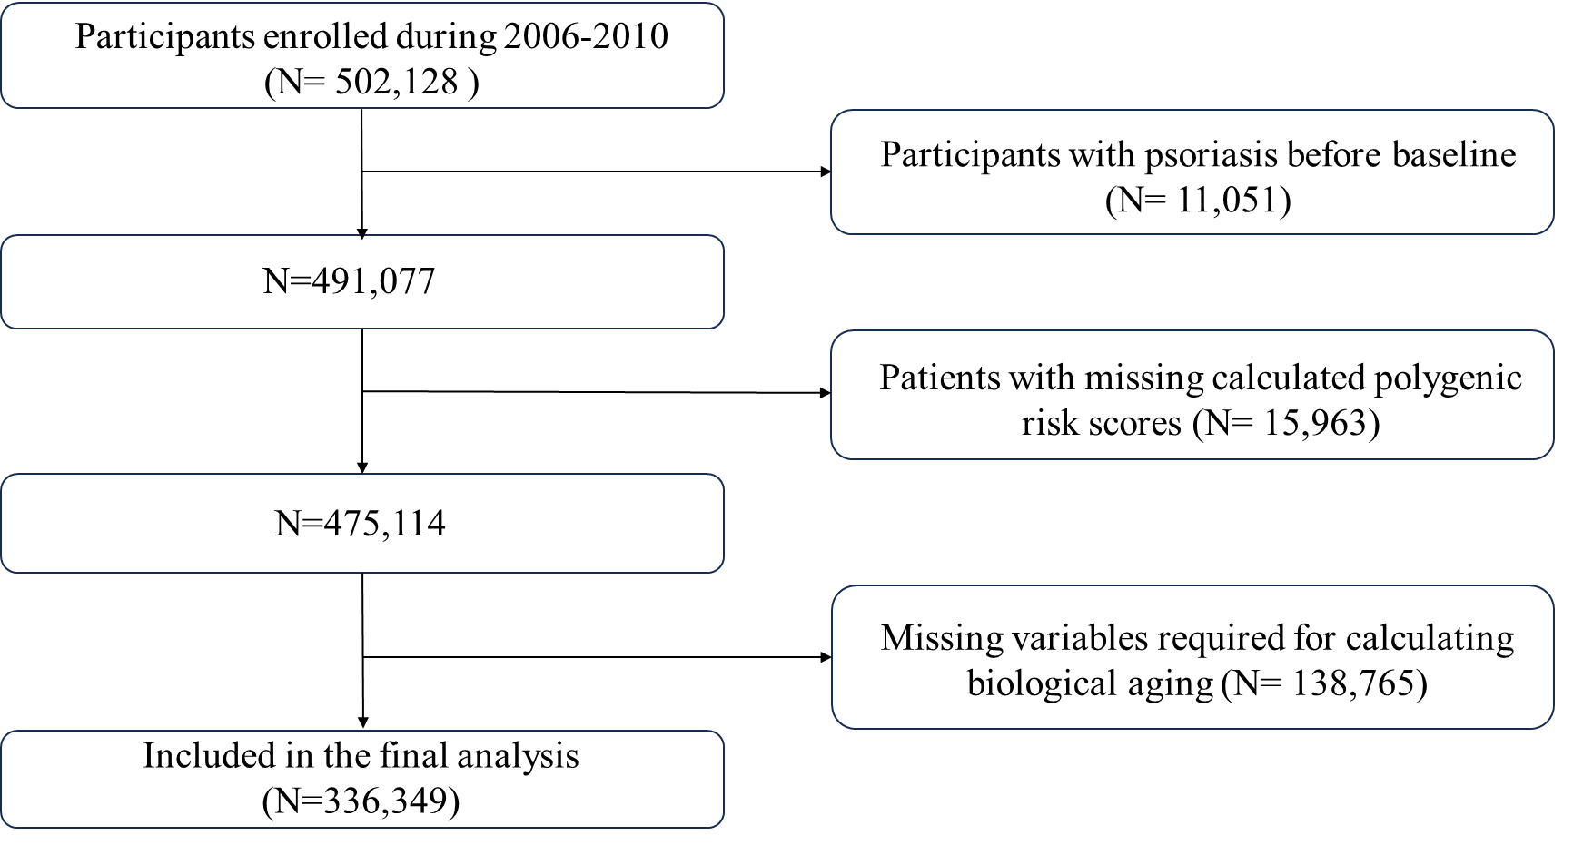
Figure S1. Selection process of the study population.

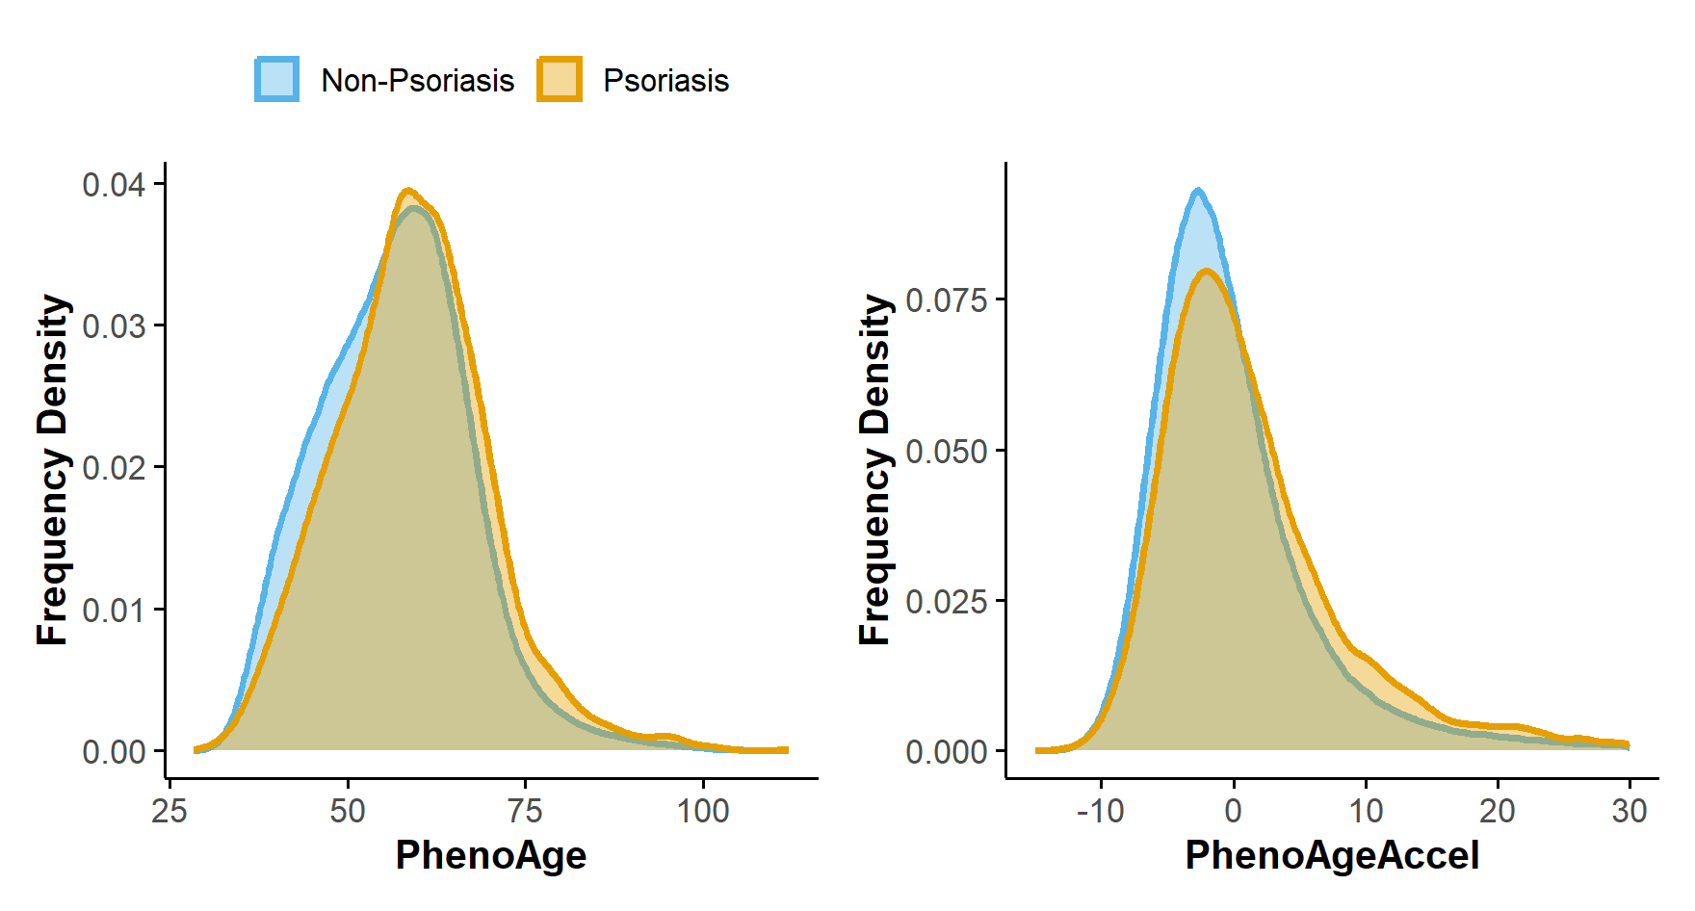
Figure S2. Density plots represent the distribution of PhenoAge and PhenoAgeAccel in psychiatric disorders.

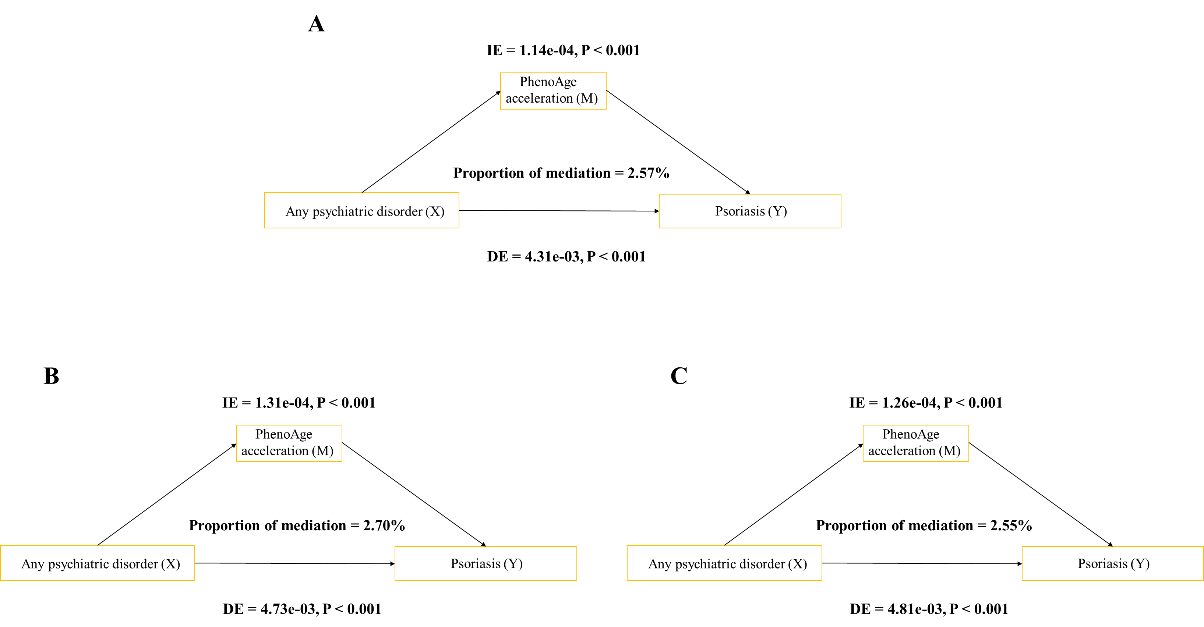
Figure S3. Mediation analysis of biological aging in the association between psychiatric disorders and psoriasis in sensitivity analyses. (A) removal of psoriasis cases with less than 2 years of follow-up; (B) exclusion of participants with missing covariates; (C) exclusion of individuals with chronic disease history. Adjusted for age, sex, ethnicity, education, BMI, TDI, alcohol status, smoking status, physical activity, hypertension, diabetes, and cardiovascular disease.

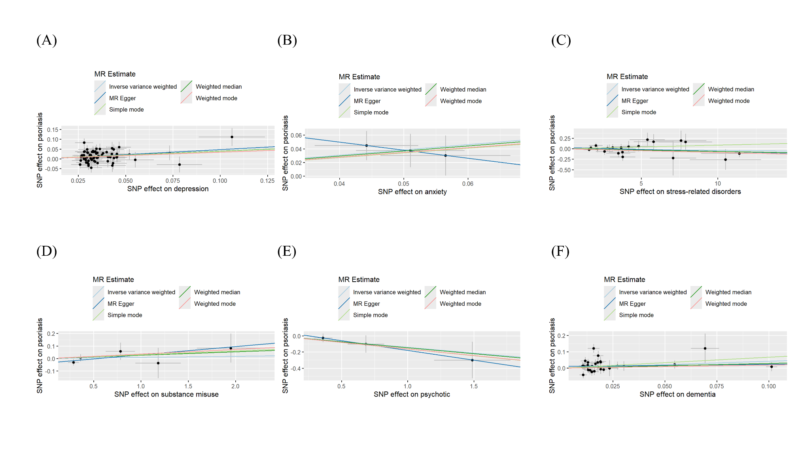
Figure S4 Scatter plots of Mendelian randomization estimates using five methods in the forward direction. Scatter plots show SNP-specific effects of genetic instruments for psychiatric and neurological traits on psoriasis. The slopes represent causal estimates derived from five MR methods, including inverse variance weighted (IVW), MR-Egger, weighted median, weighted mode, and simple mode. (A) Depression (B) Anxiety (C) Stress-related disorders (D) Substance misuse (E) Psychotic disorders (F) Dementia.

