Supplementary Materials
Compound vulnerabilities exacerbate systemic risks of food security in Somalia

This Supplementary Material contains 2 sections:

A. Definition of displacement 1
B. Extreme weather as food insecurity trigger 1

Definition of displacement
There are different types and factors contributing to human mobility, ranging from voluntary to forced migration or displacement and refugees. Situations of immobility can also occur, voluntary immobility and entrapment.¹ This Analysis concerns internal displacement as a form of human mobility. Our definition includes involuntary movement by individuals or a collection of individuals from their community notably for reasons of armed conflict, civil unrest, extreme weather events and food insecurity.

Extreme weather as food insecurity trigger
In Somalia, extreme weather events are well-known, reoccurring climate-related phenomena. However, their impacts and intensity vary across the region and require further study. The impact of climate on human wellbeing and livelihoods is further exacerbated by the absence of a central government coupled with poverty and civil conflict that can escalate to crisis-level food insecurity and large-scale displacement. After the 2016/17 drought across Somalia, heavy rains during Gu season of 2018 led to episodes of flash floods. The history of drought and flash flood displacement has continued to date along with severely food-insecure populations, adding yet another set of vulnerabilities to an already fragile country.

Food security data underlying food insecurity classifications
The food insecurity statistics are based on data from the Integrated Phase Classification (IPC). The dataset consists of seasonal records of food insecure populations at the regional level. According to the IPC methodology, populations facing acute food insecurity are grouped in five categories: minimal (IPC1), stressed (IPC2), crisis (IPC3), emergency (IPC4) and famine (IPC5). A clear advantage of this dataset lies in its large spatial coverage and data points. In South and Central Somalia, the project is implemented in Banadir, Bay, Bakool, Gedo, Lower Jubba, Hiraan, Lower Shabelle, Middle Shabelle, middle Juba and Galgaduud region. In Puntland, project operations focus on the regions of Galmadug, Mudug and Bari. In Somaliland, geographic coverage includes Woqooyi Galbeed, Marodijeh, Sool and Awdal regions. Somalia-specific data is available from 2012 to near today. Food security levels were adversely impacted in 2020 with the onset of the COVID-19 pandemic, the locust crisis and floods.^{2,3}

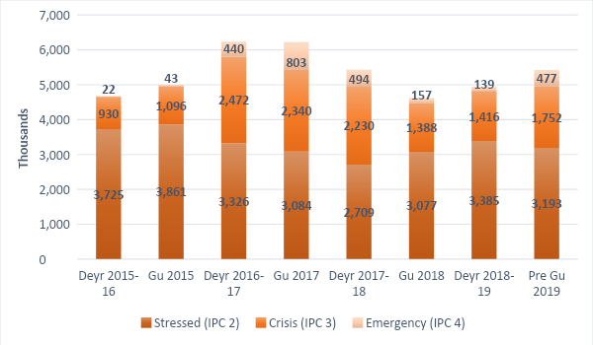
Figure S1: People in food insecurity between 2015 and 2019 by season.

Supplementary Material References

1. Black, R., Arnell, N. W., Adger, W. N., Thomas, D. & Geddes, A. Migration, immobility and displacement outcomes following extreme events. Environmental Science & Policy 27, S32–S43 (2013).
2. Integrated Food Security Phase Classification. IPC Global Platform. http://www.ipcinfo.org/ (2021).
3. Integrated Food Security Phase Classification. The IPC Famine factsheet. https://reliefweb.int/report/world/ipc-famine-factsheet-updated-december-2020 (2020).

