Supplemental figures

Figure. S1.
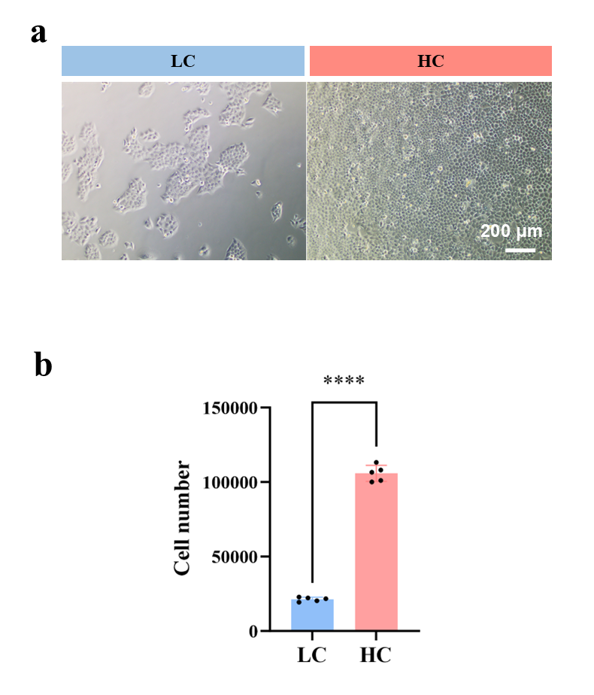

Figure S1. Characterization of the 2D crowding model. (a) Phase-contrast image of the established low-density control (LC) and high-density crowded (HC) monolayer. (b) Quantification of cell numbers in the HC and LC groups. Data represents mean ± SEM. ****p < 0.0001.

Figure. S2.

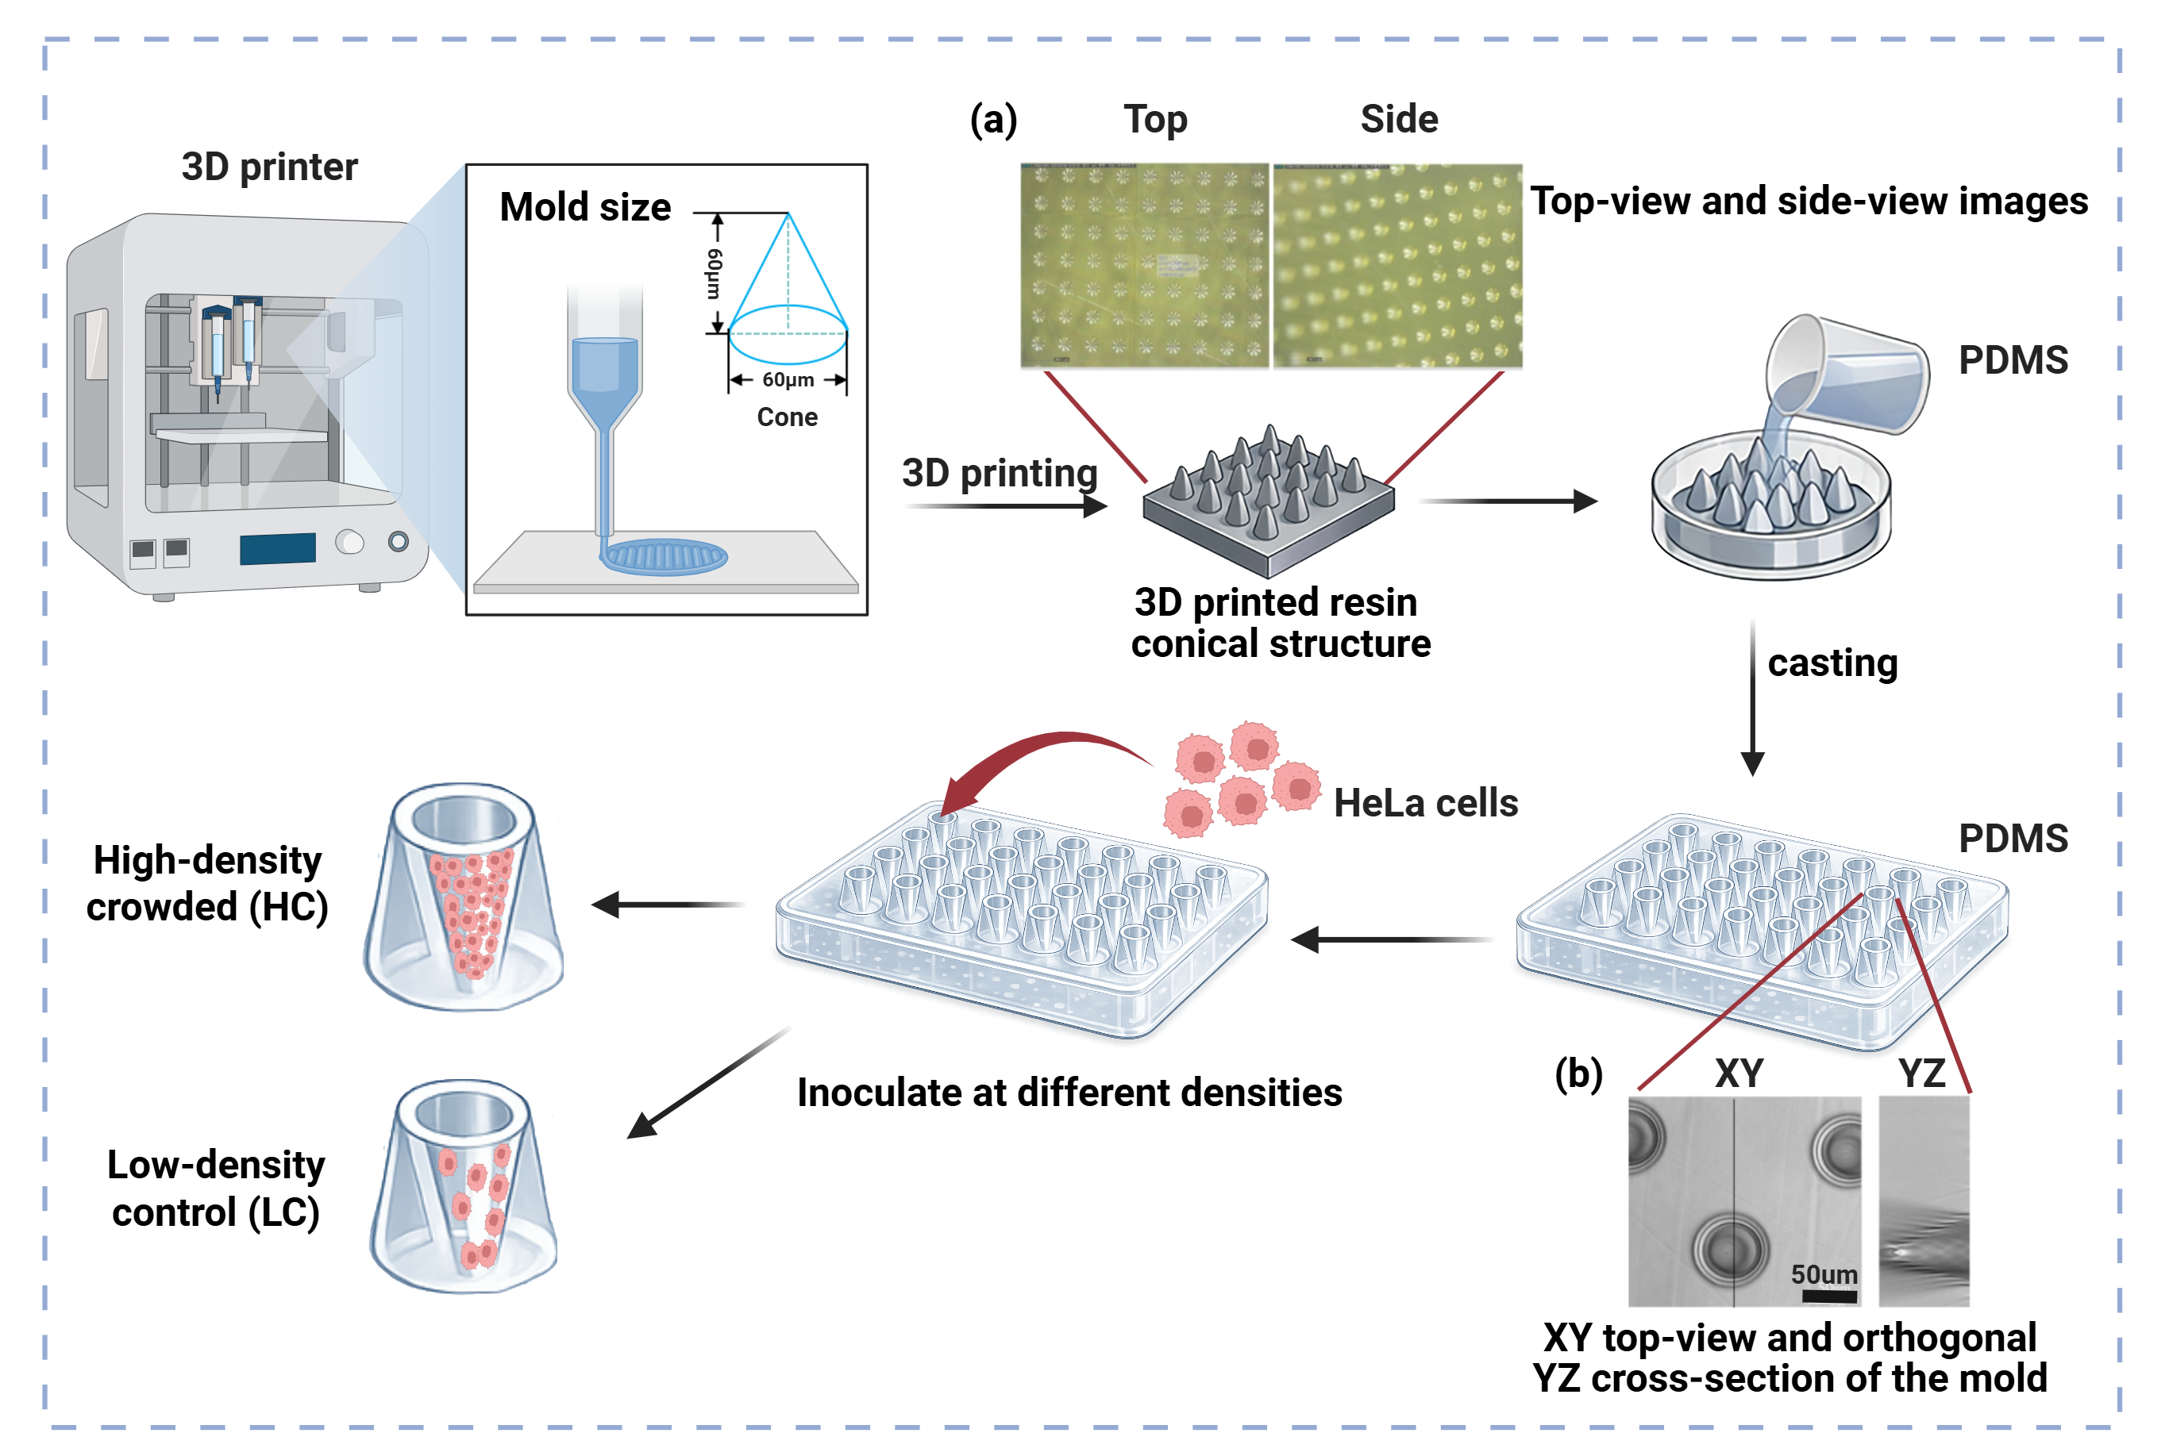
Figure S2. Design and fabrication of a 3D conical culture mold. According to schematic of the conical mold design, the mold featuring a periodic array of conical structures was designed and fabricated via 3D printing. (a) Top-view and side-view images showing a periodic array of uniform conical structures. Polydimethylsiloxane (PDMS) was slowly poured onto the 3D-printed master. PDMS negatives were carefully peeled from the masters to yield free-standing conical molds. (b) XY top-view and orthogonal YZ cross-section of the mold, confirming the faithful reproduction of the intended tapered geometry and surface precision.

Figure. S3.

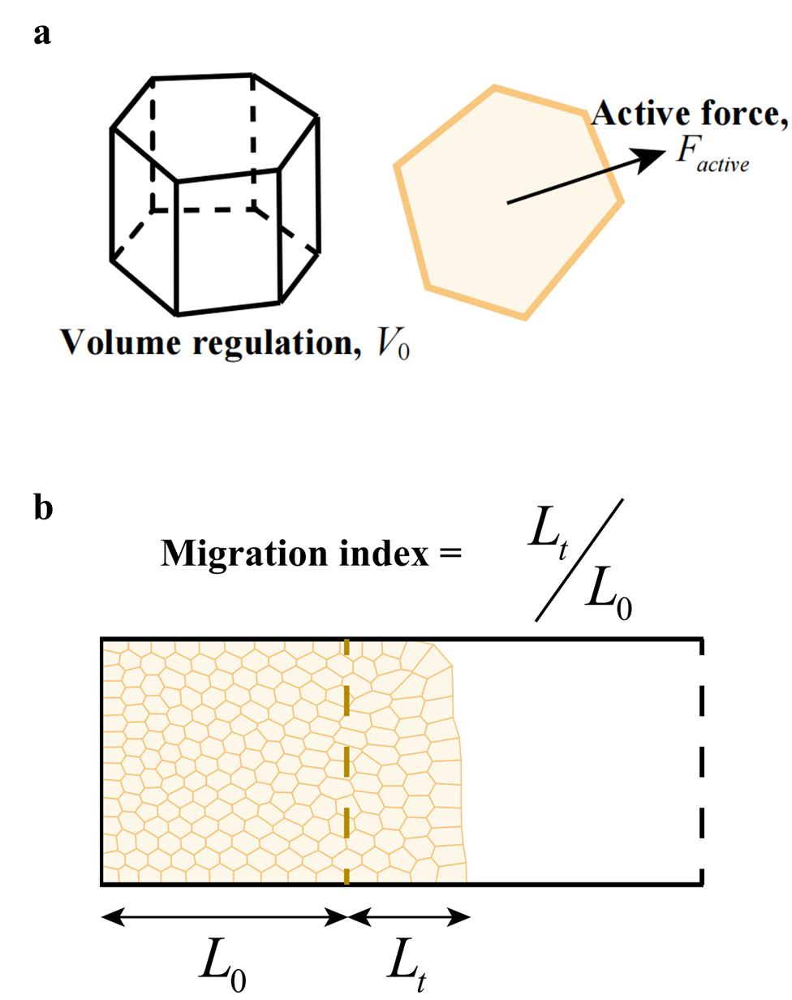
Figure S3. Simulation for cell migration under different osmotic conditions. (a) Geometrical features of a cell undergoing migration driven by a polarized active force F_{active}. A_{i} and A_{li} are the basal surface areas for cell-substrate and cell-cell adhesion. H_{i} and P_{i} are the instantaneous cell height and basal perimeter. (b) Definition of the migration index.

Figure. S4.
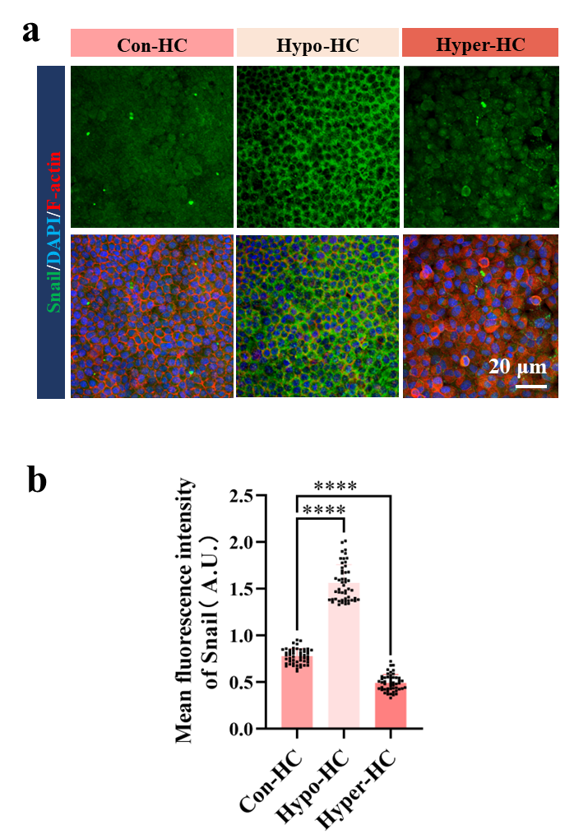
Figure S4. ΔP regulates snail expression in HeLa cells. (a) Representative confocal images of snail in crowded HeLa cells cultured under Con, Hypo, and Hyper conditions. (b) Quantification of snail fluorescence intensity normalized to the control. Data represents mean ± SEM. ****p < 0.0001.
