Supplementary Materials for

The Ttg2 ABC system in Pseudomonas aeruginosa functions as a general glycerophospholipid transporter between the two cell membranes

Daniel Yero,^{1,2} Mireia Díaz-Lobo,³ Lionel Costenaro,¹ Oscar Conchillo-Solé,¹ Adrià Mayo,¹ Mario Ferrer-Navarro,¹ Marta Vilaseca,³ Isidre Gibert,^{1,2}* Xavier Daura^{1,4}*

¹Institut de Biotecnologia i de Biomedicina (IBB), Universitat Autònoma de Barcelona (UAB), Barcelona, Spain; ²Departament de Genètica i de Microbiologia, UAB, Barcelona, Spain; ³Institute for Research in Biomedicine (IRB Barcelona), The Barcelona Institute of Science and Technology, Barcelona, Spain; ⁴Catalan Institution for Research and Advanced Studies (ICREA), Barcelona, Spain.

*Corresponding Authors: Xavier Daura, Xavier.Daura@uab.cat and Isidre Gibert, Isidre.Gibert@uab.cat.

Text S1: Supplementary methods
Text S2: Supplementary discussion
Tables S1 – S6
Figures S1 – S13
Supplementary references

Text S1: Supplementary methods

Bacterial growth conditions. Unless stated otherwise, strains were routinely cultured on Luria-Bertani broth (LB) agar plates, or to exponential phase (OD₅₅₀ of 1.0), or up to late exponential phase (OD₅₅₀ of 2.7 to 3.0) in LB at 37°C with shaking at 250 rpm. When necessary, antibiotics were added at final concentrations of 500 μg/ml for erythromycin, 10 μg/ml for gentamicin, 17 μg/ml for tetracycline, 5 μg/ml for norfloxacin, or 50 μg/ml for kanamycin for Escherichia coli or 1000 μg/ml for erythromycin, 40 μg/ml for gentamicin, or 60 μg/ml for tetracycline for Pseudomonas aeruginosa.

Ttg2D recombinant protein production in E. coli and purification. Ttg2D (PA4453) coding sequence from PAO1 strain was cloned from residues 23 (N-terminal) to 215 (C-terminal) followed by a His6 tag into a modified pET28b expression vector (primers listed in Table S6). Expression was done in E. coli BL21(DE3) in LB broth by inducing with 1 mM IPTG for 3 h. Cells were disrupted by sonication in lysis buffer (0.1% Triton X-100, 4 μg/ml Lysozyme, 8 μg/ml DNase and 2 mM MgCl₂), supplemented with a tablet of Protease Inhibitor Cocktail (Roche) per 10 ml of buffer. Recombinant protein in soluble fraction was purified by two chromatographic methods, using an ÄKTA Purifier (GE Healthcare Life sciences). Protein was first purified by metal ion affinity chromatography, using a HisTrap HP 5 ml column (GE Healthcare Life sciences) with the following buffers: binding buffer: 5 mM imidazole, 0.5 M NaCl and 20 mM Tris-HCl (pH 7.9); washing buffer: 40 mM imidazole, 0.33 M NaCl and 13.3 mM Tris-HCl (pH 7.9) and elution buffer: 125 mM imidazole, 62.5 mM NaCl and 2.5 mM Tris-HCl (pH 7.9). Eluted protein was immediately dialyzed against 50 mM Na₂HPO₄ (pH 7.0) to remove the imidazole and then subjected to size-exclusion chromatography using a HiLoad 26/600 Superdex 75 pg column (GE Healthcare Life sciences). Protein concentration was determined by Bradford method and protein purity was evaluated by SDS-PAGE. Purification gave a very good yield, obtaining 99 mg of protein with a purity >99%.

Crystallization, data collection and structure refinement. Purified Ttg2D was concentrated to 18.8 mg/ml in 100 mM NaCl, 10 mM Tris-HCl (pH 7.5) and sitting-drop crystallization trials were performed at 20ºC using commercial screens. Best diffracting crystals were obtained from drops of 200 nl of protein solution plus 200 nl of reservoir solution consisting of 0.17 M ammonium sulfate, 25.5% PEG 4K and 15% glycerol. Harvested crystals were directly flashed cooled in liquid nitrogen. X-ray diffraction data were collected at 100 K on the beamline ID23-1 at the European Synchrotron Radiation Facility (Grenoble, France) ¹. These data were indexed, integrated, scaled and merged using iMOSFLM ² and AIMLESS ³. Ttg2D_{Pae} structure was solved with Phaser ⁴ using a poly-alanine model built with MODELLER ⁵ from the homologous protein of Ralstonia solanacearum (PDB code 2QGU, 25% sequence identity). The structure was automatically re-built with one run of AutoBuild, followed by iterative cycles of restrained refinement with Phenix.refine ⁶, model building/solvent addition with Coot ⁷ and validation with MolProbity ⁸. Geometry restraint information for the phospholipid PG(16:0/cy17:0) was generated from its SMILES description with eLBOW and the semi-empirical quantum mechanical method AM1 ⁹. Feature-enhanced map ¹⁰ was used to build the lipids as the 2mF_{o} - DF_{c} electron density was weak in this region. Crystallographic data and refinement statistics are reported in Table S1. Cavities and normal modes were analyzed with the web servers CASTp ¹¹ and ElNémo ¹², respectively. The structural alignment was determined with POSA ¹³ and rendered with ESPript 3 ¹⁴ (the PDB sequences were completed to correspond to the UniProt ones). Structural figures were prepared with PyMOL (The PyMOL Molecular Graphics System, Version 1.8 Schrödinger, LLC).

Ttg2D homologous expression in P. aeruginosa and purification. A P. aeruginosa PAO1 Δttg2D mutant (Table S6) lacking wild-type protein Ttg2D was used for the homologous expression of a His-tagged variant of this protein in its natural environment. The new protein variant was expressed with its own signal peptide and under the control of the arabinose promoter using a modified pBBR1MCS vector. To generate the expression vector were ttg2D transcription is controlled by the arabinose promoter, first, the pBAD promoter and AraC encoding cassette from pBAD18-Cm was cloned into the broad-host-range cloning vector pBBR1MCS-5 (Gm^{R}) on compatible SpeI/XhoI sites by using standard techniques and primers pBAD18-Up and pBAD18-Lw (Table S6). Then, primers ttg2DcompF and ttg2DHiscompR (Table S6) were used to amplify Ttg2D coding sequence including the signal sequence and the RBS, and the resulting amplicon inserted between sites NheI and HindIII into the new vector pBBR1-pBAD-Gm. Primer ttg2DHiscompR includes a sequence coding for six consecutive histidines. The resulting expression vector pBBR1-pBAD-ttg2DHis was introduced into P. aeruginosa PAO1 Δttg2D by electroporation ¹⁵.

For protein production, P. aeruginosa mutant strain carrying plasmid pBBR1-pBAD-ttg2DHis was grown in BM2 glycerol medium with casamino acids [62 mM potassium phosphate buffer (pH 7.0), 5 mM MgSO₄, 10 µM FeSO₄, 0.5% casamino acids and 0.4% glycerol] supplemented with 40 μg/ml gentamicin. A bacterial inoculum from an overnight culture was diluted 1/100 in 1 l of fresh medium and grown to mid-exponential phase (OD₅₅₀ ∼ 0.6) at 37°C with vigorous shaking. Cells were centrifuged at 4000 g for 10 min at 4°C, washed twice in 30 mM Tris-HCl (pH 7.0) and 150 mM NaCl and they were kept in ice. The method of spheroplasting by lysozyme and sucrose¹⁶ was applied to extract periplasmic proteins from P. aeruginosa. Briefly, the bacterial pellet was resuspended in 30 mM Tris-HCl (pH 8.0), 20% sucrose, 4 mM EDTA, 0.5 mg/ml lysozyme (Sigma-Aldrich, Sigma L6876) and 1 mM PMSF, and incubated for 60 min at 30°C with gentle shaking. After 2 min incubation MgCl₂ was added at 10 mM final concentration. The suspension was centrifuged at 11000 g for 15 min at 4°C to collect the supernatant containing periplasmic proteins. The periplasmic protein fraction was filtered through a 0.2 μm sterile filter (Millipore) and immediately dialyzed against 25 mM Tris-HCl (pH 8.0) and 0.3 M NaCl (binding buffer). Protein purification was performed by the ICTS “NANBIOSIS”, more specifically the Protein Production Platform of CIBER-BBN/IBB, at the UAB sePBioEs service (Barcelona). The His-tagged protein was purified by metal ion affinity chromatography, using a Ni-NTA affinity column on the ÄKTApure FPLC system (GE Healthcare Life sciences), and eluted with a linear gradient from 0 to 200 mM of Imidazole in binding buffer after being washed extensively with the same buffer. The purified protein was concentrated and desalted in a Centricon micro-concentrator (Millipore).

Native mass spectrometry (Native-MS) analyses. Native-MS experiments were performed using a Synapt G1-HDMS mass spectrometer (Waters, Manchester, UK). All samples were in 100 mM ammonium acetate and were infused by automated chip-based nanoelectrospray using a Triversa Nanomate system (Advion BioSciences, Ithaca, NY, USA) as the interface. The ionization was performed in positive mode using a spray voltage and a gas pressure of 1.75 kV and 0.5 psi, respectively. The source pumping speed in the backing region (6.70 mbar) of the mass spectrometer was reduced to achieve optimal transmission of non-covalent complexes. Cone voltage, extraction cone and source temperature were set to 40 V, 3 V and 40ºC, respectively. Trap and transfer collision energies were set to 6 V and 4 V, respectively. After isolation of the selected ion, fragmentation was performed by CID in the transfer region by applying increasing collision energies (TOF MS/MS analysis). The pressure in the Trap and Transfer T-Wave regions were 5.93·10⁻² mbar of Ar and the pressure in the IMS T-Wave was 4.69·10⁻¹ mbar of N₂. Trap gas flow was 1.5 ml/sec. The bias voltage for entering in the T-wave cell was 15 V. The instrument was calibrated over the m/z range 300-8000 Da using a solution of cesium iodide. MassLynx version 4.1 SCN 704 software was used for data processing. The experimental optimized parameters are listed in detail in the table. Three technical replicates were performed for all MS experiments.

NanoESI + V Resolution mode |  | DC potentials (V)
m/z range | 300-8000 | Trap Collision Energy | 6
Spray voltage (kV) | 1.75 | Transfer Collision Energy | 4
Gas pressure (psi) | 0.5 | Trap DC Entrance | 5
Source Temperature (ᵒC) | 40 | Trap DC Bias | 15
Sampling Cone (V) | 40 | Trap DC Exit | 5
Extraction Cone (V) | 3 | IMS DC Entrance | 5
Desolvation temperature (ᵒC) | 250 | IMS DC Exit | 2
Cone Gas Flow (l/h) | 10 | Transfer DC Entrance | 2
Desolvation Gas Flow (l/h) | 300 | Transfer DC Exit | 2
Trap Gas Flow (ml/min) | 8
Backing region (mbar) | 6.70
Trap and Transfer T-Wave section pressure (mbar of Ar) | 5.93·10⁻²

Denaturing mass spectrometry. For denaturing MS analysis, samples were directly injected to LTQ-FT Ultra mass spectrometer (Thermo Scientific, USA) using the Triversa Nanomate system. Samples were 1/1 diluted in H₂O/ACN or they were directly injected in ammonium acetate buffer. The NanoMate aspirated the samples from a 384-well plate (protein Lobind) with disposable, conductive pipette tips, and infused the samples through the nanoESI Chip (which consists of 400 nozzles in a 20x20 array) towards the mass spectrometer. Spray voltage was 1.75 kV (positive mode) or -1.80 kV (negative mode) and delivery pressure was 0.50 psi. Capillary temperature, capillary voltage and tube lens were set to 200°C, 35 V (positive ionization) or -37 V (negative ionization), and 100 V, respectively. MS1 and MS2 spectra were acquired at 100 k resolution. Isolated ions were fragmented by CID with collision energy (CE) of 30 eV. Data was acquired with Xcalibur software, vs.2.0SR2 (ThermoScientific). Elemental compositions from experimental exact mass monoisotopic values were obtained with a dedicated algorithm integrated in Xcalibur software. Three technical replicates were performed for all MS experiments.

For LC-MS (liquid chromatography–mass spectrometry) analysis under denaturing conditions, samples were injected automatically to a BioSuite pPhenyl 1000 (Waters, 10 µm RPC 2.0x75mm) column at a flow rate of 100 µL/min using an Acquity UPLC system (Waters Corporation) provided with a Binary Solvent Manager and an automatic Autosampler. Samples were eluted using a linear gradient from 2% to 5% B in 5min and from 5% to 80% B in 60min (A= 0.1% FA in water, B= 0.1% FA in CH₃CN). The column outlet was directly connected to an LCT-Premier XE mass spectrometer (Waters). Capillary voltage and cone voltage were set to 3000 V and 100 V respectively. Desolvation temperature and source temperature were set to 350ᵒC and 120ᵒC. Cone gas flow and desolvation gas flow were set to 50 and 600 L/h. The mass spectrometer acquired full MS scans (400-4000 m/z) working in positive polarity mode. Data was acquired with MassLynx software, V4.1.SCN704 (Waters Inc.). MS spectra corresponding to chromatographic peaks were summed. Charged species in the resulting spectrum were deconvoluted to their zero charged average masses using the integrated MaxEnt1 (maximum entropy) algorithm in MassLynx Software Vs. 4.1.SCN704 (Waters). The algorithm calculates deconvoluted masses peak intensities.

Lipidome analysis from crude cellular extracts. Lipidome analysis of intact cells was done according to Angelini et al.¹⁷ with modifications. Two microliters of lipid extract were mixed with 2 μl of 9-aminoacridine (10 mg/ml dissolved in a 60:40 (v/v) isopropanol:acetonitrile solution) as MALDI matrix and 1 μl of the mixture was spotted on a ground steel plate (Bruker Daltonics, Bremen, Germany). MALDI-MS analyses were performed on an UltrafleXtreme (Bruker Daltonics) and were recorded in the reflectron negative ion mode. The ion acceleration was set to 20 kV. The spectra were processed using Flex Analysis 3.4 software (Bruker Daltonics) and they were analyzed in a mass range between m/z 450 and m/z 1500 Da.

Generation of ttg2 mutants in MDR P. aeruginosa strains using the pGPI-SceI/pDAI-SceI-SacB system. This mutagenesis method is based on the I-SceI homing endonuclease system, which relies on two independent crossover events to integrate first a deletion plasmid with a I-SceI recognition site into the genome of the recipient and then resolve the co-integrate structure by a second homologous recombination event in the presence of the I-SceI endonuclease provided in trans on a replicative plasmid ^{18, 19}. One of these mutagenesis systems relies on an improved suicide vector that contains an I-SceI restriction site and the xylE reporter gene (pGPI-SceI-XCm), and a replicative but unstable plasmid that encodes the I-SceI endonuclease and the counterselectable marker SacB (pDAI-SceI-SacB) ²⁰. To successfully achieve genetic manipulations in MDR P. aeruginosa strains, we further modified pGPI-SceI-XCm by introducing an erythromycin resistance determinant replacing the chloramphenicol resistance cassette. To make this decision, the MIC for erythromycin was previously analyzed in our P. aeruginosa strains using the microdilution technique and found to be at a level of 256 μg/ml. The erythromycin resistance (erm) gene from plasmid pNZerm ²¹ was PCR amplified using primers Erm5’-PstI and Erm3’-PstI (Table S6) and with pNZerm DNA as a template. The resulting amplicon (1026 bp) was digested with PstI and cloned into PstI-digested pGPI-SceI-XCm to create pGPI-SceI-XErm. Previously, the region between the SacI sites of plasmid pGPI-SceI-XCm (359 bp) was deleted by digestion with this restriction enzyme and ligation. This region contains the Pc promoter found in class 1 integrons (promoter for the trimethoprim resistance gene dhfrIIb in pGPI-SceI vectors) and this could cause unwanted integration of the suicide vector into the P. aeruginosa chromosome of some strains. Class 1 integrons have been detected with high prevalence in P. aeruginosa ²².

The mutagenesis plasmid for the ttg2 operon deletion (from PA4452 to PA4456 in PAO1) was constructed by PCR amplification of DNA fragments flanking this gene cluster from PAO1 strain, which were cloned into pGPI-SceI-XErm (see Table S4 for primer details). The upstream fragment (633 bp) was amplified using primers US’-ttg2-U and US’-ttg2-L. The downstream fragment (818 bp) was amplified using primers DS’-ttg2-U and DS’-ttg2-L. The upstream fragment was digested with EcoRI and NheI, the downstream fragment was digested with NheI and BglII, and both fragments were inserted in two successive cloning steps into pGPI-SceI-XErm to create pΔttg2-US’DS’. The successful construction of the mutagenesis plasmid was verified by DNA sequence analysis of the inserts. All deletion plasmids were generated and maintained in E. coli SY327.

The mutagenic plasmid pΔttg2-US’DS’ was mobilized into P. aeruginosa C17, PAER-10821 and LESB58 by triparental mating ¹⁹ using E. coli DH5α carrying the plasmid pRK2013 as a helper strain. Modifications of the method include that the recipient P. aeruginosa strains were incubated at 42°C overnight before conjugation because certain strains presumably contain restriction systems that could severely restrict foreign DNA. Erythromycin at 1000 μg ml⁻¹ was used to select for cointegrants (single-crossover clones) in these P. aeruginosa strains, and 5 μg/ml norfloxacin to counter-select against the E. coli helper and donor strains. To distinguish true cointegrants from colonies that spontaneously became resistant to erythromycin, streaks of exconjugants were sprayed with 0.45M pyrocatechol since in the presence of this compound colonies expressing 2,3-catechol-dioxygenase encoded by xylE turned bright yellow ²³. For the final mutagenesis stage, pDAI-SceI-SacB was mobilized into P. aeruginosa cointegrants, and exconjugants were selected on LB agar plates containing 60 μg/ml tetracycline and 5 μg/ml norfloxacin for PAER-10821 and LESB58 derivatives. Tetracycline-resistant colonies, appearing after 48 hours, were screened by PCR and sequencing to confirm the deletion using the primers Ext-ttg2-U and Ext-ttg2-L (Table S6) that anneal to sequences outside the deleted region. Detection of deletion mutants cured from the plasmid pDAI-SceI-SacB was achieved by growing P. aeruginosa on LB plates without salt and supplemented with 5% (wt/vol) sucrose and then screening the resulting colonies for loss of tetracycline resistance. To obtain a ttg2 mutant in the P. aeruginosa C17 strain, the derivative cointegrates have to be resolved by spontaneous recombination of the allele pair since resolution via the I-SceI endonuclease provided on the plasmid pDAI-SceI-SacB did not work. Failure during the second recombination event for C17 strain (resolution always restores the parental allele) was probably due to the mutation in the ttg2 operon making the cells more susceptible to tetracycline ²⁴, the antibiotic resistance marker to select for cells carrying plasmid pDAI-SceI-SacB. In this case, resolution of cointegrates was achieved by plating several thousand colonies on LB plates without selection. For this, the single-crossover clones were serially subcultured in LB without selection for two consecutive days and then diluted up to 10⁻⁸ prior to spread over the plates. Plates were sprayed with 0.45 M pyrocatechol to screen for xylE negative cells (no yellow coloration). The screening was facilitated because P. aeruginosa xylE negative colonies turned dark brown after spraying with pyrocatechol (Fig. S13). Selected colonies were screened by PCR to confirm the deletion using the primers Ext-ttg2-U and Ext-ttg2-L.

Vectors for complementation. For complementation purposes of the PAO1 derivative mutant strains, the broad-host-range cloning vectors pBBR1MCS-5 ²⁵ or its derivative variants pBBR1-pBAD-Gm (see Ttg2D homologous expression in P. aeruginosa) or pBBR1MCS-6 were used with the oligonucleotide primers described in supplementary Table S6 for each cloning strategy. For complementation of the MDR P. aeruginosa strains C17, PAER-10821 and LESB58, we previously modified pBBR1MCS-5 by introducing an erythromycin resistance determinant replacing the gentamicin resistance cassette. The erm gene from plasmid pNZerm ²¹ was PCR amplified using primers Erm5’-KpnI and Erm3’-BglII (Table S6) and with pNZerm DNA as a template. The resulting amplicon (1026 bp) was digested with KpnI and BglII and cloned into KpnI/BglII -digested pBBR1MCS-5 to create pBBR1MCS-6. The full ttg2 operon (3650 bp) from P. aeruginosa PAO1 was cloned separately into pBBR1MCS-5 or pBBR1MCS-6 as described in Table S6. The complementation vectors were introduced into P. aeruginosa by electroporation ¹⁵.

RNA extraction and real-time quantitative PCR. Early-log-phase cultures of the mutant and complemented strains grown on LB were adjusted to obtain a suspension of approximately 10⁹ cell/ml. 0.5 ml of the bacterial suspension were treated with 1 ml of the RNAprotect Reagent (Qiagen) according to the manufacturer's instructions for stabilization of the RNA molecules. Total RNA was extracted by using RNeasy Mini Kit (Qiagen) with on-column DNase digestion (RNase-Free DNase set, Qiagen) to remove contaminating DNA. Removal of DNA was confirmed by performing PCR using an aliquot of the DNase-treated RNA as a template. Reverse transcription reactions were carried out in 20-μl volume containing 0.1 μg RNA, random primers, and the buffer and enzyme components of the Maxima First Strand cDNA Synthesis Kit for RT-qPCR kit (Thermo Fisher Scientific) according to the supplied protocol. Initial PCR amplifications for the expression of ttg2 operon-specific mRNAs were performed on the cDNA templates from the parental strains, the Δttg2 mutants, and the complements to confirm the loss of gene expression in the Δttg2 deletion mutants and recovery in the complemented strains. Real-time qPCR analysis was carried out on the CFX96 machine at the genomics core facility of Universitat Autònoma de Barcelona using a PCR master mix containing SYBR green dye. The sequences of the ttg2D primers used in the real-time qPCR (Int-ttg2D-U and Int-ttg2D-L) are given in Table S6. These primers amplify a 215-bp conserved portion of the ttg2D gene. Relative gene expression comparisons were obtained through the ΔΔC_{T} method (CFX Manager software) by normalizing the mean cycle threshold of the investigated transcript to the housekeeping gene rpsL with primers rpsL-F; GCAAGCGCATGGTCGACAAGA) and rpsL-R; CGCTGTGCTCTTGCAGGTTGTGA (amplicon size 201bp).

Outer membrane permeabilization assay. The NPN (1-N-phenylnaphthylamine) uptake assay was done according to Loh et al. ²⁶, with modifications. Briefly, overnight cultures of the different strains in MHB were subcultured into the same medium and grown to mid-logarithmic phase. Appropriate antibiotic was added to growth plasmid-bearing strains. Cells were washed with 10 mM sodium HEPES (pH 7.2), and then resuspended at a final OD_{550nm} of 1.0 in the same buffer supplemented with a 5 μM CCCP (carbonyl cyanide m-chlorophenylhydrazone). CCCP was added to block energized secretion of NPN and to prevent a decline in fluorescence during the assay ²⁶. 50 μl of cell suspension was pipetted into a quartz cuvette containing NPN (10 μM final concentration), and as test substances either EDTA (0.2 mM final concentration) or colistin (10 μg/ml final concentration) to a total volume of 100 μl. Fluorescence was monitored by a Cari Eclipse spectrophotometer (Variant, Inc., Palo Alto, C.A) at excitation and emission wavelengths of 340 nm and 415 nm, respectively. Control experiments without added cells or without colistin or EDTA were also performed. Each assay was performed at least three times.

Analysis of antimicrobial susceptibilities. Minimal inhibitory concentration (MIC) to antibiotics of several classes including front-line antipseudomonal drugs, namely imipenem, meropenem, amikacin, tobramycin, ceftazidime, piperacillin/tazobactam, ciprofloxacin, levofloxacin and colistin, was determined by the broth microdilution method (BMD) or by Etest. The BMD method was performed on cation adjusted MH broth (CAMHB) as recommended ^{27, 28}. Bacteria were first grown overnight in CAMHB using CLSI-recommended incubation conditions and the antibiotics were serially diluted twofold across the 96 well plates. After that, 100 µl of a bacterial suspension diluted to 5x10⁵ CFU/ml in CAMHB was added to the wells containing the antibiotic dilutions. The 96-well plates were incubated for 20 h at 37°C before developing by visual inspection or with the resazurin dye ²⁹. MIC was defined as the lowest concentration of the antibiotic (in μg/ml) that prevented visual growth. As the LESB58 isolate is considered a slower growing strain compared to laboratory strain PAO1 ³⁰, incubation for bacterial growth was extended to 48 h instead of 24 h for some protocols. MICs were confirmed by two or three independent replicates, and MIC values 2-fold or greater than that of the control were considered significant. For Etest a 0.5 McFarland suspension was used to create a confluent lawn of microbial growth in 150-mm Mueller-Hinton (MH) agar plates. The MIC values were determined according to the Etest reading guide after 18 h incubation at 37°C. MICs were determined as the concentration at which the zone of inhibition intersected the Etest strip.

Tolerance to organic solvents, and SDS/EDTA
The approach to assess solvent tolerance involved overlaying solvent (100%) onto LBMg (LB medium supplemented with 10 mM MgCl₂) agar plates (55 mm glass plates) inoculated with bacteria as previously described ³¹. Briefly, late exponential phase LB broth cultures were diluted into the same medium to yield a suspension of approximately 10⁷ cells/ml. A 5-μl aliquot of the cell suspension was spread over the surface of an LBMg agar plate in duplicate and allowed to dry before being overlaid with an organic solvent to a thickness of 3 mm. The plates were sealed and growth was assessed following incubation at 37°C for 24-48 h. Wild-type PAO1 was unable to grow in modified LB agar in the presence of toluene or n-hexane, but it grew well in LBMg plates overlaid with p-xylene. MIC assays were conducted in 96 well plates to determine the bacterial sensitivity to SDS and/or EDTA. The MIC values were defined as the lowest substance concentration that inhibited 80% of growth (based on OD measurements) in comparison to the growth control.

Biofilm formation. Biofilm formation was assessed as previously described ³² with the following modifications. Sterile 96-well flat bottom polystyrene non-treated plates (BrandTech 781662) were used. Two-hundred microliters of overnight cultures adjusted to an OD_{550nm} of 0.1 were incubated in LB broth or LB supplemented with 0.05 mM EDTA for 24 hours at 37°C. Cells were washed three times with water, fixed at 60°C for 1 h and stained during 15 minutes with 200 μl of 0.1% crystal violet. The dye was discarded and the plate was rinsed in standing water and allowed to dry for 30 min at 37°C. Crystal violet was dissolved in 250 μl 95% ethanol for 15 min, and the OD of the extracted dye was measured at 550 nm. Biofilm formation was normalized by cell growth and reported as relative biofilm formation. A one-way ANOVA with Tukey's multiple comparison test (GraphPad Prism 6.0) was used to determine the significance of the data between groups.

Protein in-silico analysis and bioinformatics tools. Protein sequences were analyzed using BLAST, PSI-BLAST and CDD within NCBI (http://ncbi.nlm.nih.gov/) and PsortB (http://psort.nibb.ac.jp). Known 3D structures for P. aeruginosa Ttg2D orthologs were downloaded from PDB (https://www.rcsb.org/). Structures with accession numbers 2QGU (R. solanacearum) and 4FCZ (Pseudomonas putida) were deposited at the PDB by the Northeast Structural Genomics Consortium (NESG) without any associated publications. Structures 5UWA (E. coli) and 5UWB (re-refined coordinates for 4FCZ) were submitted to the PDB by Ekiert et al. ³³.

Homologous sequences were obtained from a set of representative proteomes at Pfam database (https://pfam.xfam.org/). First, the full sequences of the PF05494 (MlaC family) RP15 group members were downloaded, and Ttg2D orthologs in Gram-negative organisms were then selected from reciprocal best hits. In addition, sequences from unclassified bacteria were removed from the list, totaling 151 representative protein sequences for further analysis. Multiple sequence alignment using a hidden Markov model (HMM) profile was generated with the hmmalign program of the hmmer3 package (http://hmmer.org/), and sequence logos were generated with Weblogo3 ³⁴. For phylogenetic analysis, an unrooted maximum likelihood tree was reconstructed using the best model of evolution on MEGA 7 ³⁵, based on amino acid sequences. Phylogenetic tree was visualized and annotated using the interactive web platform iTOL v3 ³⁶.

Superposition of the P. aeruginosa Ttg2D and 2QGU structures was performed by aligning both sequences to the Pfam HMM profile for the MlaC family with the hmmaling program from the hmmer3 package, and using the resulting alignment to superpose the structures with Profit (http://www.bioinf.org.uk/programs/profit). In order to avoid superposing residues from the C-terminal bended helix, only residues 1 to 175 from Ttg2D and 29 to 199 from 2QGU where used. Superposition of the Ttg2D structure to representative structures of substrate-binding protein subclusters ³⁷ was carried out with the Mammoth program ³⁸. Structural domains where assigned by transferring those defined for PDB structure 2QGU in CATH database ³⁹. The search for similar structures in the whole PDB database was performed using Dali server ⁴⁰.

Text S2: Supplementary Discussion

Ttg2/Mla pathway and resistance to antimicrobial agents
The proposed function of the Ttg2/Mla pathway in membrane remodeling provides a plausible explanation for the pleiotropic resistance phenotypes shown by the ttg2 mutants in this study, including resistance to various antibiotics, chelating agents and organic solvents. In addition, these mutations increase the deleterious effect of antibiofilm agents like EDTA, a substance with known low activity against biofilms of P. aeruginosa PAO1⁴¹. Mutations in orthologous ttg2 genes in other Gram-negative organisms have been shown to affect diverse physiological processes, mainly associated with an increased OM permeability. In E. coli, the mutants defective in components of the Mla system rendered cells more susceptible to the lethal action of quinolones, the detergent SDS and EDTA^{42, 43}. Mutants for the orthologs of the Ttg2 pathway in both Shigella flexneri and Francisella novicida resulted also in increased sensitivity to lysis by SDS^{44, 45}. In addition, in S. flexneri this pathway appears to play a role in the intercellular spread of the bacteria between adjacent epithelial cells⁴⁴. In fact, the Ttg2/Mla pathway has proven to be an important virulence factor in other pathogens, like Burkholderia pseudomallei, that need to spread into neighboring cells to infect eukaryotic tissues⁴⁶. In Burkholderia cepacia complex species, mla genes are required for swarming motility and serum resistance⁴⁷. Furthermore, in nontypeable Haemophilus influenzae (NTHi), it is considered a key factor for bacterial survival in the human airway upon exposure to hydrophobic antibiotics⁴⁸. In S. flexneri, B. pseudomallei and NTHi the role of the mla operon in virulence has been inferred from mutants for the gene vacJ (mlaA)^{46, 49}. This gene is predicted to be part of the Ttg2 ABC transport system, since it is found in an operon with ttg2 homologs in other bacteria⁵⁰. In agreement with our work, it has been previously shown that in P. aeruginosa VacJ plays an important role in both virulence and antibiotic susceptibility to ciprofloxacin, chloramphenicol and tetracycline⁵¹.

Colistin is considered a last-resort antibiotic for the treatment of infections by several MDR Gram-negative pathogens, but its use against MDR P. aeruginosa is increasingly impeded by colistin resistance⁵². A variety of gene mutations are known to cause resistance to colistin by altering the OM of Gram-negative bacteria, for example, by covalent modification of the lipid A constituent of LPS as consequence of mutations in the PhoPQ two component regulatory system^{53, 54}. In P. aeruginosa, the PhoPQ system plays a role in the induction of resistance to polymyxins in response to limiting divalent cations, as well as in virulence^{55, 56}, and this system has been recently identified as a regulator of P. aeruginosa's ttg2 operon²⁴. Interestingly, in Salmonella the increase in OM cardiolipins is regulated by PhoPQ and it is necessary for their virulence⁵⁷. More recently, nucleotide polymorphisms conferring resistance to polymyxins have been detected in genes of the Mla pathway in A. baumannii⁵⁸. Although data on the precise mechanisms of resistance are scant and appear to be dependent on specific regulatory systems^{55, 59}, the activity of the Ttg2 system on membrane phospholipid homeostasis appears to be partly responsible for the lower basal susceptibility of P. aeruginosa to colistin.
Table S1. Data collection and model refinement statistics
 | Ttg2D – two PG(16:0/cy17:0)
Data collection
Wavelength (Å) | 0.9802
Space group | P3₂21
Unit cell parameters (Å) | a = b = 124.64, c = 38.06
Resolution range (Å) | 62.32 - 2.53 (2.64 - 2.53)#
No. of reflections
Total | 71,596 (6,246)
Unique | 11,489 (1,349)
Completeness (%) | 99.6 (98.0)
Average multiplicity | 6.2 (4.6)
<Ι/σ(Ι)> | 8.2 (2.0)
R_{meas} (%)† | 13.5 (79.5)
R_{pim} (%)‡ | 5.3 (35.2)
CC_{1/2} (%)§ | 99.6 (71.7)
B-factor from Wilson plot (Å²) | 43.0
Model refinement
No. of reflections used | 11462
R_{work} / R_{free} (%)¶ | 20.9 / 24.9
No. of non-H atoms (all / protein / ligands / water) | 1675 / 1527 / 127 / 21
No. of protein residues / chain per a.u. | 190 / 1
RMS deviations
Bond lengths (Å) | 0.003
Bond angles (º) | 0.47
Average B-factors (Å², all / protein / ligands / water) | 68.0 / 66.9 / 83.2 / 61.0
Molprobity scores
Overall score, %ile | 0.78, 100th
Clashscore, %ile | 0.31, 100th
Poor rotamers (%) | 1.21
Ramachandran Outliers (%) | 0
Ramachandran Favoured (%) | 97.87
PDB code | 6HSY

#Values in parentheses are for the highest resolution shell.
†R_{meas} = Σ_{h} (n_{h}/(n_{h}-1))^{½} Σ_{i} |I_{h,i} - <I_{h}>| / Σ_{h}Σ_{i} I_{h,i} , where n_{h} is the number of observations of reflection h(hkl), I_{h,i} the ith measurement of its intensity and <I_{h}> the average of all I_{h,i}.
‡R_{p.i.m.} = Σ_{h} (1/(n_{h}-1))^{½} Σ_{i} |I_{h,i} - <I_{h}>| / Σ_{h}Σ_{i} I_{h,i}.
§Correlation coefficient between intensities from random half-data sets.
¶Σ_{h} ||F_{o}| - |F_{c}|| / Σ_{h} |F_{o}|, where |F_{o}| and |F_{c}| are observed and calculated structure factor amplitudes, respectively. R_{free} was calculated using 5% of the reflections, which were not used for refinement.

Table S2. Structural alignment parameters and cavity volumes of Ttg2D proteins
Species (strain) | PDB  code | RMSD in Å (No. Cα) ‡ | Identity‡ | Similarity‡ | Volume† in Å³ | No. cavity’s  aa/atoms† | Ref.
Pseudomonas aeruginosa (PAO1) | 6HSY | 0.0 (190) | 100% | 100% | 2979 | 55/185 | This study
Pseudomonas putida (KT2440) | 5UWB | 1.6 (188) | 63% | 78% | 2510 | 52/166 | ³³
 |  |  |  |  | 2337 | 49/153
Ralstonia solanacearum (GMI1000) | 2QGU | 2.3 (180) | 25% | 48% | 1332 | 31/101 | N/A
Escherichia coli (K12) | 5UWA | 3.1 (185) | 17% | 39% | 1444 | 43/118 | ³³
 |  |  |  |  | 1369 | 43/111

‡Structural alignment parameters obtained from POSA web server for the PDB sequences.
†Molecular-surface volume (without H atoms) and the number of amino acid residues (aa) and atoms in the cavity for protein chain (chains A and B in P. putida and E. coli).

Table S3. PL released species detected by mass spectrometry from lipid-protein complexes of recombinant Ttg2D_{Pae} produced in the cytoplasm of E. coli.

PL class‡ | Monoisotopic (exact mass) | nESI-MS mode | Possible combination  of fatty acids (PL species)† | Lipidome analyses of E. coli (negative mode)#
PE | 663.480 | Positive/Negative | 16:0/14:0 | Yes
PG | 694.483 | Negative | 16:0/14:0
PE | 703.499 | Positive/Negative | 16:0/cy17:0 | Yes
PE | 717.535 | Positive | 16:0/18:1
PG | 720.499 | Negative | 14:0/18:1  16:0/16:1  15:0/cy17:0
PG | 722.515 | Negative | 16:0/16:0
PE | 729.535 | Positive | 16:1/cy19:0
PE | 731.552 | Positive | 17:0/18:1  16:0/cy19:0  18:0/cy17:0 | Yes
PG | 734.513 | Negative | 16:0/cy17:0 | Yes
PE/PC | 737.525 | Positive | (36:5)/(33:5)
PE/PC | 739.542 | Positive | (36:4)/(33:4)
PG | 748.529 | Negative | 16:0/18:1 | Yes
PE/PC | 751.541 | Positive | (37:5)/(34:5)
PE/PC | 753.520 | Positive | (37:4)/(34:4)
PG | 762.545 | Negative | 16:0/cy19:0 | Yes
PE/PC | 765.557 | Positive | (38:5)/(35:5)
PG | 770.546 | Positive | (36:4)
PG | 774.547 | Negative | 18:1/18:1 | Yes
PC | 777.557 | Positive | 17:0/18:0
PG | 788.563 | Negative | 18:1/cy19:0 | Yes
PS | 791.573 | Positive | 18:0/18:0
PC | 793.552 | Positive | (37:5)
PS | 795.530 | Positive | (37:5)

‡ The most abundant species in the mass spectra are indicated in bold. Peaks for which a clear PL species or class could not be assigned are not listed. Phosphoethanolamine (PE); Phosphatidylglycerol (PG); Phosphatidylcholine (PC); Phosphatidylserine (PS).
† Phospholipid species (PL) based on the most abundant fatty acids and PL reported in E. coli^{60, 61}. Numbers associated to each species indicate the number of carbon atoms and double bonds, respectively, for each fatty acid side chain. Fatty acid cyclopropylation (cy) is equivalent to unsaturation in terms of molecular mass. When it was not possible to assign the fatty acid species, the total number of carbon atoms and double bonds is shown in parentheses.
# Lipidome analyses made for this work are shown in Fig. S10. Column indicates whether PL was detected in these analyses.

Table S4. Phosphoethanolamine and phosphatidylglycerol released species detected by mass spectrometry from lipid-protein complexes of Ttg2D_{Pae} produced in the periplasm of P. aeruginosa.

PL class‡ | Monoisotopic (exact mass) | nESI-MS mode | Possible combination  of fatty acids (PL species)† | Lipidome analyses of P. aeruginosa (negative mode)#
PE | 689.499 | Negative | 16:0/16:1
PE | 691.515 | Negative | 16:0/16:0
PE | 715.515 | Negative | 16:1/18:1 | Yes
PE | 717.530 | Negative | 16:0/18:1 | Yes
PG | 720.494 | Negative | 16:0/16:1
PG | 722.509 | Negative | 16:0/16:0
PG | 746.509 | Negative | 16:1/18:1 | Yes
PG | 748.525 | Negative | 16:0/18:1 | Yes

‡ The most abundant species in the mass spectra are indicated in bold. Peaks for which a clear PL species or class could not be assigned are not listed. Phosphoethanolamine (PE); Phosphatidylglycerol (PG).
† Phospholipid species (PL) based on the most abundant fatty acids and PL reported in P. aeruginosa⁶². Numbers associated to each species indicate the number of carbon atoms and double bonds, respectively, for each fatty acid side chain.
# Lipidome analyses made for this work are shown in Fig. S10. Column indicates whether PL was detected in these analyses.

Table S5. Antibiotic susceptibility profile of P. aeruginosa mutants of the Ttg2/VacJ system and complemented strains for Δttg2D.
Antibiotic | MIC† in μg/ml
Antibiotic | PAO1 | Δttg2D | Δttg2C | Δttg2B | Δttg2A | ΔvacJ | Δttg2D/pBBR1-MCS-5-ttg2 | Δttg2D/pBBR1-pBAD-ttg2D
Polypeptides
Colistin | 0.5 | 0.0625* | 0.0625* | 0.0156* | 0.0312* | 0.0625* | 0.5 | 0.25
Polymyxin B | 2 | 0.75* | 1 | 1 | 1 | 1 | 4 | ND
Fluoroquinolones
Ciprofloxacin | 1 | 0.0625* | 0.0625* | 0.0312* | 0.0312* | 0.0625* | 0.125* | 0.125*
Levofloxacin | 4 | 0.125* | 0.125* | 0.0625* | 0.0625* | 0.125* | 0.5* | 0.25*
Ofloxacin | 8 | 0.25* | 0.25* | 0.25* | 0.5* | 0.5* | 1* | 0.5*
Norfloxacin | 4 | 0.25* | 0.25* | 0.25* | 0.25* | 0.25* | 0.5* | 0.5*
Tetracyclines
Minocycline | 32 | 2* | 2* | 2* | 2* | 2* | 8* | 8*
Tigecycline | 32 | 4* | 4* | 4* | 4* | 4* | 16 | 16
Chloramphenicol
Chloramphenicol | >256 | 32* | 32* | 16* | 32* | 32* | 64* | 64*
Aminoglycosides
Tobramycin | 0,25 | 0.5 | 0.5 | 0.5 | 0.5 | 0.5 | 2 | 2
Amikacin | 2 | 4 | 4 | 2 | 4 | 4 | 4 | 8
Streptomycin | 8 | 32* | 64* | 32* | 32* | 32* | 64 | 64
Carbapenems (beta-lactam)
Imipenem | 4 | 1* | 1* | 2 | 1* | 1* | 1* | 1*
Meropenem | 1 | 0.5 | 0.5 | 1 | 0.5 | 0.5 | 1 | 0.25*
Cephalosporins (beta-lactam)
Ceftazidime | 1 | 2 | 4* | 2 | 2 | 2 | 2 | 2
Penicillins (beta-lactam)
Piperacillin | 2 | 4* | 8* | 8* | 16* | 8* | 4 | 8*
Ticarcillin | 16 | 32 | 32 | 32 | 32 | 32 | 16 | 32

†Minimum inhibitory concentration (MIC) determined by the broth microdilution method except for polymyxin B that was determined by Etest (ND: not determined). MICs were confirmed by two or three independent replicates and MIC differences greater than 2-fold with respect to the wild type strain were considered significant (indicated with an asterisk). Transposon mutants of P. aeruginosa PAO1 and complemented strains are described in supplementary Table S6.

Table S6: Bacterial strains, plasmids and oligonucleotides used to study the role of the ttg2 operon in Pseudomonas aeruginosa.

Strain name | Genotype | Description | Reference
Pseudomonas aeruginosa
MPAO1‡ | Wild type | Subline of PAO1. Strain lacking a transposon insertion. PAO1 is the standard laboratory and genetic reference strain. | ⁶³
PAO1Δttg2D | ttg2D-D04::ISphoA/hah (PW8497)† | Ttg2D (PA4453) mutant; Tet^{r} | ^{63, 64}
PAO1Δttg2C | ttg2C-A12::ISphoA/hah (PW8498)† | Ttg2C (PA4454) mutant; Tet^{r} | ^{63, 64}
PAO1Δttg2B | ttg2B-A07::ISlacZ/hah (PW8500)† | Ttg2B (PA4455) mutant; Tet^{r} | ^{63, 64}
PAO1Δttg2A | ttg2A-B04::ISphoA/hah (PW8503)† | Ttg2A (PA4456) mutant; Tet^{r} | ^{63, 64}
PAO1ΔvacJ | vacJ-H08::ISphoA/hah (PW5688)† | VacJ (PA2800) mutant; Tet^{r} | ^{63, 64}
LESB58 § | Wild type | A highly virulent epidemic strain (LES) first identified in the Liverpool CF clinic center, β-lactam resistant. | ^{65, 66}
LESB58Δttg2 | Δttg2ABCDE | LESB58 carrying a deletion in ttg2 operon. | This study
C17 ¶ | Wild type | Clinical isolate from rectal swabs. | This study
C17Δttg2 | Δttg2ABCDE | C17 carrying a deletion in ttg2 operon. | This study
PAER-10821 ¶ | Wild type | Human clinical isolate. | This study
PAER-10821 Δttg2 | Δttg2ABCDE | PAR10821 carrying a deletion in ttg2 operon. | This study
Escherichia coli
DH5α | F⁻ Φ80lacZΔM15 Δ(lacZYA-argF) U169 recA1 endA1 hsdR17(r_{K}⁻ m_{K}⁺) phoA supE44 thi-1 gyrA96 relA1λ⁻ | For cloning purposes. | ⁶⁷
HY327 | Δ(lac pro) argE(Am) recA56 rif^{R} nalA λ pir | Expresses the λ Pir protein required for cloning and propagation of plasmids with the R6K origin of replication. | ⁶⁸
BL21(DE3) | F– ompT gal dcm lon hsdS_{B}(r_{B}–m_{B}–) λ(DE3 [lacI lacUV5-T7p07 ind1 sam7 nin5]) [malB⁺]_{K-12}(λ^{S}) | Host for recombinant protein expression from plasmids containing T7 promoter. | Novagen
Plasmid |  | Description | Reference
pGPI-SceI-XCm |  | Mobilizable suicide vector; carries the R6Kγ origin of replication, the I-SceI recognition site and a xylE reporter gene, Cm^{r}, Tp^{r} | ²⁰
pGPI-SceI-XErm |  | Modified pGPI-SceI-XCm vector, Erm^{r}, Tp^{r} | This study
pΔttg2-US’ |  | pGPI-SceI-XErm with a 633-bp XbaI/XhoI insert of PAO1 containing the flanking region upstream of ttg2 | This study
pΔttg2-US’DS’ |  | pΔttg2-US with a 818-bp XhoI/EcoRI insert of PAO1 containing the flanking region downstream of ttg2 | This study
pRK2013 |  | RK2-derived helper plasmid carrying the tra and mob genes for mobilization of plasmids containing oriT, Kan^{r} | ⁶⁹
pDAI-SceI-SacB |  | Mobilizable broad host range plasmid; carries the gene for the I-SceI homing endonuclease and the sacB gene, Tet^{r} | ^{18, 20}
pBBR1MCS-5 |  | Broad-host-range cloning vector used for complementation, low copy, Gm^{r} | ²⁵
pBBR1MCS-5-ttg2 |  | pBBR1MCS-5 with the ttg2 operon (PA4456-4452) inserted between sites XbaI and KpnI (opposite orientation of lacZ promoter transcription), Gm^{r} | This study
pBBR1MCS-6 |  | Modified pBBR1MCS-5 vector, Erm^{r} | This study
pBBR1MCS-6-ttg2 |  | pBBR1MCS-6 with the ttg2 operon (PA4456-4452) inserted between sites XbaI and KpnI, Erm^{r} | This study
pBAD18-Cm |  | Expression vector containing the arabinose pBAD promoter and araC, Cm^{r} | ⁷⁰
pBBR1-pBAD-Gm |  | pBBR1MCS-5 containing the arabinose pBAD promoter and araC from pBAD18-Cm, Gm^{r} | This study
pBBR1-pBAD-ttg2D |  | pBBR1-pBAD-Gm with the ttg2D (PA4453) CDS inserted between sites NheI and HindIII, Gm^{r} | This study
pBBR1-pBAD-ttg2DHis |  | pBBR1-pBAD-Gm with the ttg2D (PA4453) CDS (encoding for six C-terminal histidines) inserted between sites NheI and HindIII, Gm^{r} | This study
pET28b |  | Bacterial expression vector with T7-lacO promoter, hexa His tag (Nterm and Cterm) with Thrombin cleavage (N terminal on backbone), Kan^{r} | Novagen
Primer name | Sequence 5’ to 3’ | Description | Reference
US’-ttg2-U | GACGGAATTCTGGGCGGAATGGATGAAATC | Upstream forward primer to create pΔttg2-US’, EcoRI | This study
US’-ttg2-L | TATGCTAGCTCAGCCGCAGCAACGTGGTC | Upstream reverse primer to create pΔttg2-US’, NheI | This study
DS’-ttg2-U | CCAGCTAGCGCAGCCTTCTGGAGATCCTG | Downstream forward primer to create pΔttg2-US’DS’, NheI | This study
DS’-ttg2-L | GACAGATCTCCGCGGATATGCAGGTCGAC | Downstream reverse primer to create pΔttg2-US’DS’, BglII | This study
Ext-ttg2-U | GAGGTCGGGGCCAGGTTCAGTG | Forward primer outside the deleted region for mutant verification | This study
Ext-ttg2-L | CCTTAGCCTTGATGTAGCCGCCTTC | Reverse primer outside the deleted region for mutant verification | This study
Int-ttg2D-U | CAAGGCCGATCCGCAAAAGCTC | Forward primer for RT-PCR (amplicon size of 215 bp) | This study
Int-ttg2D-L | GCACGCGGATGTCCTGGTTGTC | Reverse primer for RT-PCR (amplicon size of 215 bp) | This study
ttg2compF | GTGTCTAGAGCGGAATGGATGAAATCG | Forward primer for cloning operon ttg2 (PA4456-PA4452) into pBBR1MCS-5, XbaI | This study
ttg2compR | ATAGGTACCTTAACGTCTTCGGCCTGC | Reverse primer for cloning operon ttg2 (PA4456-PA4452) into pBBR1MCS-5, KpnI | This study
Erm5’-PstI | AGACTGCAGGAAACGTAAAAGAAGTTATG | Forward primer to amplify erythromycin resistance cassette, used to create pGPI-SceI-XErm, PstI | This study
Erm3’-PstI | GAACTGCAGTACAAATTCCCCGTAGGC | Reverse primer to amplify erythromycin resistance cassette, used to create pGPI-SceI-XErm, PstI | This study
Erm5’-KpnI | AGAGGTACCGAAACGTAAAAGAAGTTATG | Forward primer to amplify erythromycin resistance cassette, used to create pBBR1MCS-6, KpnI | This study
Erm3’-BglII | GAGAGATCTTACAAATTCCCCGTAGGC | Reverse primer to amplify erythromycin resistance cassette, used to create pBBR1MCS-6, BglII | This study
pBAD18-Up | CCCACTAGTATGTCGGCGATATAG | Forward primer for cloning pBAD promoter and araC from pBAD18-Cm into pBBR1MCS-5, SpeI | This study
pBAD18-Lw | ATGCTCGAGGGAAATGTTGAATAC | Reverse primer for cloning pBAD promoter and araC from pBAD18-Cm into pBBR1MCS-5, XhoI | This study
ttg2DcompF | CCAGCTAGCGAGGTTTTCTTCCATGCTG | Forward primer for cloning ttg2D (CDS and RBS) into pBBR1-pBAD-Gm, NheI | This study
ttg2DcompR | TTCAAGCTTGCTGGCCTGGCTCATTTCG | Reverse primer for cloning ttg2D (CDS and RBS) into pBBR1-pBAD-Gm, HindIII | This study
ttg2DHiscompR | AATAAGCTTTCAGTGGTGGTGGTGGTGGTGTTTCGCCCCGGCCTCTTC | Reverse primer to repetitive histidine codons and for cloning ttg2D (CDS and RBS) into pBBR1-pBAD-Gm, HindIII | This study
PA4453-Up | ACACCATGGCTCCGACCCCGCAACAG | Forward primer for cloning ttg2D (mature protein) into pET28b, NcoI | This study
PA4453-Lw | CCTAAGCTTTTTCGCCCCGGCCTCTTC | Reverse primer for cloning ttg2D (mature protein) into pET28b, HindIII | This study

† Genotype for UW mutants referenced in the following way: gene name-well name as the allele number::Transposon name. tetA, tetracycline-resistance gene. kan, kanamycin-resistance gene. All mutants contained either an ISlacZ/hah or an ISphoA/hah transposon insertion. Between parenthesis strain name at the UW mutant library [http://www.gs.washington.edu/labs/manoil/libraryindex.htm].
‡ MPAO1 (PAO1 for short) was received from the distributor of the PAO1 mutant library of the University of Washington, Seattle ⁶³.
Note: Further information on UW mutants can be found at http://www.gs.washington.edu/labs/manoil/libraryindex.htm. The correct insertion of the transposon into the mutant strains was confirmed in the recent sequence-verified collection of UW mutants ⁶⁴ and for mutants showing differential phenotypes the transposon location was also confirmed by colony PCR following the protocol and primers recommended by the University of Washington Genome Science Center.
§ The Liverpool epidemic strain (LES) B58, known as LESB58, was kindly donated by Dr. Roger C. Levesque, IBIS, Université Laval, Québec (Canada).
¶ P. aeruginosa C17 was isolated from an ICU patient at Hospital Clinic, Barcelona (Spain), upon screening of surveillance rectal swabs in August 2007. P. aeruginosa MDR strain PAR-10821 was also isolated at the Hospital Clinic in 2012.

Figure S1. Multiple-sequence alignment of MlaC family proteins with known 3D structure based on a structural alignment. CATH domains 1 (D1) and 2 (D2), each with segments 1 (S1) and 2 (S2), are shown above the sequences together with their secondary structure elements. Identical residues are highlighted in red, similar residues are in red font and similar regions are boxed in blue. Residues highlighted in grey are missing in the PDB entries. Sequence numbers correspond to the P. aeruginosa protein (Ttg2D_{Pae}). Red stars indicate residues annotated in the binding site of MlaC from R. solanacearum (2QGU). Below the sequences, triangles indicate the first amino acid of the mature protein (after cleavage of the signal peptide) and squares the residues forming the cavities.

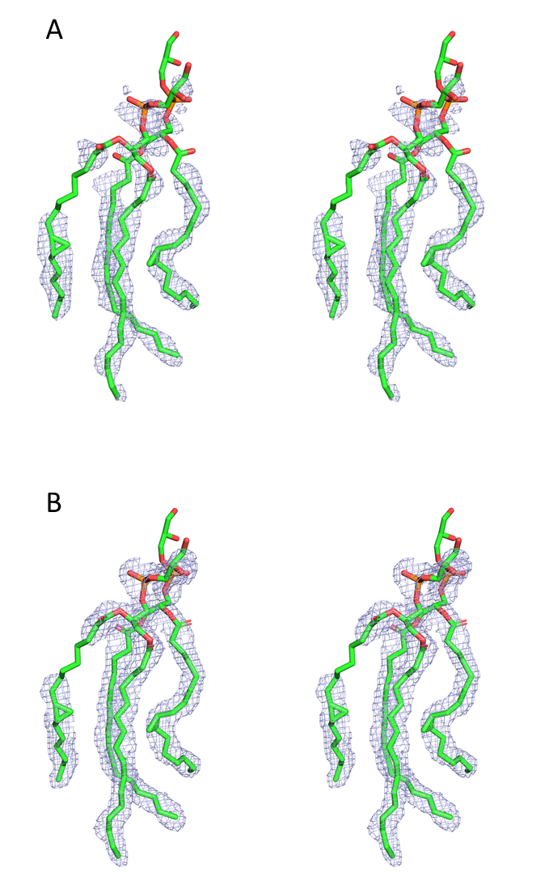
Figure S2. (A) Unbiased 2mF_{o} - DF_{c} electron density map from AutoBuild (without any ligand added) and (B) final feature-enhanced electron density map (with modeled ligands) for the refined phospholipids. Both maps are contoured at 1σ (stereo view).

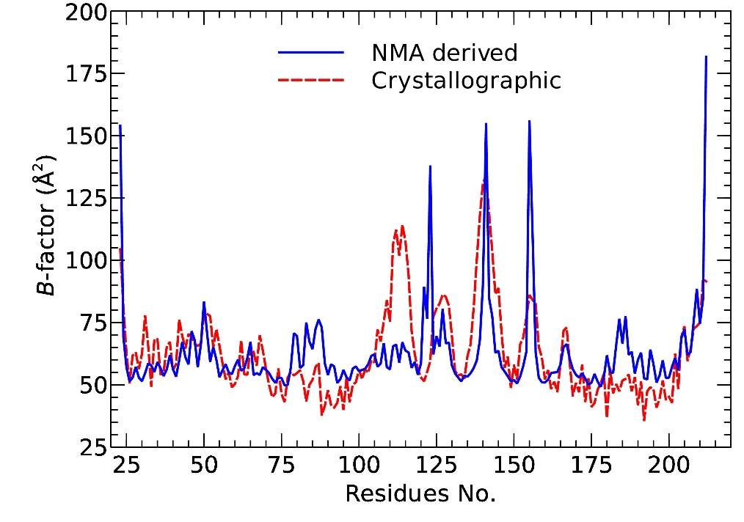

Figure S3. Correlation between normal-mode-derived and crystallographic B-factors (Cα).

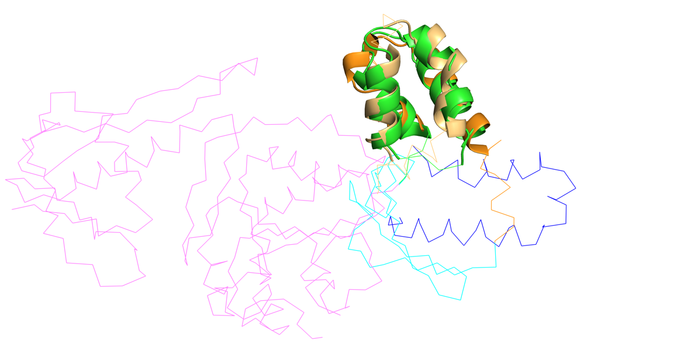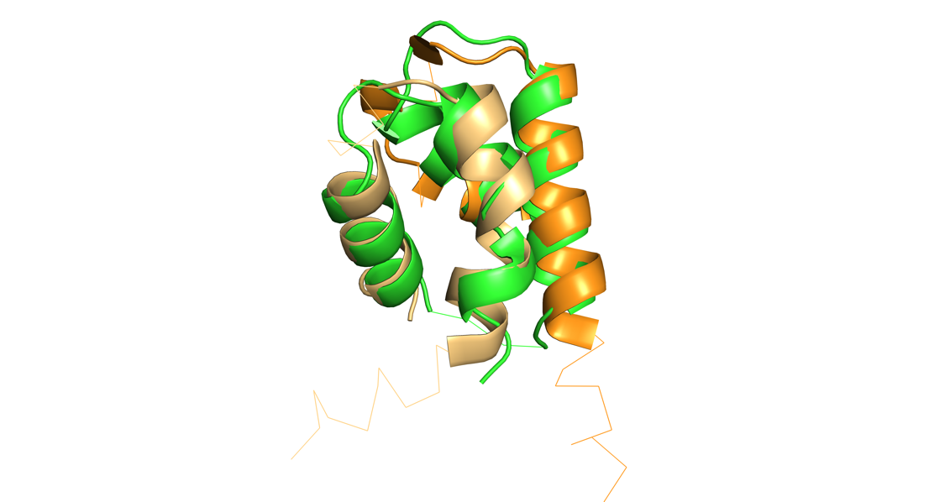

Figure S4: Superposition of Ttg2D_{Pae} with PDB 6UKS chain C, colored by domains. Ttg2D_{Pae} with same colors as in Figs. 1 and S1; 6UKS helical domain in green, other domains in magenta. Superposed residues according to DALI represented as cartoons, non-superposed as Cα-trace. Left panel: both proteins are shown. Right panel: only AAA (ATPases Associated with diverse cellular Activities) helical domain and Ttg2D_{Pae} Domain D2 are represented.

Figure S5: Superposition of Ttg2D_{Pae} (purple structures) on a representative of each subcluster (gray structures) defined in the SBP classification by G. H. Scheepers³⁷. Superposed residues are shown in thick Cα-trace. The table lists the RMSD values and the number of aligned residues for each structural alignment.

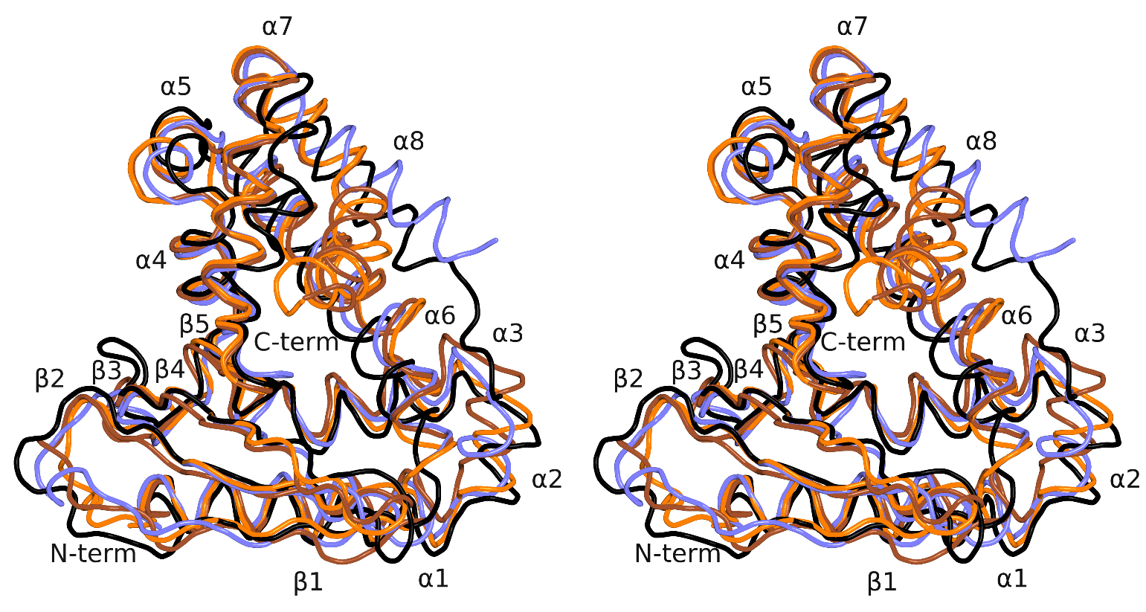
Figure S6. Superposition of the structure of Ttg2D from P. aeruginosa with known orthologous protein structures. Upper panels show superposition of Ttg2D crystal structures from P. aeruginosa (this study, PDB entry 6HSY), P. putida (5UWB), R. solanacearum (2QGU) and E. coli (5UWA) (stereo view). Same color coding as in Fig. S1. Lower panels show superposition of the structures of Ttg2D from P. aeruginosa (green) and R. solanacearum (pink) in two different views. Residues that distinguish the group of proteins that we predict to bind two diacyl lipids are indicated with residue letter and number. Besides G195 and W196, side-chain orientation and hydrophobicity of the other indicated residues in these regions could be also contributing to a tighter binding of the two diacyl phospholipids inside the ligand cavity. Residues in region 65-83 are represented as ball-and-stick and residues in region 154-198 as sticks.

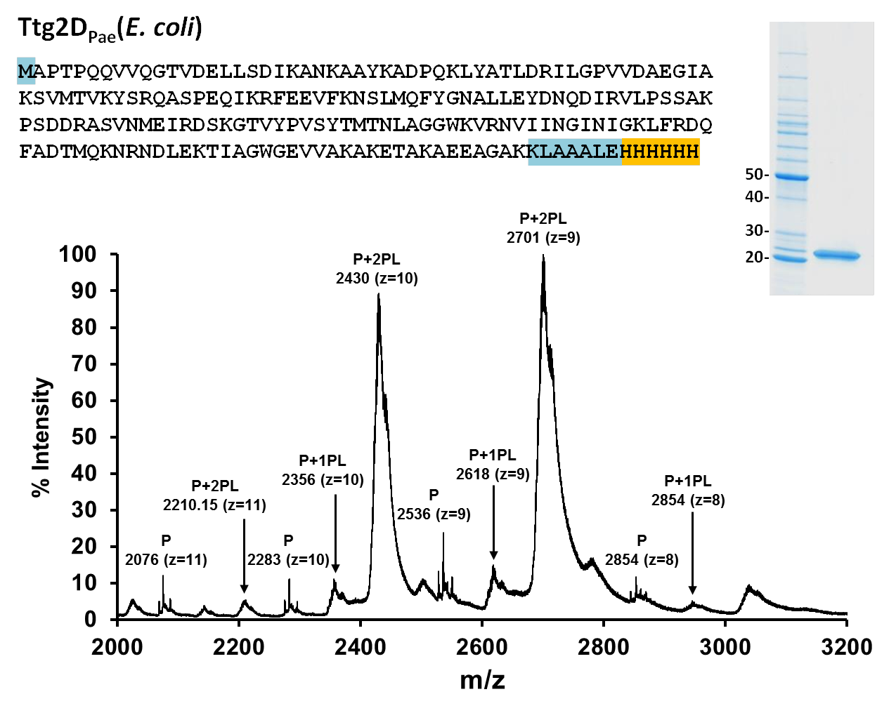
Figure S7. Zoom of the 2000-3000 m/z range of the mass spectrum of Ttg2D_{Pae}, produced in E. coli under native conditions in positive ion mode (The full mass spectrum is shown in Fig. 3A). The most represented species are complexes of the protein (P) containing either one (1PL, deconvoluted MW=23551 Da) or two (2PL, deconvoluted MW=24296) phospholipid molecules. Above the spectrum, the inferred amino acid sequence for the recombinant protein is displayed, highlighting the 6xHis tail in yellow and other added amino acids from pET vector in blue. The SDS-PAGE shows the purified recombinant protein (first column: MW marker in kDa). The theoretical monoisotopic MW of the recombinant protein that has lost the first methionine is 22836.78 Da.

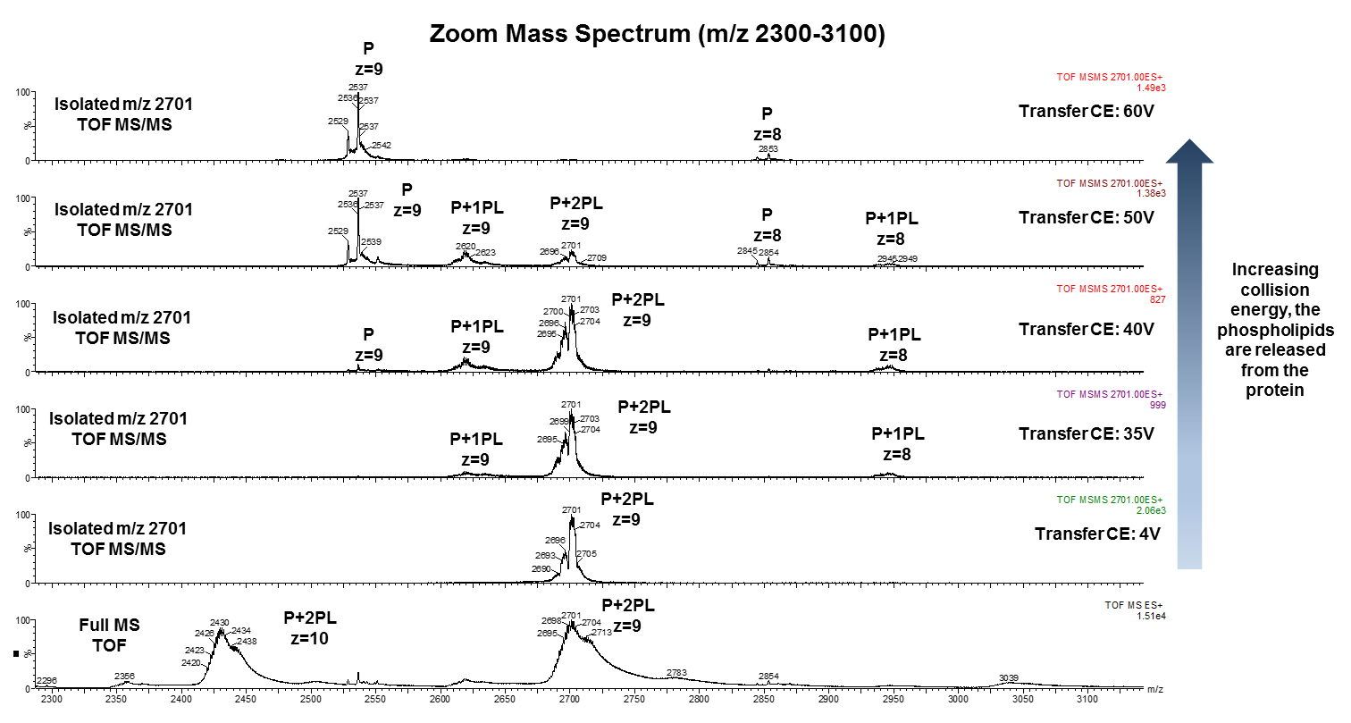
Figure S8. Complexes formed by protein Ttg2D_{Pae} produced in E. coli (P) and phospholipids (PL). Zoom of the 2300–3100 m/z range of the fragment ion mass spectra of isolated ion m/z=2700 (z=9) at varying transfer collision energies (CE). Isolation and dissociation of the species P+2PL at CE greater than 30V have allowed the detection of species with one ligand (P+1PL). However, at CE of 50V there still exists a population of fully charged species were the 2PL could correspond to CL-like molecules. Increasing the CE results in complete release of the phospholipids. The mass of the bound molecules can then be calculated from the mass difference between the bound and unbound peaks.

Figure S9. Lipid species in recombinant Ttg2D_{Pae} produced in E. coli detected by nano-electrospray ionization mass spectrometry (nESI-MS) in positive ion mode at high resolution (100 k) and accuracy (<3ppm) (A). A detailed list of detected peaks is shown in Table S3. Selected ions (m/z 730, z=1 and m/z 732, z=1) were isolated (B) and later fragmented in the gas phase to prove their lipid nature (C) observing the loss of the head of the phospholipid class phosphoethanolamine (-141 Da). Lipid and cardiolipin species in recombinant Ttg2D_{Pae} produced in E. coli detected by LC-MS under denaturing conditions in positive mode (D).

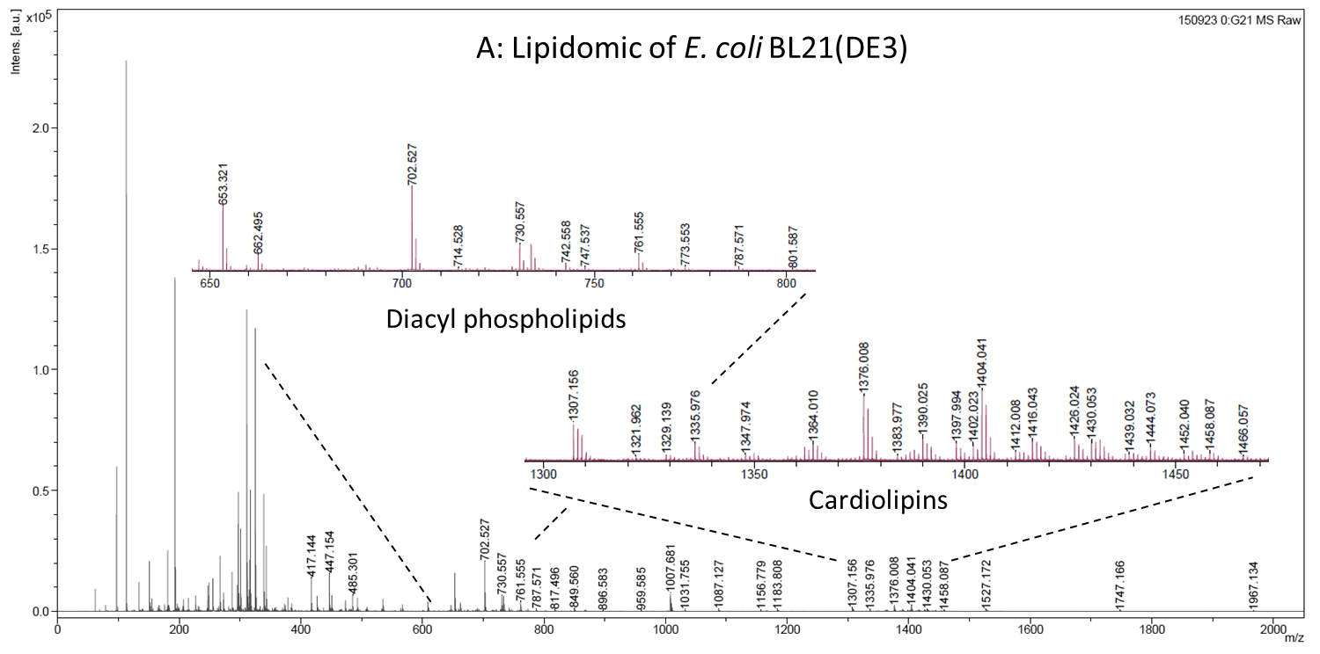
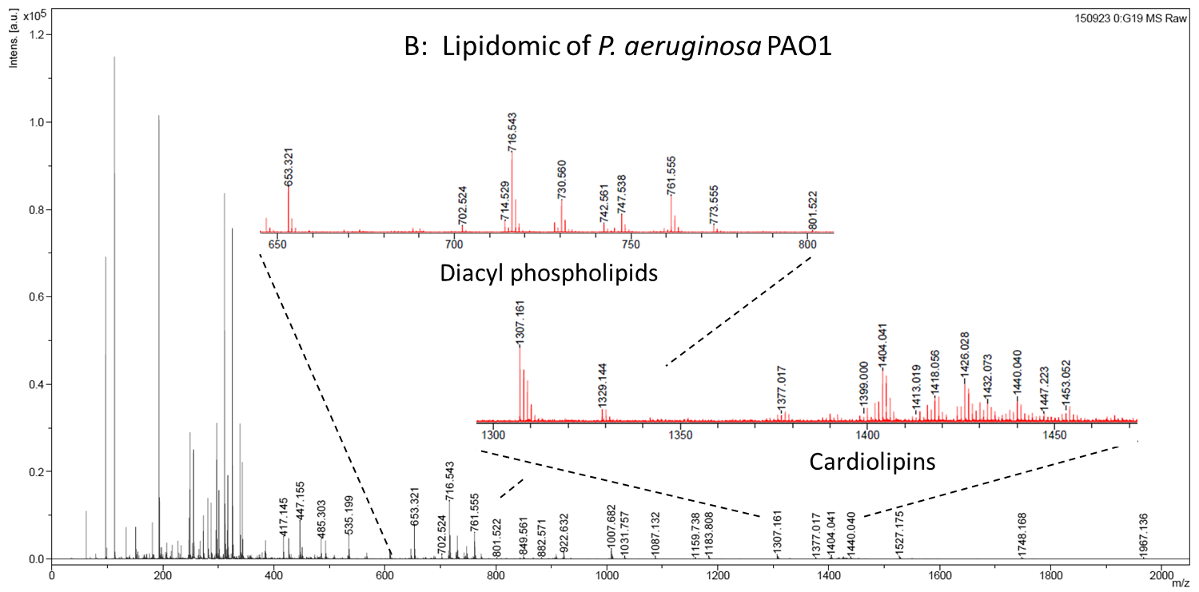
Figure S10. Negative MALDI-TOF/MS lipid profiles of the major membrane phospholipids in E. coli BL21(DE3) (A) and P. aeruginosa PAO1 (B) acquired using 9-AA as matrix.

Figure S11. Fragmentations of isolated ion m/z=2430 (z=9) at varying transfer collision energies (CE) from the ligand–binding assays to study the interaction in vitro between delipidated Ttg2D_{Pae} (P) and cardiolipin (CL). (A) Zoom of the 2000–3000 m/z mass spectra range. Increasing the CE results in partial release of the bound cardiolipin. (B) Zoom of the 200–2000 m/z mass spectra range. At the transfer CE required for cardiolipin release this molecule is easily fragmented. Fragmentation of cardiolipin usually occurs at the phosphate ester bonds to glycerol or at the ester bond of the fatty acids⁷¹.

Figure S12. Lipid species in Ttg2D_{Pae} produced in P. aeruginosa detected by nanoelectrospray ionization mass spectrometry (nESI-MS) in negative mode at high resolution (100 k) and accuracy (<3ppm). A detailed list of detected peaks in negative mode is shown in Table S4.

Figure S13: Generation of ttg2 mutants in MDR P. aeruginosa strains using a modified pGPI-SceI/pDAI-SceI-SacB system. (A) Schematic representation of the construction of the ttg2 knockout mutant. See supplementary methods for details. Primer pairs for amplification of the upstream (US) and downstream (DS) fragments for recombination events are represented as blue arrows. The second recombination event generates the desired mutant or results in reversion to wild type (WT). (B) Screening for the spontaneous resolution of cointegrates in P. aeruginosa strain C17 in the presence of pyrocatechol. In the presence of this compound, colonies expressing 2,3-catechol-dioxygenase encoded by xylE turn yellow, while P. aeruginosa xylE negative colonies turn dark brown. The picture shows a selective agar plate containing representative colonies after spraying with pyrocatechol. (C) Screening by PCR to confirm the deletion using external primers represented as orange arrows in panel A. Expected amplicon sizes in the WT and in the mutant (Δ) are 4755 bp and 1849 bp respectively. (D) Real-time PCR (qPCR) of cDNA amplified from WT and ttg2 mutants and complemented strains using ttg2D internal primers (represented as red arrows in panel A). Expression levels were normalized to the rpsL levels.

Supplementary references

1. Nurizzo D, et al. The ID23-1 structural biology beamline at the ESRF. Journal of Synchrotron Radiation 13, 227-238 (2006).

2. Battye TGG, Kontogiannis L, Johnson O, Powell HR, Leslie AGW. iMOSFLM: a new graphical interface for diffraction-image processing with MOSFLM. Acta Crystallogr D Struct Biol 67, 271-281 (2011).

3. Evans PR, Murshudov GN. How good are my data and what is the resolution? Acta Crystallogr D Struct Biol 69, 1204-1214 (2013).

4. McCoy AJ, Grosse-Kunstleve RW, Adams PD, Winn MD, Storoni LC, Read RJ. Phaser crystallographic software. J Appl Cryst 40, 658-674 (2007).

5. Eswar N, et al. Comparative Protein Structure Modeling Using Modeller. Curr Protoc Bioinformatics 0 5, Unit-5.6 (2006).

6. Adams PD, et al. PHENIX: a comprehensive Python-based system for macromolecular structure solution. Acta Crystallogr D Biol Crystallogr 66, 213-221 (2010).

7. Emsley P, Lohkamp B, Scott WG, Cowtan K. Features and development of Coot. Acta Crystallogr D Struct Biol 66, 486-501 (2010).

8. Chen VB, et al. MolProbity: all-atom structure validation for macromolecular crystallography. Acta Crystallogr D Struct Biol 66, 12-21 (2010).

9. Moriarty NW, Grosse-Kunstleve RW, Adams PD. electronic Ligand Builder and Optimization Workbench (eLBOW): a tool for ligand coordinate and restraint generation. Acta Crystallogr D Biol Crystallogr 65, 1074-1080 (2009).

10. Afonine PV, et al. FEM: feature-enhanced map. Acta Crystallogr D Biol Crystallogr 71, 646-666 (2015).

11. Dundas J, Ouyang Z, Tseng J, Binkowski A, Turpaz Y, Liang J. CASTp: computed atlas of surface topography of proteins with structural and topographical mapping of functionally annotated residues. Nucleic Acids Res 34, W116-W118 (2006).

12. Suhre K, Sanejouand Y-H. ElNémo: a normal mode web server for protein movement analysis and the generation of templates for molecular replacement. Nucleic Acids Res 32, W610-W614 (2004).

13. Li Z, Natarajan P, Ye Y, Hrabe T, Godzik A. POSA: a user-driven, interactive multiple protein structure alignment server. Nucleic Acids Res 42, W240-W245 (2014).

14. Robert X, Gouet P. Deciphering key features in protein structures with the new ENDscript server. Nucleic Acids Res 42, W320-W324 (2014).

15. Choi KH, Kumar A, Schweizer HP. A 10-min method for preparation of highly electrocompetent Pseudomonas aeruginosa cells: application for DNA fragment transfer between chromosomes and plasmid transformation. J Microbiol Methods 64, 391-397 (2006).

16. Imperi F, et al. Analysis of the periplasmic proteome of Pseudomonas aeruginosa, a metabolically versatile opportunistic pathogen. Proteomics 9, 1901-1915 (2009).

17. Angelini R, et al. Lipidomics of intact mitochondria by MALDI-TOF/MS. J Lipid Res 53, 1417-1425 (2012).

18. Flannagan RS, Linn T, Valvano MA. A system for the construction of targeted unmarked gene deletions in the genus Burkholderia. Environmental Microbiology 10, 1652-1660 (2008).

19. Aubert DF, Hamad MA, Valvano MA. A Markerless Deletion Method for Genetic Manipulation of Burkholderia cenocepacia and Other Multidrug-Resistant Gram-Negative Bacteria. Host-Bacteria Interactions: Methods and Protocols 1197, 311-327 (2014).

20. Hamad MA, Skeldon AM, Valvano MA. Construction of Aminoglycoside-Sensitive Burkholderia cenocepacia Strains for Use in Studies of Intracellular Bacteria with the Gentamicin Protection Assay. Appl Environ Microb 76, 3170-3176 (2010).

21. Podbielski A, Peterson JA, Cleary P. Surface Protein-Cat Reporter Fusions Demonstrate Differential Gene-Expression in the Vir Regulon of Streptococcus-Pyogenes. Molecular Microbiology 6, 2253-2265 (1992).

22. Deng Y, et al. Resistance integrons: class 1, 2 and 3 integrons. Ann Clin Microb Anti 14, (2015).

23. Hamad MA, Zajdowicz SL, Holmes RK, Voskuil MI. An allelic exchange system for compliant genetic manipulation of the select agents Burkholderia pseudomallei and Burkholderia mallei. Gene 430, 123-131 (2009).

24. Chen L, Duan KM. A PhoPQ-Regulated ABC Transporter System Exports Tetracycline in Pseudomonas aeruginosa. Antimicrob Agents Ch 60, 3016-3024 (2016).

25. Kovach ME, et al. Four new derivatives of the broad-host-range cloning vector pBBR1MCS, carrying different antibiotic-resistance cassettes. Gene 166, 175-176 (1995).

26. Loh B, Grant C, Hancock RE. Use of the fluorescent probe 1-N-phenylnaphthylamine to study the interactions of aminoglycoside antibiotics with the outer membrane of Pseudomonas aeruginosa. Antimicrob Agents Chemother 26, 546-551 (1984).

27. CLSI. Performance standards for antimicrobial susceptibility testing; 27th edition. CLSI M100-S27. Clinical and Laboratory Standards Institute, Wayne, PA., (2017).

28. CLSI. Methods for dilution antimicrobial susceptibility tests for bacteria that grow aerobically; approved standard. Ninth Edition. CLSI M07-A9. Clinical and Laboratory Standards Institute, Wayne, PA., (2012).

29. Sarker SD, Nahar L, Kumarasamy Y. Microtitre plate-based antibacterial assay incorporating resazurin as an indicator of cell growth, and its application in the in vitro antibacterial screening of phytochemicals. Methods 42, 321-324 (2007).

30. Jeukens J, et al. Comparative Genomics of Isolates of a Pseudomonas aeruginosa Epidemic Strain Associated with Chronic Lung Infections of Cystic Fibrosis Patients. PLoS One 9, e87611 (2014).

31. Li XZ, Zhang L, Poole K. Role of the multidrug efflux systems of Pseudomonas aeruginosa in organic solvent tolerance. J Bacteriol 180, 2987-2991 (1998).

32. O'Toole GA, Pratt LA, Watnick PI, Newman DK, Weaver VB, Kolter R. Genetic approaches to study of biofilms. Method Enzymol 310, 91-109 (1999).

33. Ekiert DC, et al. Architectures of Lipid Transport Systems for the Bacterial Outer Membrane. Cell 169, 273-285 e217 (2017).

34. Crooks GE, Hon G, Chandonia JM, Brenner SE. WebLogo: a sequence logo generator. Genome Res 14, 1188-1190 (2004).

35. Kumar S, Stecher G, Tamura K. MEGA7: Molecular Evolutionary Genetics Analysis Version 7.0 for Bigger Datasets. Mol Biol Evol 33, 1870-1874 (2016).

36. Letunic I, Bork P. Interactive tree of life (iTOL) v3: an online tool for the display and annotation of phylogenetic and other trees. Nucleic Acids Res 44, W242-245 (2016).

37. Scheepers GH, Lycklama A Nijeholt JA, Poolman B. An updated structural classification of substrate-binding proteins. FEBS letters 590, 4393-4401 (2016).

38. Ortiz AR, Strauss CE, Olmea O. MAMMOTH (matching molecular models obtained from theory): an automated method for model comparison. Protein Sci 11, 2606-2621 (2002).

39. Sillitoe I, et al. CATH: comprehensive structural and functional annotations for genome sequences. Nucleic Acids Research 43, D376-D381 (2015).

40. Holm L, Rosenstrom P. Dali server: conservation mapping in 3D. Nucleic Acids Research 38, W545-W549 (2010).

41. Banin E, Brady KM, Greenberg EP. Chelator-induced dispersal and killing of Pseudomonas aeruginosa cells in a biofilm. Appl Environ Microbiol 72, 2064-2069 (2006).

42. Han X, Geng J, Zhang L, Lu T. The role of Escherichia coli YrbB in the lethal action of quinolones. J Antimicrob Chemother 66, 323-331 (2011).

43. Malinverni JC, Silhavy TJ. An ABC transport system that maintains lipid asymmetry in the gram-negative outer membrane. Proc Natl Acad Sci U S A 106, 8009-8014 (2009).

44. Carpenter CD, et al. The Vps/VacJ ABC transporter is required for intercellular spread of Shigella flexneri. Infect Immun 82, 660-669 (2014).

45. Enstrom M, Held K, Ramage B, Brittnacher M, Gallagher L, Manoil C. Genotype-phenotype associations in a nonmodel prokaryote. MBio 3, (2012).

46. Cuccui J, et al. Development of signature-tagged mutagenesis in Burkholderia pseudomallei to identify genes important in survival and pathogenesis. Infect Immun 75, 1186-1195 (2007).

47. Bernier SP, Son S, Surette MG. The Mla Pathway Plays an Essential Role in the Intrinsic Resistance of Burkholderia cepacia Complex Species to Antimicrobials and Host Innate Components. J Bacteriol 200, (2018).

48. Fernandez-Calvet A, et al. Modulation of Haemophilus influenzae interaction with hydrophobic molecules by the VacJ/MlaA lipoprotein impacts strongly on its interplay with the airways. Sci Rep 8, 6872 (2018).

49. Suzuki T, Murai T, Fukuda I, Tobe T, Yoshikawa M, Sasakawa C. Identification and characterization of a chromosomal virulence gene, vacJ, required for intercellular spreading of Shigella flexneri. Mol Microbiol 11, 31-41 (1994).

50. Roier S, et al. A novel mechanism for the biogenesis of outer membrane vesicles in Gram-negative bacteria. Nat Commun 7, 10515 (2016).

51. Shen L, et al. PA2800 plays an important role in both antibiotic susceptibility and virulence in Pseudomonas aeruginosa. Curr Microbiol 65, 601-609 (2012).

52. Lim LM, et al. Resurgence of colistin: a review of resistance, toxicity, pharmacodynamics, and dosing. Pharmacotherapy 30, 1279-1291 (2010).

53. Miller AK, et al. PhoQ mutations promote lipid A modification and polymyxin resistance of Pseudomonas aeruginosa found in colistin-treated cystic fibrosis patients. Antimicrob Agents Chemother 55, 5761-5769 (2011).

54. Barrow K, Kwon DH. Alterations in two-component regulatory systems of phoPQ and pmrAB are associated with polymyxin B resistance in clinical isolates of Pseudomonas aeruginosa. Antimicrob Agents Chemother 53, 5150-5154 (2009).

55. Macfarlane EL, Kwasnicka A, Hancock RE. Role of Pseudomonas aeruginosa PhoP-phoQ in resistance to antimicrobial cationic peptides and aminoglycosides. Microbiology 146 ( Pt 10), 2543-2554 (2000).

56. Gooderham WJ, et al. The sensor kinase PhoQ mediates virulence in Pseudomonas aeruginosa. Microbiology 155, 699-711 (2009).

57. Dalebroux ZD, et al. Delivery of cardiolipins to the Salmonella outer membrane is necessary for survival within host tissues and virulence. Cell Host Microbe 17, 441-451 (2015).

58. Powers MJ, Trent MS. Phospholipid retention in the absence of asymmetry strengthens the outer membrane permeability barrier to last-resort antibiotics. Proc Natl Acad Sci U S A 115, E8518-E8527 (2018).

59. Moskowitz SM, et al. PmrB mutations promote polymyxin resistance of Pseudomonas aeruginosa isolated from colistin-treated cystic fibrosis patients. Antimicrob Agents Chemother 56, 1019-1030 (2012).

60. Oursel D, Loutelier-Bourhis C, Orange N, Chevalier S, Norris V, Lange CM. Lipid composition of membranes of Escherichia coli by liquid chromatography/tandem mass spectrometry using negative electrospray ionization. Rapid Commun Mass Sp 21, 1721-1728 (2007).

61. Gidden J, Denson J, Liyanage R, Ivey DM, Lay JO. Lipid compositions in Escherichia coli and Bacillus subtilis during growth as determined by MALDI-TOF and TOF/TOF mass spectrometry. Int J Mass Spectrom 283, 178-184 (2009).

62. Groenewold MK, et al. A phosphatidic acid-binding protein is important for lipid homeostasis and adaptation to anaerobic biofilm conditions in Pseudomonas aeruginosa. Biochem J 475, 1885-1907 (2018).

63. Jacobs MA, et al. Comprehensive transposon mutant library of Pseudomonas aeruginosa. Proc Natl Acad Sci U S A 100, 14339-14344 (2003).

64. Held K, Ramage E, Jacobs M, Gallagher L, Manoil C. Sequence-verified two-allele transposon mutant library for Pseudomonas aeruginosa PAO1. J Bacteriol 194, 6387-6389 (2012).

65. Cheng K, et al. Spread of beta-lactam-resistant Pseudomonas aeruginosa in a cystic fibrosis clinic. Lancet 348, 639-642 (1996).

66. Smart CH, Walshaw MJ, Hart CA, Winstanley C. Use of suppression subtractive hybridization to examine the accessory genome of the Liverpool cystic fibrosis epidemic strain of Pseudomonas aeruginosa. J Med Microbiol 55, 677-688 (2006).

67. Hanahan D. Studies on Transformation of Escherichia-Coli with Plasmids. Journal of Molecular Biology 166, 557-580 (1983).

68. Miller VL, Mekalanos JJ. A Novel Suicide Vector and Its Use in Construction of Insertion Mutations - Osmoregulation of Outer-Membrane Proteins and Virulence Determinants in Vibrio-Cholerae Requires Toxr. Journal of Bacteriology 170, 2575-2583 (1988).

69. Figurski DH, Helinski DR. Replication of an Origin-Containing Derivative of Plasmid Rk2 Dependent on a Plasmid Function Provided in Trans. P Natl Acad Sci USA 76, 1648-1652 (1979).

70. Guzman LM, Belin D, Carson MJ, Beckwith J. Tight regulation, modulation, and high-level expression by vectors containing the arabinose PBAD promoter. J Bacteriol 177, 4121-4130 (1995).

71. Zhou Y, Peisker H, Dormann P. Molecular species composition of plant cardiolipin determined by liquid chromatography mass spectrometry. J Lipid Res 57, 1308-1321 (2016).

