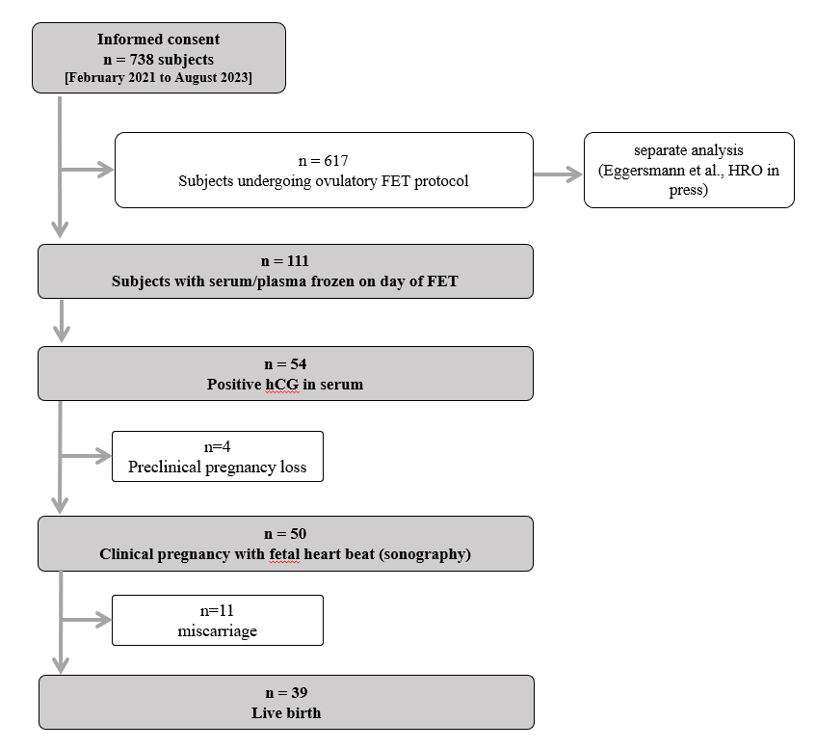
Figure S1: Flowchart depicting patients undergoing FET during the study period. The denominator for the current analysis is 111 patients on HRT-CP-FET protocol and hormone level assessments on day of FET.
 | Overall  (n=111) | No live birth  (n=72) | Live birth  (n=39)
Age at follicular puncture (years) | 32.4 (3.56) | 32.8 (3.69) | 31.7 (3.22)
Height (cm) | 168 (6.71) | 168 (6.33) | 168 [7.45]
Weight (kg) | 78.3 (19.4) | 79.0 (19.7) | 77.1 (18.9)
Body mass index (kg/m²) | 27.6 (6.37) | 27.9 (6.36) | 27.1 (6.44)
Duration of infertility (months) | 48.0 (33.4) | 52.3 (35.1) | 40.2 (28.8)
Caucasian, n (%) | 107 (96.4) | 68 (94.4) | 39 (100.0)
Eumenorrheic, n (%) | 43 (38.7) | 35 (48.6) | 8 (20.5)
AMH (ng/ml) | 5.19 (3.68) | 5.05 (3.81) | 5.45 (3.46)
Smoking, n (%) | 23 (20.7) | 18 (25.0) | 5 (12.8)
Polycystic ovarian syndrome, n (%) | 33 (29.7) | 20 (27.8) | 13 (33.3)
Endometriosis, n (%) | 16 (14.4) | 10 (13.9) | 6 (15.4)
COCs (n) | 17.1 (7.68) | 16.5 (7.98) | 18.3 (7.03)
Trigger Medication*  hCG, n (%)  GnRH-Agonist, n (%) | 72 (69.5)  38 (30.6) | 50 (69.4)  22 (30.6) | 22 (57.9)  16 (42.1)
EMT at last monitoring (mm) | 9.21 (1.72) | 9.08 (1.48) | 9.45 (2.11)
LH at last monitoring (IU/l) | 11.6 (8.74) | 11.3 (9.92) | 12.3 (6.28)
Progesterone at last monitoring (ng/ml) | 0.24 (0.20) | 0.26 (0.23) | 0.204 (0.14)
SET, n (%) | 86 (77.5) | 55 (76.4) | 31 (79.5)
DET or higher, n (%) | 25 (22.5) | 17 (23.6) | 8 (20.5)
Table S1: Demographics of the analyzed patient population with stratification for live birth achievement; depicted are mean and standard deviation or number and proportions (abbr.: AMH = Anti-Muellerian Hormone; EMT = endometrial thickness; LH = Luteinizing hormone; COCs = cumulus-oocyte-complexes; SET = single embryo transfer; DET = double embryo transfer; *missing values n=1).

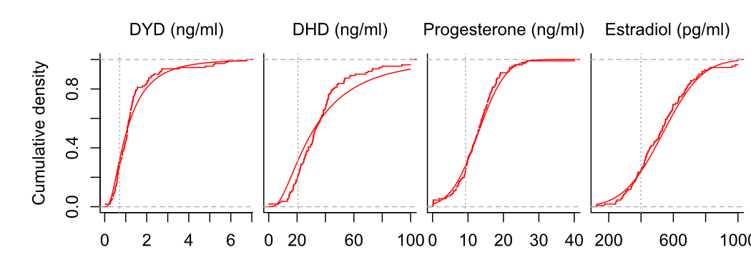
Figure S2: Empirical and theoretical hormone level distributions on day of FET. Normal distributions were assumed for P and E2, lognormal distributions for DYD and DHD. Vertical reference lines are lower quartiles at embryo transfer.

Observed quantiles of hormone concentrations on different days of FET
Day of FET | DYD (ng/ml) |  |  |  |  | DHD (ng/ml) |  |  |  |  | Progesterone (ng/ml) |  |  |  |  | E2 (pg/ml)
Day of FET | 5% | 25% | 50% | 75% | 95% | 5% | 25% | 50% | 75% | 95% | 5% | 25% | 50% | 75% | 95% | 5% | 25% | 50% | 75% | 95%
2 | 0.5420 | 0.779 | 1.070 | 1.921 | 2.598 | 19.16 | 25.23 | 33.95 | 40.41 | 50.61 | 5.648 | 7.43 | 12.18 | 13.33 | 14.30 | 366.2 | 376.1 | 489.8 | 634.6 | 708.6
3 | 0.3750 | 0.545 | 0.847 | 1.484 | 3.526 | 12.04 | 20.42 | 26.51 | 34.63 | 78.50 | 0.174 | 9.03 | 12.83 | 14.46 | 16.92 | 273.7 | 428.0 | 531.8 | 637.2 | 986.6
4 | 0.3646 | 0.563 | 0.811 | 1.059 | 1.257 | 15.91 | 19.21 | 23.33 | 27.45 | 30.75 | 6.478 | 8.51 | 11.05 | 13.59 | 15.62 | 445.7 | 484.1 | 532.0 | 579.9 | 618.3
5 | 0.4078 | 0.705 | 1.076 | 1.360 | 4.485 | 14.26 | 22.55 | 33.86 | 42.41 | 88.80 | 3.843 | 9.60 | 13.00 | 16.81 | 22.98 | 277.6 | 400.0 | 517.4 | 653.0 | 826.6

Inferred quantiles of hormone concentrations on different days of FET assuming normal distributions of P, E2 and of logarithms of DYD and DHD.
Day of FET | DYD (ng/ml) |  |  |  |  | DHD (ng/ml) |  |  |  |  | Progesterone (ng/ml) |  |  |  |  | E2 (pg/ml)
Day of FET | 5% | 25% | 50% | 75% | 95% | 5% | 25% | 50% | 75% | 95% | 5% | 25% | 50% | 75% | 95% | 5% | 25% | 50% | 75% | 95%
2 | 0.4296 | 0.7688 | 1.152 | 1.726 | 3.089 | 17.52 | 24.97 | 31.93 | 40.83 | 58.17 | 4.762 | 8.244 | 10.66 | 13.09 | 16.57 | 277.4 | 417.9 | 515.5 | 613.2 | 753.7
3 | 0.2725 | 0.5709 | 0.9545 | 1.596 | 3.343 | 10.3 | 18.4 | 27.55 | 41.25 | 73.71 | 2.564 | 7.586 | 11.08 | 14.57 | 19.59 | 183.8 | 403 | 555.3 | 707.7 | 926.9
4 | 0.1991 | 0.3971 | 0.6416 | 1.037 | 2.068 | 11.89 | 17.02 | 21.83 | 28 | 40.06 | 2.694 | 7.624 | 11.05 | 14.48 | 19.41 | 374.3 | 467.3 | 532 | 596.7 | 689.7
5 | 0.2826 | 0.6071 | 1.033 | 1.758 | 3.778 | 7.571 | 17.38 | 30.96 | 55.17 | 126.6 | 2.956 | 9.125 | 13.41 | 17.7 | 23.87 | 221.8 | 405.3 | 532.9 | 660.4 | 843.9
Table S2: Observed and inferred quantiles of hormone concentrations at different days of frozen embryo transfer (FET), assuming normal distributions of progesterone, estradiol, and of the logarithms of dydrogesterone and 20α-dihydrodydrogesterone (abbr.: DYD = dydrogesterone; DHD = 20α-dihydrodydrogesterone; E2 = estradiol; FET = frozen embryo transfer).

(A) DYD

Endpoint | RD (%) | 95%-CI | P value
Positive pregnancy test | 6.6 | -13.1 to 25.6 | 0.654
Preclinical pregnancy loss | -3.9 | -15.1 to 4.2 | 0.318
Clinical pregnancy | 10.5 | -9.1 to 28.8 | 0.365
Miscarriage | 3.9 | -8.8 to 13.3 | 0.721
Live birth | 6.5 | -13 to 24.4 | 0.646

(B) DHD

Endpoint | RD (%) | 95%-CI | P value
Positive pregnancy test | 9.4 | -12.4 to 29.8 | 0.46
Preclinical pregnancy loss | -0.9 | -13.4 to 6.1 | 1
Clinical pregnancy | 10.3 | -11.4 to 29.9 | 0.451
Miscarriage | 0.7 | -15 to 11.4 | 1
Live birth | 9.6 | -12 to 28 | 0.451

(C) P

Endpoint | RD (%) | 95%-CI | P value
Positive pregnancy test | 2.9 | -17.7 to 23.1 | 0.818
Preclinical pregnancy loss | -0.1 | -10.9 to 6.3 | 1
Clinical pregnancy | 2.9 | -17.7 to 22.8 | 0.816
Miscarriage | 2.5 | -11.5 to 12.3 | 1
Live birth | 0.5 | -20.2 to 19.7 | 1

(D) E2
Endpoint | RD (%) | 95%-CI | P value
Positive pregnancy test | -5 | -25.1 to 15.6 | 0.649
Preclinical pregnancy loss | -5 | -17.6 to 3.6 | 0.251
Clinical pregnancy | 0 | -20.3 to 19.8 | 1
Miscarriage | 3.1 | -11 to 12.8 | 1
Live birth | -3.1 | -23.7 to 16.5 | 0.814
Table S3: Risk differences for pregnancy outcomes between subgroups of low (≤25th percentile) versus normal-high (>25th percentile) hormone levels on day of FET stratified by day of embryo transfer (days 2-3 versus 4-5) (abbr.: A, DYD = dydrogesterone; B, DHD = 20α-dihydrodydrogesterone; C, Progesterone = progesterone; D, E2 = estradiol).

