Supporting Information
Computational Screening of Thermal Regimes for Carbon Pre-Nucleation on Iron Catalysts under CVD-Like Conditions Using Classical Molecular Dynamics

Table S1. Symbolic mapping between selected experimental reference pressures and the corresponding number of gas-phase molecules in the molecular dynamics simulation cell (Lx = 16.7188 Å, Ly = 16.7188 Å, Lz = 56.7188 Å) at T = 1162 K, estimated using the ideal-gas relation N = PV/(kB T). This mapping is used solely to indicate relative density regimes and does not represent the instantaneous pressure in NVT simulations.
Pressure (Pa) | Pressure (bar) | Required N (molecules) ≈ (P V/(k_{B} T)) | Interpretation
10 | 1.0×10⁻⁴ bar | 9.9×10⁻⁶ | Effectively zero molecular occupancy (N ≪ 1), outside the physically meaningful MD regime
65 | 6.5×10⁻⁴ bar | 6.4×10⁻⁵ | Extremely dilute regime (N ≪ 1)
300 | 3.0×10⁻³ bar | 2.96×10⁻⁴ | Dilute gas regime with sub-molecular occupancy
1000 | 1.0×10⁻² bar | 9.88×10⁻⁴ | Still below one molecule per simulation cell
7000 | 7.0×10⁻² bar | 6.92×10⁻³ | Purely symbolic reference point (N ≪ 1); not physically realizable within the present MD framework
Actual simulation (N=10)* | — | — | Fixed molecule count defined in the CONFIG file; corresponds to a high nominal ideal-gas pressure if interpreted macroscopically

(V=1.5853941×10⁻²⁶ m³)
It should be emphasized that the pressure values reported in this table do not represent the actual thermodynamic pressure of the simulated system. Owing to the microscopic size of the MD cell and the use of fixed-volume NVT conditions, any mapping between molecule count and macroscopic pressure is purely symbolic. Accordingly, pressure values are employed only to indicate relative gas-phase density regimes, and no physical conclusions in this work are drawn from absolute pressure values.
*Actual simulation (N = 10) — N is explicitly defined in the CONFIG file. If interpreted through an ideal-gas relation, this fixed molecule count would correspond to a high nominal pressure; however, such a mapping has no physical meaning under fixed-volume NVT conditions and is reported here solely for reference.
The reported pressure values originate from instantaneous virial calculations under fixed-volume NVT conditions and are provided solely for qualitative reference. They are not interpreted as macroscopic CVD pressures.

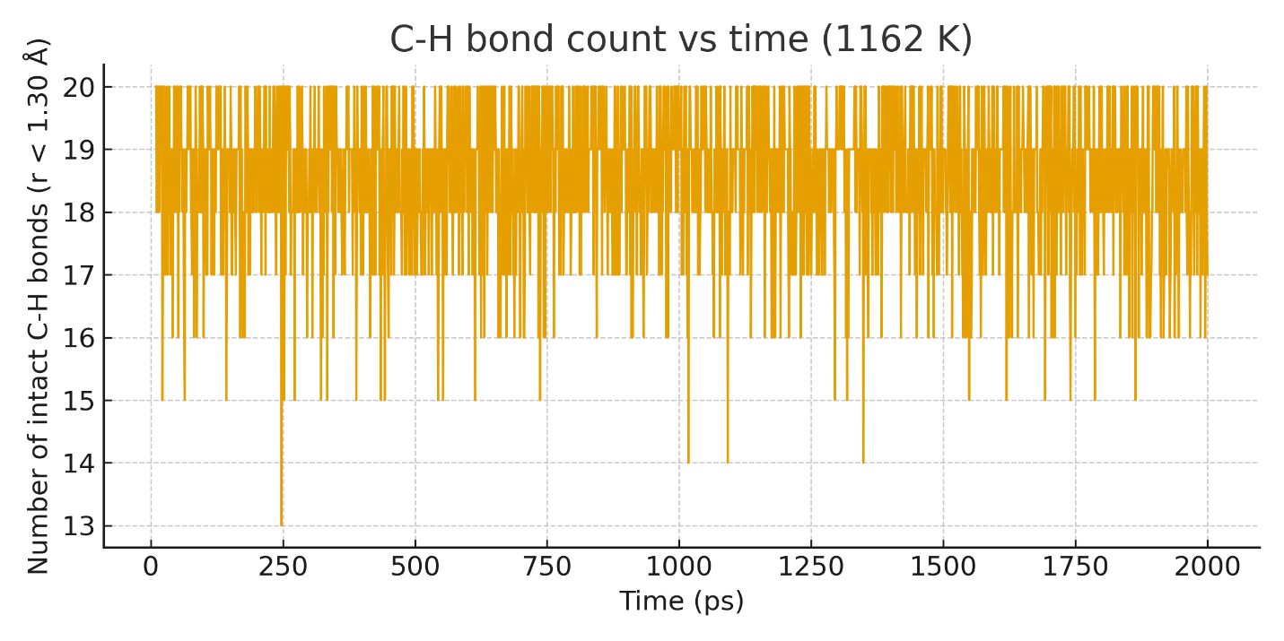
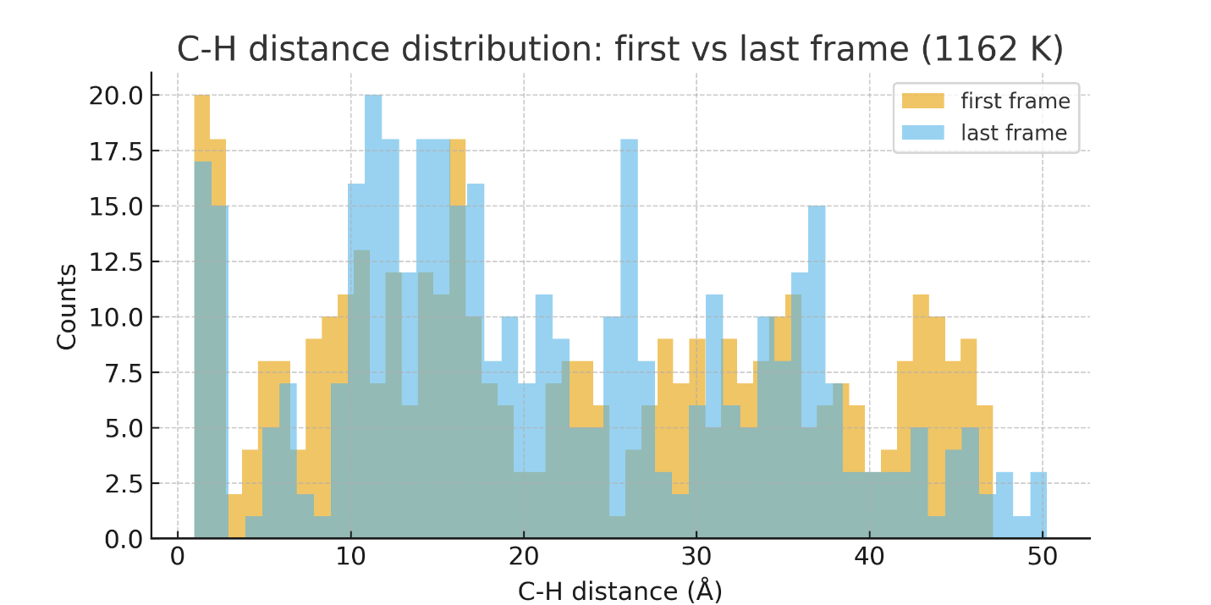
Figure S1. (a) Time evolution of the number of intact C–H bonds (defined as r < 1.30 Å) during the 2.0 ns NVT trajectory at 1162 K. Atomic configurations were saved every 10 ps. Transient decreases in the number of short C–H contacts reflect thermally induced bond stretching events within the non-reactive force-field framework. (b) Histogram of C–H bond-length distributions extracted from the first (orange) and last (blue) saved trajectory frames. The reduced population of short C–H distances at later times indicates enhanced thermal activation and increased atomic mobility, rather than true chemical bond dissociation.

Table S2. Instantaneous virial pressures and average kinetic temperatures obtained from NVT molecular dynamics simulations.
Temperature (K) | Average virial pressure (Pa) | Standard deviation (Pa) | Average Temp (K) | Notes
971 | 6.8×10³ | ±0.4×10³ | 971±4 | Well-equilibrated NVT trajectory
1020 | 6.9×10³ | ±0.6×10³ | 1020±5 | Well-equilibrated NVT trajectory
1059 | 7.1×10³ | ±0.5×10³ | 1059±6 | Well-equilibrated NVT trajectory
1111 | 6.9×10³ | ±0.4×10³ | 1111±4 | Well-equilibrated NVT trajectory
1162 | 7.0×10³ | ±0.5×10³ | 1162±5 | Representative condition used for detailed analysis
1234 | 7.1×10³ | ±0.6×10³ | 1234±6 | Well-equilibrated NVT trajectory
1298 | 7.2×10³ | ±0.7×10³ | 1298±5 | Increased thermal fluctuations observed
Instantaneous pressures were calculated from the virial expression reported in the DL_POLY output. Because the simulations were performed under fixed-volume NVT conditions in a microscopic simulation cell, these virial pressures do not correspond to macroscopic thermodynamic pressures. The reported values exhibit small fluctuations arising from density and kinetic-energy variations inherent to the NVT ensemble and are provided solely for internal consistency and methodological transparency.
* No conclusions in this work are drawn from absolute pressure values; all analyses are based on relative temperature-dependent trends.

Because a non-reactive force field is employed, the observed C–H bond elongation events reflect thermally induced bond stretching rather than true chemical dissociation. These events are therefore used exclusively as qualitative indicators of temperature-driven molecular excitation within the classical MD framework.

Table S3. Table S3. Statistics of thermally induced C–H bond stretching and high-elongation events observed during NVT molecular dynamics simulations. All reported bond-elongation events are defined within a non-reactive force-field framework and do not correspond to chemical bond dissociation.
Temperature (K) | Bond-stretching events (r > 1.30 Å) | High-elongation events (r > 1.60 Å) | Average Duration (ps) |  | Comments
971 | 0 | 0 |  | – |  | Stable acetylene configuration
1020 | 2 | 0 |  | – |  | Minor thermally induced bond stretching
1059 | 3 | 1 |  | 20±5 |  | Initial thermal activation events
1111 | 5 | 2 |  | 15±4 |  | Increased frequency of high-elongation events
1162 | 7 | 3 |  | 12±3 |  | Thermally activated carbon configurations exhibiting enhanced surface affinity
1234 | 4 | 1 |  | 10±3 |  | Short-lived high-elongation events
1298 | 2 | 1 |  | 8±2 |  | Increased gas-phase mobility and reduced surface residence

Table S4. Tersoff potential parameters used to describe Si–O interactions in the rigid SiO₂ substrate.
Parameter | Value | Units
A | 7.010×10⁻²⁰ | J
B | 1.804×10⁻²⁰ | J
λ | 2.4799 | Å⁻¹
μ | 1.7322 | Å⁻¹
β | 1.100×10⁻⁶ | –
n | 0.787 | –
c | 1.0039×10⁵ | –
d | 1.6217×10¹ | –
h | –0.598 | –
Cut-off range | 2.5–2.8 | Å
Scaling (Si–O) | 1.17945 | –

These parameters correspond to those implemented in the DL_POLY FIELD file and are employed to maintain the structural integrity of the amorphous SiO₂ substrate during the simulations. The SiO₂ substrate was treated as rigid to reduce computational cost and to isolate the temperature-dependent behavior of carbon species on the Fe catalyst. This approximation is commonly adopted in atomistic screening studies where the substrate is not the primary focus of the analysis.

Table S5. Lennard–Jones (12–6) parameters used to describe non-bonded interactions between atomic species in the classical MD simulations.
Atom 1 | Atom 2 | ε (J) | σ (Å) | Comment
C | C | 9.216×10⁻²⁶ | 3.40 | Weak non-bonded carbon–carbon interactions
C | Fe | 1.361×10⁻²⁴ | 2.86 | Carbon–catalyst surface interaction
Fe | Fe | 2.015×10⁻²³ | 2.33 | Effective metallic cohesion (non-reactive)
Si | C | 3.446×10⁻²⁵ | 3.70 | Weak carbon–substrate interaction
Si | Fe | 3.690×10⁻²³ | 5.20 | Cross interaction at catalyst–support interface
O | C | 4.908×10⁻²⁵ | 3.19 | Weak physisorption / excluded-volume interaction
O | Fe | 1.099×10⁻²² | 0.0639 | Effective surface interaction (non-reactive)
C | H | 1.50×10⁻²⁵ | 3.315 | Short-range repulsive interaction (non-bonded)
Fe | H | 3.939×10⁻²⁵ | 1.88 | Weak hydrogen–metal interaction
Si | H | 2.089×10⁻²⁵ | 1.35 | Weak hydrogen–substrate interaction
H | H | 7.648×10⁻²⁷ | 1.436 | Reference non-bonded interaction
The Lennard–Jones parameters listed in this table constitute an internally consistent non-reactive force-field framework implemented in DL_POLY. Some ε values differ from those commonly reported in the literature due to internal unit conventions and numerical stabilization strategies adopted to ensure stable time integration and excluded-volume behavior at elevated temperatures. These parameters are not intended to represent physically measurable interaction energies. Consequently, all physical interpretations in this study are based on relative temperature-dependent trends in dynamical and structural descriptors rather than on absolute energetic magnitudes. Terms such as coordination number and interatomic distance are therefore used throughout this work instead of chemical bond descriptors.

