Supplementary Information

Interfacial Redox Buffering Stabilizes Halide Solid Electrolytes Against Low-Potential Anodes

Hyunwon Chu¹, Shuhao Yang¹, Sanggyu Chong², Pravin Didwal¹,
Partha P. Paul³, and Guoying Chen¹*

Hyunwon Chu,¹ Shuhao Yang,¹ Sanggyu Chong,² Pravin Didwal,¹
Partha P. Paul,³ and Guoying Chen^{1,}*

1. Energy Technologies and Systems Division, Lawrence Berkeley National Laboratory, Berkeley, California 94720, United States
2. Laboratory of Computational Science and Modeling, Institute of Materials, École Polytechnique Fédérale de Lausanne, 1015 Lausanne, Switzerland
3. Stanford Synchrotron Radiation Lightsource, SLAC National Accelerator Laboratory, Menlo Park, California 94075, United States

*Corresponding author: gchen@lbl.gov

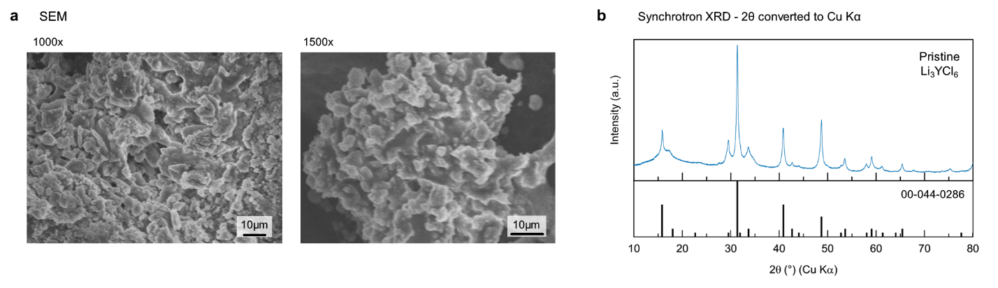
Supplementary Fig. 1 | Morphology and Phase Identification of Pristine LYC. a, Scanning Electron Microscopy (SEM) image showing primary and secondary particles of the pristine LYC powder synthesized by a mechanochemical route. X-ray Diffraction (XRD) pattern of the as-synthesized powder plotted together with the reference pattern for LYC (PDF #00-044-0286).

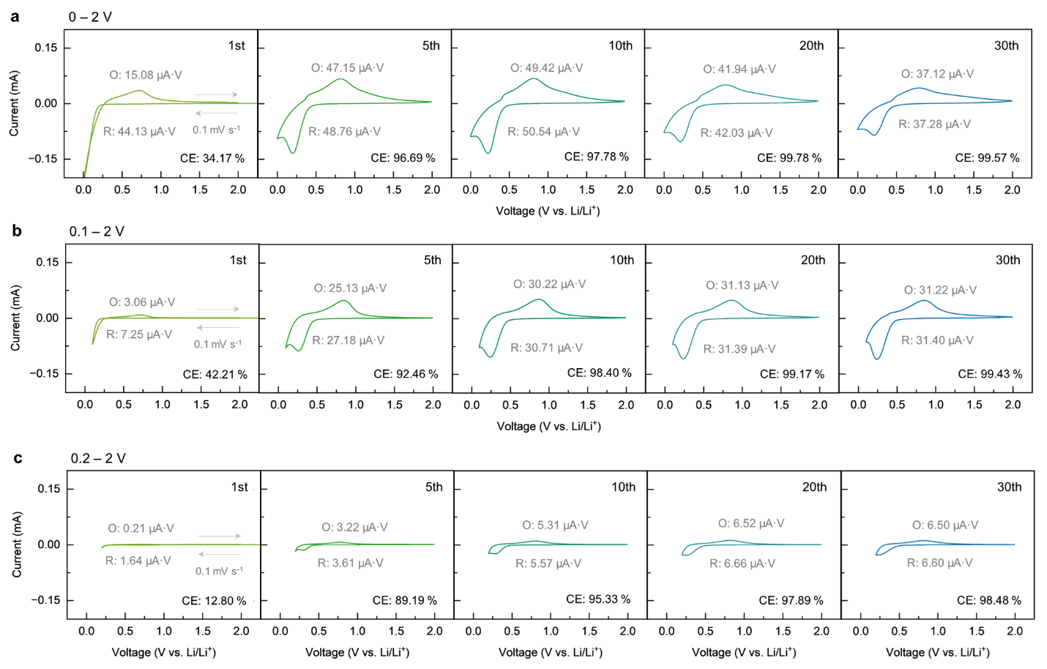
Supplementary Fig. 2 | Extended Cyclic Voltammetry Scans of SS | LYC | Li-In cells. Full CV cycle sets collected up to 30 forward and reverse scans at a scan rate of 0.1 mV s⁻¹ with voltage windows of a, 0–2 V, b, 0.1–2 V, and c, 0.2–2 V. The Coulombic efficiency (CE) of the reduction and oxidation processes is obtained by integrating the respective peak areas, and the resulting CE values are shown in the inset.

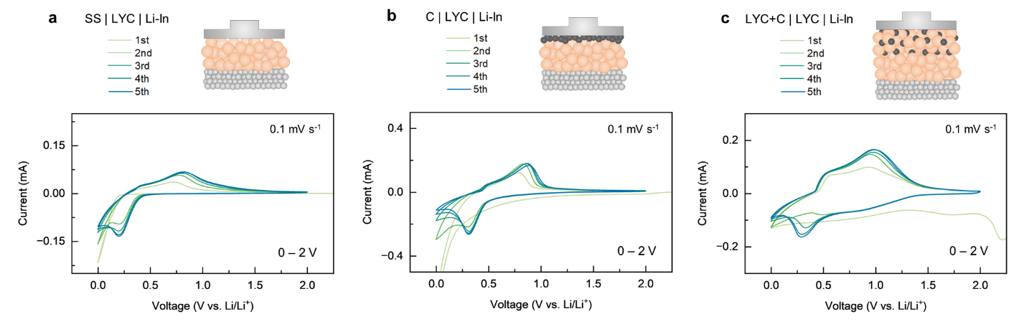
Supplementary Fig. 3 | CV Comparison Under Different Cell Configurations. CV responses between 0–2 V are compared for three cell configurations: a, SS | LYC | Li-In; b, C | LYC | Li-In; and c, LYC+C | LYC | Li-In. The LYC mass is fixed at 100 mg, and the Li-In electrode thickness is set to 150 µm. For b, 4 mg of carbon is used to fully cover the surface. For c, 8 mg of LYC is mixed with 2 mg of carbon through low-energy ball milling to ensure homogeneous mixing. All CV scans are collected over the same voltage window (0–2 V) and at the same scan rate (0.1 mV s⁻¹), and the first five cycles are shown for comparison.

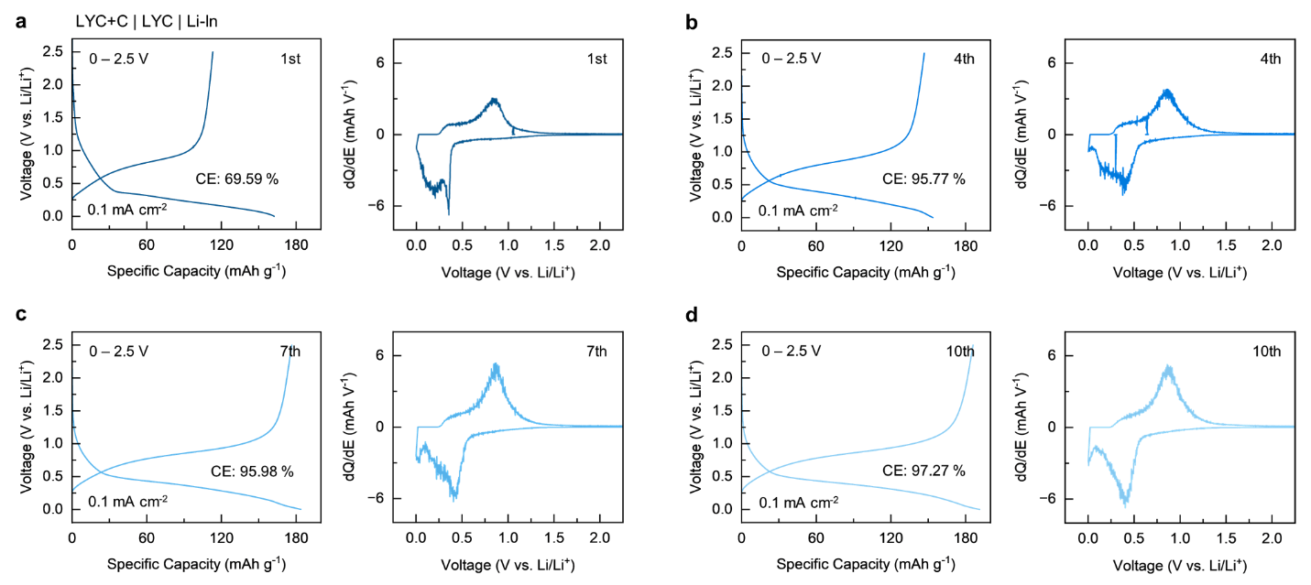
Supplementary Fig. 4 | Extended Galvanostatic Cycling and Differential Capacity. Charge-discharge curves and Coulombic efficiencies (CE) at a, 1st; b, 4th; c, 7th; and d, 10th cycles for LYC/C | LYC | Li-In. The cell was cycled between 0 and 2.5 V at 0.1 mA cm⁻², extending beyond the two representative cycles shown in Fig. 1b. Differential capacity (dQ/dE) plots are provided together with the voltage profiles to highlight the voltage-dependent reduction and oxidation processes.

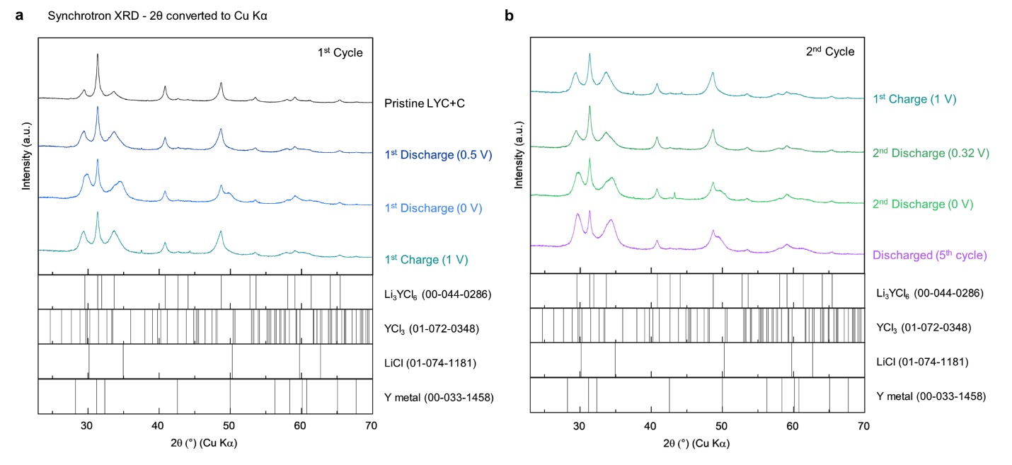
Supplementary Fig. 5 | Phase Comparison of LYC at Different Lithiation States. XRD patterns of LYC/C powders collected after interrupting the cell at selected potentials during the a, 1st and b, 2nd discharge/charge cycles. The synchrotron diffraction data were recalculated to the equivalent 2θ positions for the Cu Kα wavelength using¹:
$$2θ_{Cu Ka}=2\sin^{-1}\left(\frac{λ_{Cu Ka}}{λ_{Synchro}}\sin\left(\frac{2θ_{Synchro}}{2}\right)\right)$$
, where $λ_{Cu Ka}$= 1.5406 Å and $λ_{Synchro}$ = 0.7293 Å. The conversion enables direct comparison with reference diffraction patterns. The profiles are compared against reference patterns of Li₃YCl₆ (PDF #00-044-0286), YCl₃ (PDF #01-072-0348), LiCl (PDF #01-074-1181), and Y metal (PDF #00-033-1458).

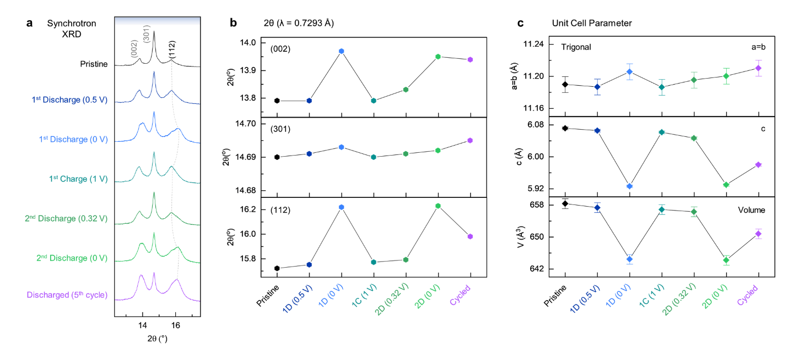
Supplementary Fig. 6 | Lattice Parameter Extraction of LYC During Lithiation and De-lithiation. a, Synchrotron XRD spectra zoomed in the 12-17° 2θ range showing the peak positions of the (002), (301), and (112) reflections at various lithiation and de-lithiation states. b, 2θ values of the (002), (301), and (112) planes plotted as a function of the electrochemical state to visualize the peak-shift evolution more clearly. c, Lattice parameters a=b, c, and unit-cell volume V calculated from the three reflections using the trigonal relations. For the trigonal lattice (hexagonal setting), the d-spacing is given by²:
$$\frac{1}{d_{hkl}^{2}}=\frac{4}{3}\frac{h^{2}+hk+k^{2}}{a^{2}}+\frac{l^{2}}{c^{2}}$$
Using Bragg’s law³:
$$d_{hkl}=\frac{λ}{2\sin{θ_{hkl}}}$$
The lattice parameters were obtained by solving the system of equations from the (002), (301), and (112) reflections. The unit-cell volume was calculated using²:
$$V=\frac{\sqrt{3}}{2}a^{2}c$$

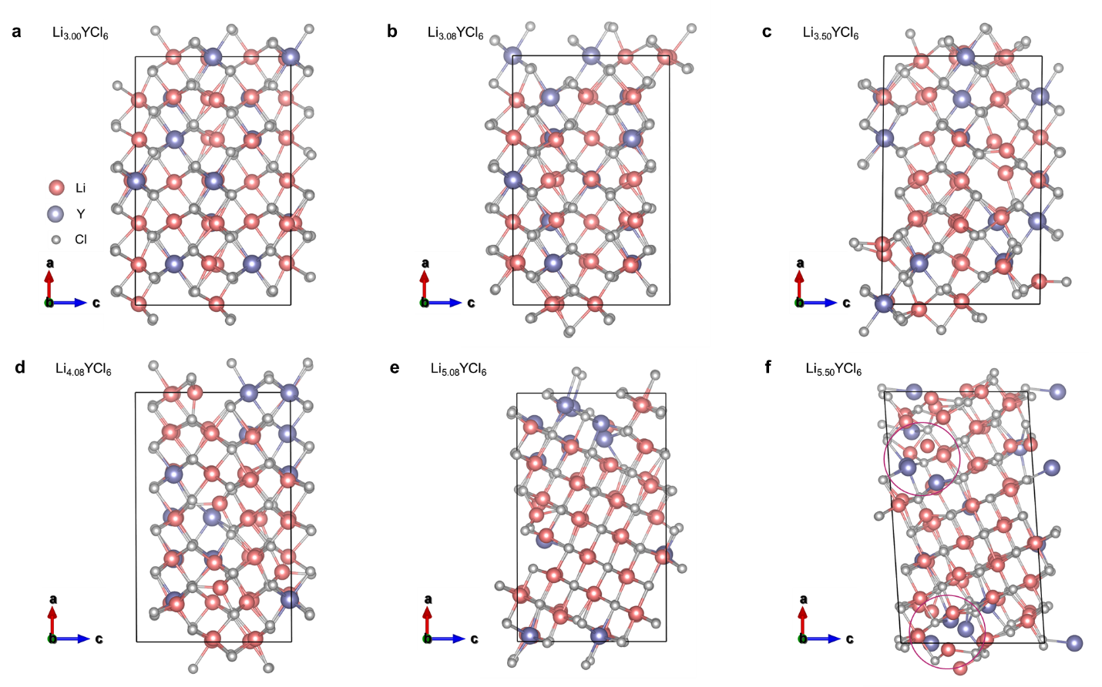
Supplementary Fig. 7 | Structural evolution of the LYC framework at varying lithiation levels. Computationally relaxed atomic structures of Li_{x}YCl₆ using Machine Learning Interatomic Potential (MLIP) and Density Functional Theory (DFT) at Li contents of x = a, 3.00; b, 3.08; c, 3.50; d, 4.08; e, 5.08; and f, 5.50. The crystalline framework remains structurally intact and well-maintained across the reversible lithiation range from Li_{3.00} to Li_{5.08}. However, at a deeper lithiation level of Li_{5.50}, structural degradation starts to appear, characterized by the local accumulation of Y atoms and prominent bond breakages within the halide lattice.
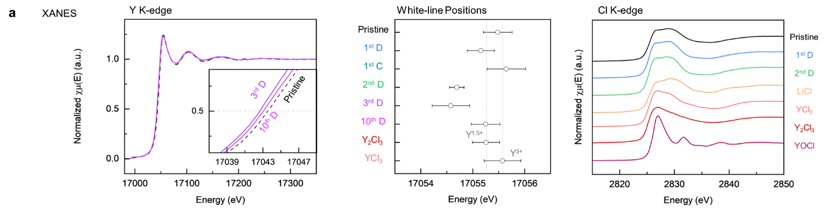
Supplementary Fig. 8 | Y and Cl K-edge XAS of LYC Across Selected Lithiation and De-lithiation States. a, Y K-edge spectra of pristine LYC, the 3rd-cycle discharged (3rd D) sample, and the 10th-cycle discharged (10th D) sample. The extended fine-structure (EXAFS) oscillations remain effectively unchanged, while the near-edge region shows clear energy shifts. b, Energy position of the Y K-edge white line, defined as the maximum of the main absorption peak in the near-edge region, plotted for selected discharge and charge points. Horizontal dashed lines indicate the reference white-line energies of YCl₃ and Y₂Cl₃, corresponding to nominal Y oxidation states of +3 and +1.5. c, Cl K-edge spectra of LYC measured at the same set of lithiation points, compared with reference spectra representing Li-Cl and Y-Cl coordination motifs and possible decomposition products.

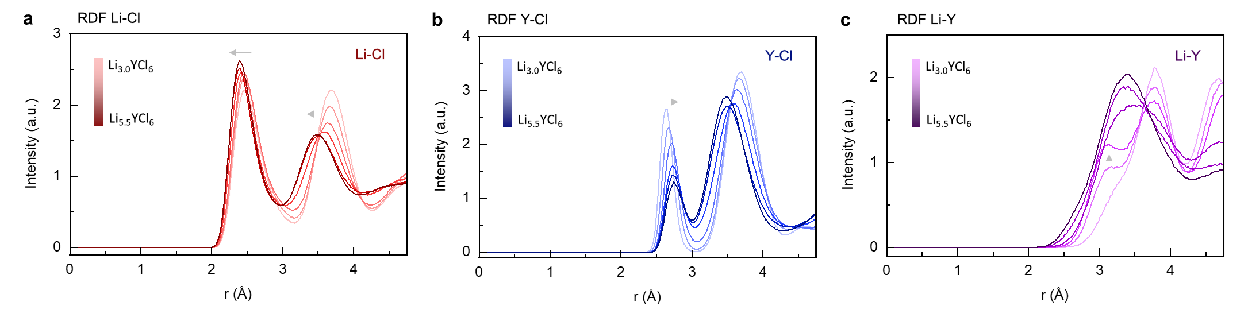
Supplementary Fig. 9 | Evolution of local coordination environments in computationally modeled LYC at varying lithiation levels. Radial distribution function (RDF) profiles for a, Li–Cl, b, Y–Cl, and c, Li–Y pairs extracted from the simulated Li_{x}YCl₆ structures at Li contents of x = 3.0, 3.5, 4.0, 4.5, 5.0, and 5.5. The Li–Cl and Y–Cl RDF profiles show no substantial coordination changes except for bond length variations across the examined lithiation range, confirming that the local structural motifs of the halide framework remain highly stable. In contrast, the Li–Y RDF reveals the emergence and growth of a shorter-distance coordination peak starting around the Li_{4.0} level, which indicates the progressive filling of tetrahedral interstitial sites that typically serve as ionic conduction pathways.

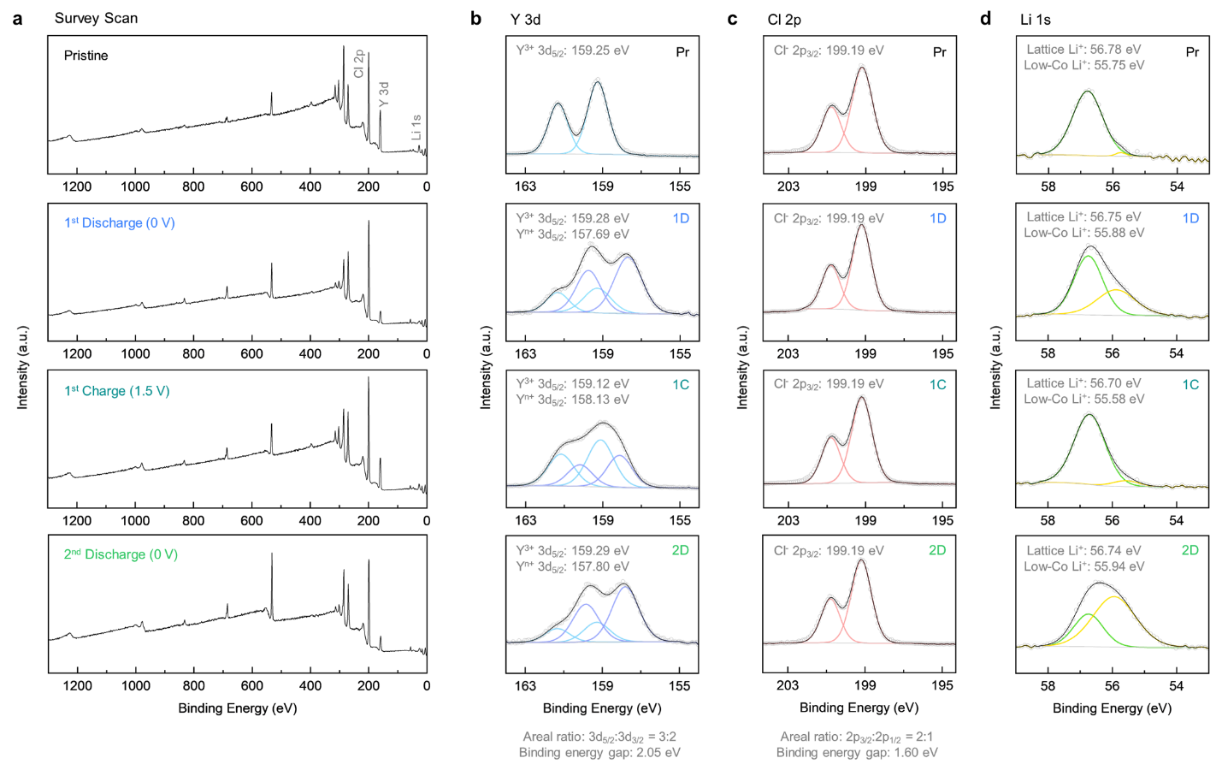
Supplementary Fig. 10 | XPS Analysis of LYC During Lithiation and De-lithiation. a, Survey XPS spectra of the samples collected after the 1st discharge, 1st charge, and 2nd discharge. b, Y 3d core-level spectra with fitted components. The extracted binding energy of the Y 3d_{5/2} peak for each state is listed in the inset. The fitting constraints used for the Y 3d doublet are provided below the panel. c, Cl 2p core-level spectra after fitting. The binding energy of the Cl 2p_{3/2} component is reported in the inset, and the fitting constraints for the Cl 2p doublet are also shown below the panel. d, Li 1s spectra with fitted components. The dominant Li–Cl bonding feature is marked by the green peak. An additional feature appears reversibly in the discharged samples (yellow peak), possibly reflecting changes in the local Li coordination environment upon excess Li insertion. Further investigation is required to identify the precise origin of this component.

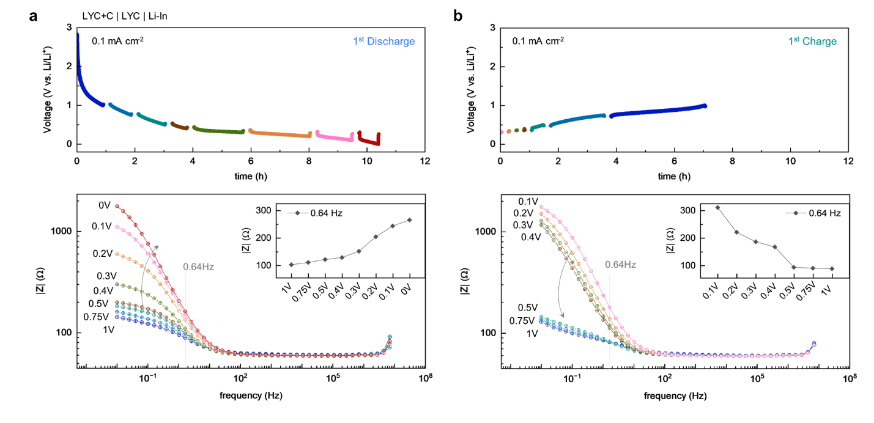
Supplementary Fig. 11 | Impedance Evolution of the LYC/C | LYC | Li-In Cell. Voltage-time profile of the a, 1st discharge and b, 1st charge, segmented at each measurement step. The lower panel shows the Bode impedance spectra overlaid for all sampled voltages. A grey dashed line indicates 0.64 Hz, the top frequency of the electrode-related semicircle in the Nyquist plot, used to visualize how the impedance evolves within LYC/C composite. An inset presents the single-frequency impedance transient at 0.64 Hz.

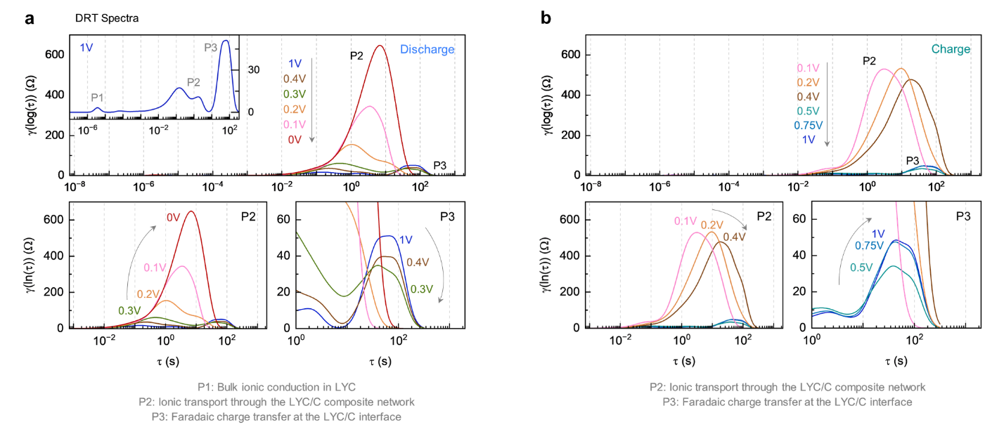
Supplementary Fig. 12 | DRT analysis of the LYC/C | LYC | Li-In cell during discharge and charge. a, Raw DRT spectra collected during the a, 1st discharge and b, 1st charge, using python-based DRTtools⁴. The initial DRT spectra show three distinct relaxation processes labeled P1, P2, and P3. P1 appears at short relaxation times (~10⁻⁶ s) and corresponds to ionic conduction in bulk LYC. P2 appears at intermediate relaxation times (~10⁰ s) and reflects Li-ion transport through the LYC/C composite network. P3 emerges at the longest relaxation times (~10² s) and represents the faradaic charge-transfer step associated with Y-centered redox at the LYC/C interface. During discharge, P2 grows because vacancy filling lowers Li⁺ transport in the LYC/C network and P3 diminishes because progressive Y³⁺ reduction lowers the barrier for further redox. During charge, both P2 and P3 recover toward their initial values.

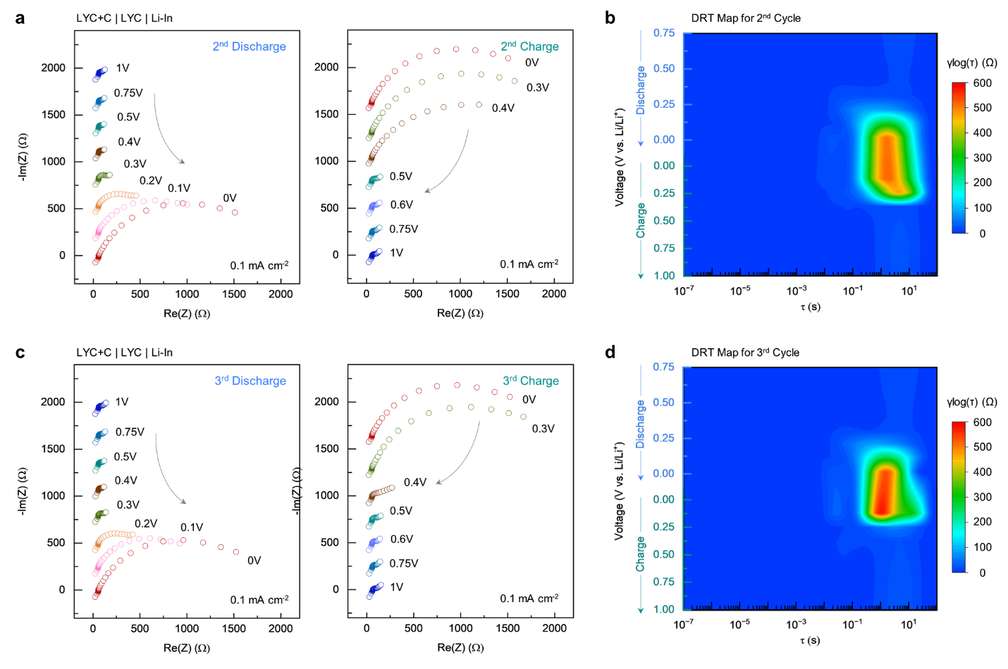
Supplementary Fig. 13 | Impedance and DRT evolution over the 2nd and 3rd cycles. a, Nyquist impedance spectra collected during the 2nd discharge and 2nd charge steps. Each spectrum is segmented according to the applied voltage and shows trends consistent with those observed in the 1st cycle. b, DRT γ-intensity map generated from the spectra in a, illustrating how the kinetic processes evolve through the 2nd insertion and extraction steps. c, Nyquist impedance spectra recorded during the 3rd discharge and charge steps, again displayed at each voltage segment. d, Corresponding DRT intensity map for the 3rd cycle, showing the reproducible evolution across consecutive cycles.

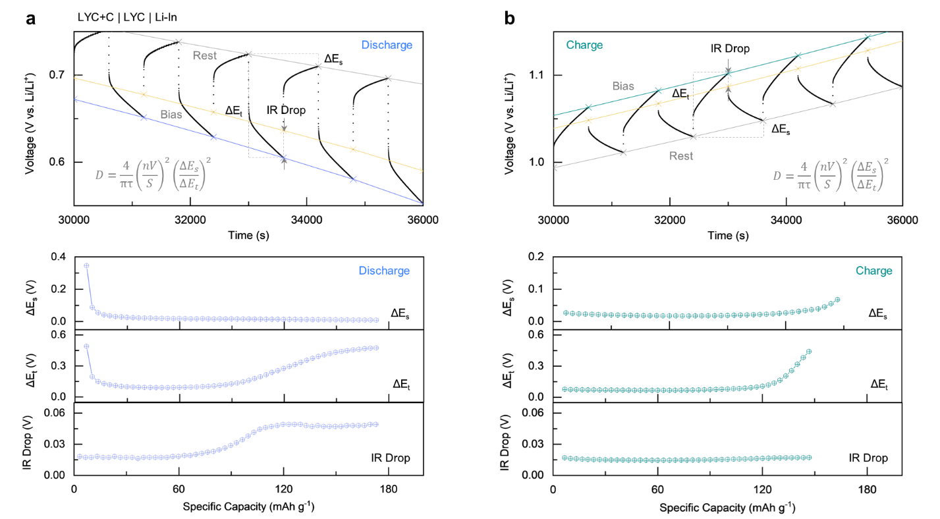
Supplementary Fig. 14 | GITT analysis and effective Li⁺ diffusivity during discharge and charge. Galvanostatic Intermittent Titration Technique (GITT) data collected during the a, discharge and b, charge step. The upper panel shows an enlarged voltage-time trace that displays the bias-voltage evolution during each current pulse and the rest-voltage evolution during the relaxation period. Three quantities required for calculating the effective diffusivity are marked on the plot. ΔE_{t} is the transient voltage change measured during the current pulse after removing the instantaneous IR drop. ΔE_{s} is the steady-state voltage change obtained from the relaxed voltage. The IR drop is the instantaneous potential recovery that appears at the moment the current is switched off. The lower panel plots ΔE_{t}, ΔE_{s}, and the IR drop as a function of capacity. The effective Li⁺ diffusivity is calculated using the following equation⁵⁻⁶:
$$D_{Li^{+}, eff}=\frac{4}{πτ}{\left(\frac{nV}{S}\right)}^{2}{\left(\frac{ΔE_{S}}{ΔE_{t}}\right)}^{2}$$
, where τ is the duration of the current pulse, n is the number of moles of LYC, V is the molar volume of LYC, and S is the apparent electrode area.

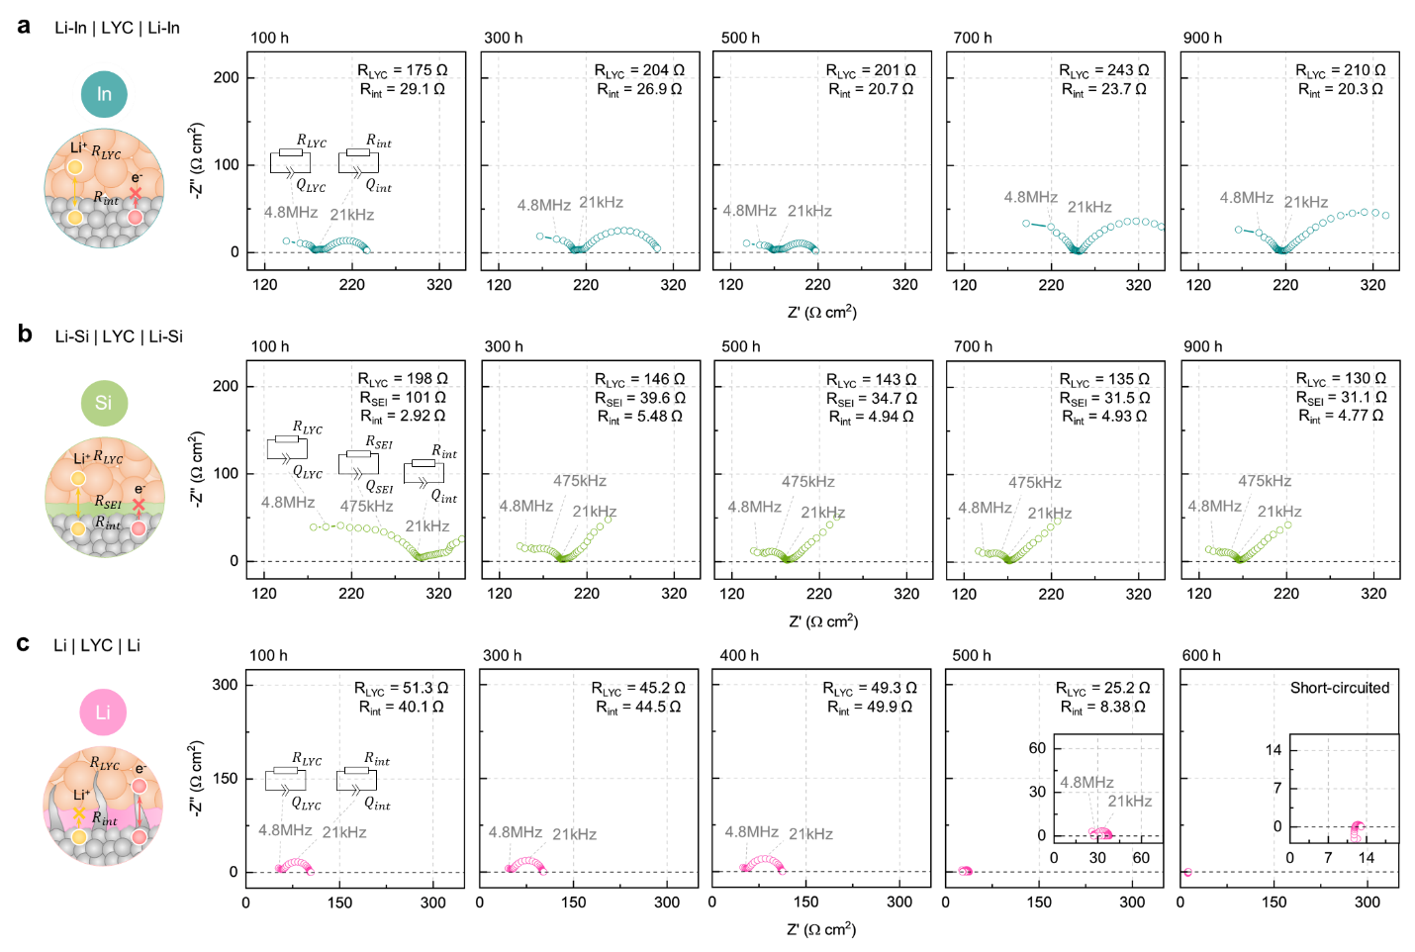
Supplementary Fig. 15 | Cycle-wise EIS and equivalent-circuit fitting for different symmetric cells. a, EIS spectra of the Li-In symmetric cell collected at 100, 300, 500, 700, and 900 h of cycling, together with the corresponding equivalent-circuit fitting results. Two RQ elements reproduce the impedance evolution: one associated with LYC bulk conduction in the high-frequency region (~10⁶ Hz) and the other corresponding to the LYC/anode interfacial response in the mid-frequency region (~10⁴ Hz)⁷. b, EIS spectra of the Li-Si symmetric cell collected at the same cycling times. Three RQ elements are required to fit the spectra. In addition to the LYC bulk (~10⁶ Hz) and interface (~10⁴ Hz) contributions, a third mid-frequency component emerges around ~10⁵ Hz, and this additional feature is included in the fits as “film” resistance. c, EIS spectra of the Li symmetric cell collected at 100, 300, 400, 500, and 600 h, with fitting results shown alongside. Two RQ elements capture the bulk and interfacial responses. The dataset ends at 600 h due to short-circuit formation. For all three anodes, the characteristic frequencies corresponding to the peaks of each fitted semicircle are annotated directly on the Nyquist plots. The rightmost schematic summarizes the expected interfacial response of LYC when contacting Li-In, Li-Si, and Li metal, illustrating the qualitative behaviors associated with each reducing environment.

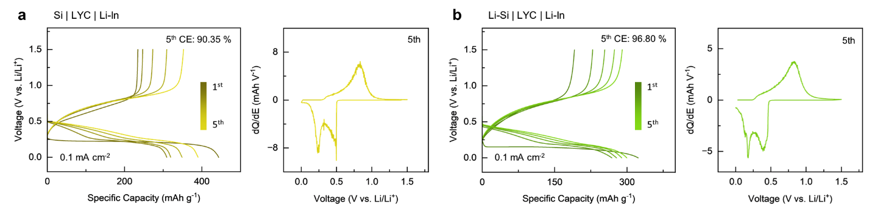
Supplementary Fig. 16 | Electrochemical features of Si and pre-lithiated Si anodes. Voltage-capacity profiles for the first five cycles are shown for both the a, Si | LYC | Li-In cell and the b, pre-lithiated Si (Li-Si) | LYC | Li-In cell, together with their corresponding differential capacity (dQ/dE) plots for the 5th cycle. The dQ/dE curves highlight the lithiation signature of Si, which extends broadly from approximately 0.25 to 0.5 V vs. Li/Li⁺, with a central feature near 0.4 V that defines the operational lithiation window used in subsequent experiments. Early-cycle Coulombic efficiencies are listed for comparison. Pre-lithiation leads to a notable improvement in the 5th cycle CE, increasing from 90.35 % for the pristine Si electrode to 96.80 % for the pre-lithiated case.

References
1. Huang, T. C., Parrish, W., Masciocchi, N. & Wang, P. W. Derivation of d-values from digitized X-ray and synchrotron diffraction data. Adv. X-ray Anal. 33, 295–303 (1989).
2. Cullity, B. D. & Stock, S. R. Elements of X-Ray Diffraction, 3rd ed.; Pearson: New York, 2001.
3. Bragg, W. H. & Bragg, W. L. The reflection of X-rays by crystals. Proc. R. Soc. A 88, 428–438 (1913).
4. Wan, T. H., Saccoccio, M., Chen, C. & Ciucci, F. Influence of the discretization methods on the distribution of relaxation times deconvolution: Implementing radial basis functions with DRTtools. Electrochim. Acta 184, 483–499 (2015).
5. Weppner, W. & Huggins, R. A. Determination of the kinetic parameters of mixed-conducting electrodes and application to the system Li₃Sb. J. Electrochem. Soc. 124, 1569–1578 (1977).
6. Deiss, E. Spurious chemical diffusion coefficients of Li⁺ in electrode materials evaluated with GITT. Electrochim. Acta 50, 2927–2932 (2005).
7. Irvine, J. T. S., Sinclair, D. C. & West, A. R. Electroceramics: Characterization by impedance spectroscopy. Adv. Mater. 2, 132–138 (1990).

