Supplemental Digital Contents
Table of Contents

- Author Information
- Supplemental Table 1. Recommendations Not Updated from 2016 Guideline
- Additional Search Details and Strategy
- Supplementary tables and figures for individual PICOs
  - PICO 1
  - PICO 2
  - PICO 3
  - PICO 4
  - PICO 5

Author information
First/ Middle name | Last Name | Highest Academic Degree | Institutional Affiliation | Chair position | PICO Assignment
Adam | Cuker | MD | Department of Medicine and Department of Pathology & Laboratory Medicine, Perelman School of Medicine, University of Pennsylvania, Philadelphia, PA |  | 3
Bradley | Dengler | MD, FAANS, FACS | Military Traumatic Brain Injury Initiative, Uniformed Services University, Bethesda, MD | SCCM Chair | 5
Charlotte | Cordonnier | MD, PhD | University of Lille, Inserm, CHU Lille, U1172 - LilNCog - Lille Neuroscience & Cognition, Lille, France |  | 4
Colleen | Barthol | PharmD, BCCCP, FNCS | University Health, Department of Pharmacotherapy and Pharmacy Services, San Antonio, TX |  | 4
Joseph D. | Burns | MD | Lahey Hospital and Medical Center, Division of Neurology, Section of Neurocritical Care, Burlington, MA; and UMass Chan Medical School, Department of Neurology, Worcester, MA |  | 3
Lori S. | Kennedy | PhD, RN, ACNP-BC, FNCS, FAAN | UC Davis Health, Center for Nursing Science, Sacramento, CA; Betty Irene Moore School of Nursing at UC Davis, Davis, CA | SCCM Vice Chair | 5
Meghan | Caylor Vallejo | PharmD, BCCCP, FCCM | Temple University Hospital, Department of Pharmacy  Philadelphia, PA | NCS Vice Chair | 2
Monisha A. | Kumar | MD, FNCS | Departments of Neurology, Neurosurgery, & Anesthesiology & Critical Care University of Pennsylvania, Philadelphia, PA | NCS Chair | 1
Sherif Hanafy | Mahmoud | PhD, FNCS | University of Alberta, Faculty of Pharmacy and Pharmaceutical Sciences, Edmonton, AB, Canada |  | 1
Veda K. | Chau | PA-C | Stanford Health Care, Neurocritical Care, Palo Alto, CA |  | 2
Emilie P. | Belley-Cote | MD, PhD | Department of Medicine, Divisions of Cardiology and Critical Care, McMaster University, Ontario; Canada  Population Health Research Institute, Ontario, Canada |  | GUIDE Methodologist
Kimia | Honarmand | MD, MSc, PhD, FRCPC | Division of Critical Care, Department of Medicine, Mackenzie Health, Vaughan, Canada |  | GUIDE Methodologist
M. Elizabeth | Wilcox | MD, PhD | Department of Critical Care Medicine, Faculty of Medicine and Dentistry, University of Alberta, Edmonton, Alberta, Canada;  Neurosciences and Mental Health Institute, University of Alberta, Edmonton, Alberta, Canada |  | GUIDE Methodologist

Supplemental Table 1
Topic | Recommendations Not Updated from 2016 Guideline for Reversal of Antithrombotics in Intracranial Hemorrhage
Vitamin K Antagonists | - We recommend discontinuing vitamin K antagonists when intracranial hemorrhage is present or suspected. (Good Practice statement)  - We recommend urgent reversal of vitamin K antagonists in patients with intracranial hemorrhage (Strong recommendation, moderate quality evidence) with the following considerations:  - We suggest against VKA reversal in patients where there is a high suspicion of intracranial hemorrhage due to cerebral venous thrombosis. (Conditional recommendation, very low-quality evidence)  - We recommend assessing risks and benefits when considering VKA reversal in intracranial hemorrhage patients with concurrent symptomatic or life-threatening thrombosis, ischemia, heparin-induced thrombocytopenia, or DIC. (Good Practice statement)  - We recommend administration of Vitamin K to ensure durable reversal of INR following VKA associated intracranial hemorrhage. Vitamin K should be dosed as soon as possible or concomitantly with other reversal agents. (Strong recommendation, moderate quality evidence)  - We suggest one dose of Vitamin K 10 mg IV. Subsequent treatment should be guided by follow-up INR. (Good Practice statement)  - If repeat INR is still elevated ≥1.4 within the first 24–48 h after reversal agent administration, we suggest redosing with vitamin K 10 mg IV. (Good Practice statement)  - We recommend administering 3-factor or 4-factor PCC rather than FFP to patients with VKA-associated intracranial hemorrhage and INR ≥ 1.4. (Strong recommendation, moderate quality evidence)  - We suggest the use of 4-factor PCC over 3-factor PCC. (Conditional recommendation, low-quality evidence)  - We suggest initial reversal with PCC alone (either 3- or 4- factor) rather than combined with FFP or rFVIIa. (Conditional recommendation, low-quality evidence)  - We recommend that PCC dosing should be weight-based and vary according to admission INR and type of PCC used. (Strong recommendation, moderate quality evidence)  - We recommend repeating INR testing soon after PCC administration (15–60 min), and serially every 6–8 h for the next 24–48 h. Subsequent treatment should be guided by follow-up INR, with consideration given to the fact that repeat PCC dosing may lead to increased thrombotic complications and risk of DIC. (Good Practice statement)  - If the repeat INR is still elevated ≥1.4 within the first 24–48 h after initial PCC dosing, we suggest further correction with FFP. (Conditional recommendation, low-quality evidence)  - We recommend against administration of rFVIIa for the reversal of VKA. (Strong recommendation, low quality evidence)  - If PCCs are not available or contraindicated, alternative treatment is recommended over no treatment. (Strong recommendation, moderate quality evidence) Treatment choice may be guided by available therapies and patient-specific factors. (Good Practice statement)  - Treatment with FFP and Vitamin K is recommended over no treatment. (Strong recommendation, moderate quality evidence)  - We suggest dosing FFP at 10–15 ml/kg IV along with one dose of vitamin K 10 mg IV. (Conditional recommendation, low-quality evidence)
Direct Thrombin Inhibitors | - We recommend discontinuing direct thrombin inhibitors when intracranial hemorrhage is present or suspected. (Good Practice statement)  - We recommend assessing the time and amount of the last ingested dose, renal function, and possible medication interactions to assist in estimating the degree of anticoagulation exposure. (Good Practice statement)  - We suggest that pharmacological reversal of direct thrombin inhibitors should be guided primarily by bleeding (major or intracranial) and not primarily by laboratory testing. (Conditional recommendation, low-quality evidence)  - We suggest administering activated charcoal (50 g) to intubated intracranial hemorrhage patients with enteral access and/or those at low risk of aspiration who present within 2 h of ingestion of an oral direct thrombin inhibitor. (Conditional recommendation, very low-quality evidence)  - We recommend administering idarucizumab (5 g IV in two divided doses) to patients with intracranial hemorrhage associated with dabigatran if:  - The dabigatran was administered within a period of 3–5 half-lives and there is no evidence of renal failure (Strong recommendation, moderate quality of evidence) or  - There is renal insufficiency leading to continued drug exposure beyond the normal 3–5 half-lives (Strong recommendation, moderate quality of evidence)  - We suggest administering aPCC (50 units/kg) or 4-factor PCC (50 units/kg) to patients with intracranial hemorrhage associated with direct thrombin inhibitors if idarucizumab is not available or if the hemorrhage is associated with a DTI other than dabigatran if:  - The direct thrombin inhibitor was administered within a period of 3–5 half-lives and there is no evidence of renal failure (Conditional recommendation, low-quality evidence) or  - There is renal insufficiency leading to continued drug exposure beyond the normal 3–5 half-lives. (Conditional recommendation, low-quality evidence)  - In patients with dabigatran-associated intracranial hemorrhage and renal insufficiency or dabigatran overdose, we suggest hemodialysis if idarucizumab is not available. (Conditional recommendation, low quality data)  - In patients with dabigatran-associated intracranial hemorrhage who have already been treated with idarucizumab, PCC, or aPCC, with ongoing evidence of clinically significant bleeding, we suggest consideration of redosing idarucizumab and/or hemodialysis. (Conditional recommendation, low quality evidence)  - We recommend against administration of rFVIIa or FFP in direct thrombin inhibitor-related intracranial hemorrhage. (Strong recommendation, low-quality evidence)
Unfractionated Heparin | - We recommend discontinuing heparin infusions when intracranial hemorrhage is present or suspected. (Good Practice statement)  - We recommend urgently reversing anticoagulation in patients who develop intracranial hemorrhage during full dose heparin infusion. (Good Practice statement)  - We do not recommend routinely reversing prophylactic subcutaneous heparin. (Good Practice statement)  - We suggest considering reversal of prophylactic subcutaneous heparin if the aPTT is significantly prolonged. (Good Practice statement)  - We recommend administering intravenous protamine sulfate to reverse heparin in the context of intracranial hemorrhage. (Strong recommendation, moderate quality evidence)  - We recommend dosing protamine according to the dose of heparin infused over the preceding 2–3 h. (Strong recommendation, high-quality evidence)  - We recommend dosing protamine sulfate at 1 mg for every 100 units of heparin given in the previous 2–3 h with a maximum single dose of 50 mg. (Strong recommendation, moderate quality evidence)  - If the aPTT remains elevated, we suggest repeat administration of protamine at a dose of 0.5 mg protamine per 100 units of UFH. (Conditional recommendation, low quality of evidence)
Low-Molecular Weight Heparin (LMWH) | - We recommend discontinuing LMWH when intracranial hemorrhage is present or suspected. (Good Practice statement)  - We recommend reversing LMWH in patients with intracranial hemorrhage receiving therapeutic doses of LMWH. (Strong recommendation, moderate evidence)  - We recommend protamine administration by slow intravenous injection over a period of about 10 min according to the following dosing:  - For enoxaparin: If enoxaparin was given within 8 h, protamine sulfate should be administered at a dose of 1 mg per 1 mg of enoxaparin administered (up to a maximum single dose of 50 mg). If enoxaparin was given within 8–12 h, a dose of 0.5 mg of protamine per 1 mg of enoxaparin should be administered. After 3–5 half-lives have elapsed, protamine is probably not needed. (Strong recommendation, moderate quality evidence)  - For dalteparin, nadroparin, and tinzaparin: Dose protamine at 1 mg per 100 anti-Xa units of LMWH administered in the past 3–5 half-lives of the drug, up to a maximum single dose of 50 mg. (Strong recommendation, moderate quality evidence)  - If life-threatening bleeding persists, or the patient has renal insufficiency, we suggest redosing protamine (0.5 mg of protamine per 100 anti-Xa units or per 1 mg of enoxaparin). (Conditional recommendation, very low-quality evidence)  - We suggest considering recombinant Factor VIIa (90 mcg/kg IV) if protamine is contraindicated. (Conditional recommendation, very low-quality evidence)  - We recommend against the reversal of LMWH in patients with intracranial hemorrhage receiving prophylactic dosing of LMWH. (Good Practice statement).  - We suggest against reversing danaparoid with protamine. (Conditional recommendation, low-quality evidence)  - We suggest reversing danaparoid with recombinant Factor VIIa (90 mcg/kg IV once) in the context of intracranial hemorrhage. (Conditional recommendation, very low-quality evidence)  - We suggest against using FFP, PCC, or aPCC to reverse LMWH. (Conditional recommendation, low quality evidence)
Pentasaccharides | - We recommend discontinuing pentasaccharides when intracranial hemorrhage is present or suspected. (Good Practice statement)  - We suggest reversing pentasaccharides in patients with intracranial hemorrhage receiving full therapeutic doses. (Good Practice statement)  - We suggest administration of aPCC (20 IU/kg) for reversal of pentasaccharides. (Conditional recommendation, low-quality evidence)  - If aPCC is contraindicated or not available, we suggest administration of rFVIIa (90 mcg/kg). (Conditional recommendation, low-quality evidence)  - We recommend against protamine for reversal of pentasaccharides. (Strong recommendation, low-quality evidence)  - In intracranial hemorrhage patients receiving pentasaccharides for venous thromboembolism prophylaxis, we suggest against reversal unless there is evidence of bioaccumulation or impaired clearance. (Good Practice statement)
Thrombolytics (Plasminogen Activators) | - We recommend discontinuing thrombolytic agents when intracranial hemorrhage is present or suspected. (Good Practice statement)  - We suggest using cryoprecipitate (10 units initial dose) in patients with thrombolytic agent-related symptomatic intracranial hemorrhage who have received a thrombolytic agent in the previous 24 h. (Conditional recommendation, low-quality evidence)  - In cases where cryoprecipitate is contraindicated or not available in a timely manner, we suggest using an antifibrinolytic agent (tranexamic acid 10–15 mg/kg IV over 20 min or e-aminocaproic acid 4–5 g IV) as an alternative to cryoprecipitate. (Conditional recommendation, very low-quality evidence)  - We suggest checking fibrinogen levels after administration of reversal agents. If the fibrinogen is less than 150 mg/dL, we suggest administration of additional cryoprecipitate. (Conditional recommendation, very low-quality evidence)  - It is unclear if platelet transfusion is useful and we cannot offer a recommendation at this time.
Supplemental Material 1. Search Details
Search Strategy: The search strategy consisted of both controlled vocabulary, such as the National Library of Medicine’s MeSH (Medical Subject Headings), and keywords. The main search concepts were intracranial hemorrhage and relevant intervention concepts, along with synonyms.
Methodological search filters were applied to limit the retrieval by randomized controlled trial / controlled clinical trial (reference: RCT / CCT - MEDLINE, Embase. In: CADTH Search Filters Database. Ottawa: CADTH; 2024: https://searchfilters.cadth.ca/link/122. Accessed 2024-01-25) or clinical trials / observational studies (reference: All Clinical Trials - MEDLINE, Embase. In: CADTH Search Filters Database. Ottawa: CADTH; 2024: https://searchfilters.cadth.ca/link/117. Accessed 2024-01-25; Observational Studies - MEDLINE. In: CADTH Search Filters Database. Ottawa: CADTH; 2024: https://searchfilters.cadth.ca/link/38. Accessed 2024-01-25; Observational Studies - Embase. In: CADTH Search Filters Database. Ottawa: CADTH; 2024: https://searchfilters.cadth.ca/link/37. Accessed 2024-01-25). Record retrieval was not limited by date or language. Animal only studies were removed. Duplicate records were removed between Medline and Embase using Ovid default duplicate detection, with any additional duplicates identified and removed in EndNote and Covidence.

2a. Concepts
Concept
Intracranial hemorrhage | exp Intracranial Hemorrhages/ use medall  exp Brain Hemorrhage/ use oemezd  (((brain OR cerebrum OR cerebral OR cerebellum OR corpus callosum OR intracerebral OR intra-cerebral OR intracortical OR intra-cortical OR intracranial* OR intra-cranial* OR intraventricular OR intra-ventricular OR periventricular OR peri-ventricular OR posterior fossa OR subarachnoid) ADJ2 (bleed* OR haemorrhage? OR hemorrhage? OR microbleed* OR microhaemorrhage? OR microhemorrhage?)) OR encephalorrhagia? OR haemorrhagic apoplexy OR haemorrhagic stroke? OR hematencephalon OR hemorrhagic apoplexy OR hemorrhagic stroke? OR ICH OR ICHs OR pituitary apoplexy).tw,kf,kw.  [Intracranial Hemorrhage]
Andexanet Alfa (Q1) | Andexanet Alfa/ use oemezd  ("alxn 2070" OR alxn2070 OR andexanet alfa OR andexxa OR 1262449-58-0 OR andexanetum alfa OR BI009E452R OR indexxa OR "Factor Xa (recombinant)" OR Ondexxya OR PRT064445 OR PRT-064445 OR PRT4445 OR PRT-4445 OR r-Antidote OR rfXa Inhibitor Antidote OR UNII-BI009E452R OR V03AB38).mp.  [Andexanet Alfa]
Antiplatelets (Q2 & Q3) | Platelet Aggregation Inhibitors/ use medall  exp Antithrombocytic Agent/ use oemezd  Dual Anti-Platelet Therapy/ use medall  Dual Antiplatelet Therapy/ use oemezd  Antiplatelet Activity/ use oemezd  (antiplatelet? OR anti-platelet? OR antithrombocytic? OR anti-thrombocytic? OR (platelet? ADJ2 (antagonist? OR antiaggregant? OR anti-aggregant? OR (aggregat* ADJ2 inhibitor?) OR inhibitor?)) OR protease-activated receptor-1 antagonist? OR PAR-1 antagonist? OR thrombocyte aggregation inhibit*).tw,kf,kw.  [Antiplatelets]
Platelet transfusion (Q2) | Platelet Transfusion/ use medall  Thrombocyte Transfusion/ use oemezd  ((blood platelet? OR platelet? OR thrombocyt*) ADJ2 transfus*).tw,kf,kw.  [Platelet Transfusion]
Desmopressin (Q3) | Deamino Arginine Vasopressin/ use medall  Desmopressin/ use oemezd  (deamino arginine vasopressin* OR desmopressin* OR "1-deamino-8-d-arginine vasopressin*" OR "1-desamino-8-arginine vasopressin*" OR "(1 deamino 8 dextro arginine)vasopressin*" OR "1 deamine 8 d arginine vasopressin*" OR "1 desamino 8 d arginine vasopressin*" OR "8 (1 desaminoarginine)vasopressin*" OR "[deamino 8 cysteine d arginine]vasopressin*" OR "[deamino 8 cysteine dextro arginine]vasopressin*" OR "[deamino 8 dextro arginine]vasopressin*" OR "deamino 8d arginine vasopressin*" OR "deamino dextro arginine vasopressin*" OR "deaminovasopressin [8 d arginine]" OR "16679-58-6" OR "62288-83-9" OR "62357-86-2" OR adin OR adiuretin OR apo-desmopressin* OR "av 002" OR av002 OR concentraid OR d-void OR "dav ritter" OR ddavp OR defirin OR desmirin OR desmogalen OR desmomelt OR desmopresina OR desmospray OR desmotab? OR desurin OR emosint OR enr1llb0fp OR enupresol OR "fe 992026" OR fe992026 OR minirin OR minirine* OR minirinmelt OR minrin OR minurin OR miram OR nictur OR niwinas OR nocdurna OR noctisson OR noctiva OR nocturin OR nocutil OR nokdirna OR noqdirna OR noqturina OR nordurine OR novidin OR nucotil nasenspray OR octim OR octostim OR presinex OR pseurin OR "ser 120" OR ser120 OR stimate OR wetirin OR xb13hyu18u OR ENR1LLB0FP).mp.  [Desmopressin]
Anticoagulation reversal (Q4) | Anticoagulants/ use medall  exp Anticoagulant Agent/ use oemezd  Fibrinolytic Agents/ use medall  exp Fibrinolytic Agent/ use oemezd  exp Thrombolytic Therapy/ use medall  (anticoagulant? OR anti-coagulant? OR anticoagulati* OR anti-coagulati* OR antithrombic? OR anti-thrombic? OR fibrinolyser? OR antithrombin? OR anti-thrombin? OR antithrombogenic? OR anti-thrombogenic? OR antithrombotic? OR anti-thrombotic? OR fibrinolytic? OR indirect thrombin inhibitor? OR thrombolytic?).mp.  OR/  Anticoagulation Reversal/ [both]  Anticoagulant Reversal Agents/ use medall  Anticoagulant Reversal Agent/ use oemezd  (reversing OR reverse? OR reversal?).mp.  OR/  3 AND 6  [Anticoagulation Reversal]
Viscoelastic hemostatic assays (VHAs) (Q5) | Thrombelastography/ use medall  exp Thromboelastography/ use oemezd  (viscoelastic adj2 (assay? or test? or testing)).tw,kf,kw.  (thrombelastogra* or thromboelastogra* or thrombo-elastogra* or thromboelastometr* or thrombo-elastometr* or thromboelasto-metr* or VEA or VEAS or VET or TEG).tw,kf,kw.  ("Rotational Thromboelastometry" OR ROTEG OR ROTEM OR TEM).tw,kf,kw.  ("Quantra Hemostasis Analyzer" or quantra).tw,kf,kw.  [Viscoelastic Hemostatic Assays]

2b. Filters
Filter
Animals only (NOT’d) | (exp animals/ OR exp animal experimentation/ or exp animal experiment/ OR exp models animal/ OR nonhuman/ OR exp vertebrate/ or exp vertebrates/) NOT (exp humans/ OR exp human experimentation/ OR exp human experiment/)
All clinical trials* | (Randomized Controlled Trial or Controlled Clinical Trial or Pragmatic Clinical Trial or Clinical Study or Adaptive Clinical Trial or Equivalence Trial).pt. OR (Clinical Trial or Clinical Trial, Phase I or Clinical Trial, Phase II or Clinical Trial, Phase III or Clinical Trial, Phase IV or Clinical Trial Protocol).pt. OR Multicenter Study.pt. OR Clinical Studies as Topic/ OR exp Clinical Trial/ or exp Clinical Trials as Topic/ or Clinical Trial Protocol/ or Clinical Trial Protocols as Topic/ or exp "Clinical Trial (topic)"/ OR Multicenter Study/ or Multicenter Studies as Topic/ or "Multicenter Study (topic)"/ OR Randomization/ OR Random Allocation/ OR Double-Blind Method/ OR Double Blind Procedure/ OR Double-Blind Studies/ OR Single-Blind Method/ OR Single Blind Procedure/ OR Single-Blind Studies/ OR Placebos/ OR Placebo/ OR Control Groups/ OR Control Group/ OR Cross-Over Studies/ or Crossover Procedure/ OR (random* or sham or placebo*).tw,hw,kf,kw. OR ((singl* or doubl*) adj (blind* or dumm* or mask*)).tw,hw,kf,kw. OR ((tripl* or trebl*) adj (blind* or dumm* or mask*)).tw,hw,kf,kw. OR (control* adj3 (study or studies or trial* or group*)).tw,hw,kf,kw. OR (clinical adj3 (study or studies or trial*)).tw,hw,kf,kw. OR (Nonrandom* or non random* or non-random* or quasi-random* or quasirandom*).tw,hw,kf,kw. OR (phase adj3 (study or studies or trial*)).tw,hw,kf,kw. OR ((crossover or cross-over) adj3 (study or studies or trial*)).tw,hw,kf,kw. OR ((multicent* or multi-cent*) adj3 (study or studies or trial*)).tw,hw,kf,kw. OR allocated.tw,hw. OR ((open label or open-label) adj5 (study or studies or trial*)).tw,hw,kf,kw. OR ((equivalence or superiority or non-inferiority or noninferiority) adj3 (study or studies or trial*)).tw,hw,kf,kw. OR (pragmatic study or pragmatic studies).tw,hw,kf,kw. OR ((pragmatic or practical) adj3 trial*).tw,hw,kf,kw. OR ((quasiexperimental or quasi-experimental) adj3 (study or studies or trial*)).tw,hw,kf,kw. OR trial.ti,kf,kw.
Observational studies** | Epidemiologic Methods/ OR exp Epidemiologic Studies/ OR Observational Studies as Topic/ OR Clinical Studies as Topic/ OR single-case studies as topic/ OR case reports as topic/ OR (Observational Study or Validation Studies or Clinical Study).pt. OR observational study/ OR cohort analysis/ OR longitudinal study/ OR follow up/ OR retrospective study/ OR exp case control study/ OR cross-sectional study/ OR quasi experimental study/ OR prospective study/ OR (observational adj3 (study or studies or design or analysis or analyses)).tw,kf,kw. OR cohort*.tw,kf,kw. OR (prospective adj7 (study or studies or design or analysis or analyses)).tw,kf,kw. OR ((follow up or followup) adj7 (study or studies or design or analysis or analyses)).tw,kf,kw. OR ((longitudinal or longterm or (long adj term)) adj7 (study or studies or design or analysis or analyses or data)).tw,kf,kw. OR (retrospective adj7 (study or studies or design or analysis or analyses or data or review)).tw,kf,kw. OR ((case adj control) or (case adj comparison) or (case adj controlled)).tw,kf,kw. OR (case-referent adj3 (study or studies or design or analysis or analyses)).tw,kf,kw. OR (population adj3 (study or studies or analysis or analyses)).tw,kf,kw. OR (descriptive adj3 (study or studies or design or analysis or analyses)).tw,kf,kw. OR ((multidimensional or (multi adj dimensional)) adj3 (study or studies or design or analysis or analyses)).tw,kf,kw. OR (cross adj sectional adj7 (study or studies or design or research or analysis or analyses or survey or findings)).tw,kf,kw. OR ((natural adj experiment) or (natural adj experiments)).tw,kf,kw. OR (quasi adj (experiment or experiments or experimental)).tw,kf,kw. OR ((non experiment or nonexperiment or non experimental or nonexperimental) adj3 (study or studies or design or analysis or analyses)).tw,kf,kw. OR (prevalence adj3 (study or studies or analysis or analyses)).tw,kf,kw. OR case series.tw,kf,kw. OR case reports.pt. OR case study/ OR case report/ OR (case adj3 (report or reports or study or studies or histories)).tw,kf,kw. OR organizational case studies/
RCT/CCT*** | (Randomized Controlled Trial or Controlled Clinical Trial or Pragmatic Clinical Trial or Equivalence Trial or Clinical Trial, Phase III).pt. OR Randomized Controlled Trial/ OR exp Randomized Controlled Trials as Topic/ OR "Randomized Controlled Trial (topic)"/ OR Controlled Clinical Trial/ OR exp Controlled Clinical Trials as Topic/ OR "Controlled Clinical Trial (topic)"/ OR Randomization/ OR Random Allocation/ OR Double-Blind Method/ OR Double Blind Procedure/ OR Double-Blind Studies/ OR Single-Blind Method/ OR Single Blind Procedure/ OR Single-Blind Studies/ OR Placebos/ OR Placebo/ OR Control Groups/ OR Control Group/ OR (random* or sham or placebo*).tw,hw,kf,kw. OR ((singl* or doubl*) adj (blind* or dumm* or mask*)).tw,hw,kf,kw. OR ((tripl* or trebl*) adj (blind* or dumm* or mask*)).tw,hw,kf,kw. OR (control* adj3 (study or studies or trial* or group*)).tw,kf,kw. OR (Nonrandom* or non random* or non-random* or quasi-random* or quasirandom*).tw,hw,kf,kw. OR allocated.tw,hw. OR ((open label or open-label) adj5 (study or studies or trial*)).tw,hw,kf,kw. OR ((equivalence or superiority or non-inferiority or noninferiority) adj3 (study or studies or trial*)).tw,hw,kf,kw. OR (pragmatic study or pragmatic studies).tw,hw,kf,kw. OR ((pragmatic or practical) adj3 trial*).tw,hw,kf,kw. OR ((quasiexperimental or quasi-experimental) adj3 (study or studies or trial*)).tw,hw,kf,kw. OR (phase adj3 (III or "3") adj3 (study or studies or trial*)).ti,hw,kf,kw.
*All Clinical Trials - MEDLINE, Embase. In: CADTH Search Filters Database. Ottawa: CADTH; 2024: https://searchfilters.cadth.ca/link/117. Accessed 2024-01-25; **Observational Studies - MEDLINE. In: CADTH Search Filters Database. Ottawa: CADTH; 2024: https://searchfilters.cadth.ca/link/38. Accessed 2024-01-25; Observational Studies - Embase. In: CADTH Search Filters Database. Ottawa: CADTH; 2024: https://searchfilters.cadth.ca/link/37. Accessed 2024-01-25; ***RCT / CCT - MEDLINE, Embase. In: CADTH Search Filters Database. Ottawa: CADTH; 2024: https://searchfilters.cadth.ca/link/122. Accessed 2024-01-25.

2c. Ovid
Database(s): Embase 1974 to 2024 January 24, Ovid MEDLINE(R) ALL 1946 to January 24, 2024
Search Strategy:
# | Searches | Results
1 | exp Intracranial Hemorrhages/ use medall | 81604
2 | exp Brain Hemorrhage/ use oemezd | 182736
3 | (((brain or cerebrum or cerebral or cerebellum or corpus callosum or intracerebral or intra-cerebral or intracortical or intra-cortical or intracranial* or intra-cranial* or intraventricular or intra-ventricular or periventricular or peri-ventricular or posterior fossa or subarachnoid) adj2 (bleed* or haemorrhage? or hemorrhage? or microbleed* or microhaemorrhage? or microhemorrhage?)) or encephalorrhagia? or haemorrhagic apoplexy or haemorrhagic stroke? or hematencephalon or hemorrhagic apoplexy or hemorrhagic stroke? or ICH or ICHs or pituitary apoplexy).tw,kf,kw. | 252489
4 | or/1-3 [Intracranial Hemorrhage] | 354493
5 | Andexanet Alfa/ use oemezd | 928
6 | ("alxn 2070" or alxn2070 or andexanet alfa or andexxa or 1262449-58-0 or andexanetum alfa or BI009E452R or indexxa or "Factor Xa (recombinant)" or Ondexxya or PRT064445 or PRT-064445 or PRT4445 or PRT-4445 or r-Antidote or rfXa Inhibitor Antidote or UNII-BI009E452R or V03AB38).mp. | 1447
7 | or/5-6 [Andexanet Alfa] | 1447
8 | Platelet Aggregation Inhibitors/ use medall | 41509
9 | exp Antithrombocytic Agent/ use oemezd | 415100
10 | Dual Anti-Platelet Therapy/ use medall | 568
11 | Dual Antiplatelet Therapy/ use oemezd | 15315
12 | Antiplatelet Activity/ use oemezd | 1670
13 | (antiplatelet? or anti-platelet? or antithrombocytic? or anti-thrombocytic? or (platelet? adj2 (antagonist? or antiaggregant? or anti-aggregant? or (aggregat* adj2 inhibitor?) or inhibitor?)) or protease-activated receptor-1 antagonist? or PAR-1 antagonist? or thrombocyte aggregation inhibit*).tw,kf,kw. | 122203
14 | or/8-13 [Antiplatelets] | 510129
15 | Platelet Transfusion/ use medall | 7876
16 | Thrombocyte Transfusion/ use oemezd | 23992
17 | ((blood platelet? or platelet? or thrombocyt*) adj2 transfus*).tw,kf,kw. | 22590
18 | or/15-17 [Platelet Transfusion] | 40641
19 | Deamino Arginine Vasopressin/ use medall | 4417
20 | Desmopressin/ use oemezd | 14195
21 | (deamino arginine vasopressin* or desmopressin* or "1-deamino-8-d-arginine vasopressin*" or "1-desamino-8-arginine vasopressin*" or "(1 deamino 8 dextro arginine)vasopressin*" or "1 deamine 8 d arginine vasopressin*" or "1 desamino 8 d arginine vasopressin*" or "8 (1 desaminoarginine)vasopressin*" or "[deamino 8 cysteine d arginine]vasopressin*" or "[deamino 8 cysteine dextro arginine]vasopressin*" or "[deamino 8 dextro arginine]vasopressin*" or "deamino 8d arginine vasopressin*" or "deamino dextro arginine vasopressin*" or "deaminovasopressin [8 d arginine]" or "16679-58-6" or "62288-83-9" or "62357-86-2" or adin or adiuretin or apo-desmopressin* or "av 002" or av002 or concentraid or d-void or "dav ritter" or ddavp or defirin or desmirin or desmogalen or desmomelt or desmopresina or desmospray or desmotab? or desurin or emosint or enr1llb0fp or enupresol or "fe 992026" or fe992026 or minirin or minirine* or minirinmelt or minrin or minurin or miram or nictur or niwinas or nocdurna or noctisson or noctiva or nocturin or nocutil or nokdirna or noqdirna or noqturina or nordurine or novidin or nucotil nasenspray or octim or octostim or presinex or pseurin or "ser 120" or ser120 or stimate or wetirin or xb13hyu18u or ENR1LLB0FP).mp. | 23526
22 | or/19-21 [Desmopressin] | 23526
23 | Anticoagulants/ use medall | 90073
24 | exp Anticoagulant Agent/ use oemezd | 806928
25 | Fibrinolytic Agents/ use medall | 34496
26 | exp Fibrinolytic Agent/ use oemezd | 173602
27 | exp Thrombolytic Therapy/ use medall | 27299
28 | (anticoagulant? or anti-coagulant? or anticoagulati* or anti-coagulati* or antithrombic? or anti-thrombic? or fibrinolyser? or antithrombin? or anti-thrombin? or antithrombogenic? or anti-thrombogenic? or antithrombotic? or anti-thrombotic? or fibrinolytic? or indirect thrombin inhibitor? or thrombolytic?).mp. | 638531
29 | or/23-28 | 1249759
30 | Anticoagulation Reversal/ [both] | 244
31 | Anticoagulant Reversal Agents/ use medall | 8
32 | Anticoagulant Reversal Agent/ use oemezd | 49
33 | (reversing or reverse? or reversal?).mp. | 1789126
34 | or/30-33 | 1789126
35 | 29 and 34 [Anticoagulation Reversal] | 39205
36 | Thrombelastography/ use medall | 6184
37 | exp Thromboelastography/ use oemezd | 11734
38 | (viscoelastic adj2 (assay? or test? or testing)).tw,kf,kw. | 2185
39 | (thrombelastogra* or thromboelastogra* or thrombo-elastogra* or thromboelastometr* or thrombo-elastometr* or thromboelasto-metr* or VEA or VEAS or VET or TEG).tw,kf,kw. | 27411
40 | ("Rotational Thromboelastometry" or ROTEG or ROTEM or TEM).tw,kf,kw. | 151417
41 | ("Quantra Hemostasis Analyzer" or quantra).tw,kf,kw. | 211
42 | or/36-41 [Viscoelastic Hemostatic Assays] | 179433
43 | (Randomized Controlled Trial or Controlled Clinical Trial or Pragmatic Clinical Trial or Clinical Study or Adaptive Clinical Trial or Equivalence Trial or (Clinical Trial or Clinical Trial, Phase I or Clinical Trial, Phase II or Clinical Trial, Phase III or Clinical Trial, Phase IV or Clinical Trial Protocol) or Multicenter Study).pt. or Clinical Studies as Topic/ or exp Clinical Trial/ or exp Clinical Trials as Topic/ or Clinical Trial Protocol/ or Clinical Trial Protocols as Topic/ or exp "Clinical Trial (topic)"/ or Multicenter Study/ or Multicenter Studies as Topic/ or "Multicenter Study (topic)"/ or Randomization/ or Random Allocation/ or Double-Blind Method/ or Double Blind Procedure/ or Double-Blind Studies/ or Single-Blind Method/ or Single Blind Procedure/ or Single-Blind Studies/ or Placebos/ or Placebo/ or Control Groups/ or Control Group/ or Cross-Over Studies/ or Crossover Procedure/ or (random* or sham or placebo*).tw,hw,kf,kw. or ((singl* or doubl*) adj (blind* or dumm* or mask*)).tw,hw,kf,kw. or ((tripl* or trebl*) adj (blind* or dumm* or mask*)).tw,hw,kf,kw. or (control* adj3 (study or studies or trial* or group*)).tw,hw,kf,kw. or (clinical adj3 (study or studies or trial*)).tw,hw,kf,kw. or (Nonrandom* or non random* or non-random* or quasi-random* or quasirandom*).tw,hw,kf,kw. or (phase adj3 (study or studies or trial*)).tw,hw,kf,kw. or ((crossover or cross-over) adj3 (study or studies or trial*)).tw,hw,kf,kw. or ((multicent* or multi-cent*) adj3 (study or studies or trial*)).tw,hw,kf,kw. or allocated.tw,hw. or ((open label or open-label) adj5 (study or studies or trial*)).tw,hw,kf,kw. or ((equivalence or superiority or non-inferiority or noninferiority) adj3 (study or studies or trial*)).tw,hw,kf,kw. or (pragmatic study or pragmatic studies).tw,hw,kf,kw. or ((pragmatic or practical) adj3 trial*).tw,hw,kf,kw. or ((quasiexperimental or quasi-experimental) adj3 (study or studies or trial*)).tw,hw,kf,kw. or trial.ti,kf,kw. | 18997216
44 | Epidemiologic Methods/ or exp Epidemiologic Studies/ or Observational Studies as Topic/ or Clinical Studies as Topic/ or single-case studies as topic/ or case reports as topic/ or (Observational Study or Validation Studies or Clinical Study).pt. or observational study/ or cohort analysis/ or longitudinal study/ or follow up/ or retrospective study/ or exp case control study/ or cross-sectional study/ or quasi experimental study/ or prospective study/ or (observational adj3 (study or studies or design or analysis or analyses)).tw,kf,kw. or cohort*.tw,kf,kw. or (prospective adj7 (study or studies or design or analysis or analyses)).tw,kf,kw. or ((follow up or followup) adj7 (study or studies or design or analysis or analyses)).tw,kf,kw. or ((longitudinal or longterm or (long adj term)) adj7 (study or studies or design or analysis or analyses or data)).tw,kf,kw. or (retrospective adj7 (study or studies or design or analysis or analyses or data or review)).tw,kf,kw. or ((case adj control) or (case adj comparison) or (case adj controlled)).tw,kf,kw. or (case-referent adj3 (study or studies or design or analysis or analyses)).tw,kf,kw. or (population adj3 (study or studies or analysis or analyses)).tw,kf,kw. or (descriptive adj3 (study or studies or design or analysis or analyses)).tw,kf,kw. or ((multidimensional or (multi adj dimensional)) adj3 (study or studies or design or analysis or analyses)).tw,kf,kw. or (cross adj sectional adj7 (study or studies or design or research or analysis or analyses or survey or findings)).tw,kf,kw. or ((natural adj experiment) or (natural adj experiments)).tw,kf,kw. or (quasi adj (experiment or experiments or experimental)).tw,kf,kw. or ((non experiment or nonexperiment or non experimental or nonexperimental) adj3 (study or studies or design or analysis or analyses)).tw,kf,kw. or (prevalence adj3 (study or studies or analysis or analyses)).tw,kf,kw. or case series.tw,kf,kw. or case reports.pt. or case study/ or case report/ or (case adj3 (report or reports or study or studies or histories)).tw,kf,kw. or organizational case studies/ | 19039664
45 | 43 or 44 [All Clinical Trials or Observational Studies] | 30997465
46 | (Randomized Controlled Trial or Controlled Clinical Trial or Pragmatic Clinical Trial or Equivalence Trial or Clinical Trial, Phase III).pt. or Randomized Controlled Trial/ or exp Randomized Controlled Trials as Topic/ or "Randomized Controlled Trial (topic)"/ or Controlled Clinical Trial/ or exp Controlled Clinical Trials as Topic/ or "Controlled Clinical Trial (topic)"/ or Randomization/ or Random Allocation/ or Double-Blind Method/ or Double Blind Procedure/ or Double-Blind Studies/ or Single-Blind Method/ or Single Blind Procedure/ or Single-Blind Studies/ or Placebos/ or Placebo/ or Control Groups/ or Control Group/ or (random* or sham or placebo*).tw,hw,kf,kw. or ((singl* or doubl*) adj (blind* or dumm* or mask*)).tw,hw,kf,kw. or ((tripl* or trebl*) adj (blind* or dumm* or mask*)).tw,hw,kf,kw. or (control* adj3 (study or studies or trial* or group*)).tw,kf,kw. or (Nonrandom* or non random* or non-random* or quasi-random* or quasirandom*).tw,hw,kf,kw. or allocated.tw,hw. or ((open label or open-label) adj5 (study or studies or trial*)).tw,hw,kf,kw. or ((equivalence or superiority or non-inferiority or noninferiority) adj3 (study or studies or trial*)).tw,hw,kf,kw. or (pragmatic study or pragmatic studies).tw,hw,kf,kw. or ((pragmatic or practical) adj3 trial*).tw,hw,kf,kw. or ((quasiexperimental or quasi-experimental) adj3 (study or studies or trial*)).tw,hw,kf,kw. or (phase adj3 (III or "3") adj3 (study or studies or trial*)).ti,hw,kf,kw. [RCT / CCT] | 6554832
47 | (exp animals/ or exp animal experimentation/ or exp animal experiment/ or exp models animal/ or nonhuman/ or exp vertebrate/ or exp vertebrates/) not (exp humans/ or exp human experimentation/ or exp human experiment/) [Animal Only] | 12548773
48 | (4 and 7 and 45) not 47 [Q1] | 376
49 | remove duplicates from 48 | 312
50 | (4 and 14 and 18 and 45) not 47 [Q2] | 480
51 | remove duplicates from 50 | 400
52 | (4 and 14 and 22 and 45) not 47 [Q3] | 170
53 | remove duplicates from 52 | 148
54 | (4 and 35 and 46) not 47 [Q4] | 640
55 | remove duplicates from 54 | 503
56 | (4 and 42 and 45) not 47 [Q5] | 565
57 | remove duplicates from 56 | 492

Supplementary Material 2. Rating of Outcomes
Per GRADE methodology, proposed outcomes were rated individually by panelists and the designated patient/family representative on a scale of 1 (least important) to 9 (most important) from the patient’s perspective. Mean scores were tabulated for the final rating and rankings.
Scoring Guide
Scores | Importance
1-3 | Limited importance
4-6 | Important
7-9 | Critically important

Rank | Outcome | Average
1 | Mortality | 8.91
2 | Functional outcome | 8.64
3 | Thrombosis | 7.18
4 | Hematoma expansion | 6.18
5 | Hospital readmission | 5.91
6 | Platelet transfusion reaction (infection, transfusion reaction, alloimmunization, post-transfusion purpura, TACO, TRALI)* (*PICOs 2 and 5 only) | 5.73
7 | Blood product transfusion reaction (infection, transfusion reaction, alloimmunization, post-transfusion purpura, TACO, TRALI)* (*PICO 5 only) | 5.73
8 | Desmopressin adverse effect (hyponatremia, seizure due to hyponatremia, anaphylaxis)* (*PICO 3 only) | 5.45
9 | Intensive care unit length of stay | 5.36
10 | Hospital length of stay | 5.27
11 | Blood product utilization (volume / dose needed. reversal agents administered, distribution of products administered)* (*PICO 5 only) | 4.45
PICO 1 – Andexanet alfa versus 4F-PCC for reversal of factor Xa inhibitors
Supplemental Figure 1. Prisma Flow Sheet of Article Inclusion and Exclusion for PICO 1
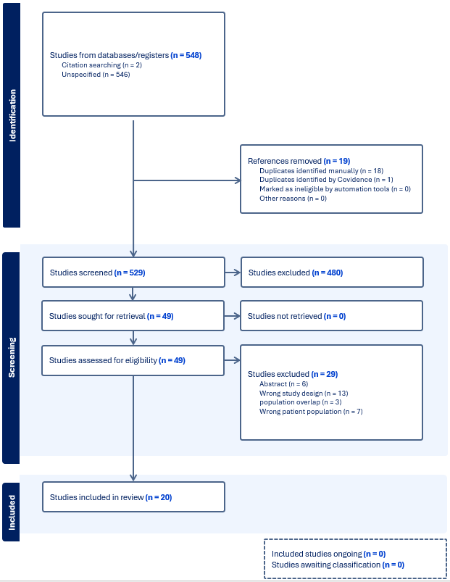

Supplemental Table 2. Summary of Findings Table for PICO 1, Adexanet versus PCC for reversal of factor Xa inhibitors in spontaneous ICH
Certainty assessment |  |  |  |  |  |  | № of patients |  | Effect |  | Certainty | Importance
№ of studies | Study design | Risk of bias | Inconsistency | Indirectness | Imprecision | Other considerations | andexanet alpha | prothrombin complex concentrate | Relative  (95% CI) | Absolute  (95% CI) | Certainty | Importance
Mortality (RCT)
1 | randomised trials | not serious | not serious | not serious | seriousª | none | 73/263 (27.8%) | 68/267 (25.5%) | RR 1.09  (0.82 to 1.45) | 23 more per 1,000  (from 46 fewer to 115 more) | ⨁⨁⨁◯  Moderateª | CRITICAL
Mortality (observational - adjusted)
1 | non-randomised studies | serious^{b} | not serious | not serious | seriousª | none |  | 148/481 (30.8%) | OR 0.49  (0.24 to 1.00) | 129 fewer per 1,000  (from 211 fewer to 0 fewer) | ⨁◯◯◯  Very low^{a,b} | CRITICAL
Mortality (observational, unadjusted)
3 | non-randomised studies | serious^{c} | not serious | not serious | serious^{d} | none | 86/319 (27.0%) | 148/481 (30.8%) | RR 0.91  (0.68 to 1.21) | 28 fewer per 1,000  (from 98 fewer to 65 more) | ⨁◯◯◯  Very low^{c,d} | CRITICAL
Funcțional outcome (poor)
1 | randomised trials | not serious | not serious | not serious | serious^{d} | none | 177/246 (72.0%) | 176/255 (69.0%) | RR 1.04  (0.93 to 1.17) | 28 more per 1,000  (from 48 fewer to 117 more) | ⨁⨁⨁◯  Moderate^{d} | CRITICAL
Functional outcome (poor, adjusted observational study)
1 | non-randomised studies | serious^{b} | not serious | not serious | serious^{d} | none | 0/0 | 109/198 (55.1%) | OR 0.91  (0.73 to 1.14) | 23 fewer per 1,000  (from 78 fewer to 32 more) | ⨁◯◯◯  Very low^{b,d} | CRITICAL
Thrombosis (RCT)
1 | randomised trials | not serious | not serious | not serious | serious^{e} | none | 27/263 (10.3%) | 15/267 (5.6%) | RR 1.83  (1.00 to 3.36) | 47 more per 1,000  (from 0 fewer to 133 more) | ⨁⨁⨁◯  Moderate^{e} | CRITICAL
Thrombosis (observational, unadjusted)
3 | non-randomised studies | serious^{c} | not serious | not serious | not serious | none | 34/319 (10.7%) | 22/463 (4.8%) | RR 1.99  (1.15 to 3.45) | 47 more per 1,000  (from 7 more to 116 more) | ⨁◯◯◯  Very low^{c} | CRITICAL
Hemorrhage expansion (RCT - yes/no)
1 | randomised trials | not serious | not serious | not serious | serious^{d} | none | 24/216 (11.1%) | 36/214 (16.8%) | RR 0.66  (0.41 to 1.07) | 57 fewer per 1,000  (from 99 fewer to 12 more) | ⨁⨁⨁◯  Moderate^{d} | IMPORTANT
Hemorrhage expansion (observational, adjusted)
1 | non-randomised studies | serious^{b} | not serious | not serious | very serious^{f} | none |  | 6/29 (20.7%) | OR 0.30  (0.05 to 1.70) | 134 fewer per 1,000  (from 194 fewer to 100 more) | ⨁◯◯◯  Very low^{b,f} | IMPORTANT
Hemorrhage expansion (observational, unadjusted)
2 | non-randomised studies | serious^{c} | not serious | not serious | very serious^{f} | none | 4/33 (12.1%) | 6/29 (20.7%) | RR 0.60  (0.19 to 1.93) | 83 fewer per 1,000  (from 168 fewer to 192 more) | ⨁◯◯◯  Very low^{c,f} | IMPORTANT
Hemostatic efficacy (RCT -good/excellent)
1 | randomised trials | not serious | not serious | not serious | not serious | none | 150/224 (67.0%) | 121/228 (53.1%) | RR 1.26  (1.08 to 1.47) | 138 more per 1,000  (from 42 more to 249 more) | ⨁⨁⨁⨁  High | IMPORTANT
Hemostatic efficacy (adjusted observational - good/excellent)
1 | non-randomised studies | serious^{b} | not serious | not serious | very serious^{f} | none |  | 165/203 (81.3%) | OR 3.30  (0.59 to 18.49) | 122 more per 1,000  (from 94 fewer to 175 more) | ⨁◯◯◯  Very low^{b,f} | IMPORTANT
Hemostatic efficacy (observational, unadjusted)
2 | non-randomised studies | serious^{c} | not serious | not serious | not serious | none | 117/131 (89.3%) | 165/203 (81.3%) | RR 1.1  (1.0 to 1.2) | 81 more per 1,000  (from 0 fewer to 163 more) | ⨁◯◯◯  Very low^{c} | IMPORTANT
CI: confidence interval; OR: odds ratio; RR: risk ratio

Explanations
a. Confidence interval includes the possibility of harm.
b. Small studies that adjusted for limited number of variables.
c. Unadjusted analyses of observational studies.
d. Confidence interval includes the possibility of benefit and harm.
e. Low number of events; 95% CI includes 1.0.
f. Very wide confidence interval that includes very important harm and very important benefit.
GRADEPro software generates a certainty level ranging from very low to high based on the risk of bias assessments, inconsistency (heterogeneity across different studies, typically signified by high I2 values), indirectness (how closely the studies pertain to the PICO), imprecision (unclear effect size due to low event rates, small sample sizes, or wide confidence intervals), and publication bias. The certainty of evidence could be increased by a large effect size, a dose–response gradient, or residual confounding that favors the comparator

Supplemental Table 3. Summary of Findings Table for PICO 1, Adexanet versus PCC for reversal of factor Xa inhibitors in traumatic ICH
Certainty assessment |  |  |  |  |  |  | № of patients |  | Effect |  | Certainty | Importance
№ of studies | Study design | Risk of bias | Inconsistency | Indirectness | Imprecision | Other considerations | andexanet alpha | prothrombin complex concentrate | Relative  (95% CI) | Absolute  (95% CI) | Certainty | Importance
Mortality (observational - adjusted)
1 | non-randomised studies | seriousª | not serious | not serious | serious^{b} | none | 0/0 | 205/990 (20.7%) | OR 1.34  (0.67 to 2.69) | 52 more per 1,000  (from 58 fewer to 206 more) | ⨁◯◯◯  Very low^{a,b} | CRITICAL
Mortality (observational, unadjusted)
3 | non-randomised studies | serious^{c} | not serious | not serious | serious^{d} | none | 90/555 (16.2%) | 205/990 (20.7%) | RR 0.88  (0.54 to 1.46) | 25 fewer per 1,000  (from 95 fewer to 95 more) | ⨁◯◯◯  Very low^{c,d} | CRITICAL
Functional outcome (discharge to hospice, observational - adjusted)
1 | non-randomised studies | seriousª | not serious | not serious | serious^{d} | none |  | 49/265 (18.5%) | OR 1.34  (0.67 to 2.69) | 48 more per 1,000  (from 53 fewer to 194 more) | ⨁◯◯◯  Very low^{a,d} | CRITICAL
Functional outcome (discharge to hospice, unadjusted observational study)
1 | non-randomised studies | serious^{c} | not serious | not serious | serious^{d} | none | 15/59 (25.4%) | 49/265 (18.5%) | RR 1.37  (0.83 to 2.28) | 68 more per 1,000  (from 31 fewer to 237 more) | ⨁◯◯◯  Very low^{c,d} | CRITICAL
Thrombosis (observational, unadjusted)
3 | non-randomised studies | serious^{c} | not serious | not serious | serious^{d} | none | 15/228 (6.6%) | 39/624 (6.3%) | RR 1.14  (0.63 to 2.04) | 9 more per 1,000  (from 23 fewer to 65 more) | ⨁◯◯◯  Very low^{c,d} | CRITICAL
Hemorrhage expansion (observational, unadjusted)
1 | non-randomised studies | serious^{c} | not serious | not serious | very serious^{e,f} | none | 1/7 (14.3%) | 4/6 (66.7%) | RR 0.21  (0.03 to 1.43) | 527 fewer per 1,000  (from 647 fewer to 287 more) | ⨁◯◯◯  Very low^{c,e,f} | IMPORTANT
Hemostatic efficacy (observational, unadjusted)
2 | non-randomised studies | serious^{c} | not serious | not serious | serious^{d} | none | 123/141 (87.2%) | 248/303 (81.8%) | RR 1.06  (0.97 to 1.15) | 49 more per 1,000  (from 25 fewer to 123 more) | ⨁◯◯◯  Very low^{c,d} | IMPORTANT

Supplemental Figure 2.
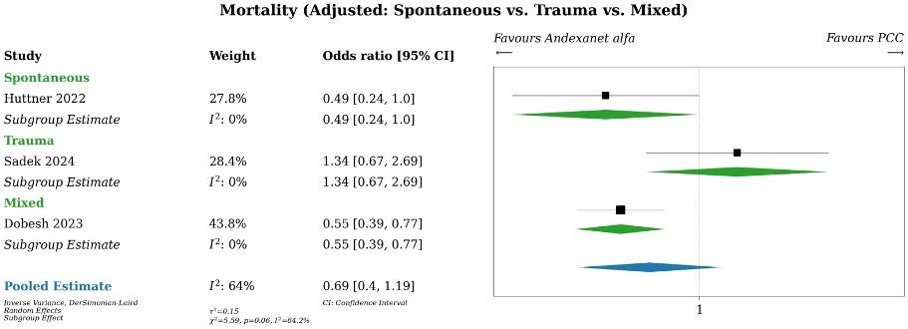
Supplemental Figure 2. PICO 1, Andexanet alfa versus PCC for factor Xa inhibitor-associated ICH. Meta-analysis of mortality (adjusted), stratified by hemorrhage mechanism subtype. PCC, prothrombin complex concentrates; RCT, randomized controlled trial; RR, relative risk.

Supplemental Figure 3.
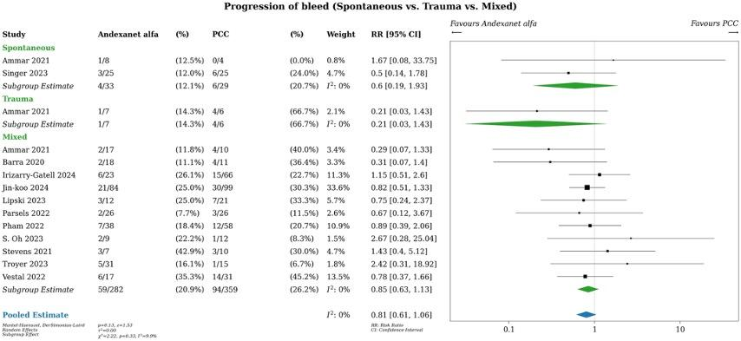
Supplemental Figure 3. PICO 1, Andexanet versus PCC for reversal of factor Xa inhibitors. Meta-analysis of hemorrhage expansion (unadjusted) stratified by hemorrhage subtype. PCC, prothrombin complex concentrates; RCT, randomized controlled trial; RR, relative risk.
Supplemental Figure 4.
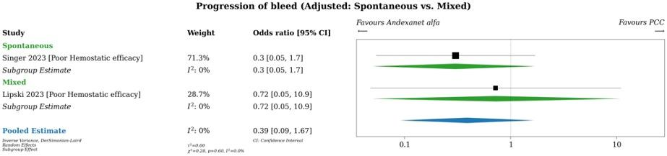
Supplemental Figure 4. PICO 1, Andexanet versus PCC for reversal of factor Xa inhibitors. Meta-analysis of hematoma expansion (adjusted) stratified by hemorrhage subtype. PCC, prothrombin complex concentrates.
Supplemental Figure 5.
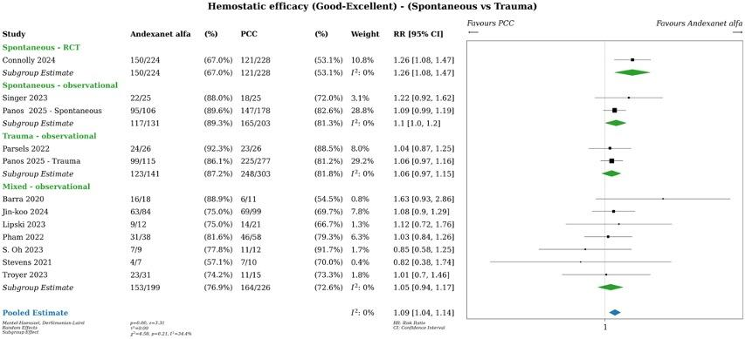
Supplemental Figure 5. PICO 1, Andexanet versus PCC for reversal of factor Xa inhibitors. Meta-analysis of good-excellent hemostatic efficacy (unadjusted) stratified by hemorrhage subtype and by randomized versus non-randomized study design. PCC, prothrombin complex concentrates; RCT, randomized controlled trial; RR, relative risk.

Supplemental Figure 6.
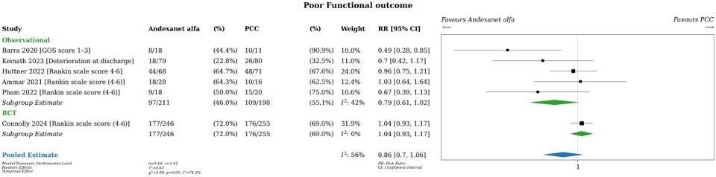
Supplemental Figure 6. PICO 1, Andexanet versus PCC for reversal of factor Xa inhibitors. Meta-analysis of poor functional outcome (unadjusted) in combined (all ICH subtypes) cohort, stratified by randomized versus non-randomized study design. PCC, prothrombin complex concentrates; RR, relative risk.
Supplemental Figure 7.
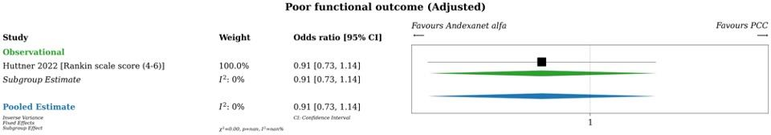
Supplemental Figure 7. PICO 1, Andexanet versus PCC for reversal of factor Xa inhibitors. Meta-analysis of poor functional outcome (adjusted) in spontaneous IPH cohort. PCC, prothrombin complex concentrates.
Supplemental Figure 8.
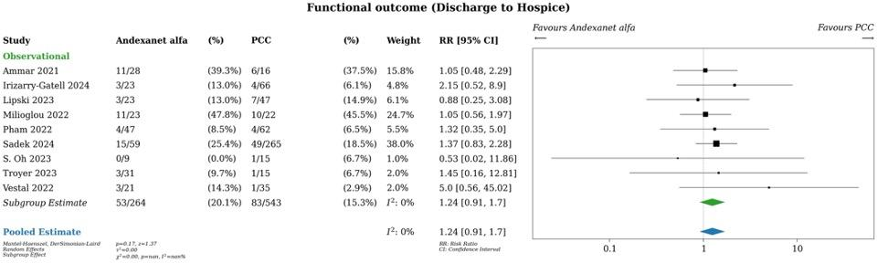
Supplemental Figure 8. PICO 1, Andexanet versus PCC for reversal of factor Xa inhibitors. Meta-analysis of poor functional outcome (defined as discharge to hospice, unadjusted) in combined (all ICH subtypes) cohort. PCC, prothrombin complex concentrates; RR, relative risk.
Supplemental Figure 9.
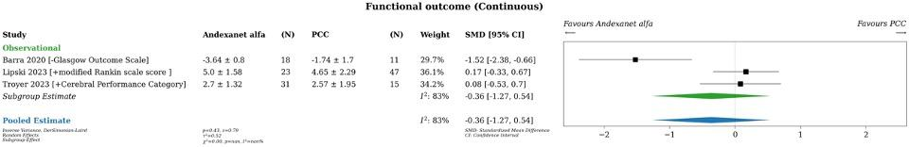
Supplemental Figure 9. PICO 1, Andexanet versus PCC for reversal of factor Xa inhibitors. Meta-analysis of functional outcome as a continuous variable in combined (all ICH subtypes) cohort. PCC, prothrombin complex concentrates; SMD, standardized mean difference.
Supplemental Figure 10.
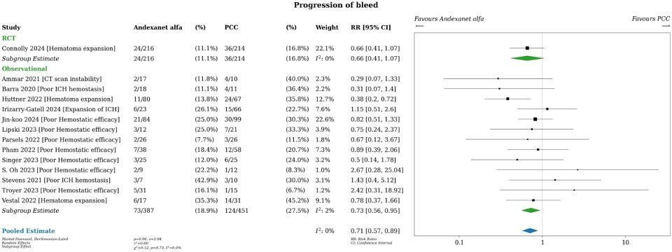
Supplemental Figure 10. PICO 1, Andexanet versus PCC for reversal of factor Xa inhibitors. Meta-analysis of hematoma expansion (defined as a binary outcome, unadjusted) in combined (all ICH subtypes) cohort. PCC, prothrombin complex concentrates; RCT, randomized controlled trial; RR, relative risk.
Supplemental Figure 11.
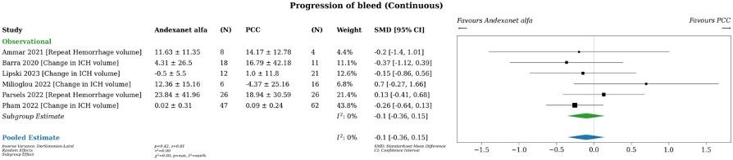
Supplemental Figure 11. PICO 1, Andexanet versus PCC for reversal of factor Xa inhibitors. Meta-analysis of hematoma expansion as a continuous variable in combined (all ICH subtypes) cohort. PCC, prothrombin complex concentrates; SMD, standardized mean difference.
Supplemental Figure 12.
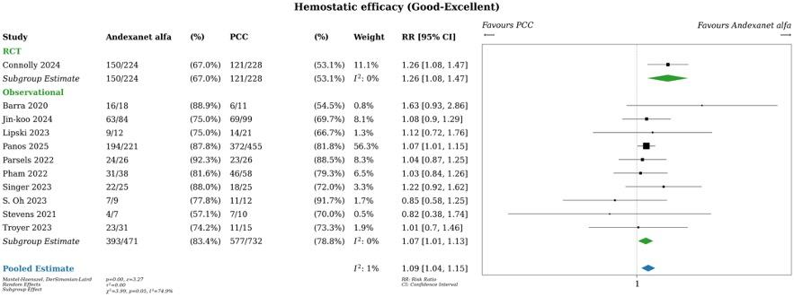
Supplemental Figure 12. PICO 1, Andexanet versus PCC for reversal of factor Xa inhibitors. Meta-analysis of good-excellent hemostatic efficacy (adjusted) in combined (all ICH subtypes) cohort, stratified by randomized versus nonrandomized design. PCC, prothrombin complex concentrates; RR, relative risk.
Supplemental Figure 13.
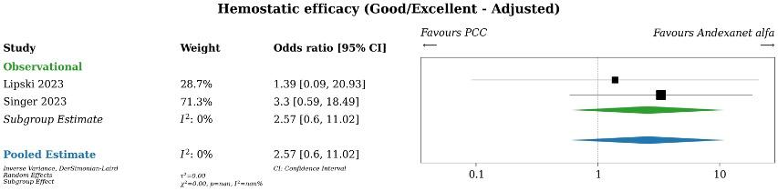
Supplemental Figure 13. PICO 1, Andexanet versus PCC for reversal of factor Xa inhibitors. Meta-analysis of good-excellent hemostatic efficacy (adjusted) in combined (all ICH subtypes) cohort. PCC, prothrombin complex concentrates.
Supplemental Figure 14.
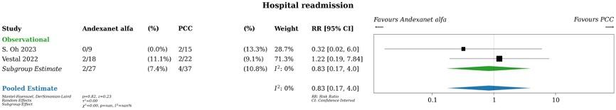
Supplemental Figure 14. PICO 1, Andexanet versus PCC for reversal of factor Xa inhibitors. Meta-analysis of hospital readmission (unadjusted) in combined (all ICH subtypes) cohort. PCC, prothrombin complex concentrates; RCT, randomized controlled trial; RR, relative risk.
Supplemental Figure 15.
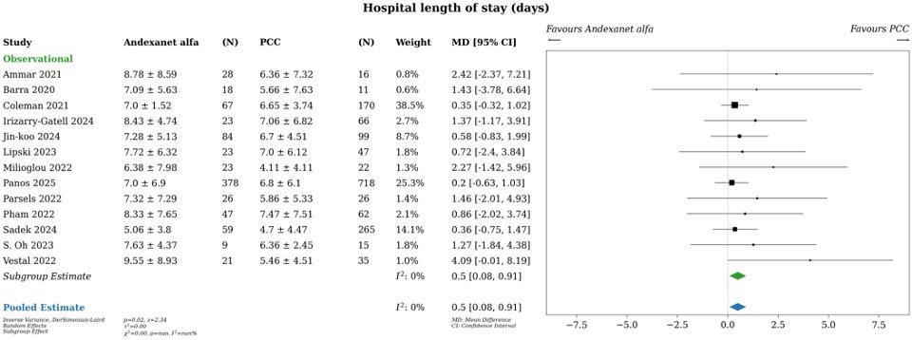
Supplemental Figure 15. PICO 1, Andexanet versus PCC for reversal of factor Xa inhibitors. Meta-analysis of hospital length of stay (unadjusted) in combined (all ICH subtypes) cohort. MD, mean difference; PCC, prothrombin complex concentrates.
Supplemental Figure 16.
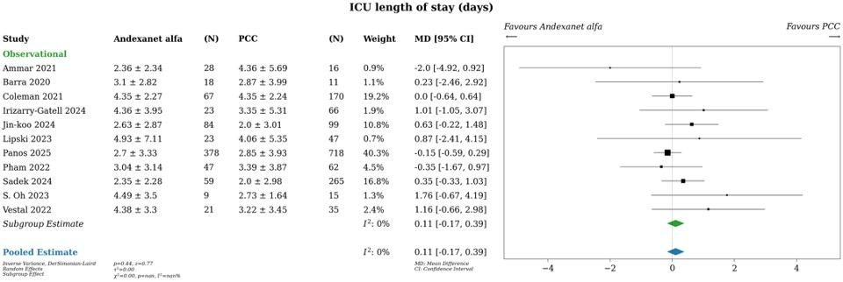
Supplemental Figure 16. PICO 1, Andexanet versus PCC for reversal of factor Xa inhibitors. Meta-analysis of ICU length of stay (unadjusted) in combined (all ICH subtypes) cohort. ICU, intensive care unit; MD, mean difference; PCC, prothrombin complex concentrate.

Supplemental Figure 17
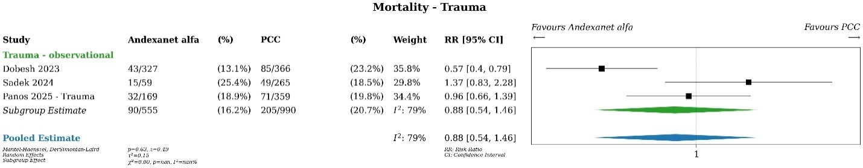
Supplemental Figure 17. PICO 1, Andexanet versus PCC for reversal of factor Xa inhibitors. Meta-analysis of mortality (unadjusted) in traumatic ICH subgroup. PCC, prothrombin complex concentrate; RR, relative risk.

Supplemental Table 4. Summary of Judgements for PICO 1 (Spontaneous IPH)
 | Judgement
Problem | No | Probably no | Probably yes | Yes |  | Varies | Don't know
Desirable Effects | Trivial | Small | Moderate | Large |  | Varies | Don't know
Undesirable Effects | Trivial | Small | Moderate | Large |  | Varies | Don't know
Certainty of evidence | Very low | Low | Moderate | High |  |  | No included studies
Values | Important uncertainty or variability | Possibly important uncertainty or variability | Probably no important uncertainty or variability | No important uncertainty or variability
Balance of effects | Favors the comparison | Probably favors the comparison | Does not favor either the intervention or the comparison | Probably favors the intervention | Favors the intervention | Varies | Don't know
Resources required | Large costs | Moderate costs | Negligible costs and savings | Moderate savings | Large savings | Varies | Don't know
Certainty of evidence of required resources | Very low | Low | Moderate | High |  |  | No included studies
Cost effectiveness | Favors the comparison | Probably favors the comparison | Does not favor either the intervention or the comparison | Probably favors the intervention | Favors the intervention | Varies | No included studies
Equity | Reduced | Probably reduced | Probably no impact | Probably increased | Increased | Varies | Don't know
Acceptability | No | Probably no | Probably yes | Yes |  | Varies | Don't know
Feasibility | No | Probably no | Probably yes | Yes |  | Varies | Don't know

Supplemental Table 5. Summary of Judgements for PICO 1 (Traumatic ICH)
 | Judgement
Problem | No | Probably no | Probably yes | Yes |  | Varies | Don't know
Desirable Effects | Trivial | Small | Moderate | Large |  | Varies | Don't know
Undesirable Effects | Trivial | Small | Moderate | Large |  | Varies | Don't know
Certainty of evidence | Very low | Low | Moderate | High |  |  | No included studies
Values | Important uncertainty or variability | Possibly important uncertainty or variability | Probably no important uncertainty or variability | No important uncertainty or variability
Balance of effects | Favors the comparison | Probably favors the comparison | Does not favor either the intervention or the comparison | Probably favors the intervention | Favors the intervention | Varies | Don't know
Resources required | Large costs | Moderate costs | Negligible costs and savings | Moderate savings | Large savings | Varies | Don't know
Certainty of evidence of required resources | Very low | Low | Moderate | High |  |  | No included studies
Cost effectiveness | Favors the comparison | Probably favors the comparison | Does not favor either the intervention or the comparison | Probably favors the intervention | Favors the intervention | Varies | No included studies
Equity | Reduced | Probably reduced | Probably no impact | Probably increased | Increased | Varies | Don't know
Acceptability | No | Probably no | Probably yes | Yes |  | Varies | Don't know
Feasibility | No | Probably no | Probably yes | Yes |  | Varies | Don't know

Supplemental Table 6. Characteristics of Included Trials for PICO 1 (See Excel file)

PICO 2 – Platelet transfusion versus no transfusion in antiplatelet-associated ICH
Supplemental Figure 18. Prisma Flow Sheet of Article Inclusion and Exclusion for PICO 2
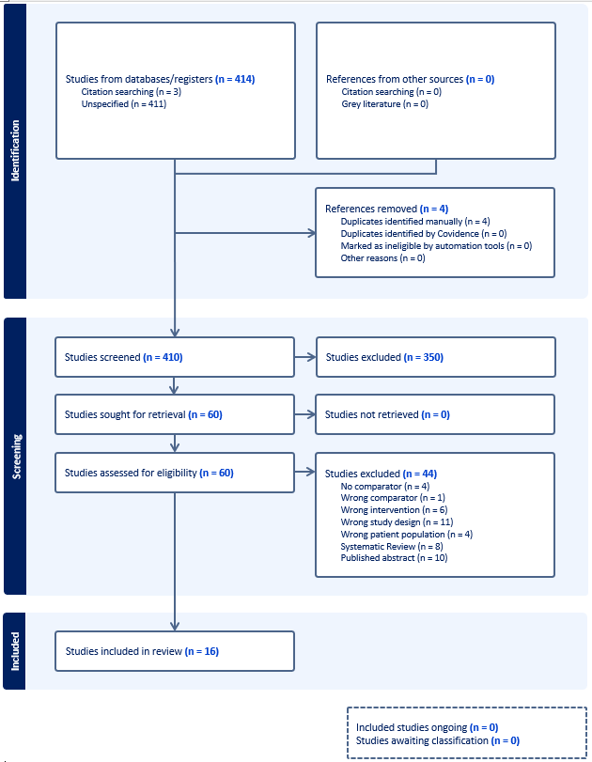
Supplemental Table 7. Summary of Findings Table for PICO 2, platelet transfusion versus no transfusion in antiplatelet-associated spontaneous ICH without surgical intervention
Certainty assessment |  |  |  |  |  |  | № of patients |  | Effect |  | Certainty | Importance
№ of studies | Study design | Risk of bias | Inconsistency | Indirectness | Imprecision | Other considerations | platelet transfusion | no platelet transfusion | Relative  (95% CI) | Absolute  (95% CI) | Certainty | Importance
Survival [adjusted]
1 | randomised trials | not serious | not serious | not serious | very seriousª | none |  |  | OR 0.62  (0.33 to 1.18) |  | ⨁⨁◯◯  Lowª | CRITICAL
Mortality [unadjusted]
1 | randomised trials | not serious | not serious | not serious | very seriousª | none | 31/97 (32.0%) | 21/93 (22.6%) | RR 1.42  (0.88 to 2.28) | 95 more per 1,000  (from 27 fewer to 289 more) | ⨁⨁◯◯  Lowª | CRITICAL
Mortality [unadjusted]
3 | non-randomised studies | not serious | serious^{b} | not serious | very seriousª | none | 23/123 (18.7%) | 32/157 (20.4%) | RR 1.13  (0.32 to 4.00) | 26 more per 1,000  (from 139 fewer to 611 more) | ⨁◯◯◯  Very low^{a,b} | CRITICAL
Poor functional outcomes [adjusted]
1 | randomised trials | not serious | not serious | not serious | seriousª | none |  |  | OR 2.04  (1.12 to 3.73) |  | ⨁⨁⨁◯  Moderateª | CRITICAL
Poor functional outcomes [unadjusted]
1 | randomised trials | not serious | not serious | not serious | seriousª | none | 70/97 (72.2%) | 52/93 (55.9%) | RR 1.29  (1.04 to 1.61) | 162 more per 1,000  (from 22 more to 341 more) | ⨁⨁⨁◯  Moderateª | CRITICAL
Poor functional outcomes [unadjusted]
3 | non-randomised studies | not serious | serious^{b} | not serious | seriousª | none | 75/123 (61.0%) | 99/157 (63.1%) | RR 0.95  (0.69 to 1.32) | 32 fewer per 1,000  (from 195 fewer to 202 more) | ⨁◯◯◯  Very low^{a,b} | CRITICAL
Functional outcomes [continuous]
1 | randomised trials | not serious | not serious | not serious | seriousª | none | 97 | 93 | - | MD 0.52 higher  (0.07 higher to 0.97 higher) | ⨁⨁⨁◯  Moderateª | CRITICAL
Functional outcomes [continuous]
1 | non-randomised studies | not serious | not serious | not serious | seriousª | none | 31 | 31 | - | MD 0.04 lower  (0.96 lower to 0.51 higher) | ⨁◯◯◯  Very lowª | CRITICAL
Arterial & venous thrombosis [unadjusted]
1 | randomised trials | not serious | not serious | not serious | very seriousª | none | 4/97 (4.1%) | 1/93 (1.1%) | RR 3.84  (0.44 to 33.68) | 31 more per 1,000  (from 6 fewer to 351 more) | ⨁⨁◯◯  Lowª | CRITICAL
Arterial & venous thrombosis [unadjusted]
2 | non-randomised studies | not serious | not serious | not serious | seriousª | none | 7/74 (9.5%) | 6/89 (6.7%) | RR 1.61  (0.57 to 4.53) | 41 more per 1,000  (from 29 fewer to 238 more) | ⨁◯◯◯  Very lowª | CRITICAL
Hematoma expansion [unadjusted]
1 | randomised trials | not serious | not serious | not serious | seriousª | none | 15/97 (15.5%) | 13/93 (14.0%) | RR 1.11  (0.56 to 2.20) | 15 more per 1,000  (from 62 fewer to 168 more) | ⨁⨁⨁◯  Moderateª | IMPORTANT
Hematoma expansion [unadjusted]
3 | non-randomised studies | not serious | not serious | not serious | seriousª | none | 24/113 (21.2%) | 13/113 (11.5%) | RR 1.36  (0.76 to 2.44) | 41 more per 1,000  (from 28 fewer to 166 more) | ⨁◯◯◯  Very lowª | IMPORTANT
CI: confidence interval; MD: mean difference; OR: odds ratio; RR: risk ratio

Explanations
a. Rated down for imprecision due to wide confidence interval failing to exclude important benefit or harm.
b. Rated down for inconsistency due to high heterogeneity across study findings.

Supplemental Figure 19.
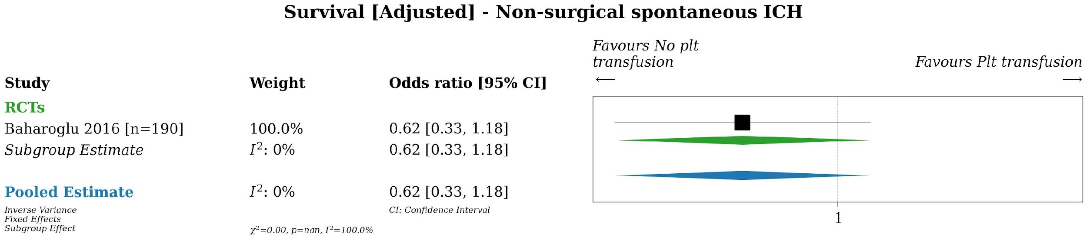
Supplemental Figure 19. PICO 2, Platelet transfusion versus no platelet transfusion in antiplatelet-associated spontaneous ICH without neurosurgical intervention. Meta-analysis of survival (adjusted). ICH, intracranial hemorrhage; Plt, platelet; RCT, randomized controlled trial.

Supplemental Figure 20.
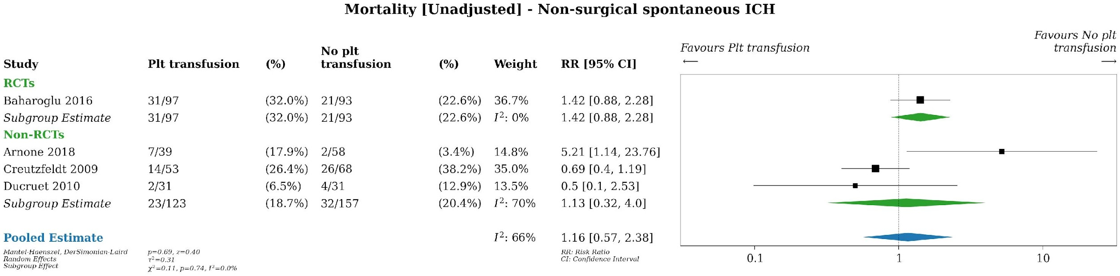
Supplemental Figure 20. PICO 2, Platelet transfusion versus no platelet transfusion in antiplatelet-associated spontaneous ICH without neurosurgical intervention. Meta-analysis of mortality (unadjusted) stratified by randomized and non-randomized design. ICH, intracranial hemorrhage; non-RCT, non-randomized controlled trial; Plt, platelet; RCT, randomized controlled trial; RR, risk ratio.
Supplemental Figure 21.
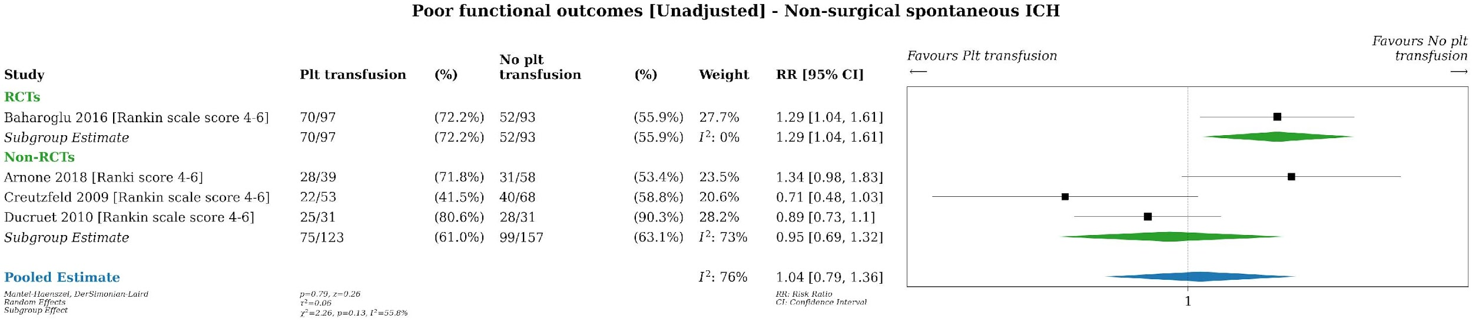
Supplemental Figure 21. PICO 2, Platelet transfusion versus no platelet transfusion in antiplatelet-associated spontaneous ICH without neurosurgical intervention. Meta-analysis of poor functional outcome (unadjusted) stratified by randomized and non-randomized design. ICH, intracranial hemorrhage; non-RCT, non-randomized controlled trial; Plt, platelet; RCT, randomized controlled trial; RR, risk ratio.

Supplemental Figure 22.
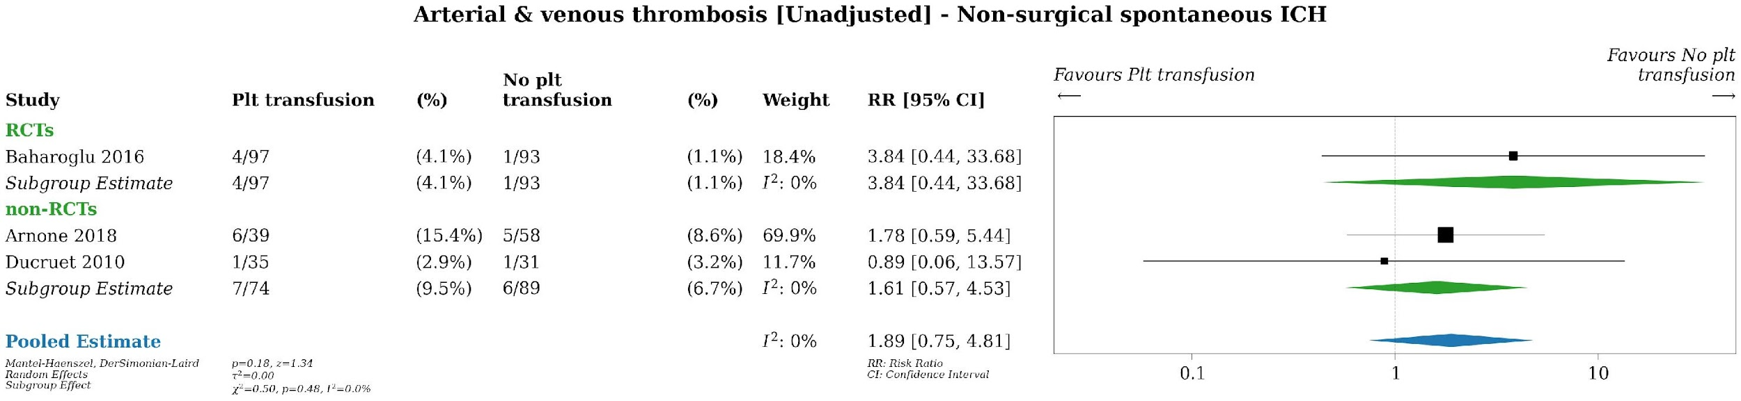
Supplemental Figure 22. PICO 2, Platelet transfusion versus no platelet transfusion in antiplatelet-associated spontaneous ICH without neurosurgical intervention. Meta-analysis of arterial and venous thrombosis (unadjusted). ICH, intracranial hemorrhage; non-RCT, non-randomized controlled trial; Plt, platelet; RCT, randomized controlled trial; RR, risk ratio.

Supplemental Table 8. Summary of Judgements for PICO 2 – Platelet transfusion versus no platelet transfusion in antiplatelet-associated spontaneous ICH without neurosurgical intervention
 | JUDGEMENT
PROBLEM | No | Probably no | Probably yes | Yes |  | Varies | Don't know
DESIRABLE EFFECTS | Trivial | Small | Moderate | Large |  | Varies | Don't know
UNDESIRABLE EFFECTS | Trivial | Small | Moderate | Large |  | Varies | Don't know
CERTAINTY OF EVIDENCE | Very low | Low | Moderate | High |  |  | No included studies
VALUES | Important uncertainty or variability | Possibly important uncertainty or variability | Probably no important uncertainty or variability | No important uncertainty or variability
BALANCE OF EFFECTS | Favors the comparison | Probably favors the comparison | Does not favor either the intervention or the comparison | Probably favors the intervention | Favors the intervention | Varies | Don't know
RESOURCES REQUIRED | Large costs | Moderate costs | Negligible costs and savings | Moderate savings | Large savings | Varies | Don't know
CERTAINTY OF EVIDENCE OF REQUIRED RESOURCES | Very low | Low | Moderate | High |  |  | No included studies
COST EFFECTIVENESS | Favors the comparison | Probably favors the comparison | Does not favor either the intervention or the comparison | Probably favors the intervention | Favors the intervention | Varies | No included studies
EQUITY | Reduced | Probably reduced | Probably no impact | Probably increased | Increased | Varies | Don't know
ACCEPTABILITY | No | Probably no | Probably yes | Yes |  | Varies | Don't know
FEASIBILITY | No | Probably no | Probably yes | Yes |  | Varies | Don't know

Supplemental Table 9. Summary of Findings Table for PICO 2, Platelet transfusion versus no transfusion in aspirin-associated spontaneous IPH in patients undergoing neurosurgical intervention
Certainty assessment |  |  |  |  |  |  | № of patients |  | Effect |  | Certainty | Importance
№ of studies | Study design | Risk of bias | Inconsistency | Indirectness | Imprecision | Other considerations | we administer platelet transfusion | no platelet transfusion | Relative  (95% CI) | Absolute  (95% CI) | Certainty | Importance
Mortality [unadjusted]
1 | randomised trials | seriousª | not serious | serious | not serious | none | 39/244 (16.0%) | 42/122 (34.4%) | RR 0.46  (0.32 to 0.68) | 186 fewer per 1,000  (from 234 fewer to 110 fewer) | ⨁⨁◯◯  Lowª | CRITICAL
Poor functional outcomes [unadjusted]
1 | randomised trials | seriousª | not serious | serious | not serious | none | 51/244 (20.9%) | 41/122 (33.6%) | RR 0.62  (0.44 to 0.88) | 128 fewer per 1,000  (from 188 fewer to 40 fewer) | ⨁⨁◯◯  Lowª | CRITICAL
Functional outcomes [continuous]
1 | randomised trials | seriousª | not serious | serious | not serious | none | 244 | 122 | - | MD 0.56 higher  (0.34 higher to 0.78 higher) | ⨁⨁◯◯  Lowª | CRITICAL
Hematoma expansion [unadjusted]
1 | randomised trials | seriousª | not serious | serious | not serious | none | 32/244 (13.1%) | 40/122 (32.8%) | RR 0.40  (0.27 to 0.60) | 197 fewer per 1,000  (from 239 fewer to 131 fewer) | ⨁⨁◯◯  Lowª | IMPORTANT
Hematoma expansion [continuous]
1 | randomised trials | seriousª | not serious | serious | not serious | none | 244 | 122 | - | MD 20.89 lower  (25.05 lower to 16.73 lower) | ⨁⨁◯◯  Lowª | IMPORTANT
CI: confidence interval; MD: mean difference; RR: risk ratio

Explanations
a. Rated down for high risk of bias.

Supplemental Figure 23.
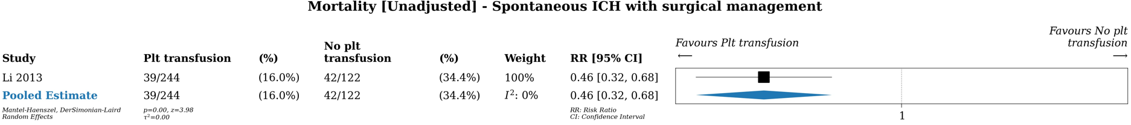
Supplemental Figure 23. PICO 2, Platelet transfusion versus no platelet transfusion in aspirin-associated spontaneous IPH with neurosurgical intervention. Analysis of mortality (unadjusted). CI, confidence interval; ICH, intracranial hemorrhage, Plt, platelet; RR, risk ratio.
Supplemental Figure 24.
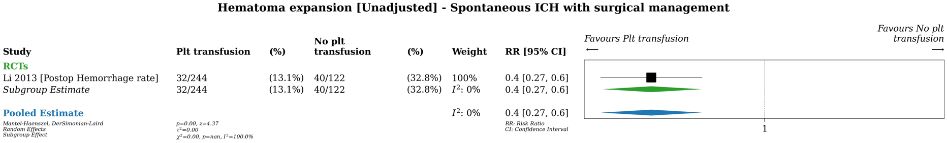
Supplemental Figure 24. PICO 2, Platelet transfusion versus no platelet transfusion in aspirin-associated spontaneous IPH with neurosurgical intervention. Analysis of hematoma expansion (unadjusted). CI, confidence interval; ICH, intracranial hemorrhage, Plt, platelet; RR, risk ratio.
Supplemental Figure 25.
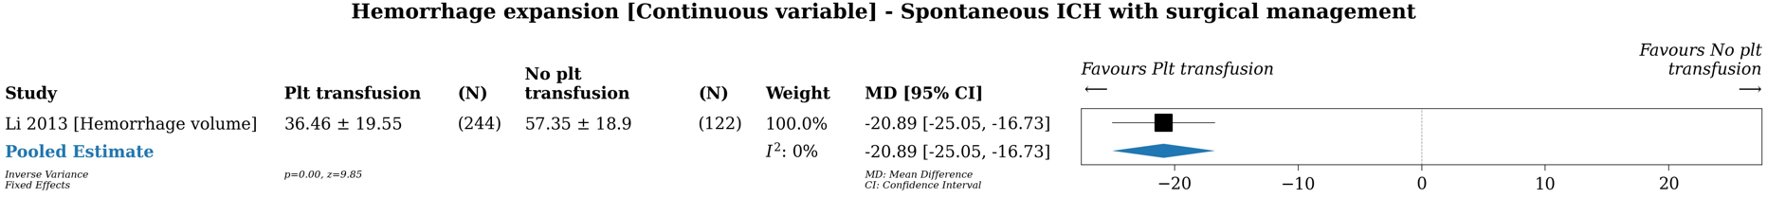
Supplemental Figure 25. PICO 2, Platelet transfusion versus no platelet transfusion in aspirin-associated spontaneous IPH with neurosurgical intervention. Analysis of hematoma expansion as a continuous variable. CI, confidence interval; ICH, intracranial hemorrhage; MD, mean difference; Plt, platelet.
Supplemental Figure 26.
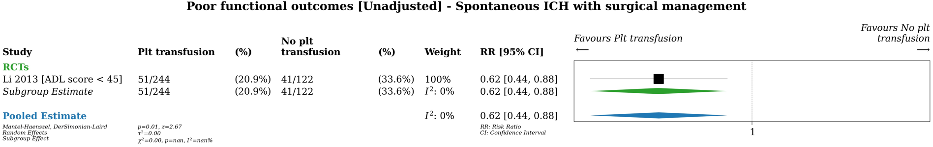
Supplemental Figure 26. PICO 2, Platelet transfusion versus no platelet transfusion in aspirin-associated spontaneous IPH with neurosurgical intervention. Analysis of poor functional outcome (unadjusted). ADL score, Activities of Daily Living score; CI, confidence interval; ICH, intracranial hemorrhage; Plt, platelet; RR, risk ratio.

Supplemental Table 10. Summary of Judgements for PICO 2 – Platelet transfusion versus no platelet transfusion in aspirin-associated IPH with neurosurgical intervention
 | JUDGEMENT
PROBLEM | No | Probably no | Probably yes | Yes |  | Varies | Don't know
DESIRABLE EFFECTS | Trivial | Small | Moderate | Large |  | Varies | Don't know
UNDESIRABLE EFFECTS | Trivial | Small | Moderate | Large |  | Varies | Don't know
CERTAINTY OF EVIDENCE | Very low | Low | Moderate | High |  |  | No included studies
VALUES | Important uncertainty or variability | Possibly important uncertainty or variability | Probably no important uncertainty or variability | No important uncertainty or variability
BALANCE OF EFFECTS | Favors the comparison | Probably favors the comparison | Does not favor either the intervention or the comparison | Probably favors the intervention | Favors the intervention | Varies | Don't know
RESOURCES REQUIRED | Large costs | Moderate costs | Negligible costs and savings | Moderate savings | Large savings | Varies | Don't know
CERTAINTY OF EVIDENCE OF REQUIRED RESOURCES | Very low | Low | Moderate | High |  |  | No included studies
COST EFFECTIVENESS | Favors the comparison | Probably favors the comparison | Does not favor either the intervention or the comparison | Probably favors the intervention | Favors the intervention | Varies | No included studies
EQUITY | Reduced | Probably reduced | Probably no impact | Probably increased | Increased | Varies | Don't know
ACCEPTABILITY | No | Probably no | Probably yes | Yes |  | Varies | Don't know
FEASIBILITY | No | Probably no | Probably yes | Yes |  | Varies | Don't know

Supplemental Table 11. Summary of Findings Table for PICO 2, platelet transfusion versus no transfusion in antiplatelet-associated traumatic ICH

Certainty assessment |  |  |  |  |  |  | № of patients |  | Effect |  | Certainty | Importance
№ of studies | Study design | Risk of bias | Inconsistency | Indirectness | Imprecision | Other considerations | platelet transfusion | no platelet transfusion | Relative  (95% CI) | Absolute  (95% CI) | Certainty | Importance
Mortality [adjusted]
4 | non-randomised studies | not serious | seriousª | not serious | serious^{b} | none |  |  | OR 0.97  (0.76 to 1.22) |  | ⨁◯◯◯  Very low^{a,b} | CRITICAL
Mortality [unadjusted]
9 | non-randomised studies | not serious | seriousª | not serious | serious^{b} | none | 134/1277 (10.5%) | 492/5468 (9.0%) | RR 1.16  (0.63 to 2.12) | 14 more per 1,000  (from 33 fewer to 101 more) | ⨁◯◯◯  Very low^{a,b} | CRITICAL
Poor functional outcomes [adjusted]
2 | non-randomised studies | not serious | seriousª | not serious | serious^{b} | none |  |  | OR 0.69  (0.40 to 1.18) |  | ⨁◯◯◯  Very low^{a,b} | CRITICAL
Poor functional outcomes [unadjusted]
2 | non-randomised studies | not serious | seriousª | not serious | serious^{b} | none | 10/108 (9.3%) | 24/243 (9.9%) | RR 1.14  (0.14 to 9.41) | 14 more per 1,000  (from 85 fewer to 831 more) | ⨁◯◯◯  Very low^{a,b} | CRITICAL
Functional outcomes [continuous]
2 | non-randomised studies | not serious | seriousª | not serious | serious^{b} | none | 317 | 269 | - | SMD 0.2 SD higher  (0.17 lower to 0.56 higher) | ⨁◯◯◯  Very low^{a,b} | CRITICAL
Arterial & venous thrombosis [unadjusted]
1 | non-randomised studies | not serious | not serious | not serious | serious^{b} | none | 4/108 (3.7%) | 2/99 (2.0%) | RR 1.83  (0.34 to 9.79) | 17 more per 1,000  (from 13 fewer to 178 more) | ⨁◯◯◯  Very low^{b}
Hematoma expansion [adjusted]
2 | non-randomised studies | not serious | not serious | not serious | serious^{b} | none |  |  | OR 0.68  (0.54 to 0.88) |  | ⨁◯◯◯  Very low^{b} | IMPORTANT
Hematoma expansion [unadjusted]
8 | non-randomised studies | not serious | seriousª | not serious | serious^{b} | none | 160/809 (19.8%) | 239/740 (32.3%) | RR 1.06  (0.52 to 2.16) | 19 more per 1,000  (from 155 fewer to 375 more) | ⨁◯◯◯  Very low^{a,b} | IMPORTANT
ICU length of stay [unadjusted]
5 | non-randomised studies | not serious | very seriousª | not serious | serious^{b} | none | 824 | 5101 | - | MD 1.43 days higher  (0.1 higher to 2.77 higher) | ⨁◯◯◯  Very low^{a,b} | IMPORTANT
CI: confidence interval; MD: mean difference; OR: odds ratio; RR: risk ratio; SMD: standardised mean difference

Explanations
a. Rated down for inconsistency due to heterogeneity across studies.
b. Rated down for imprecision due to wide confidence interval failing to exclude important benefit or harm.

Supplemental Figure 27.
Mortality (adjusted) with transfusion of one pack of platelets
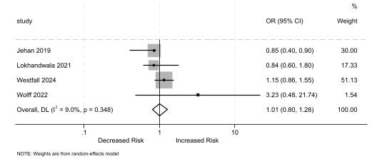
Supplemental Figure 27. PICO 2, Platelet transfusion versus no platelet transfusion in antiplatelet-associated traumatic ICH. Meta-analysis of mortality (adjusted) with transfusion of one pack of platelets. Adjusted analyses completed with STATA (StataCorp 2025, College Station, TX).
Supplemental Figure 28.
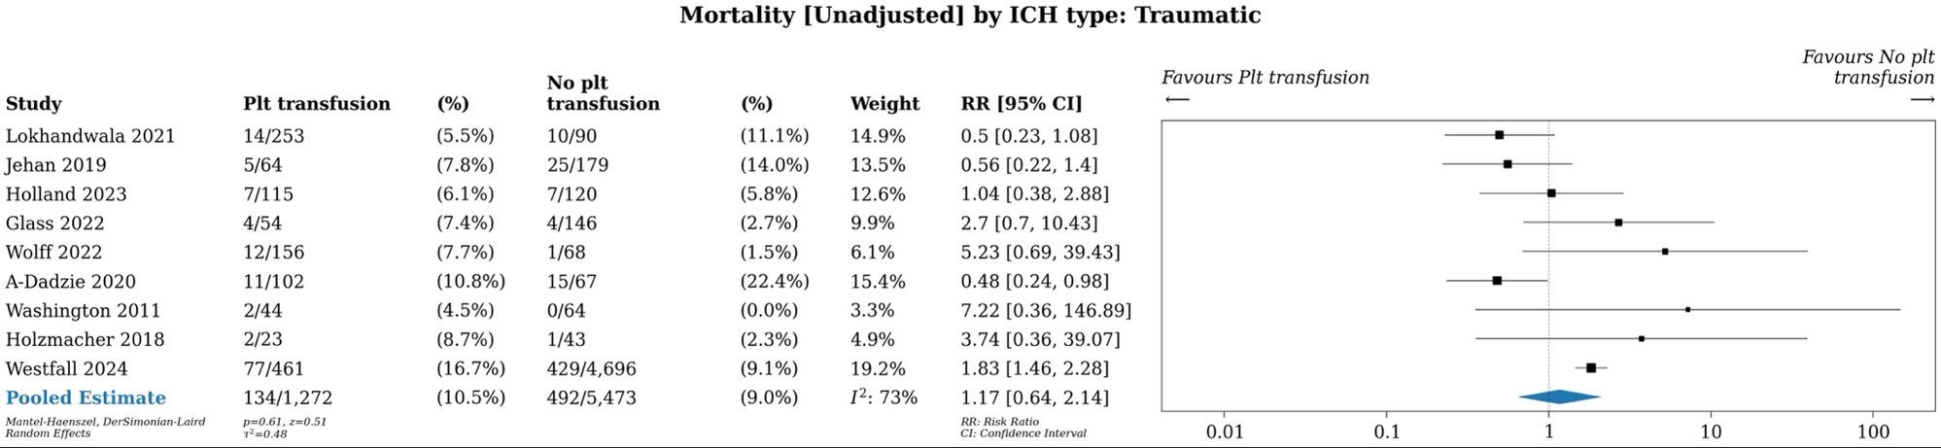
Supplemental Figure 28. PICO 2, Platelet transfusion versus no platelet transfusion in antiplatelet-associated traumatic ICH. Meta-analysis of mortality (unadjusted). ICH, intracranial hemorrhage; Plt, platelet; RR, relative risk.

Supplemental Figure 29.
Hematoma expansion (adjusted) with transfusion of one pack of platelets
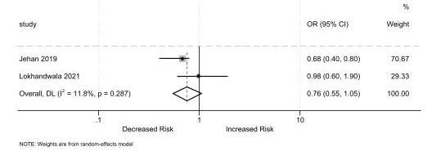
Supplemental Figure 29. PICO 2, Platelet transfusion versus no platelet transfusion in antiplatelet-associated traumatic ICH. Meta-analysis of hematoma expansion (adjusted) with transfusion of one pack of platelets. Adjusted analyses completed in STATA (StataCorp 2025, College Station, TX).

Supplemental Figure 30.
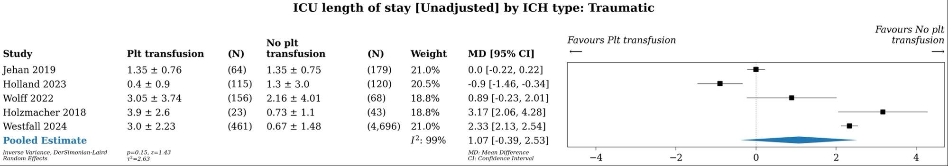
Supplemental Figure 30. PICO 2, Platelet transfusion versus no platelet transfusion in antiplatelet-associated traumatic ICH. Meta-analysis of ICU length of stay (unadjusted). ICH, intracranial hemorrhage; ICU, intensive care unit; MD, mean difference; Plt, platelet.

Supplemental Figure 31.
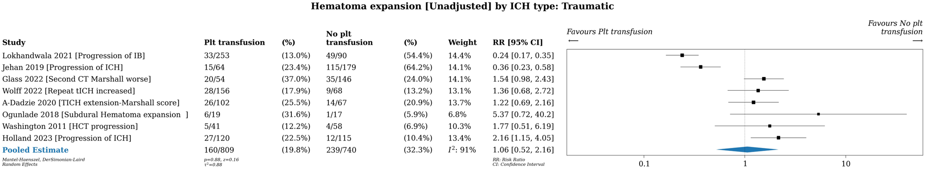
Supplemental Figure 31. PICO 2, Platelet transfusion versus no platelet transfusion in antiplatelet-associated traumatic ICH. Meta-analysis of hematoma expansion (unadjusted). CT, computed tomography; IB, intracranial bleed; HCT, head computed tomography; ICH, intracranial hemorrhage; Plt, platelet; RR, relative risk; tICH, traumatic intracranial hemorrhage.
Supplemental Figure 32.
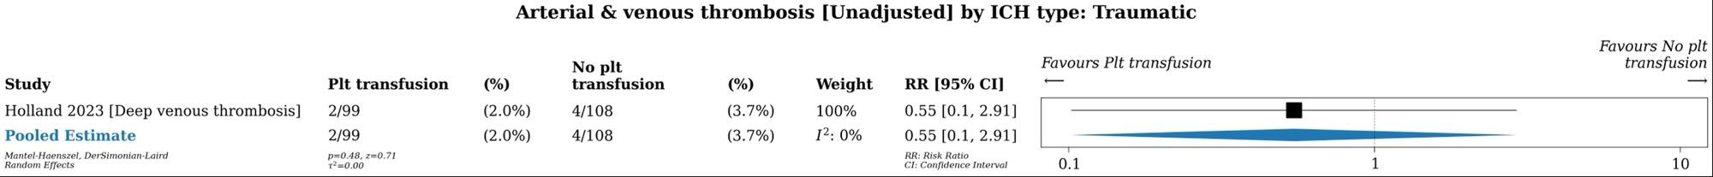
Supplemental Figure 32. PICO 2, Platelet transfusion versus no platelet transfusion in antiplatelet-associated traumatic ICH. Meta-analysis of arterial and venous thrombosis (unadjusted). ICH, intracranial hemorrhage; ICU, intensive care unit; Plt, platelet; RR, risk ratio.

Supplemental Table 12. Summary of Judgements for PICO 2 – Platelet transfusion versus no platelet transfusion in antiplatelet-associated traumatic ICH
 | JUDGEMENT
PROBLEM | No | Probably no | Probably yes | Yes |  | Varies | Don't know
DESIRABLE EFFECTS | Trivial | Small | Moderate | Large |  | Varies | Don't know
UNDESIRABLE EFFECTS | Trivial | Small | Moderate | Large |  | Varies | Don't know
CERTAINTY OF EVIDENCE | Very low | Low | Moderate | High |  |  | No included studies
VALUES | Important uncertainty or variability | Possibly important uncertainty or variability | Probably no important uncertainty or variability | No important uncertainty or variability
BALANCE OF EFFECTS | Favors the comparison | Probably favors the comparison | Does not favor either the intervention or the comparison | Probably favors the intervention | Favors the intervention | Varies | Don't know
RESOURCES REQUIRED | Large costs | Moderate costs | Negligible costs and savings | Moderate savings | Large savings | Varies | Don't know
CERTAINTY OF EVIDENCE OF REQUIRED RESOURCES | Very low | Low | Moderate | High |  |  | No included studies
COST EFFECTIVENESS | Favors the comparison | Probably favors the comparison | Does not favor either the intervention or the comparison | Probably favors the intervention | Favors the intervention | Varies | No included studies
EQUITY | Reduced | Probably reduced | Probably no impact | Probably increased | Increased | Varies | Don't know
ACCEPTABILITY | No | Probably no | Probably yes | Yes |  | Varies | Don't know
FEASIBILITY | No | Probably no | Probably yes | Yes |  | Varies | Don't know

Supplemental Table 13. Characteristics of Included Trials for PICO 2 (See Excel file)

PICO 3 – Desmopressin versus no desmopressin for antiplatelet-associated ICH
Supplemental Figure 33. Prisma Flow Sheet of Article Inclusion and Exclusion for PICO 3
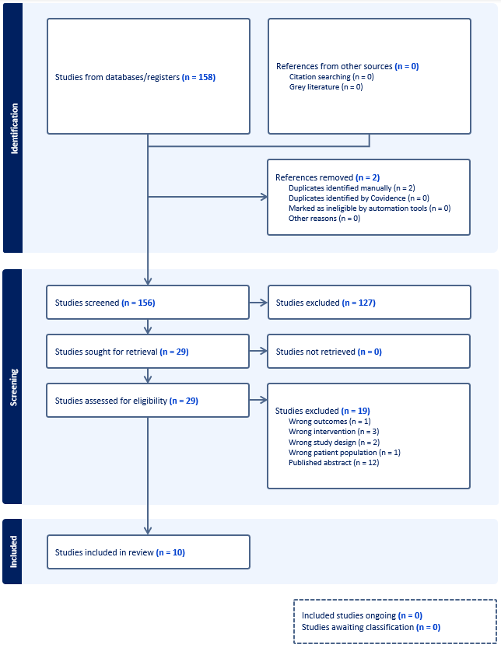

Supplemental Table 14. Summary of Findings Table for PICO 3 - DDAVP versus no DDAVP for antiplatelet-associated ICH
Certainty assessment |  |  |  |  |  |  | № of patients |  | Effect |  | Certainty | Importance
№ of studies | Study design | Risk of bias | Inconsistency | Indirectness | Imprecision | Other considerations | we administer DDAVP | no DDAVP | Relative  (95% CI) | Absolute  (95% CI) | Certainty | Importance
Mortality or discharge to hospital - randomized studies
1 | randomised trials | seriousª | not serious | not serious | very serious^{b} | none | 5/27 (18.5%) | 7/27 (25.9%) | RR 0.71  (0.26 to 1.97) | 75 fewer per 1,000  (from 192 fewer to 251 more) | ⨁◯◯◯  Very low^{a,b} | CRITICAL
Mortality or discharge to hospital - non-randomized studies
8 | non-randomised studies | seriousª | not serious | not serious | serious^{b} | none | 106/681 (15.6%) | 512/5200 (9.8%) | RR 1.18  (0.94 to 1.48) | 18 more per 1,000  (from 6 fewer to 47 more) | ⨁◯◯◯  Very low^{a,b} | CRITICAL
Unfavorable neurological outcomes [mRS or GOS] - randomized studies
1 | randomised trials | seriousª | not serious | not serious | serious^{b} | none | 14/27 (51.9%) | 15/27 (55.6%) | RR 0.93  (0.57 to 1.53) | 39 fewer per 1,000  (from 239 fewer to 294 more) | ⨁⨁◯◯  Low^{a,b} | CRITICAL
Unfavorable neurological outcomes [mRS or GOS] - non-randomized studies
2 | non-randomised studies | seriousª | serious^{c} | not serious | serious^{b} | none | 38/103 (36.9%) | 32/168 (19.0%) | RR 2.07  (0.67 to 6.38) | 204 more per 1,000  (from 63 fewer to 1,000 more) | ⨁◯◯◯  Very low^{a,b,c} | CRITICAL
Unfavorable neurological outcomes [variable measures] - randomized studies
1 | randomised trials | seriousª | not serious | not serious | not serious | none | One RCT reported no differences in a subset of patients who were evaluated for quality of life and cognition at 90 days (Desborough 2023). |  |  |  | ⨁⨁⨁◯  Moderateª
Unfavorable neurological outcomes [variable measures] - non-randomized studies
2 | non-randomised studies | seriousª | serious^{c} | not serious | serious^{b} | none | One observational study reported that DDAVP treatment was associated with 47% improvement in the odds of good neurological outcome (OR 1.47, 95% CI 1.06 to 2.03) after adjusting for potential confounding variables (Francoeur 2019).  Conversely, one observational study reported that patients who received DDAVP were more likely to be transferred to a rehabilitation or skilled nursing facility (vs. discharge to home; 42.4% vs. 25.3%; Summer 2023).  Based on these studies, the effect of DDAVP on functional outcomes is uncertain (very low certainty in the evidence). |  |  |  | ⨁◯◯◯  Very low^{a,b,c}
Arterial & venous thrombosis - randomized studies
1 | randomised trials | seriousª | not serious | not serious | very serious^{b} | none | 1/27 (3.7%) | 1/27 (3.7%) | RR 1.00  (0.07 to 15.18) | 0 fewer per 1,000  (from 34 fewer to 525 more) | ⨁◯◯◯  Very low^{a,b} | CRITICAL
Arterial & venous thrombosis - non-randomized studies
6 | non-randomised studies | seriousª | not serious | not serious | serious^{b} | none | 33/601 (5.5%) | 213/1779 (12.0%) | RR 0.85  (0.59 to 1.23) | 18 fewer per 1,000  (from 49 fewer to 28 more) | ⨁◯◯◯  Very low^{a,b} | CRITICAL
Hematoma expansion - randomized studies
1 | randomised trials | seriousª | not serious | not serious | very serious^{b} | none | 5/24 (20.8%) | 5/22 (22.7%) | RR 0.92  (0.31 to 2.74) | 18 fewer per 1,000  (from 157 fewer to 395 more) | ⨁◯◯◯  Very low^{a,b} | IMPORTANT
Hematoma expansion [adjusted analysis] - non-randomized studies
3 | non-randomised studies | not serious | serious^{c} | not serious | serious^{b} | none |  |  | OR 0.66  (0.34 to 1.30) | -- per 1,000  (from -- to 0 fewer) | ⨁◯◯◯  Very low^{b,c} | IMPORTANT
Hematoma expansion - non-randomized studies
8 | non-randomised studies | seriousª | serious^{c} | not serious | serious^{b} | none | 102/646 (15.8%) | 239/1996 (12.0%) | RR 0.83  (0.45 to 1.55) | 20 fewer per 1,000  (from 66 fewer to 66 more) | ⨁◯◯◯  Very low^{a,b,c} | IMPORTANT
Moderate to severe hyponatremia [< 125 mEq/L] - randomized studies
1 | randomised trials | seriousª | not serious | not serious | serious^{b} | none | One RCT of 54 patients with ICH found that no patients had hyponatremia as defined by serum sodium level of less than 125 mEq/L in either group. |  |  |  | ⨁⨁◯◯  Low^{a,b} | IMPORTANT
Hyponatremia [< 135 mEq/L] - randomized studies
1 | randomised trials | seriousª | not serious | not serious | very serious^{b} | none | 8/23 (34.8%) | 3/24 (12.5%) | RR 2.78  (0.84 to 9.21) | 222 more per 1,000  (from 20 fewer to 1,000 more) | ⨁◯◯◯  Very low^{a,b} | IMPORTANT
Hyponatremia [< 135 mEq/L] - non-randomized studies
2 | non-randomised studies | seriousª | not serious | not serious | serious^{b} | none | 40/245 (16.3%) | 234/1550 (15.1%) | RR 1.04  (0.76 to 1.42) | 6 more per 1,000  (from 36 fewer to 63 more) | ⨁◯◯◯  Very low^{a,b} | IMPORTANT
Seizures - randomized studies
1 | randomised trials | seriousª | not serious | not serious | very serious^{b} | none | 2/27 (7.4%) | 2/27 (7.4%) | RR 1.00  (0.15 to 6.59) | 0 fewer per 1,000  (from 63 fewer to 414 more) | ⨁◯◯◯  Very low^{a,b} | IMPORTANT
Seizures - non-randomized studies
1 | non-randomised studies | not serious | not serious | not serious | very serious^{b} | none | 2/37 (5.4%) | 5/55 (9.1%) | RR 0.59  (0.12 to 2.90) | 37 fewer per 1,000  (from 80 fewer to 173 more) | ⨁◯◯◯  Very low^{b} | IMPORTANT
ICU length of stay - non-randomizes studies
3 | non-randomised studies | seriousª | not serious | not serious | not serious | none | 247 | 4828 | - | MD 0.44 higher  (0.26 lower to 1.14 higher) | ⨁◯◯◯  Very lowª | IMPORTANT
CI: confidence interval; MD: mean difference; OR: odds ratio; RR: risk ratio

Explanations
a. Rated down due to high or uncertain risk of bias.
b. Rated down for imprecision due to wide confidence interval (i.e., meaningful benefit or harm cannot be excluded).
c. Rated down for inconsistency due to variability in conclusions across studies and high measures of heterogeneity.

Supplemental Figure 34.
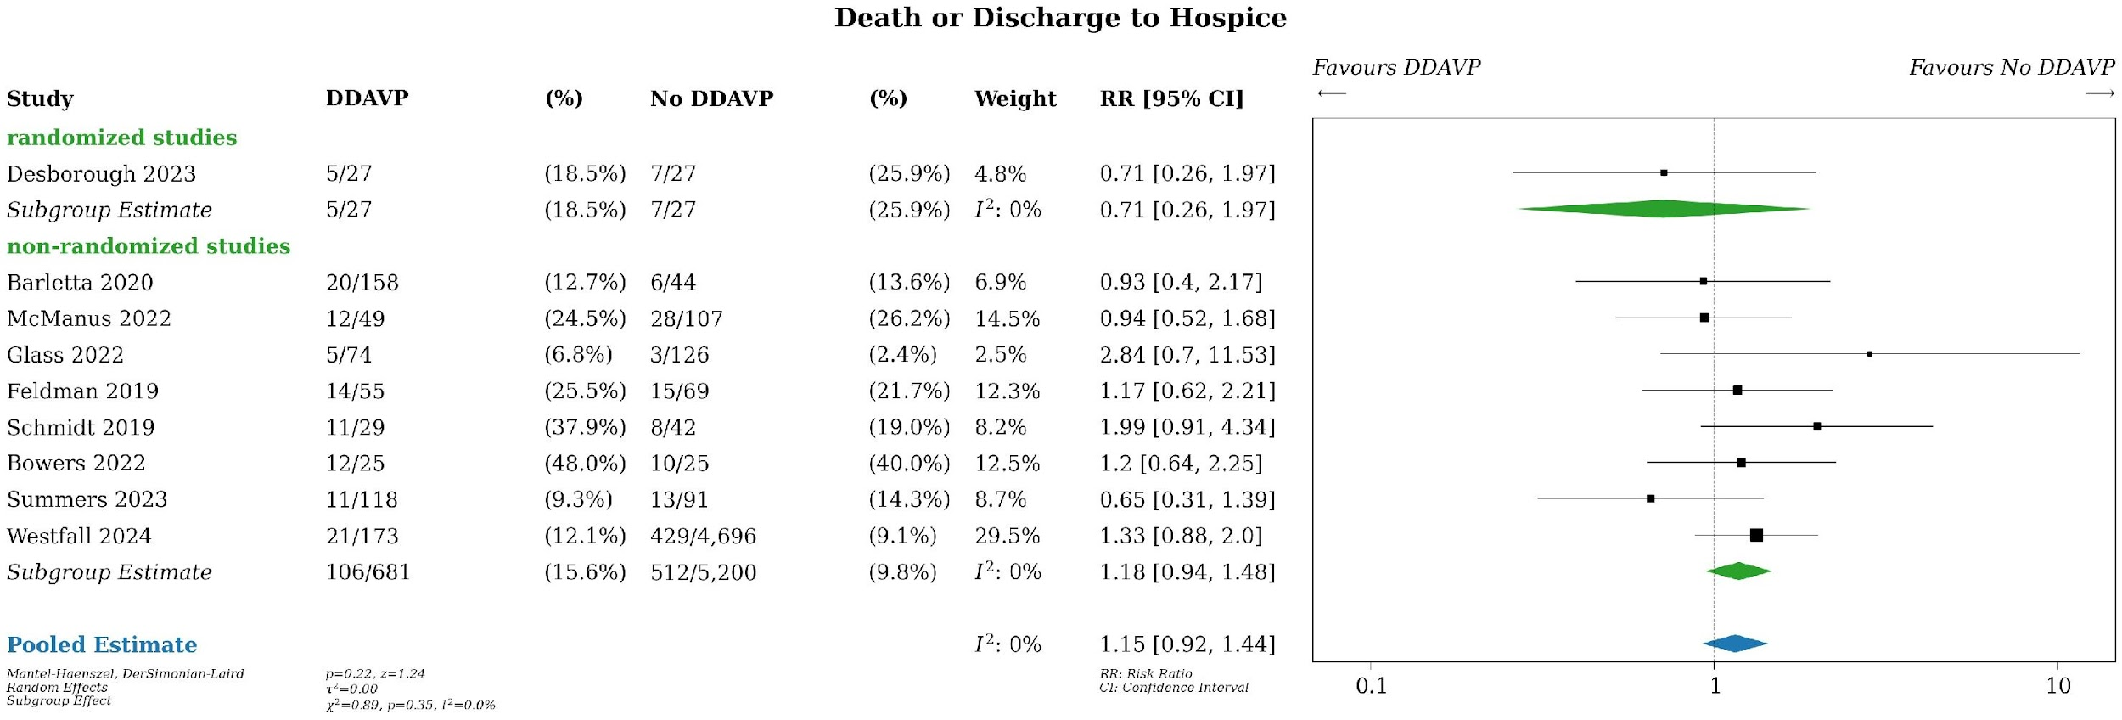
Supplemental Figure 34. PICO 3, DDAVP versus no DDAVP in antiplatelet-associated ICH. Meta-analysis of death or discharge to hospice (unadjusted), stratified by randomized versus non-randomized study design. CI, confidence interval; DDAVP, desmopressin; RR, risk ratio.
Supplemental Figure 35.
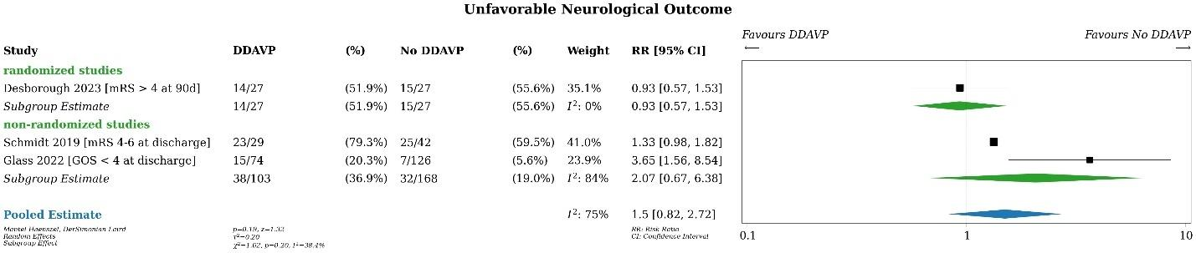
Supplemental Figure 35. PICO 3, DDAVP versus no DDAVP in antiplatelet-associated ICH. Meta-analysis of unfavorable neurologic outcome (unadjusted), stratified by randomized versus non-randomized study design. CI, confidence interval; DDAVP, desmopressin; GOS, Glasgow Outcome Scale; mRS, modified Rankin scale; RR, risk ratio.
Supplemental Figure 36.
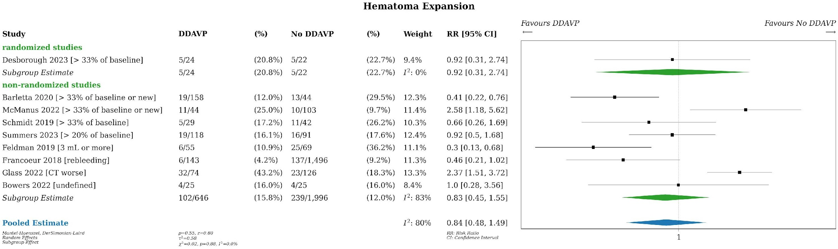
Supplemental Figure 36. PICO 3, DDAVP versus no DDAVP in antiplatelet-associated ICH. Meta-analysis of hematoma expansion (unadjusted), stratified by randomized versus non-randomized study design. CI, confidence interval; DDAVP, desmopressin; RR, risk ratio.
Supplemental Figure 37.
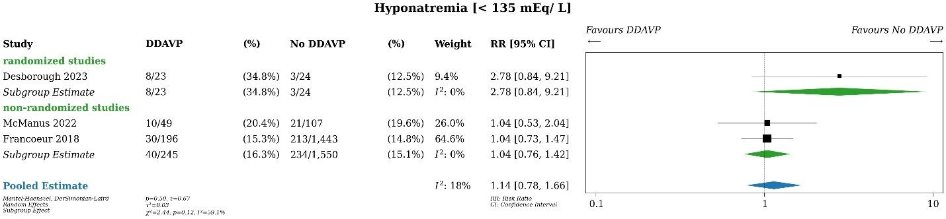
Supplemental Figure 37. PICO 3, DDAVP versus no DDAVP in antiplatelet-associated ICH. Meta-analysis of hyponatremia (defined as serum sodium <135 mEq/L, unadjusted), stratified by randomized versus non-randomized study design. CI, confidence interval; DDAVP, desmopressin; RR, risk ratio.
Supplemental Figure 38.
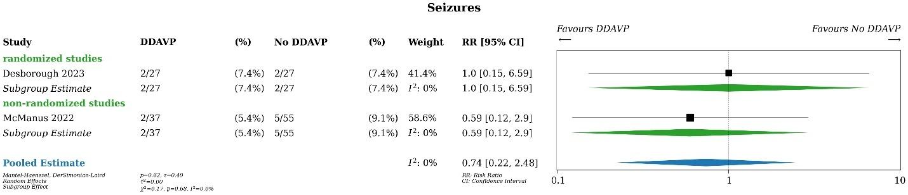
Supplemental Figure 38. PICO 3, DDAVP versus no DDAVP in antiplatelet-associated ICH. Meta-analysis of seizures (unadjusted), stratified by randomized versus non-randomized study design. CI, confidence interval; DDAVP, desmopressin; RR, risk ratio.
Supplemental Figure 39.
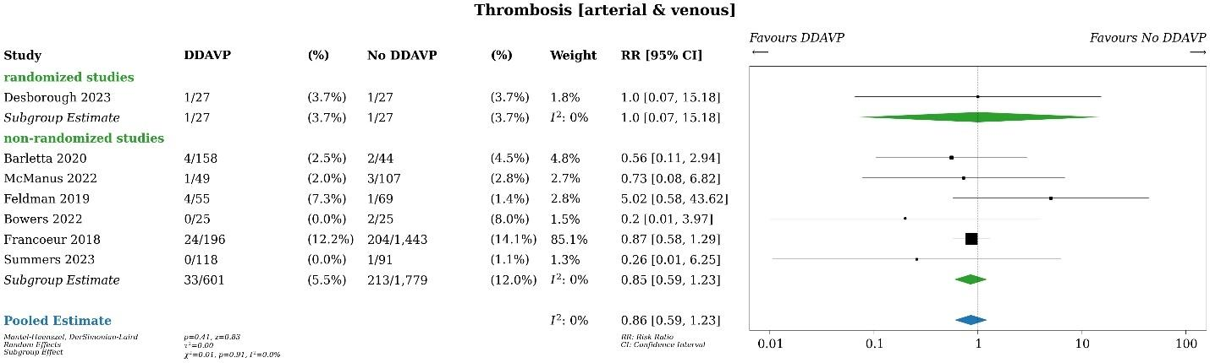
Supplemental Figure 39. PICO 3, DDAVP versus no DDAVP in antiplatelet-associated ICH. Meta-analysis of arterial and venous thrombosis, stratified by randomized versus non-randomized study design. CI, confidence interval; DDAVP, desmopressin; RR, risk ratio.

Supplemental Figure 40.
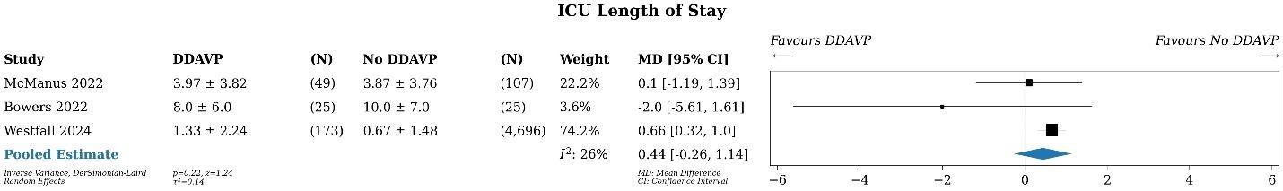
Supplemental Figure 40. PICO 3, DDAVP versus no DDAVP in antiplatelet-associated ICH. Meta-analysis of ICU length of stay (unadjusted). CI, confidence interval; DDAVP, desmopressin; ICU, intensive care unit; MD, mean difference.

Supplemental Table 15. Summary of Judgements for PICO 3
 | JUDGEMENT
PROBLEM | No | Probably no | Probably yes | Yes |  | Varies | Don't know
DESIRABLE EFFECTS | Trivial | Small | Moderate | Large |  | Varies | Don't know
UNDESIRABLE EFFECTS | Trivial | Small | Moderate | Large |  | Varies | Don't know
CERTAINTY OF EVIDENCE | Very low | Low | Moderate | High |  |  | No included studies
VALUES | Important uncertainty or variability | Possibly important uncertainty or variability | Probably no important uncertainty or variability | No important uncertainty or variability
BALANCE OF EFFECTS | Favors the comparison | Probably favors the comparison | Does not favor either the intervention or the comparison | Probably favors the intervention | Favors the intervention | Varies | Don't know
RESOURCES REQUIRED | Large costs | Moderate costs | Negligible costs and savings | Moderate savings | Large savings | Varies | Don't know
CERTAINTY OF EVIDENCE OF REQUIRED RESOURCES | Very low | Low | Moderate | High |  |  | No included studies
COST EFFECTIVENESS | Favors the comparison | Probably favors the comparison | Does not favor either the intervention or the comparison | Probably favors the intervention | Favors the intervention | Varies | No included studies
EQUITY | Reduced | Probably reduced | Probably no impact | Probably increased | Increased | Varies | Don't know
ACCEPTABILITY | No | Probably no | Probably yes | Yes |  | Varies | Don't know
FEASIBILITY | No | Probably no | Probably yes | Yes |  | Varies | Don't know

Supplemental Table 16. Characteristics of Included Trials for PICO 3 (See Excel file)

PICO 4 – Reversal versus no reversal of anticoagulants in small IPH
Supplemental Figure 41. Prisma Flow Sheet of Article Inclusion and Exclusion for PICO 4
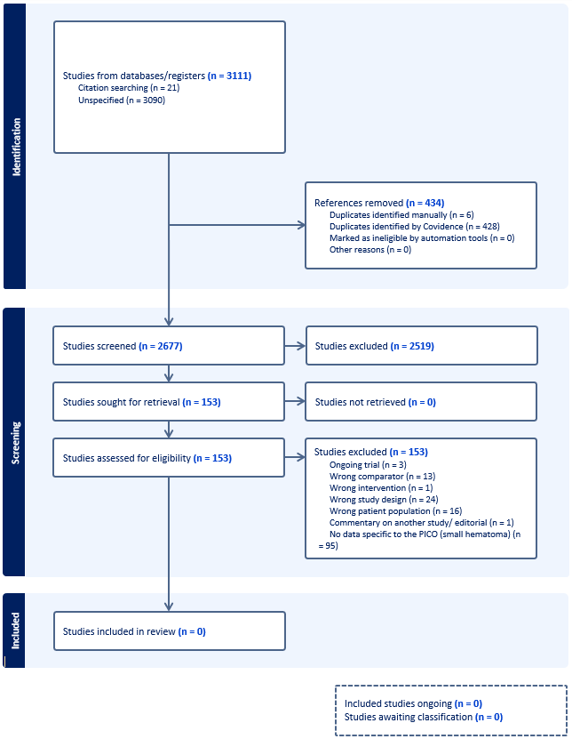

PICO 5 - VHA-guided versus no-VHA guided reversal of coagulopathy in TBI
Supplemental Figure 42. Prisma Flow Sheet of Article Inclusion and Exclusion for PICO 5
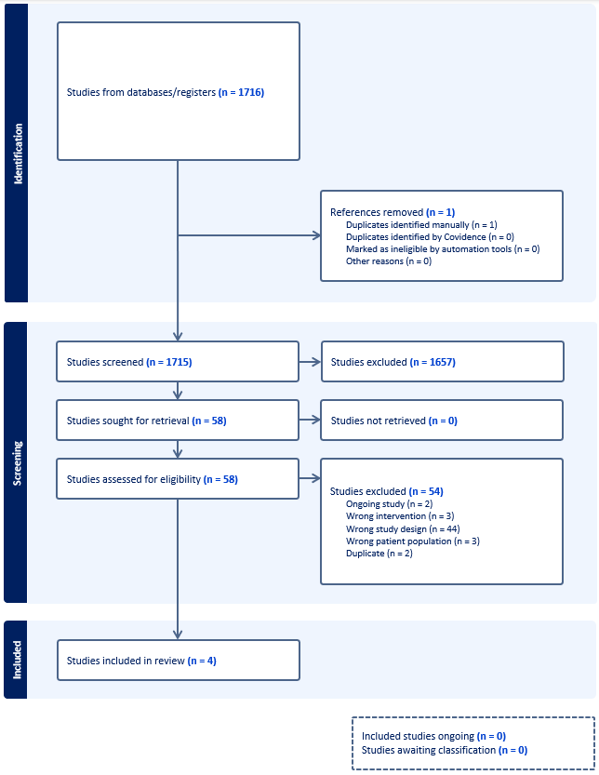

Supplemental Table 17. Summary of Findings Table for PICO 5 – VHA use versus no VHA use in TBI
Certainty assessment |  |  |  |  |  |  | № of patients |  | Effect |  | Certainty | Importance
№ of studies | Study design | Risk of bias | Inconsistency | Indirectness | Imprecision | Other considerations | viscoelastic hemostatic assays | standard care | Relative  (95% CI) | Absolute  (95% CI) | Certainty | Importance
Mortality - RCT
1 | randomised trials | very seriousª | not serious | not serious | not serious | none | 17/39 (43.6%) | 25/34 (73.5%) | RR 0.59  (0.39 to 0.89) | 301 fewer per 1,000  (from 449 fewer to 81 fewer) | ⨁⨁◯◯  Lowª | CRITICAL
Mortality - observational studies
3 | non-randomised studies | serious^{b} | not serious | not serious | serious^{c} | none | 48/185 (25.9%) | 35/166 (21.1%) | RR 1.19  (0.80 to 1.77) | 40 more per 1,000  (from 42 fewer to 162 more) | ⨁◯◯◯  Very low^{b,c} | CRITICAL
Poor functional outcome
1 | non-randomised studies | serious^{b} | not serious | not serious | serious^{c} | none | 45/131 (34.4%) | 46/102 (45.1%) | RR 0.85  (0.64 to 1.12) | 68 fewer per 1,000  (from 162 fewer to 54 more) | ⨁◯◯◯  Very low^{b,c} | CRITICAL
Hemorrhagic expansion
2 | non-randomised studies | not serious | serious^{d} | not serious | serious^{c} | none | 38/131 (29.0%) | 38/102 (37.3%) | RR 0.90  (0.40 to 2.01) | 37 fewer per 1,000  (from 224 fewer to 376 more) | ⨁◯◯◯  Very low^{c,d} | CRITICAL
Hospital length of stay
1 | non-randomised studies | serious^{b} | not serious | not serious | serious^{c} | none | Length of stay in days, median (IQR)  VHA guided reversal  N=69  17 (11-24)  Standard care  N=6522 (11-27)  P-value 0.28 |  |  |  | ⨁◯◯◯  Very low^{b,c} | IMPORTANT
Any blood product
1 | non-randomised studies | serious^{b} | not serious | not serious | serious^{c} | none | Any blood product, n(%)  VHA guided reversal  N=69  24 (35%)  Standard care  N=65  23 (35%)  P-value  0.94 |  |  |  | ⨁◯◯◯  Very low^{b,c} | IMPORTANT
Platelet transfusion
1 | non-randomised studies | serious^{b} | not serious | serious^{d} | serious^{c} | none | 14/131 (10.7%) | 28/102 (27.5%) | RR 0.42  (0.07 to 2.56) | 159 fewer per 1,000  (from 255 fewer to 428 more) | ⨁◯◯◯  Very low^{b,c,d}
Thrombosis
0 |  |  |  |  |  |  | 0/0 | 0/0 | not estimable |  | -
Hospital readmission
0 |  |  |  |  |  |  | 0/0 | 0/0 | not estimable |  | -
ICU length of stay
0 |  |  |  |  |  |  | 0/0 | 0/0 | not estimable |  | -
Transfusion reaction
0 |  |  |  |  |  |  | 0/0 | 0/0 | not estimable |  | -
CI: confidence interval; RR: risk ratio

Explanations
a. small subgroup on a variable that was not a stratification variable
b. unadjusted results in observational data
c. confidence interval includes meaningful harm and benefit
d. substantial statistical heterogeneity

Supplemental Figure 43.
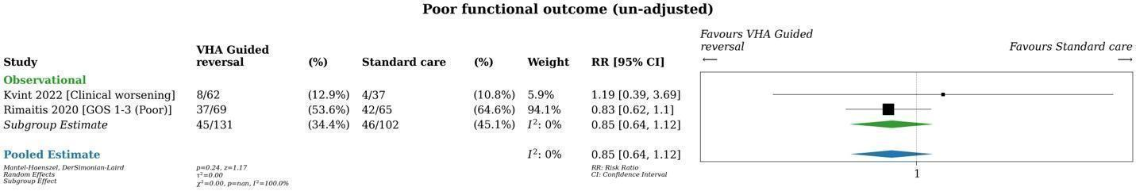
Supplemental Figure 43. PICO 5, VHA use versus no VHA use in traumatic ICH. Meta-analysis of poor functional outcome (unadjusted). CI, confidence interval; GOS, Glasgow outcome scale; ICH, intracranial hemorrhage; RR, relative risk; VHA, viscoelastic hemostatic assay.
Supplemental Figure 44.
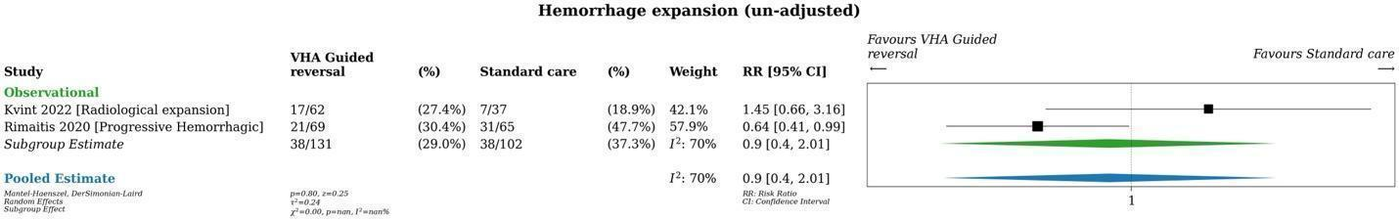
Supplemental Figure 44. PICO 5, VHA use versus no VHA use in traumatic ICH. Meta-analysis of hemorrhage expansion (unadjusted). CI, confidence interval; ICH, intracranial hemorrhage; RR, relative risk; VHA, viscoelastic hemostatic assay.

Supplemental Figure 45.
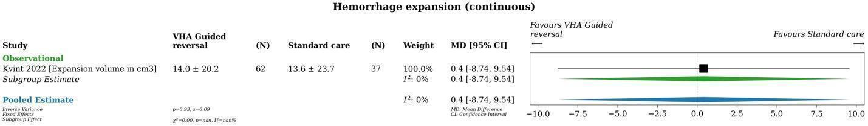
Supplemental Figure 45. PICO 5, VHA use versus no VHA use in traumatic ICH. Meta-analysis of hemorrhage expansion (continuous). CI, confidence interval; ICH, intracranial hemorrhage; MD, mean difference; VHA, viscoelastic hemostatic assay.

Supplemental Figure 46.
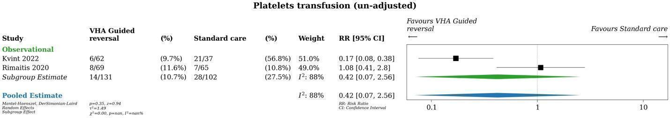
Supplemental Figure 46. PICO 5, VHA use versus no VHA use in traumatic ICH. Meta-analysis of platelet transfusion requirements (unadjusted). CI, confidence interval; ICH, intracranial hemorrhage; RR, relative risk; VHA, viscoelastic hemostatic assay.

Supplemental Table 18. Summary of Judgements for PICO 5
 | JUDGEMENT
PROBLEM | No | Probably no | Probably yes | Yes |  | Varies | Don't know
DESIRABLE EFFECTS | Trivial | Small | Moderate | Large |  | Varies | Don't know
UNDESIRABLE EFFECTS | Trivial | Small | Moderate | Large |  | Varies | Don't know
CERTAINTY OF EVIDENCE | Very low | Low | Moderate | High |  |  | No included studies
VALUES | Important uncertainty or variability | Possibly important uncertainty or variability | Probably no important uncertainty or variability | No important uncertainty or variability
BALANCE OF EFFECTS | Favors the comparison | Probably favors the comparison | Does not favor either the intervention or the comparison | Probably favors the intervention | Favors the intervention | Varies | Don't know
RESOURCES REQUIRED | Large costs | Moderate costs | Negligible costs and savings | Moderate savings | Large savings | Varies | Don't know
CERTAINTY OF EVIDENCE OF REQUIRED RESOURCES | Very low | Low | Moderate | High |  |  | No included studies
COST EFFECTIVENESS | Favors the comparison | Probably favors the comparison | Does not favor either the intervention or the comparison | Probably favors the intervention | Favors the intervention | Varies | No included studies
EQUITY | Reduced | Probably reduced | Probably no impact | Probably increased | Increased | Varies | Don't know
ACCEPTABILITY | No | Probably no | Probably yes | Yes |  | Varies | Don't know
FEASIBILITY | No | Probably no | Probably yes | Yes |  | Varies | Don't know

Supplemental Table 19. Characteristics of Included Trials for PICO 5 (See Excel file)

