SUPPORTING INFORMATION

SUPPORTING METHODS 1
Calculation of tree diversity variables
For each plot, we calculated Hill ⁰D (species richness) and Hill ²D (inverse Simpson index) diversity indices for AM trees alone, ECM trees alone, and combined ECM and AM trees (Hill 1973; Chao et al. 2014). We used both basal area and stem counts for calculation of Hill ²D because they were not highly correlated (r <0.6) and represent measures that give more weight to overstory and understory dominance of each tree species, respectively (Mueller-Dombois and Ellenberg 1974). For indices of tree phylogenetic diversity, we generated a phylogenetic tree in R version 4.2.2 (R Core Team 2022) for all tree species sampled in our plots from the megatree created by Smith and Brown (2018) using the package rtrees (Li 2023; Fig. S1). Summed branch lengths from the phylogenetic tree (Faith 1992) were used to calculate plot-level phylogenetic diversity (phylo-Hill ⁰D and phylo-Hill ²D, derived from basal area) for AM, ECM, and combined AM-ECM tree communities with the package adiv (Pavoine 2020). To generate phylogenetically-weighted variables representing tree community composition, we then used the package betapart (Baselga and Orme 2012) to calculate plot-level pairwise Sørensen phylogenetic dissimilarity for AM, ECM, and combined AM and ECM tree communities, which we then converted into phylogenetic eigenvectors using principal coordinate analysis (PCoA) with the package vegan (Oksanen 2019). Summaries of tree taxonomic and phylogenetic diversity variables (except for phylogenetic eigenvectors) can be found in the Supporting Information (Table S2).
SUPPORTING METHODS 2
Modeling ECMF diversity responses
First, we used linear mixed-effects regressions, with site (Shingle Shanty, Huntington Forest, Deer Leap) as a random effect, with the package lme4 (Bates et al. 2014). We constructed separate global models containing each suite of AM tree diversity (Table S2), ECM tree diversity (Table S2), combined AM-ECM tree diversity (Table S2), tree community abundance by mycorrhizal type (AM, ECM, and combined AM-ECM; Table S3), and soil variables (Table S4) to identify the most informative variables from each of the five variable suites. Among tree diversity variables, we included Hill ⁰D (species richness), Hill ²D (inverse Simpson’s diversity index) using basal area and stem counts as separate abundance measures, phylogenetic Hill ⁰D (Faith’s distance; Faith 1992), as well as phylogenetic Hill ²D for AM, ECM, and combined AM-ECM tree communities. Second, we tested for multicollinearity within each variable suite by calculating the variance inflation factor (VIF) of each global model using the package car (Fox and Weisberg 2018). If models contained variables with VIF ≥ 10, we sequentially removed individual candidate variables with the highest VIF, refit the model, and then repeated until VIF < 10 for all remaining variables (Borcard et al. 2018). Third, we conducted unsupervised variable selection on each global model containing separate suites of variables (e.g., AM tree diversity, ECM tree diversity, combined AM-ECM tree diversity, tree community abundance by mycorrhizal type, and soil variables), and ranked the models with corrected Akaike’s Information Criterion (AICc) using the dredge() function with the package MuMIn (Bartoń 2023). We then selected all variables included in each top AICc-ranked model, representing the most informative predictors from each variable suite, to be included in the next model selection step. Fourth, we conducted supervised variable selection by fitting separate linear mixed-effects models containing variables individually, or in biologically relevant combinations. For this step we specified models with each unique combination of soil variables but only allowed one tree abundance and one tree diversity variable in the same model. We specified interaction terms between soil variables if multiple were included in the same model, as well as interactions between tree abundance and diversity variables. However, to avoid uninterpretable higher-order interactions, we did not specify interactions between soil variables and tree diversity or abundance variables. We also specified a null model only containing the intercept random effect terms. We then ranked all candidate models with AICc using the package AICcmodavg (Mazerolle 2023) to identify the most parsimonious models explaining each ECMF taxonomic diversity response. We checked the residuals of each top model to ensure the assumptions of normality and homogeneity of variance were fulfilled. To assess overall model fit, we calculated conditional R² values for each top-ranked model with the package MuMIn. Fifth, we removed all models containing variables that were collinear (VIF≥ 10) to those contained in the top-ranked model. We also removed any candidate models <2 ΔAICc containing uninformative parameters that were extensions of the top model (sensu Arnold 2010). The remaining set of models was then used to model-average ECMF diversity responses to each variable using the package AICcmodavg. We assessed the significance of each variable by examining the 95% confidence intervals; if confidence intervals did not intersect zero, then the variable was considered significant.
SOURCES
Bartoń K (2023) MuMIn: Multi-Model Inference. R package ver. 1.47.5.
Baselga A, Orme CDL (2012) betapart: an R package for the study of beta diversity. Methods in Ecology and Evolution 3: 808–812.
Bates D, Mächler M, Bolker B, Walker S (2014) Fitting Linear Mixed-Effects Models using lme4.
Fox J, Weisberg S (2018) An R Companion to Applied Regression. SAGE Publications.
Faith DP (1992) Conservation evaluation and phylogenetic diversity. Biological Conservation 61: 1–10.
Hill MO (1973) Diversity and Evenness: A Unifying Notation and Its Consequences. Ecology 54: 427–432.
Mazerolle MJ (2023) AICcmodavg: Model Selection and Multimodel Inference Based on (Q)AIC(c) ver. 2.3-3.
Mueller-Dombois D, Ellenberg H (1974) Aims and methods of vegetation ecology.
Oksanen J (2019) Package ‘Vegan’.
Pavoine S (2020) adiv: An r package to analyse biodiversity in ecology. Methods in Ecology and Evolution 11: 1106–1112.
Smith SA, Brown JW (2018) Constructing a broadly inclusive seed plant phylogeny. American Journal of Botany 105: 302–314.

Table S1 Percent basal area (± SE) of arbuscular mycorrhizal (AM) and ectomycorrhizal (ECM) trees sampled from 71 plots across three sites in the Adirondack Mountains, NY (2017)
Tree species | Deer Leap | Huntington Forest | Shingle Shanty
Acer saccharum (AM) | 35.51 ± 4.31 | 33.39 ± 4.38 | 16.96 ± 4.05
Acer rubrum (AM) | 1.26 ± 0.58 | 0.76 ± 0.52 | 21.75 ± 5.05
Acer pensylvanicum (AM) | 0.12 ± 0.05 | 0.46 ± 0.27 | 0.60 ± 0.22
Fagus grandifolia (EM) | 19.57 ± 2.79 | 31.79 ± 4.30 | 39.24 ± 3.71
Ostrya virginiana (EM) | 0.86 ± 0.35 | 0.07 ± 0.07 | 0.00 ± 0.00
Tsuga canadensis (EM) | 1.34 ± 0.50 | 11.46 ± 2.84 | 5.15 ± 2.83
Pinus strobus (EM) | 10.19 ± 4.03 | 0.00 ± 0.00 | 0.00 ± 0.00
Pinus resinosa (EM) | 0.22 ± 0.22 | 0.00 ± 0.00 | 0.00 ± 0.00
Picea rubens (EM) | 0.00 ± 0.00 | 3.26 ± 1.16 | 6.24 ± 1.23
Betula alleghaniensis (EM) | 9.67 ± 2.45 | 17.48 ± 4.18 | 10.02 ± 2.61
Betula papyrifera (EM) | 1.59 ± 0.73 | 0.05 ± 0.05 | 0.00 ± 0.00
Hamamelis virginiana (AM) | 0.02 ± 0.01 | 0.00 ± 0.00 | 0.00 ± 0.00
Quercus rubra (EM) | 10.07 ± 3.32 | 0.00 ± 0.00 | 0.00 ± 0.00
Quercus alba (EM) | 0.80 ± 0.38 | 0.00 ± 0.00 | 0.00 ± 0.00
Fraxinus americana (AM) | 6.55 ± 1.61 | 1.29 ± 0.47 | 0.04 ± 0.04
Ulmus americana (AM) | 0.01 ± 0.00 | 0.00 ± 0.00 | 0.00 ± 0.00
Populus grandidentata (EM) | 0.44 ± 0.36 | 0.00 ± 0.00 | 0.00 ± 0.00
Tilia americana (EM) | 1.77 ± 0.76 | 0.00 ± 0.00 | 0.00 ± 0.00

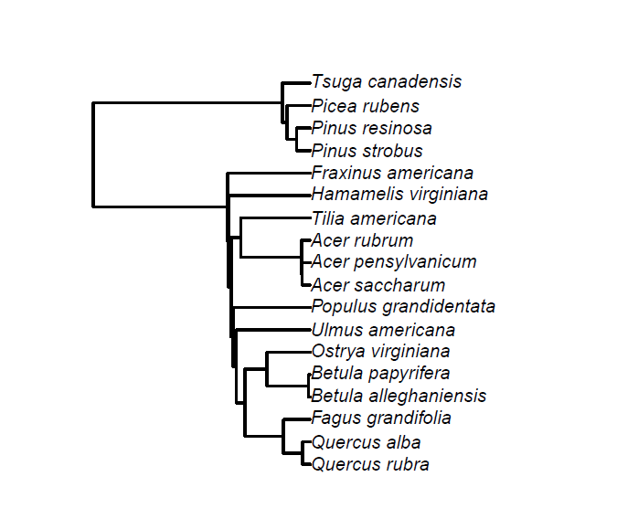
Fig. S1 Phylogenetic tree (Li, 2023) of AM and ECM tree species present in study used for calculating plot-level AM, ECM, and combined AM-ECM phylogenetic diversity from the Adirondack Mountains, USA (2017)

Table S2 Plot ectomycorrhizal (ECM), arbuscular mycorrhizal (AM), and combined AM-ECM tree diversity variable summaries used in models of ECMF taxonomic and functional diversity from the Adirondack Mountains, USA (2017)
Variable | Mean ± SE
AM tree phylogenetic Hill ⁰D | 456.14 ± 10.03
AM tree phylogenetic Hill ²D | 404.28 ± 2.66
ECM tree phylogenetic Hill ⁰D | 775.73 ± 16.08
ECM tree phylogenetic Hill ²D | 520.89 ± 11.37
Combined ECM and AM tree phylogenetic Hill ⁰D | 957.84 ± 19.24
Combined ECM and AM tree phylogenetic Hill ²D | 545.46 ± 10.19
AM tree Hill ⁰D | 2.21 ± 0.11
AM stem Hill ²D | 1.57 ± 0.06
AM basal area Hill ²D | 1.16 ± 0.04
ECM tree Hill ⁰D | 3.49 ± 0.16
ECM stem Hill ²D | 1.66 ± 0.06
ECM basal area Hill ²D | 2.17 ± 0.11
Combined ECM and AM tree Hill ⁰D | 5.69 ± 0.22
Combined ECM and AM basal area Hill ²D | 2.82 ± 0.11
Combined ECM and AM stem Hill ²D | 2.23 ± 0.10

Table S3 Plot tree community abundance variable summaries used in models of ECMF taxonomic and functional diversity from the Adirondack Mountains, USA (2017)
Variable | Mean ± SE
Combined ECM and AM stems | 1595.29 ± 55.09
Combined ECM and AM basal area (m²) | 2.55 ± 0.07
% Conifer basal area | 13.05 ± 2.00
% ECM stems | 84.08 ± 1.49
% ECM basal area | 60.46 ± 2.48
ECM importance value (IV) | 144.54 ± 3.31
Total ECM basal area (m²) | 1.54 ± 0.08
% AM stems | 15.92 ± 1.49
% AM basal area | 39.54 ± 2.48
AM importance value (IV) | 55.46 ± 3.31
Total AM basal area (m²) | 1.01 ± 0.07
Total AM stems | 230.10 ± 20.01
Total ECM stems | 1365.20 ± 61.18

Table S4 Plot soil variable summaries from the Adirondack Mountains, USA (2017)
Variable | Mean ± SE
pH | 4.27 ± 0.09
% Carbon | 17.6 ± 1.50
% Nitrogen | 0.83 ± 0.06
C:N ratio | 20.40 ± 0.59
NH₄⁺ (μg g⁻¹) | 24.45 ± 2.20
N mineralization (μg g⁻¹ day⁻¹) | 7.56 ± 0.50
NO₃⁻ (μg g⁻¹) | 10.86 ± 1.20
Nitrification (μg g⁻¹ day⁻¹) | 4.09 ± 0.38
Total inorganic nitrogen (μg g⁻¹) | 35.32 ± 2.83
Forest floor (Oi + Oe) mass (g m⁻³) | 945.72 ± 36.03
Fine root biomass (kg m⁻³) | 2.31 ± 0.08
Soil respiration (μmol CO₂ m⁻²s⁻¹) | 12.21 ± 0.43

Table S5 Soil variable correlations with tree diversity and abundance variables from the Adirondack Mountains, USA (2017). Significant (p<0.05) correlations are indicated in bold text
 | NH₄⁺ | N min. | NO₃⁻ | Nitrification | Inorg. N | Forest floor mass | Fine root mass | Soil resp. | pH | % C | % N | C:N ratio
AM tree phylo. ⁰D | -0.04 | -0.25 | -0.07 | 0.02 | -0.06 | 0.31 | -0.17 | -0.27 | 0.57 | -0.37 | -0.39 | -0.08
AM tree phylo. ²D | -0.10 | -0.19 | -0.03 | 0.02 | -0.09 | 0.22 | -0.32 | -0.30 | 0.47 | -0.35 | -0.37 | -0.03
AM tree ⁰D | 0.20 | -0.11 | -0.02 | -0.02 | 0.15 | 0.07 | 0.07 | -0.12 | 0.40 | -0.16 | -0.19 | 0.04
AM stem ²D | 0.30 | 0.10 | -0.07 | -0.06 | 0.20 | -0.26 | 0.18 | 0.10 | -0.02 | 0.20 | 0.17 | 0.12
AM basal area ²D | 0.12 | -0.16 | 0.07 | -0.18 | 0.12 | -0.01 | -0.05 | -0.05 | 0.06 | -0.09 | -0.12 | 0.14
ECM tree phylo. ⁰D | 0.17 | 0.02 | -0.01 | -0.06 | 0.12 | 0.24 | -0.04 | -0.08 | 0.03 | 0.13 | 0.08 | 0.31
ECM tree phylo ²D | 0.18 | 0.10 | -0.02 | -0.12 | 0.13 | 0.20 | -0.20 | 0.05 | 0.05 | 0.25 | 0.19 | 0.28
ECM tree ⁰D | -0.04 | -0.33 | -0.15 | -0.18 | -0.10 | 0.53 | -0.26 | -0.42 | 0.45 | -0.21 | -0.23 | 0.05
ECM stem ²D | 0.37 | -0.08 | 0.11 | -0.17 | 0.33 | 0.05 | -0.02 | -0.13 | 0.02 | 0.15 | 0.09 | 0.27
ECM basal area ²D | -0.05 | -0.06 | 0.11 | 0.03 | 0.01 | 0.32 | -0.22 | -0.27 | 0.48 | -0.17 | -0.19 | -0.04
AM + ECM tree phylo ⁰D | 0.00 | -0.03 | -0.05 | -0.12 | -0.02 | 0.30 | -0.24 | -0.07 | 0.05 | 0.14 | 0.09 | 0.21
AM + ECM tree phylo ²D | 0.13 | -0.10 | -0.05 | -0.04 | 0.08 | 0.36 | -0.12 | -0.20 | 0.29 | -0.07 | -0.12 | 0.23
AM + ECM tree ⁰D | 0.07 | -0.29 | -0.12 | -0.14 | 0.00 | 0.42 | -0.15 | -0.37 | 0.52 | -0.23 | -0.26 | 0.06
AM + ECM basal area ²D | -0.08 | -0.14 | 0.06 | -0.01 | -0.04 | 0.30 | -0.16 | -0.28 | 0.41 | -0.11 | -0.12 | -0.05
AM + ECM stem ²D | 0.32 | -0.09 | 0.10 | -0.18 | 0.29 | 0.16 | 0.03 | -0.18 | 0.20 | 0.09 | 0.06 | 0.16
Stem density | 0.35 | 0.50 | 0.37 | 0.23 | 0.43 | -0.32 | 0.18 | 0.35 | -0.55 | 0.16 | 0.06 | 0.37
Basal area | 0.00 | -0.32 | -0.09 | -0.17 | -0.04 | 0.38 | -0.24 | -0.20 | 0.29 | -0.10 | -0.11 | 0.03
% AM stems | 0.12 | -0.05 | 0.04 | -0.02 | 0.11 | 0.24 | 0.03 | -0.25 | 0.47 | -0.16 | -0.15 | -0.13
% AM basal area | -0.09 | 0.01 | 0.05 | 0.05 | -0.05 | -0.15 | 0.14 | 0.01 | 0.14 | -0.08 | -0.03 | -0.34
AM importance value | -0.01 | -0.01 | 0.05 | 0.03 | 0.02 | 0.00 | 0.12 | -0.10 | 0.32 | -0.13 | -0.08 | -0.31
AM basal area | -0.13 | -0.08 | 0.03 | 0.01 | -0.08 | -0.08 | 0.07 | -0.01 | 0.19 | -0.07 | -0.02 | -0.34
% ECM stems | -0.12 | 0.05 | -0.04 | 0.02 | -0.11 | -0.24 | -0.03 | 0.25 | -0.47 | 0.16 | 0.15 | 0.13
% ECM basal area | 0.09 | -0.01 | -0.05 | -0.05 | 0.05 | 0.15 | -0.14 | -0.01 | -0.14 | 0.08 | 0.03 | 0.34
EM importance value | 0.01 | 0.01 | -0.05 | -0.03 | -0.02 | 0.00 | -0.12 | 0.10 | -0.32 | 0.13 | 0.08 | 0.31
ECM basal area | 0.11 | -0.19 | -0.10 | -0.15 | 0.04 | 0.39 | -0.25 | -0.16 | 0.08 | -0.02 | -0.08 | 0.31
ECM dominance | 0.00 | -0.04 | 0.02 | -0.07 | 0.01 | 0.07 | -0.07 | 0.07 | -0.25 | 0.21 | 0.15 | 0.36
NH₄⁺ |  | 0.49 | 0.34 | -0.01 | 0.92 | -0.16 | 0.13 | 0.13 | -0.13 | 0.26 | 0.18 | 0.49
N_min | 0.49 |  | 0.59 | 0.66 | 0.63 | -0.22 | 0.29 | 0.27 | -0.18 | 0.16 | 0.08 | 0.22
NO₃⁻ | 0.34 | 0.59 |  | 0.50 | 0.69 | -0.21 | 0.14 | 0.21 | -0.25 | 0.05 | -0.05 | 0.38
Nitrification | -0.01 | 0.66 | 0.50 |  | 0.21 | -0.04 | 0.09 | 0.09 | 0.08 | -0.16 | -0.18 | -0.07
Total inorganic N | 0.92 | 0.63 | 0.69 | 0.21 |  | -0.21 | 0.16 | 0.19 | -0.21 | 0.22 | 0.12 | 0.54
Forest floor mass | -0.16 | -0.22 | -0.21 | -0.04 | -0.21 |  | -0.18 | -0.38 | 0.48 | -0.27 | -0.22 | -0.22
Fine root mass | 0.13 | 0.29 | 0.14 | 0.09 | 0.16 | -0.18 |  | 0.41 | -0.18 | 0.19 | 0.19 | 0.06
Soil respiration | 0.13 | 0.27 | 0.21 | 0.09 | 0.19 | -0.38 | 0.41 |  | -0.49 | 0.46 | 0.43 | 0.36
pH | -0.13 | -0.18 | -0.25 | 0.08 | -0.21 | 0.48 | -0.18 | -0.49 |  | -0.52 | -0.45 | -0.48
% C | 0.26 | 0.16 | 0.05 | -0.16 | 0.22 | -0.27 | 0.19 | 0.46 | -0.52 |  | 0.97 | 0.49
% N | 0.18 | 0.08 | -0.05 | -0.18 | 0.12 | -0.22 | 0.19 | 0.43 | -0.45 | 0.97 |  | 0.30
C:N ratio | 0.49 | 0.22 | 0.38 | -0.07 | 0.54 | -0.22 | 0.06 | 0.36 | -0.48 | 0.49 | 0.30

Table S6 List of ectomycorrhizal fungi (ECMF) sequenced from roots and soils from 72 plots across three sites in the Adirondack Mountains, NY (2017)
 | Deer Leap (% ± SE) |  | Huntington Forest (% ± SE) |  | Shingle Shanty (% ± SE)
ECMF Genus | Root | Soil | Root | Soil | Root | Soil
Amanita | 0.15 ± 0.06 | 0.92 ± 0.58 | 0.98 ± 0.23 | 3.17 ± 0.72 | 1.85 ± 0.52 | 3.17 ± 0.72
Amphinema | 0.11 ± 0.09 | 0.24 ± 0.13 | 0.00 ± 0.00 | 0.01 ± 0.01 | 0.00 ± 0.00 | 0.01 ± 0.01
Boletus | 0.01 ± 0.01 | 0.03 ± 0.02 | 0.12 ± 0.12 | 0.00 ± 0.00 | 0.00 ± 0.00 | 0.00 ± 0.00
Byssocorticium | 0.00 ± 0.00 | 0.07 ± 0.04 | 0.01 ± 0.01 | 0.03 ± 0.02 | 0.00 ± 0.00 | 0.03 ± 0.02
Cantharellus | 0.00 ± 0.00 | 0.00 ± 0.00 | 0.00 ± 0.00 | 0.00 ± 0.00 | 0.00 ± 0.00 | 0.00 ± 0.00
Cenococcum | 1.81 ± 0.66 | 1.11 ± 0.23 | 1.35 ± 0.41 | 1.21 ± 0.31 | 2.33 ± 0.48 | 1.21 ± 0.31
Clavulina | 0.23 ± 0.23 | 0.63 ± 0.61 | 0.71 ± 0.65 | 2.59 ± 1.45 | 0.05 ± 0.03 | 2.59 ± 1.45
Coltricia | 0.03 ± 0.02 | 0.04 ± 0.03 | 0.00 ± 0.00 | 0.00 ± 0.00 | 0.00 ± 0.00 | 0.00 ± 0.00
Cortinarius | 5.83 ± 2.60 | 6.34 ± 2.90 | 1.11 ± 0.36 | 2.73 ± 0.82 | 2.63 ± 1.28 | 2.73 ± 0.82
Craterellus | 0.72 ± 0.58 | 0.81 ± 0.69 | 0.33 ± 0.25 | 0.54 ± 0.48 | 0.00 ± 0.00 | 0.54 ± 0.48
Densospora | 0.00 ± 0.00 | 0.00 ± 0.00 | 0.00 ± 0.00 | 0.00 ± 0.00 | 0.00 ± 0.00 | 0.00 ± 0.00
Elaphomyces | 0.01 ± 0.01 | 0.15 ± 0.15 | 0.01 ± 0.01 | 0.52 ± 0.23 | 0.01 ± 0.01 | 0.52 ± 0.23
Genea | 0.00 ± 0.00 | 0.02 ± 0.02 | 0.02 ± 0.02 | 0.01 ± 0.01 | 0.00 ± 0.00 | 0.01 ± 0.01
Gyroporus | 0.00 ± 0.00 | 0.00 ± 0.00 | 0.00 ± 0.00 | 0.01 ± 0.01 | 0.00 ± 0.00 | 0.01 ± 0.01
Hebeloma | 0.18 ± 0.15 | 0.20 ± 0.12 | 0.16 ± 0.09 | 0.29 ± 0.20 | 0.03 ± 0.03 | 0.29 ± 0.20
Helvellosebacina | 0.08 ± 0.05 | 0.40 ± 0.20 | 0.00 ± 0.00 | 0.00 ± 0.00 | 0.00 ± 0.00 | 0.00 ± 0.00
Humaria | 0.08 ± 0.04 | 0.05 ± 0.04 | 0.00 ± 0.00 | 0.00 ± 0.00 | 0.00 ± 0.00 | 0.00 ± 0.00
Hydnobolites | 0.01 ± 0.01 | 0.11 ± 0.07 | 0.00 ± 0.00 | 0.00 ± 0.00 | 0.00 ± 0.00 | 0.00 ± 0.00
Hydnotrya | 0.00 ± 0.00 | 0.00 ± 0.00 | 0.00 ± 0.00 | 0.03 ± 0.02 | 0.00 ± 0.00 | 0.03 ± 0.02
Hydnum | 0.08 ± 0.06 | 0.09 ± 0.06 | 0.10 ± 0.10 | 0.26 ± 0.26 | 0.00 ± 0.00 | 0.26 ± 0.26
Hygrophorus | 0.32 ± 0.18 | 1.89 ± 1.56 | 0.01 ± 0.01 | 0.01 ± 0.01 | 0.00 ± 0.00 | 0.01 ± 0.01
Hymenogaster | 0.03 ± 0.03 | 0.17 ± 0.10 | 0.05 ± 0.05 | 0.00 ± 0.00 | 0.00 ± 0.00 | 0.00 ± 0.00
Hysterangium | 0.00 ± 0.00 | 0.00 ± 0.00 | 0.00 ± 0.00 | 0.00 ± 0.00 | 0.00 ± 0.00 | 0.00 ± 0.00
Imleria | 0.00 ± 0.00 | 0.02 ± 0.02 | 0.05 ± 0.03 | 0.38 ± 0.15 | 0.16 ± 0.06 | 0.38 ± 0.15
Inocybe | 0.58 ± 0.26 | 2.85 ± 1.25 | 1.87 ± 0.63 | 6.01 ± 1.63 | 0.50 ± 0.21 | 6.01 ± 1.63
Laccaria | 0.07 ± 0.03 | 0.42 ± 0.25 | 0.06 ± 0.04 | 0.33 ± 0.12 | 0.02 ± 0.02 | 0.33 ± 0.12
Lactarius | 1.43 ± 0.39 | 0.70 ± 0.21 | 1.22 ± 0.35 | 1.12 ± 0.25 | 0.27 ± 0.11 | 1.12 ± 0.25
Lactifluus | 0.03 ± 0.03 | 0.08 ± 0.08 | 0.00 ± 0.00 | 0.01 ± 0.01 | 0.11 ± 0.10 | 0.01 ± 0.01
Leccinum | 0.00 ± 0.00 | 0.03 ± 0.02 | 0.14 ± 0.13 | 0.10 ± 0.07 | 0.01 ± 0.01 | 0.10 ± 0.07
Leotia | 0.00 ± 0.00 | 0.00 ± 0.00 | 0.00 ± 0.00 | 0.00 ± 0.00 | 0.00 ± 0.00 | 0.00 ± 0.00
Membranomyces | 0.19 ± 0.13 | 0.21 ± 0.10 | 0.04 ± 0.02 | 0.19 ± 0.09 | 0.05 ± 0.04 | 0.19 ± 0.09
Naucoria | 0.02 ± 0.02 | 0.06 ± 0.06 | 0.00 ± 0.00 | 0.01 ± 0.01 | 0.00 ± 0.00 | 0.01 ± 0.01
Octaviania | 0.00 ± 0.00 | 0.00 ± 0.00 | 0.00 ± 0.00 | 0.00 ± 0.00 | 0.00 ± 0.00 | 0.00 ± 0.00
Otidea | 0.04 ± 0.04 | 0.16 ± 0.11 | 0.00 ± 0.00 | 0.00 ± 0.00 | 0.00 ± 0.00 | 0.00 ± 0.00
Pachyphlodes | 0.21 ± 0.11 | 0.59 ± 0.18 | 0.10 ± 0.07 | 0.62 ± 0.35 | 0.00 ± 0.00 | 0.62 ± 0.35
Paxillus | 0.00 ± 0.00 | 0.04 ± 0.03 | 0.00 ± 0.00 | 0.03 ± 0.01 | 0.00 ± 0.00 | 0.03 ± 0.01
Phaeocollybia | 0.00 ± 0.00 | 0.00 ± 0.00 | 0.00 ± 0.00 | 0.00 ± 0.00 | 0.07 ± 0.06 | 0.00 ± 0.00
Phaeohelotium | 0.58 ± 0.22 | 0.03 ± 0.01 | 2.87 ± 0.86 | 0.14 ± 0.07 | 0.82 ± 0.42 | 0.14 ± 0.07
Piloderma | 5.64 ± 1.94 | 6.63 ± 3.08 | 0.61 ± 0.38 | 0.61 ± 0.34 | 1.78 ± 1.16 | 0.61 ± 0.34
Protoglossum | 0.00 ± 0.00 | 0.25 ± 0.15 | 0.00 ± 0.00 | 0.00 ± 0.00 | 0.00 ± 0.00 | 0.00 ± 0.00
Pseudotomentella | 0.17 ± 0.13 | 0.08 ± 0.04 | 0.06 ± 0.05 | 0.02 ± 0.02 | 0.02 ± 0.02 | 0.02 ± 0.02
Ramaria | 0.00 ± 0.00 | 0.03 ± 0.03 | 0.00 ± 0.00 | 0.00 ± 0.00 | 0.00 ± 0.00 | 0.00 ± 0.00
Rhizopogon | 0.00 ± 0.00 | 0.00 ± 0.00 | 0.00 ± 0.00 | 0.00 ± 0.00 | 0.00 ± 0.00 | 0.00 ± 0.00
Rhodoscypha | 0.00 ± 0.00 | 0.00 ± 0.00 | 0.02 ± 0.02 | 0.01 ± 0.01 | 0.00 ± 0.00 | 0.01 ± 0.01
Russula | 4.73 ± 1.23 | 9.17 ± 2.18 | 7.95 ± 1.72 | 11.91 ± 2.23 | 8.96 ± 1.45 | 11.91 ± 2.23
Sarcodon | 1.51 ± 1.51 | 0.49 ± 0.49 | 0.00 ± 0.00 | 0.00 ± 0.00 | 0.00 ± 0.00 | 0.00 ± 0.00
Scabropezia | 0.00 ± 0.00 | 0.11 ± 0.11 | 0.00 ± 0.00 | 0.00 ± 0.00 | 0.00 ± 0.00 | 0.00 ± 0.00
Scleroderma | 0.00 ± 0.00 | 0.00 ± 0.00 | 0.00 ± 0.00 | 0.01 ± 0.01 | 0.00 ± 0.00 | 0.01 ± 0.01
Sebacina | 0.83 ± 0.24 | 1.70 ± 0.39 | 1.06 ± 0.27 | 2.67 ± 0.75 | 0.98 ± 0.34 | 2.67 ± 0.75
Suillus | 0.12 ± 0.09 | 0.25 ± 0.11 | 0.00 ± 0.00 | 0.00 ± 0.00 | 0.00 ± 0.00 | 0.00 ± 0.00
Tarzetta | 0.00 ± 0.00 | 0.00 ± 0.00 | 0.00 ± 0.00 | 0.00 ± 0.00 | 0.00 ± 0.00 | 0.00 ± 0.00
Thelephora | 0.01 ± 0.01 | 0.03 ± 0.03 | 0.11 ± 0.06 | 0.16 ± 0.07 | 0.05 ± 0.05 | 0.16 ± 0.07
Tomentella | 1.28 ± 0.32 | 1.16 ± 0.24 | 0.74 ± 0.24 | 0.72 ± 0.13 | 0.52 ± 0.28 | 0.72 ± 0.13
Tomentellopsis | 0.00 ± 0.00 | 0.01 ± 0.01 | 0.00 ± 0.00 | 0.01 ± 0.01 | 0.00 ± 0.00 | 0.01 ± 0.01
Tremellodendropsis | 0.00 ± 0.00 | 0.07 ± 0.05 | 0.00 ± 0.00 | 0.00 ± 0.00 | 0.00 ± 0.00 | 0.00 ± 0.00
Tricholoma | 2.01 ± 1.64 | 2.41 ± 1.37 | 0.02 ± 0.02 | 0.15 ± 0.10 | 0.00 ± 0.00 | 0.15 ± 0.10
Trichophaea | 0.00 ± 0.00 | 0.01 ± 0.00 | 0.00 ± 0.00 | 0.00 ± 0.00 | 0.00 ± 0.00 | 0.00 ± 0.00
Tuber | 0.11 ± 0.05 | 0.05 ± 0.03 | 0.17 ± 0.09 | 0.10 ± 0.06 | 0.01 ± 0.01 | 0.10 ± 0.06
Tylopilus | 0.00 ± 0.00 | 0.01 ± 0.01 | 0.24 ± 0.16 | 0.09 ± 0.05 | 0.01 ± 0.01 | 0.09 ± 0.05
Wilcoxina | 0.05 ± 0.03 | 0.02 ± 0.01 | 0.00 ± 0.00 | 0.00 ± 0.00 | 0.00 ± 0.00 | 0.00 ± 0.00
Xanthoconium | 0.01 ± 0.01 | 0.00 ± 0.00 | 0.04 ± 0.03 | 0.13 ± 0.05 | 0.04 ± 0.02 | 0.13 ± 0.05
Xerocomellus | 0.00 ± 0.00 | 0.00 ± 0.00 | 0.00 ± 0.00 | 0.08 ± 0.03 | 0.00 ± 0.00 | 0.08 ± 0.03
Xerocomus | 0.00 ± 0.00 | 0.07 ± 0.04 | 0.10 ± 0.10 | 0.03 ± 0.01 | 0.00 ± 0.00 | 0.03 ± 0.01

Table S7 AICc table showing null and top-ranked models used for model-averaged predicted responses of soil and root ECMF taxonomic diversity to tree abundance and diversity, as well as soil variables from the Adirondack Mountains, USA (2017)
 | Model^{ab} | K^{c} | logLik^{d} | AICc | ΔAICc | W_{i}^{e} | Cond. R²
Soil ECMF genus ⁰D | % ECM BA + AM tree phylo. ²D + NO₃⁻ | 6 | -161.03 | 335.45 | 0.00 | 0.52 | 0.48
Soil ECMF genus ⁰D | % ECM BA × AM tree phylo. ²D + NO₃⁻ | 7 | -160.98 | 337.86 | 2.41 | 0.15 | 0.48
Soil ECMF genus ⁰D | % ECM BA + ECM tree ⁰D + NO₃⁻ | 6 | -162.90 | 339.21 | 3.76 | 0.08 | 0.45
Soil ECMF genus ⁰D | % ECM BA + AM tree phylo. ²D + NO₃⁻ + C:N ratio + Forest floor mass | 8 | -160.62 | 339.72 | 4.27 | 0.06 | 0.48
Soil ECMF genus ⁰D | % ECM BA + Total (AM + ECM) tree ⁰D + NO₃⁻ | 6 | -161.00 | 340.61 | 5.16 | 0.04 | 0.43
Soil ECMF genus ⁰D | Null (intercept + random effect) | 3 | -182.13 | 370.64 | 35.19 | 0.00 | 0.03
Soil ECMF genus ²D | Total (AM + ECM) stem ²D + pH + Soil respiration + Nitrification | 7 | -112.40 | 240.71 | 0.00 | 0.20 | 0.33
Soil ECMF genus ²D | % ECM BA + total (AM + ECM) stem ²D + pH + Soil respiration + Nitrification | 8 | -112.16 | 242.80 | 2.09 | 0.07 | 0.33
Soil ECMF genus ²D | ECM IV + total (AM + ECM) stem ²D + pH + Soil respiration + Nitrification | 8 | -112.25 | 242.98 | 2.27 | 0.06 | 0.33
Soil ECMF genus ²D | Total (AM + ECM) stem ²D + Soil respiration | 5 | -116.31 | 243.60 | 2.90 | 0.05 | 0.27
Soil ECMF genus ²D | Total (AM + ECM) stem ²D | 4 | -117.75 | 244.15 | 3.44 | 0.04 | 0.23
Soil ECMF genus ²D | Null (intercept + random effect) | 3 | -123.50 | 253.39 | 12.68 | 0.00 | 0.02
Root ECMF genus ⁰D | % ECM BA + %N × Forest floor mass | 7 | -140.52 | 297.15 | 0.00 | 0.84 | 0.51
Root ECMF genus ⁰D | % ECM BA + %N × Nitrification × Forest floor mass | 11 | -137.93 | 303.24 | 6.09 | 0.04 | 0.55
Root ECMF genus ⁰D | Total (AM + ECM) tree phyl. ²D + % ECM BA + %N × Nitrification × Forest floor mass | 12 | -137.81 | 306.12 | 8.97 | 0.01 | 0.55
Root ECMF genus ⁰D | ECM tree ⁰D + % ECM BA + %N × Nitrification × Forest floor mass | 12 | -137.81 | 306.13 | 8.97 | 0.01 | 0.55
Root ECMF genus ⁰D | ECM BA ²D + % ECM BA + %N × Nitrification × Forest floor mass | 12 | -137.83 | 306.16 | 9.01 | 0.01 | 0.55
Root ECMF genus ⁰D | Null (intercept + random effect) | 3 | -160.35 | 327.12 | 29.96 | 0.00 | 0.10
Root ECMF ²D | AM tree ⁰D × % ECM BA | 6 | -107.87 | 229.29 | 0.00 | 0.21 | 0.26
Root ECMF ²D | AM tree ⁰D + % ECM BA | 5 | -109.48 | 230.05 | 0.76 | 0.15 | 0.22
Root ECMF ²D | AM tree ⁰D | 4 | -111.29 | 231.29 | 2.00 | 0.08 | 0.18
Root ECMF ²D | AM tree ⁰D + % ECM BA + N_min | 6 | -108.98 | 231.51 | 2.22 | 0.07 | 0.21
Root ECMF ²D | AM tree ⁰D + ECM BA | 5 | -110.28 | 231.65 | 2.35 | 0.07 | 0.20
Root ECMF ²D | Null (intercept + random effect) | 3 | -114.93 | 236.27 | 6.98 | 0.01 | 0.07
ªModels containing variables correlated with those in the top model, or those < 2 ΔAICc that are extensions of top model (more parameters) removed from model averaging
^{b}+ = Without interaction terms; × = with interaction terms
^{c}K = Number of parameters
^{d}logLik = loglikelihood
^{e}W_{i} = AICc model weight

Table S8 AICc table showing top-ranked models used for model-averaged predicted responses of soil and root ECMF functional diversity to tree abundance and diversity, as well as soil variables from the Adirondack Mountains, USA (2017)
Response | Model^{ab} | K^{c} | logLik^{d} | AICc | ΔAICc | W_{i}^{e} | Cond. R²
Soil ECMF funct. ⁰D | ECM focal tree + Total (AM + ECM) phyl. ⁰D + NO₃⁻ + C:N ratio + pH + N mineralization | 9 | -60.69 | 142.60 | 0.00 | 0.19 | 0.40
Soil ECMF funct. ⁰D | ECM focal tree + ECM tree phyl. ⁰D + NO₃⁻ + C:N ratio + pH + N mineralization | 9 | -61.03 | 143.27 | 0.67 | 0.14 | 0.39
Soil ECMF funct. ⁰D | ECM focal tree + Total (AM + ECM) tree ⁰D + NO₃⁻ + C:N ratio + pH + N mineralization | 9 | -61.69 | 144.58 | 1.98 | 0.07 | 0.38
Soil ECMF funct. ⁰D | Total (AM + ECM) tree PD ⁰D + NO₃⁻ + C:N ratio + pH + N mineralization | 8 | -63.06 | 144.65 | 2.04 | 0.07 | 0.35
Soil ECMF funct. ⁰D | ECM focal tree × ECM tree PD ⁰D + NO₃⁻ + C:N ratio + pH + N mineralization | 10 | -60.36 | 144.71 | 2.11 | 0.07 | 0.41
Soil ECMF funct. ⁰D | Null (intercept and random) | 3 | -77.34 | 161.06 | 18.46 | 0.00 | 0.00
Soil ECMF funct. ²D | ECM tree phyl. ²D + Soil respiration + Nitrification + pH | 7 | -68.93 | 153.79 | 0.00 | 0.15 | 0.24
Soil ECMF funct. ²D | Total (AM + ECM) stem ²D + Soil respiration + Nitrification + pH | 7 | -69.34 | 154.62 | 0.83 | 0.10 | 0.23
Soil ECMF funct. ²D | Soil respiration + Nitrification + pH | 6 | -70.78 | 154.99 | 1.20 | 0.08 | 0.20
Soil ECMF funct. ²D | % ECM BA + ECM tree phyl. ²D + Soil respiration + Nitrification + pH | 8 | -68.80 | 156.13 | 2.35 | 0.05 | 0.24
Soil ECMF funct. ²D | Total (AM + ECM) stem ²D + Soil respiration | 5 | -72.63 | 156.26 | 2.48 | 0.04 | 0.22
Soil ECMF funct. ²D | Null (intercept + random) | 3 | -77.90 | 162.18 | 8.39 | 0.00 | 0.00
Root ECMF funct. ⁰D | ECM focal tree + ECM tree ⁰D + Fine root biomass | 6 | -71.09 | 155.76 | 0.00 | 0.16 | 0.30
Root ECMF funct. ⁰D | ECM focal tree + total (AM + ECM) tree ⁰D + Fine root biomass | 6 | -71.53 | 156.65 | 0.88 | 0.11 | 0.29
Root ECMF funct. ⁰D | ECM focal tree + nitrification + Fine root biomass + pH | 7 | -70.40 | 156.96 | 1.20 | 0.09 | 0.32
Root ECMF funct. ⁰D | ECM focal tree + Fine root biomass | 5 | -72.98 | 157.06 | 1.30 | 0.09 | 0.25
Root ECMF funct. ⁰D | ECM focal tree × total (AM + ECM) tree ⁰D + Fine root biomass | 7 | -70.53 | 157.22 | 1.46 | 0.08 | 0.32
Root ECMF funct. ⁰D | Null (intercept and random) | 3 | -81.51 | 169.44 | 13.68 | 0.00 | 0.04
Root ECMF funct. ²D | ECM tree phyl. ²D + %N + NO₃⁻ + Soil respiration | 7 | -68.43 | 153.02 | 0.00 | 0.10 | 0.24
Root ECMF funct. ²D | Total (ECM + AM) tree phyl. ⁰D + %N + NH₄⁺ + NO₃⁻ + Soil respiration | 8 | -67.89 | 154.61 | 1.60 | 0.04 | 0.25
Root ECMF funct. ²D | Total (ECM + AM) tree phyl. ⁰D + Soil respiration | 5 | -71.90 | 154.92 | 1.90 | 0.04 | 0.15
Root ECMF funct. ²D | ECM BA + AM stem ²D + Soil respiration | 6 | -71.10 | 155.78 | 2.76 | 0.02 | 0.17
Root ECMF funct. ²D | ECM BA + ECM tree phyl. ²D + %N + NH₄⁺ + NO₃⁻ + Soil respiration | 9 | -67.13 | 155.86 | 2.85 | 0.02 | 0.27
Root ECMF funct. ²D | Null (intercept + random) | 3 | -76.58 | 159.59 | 6.57 | 0.00 | 0.00
ªModels containing variables correlated with those in the top model, or those < 2 ΔAICc that are extensions of top model (more parameters) removed from model averaging
^{b}+ = Without interaction terms; × = with interaction terms
^{c}K = Number of parameters
^{d}logLik = loglikelihood
^{e}W_{i} = AICc model weight

Table S9 AICc table showing top-ranked models used for model-averaged predicted responses of relative abundance of medium distance-fringe (MD fringe) ECMF fungi to tree abundance and diversity, as well as soil variables from the Adirondack Mountains, USA (2017)
Response | Modelª | K^{b} | logLik^{c} | AICc | ΔAICc | W_{i}^{d}
Soil MD fringe rel. abundance | AM tree ⁰D + C:N ratio | 6 | 10.95 | -8.48 | 0.00 | 0.19
Soil MD fringe rel. abundance | C:N ratio + NH₄⁺ | 6 | 10.71 | -8.00 | 0.48 | 0.15
Soil MD fringe rel. abundance | C:N ratio | 5 | 9.17 | -7.34 | 1.14 | 0.10
Soil MD fringe rel. abundance | C:N ratio + NH₄⁺ + pH | 7 | 11.42 | -6.91 | 1.57 | 0.08
Soil MD fringe rel. abundance | AM tree ⁰D + C:N + NH₄⁺ + pH | 8 | 12.47 | -6.41 | 2.08 | 0.07
Soil MD fringe rel. abundance | Null (intercept + random) | 4 | 6.86 | -5.07 | 3.41 | 0.03
Root MD fringe rel. abundance | ECM tree phyl. ⁰D + C:N ratio | 6 | -0.51 | 14.60 | 0.00 | 0.30
Root MD fringe rel. abundance | ECM tree phyl. ⁰D + C:N ratio + pH | 7 | -0.44 | 17.04 | 2.44 | 0.09
Root MD fringe rel. abundance | AM tree phyl. ⁰D | 5 | -3.08 | 17.28 | 2.67 | 0.08
Root MD fringe rel. abundance | ECM tree phyl. ⁰D | 5 | -3.28 | 17.68 | 3.08 | 0.06
Root MD fringe rel. abundance | C:N ratio | 5 | -3.56 | 18.24 | 3.64 | 0.05
Root MD fringe rel. abundance | Null (intercept + random) | 4 | -4.90 | 18.54 | 3.93 | 0.04
ªModels containing variables correlated with those in the top model, or those < 2 ΔAICc that are extensions of top model (more parameters) removed from model averaging
^{b}K = Number of parameters
^{c}logLik = loglikelihood
^{d}W_{i} = AICc model weight

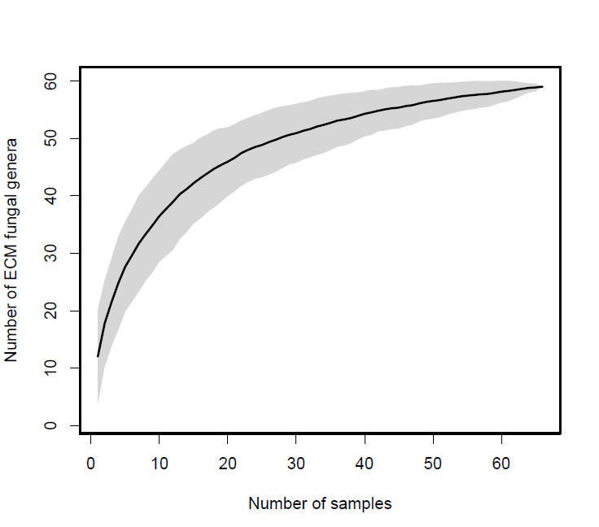
Fig. S2 Accumulation curve of ECMF genera sequenced from soils from the Adirondack Mountains, USA (2017)

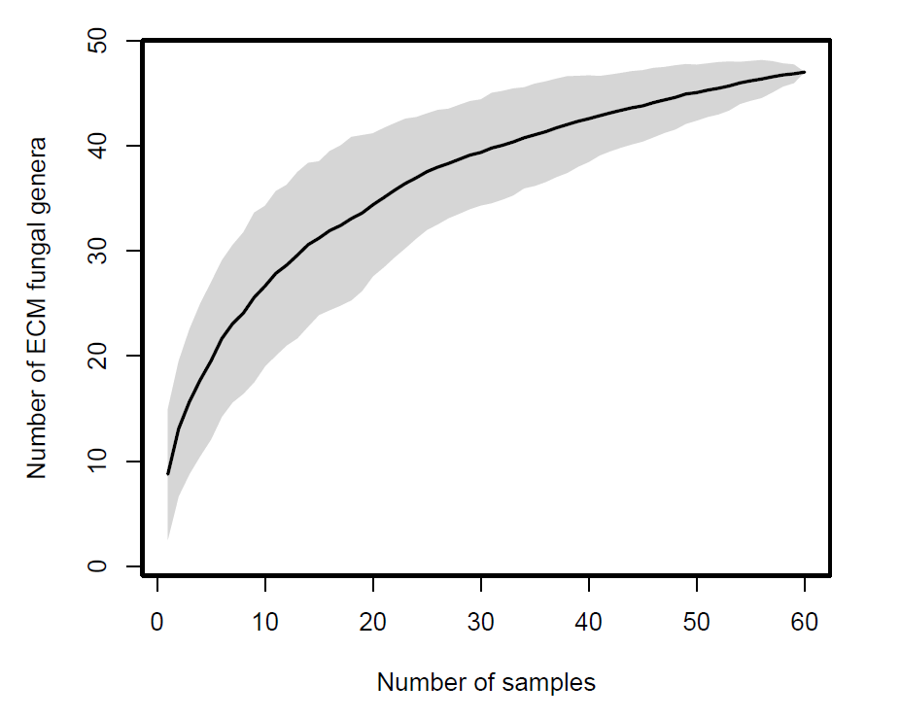
Fig. S3 Accumulation curve of ECMF genera sequenced from roots from the Adirondack Mountains, USA (2017)

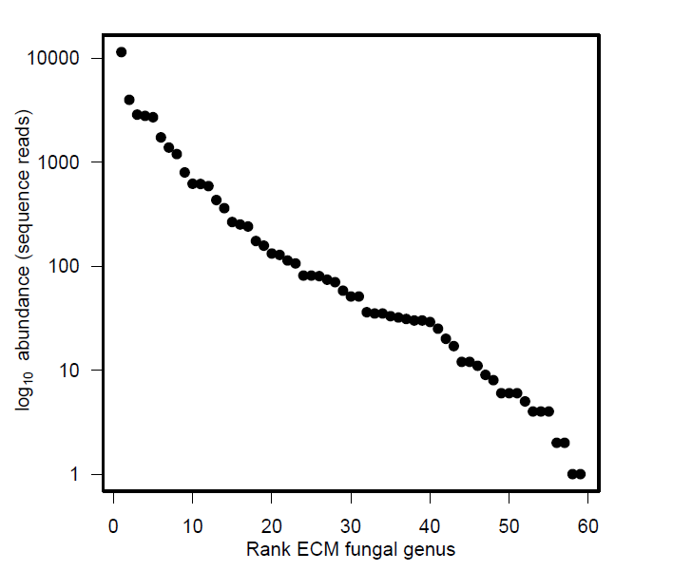
Fig. S4 rank abundance curve for ECMF genera sequenced from soils from the Adirondack Mountains, USA (2017)

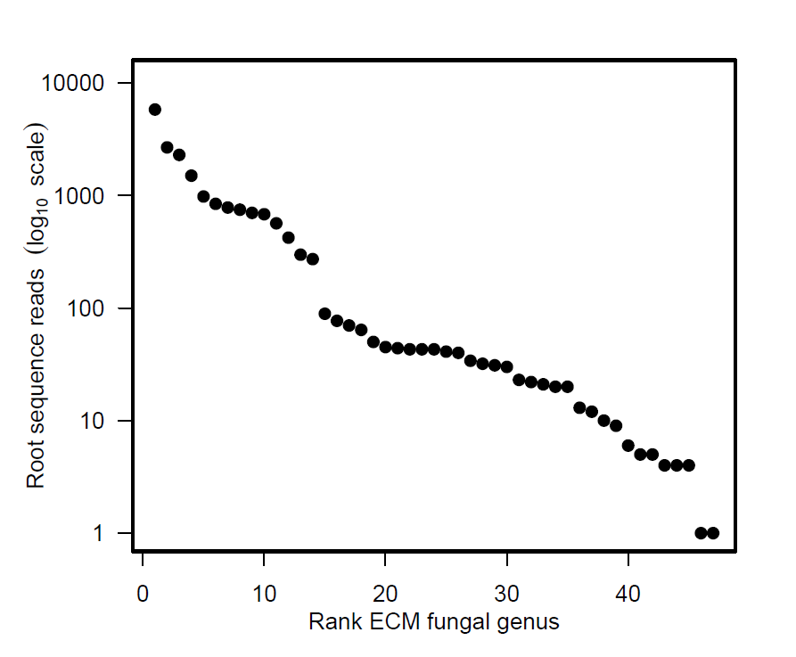
Fig. S5 Rank abundance curve for ECMF genera sequenced from roots from the Adirondack Mountains, USA (2017)

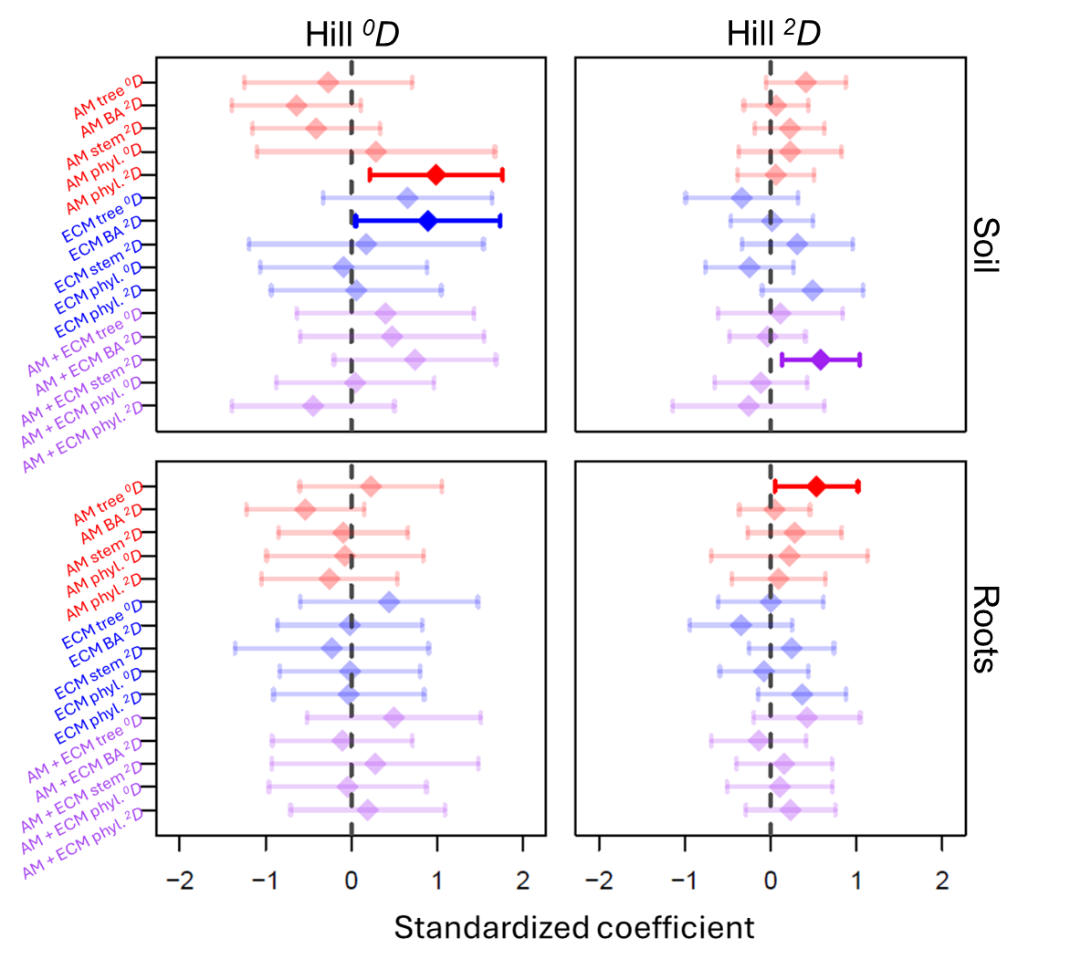
Fig. S6 Model-averaged responses of ECMF taxonomic Hill ⁰D (left) and Hill ²D (right) from soil (top) and roots (bottom) in relation to arbuscular mycorrhizal (AM; top), ECM (middle), along with combined AM-ECM (bottom) tree phylogenetic and species Hill ⁰D and ²D diversity from the Adirondack Mountains, USA (2017). Soil variables included in top AICc-ranked models were also included for each response (Tables S7-S8). Bolded points indicate significant responses with 95% confidence intervals that do not intersect zero (dashed lines)

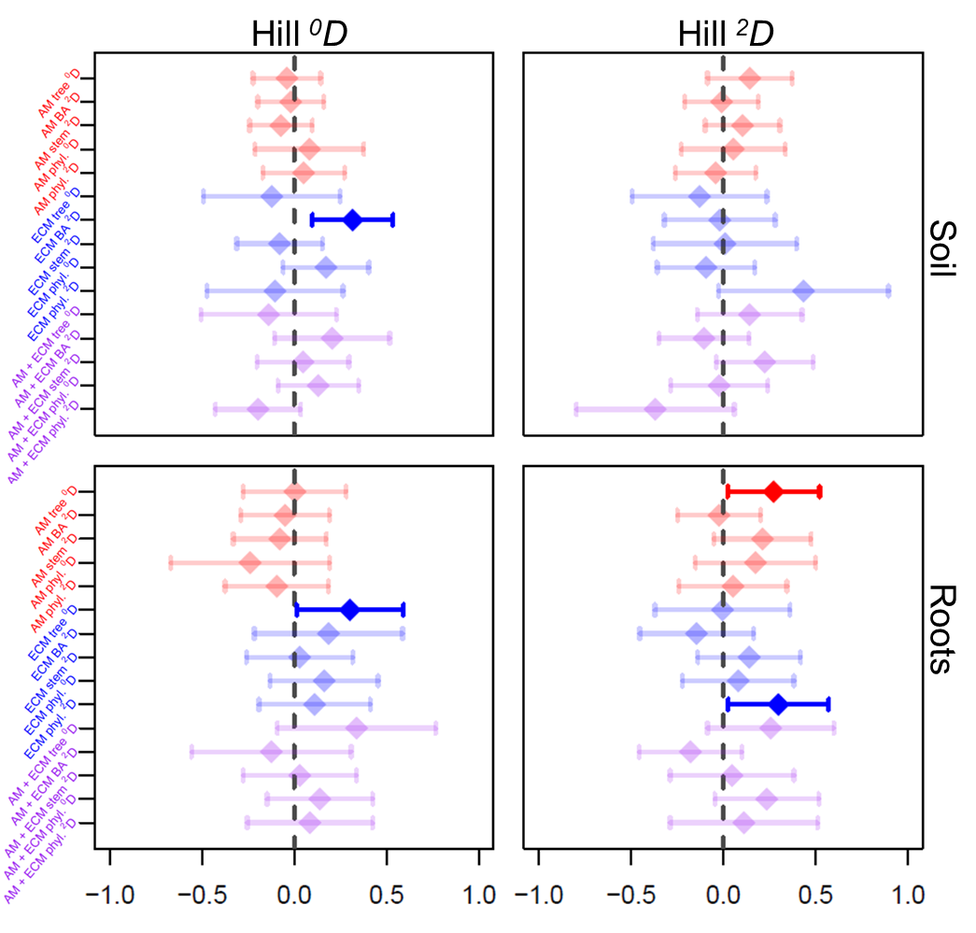
Fig. S7 Model-averaged responses of ECMF functional Hill ⁰D (left) and Hill ²D (right) from soil (top) and roots (bottom) in relation to arbuscular mycorrhizal (AM; top), ECM (middle), along with combined AM-ECM (bottom) tree phylogenetic and species Hill ⁰D and ²D diversity from the Adirondack Mountains, USA (2017). Soil variables included in top AICc-ranked models were also included for each response (Tables S7-S8). Error bars represent 95% confidence intervals; bold colors represent significant variables with confidence intervals that do not intersect zero (dashed lines)

