Supplemental tables:

Table S1 Effects of SFN combined with PP242 on the parameters of blood routine
Blood routine | Control | SFN | PP242 | S+P
WBC (×10⁹/L) | 5.84 ± 0.65 | 5.14 ± 0.23 | 5.89 ± 0.90 | 5.88 ± 0.67
RBC (×10¹²/L) | 9.02 ± 0.40 | 9.16 ± 0.39 | 8.89 ± 0.15 | 9.27 ± 0.24
HGB (g/L) | 146.00 ± 5.34 | 147.00 ± 5.43 | 143.40 ± 1.67 | 149.83 ± 2.88
HCT (%) | 44.06 ± 1.71 | 43.36 ± 1.71 | 43.76 ± 0.79 | 43.45 ± 1.89
MCV (fL) | 52.54 ± 4.37 | 49.94 ± 0.84 | 49.88 ± 0.28 | 50.12 ± 0.48
RDW (%) | 15.72 ± 0.41 | 15.42 ± 0.36 | 15.06 ± 0.46 | 14.80 ± 0.44
MCH (pg) | 16.18 ± 0.37 | 16.06 ± 0.39 | 16.14 ± 0.25 | 16.15 ± 0.08
MCHC (g/L) | 320.20 ± 5.07 | 321.80 ± 8.41 | 323.40 ± 5.22 | 322.83 ± 3.94
PLT (×10⁹/L) | 810.00 ± 108.52 | 817.00 ± 97.58 | 966.60 ± 67.67 | 941.17 ± 56.21

Table S2 Effects of SFN combined with PP242 on hepatorenal function.
Index | Control | SFN | PP242 | S+P
AST/GOT (U/L) | 41.23 ± 5.41 | 34.76 ± 7.09 | 32.59 ± 5.36 | 37.10 ± 2.90
ALT/GPT (U/L) | 10.44 ± 3.46 | 14.31 ± 1.25 | 19.21 ± 3.99 | 13.81 ± 3.70
UA (μmol/L) | 102.65 ± 6.25 | 103.74 ± 20.72 | 87.30 ± 13.20 | 84.02 ± 12.25
Cr (μmol/L) | 25.43 ± 6.15 | 25.59 ± 4.72 | 29.07 ± 5.26 | 14.34 ± 3.88

Table S3 Effects of SFN combined PP242 on organ coefficient in nude mice (%)
Organ | Control | SFN | PP242 | S+P
Heart | 0.50 ± 0.07 | 0.56 ± 0.05 | 0.61 ± 0.10 | 0.63 ± 0.06
Liver | 5.80 ± 0.56 | 6.01 ± 0.34 | 6.07 ± 0.24 | 6.20 ± 0.21
Spleen | 0.75 ± 0.05 | 0.63 ± 0.18 | 0.74 ± 0.09 | 0.65 ± 0.06
Lung | 0.65 ± 0.11 | 0.61 ± 0.12 | 0.73 ± 0.06 | 0.52 ± 0.07
Left kidney | 0.83 ± 0.08 | 0.75 ± 0.11 | 0.87 ± 0.12 | 0.80 ± 0.05
Right kidney | 0.85 ± 0.09 | 0.78 ± 0.10 | 0.82 ± 0.09 | 0.80 ± 0.08

Original bands for WB
Fig. 2A
ECa109
C-caspase9
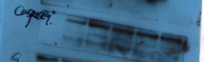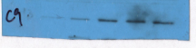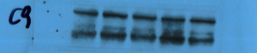
Bcl-2
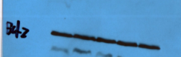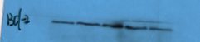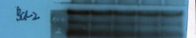

Bax
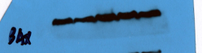
GAPDH
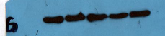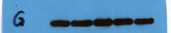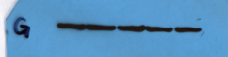
EC9706

C-caspase9
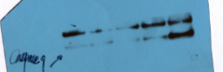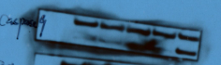
Bcl-2
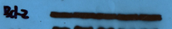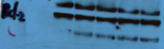

Bax
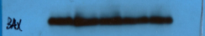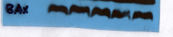
GAPDH 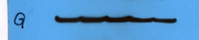  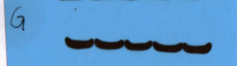
Fig. 2B
ECa109
p-p70S6K
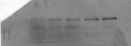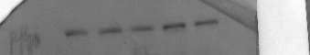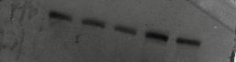
P70S6K
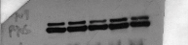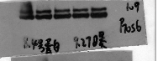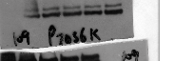
p-Akt(Ser473)
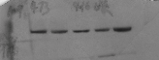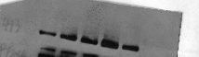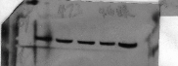
Akt
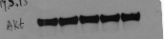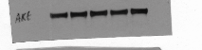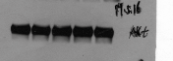
GAPDH
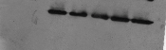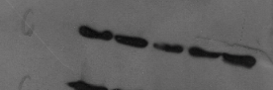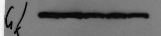
EC9706
p-p70S6K
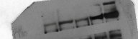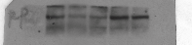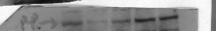
P70S6K
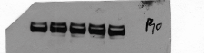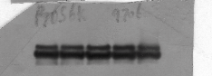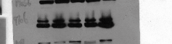
p-Akt(Ser473)
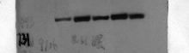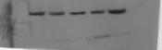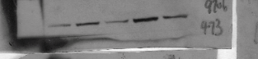
Akt
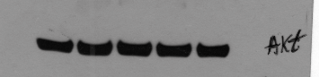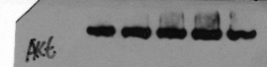
GAPDH
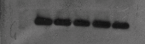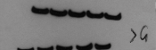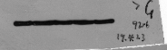

Fig. 5
ECa109
p-Rictor
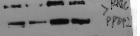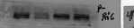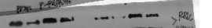
Rictor
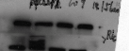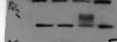
p-p70S6k (Thr389)
P70S6K
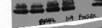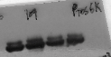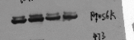
p-Akt (Ser473)
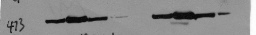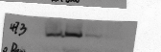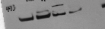
Akt
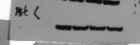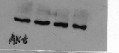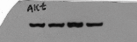
p-PRAS40
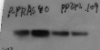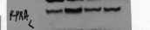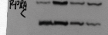
PRAS40
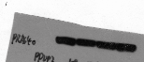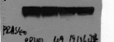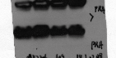
GAPDH
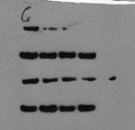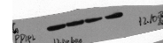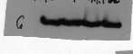

EC9706
p-Rictor
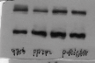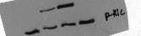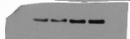
Rictor
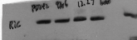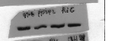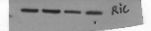
p-p70S6k (Thr389)
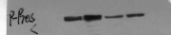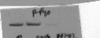
P70S6K
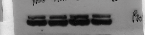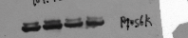
p-Akt (Ser473)
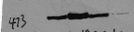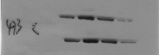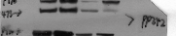
Akt
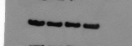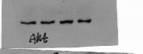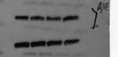
p-PRAS40
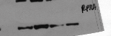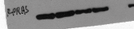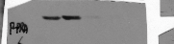
PRAS40
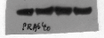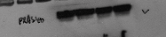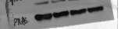
GAPDH
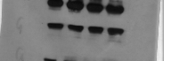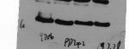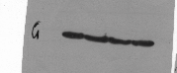

Fig. 6D
p-Rictor
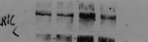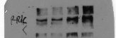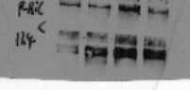
Rictor
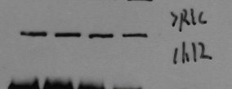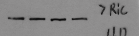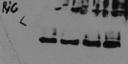

p-p70S6K (Thr389)
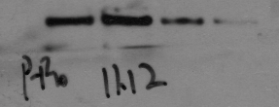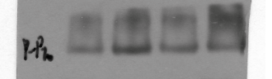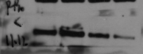p70S6K
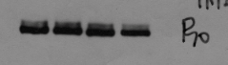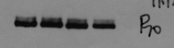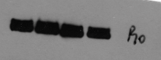
P-Akt (Ser473)
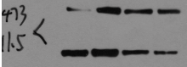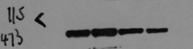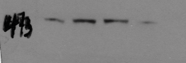
Akt
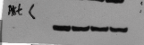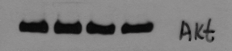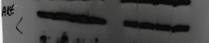
p-PRAS40
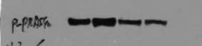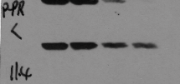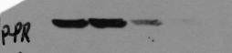
PRAS40
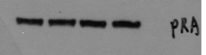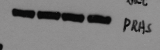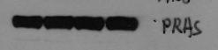
GAPDH
