SUPPLEMENTARY MATERIAL

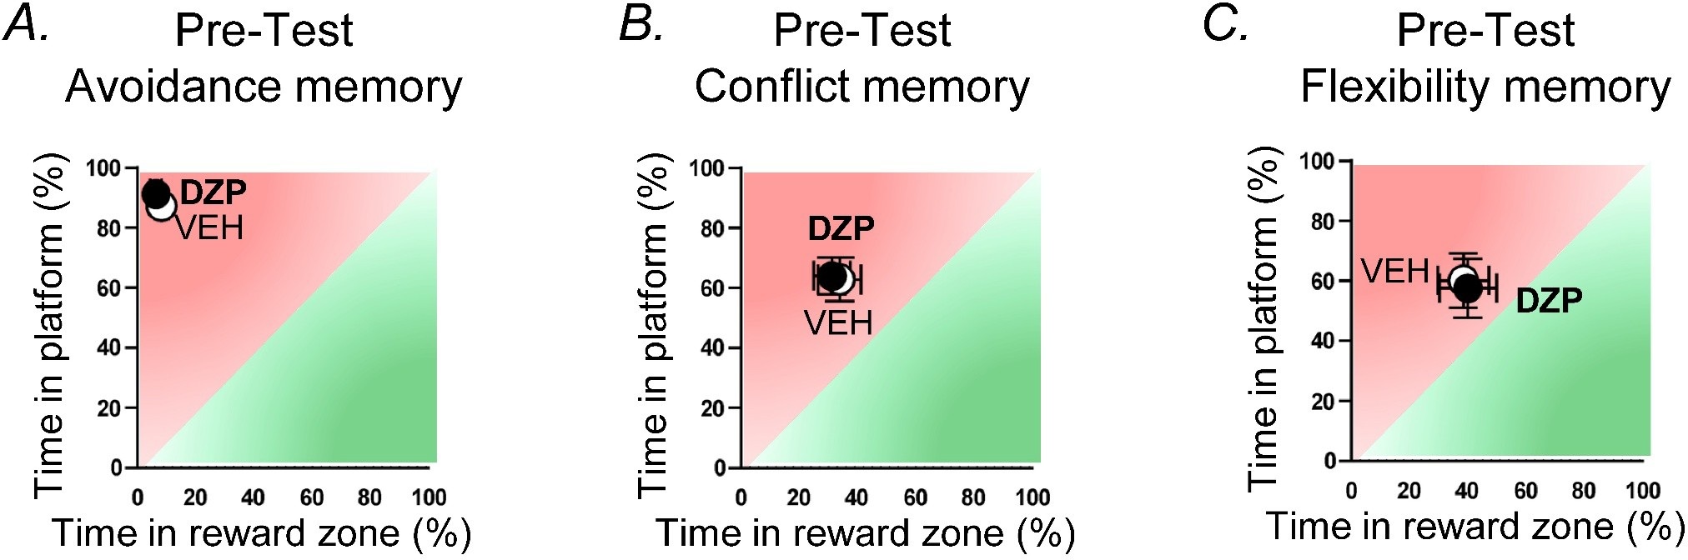

Fig. S1 The pre-test balance indices were comparable between the groups. Pre-test avoidance/approach balance indices prior to the (A) avoidance memory test (vehicle, n
= 16; diazepam, n = 16), (B) conflict memory test (vehicle, n = 16; diazepam, n = 16), and
(C) flexibility memory test (vehicle, n = 12; diazepam, n = 12). Data are presented as mean
± SEM with individual data points.

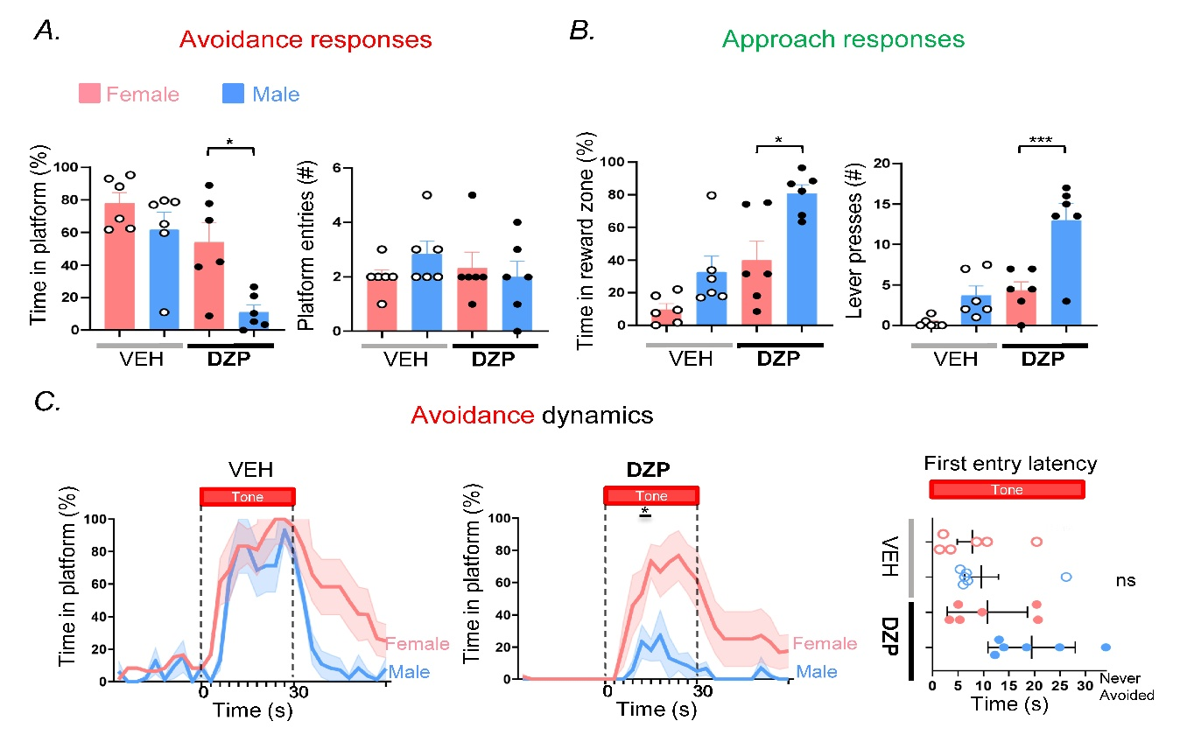

Fig. S2 Sex-disaggregated behavioral measures and avoidance dynamics. Sex-disaggregated avoidance and approach measures underlying the balance index during the flexibility memory test (vehicle: females, n = 6; males, n = 6; diazepam: females, n = 6; males, n = 6). (A) Avoidance responses (platform time and platform entries). (B) Approach responses (reward zone time and lever presses). (C) Avoidance dynamics during tone presentation shown separately by sex for vehicle- and diazepam-treated rats, with latency to the first platform entry shown on the right. Data are presented as mean ± SEM with individual data points shown. *p < 0.05, ***p < 0.001.

