Figure S1. PRISMA flowchart of included studies.

Identification of studies via other methods
Identification of studies via databases and registers

Records identified from:
Grey literature sources (n = 0)
Citation searching (n = 2)
Records removed before screening:
Duplicate records removed (n = 1769)
Records identified from:
Databases (n = 4738)
Registers (n = 13)

Identification

Records screened
(n = 2982)
Records excluded
(n = 2959)

Reports not retrieved
(n = 0)
Reports sought for retrieval
(n = 2)
Reports sought for retrieval
(n = 23)
Reports not retrieved
(n = 0)

Screening

Reports assessed for eligibility
(n = 2)
Reports excluded (n = 2)
Reports assessed for eligibility
(n = 23)
Reports excluded (n=16):
Wrong study design (n = 13)
Wrong intervention or control (n = 3)

Studies included in review
(n = 7)
Reports of included studies
(n = 7)
Included

Figure S2. Quality assessment of included trials.
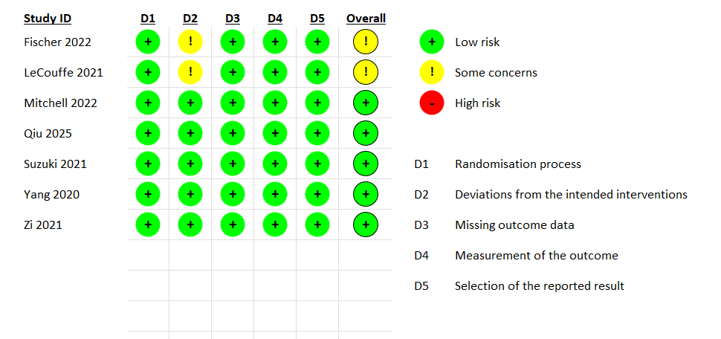

Figure S3. Subgroup analysis for good functional outcome according to baseline NIHSS score.

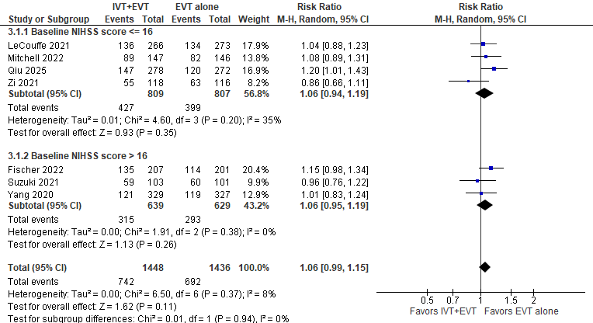

Figure S4. Subgroup analysis for good functional outcome according to baseline ASPECTS.

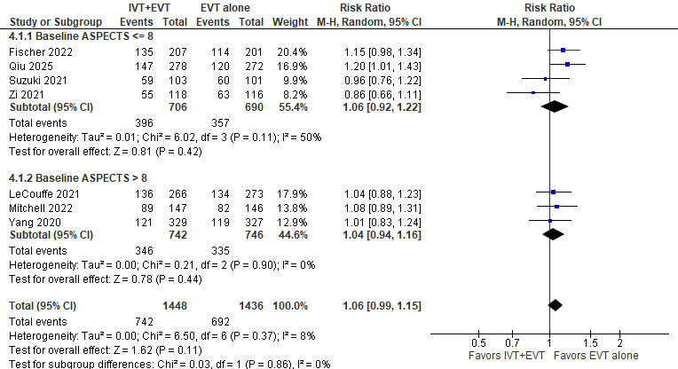

Figure S5. Subgroup analysis for good functional outcome according to time from stroke onset to randomization.
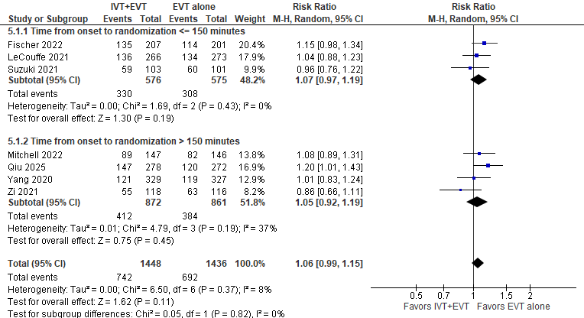

Figure S6. Subgroup analysis for all-cause mortality according to baseline NIHSS score.

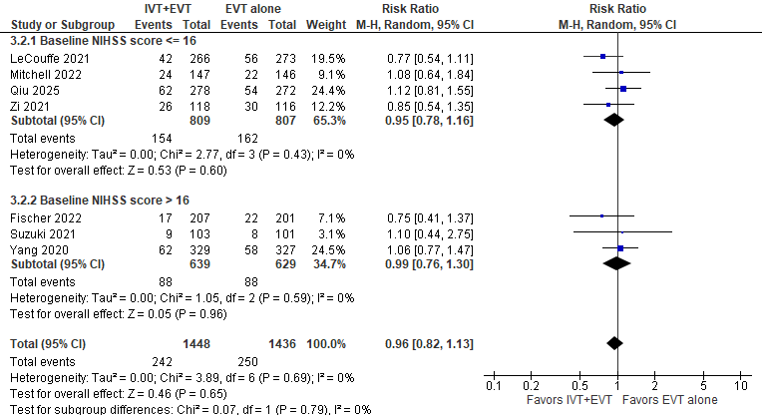

Figure S7. Subgroup analysis for all-cause mortality according to baseline ASPECTS.

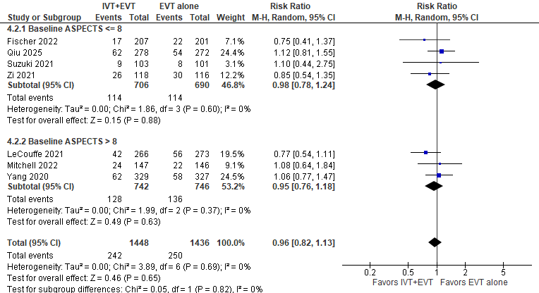

Figure S8. Subgroup analysis for all-cause mortality according to time from stroke onset to randomization.

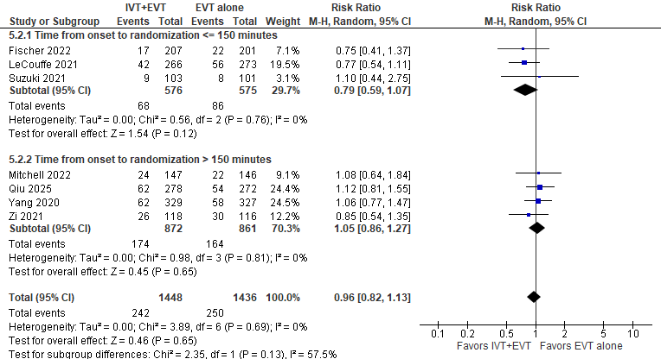

Figure S9. Forest plot for excellent functional outcome.
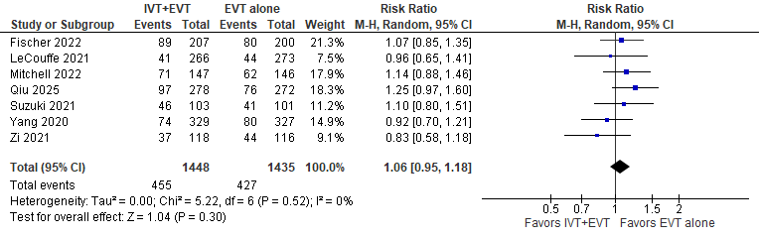

Figure S10. Forest plot for mRS 0-3.
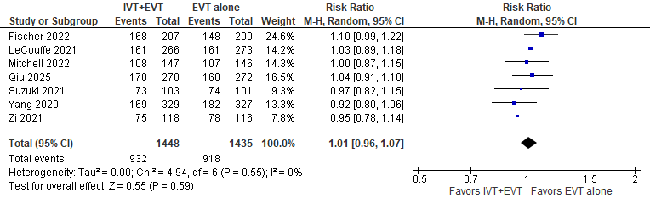

Figure S11. Forest plot for successful reperfusion (mTICI or eTICI score 2b–3).
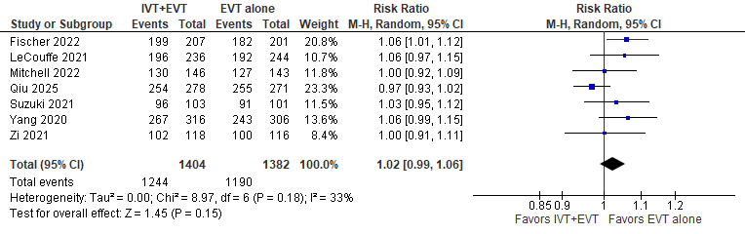

Figure S12. Forest plot for any intracranial hemorrhage.
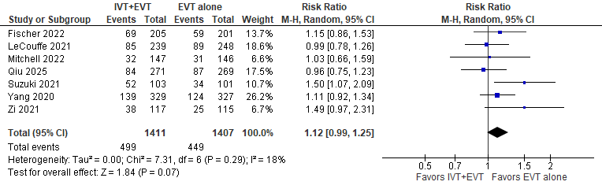

Figure S13. Forest plot for symptomatic intracranial hemorrhage.
