Supplementary Information for “Co-creating data ecosystems with urban informal communities for justice and transformation”

This file presents additional figures and tables to further support the main arguments developed in the article “Co-creating data ecosystems with urban informal communities for justice and transformation”.

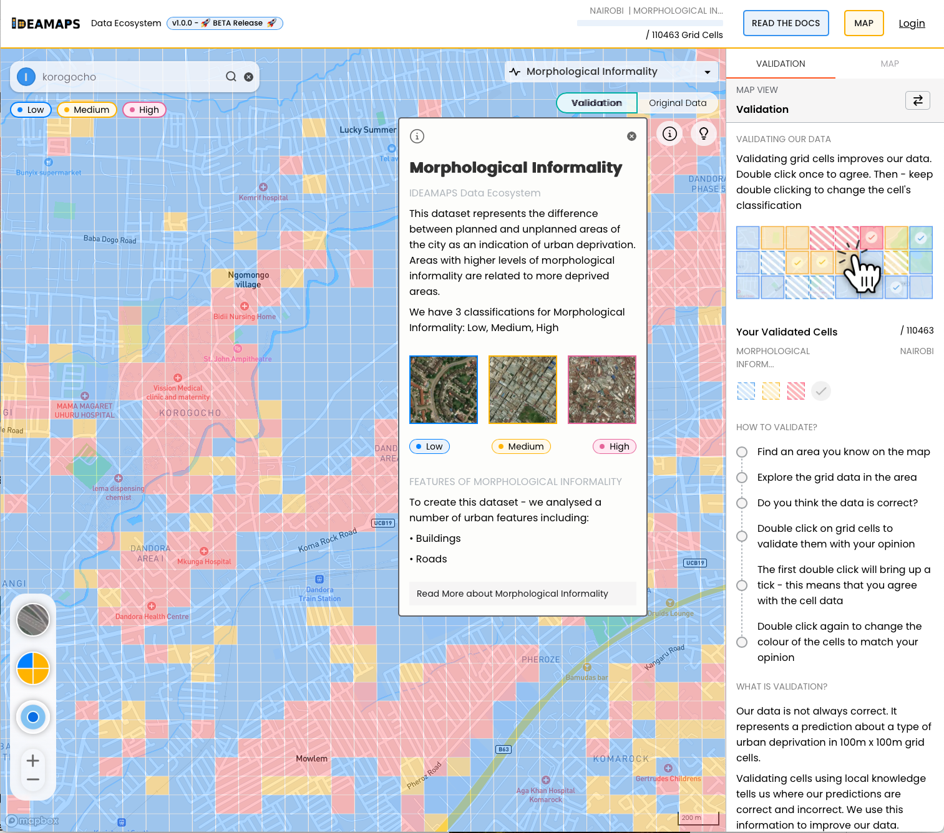

Figure S1. User interface of the IDEAMAPS Data Ecosystem Platform: a data-driven citizen science tool for improving urban science models. The interface presents users with a choice of models to validate (drop-down list in the upper bar), a description of the model bands (box in the middle of the figure) and basic instructions on how to proceed (right-hand side column).

Table S1. Summary of stakeholder engagement activities of the IDEAMAPS Data Ecosystem Co-creation Process in Lagos, Kano and Nairobi.

Date | Engagement event and topic | Participant profile and number of participants in each city | Methods and activities
February-May 2023 | Inception Cross-sectoral Workshops (launch events) | Community leaders, NGOs, local and national governmental agencies  Lagos: 50  Nairobi: 25 | In this open launch events, the project plans were introduced and discussed with a range of stakeholders. The team sought feedback through plenary discussions and focus group discussions on data gaps and opportunities, as well as the potential impact pathways for the project outputs and data.
June-September 2023 | PAR 1: Ranking of Priorities (Deprivation Subdomains⁴⁴) and Co-creation of basemap | Residents of partner communities  Nairobi: 27 (13f, 14m)  Lagos: 29  Kano: 32 (5f, 27m) | Focus group discussions were conducted in each partner community led by field interviewers. The discussions covered:  1. Identifying what depicts deprivation in the community.  2. Ranking the different pre-identified subdomains of deprivation.  3. Mapping the deprivation.  Communities were also presented two maps (Satellite and Vector) at three different zooms (resolutions), high, medium, and low of the specific community areas.
February 2024 | PAR 2: Photovoice of deprivation in communities | Residents of partner communities  Lagos: 31 (16f, 15m)  Kano: 33 (15f, 18m)  Nairobi: 10 (5m/5f) | The participants were taken through the four subdomains of deprivation: small and dense, irregular layout, wastes and non-durable building materials. They were trained on the use of cameras and photo-ethics.  The community members choose photos that best described their lived realities to be displayed at an exhibition accompanied by captions written on manila papers alongside the photos.
February 2024 | Mid-term Cross-Sectoral Stakeholder Workshop;  Capacity Building Training | Community leaders, governmental agencies, NGOs, researchers  Partner communities  Kano: 36 (10f, 26m)  Lagos: 44 6 academia/students,21 community, 9 government, 2 NGO/civil society, 6 facilitators)  Nairobi: 55 (25f, 30m) | The workshop introduced and described 3 modelled subdomains of deprivation: Irregular Layout, Small-Dense Structures, Overall Deprivation. After a demonstration of the process for validating model results on the platform:  - Divided into groups based on sector representation to complete validation in the platform based on local knowledge and lived experience, indicating agree or disagree with the classifications of urban areas on the map  - Guided discussions about the user experience, the accuracy of the maps, and how the maps could be used enable change and support government interventions  The second day was a day-long workshop to share skills with community leaders and other stakeholders in reading and exploring common data files and visualising data in charts to create a narrative. Hands-on activities included:  - Downloading datasets  - Customising data using sort features  - Selecting images to support data and describe information displayed in charts  - Crafting draft blog posts about a selected topic for a specific audience
June/July 2024 | PAR 3: Community Assets Mapping | Partner communities  Kano: 52 (17 female, 35 male)  Lagos: 41 (24 male, 17 female including community members, students, youth mappers, and government)  Nairobi: 26 participants (10 male, 16 female) | Four focused group discussions were conducted: two in each community led by Field interviewers.  1. Community members identifying the community’s assets and what they would like to see on the map (focusing on WASH facilities).  2.Mapping of community assets; Community members were provided with maps for their villages.  3. FIs were trained on how to use Survey CTO. They then proceeded to ground truth and collect additional data from the field. This data was used to update the maps.
September 2024 | Curation of data into OpenStreetMap | Community leaders and researchers  Kano: 30 (17 female, 13 male)  Lagos: 3  Nairobi: 15 (6 Nairobi field interviewers, 4 APHRC interns, 3 IDEAMAPS Nigeria team, 2 IDEAMAPS Glasgow team) | OSM Kenya community lead took the team on editing and uploading data on OpenStreetMap. This was done using QGIS, where the team were able to edit the features attributes and export to GeoJSON.  The data was then opened in JOSM software which was used to upload and update the data to OSM.  This was then followed by a validation exercise.
October/November 2024 | PAR 4: Validation of morphological informality model v1 | Partner communities  Kano: 30 (17 female, 13 male)  Lagos: 20 (12 Male, 8 Female)  Nairobi: 23 (15 female, 8 male) | The community members were introduced to the platform. They then proceed to interact with the platform and validate the classifications within their communities. Guidance by the team was provided where necessary.  Four focused group discussions were then conducted; two in each community led by Field interviewers. The discussions covered:  1. Feedback on interaction with the platform and level of accuracy of the model.  2. Reviewing the community assets that have been uploaded to OSM and get feedback on the impact and further data needs.
November 2024 | International cross-sectoral engagements | Community leaders, governmental agencies, NGOs, researchers  More than 100 participants across several sessions | During the 12th World Urban Forum in Cairo, several networking, training and “voices from cities” events were organised by the IDEAMAPS teams to present and discuss the findings of the project.
May-September 2025 | Citywide model validation campaigns (including morphological informality v2) and closing cross-sectoral workshops | Community leaders, governmental agencies, NGOs, researchers  Kano: 40 (20 female, 20 male)  Abuja: 51 (33m, 18f)  Nairobi: 35 | The project presented findings from the mapping of deprivation in two communities each in Lagos, Kano, and Nairobi focusing on access to general healthcare, emergency obstetric care (EMoC), road connectivity, levels of morphological informality, and exposure to flood hazards. These results formed the basis for cross-sectoral engagement, bringing together stakeholders from health, climate, and urban planning to jointly review and validate the models and explore shared challenges.

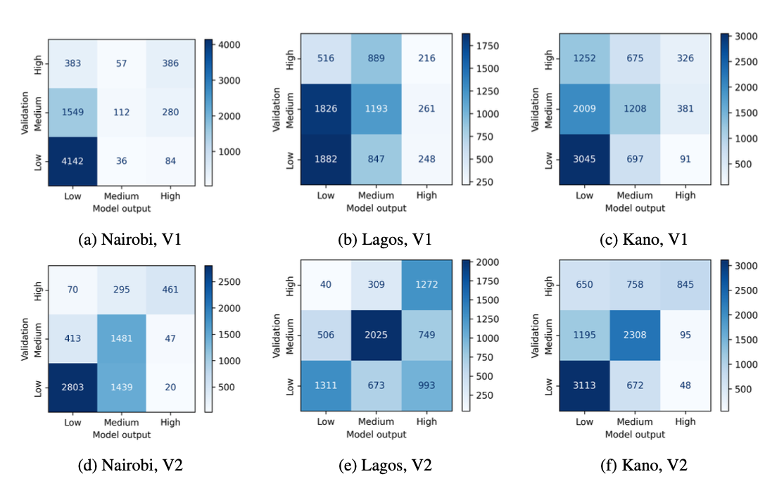

Figure S2. Confusion matrix showing classification performance across modelled and validated deprivation levels. Rows represent the community-sourced deprivation levels, and columns represent modelled deprivation levels. Ascending diagonal cells indicate correct classifications, while off-diagonal cells represent misclassifications. Comparing the numbers of correct classifications, it is noticeable that the v2 model has improved classification performance across all bands in all cities, except for the “low” morphological information band in Nairobi.

Table S2. Overview of validation data collected and analysed on morphological informality v1. Validation data were collected in Nairobi with community members (PAR sessions) on 24 and 28 October 2024. Validation data in Kano were collected for the partner communities on 30 October 2024.

Table S3. Overview of validation data collected and analysed on morphological informality. Validation data were collected in Nairobi with community members from Korogocho and Viwandani on 4 and 5 June 2025, respectively. The city-wide validation campaign in Nairobi was conducted on 30 July 2025 (validations on 1 August 2025 were also included). Validation data in Kano were collected for the partner communities on 22 May 2025, and the city-wide validation campaign was conducted from 27 June to 3 July 2025. For Lagos, the city-wide validation campaign, including members from the local partner communities Okerube and Ajegunle-Ikorodu, was conducted on 11 and 12 June 2025.

