Variability of climate-induced rice yields in northwest Bangladesh using multiple statistical modeling
Abu Reza Md. Towfiqul Islam^{1,2, 3}, Irtifa Alam Nabila⁴, Md. Hasanuzzaman³, Md. Bozlar Rahman³, Ahmed Elbeltegi⁵, Javed Mallick⁶, Kuaanan Techato^{1, 2*}
¹Faculty of Environmental Management, Prince of Songkla University, Songkhla, Thailand, email: towfiq_dm@brur.ac.bd
²Environmental Assessment and Technology for Hazardous Waste Management Research Center, Faculty of Environmental Management, Prince of Songkla University, 90110 Songkhla, Thailand
³Department of Disaster Management, Begum Rokeya University, Rangpur 5400, Bangladesh, email: ruquiasalam@gmail.com
⁴Department of Disaster and Human Security Management, Bangladesh University of Professionals, Dhaka, Bangladesh
⁵Agricultural Engineering Dept., Faculty of Agriculture, Mansoura University, Mansoura 35516, Egypt
⁶Department of Civil Engineering, King Khalid University, Abha, Saudi Arabia

*Corresponding author: kuaanan.t@psu.ac.th
Kuaanan Techato, PhD
ORCID: 0000-0002-9178-8416

Submission: September, 2021

Supplementary materials
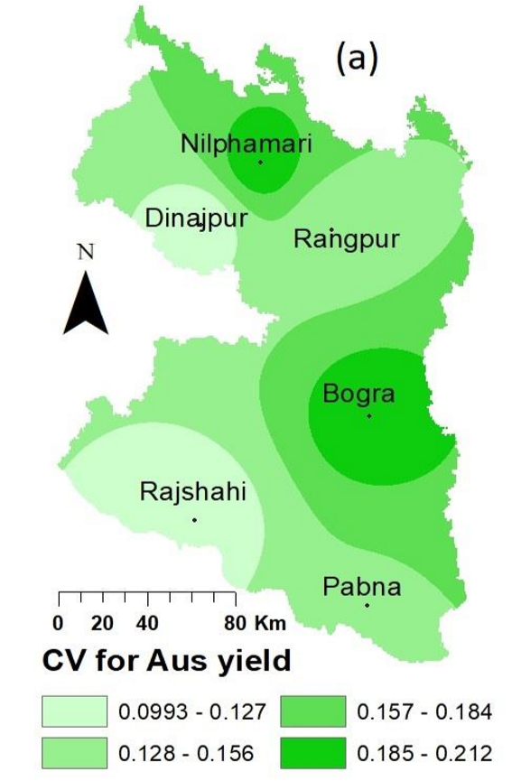
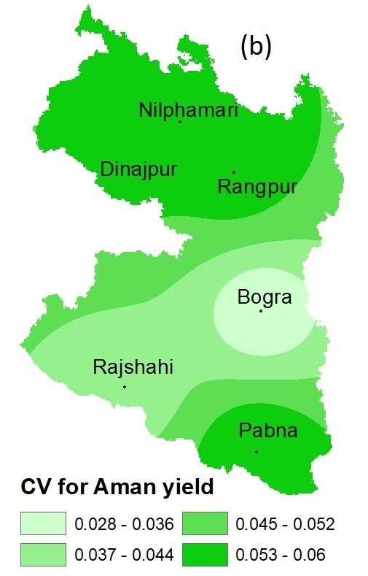
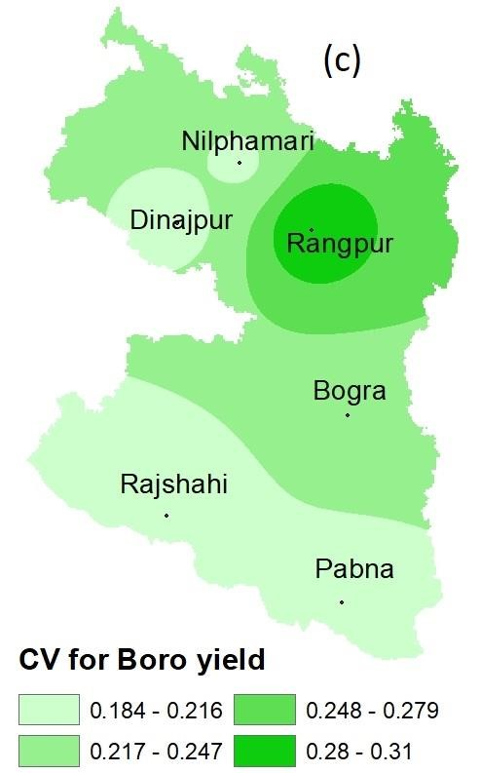
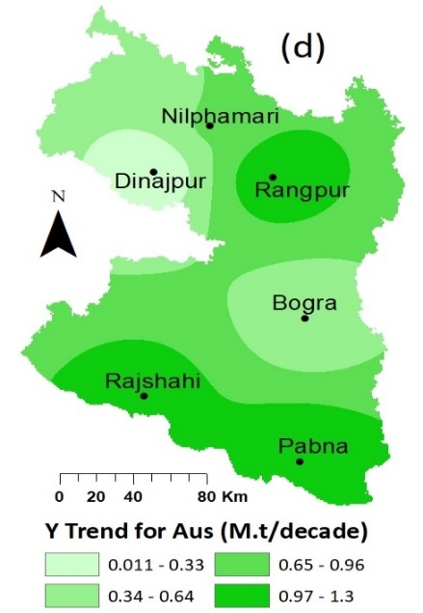
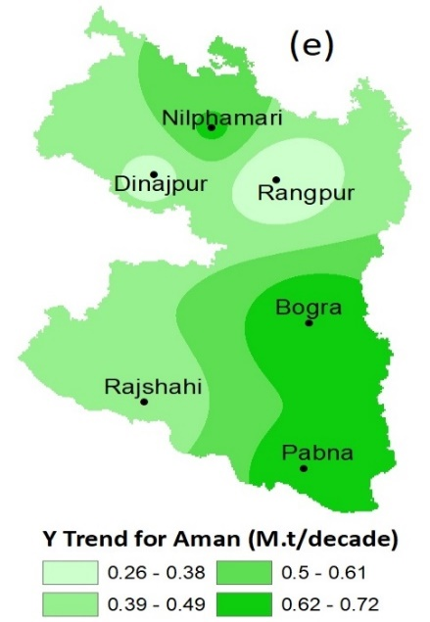
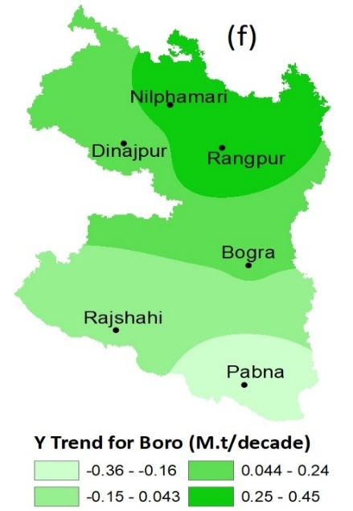

Fig. S1. Coefficient of Variation (CV) and trend for (a) Aus (b) Aman and (c) Boro yields in northwest Bangladesh

Fig. S2. The linear trends of the total rainfall, temperature, humidity and sunshine in northwest Bangladesh

Supplementary Tables
Table S1 Augmented Dickey-Fuller (ADF) test for checking the stationarity of the data series.
Variables | Integration of  Order for Aus | Integration of  Order for Aman | Integration of  Order for Boro
Rainfall | I(0) | I(0) | I(0)
Temperature | I(0) | I(0) | I(0)
Humidity | I(0) | I(0) | I(0)
Sunshine | I(0) | I(0) | I(0)
Yield | I(0) | I(1) | I(1)

