Supplementary Data
A new perspective on calmodulin regulated calcium and ros homeostasis upon carbon black nanoparticle exposure
Nisha Verma¹*, Mario Pink¹, and Simone Schmitz-Spanke¹
¹Institute and Outpatient Clinic of Occupational, Social and Environmental Medicine, University of Erlangen-Nuremberg, Germany

*Correspondence:
Nisha Verma, Institute and Outpatient Clinic of Occupational, Social and Environmental Medicine, University of Erlangen-Nuremberg, Henkestrasse 9-11, D-91054 Erlangen, Germany
E-mail: nishaverma24@gmail.com
Fax: +49-9131-8522317

Supplementary Figure 1: Alterations of cellular ROS and calcium homeostasis after exposure to CBN for 3 h Cells (A549) were cultured on a clear bottom 96 well plates and exposed to 2-250 µg/ml of CBN for 3 h. For the analysis, the cells were loaded with fluorescent dyes H₂DCFDA (10 μM for ROS) [A] Fluo-4/AM (1.4 µM and Rhod-2 AM (3.6 µM). for calcium measurements) [B-C], respectively for 30 min. The fluorescence was recorded by using a plate reader (Fluo 4/AM, λ_{excitation} = 488; Rhod-2/AM, λ_{excitation} = 543; λ_{emission} = 560 nm; λ_{emission} = 505 nm, H₂DCFDA λ_{excitation} = 485; λ_{emission} = 535 nm). As evident from the graphs after 3 h exposure, no significant alterations were observed. The data were presented as mean ± standard deviation of four independent experiments with A549. The level of significance relative to the control was determined by using the t-test (*p <0.05).
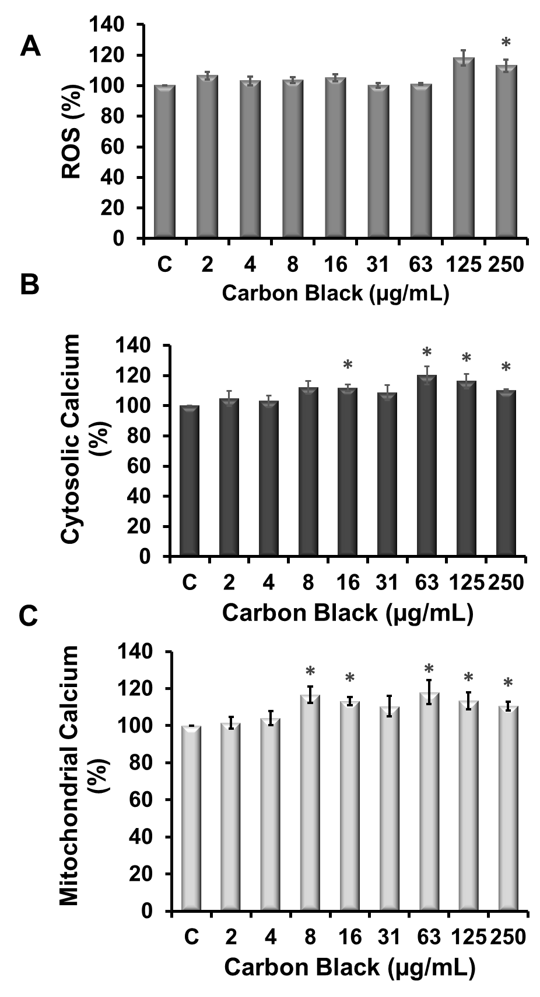

Supplementary Fig. 2: Interaction between ROS and Ca²⁺ upon CB exposure CB exposed cells showed increased levels of both ROS and intracellular Ca ²⁺ ions. To analyze a possible mutual interplay between two signaling systems in the cell models we used antioxidants N-acetylcysteine (NAC) and Trolox and Ca²⁺ pump inhibitors (verapamil) /chelators (BAPTA) as shown below.

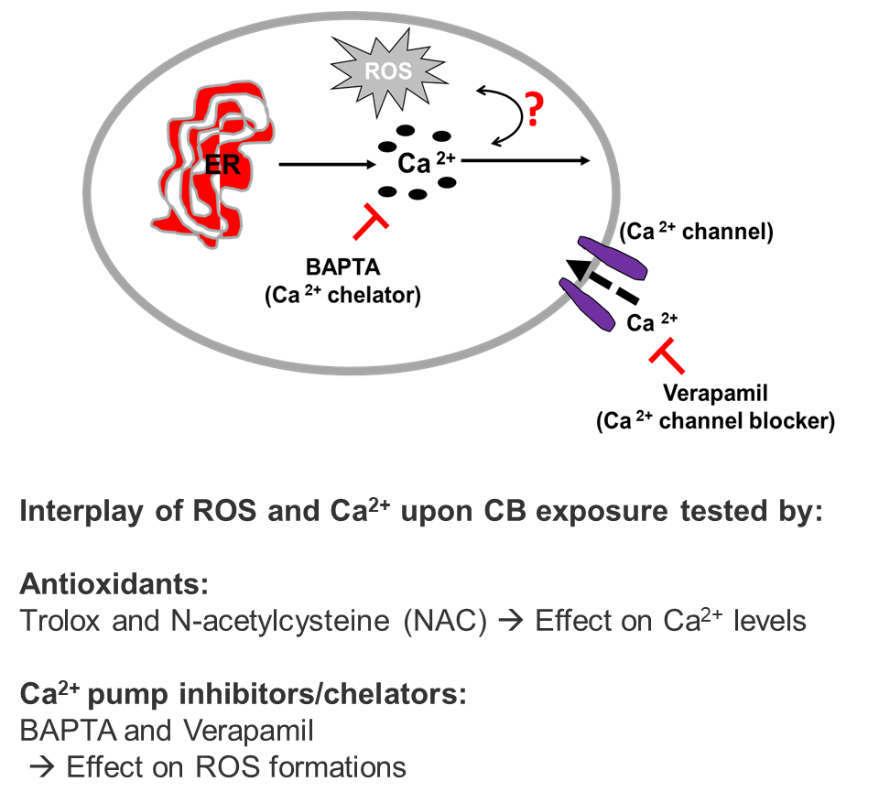

Supplementary Figure 3: Changes in mitochondrial ROS and mitochondrial membrane potential (MMP) after exposure to CBN for 3 h. Cells (A549) were cultured on a clear bottom 96 well plates and exposed to 2-250 µg/ml of CBN for 3 h. For MMP measurements, the cells were loaded with JC-1 dye (5 μM) [A]. Measurements were obtained immediately as a ratio of a red aggregate of JC -1 dye with absorption/emission at 585/590 nm /green aggregate of the dye with absorption/emission of 510/527 nm in the mitochondria by using the Tecan microplate reader (Tecan, Mainz, Germany). For the mitochondrial ROS production MitoSOX Red (5 µM) (mitochondria-targeted superoxide indicator) dye was used. [B]. The fluorescence was recorded by using a plate reader (Mitosox, λ_{excitation} = 510; λ_{emission} = 580 nm). The data were presented as mean ± standard deviation of four independent experiments with A549 cells. The level of significance relative to the control was determined by using the t-test (*p <0.05).
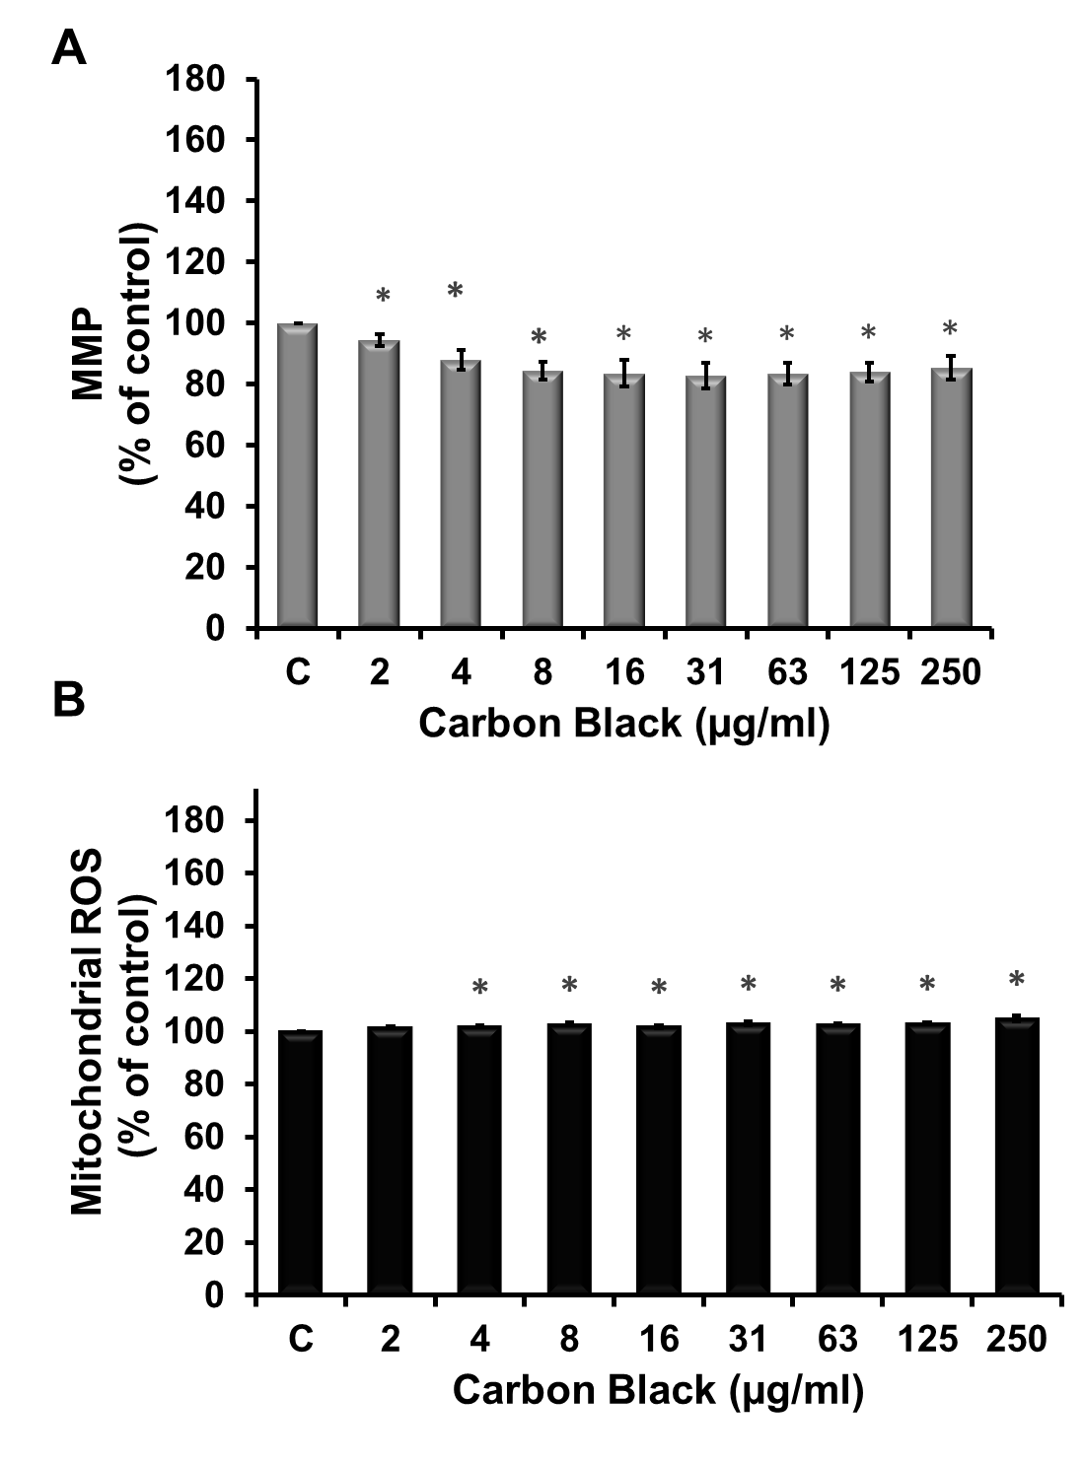

Supplementary Fig.4
Pathway Enrichment Analysis of the identified proteins using the STITCH software. The gene name was uploaded into the STITCH search engine that assigned it to different protein pathways. The bar graph represents the number of genes enriched per pathway

.

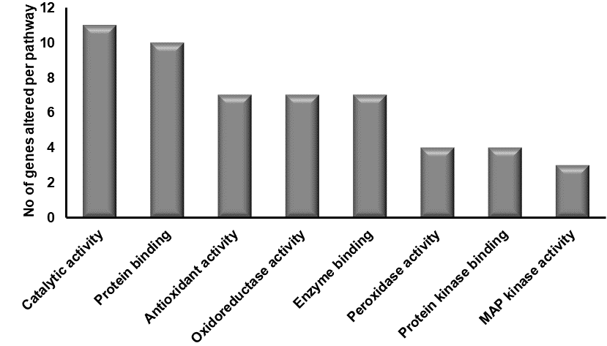

Table 1: A complete list of 84 oxidative stress-associated genes used to analyze the transcriptional profiling of oxidative stress-related genes in CB exposed cells. The Human Oxidative Stress Plus RT² Profiler PCR array from Qiagen was used for the present study.

Position | Ref Seq Number | Gene Symbol | Description
A01 | NM_000477 | ALB | Albumin
A02 | NM_000697 | ALOX12 | Arachidonate 12-lipoxygenase
A03 | NM_001159 | AOX1 | Aldehyde oxidase 1
A04 | NM_000041 | APOE | Apolipoprotein E
A05 | NM_004045 | ATOX1 | antioxidant protein 1 homolog (yeast)
A06 | NM_004052 | BNIP3 | BCL2/adenovirus E1B 19kDa interacting protein 3
A07 | NM_001752 | CAT | Catalase
A08 | NM_002985 | CCL5 | Chemokine (C-C motif) ligand 5
A09 | NM_005125 | CCS | Copper chaperone for superoxide dismutase
A10 | NM_000397 | CYBB | Cytochrome b-245, beta polypeptide
A11 | NM_134268 | CYGB | Cytoglobin
A12 | NM_014762 | DHCR24 | 24-dehydrocholesterol reductase
B01 | NM_175940 | DUOX1 | Dual oxidase 1
B02 | NM_014080 | DUOX2 | Dual oxidase 2
B03 | NM_004417 | DUSP1 | Dual specificity phosphatase 1
B04 | NM_001979 | EPHX2 | Epoxide hydrolase 2, cytoplasmic
B05 | NM_000502 | EPX | EPX Eosinophil peroxidase
B06 | B06 NM_021953 | FOXM1 | FOXM1 Forkhead box M1
B07 | B07 NM_002032 | FTH1 | Ferritin, heavy polypeptide 1
B08 | B08 NM_001498 | GCLC | Glutamate-cysteine ligase, catalytic subunit
B09 | B09 NM_002061 | GCLM | Glutamate-cysteine ligase, modifier subunit
B10 | B10 NM_000581 | GPX1 | Glutathione peroxidase 1
B11 | NM_002083 | GPX2 | Glutathione peroxidase 2 (gastrointestinal)
B12 | NM_002084 | GPX3 | Glutathione peroxidase 3 (plasma)
C01 | NM_002085 | GPX4 | Glutathione peroxidase 4 (phospholipid hydroperoxidase)
C02 | NM_001509 | GPX5 | Glutathione peroxidase 5 (epididymal androgen-related protein)
C03 | NM_182701 | GPX6 | Glutathione peroxidase 6 (olfactory)
C04 | NM_015696 | GPX7 | Glutathione peroxidase 7
C05 | NM_000637 | GSR | Glutathione reductase
C06 | NM_000178 | GSS | Glutathione synthetase
C07 | NM_000852 | GSTP1 | Glutathione S-transferase pi 1
C08 | NM_001513 GSTZ1 | GSTZ1 | Glutathione transferase zeta 1
C09 | NM_001518 GTF2I | GTF2I | General transcription factor IIi
C10 | NM_002133 | HMOX1 | Heme oxygenase (decycling) 1
C11 | NM_005345 | HSPA1A | Heat shock 70kDa protein 1A
C12 | NM_006121 | KRT1 | Keratin 1
D01 | NM_006151 | LPO | Lactoperoxidase
D02 | NM_005368 | MB | Myoglobin
D03 | NM_000242 | MBL2 | Mannose-binding lectin (protein C) 2, soluble
D04 | NM_004528 | MGST3 | Microsomal glutathione S-transferase 3
D11 | NM_000625 | NOS2 | Nitric oxide synthase 2, inducible
D12 | NM_016931 | NOX4 | NADPH oxidase 4
E01 | NM_024505 | NOX5 | NADPH oxidase, EF-hand calcium binding domain 5
E02 | NM_000903 | NQO1 | NAD(P)H dehydrogenase, quinone 1
E03 | NM_002452 | NUDT1 | Nudix (nucleoside diphosphate linked moiety X)-type motif 1
E04 | NM_181354 | OXR1 | Oxidation resistance 1
E05 | NM_005109 | OXSR1 | Oxidative-stress responsive 1
E06 | NM_020992 | PDLIM1 | PDZ and LIM domain 1
E07 | NM_007254 | PNKP | Polynucleotide kinase 3'-phosphatase
E08 | NM_002574 | PRDX1 | Peroxiredoxin 1
E09 | NM_005809 | PRDX2 | Peroxiredoxin 2
E10 | NM_006793 | PRDX3 | Peroxiredoxin 3
E11 | NM_006406 | PRDX4 | Peroxiredoxin 4
E12 | NM_181652 | PRDX5 | Peroxiredoxin 5
F01 | NM_004905 | PRDX6 | Peroxiredoxin 6
F02 | NM_020820 | PREX1 | Phosphatidylinositol-3,4,5-trisphosphate-dependent Rac exchange factor 1
F03 | NM_183079 | PRNP | Prion protein
F04 | NM_000962 | PTGS1 | Prostaglandin-endoperoxide synthase 1 (prostaglandin G/H synthase and cyclooxygenase)
F05 | NM_000963 | PTGS2 | Prostaglandin-endoperoxide synthase 2 (prostaglandin G/H synthase and cyclooxygenase)
F06 | NM_012293 | PXDN | Peroxidasin homolog (Drosophila)
F07 | NM_014245 | RNF7 | Ring finger protein 7
F08 | NM_182826 | SCARA3 | Scavenger receptor class A, member 3
F09 | NM_203472 | VIMP | Selenoprotein S
F10 | NM_005410 | SEPP1 | Selenoprotein P, plasma, 1
F11 | NM_003019 | SFTPD | Surfactant protein D
F12 | NM_012237 | SIRT2 | Sirtuin 2
G01 | NM_000454 | SOD1 | Superoxide dismutase 1, soluble
G02 | NM_000636 | SOD2 | Superoxide dismutase 2, mitochondrial
G03 | NM_003102 | SOD3 | Superoxide dismutase 3, extracellular
G04 | NM_003900 | SQSTM1 | Sequestosome 1
G05 | NM_080725 | SRXN1 | Sulfiredoxin 1
G06 | NM_006374 | STK25 | Serine/threonine kinase 25
G07 | NM_000547 | TPO | Thyroid peroxidase
G08 | NM_003319 | TTN | Titin
G09 | NM_003329 | TXN | Thioredoxin
G10 | NM_003330 | TXNRD1 | Thioredoxin reductase 1
G11 | NM_006440 | TXNRD2 | Thioredoxin reductase 2
G12 | NM_003355 | UCP2 | Uncoupling protein 2 (mitochondrial, proton carrier)
H01 | NM_001101 | ACTB | Actin, beta
H02 | NM_004048 | B2M | Beta-2-microglobulin
H03 | NM_002046 | GAPDH | Glyceraldehyde-3-phosphate dehydrogenase
H04 | NM_000194 | HPRT1 | Hypoxanthine phosphoribosyltransferase 1
H05 | NM_001002 | RPLP0 | Ribosomal protein, large, P0
H06 | SA_00105 | HGDC | Human Genomic DNA Contamination
H07 | SA_00104 | RTC | Reverse Transcription Control
H08 | SA_00104 | RTC | RTC Reverse Transcription Control
H09 | SA_00104 | RTC | Reverse Transcription Control
H10 | SA_00103 | PPC | Positive PCR Control
H11 | SA_00103 | PPC | Positive PCR Control
H12 | SA_00103 | PPC | Positive PCR Control

Supplementary Table 1: List of genes showing differentially altered expression in the cells exposed to CB when compared with the control group (with a fold change regulation of ≥ 1.5-fold and a statistical cutoff at P ⩽ .05)

Control vs Group 1

Position | Symbol | Fold Change | P-value
A07 | CAT | 1.70 | 0.021966
A08 | CCL5 | 2.86 | 0.031665
B11 | GPX2 | 1.69 | 0.021280
C01 | GPX4 | 1.69 | 0.023706
D04 | MGST3 | 1.70 | 0.024464
D06 | MPV17 | 1.70 | 0.022502
E12 | PRDX5 | 1.70 | 0.021400
F05 | PTGS2 | 4.03 | 0.024853
F09 | VIMP | 1.70 | 0.022478
G02 | SOD2 | 1.68 | 0.023694
G12 | UCP2 | 1.69 | 0.024535

Supplementary Table 2: List of genes showing altered expression in cell pre-exposed to CaM inhibitor W-7 for one hour followed by CB (125 µg/ml) exposure for another 24 h, when compared with the control group (with a fold change regulation of ≥ 1.5-fold and a statistical cutoff at P ⩽ .05)

Control VS Group 2

Position | Symbol | Fold Change | P value
A08 | CCL5 | 4.03 | 0.000109
B11 | GPX2 | 1.68 | 0.023139
C01 | GPX4 | 1.69 | 0.025359
D05 | MPO | 8.03 | 0.043211
D08 | MT3 | 5.67 | 0.049764
D11 | NOS2 | 3.37 | 0.039602
F04 | PTGS1 | 2.38 | 0.031400
F09 | VIMP | 1.69 | 0.023559
G02 | SOD2 | 1.68 | 0.023932

