SUPPLEMENTARY INFORMATION

Conformational, Molecular, Spectral and Binding Properties of Zn(II)-Coordinated Glycol Nucleic Acid Monophosphates: A DFT, Docking and Molecular Dynamics Assessment
Mwikwm Basumatary, Phulung Basumatary, Satyajit Barman, Gunajyoti Das*
Department of Chemistry, Central Institute of Technology, Kokrajhar 783370, Assam, India.

CONTENTS
- Table S1. Scaled zero-point energies (ZPE), total energies, enthalpies, free energies, dipole moments and polarizabilities of GNA monomers with and without metal.
- Table S2. HOMO, LUMO, E_{gap}, and global reactivity descriptors of GNA species (with and without Zn(II) coordination) computed at B3LYP/6-311++G(d,p) with CPCM solvation.
- Fig. S1. HOMO-LUMO (E_{gap}) energy gaps of: GNA_{CR}, GNA_{CR}–Zn, GNA_{CS}, GNA_{CS}–Zn, GNA_{TR}, GNA_{TR}–Zn, GNA_{UR}, GNA_{UR}–Zn, GNA_{US}, and GNA_{US}–Zn
- Fig. S2. IR spectra (not scaled) obtained for GNA_{CR} and GNA_{CR}–Zn, GNA_{CS}, and GNA_{CS}–Zn at B3LYP/6-311++G(d,p) level of theory with CPCM solvation.
- Fig. S3. IR spectra (not scaled) obtained for GNA_{TR} and GNA_{TR}–Zn, GNA_{TS}, and GNA_{TS}–Zn at B3LYP/6-311++G(d,p) level of theory with CPCM solvation.
- Fig. S4. IR spectra (not scaled) obtained for GNA_{UR} and GNA_{UR}–Zn, GNA_{US}, and GNA_{US}–Zn at B3LYP/6-311++G(d,p) level of theory with CPCM solvation.
- Fig. S5. Superimposed docked poses of LF1 (magenta), LG1 (yellow) and LH1 (cyan) including the positions of amino acid residues; ASP30 (green), GLU31 (wheat) and GLY13 (warm pink) in apo-KRAS.
- Table S3. Estimated binding scores (kcal/mol) of metal bound GNA conformers against apo-KRAS obtained after docking.
- Table S4. Calculated single frame binding free energies* (ΔG_{Binding}) in kcal/mol of the docked complexes.
- Table S5. GAFF atom types and AM1-BCC partial charges assigned to GNA_{TR} ligand in absence of metal.
- Fig. S6. Atom identities of LG1: A without metal; B with metal, used for the GAFF atom assignment and MCPB force field parameterization.
- Table S6a. Calculated Mean RMSD, Standard Deviation (SD) and Standard Error of the Mean (SEM) of Cα atoms after lsq fit on Cα for the replicas.
- Table S6b. Mean RMSD, Standard Deviation (SD) and Standard Error of the Mean (SEM) of LG1 after lsq fit on Protein for the replicas.
- Table S7a. Mean RMSF, Standard Deviation (SD) and Standard Error of the Mean (SEM) of Cα atoms after lsq fit on Cα for the replicas.
- Table S7b. Mean RMSF, Standard Deviation (SD) and Standard Error of the Mean (SEM) of LG1 after lsq fit on Protein for the replicas.
- Table S8. Mean Radius of Gyration (R_{g}), Standard Deviation (SD) and Standard Error of the Mean (SEM) across the replicas.
- Table S9a. Force Field parameters obtained for LF1 in the KR–LF1 complex using DFT (B3LYP/6-31G(d)/SDD).
- Table S9b. Force Field parameters obtained for LF2 in the KR–LF2 complex using DFT (B3LYP/6-31G(d)/SDD).
- Table S9c. Force Field parameters obtained for LG1 in the KR–LG1 complex using DFT (B3LYP/6-31G(d)/SDD).
- Table S9d. Force Field parameters obtained for LG2 in the KR–LG2 complex using DFT (B3LYP/6-31G(d)/SDD).
- Table S9e. Force Field parameters obtained for LH1 in the KR–LH1 complex using DFT (B3LYP/6-31G(d)/SDD).
- Table S9f. Force Field parameters obtained for LH2 in the KR–LH2 complex using DFT (B3LYP/6-31G(d)/SDD).

Table S1. Scaled Zero-Point Energies (ZPE)ª, Total Energies (E), Enthalpies (H), Free Energies (G), dipole moments (μ), and polarizabilities (α) of glycol nucleic acid (GNA) monomers with and without Zn (II).
Systems | ZPE (scaled) | Total Energy (E) | Enthalpy (H) | Gibbs Energy (G) | Dipole Moment (µ) | Polarizability (α)
GNA_{CR} | 0.213590 | –1231.152881 | –1230.917314 | –1230.985291 | 7.45 | 196.48
GNA_{CS} | 0.213455 | –1231.150369 | –1230.914943 | –1230.98259 | 10.22 | 196.66
GNA_{CR}–Zn | 0.216580 | –3010.222098 | –3009.982180 | –3010.053900 | 26.88 | 198.85
GNA_{CS}–Zn | 0.216296 | –3010.220845 | –3009.981075 | –3010.05328 | 24.37 | 198.96
GNA_{TR} | 0.229798 | –1290.351231 | –1290.098321 | –1290.167871 | 7.99 | 202.94
GNA_{TS} | 0.229744 | –1290.34984 | –1290.096978 | –1290.166779 | 11.04 | 203.12
GNA_{TR}–Zn | 0.232127 | –3069.401514 | –3069.144841 | –3069.218443 | 36.43 | 209.37
GNA_{TS}–Zn | 0.232673 | –3069.400746 | –3069.143482 | –3069.216320 | 32.75 | 209.76
GNA_{UR} | 0.202462 | –1251.050484 | –1250.826858 | –1250.893473 | 6.71 | 185.16
GNA_{US} | 0.202304 | –1251.048871 | –1250.825371 | –1250.892455 | 8.36 | 185.24
GNA_{UR}–Zn | 0.204285 | –3030.101936 | –3029.874844 | –3029.945520 | 37.71 | 191.73
GNA_{US}–Zn | 0.204577 | –3030.099334 | –3029.872011 | –3029.942432 | 35.23 | 191.64

ª ZPE correction has been applied on all the energies using the scaling factor of 0.9877, the corresponding energy values are reported in Hartree, dipole moment in Debye and polarizability in a.u.
Table S2. HOMO, LUMO, E_{gap} (eV), chemical potential (μ), Chemical hardness (η) and Electrophilicity index (ω) of the GNA species computed using B3LYP/6-311++G(d,p) level with CPCM solvation.
System | HOMO (E_{HOMO}) | LUMO (E_{LUMO}) | E_{gap} (E_{LUMO} – E_{HOMO}) | Chemical potential (μ) | Chemical hardness (η) | Electrophilicity index (ω)
GNA_{CR} | –6.71 | –1.30 | 5.41 | –4.00 | 2.70 | 2.96
GNA_{CS} | –6.71 | –1.37 | 5.34 | –4.04 | 2.67 | 3.06
GNA_{TR} | –6.75 | –1.47 | 5.28 | –4.11 | 2.64 | 3.20
GNA_{TS} | –6.76 | –1.50 | 5.26 | –4.13 | 2.63 | 3.24
GNA_{UR} | –7.04 | –1.56 | 5.48 | –4.30 | 2.74 | 3.37
GNA_{US} | –7.06 | –1.62 | 5.44 | –4.34 | 2.72 | 3.46

GNA conformers without Zn (II) coordination
System | HOMO (E_{HOMO}) | LUMO (E_{LUMO}) | E_{gap} (E_{LUMO} – E_{HOMO}) | Chemical potential (μ) | Chemical hardness (η) | Electrophilicity index (ω)
GNA_{CR}–Zn | –7.70 | –2.75 | 4.95 | –5.22 | 2.47 | 5.52
GNA_{CS}–Zn | –7.69 | –2.74 | 4.95 | –5.21 | 2.47 | 5.49
GNA_{TR}–Zn | –7.37 | –3.16 | 4.21 | –5.26 | 2.10 | 6.59
GNA_{TS}–Zn | –7.34 | –3.18 | 4.16 | –5.26 | 2.08 | 6.65
GNA_{UR}–Zn | –7.65 | –3.17 | 4.48 | –5.41 | 2.24 | 6.53
GNA_{US}–Zn | –7.65 | –3.20 | 4.45 | –5.42 | 2.22 | 6.62

GNA conformers with Zn (II) coordinated

Fig. S1. HOMO–LUMO energy gaps (E_{gap} in eV) of GNA_{CR} (on left; E_{gap} = 5.41 eV) and GNA_{CR}–Zn (on right; E_{gap} = 4.95 eV).

Fig. S1 (Continued). HOMO–LUMO energy gaps (E_{gap} in eV) of GNA_{CS} (on left; E_{gap} = 5.34 eV) and GNA_{CS}–Zn (on right; E_{gap} = 4.95 eV).

Fig. S1 (Continued). HOMO–LUMO energy gaps (E_{gap} in eV) of GNA_{TR} (on left; E_{gap} = 5.28 eV) and GNA_{TR}–Zn (on right; E_{gap} = 4.21 eV).

Fig. S1 (Continued). HOMO–LUMO energy gaps (E_{gap} in eV) of GNA_{UR} (on left; E_{gap} = 5.48 eV) and GNA_{UR}–Zn (on right; E_{gap} = 4.48 eV).

Fig. S1 (Continued). HOMO–LUMO energy gaps (E_{gap} in eV) of GNA_{US} (on left; E_{gap} = 5.44 eV) and GNA_{US}–Zn (on right; E_{gap} = 4.45 eV).

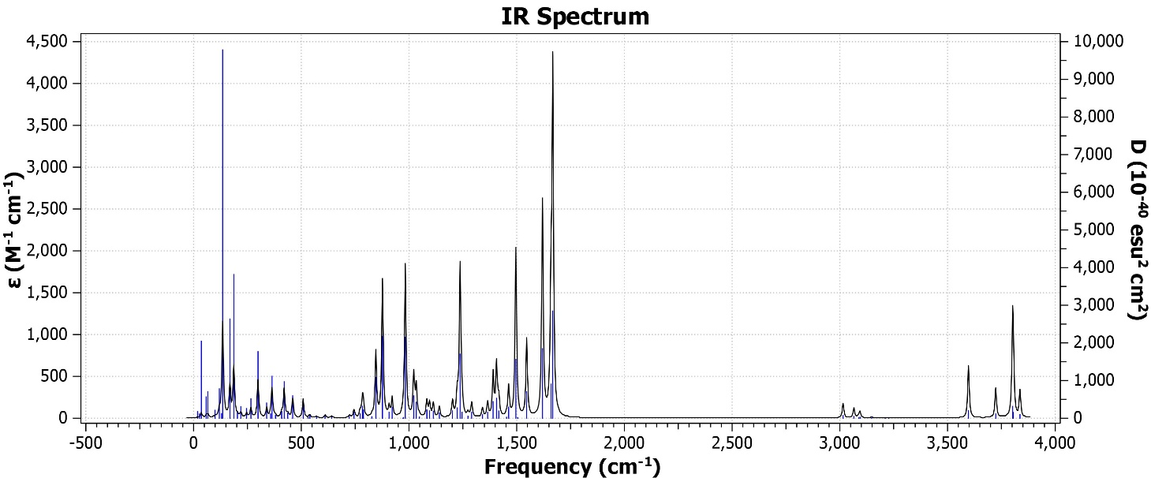

IR spectra for GNA_{CR}

IR spectra for GNA_{CR}–Zn

Fig. S2. IR spectra (not scaled) obtained for GNA_{CR} and GNA_{CR}–Zn at B3LYP/6-311++G(d,p) level of theory with CPCM solvation.

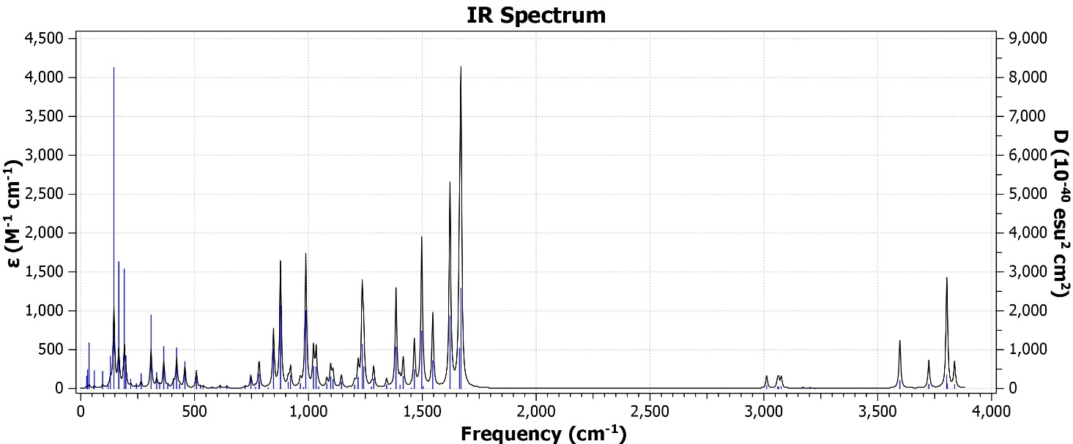

IR spectra for GNA_{CS}

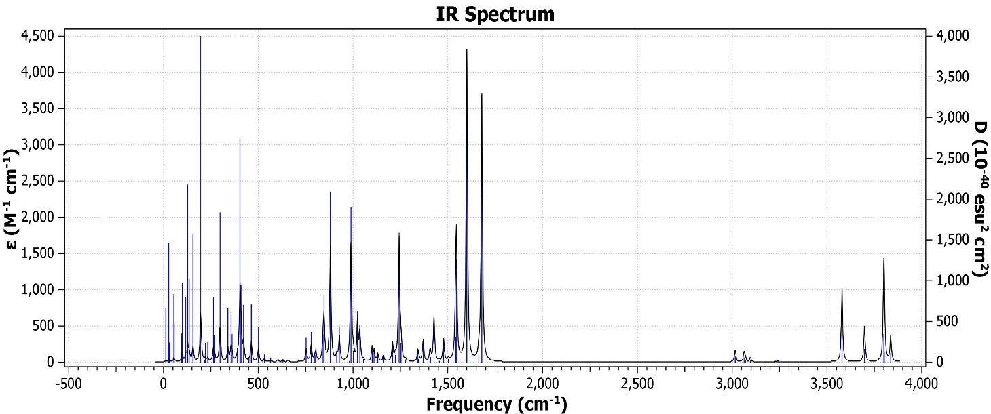

IR spectra for GNA_{CS}–Zn

Fig. S2. Continued

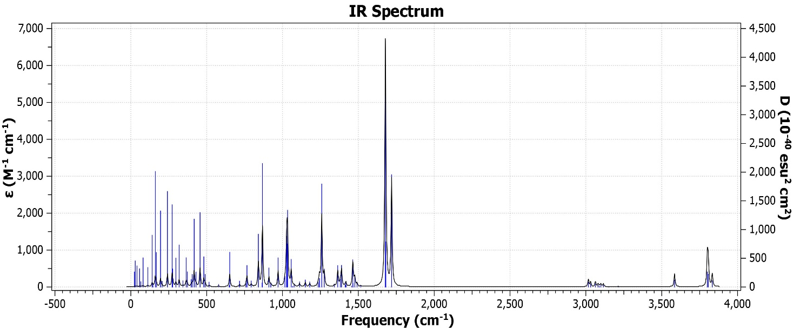

IR spectra for GNA_{TR}

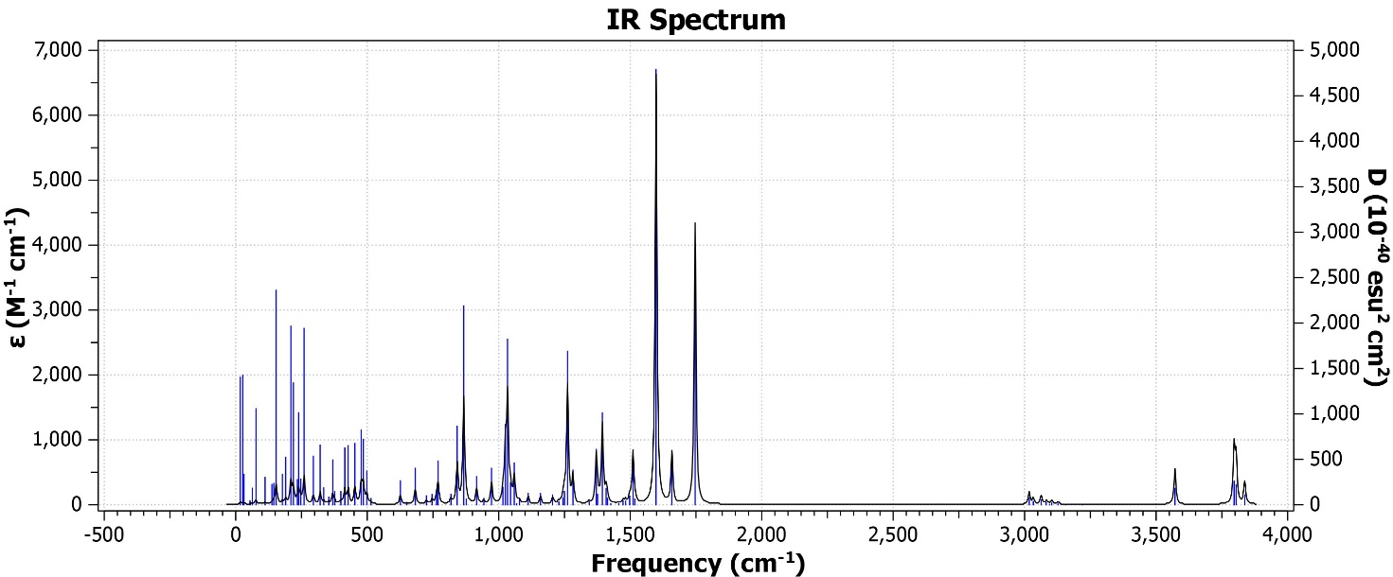

IR spectra for GNA_{TR}–Zn

Fig. S3. IR spectra obtained (not scaled) for GNA_{TR} and GNA_{TR}–Zn at B3LYP/6-311++G(d,p) level of theory with CPCM solvation.

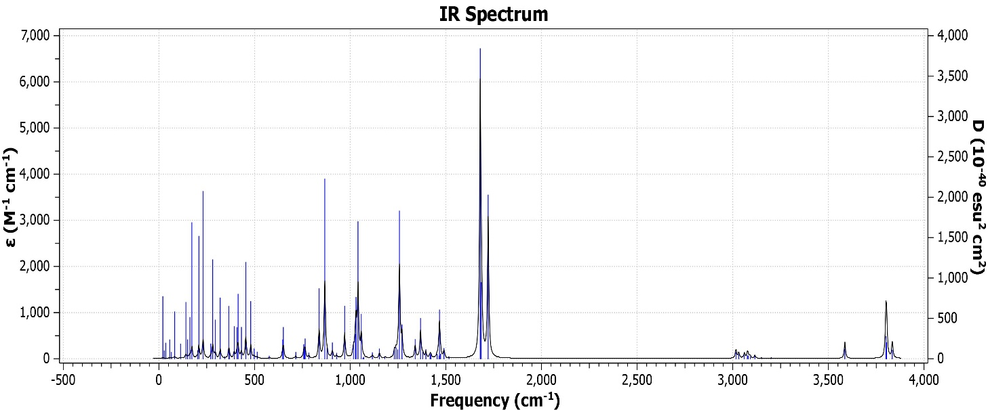

IR spectra for GNA_{TS}

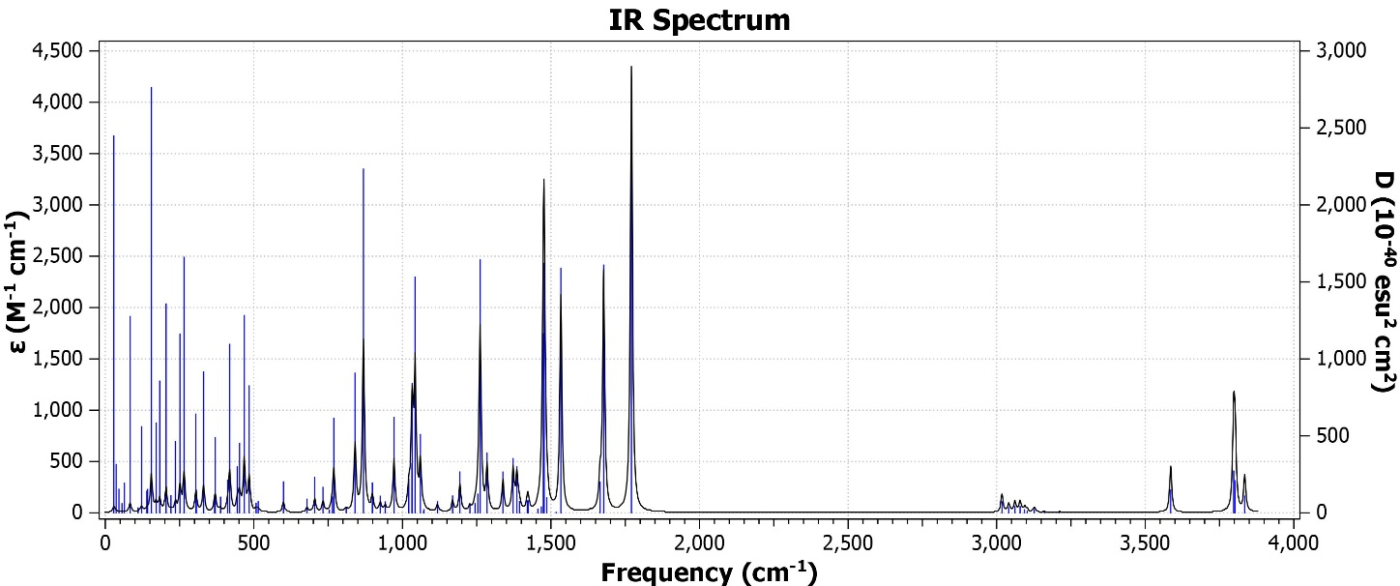

IR spectra for GNA_{TS}–Zn

Fig. S3. Continued.

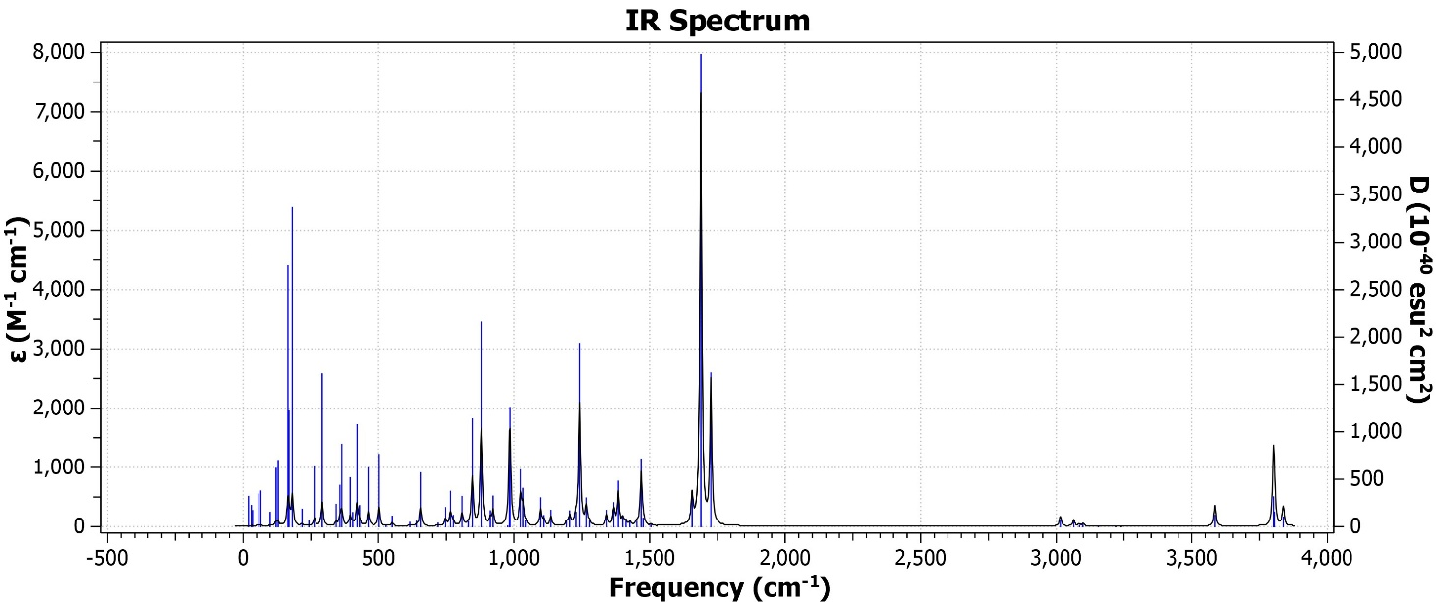

IR spectra for GNA_{UR}

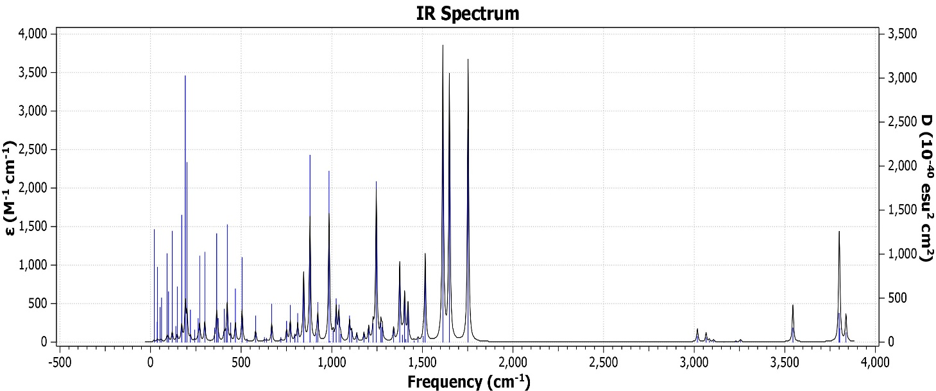

IR spectra for GNA_{UR}–Zn

Fig. S4. IR spectra obtained (not scaled) for GNA_{UR} and GNA_{UR}–Zn at B3LYP/6-311++G(d,p) level of theory with CPCM solvation.

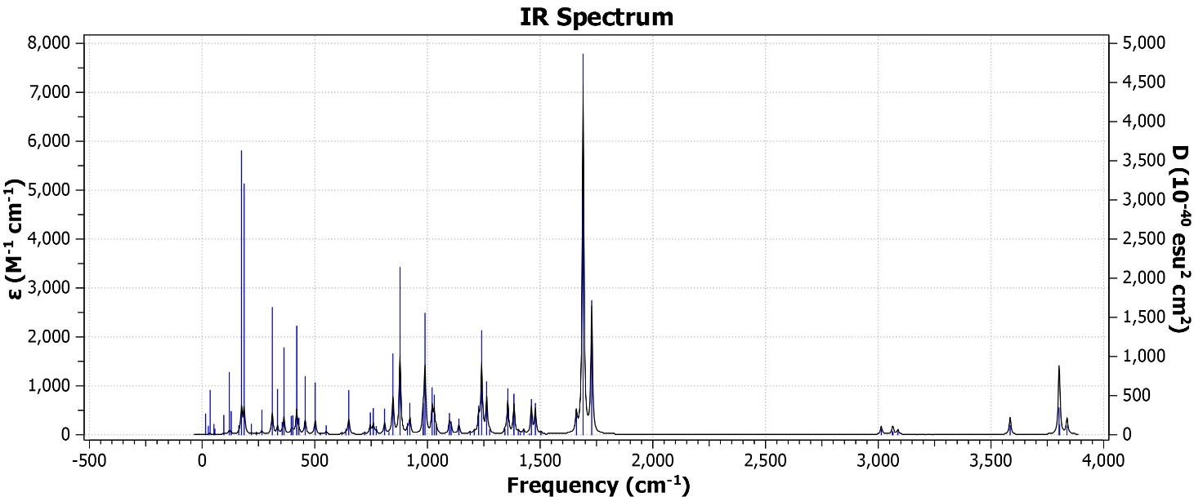

IR spectra for GNA_{US}

IR spectra for GNA_{UR}–Zn

Fig. S4. Continued.

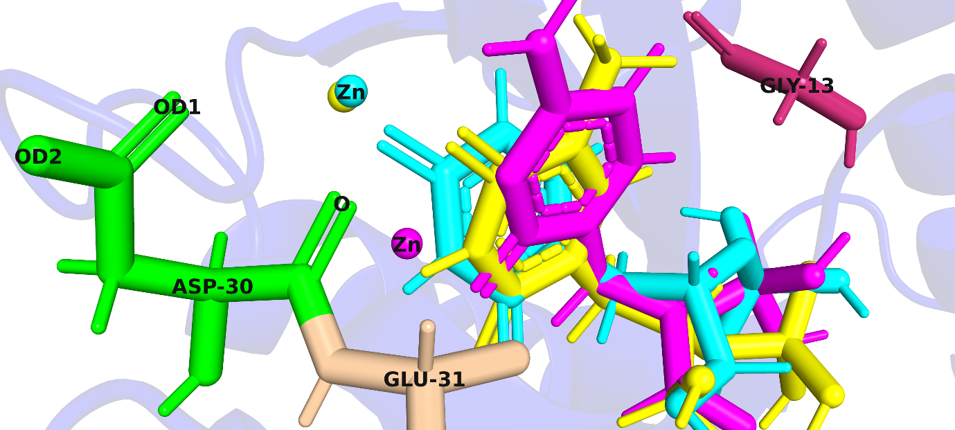

Fig. S5. Superimposed docked poses of LF1 (magenta), LG1 (yellow) and LH1 (cyan) including the positions of amino acid residues; ASP30 (green), GLU31 (wheat) and GLY13 (warm pink) in apo-KRAS.

Table S3. Estimated binding scores (kcal/mol) of a metal bound GNA conformers against apo-KRAS obtained after docking.

GNA Conformers | Binding Scores (E_{binding}) in kcal/mol
KR–LF1 | –7.2
KR–LF2 | –7.1
KR–LG1 | –7.2
KR–LG2 | –7.2
KR–LH1 | –7.4
KR–LH2 | –7.6

GNA Conformers | vdW | EEL | EPB | ΔG_{Gas} | ΔG_{Solv} | ΔG_{Binding}
KR–LF1 | –29.43 | –81.88 | 88.20 | –111.31 | 104.53 | –6.78
KR–LF2 | –28.83 | –77.87 | 85.85 | –106.70 | 103.16 | –3.54
KR–LG1 | –37.59 | –64.47 | 74.63 | –102.06 | 92.16 | –9.90
KR–LG2 | –29.94 | –83.49 | 89.35 | –113.34 | 105.91 | –7.43
KR–LH1 | –31.72 | –80.13 | 87.37 | –111.85 | 103.94 | –7.91
KR–LH2 | –31.42 | –80.58 | 87.87 | –112.00 | 105.00 | –7.01
Table S4. Calculated single frame binding free energies* (ΔG_{Binding}) in kcal/mol of the docked complexes.
*Internal dielectric constant; ε = 4 was applied for the calculation of PB based binding free energies of all the GNA conformers with ionic strength of 0.15 M.

Table S5. GAFF atom types and AM1-BCC partial charges assigned to GNA_{TR} ligand in absence of metal.

Atom | Type | Charge
N1 | n | –0.378000
N3 | n | –0.581500
C1ʹ | c3 | 0.082000
C2 | c | 0.808500
C4 | c | 0.714700
C5 | cc | –0.243400
C6 | cd | 0.033600
C9 | c3 | –0.033900
C2ʹ | c3 | 0.125100
C3ʹ | c3 | 0.126400
O7 | o | –0.661500
O8 | o | –0.598500
O4ʹ | oh | –0.587800
O5ʹ | os | –0.575200
O7ʹ | o | –0.812300
O8ʹ | oh | –0.754900
O9ʹ | oh | –0.754900
P6ʹ | p5 | 1.637500
H1ʹa | h1 | 0.085200
H1ʹb | h1 | 0.085200
H3 | hn | 0.356500
H6 | h4 | 0.174000
H9a | hc | 0.055033
H9b | hc | 0.055033
H9c | hc | 0.055033
H2ʹ | h1 | 0.073700
H3ʹa | h1 | 0.055200
H3ʹb | h1 | 0.055200
H4ʹ | ho | 0.424000
H8ʹ | ho | 0.491000
H9ʹ | ho | 0.491000

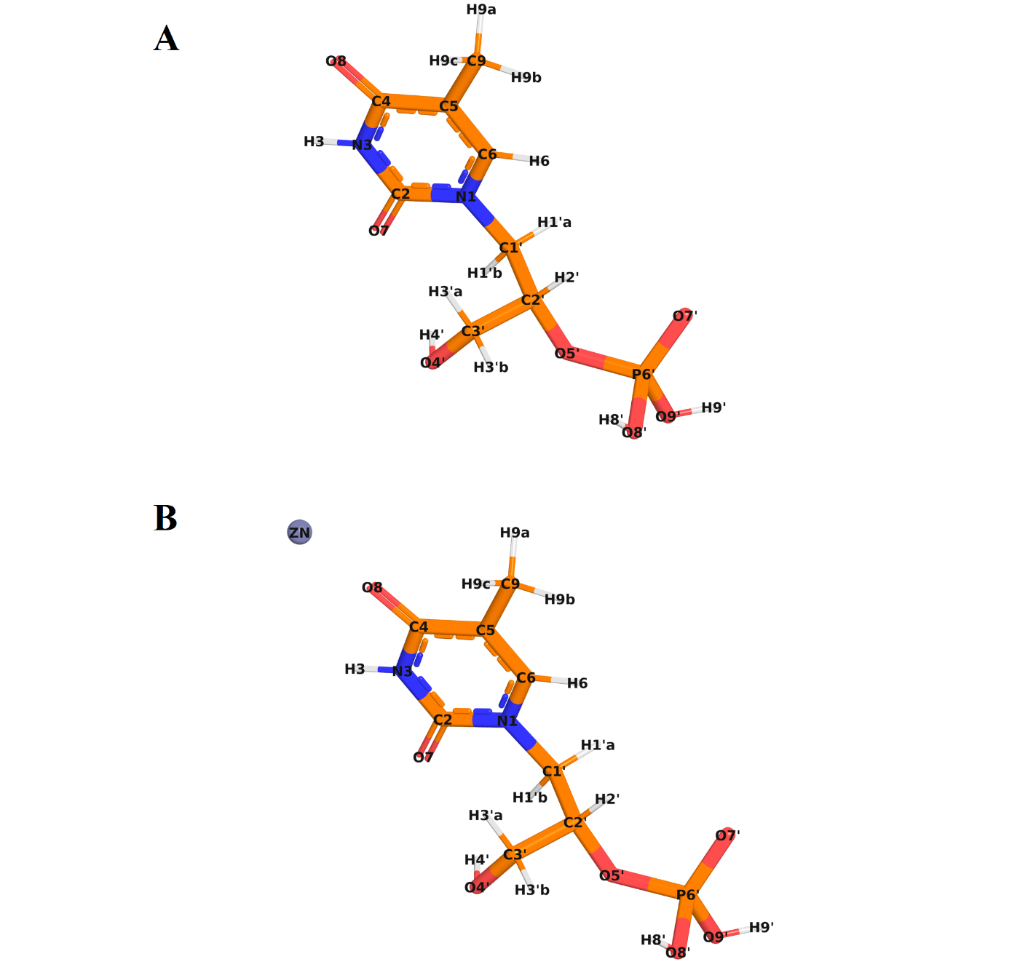

Fig. S6. Atom identities of LG1: A; without metal B; with metal, used for the GAFF atom assignment and MCPB force field parameterization.

Table S6a. Mean RMSD, Standard Deviation (SD) and Standard Error of the Mean (SEM) of Cα atoms after lsq fit on Cα for the replicas.
Replicas | Mean RMSD | SD | SEM
Rep A | 0.1361933 | 0.0179091 | 0.0005661
Rep B | 0.155158 | 0.0497492 | 0.0015724
Rep C | 0.131169 | 0.0157419 | 0.0004976

Calculations are derived from the equations shown below.
- $\text{Mean}=\frac{\sum_{i=1}^{n}{x_{i}}}{n}$
- $\text{SD}=\sqrt{\frac{\sum_{i=1}^{n}{{\left(x_{i}-\text{Mean}\right)}^{2}}}{n-1}}$
- $\text{SEM}=\frac{\text{SD}}{\sqrt{n}}$

Table S6b. Mean RMSD, Standard Deviation (SD) and Standard Error of the Mean (SEM) of LG1 after lsq fit on Protein for the replicas.

Replicas | Mean RMSD | SD | SEM
Rep A | 0.835725 | 0.58602 | 0.018522
Rep B | 0.413058 | 0.132937 | 0.004202
Rep C | 0.184253 | 0.052584 | 0.001662

Table S7a. Mean RMSF, Standard Deviation (SD) and Standard Error of the Mean (SEM) of Cα atoms after lsq fit on Cα for the replicas.

Replicas | Mean RMSF | SD | SEM
Rep A | 0.071466 | 0.042977 | 0.003277
Rep B | 0.082645 | 0.069911 | 0.005331
Rep C | 0.069967 | 0.039334 | 0.002999

Table S7b. Mean RMSF, Standard Deviation (SD) and Standard Error of the Mean (SEM) of LG1 after lsq fit on Protein for the replicas.

Replicas | Mean RMSF | SD | SEM
Rep A | 0.124531 | 0.044600 | 0.007884
Rep B | 0.082341 | 0.032288 | 0.005708
Rep C | 0.039938 | 0.024080 | 0.004257

Table S8. Mean Radius of Gyration (R_{g}), Standard Deviation (SD) and Standard Error of the Mean (SEM) across the replicas.

Replicas | Mean R_{g} | SD | SEM
Rep A | 1.568515 | 0.010742 | 0.00034
Rep B | 1.570916 | 0.00906 | 0.000286
Rep C | 1.557741 | 0.006757 | 0.000214

Type | Interaction | Parameters | Notes
MASS | M1 | Mass = 65.4 | Zn ion
MASS | Y1 | Mass = 14.01; Charge = 0.530 | Sp2 N in non–pure aromatic systems
MASS | Y2 | Mass = 16.00; Charge = 0.434 | O with one connected atom
BOND | Y1–M1 | k = 61.4 kcal·mol^{–1} ·Å²; r₀ = 2.03 Å | Seminario
BOND | Y2–M1 | k = 89.4 kcal·mol^{–1} ·Å²; r₀ = 1.95 Å | Seminario
BOND | Y1–c | k = 416.9 kcal·mol^{–1} ·Å²; r₀ = 1.39 Å | CORR_SOURCE5
BOND | Y1–cd | k = 525.4 kcal·mol^{–1} ·Å²; r₀ = 1.32 Å | SOURCE3_SOURCE5
BOND | c–Y2 | k = 637.7 kcal·mol^{–1} ·Å²; r₀ = 1.22 Å | SOURCE1_SOURCE5
ANGL | M1–Y1–c | k = 106.95; θ₀ = 85.41° | Seminario
ANGL | M1–Y1–cd | k = 108.67; θ₀ = 152.97° | Seminario
ANGL | Y1–M1–Y2 | k = 66.70; θ₀ = 68.68° | Seminario
ANGL | c –Y2–M1 | k = 59.95; θ₀ = 90.80° | Seminario
ANGL | Y1–c –Y2 | k = 73.9; θ₀ = 123.18° | CORR_SOURCE5
ANGL | Y1–cd–cd | k = 71.6; θ₀ = 112.56° | SOURCE3
ANGL | Y1–cd–nh | k = 72.4; θ₀ = 120.65° | SOURCE3_SOURCE5
ANGL | cd–Y1–c | k = 66.7; θ₀ = 120.49° | CORR_SOURCE5
ANGL | n –c –Y1 | k = 71.6; θ₀ = 117.11° | CORR_SOURCE5
ANGL | n –c –Y2 | k = 74.2; θ₀ = 123.05° | SOURCE3_SOURCE5
DIHE | X –c –Y1–X | IDIVF = 2; k = 8.0; γ = 180°; n = 2.0 | same as X–C–NC–X
DIHE | X –cd–Y1–X | IDIVF = 2; k = 9.5; γ = 180°; n = 2.0 | statistiv value from parm94
DIHE | M1–Y1–c –Y2 | IDIVF = 3; k = 0.0; γ = 0°; n = 3.0 | Treat as zero by MCPB.py
DIHE | M1–Y1–cd–cd | IDIVF = 3; k = 0.0; γ = 0°; n = 3.0 | Treat as zero by MCPB.py
DIHE | M1–Y1–cd–nh | IDIVF = 3; k = 0.0; γ = 0°; n = 3.0 | Treat as zero by MCPB.py
DIHE | Y1–M1–Y2–c | IDIVF = 3; k = 0.0; γ = 0°; n = 3.0 | Treat as zero by MCPB.py
DIHE | Y1–c –Y2–M1 | IDIVF = 3; k = 0.0; γ = 0°; n = 3.0 | Treat as zero by MCPB.py
DIHE | Y2–M1–Y1–c | IDIVF = 3; k = 0.0; γ = 0°; n = 3.0 | Treat as zero by MCPB.py
DIHE | Y2–M1–Y1–cd | IDIVF = 3; k = 0.0; γ = 0°; n = 3.0 | Treat as zero by MCPB.py
DIHE | cd–Y1–c –Y2 | IDIVF = 3; k = 0.0; γ = 0°; n = 3.0 | Treat as zero by MCPB.py
DIHE | n –c –Y1–M1 | IDIVF = 3; k = 0.0; γ = 0°; n = 3.0 | Treat as zero by MCPB.py
DIHE | n –c –Y2–M1 | IDIVF = 3; k = 0.0; γ = 0°; n = 3.0 | Treat as zero by MCPB.py
IMPR | X –X –c –Y2 | k = 10.5; γ = 180°; n = 2 | JCC, 7, (1986),230
IMPR | Y1–Y2–c –n | k = 10.5; γ = 180°; n = 2 | Using general improper torsional angle X– X– c– o, penalty score = 6.0
IMPR | Y1–cd–cd–nh | k = 1.1; γ = 180°; n = 2 | Using the default value
NONB | M1 | R_{min}/2 = 1.37 Å; ε = 0.01 | IOD set for Zn2+ ion for the OPC water model from Li et al. JCTC, 2020, 16, 4429
NONB | Y1 | R_{min}/2 = 1.82 Å; ε = 0.17 | OPLS
NONB | Y2 | R_{min}/2 = 1.66 Å; ε = 0.21 | OPLS
Table S9a. Force Field parameters obtained for LF1 in the KR–LF1 complex using DFT (B3LYP/6-31G(d)/SDD).

Type | Interaction | Parameters | Notes
MASS | M1 | Mass = 65.4 amu | Zn ion
MASS | Y1 | Mass = 14.01 Charge = 0.530 | Sp2 N in non–pure aromatic systems
MASS | Y2 | Mass = 16.00 amu; Charge = 0.434 | O with one connected atom
BOND | Y1–M1 | k = 48.1 kcal·mol^{–1} ·Å²; r₀ = 2.09 Å | Seminario
BOND | Y2–M1 | k = 61.9 kcal·mol^{–1} ·Å²; r₀ = 2.01 Å | Seminario
BOND | Y1–c | k = 416.9 kcal·mol^{–1} ·Å²; r₀ = 1.39 Å | CORR_SOURCE5
BOND | Y1–cd | k = 525.4 kcal·mol^{–1} ·Å²; r₀ = 1.32 Å | SOURCE3_SOURCE5
BOND | c–Y2 | k = 637.7 kcal·mol^{–1} ·Å²; r₀ = 1.22 Å | SOURCE1_SOURCE5
ANGL | M1–Y1–c | k = 103.50; θ₀ = 82.28° | Seminario
ANGL | M1–Y1–cd | k = 113.68; θ₀ = 148.96° | Seminario
ANGL | Y1–M1–Y2 | k = 83.45; θ₀ = 66.12° | Seminario
ANGL | c –Y2–M1 | k = 87.36; θ₀ = 87.81° | Seminario
ANGL | Y1–c –Y2 | k = 73.9; θ₀ = 123.18° | CORR_SOURCE5
ANGL | Y1–cd–cd | k = 71.6; θ₀ = 112.56° | SOURCE3
ANGL | Y1–cd–nh | k = 72.4; θ₀ = 120.65° | SOURCE3_SOURCE5
ANGL | cd–Y1–c | k = 66.7; θ₀ = 120.49° | CORR_SOURCE5
ANGL | n –c –Y1 | k = 71.6; θ₀ = 117.11° | CORR_SOURCE5
ANGL | n –c –Y2 | k = 74.2; θ₀ = 123.05° | SOURCE3_SOURCE5
DIHE | X –c –Y1–X | IDIVF = 2; k = 8.0; γ = 180°; n = 2.0 | same as X–C–NC–X
DIHE | X –cd–Y1–X | IDIVF = 2; k = 9.5; γ = 180°; n = 2.0 | statistiv value from parm94
DIHE | M1–Y1–c –Y2 | IDIVF = 3; k = 0.0; γ = 0°; n = 3.0 | Treat as zero by MCPB.py
DIHE | M1–Y1–cd–cd | IDIVF = 3; k = 0.0; γ = 0°; n = 3.0 | Treat as zero by MCPB.py
DIHE | M1–Y1–cd–nh | IDIVF = 3; k = 0.0; γ = 0°; n = 3.0 | Treat as zero by MCPB.py
DIHE | Y1–M1–Y2–c | IDIVF = 3; k = 0.0; γ = 0°; n = 3.0 | Treat as zero by MCPB.py
DIHE | Y1–c –Y2–M1 | IDIVF = 3; k = 0.0; γ = 0°; n = 3.0 | Treat as zero by MCPB.py
DIHE | Y2–M1–Y1–c | IDIVF = 3; k = 0.0; γ = 0°; n = 3.0 | Treat as zero by MCPB.py
DIHE | Y2–M1–Y1–cd | IDIVF = 3; k = 0.0; γ = 0°; n = 3.0 | Treat as zero by MCPB.py
DIHE | cd–Y1–c –Y2 | IDIVF = 3; k = 0.0; γ = 0°; n = 3.0 | Treat as zero by MCPB.py
DIHE | n –c –Y1–M1 | IDIVF = 3; k = 0.0; γ = 0°; n = 3.0 | Treat as zero by MCPB.py
DIHE | n –c –Y2–M1 | IDIVF = 3; k = 0.0; γ = 0°; n = 3.0 | Treat as zero by MCPB.py
IMPR | X –X –c –Y2 | k = 10.5; γ = 180°; n = 2 | JCC, 7, (1986),230
IMPR | Y1–Y2–c –n | k = 10.5; γ = 180°; n = 2 | Using general improper torsional angle X– X– c– o, penalty score = 6.0
IMPR | Y1–cd–cd–nh | k = 1.1; γ = 180°; n = 2 | Using the default value
NONB | M1 | R_{min}/2 = 1.37 Å; ε = 0.01 | IOD set for Zn2+ ion for the OPC water model from Li et al. JCTC, 2020, 16, 4429
NONB | Y1 | R_{min}/2 = 1.82 Å; ε = 0.17 | OPLS
NONB | Y2 | R_{min}/2 = 1.66 Å; ε = 0.21 | OPLS
Table S9b. Force Field parameters obtained for LF2 in the KR–LF2 complex using DFT (B3LYP/6-31G(d)/SDD).
Table S9c. Force Field parameters obtained for LG1 in the KR–LG1 complex using DFT (B3LYP/6-31G(d)/SDD).

Type | Interaction | Parameters | Notes
MASS | M1 | Mass = 65.4 amu | Zn ion
MASS | Y1 | Mass = 16.00 amu; Charge = 0.434 | O with one connected atom
BOND | Y1–M1 | k = 74.6 kcal·mol^{–1} ·Å²; r₀ = 1.92 Å | Seminario
BOND | c–Y1 | k = 637.7; r₀ = 1.22 Å | SOURCE1_SOURCE5
ANGL | c–Y1–M1 | k = 37.88; θ₀ = 125.55° | Seminario
ANGL | Y1–c–cc | k = 69.1; θ₀ = 123.93° | SOURCE3_SOURCE5
ANGL | n–c–Y1 | k = 74.2; θ₀ = 123.05° | SOURCE3_SOURCE5
DIHE | M1–Y1–c–cc | IDIVF = 3; k = 0.0; γ = 0°; n = 3.0 | Treat as zero by MCPB.py
DIHE | hn–n–c–Y1 | IDIVF = 1; k = 2.5; γ = 180°; n = –2.0 | JCC, 7, (1986), 230
DIHE | hn–n–c–Y1 | IDIVF = 1; k = 2.0; γ = 0°; n = 1.0 | J.C. cistrans–NMA DE
DIHE | n–c–Y1–M1 | IDIVF = 3; k = 0.0; γ = 0°; n = 3.0 | Treat as zero by MCPB.py
IMPR | X–X–c–Y1 | k = 10.5; γ = 180°; n = 2 | JCC, 7, (1986), 230
IMPR | Y1–cc–c–n | k = 10.5; γ = 180°; n = 2 | Using general improper torsional angle X– X– c– o, penalty score = 6.0)
NONB | M1 | R_{min}/2 = 1.37 Å; ε = 0.01 | IOD set for Zn2+ ion for the OPC water model from Li et al. JCTC, 2020, 16, 4429
NONB | Y1 | R_{min}/2 = 1.66 Å; ε = 0.21 | OPLS

Table S9d. Force Field parameters obtained for LG2 in the KR–LG2 complex using DFT (B3LYP/6-31G(d)/SDD).

Type | Interaction | Parameters | Notes
MASS | M1 | Mass = 65.4 amu | Zn ion
MASS | Y1 | Mass = 16.00 amu; Charge = 0.434 | O with one connected atom
BOND | Y1–M1 | k = 81.3 kcal·mol^{–1} ·Å²; r₀ = 1.92 Å | Seminario
BOND | c–Y1 | k = 637.7; r₀ = 1.22 Å | SOURCE1_SOURCE5
ANGL | c–Y1–M1 | k = 43.72; θ₀ = 123.18° | Seminario
ANGL | Y1–c–cc | k = 69.1; θ₀ = 123.93° | SOURCE3_SOURCE5
ANGL | n–c–Y1 | k = 74.2; θ₀ = 123.05° | SOURCE3_SOURCE5
DIHE | M1–Y1–c–cc | IDIVF = 3; k = 0.0; γ = 0°; n = 3.0 | Treat as zero by MCPB.py
DIHE | hn–n–c–Y1 | IDIVF = 1; k = 2.5; γ = 180°; n = –2.0 | JCC, 7, (1986), 230
DIHE | hn–n–c–Y1 | IDIVF = 1; k = 2.0; γ = 0°; n = 1.0 | J.C. cistrans–NMA DE
DIHE | n–c–Y1–M1 | IDIVF = 3; k = 0.0; γ = 0°; n = 3.0 | Treat as zero by MCPB.py
IMPR | X–X–c–Y1 | k = 10.5; γ = 180°; n = 2 | JCC, 7, (1986), 230
IMPR | Y1–cc–c–n | k = 10.5; γ = 180°; n = 2 | Using general improper torsional angle X– X– c– o, penalty score = 6.0)
NONB | M1 | R_{min}/2 = 1.37 Å; ε = 0.01 | IOD set for Zn2+ ion for the OPC water model from Li et al. JCTC, 2020, 16, 4429
NONB | Y1 | R_{min}/2 = 1.66 Å; ε = 0.21 | OPLS

Table S9e. Force Field parameters obtained for LH1 in the KR–LH1 complex using DFT (B3LYP/6-31G(d)/SDD).

Type | Interaction | Parameters | Notes
MASS | M1 | Mass = 65.4 amu | Zn ion
MASS | Y1 | Mass = 16.00 amu; Charge = 0.434 | O with one connected atom
BOND | Y1–M1 | k = 74.3 kcal·mol^{–1} ·Å²; r₀ = 1.91 Å | Seminario
BOND | c–Y1 | k = 637.7; r₀ = 1.22 Å | SOURCE1_SOURCE5
ANGL | c–Y1–M1 | k = 37.97; θ₀ = 137.68° | Seminario
ANGL | Y1–c–cc | k = 69.1; θ₀ = 123.93° | SOURCE3_SOURCE5
ANGL | n–c–Y1 | k = 74.2; θ₀ = 123.05° | SOURCE3_SOURCE5
DIHE | M1–Y1–c–cc | IDIVF = 3; k = 0.0; γ = 0°; n = 3.0 | Treat as zero by MCPB.py
DIHE | hn–n–c–Y1 | IDIVF = 1; k = 2.5; γ = 180°; n = –2.0 | JCC, 7, (1986), 230
DIHE | hn–n–c–Y1 | IDIVF = 1; k = 2.0; γ = 0°; n = 1.0 | J.C. cistrans–NMA DE
DIHE | n–c–Y1–M1 | IDIVF = 3; k = 0.0; γ = 0°; n = 3.0 | Treat as zero by MCPB.py
IMPR | X–X–c–Y1 | k = 10.5; γ = 180°; n = 2 | JCC, 7, (1986), 230
IMPR | Y1–cc–c–n | k = 10.5; γ = 180°; n = 2 | Using general improper torsional angle X– X– c– o, penalty score = 6.0)
NONB | M1 | R_{min}/2 = 1.37 Å; ε = 0.01 | IOD set for Zn2+ ion for the OPC water model from Li et al. JCTC, 2020, 16, 4429
NONB | Y1 | R_{min}/2 = 1.66 Å; ε = 0.21 | OPLS

Table S9f. Force Field parameters obtained for LH2 in the KR–LH2 complex using DFT (B3LYP/6-31G(d)/SDD).

Type | Interaction | Parameters | Notes
MASS | M1 | Mass = 65.4 amu | Zn ion
MASS | Y1 | Mass = 16.00 amu; Charge = 0.434 | O with one connected atom
BOND | Y1–M1 | k = 73.7 kcal·mol^{–1} ·Å²; r₀ = 1.91 Å | Seminario
BOND | c–Y1 | k = 637.7; r₀ = 1.22 Å | SOURCE1_SOURCE5
ANGL | c–Y1–M1 | k = 38.27; θ₀ = 137.73° | Seminario
ANGL | cd–c–Y1 | k = 69.1; θ₀ = 123.93° | SOURCE3_SOURCE5
ANGL | n–c–Y1 | k = 74.2; θ₀ = 123.05° | SOURCE3_SOURCE5
DIHE | cd–c–Y1–M1 | IDIVF = 3; k = 0.0; γ = 0°; n = 3.0 | Treat as zero by MCPB.py
DIHE | hn–n–c–Y1 | IDIVF = 1; k = 2.5; γ = 180°; n = –2.0 | JCC, 7, (1986), 230
DIHE | hn–n–c–Y1 | IDIVF = 1; k = 2.0; γ = 0°; n = 1.0 | J.C. cistrans–NMA DE
DIHE | n–c–Y1–M1 | IDIVF = 3; k = 0.0; γ = 0°; n = 3.0 | Treat as zero by MCPB.py
IMPR | X–X–c–Y1 | k = 10.5; γ = 180°; n = 2 | JCC, 7, (1986), 230
IMPR | Y1–cd–c–n | k = 10.5; γ = 180°; n = 2 | Using general improper torsional angle X– X– c– o, penalty score = 6.0)
NONB | M1 | R_{min}/2 = 1.37 Å; ε = 0.01 | IOD set for Zn2+ ion for the OPC water model from Li et al. JCTC, 2020, 16, 4429
NONB | Y1 | R_{min}/2 = 1.66 Å; ε = 0.21 | OPLS

