TITLE PAGE.
Title: High prevalence of intrathecal IgA synthesis in multiple sclerosis patients.
Úrsula Muñoz PhD1, Cristina Sebal Phd1, Esther Escudero PhD1, Maria Isabel García Sánchez PhD2, Elena Urcelay PhD3, Asier Jayo PhD1, Rafael Arroyo MD PhD4, Maria A García-Martínez LA5, Roberto Álvarez-Lafuente PhD5, María C Sádaba, PhD1.
1 Facultad de Medicina, Instituto de Medicina Molecular Aplicada (IMMA), Universidad San Pablo-CEU, CEU Universities. Crta Boadilla del Monte Km 5,3. Madrid. Spain.
2 UGC Neurología (Biobanco Hospitalario), Hospital Universitario Virgen Macarena, Red Española de Esclerosis Múltiple (REEM), Madrid, Spain.
3 Instituto de Investigación Sanitaria San Carlos (IdISSC) / Hospital Clínico San Carlos, Madrid. Spain.
4Departamento de Neurología. Hospital Universitario Quironsalud Madrid. Spain
5Grupo de Investigación de Factores ambientales en enfermedades degenerativas. Instituto de Investigación Sanitaria San Carlos (IdISSC) / Hospital Clínico San Carlos. Madrid. Spain.

Correspondence to:
Maria Cruz Sadaba Argaiz
Facultad de Medicina, Instituto de Medicina Molecular Aplicada (INMA), Universidad San Pablo-CEU, CEU Universities. Crta Boadilla del Monte Km 5,3. Madrid. Spain.
Email: mariacruz.sadabaargaiz@ceu.es
Telephone: (+34) 914566300
Roberto Álvarez Lafuente
Grupo de Investigación de Factores ambientales en enfermedades degenerativas. Instituto de Investigación Sanitaria San Carlos (IdISSC) / Hospital Clínico San Carlos. Madrid. Spain.
Email: ralvarezlafuente@yahoo.es
Telephone: (+34) 913303726
Keywords: multiple sclerosis, oligoclonal bands, isoelectrofocusing, intrathecal IgA synthesis.

DISCLOSURE OF CONFLICTS OF INTEREST
Authors have nothing to disclosure.

Supplementary Data 1.
- Validation of the ELISA to analyze the IgA concentration in CSF and serum samples.
In order to analyze the IgA concentration in CSF and serum samples we developed a new ELISA in our laboratory. First, we validated the ELISA in order to assess the quality of the assay. We observed a high correlation between the IgA concentration and the absorbance (r= 0.940, p< 0.0001) when the concentration of this immunoglobulin ranged from 10 ng/mL to 0.3125 ng/mL (Fig. S2.1A). The multicollinearity test (VIF= 7.92; p< 0.0001) also demonstrated the linearity of the assay, and the analysis of the distribution of the residuals demonstrated the normality and homoscedasticity of the data (Fig. S1.1B-C).
Then, we calculated the coefficient of variation of the ELISA, 10.26%. In addition, the lower IgA concentration within the linear range was higher than the limit of blank (0.318 ng/mL) and the limit of detection (0.500 ng/mL).

Supplementary Data 2.
- Validation of the isoelectrofocusing to analyze the presence of OGIgAB in CSF and serum samples.
Once achieved the best conditions to detect OGIgAB, we validated the IEF and immunodetection assay in order to assess its quality. First, we quantify the total optical density of the different dilutions of IgA applied on the gel (Fig.1) to assess the linearity of the assay, and we could observe a high correlation (r= 0.972, p< 0.0001) between the concentration and the optic density obtained (Fig S2.1A). The multicollinearity test (VIF= 12.5; p= 0.001) also demonstrated the linearity of the assay, and the analysis of the distribution of the residuals demonstrated the normality and homoscedasticity of the data (Fig. S2.1B-C). Then, we analyzed the coefficient of variation (12.83%) of the IEF and immunodetection assay.

LEGENDS:
Supplementary Figure 1. Analysis of the linearity of the quantitative ELISA. A) Study of the linear correlation of absorbances and IgA concentration. The empty circles and the whiskers represent the median and the standard deviation of the absorbances respectively and the straight line is the reference line. B) The normal P-P plot of distribution of regression standardized residual showed dots following the normality line. C) Scatterplot of the residuals showed a homogeneous distribution of the dots.

Suplementary Figure 2. Analysis of the linearity of the IEF and immunodetection assay. A) Relation between the concentration of IgA and the optic density (O.D). The dots represent the median of the lectures and the bars the standard deviation. The line represent the reference line. B) The normal P-P plot of distribution of regression standardized residual showed dots following the normality line. C) Scatterplot of the residuals showed a homogeneous distribution of the dots.

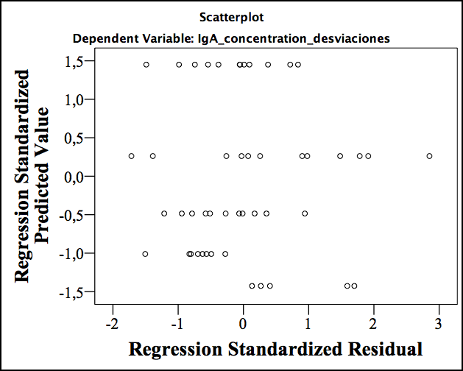
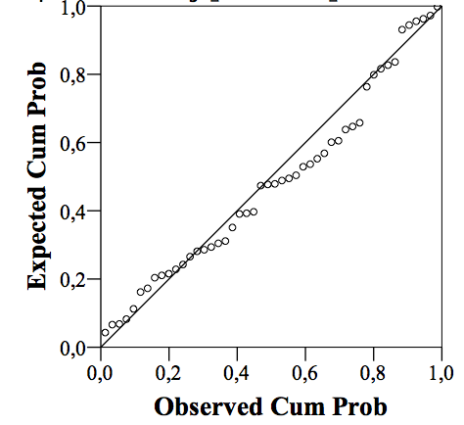
Figure S1.
A
B
C

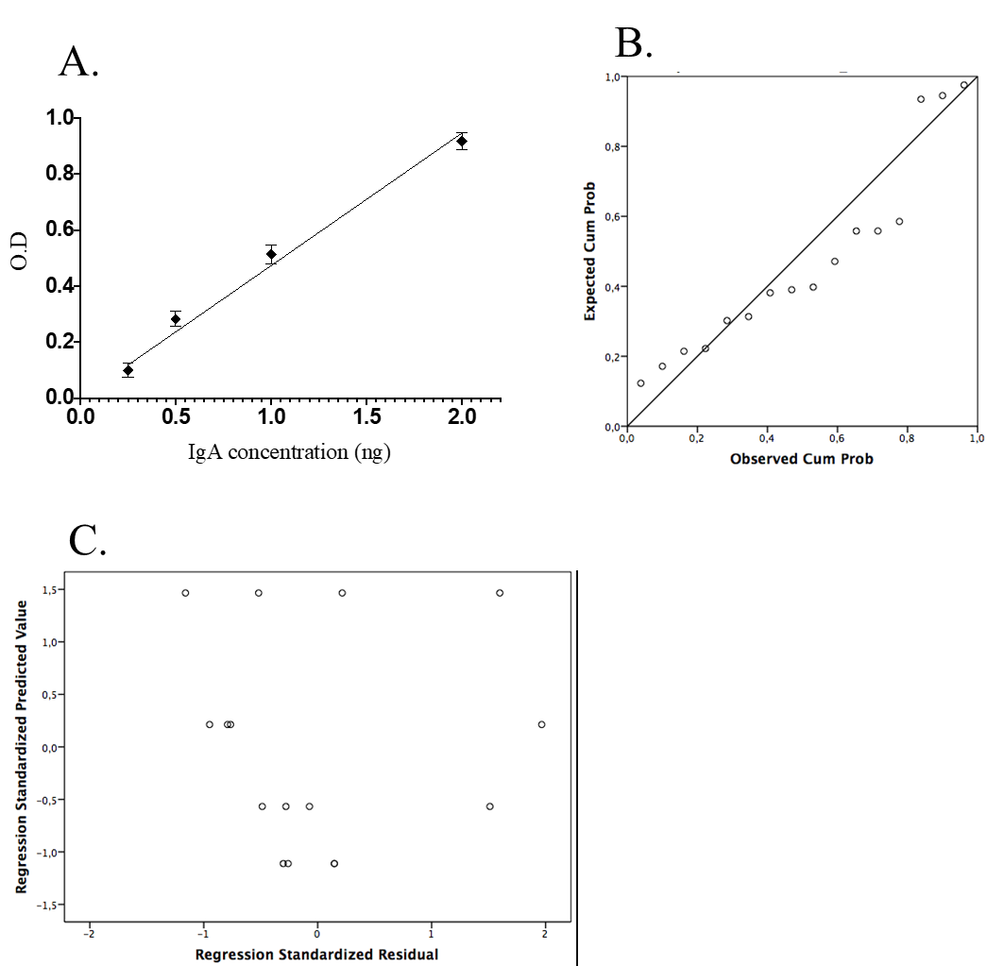
Figure S2.

