Extended data figures
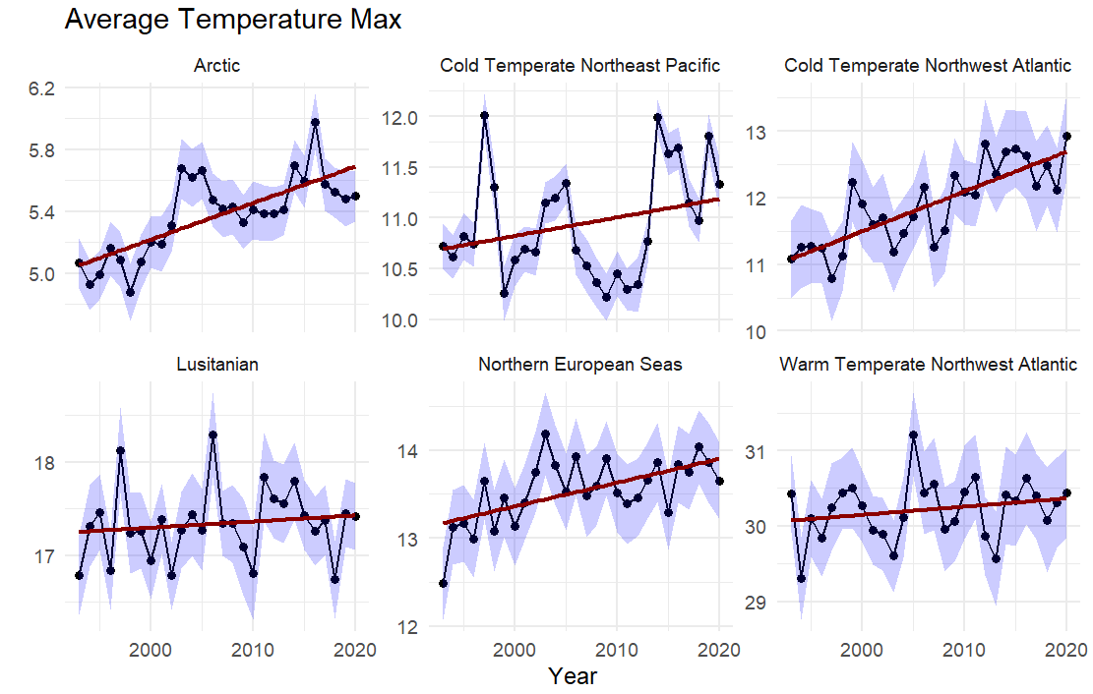
Extended Data Fig.1. Temporal trends in sea bottom temperature across the six Marine Provinces defined by Spalding et al. (2007) analysed in this study. Dots represent the mean temperature of the four warmest months for each year, while the shaded confidence intervals indicate the variability among grid cells within each province.
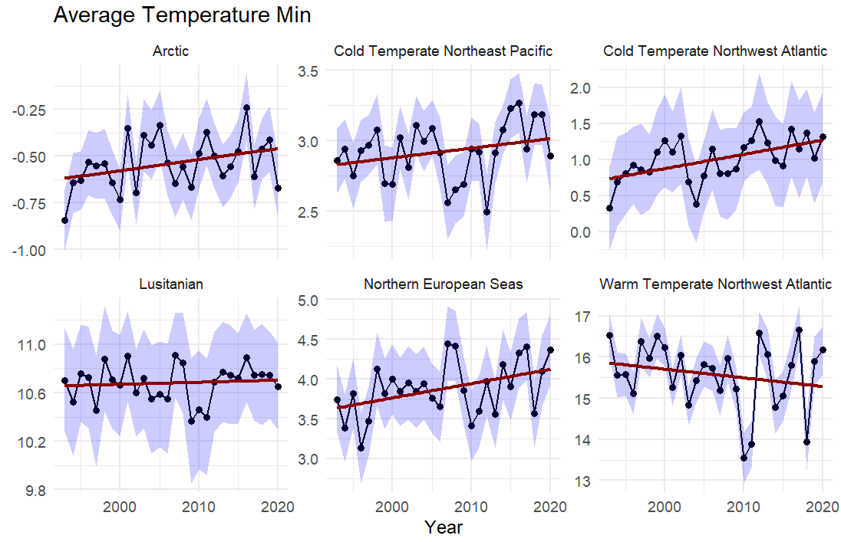
Extended Data Fig.2. Temporal trends in sea bottom temperature across the six Marine Provinces defined by Spalding et al. (2007) analysed in this study. Dots represent the mean temperature of the four coldest months for each year, while the shaded confidence intervals indicate the variability among grid cells within each province.

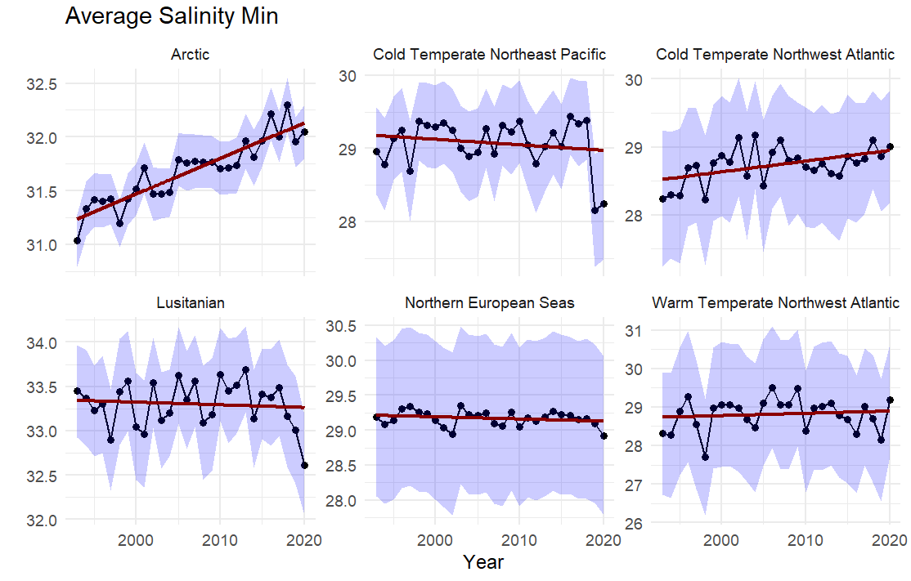
Extended Data Fig.3. Temporal trends in sea bottom salinity across the six Marine Provinces defined by Spalding et al. (2007) analysed in this study. Dots represent the mean salinity of the four months with the lowest values for each year, while the shaded confidence intervals indicate variability among grid cells within each province.

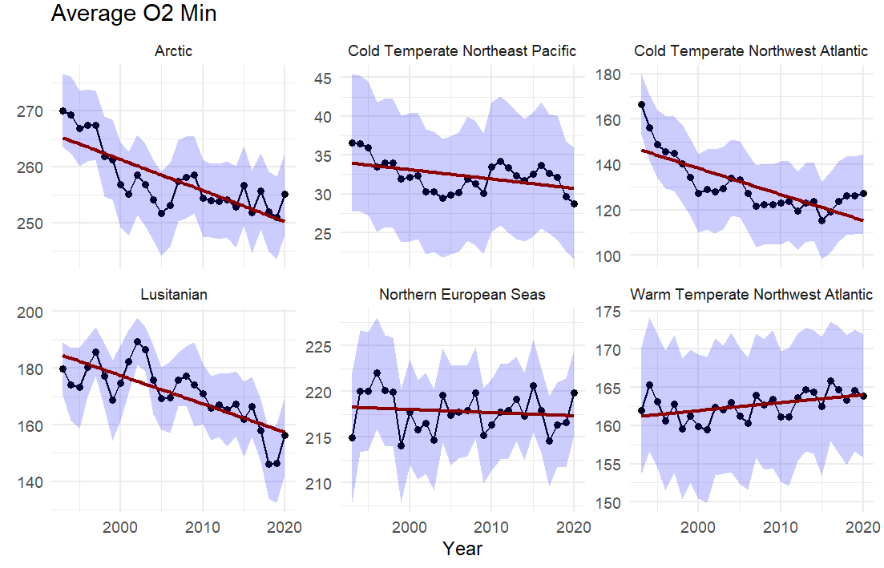
Extended Data Fig.4. Temporal trends in sea bottom oxygen across the six Marine Provinces defined by Spalding et al. (2007) analysed in this study. Dots represent the mean oxygen concentration of the four months with the lowest values for each year, while the shaded confidence intervals indicate variability among grid cells within each province.
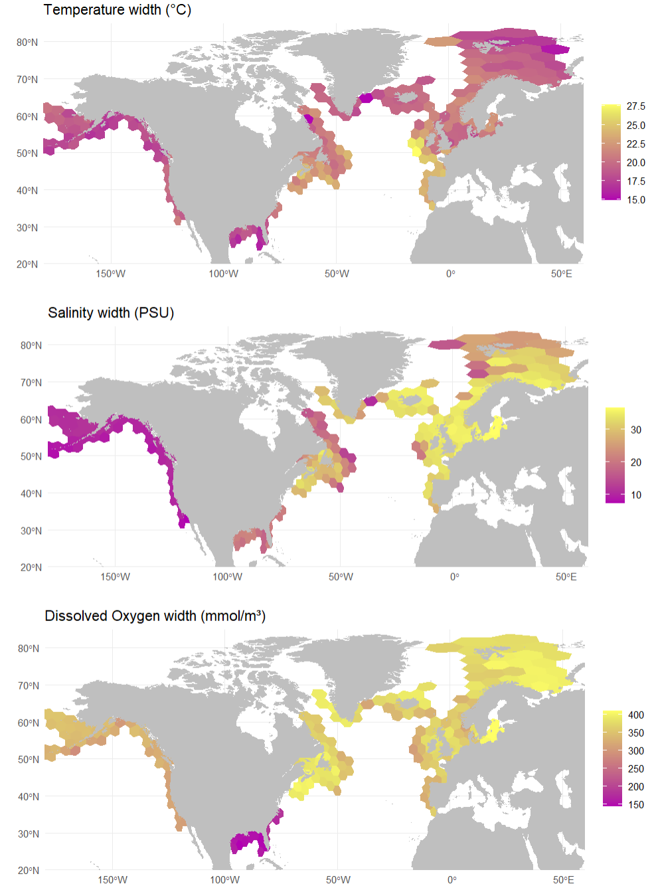
Extended Data Fig.5. Environmental tolerance widths (maximum–minimum) across the study area for the three environmental variables: temperature, oxygen, and salinity. Tolerance widths were first calculated for each species within a grid cell, weighted by species biomass to obtain a community-weighted mean (CWM), and then averaged across species to obtain a single value per grid cell.

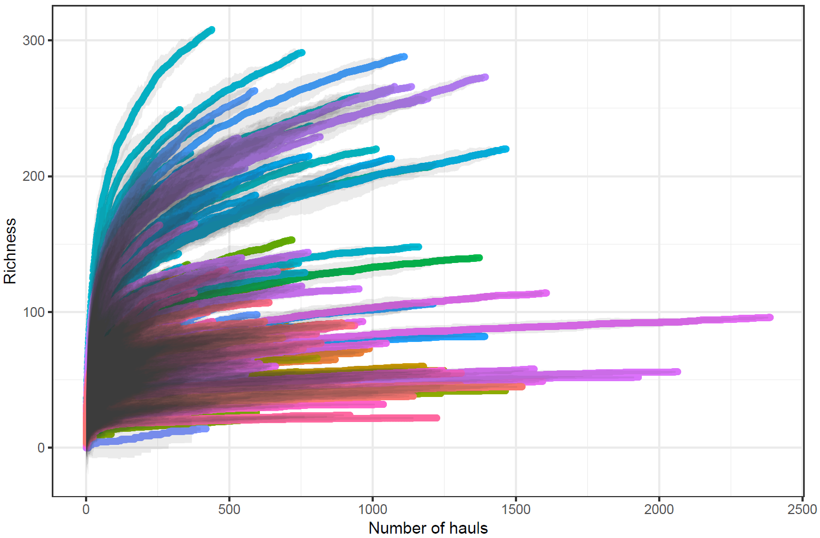
Extended Data Fig.6. Sampling effort heterogeneity between grid cells and decades (i.e., number of hauls in each sampling unit) as shown by species accumulation curves, where species richness is a function of the number of hauls within sample units.

