Run | Radius | Velocity | Voltage | Eff_1e-2 | Eff_1e-1 | Eff_1e0 | Eff_1e1
1 | 0.005 | 10 | 10 | 0.08 | 0.02 | 0.1 | 0.15
2 | 0.005 | 10 | 30 | 0.3 | 0.15 | 0.24 | 0.63
3 | 0.005 | 10 | 50 | 0.55 | 0.29 | 0.45 | 1
4 | 0.005 | 30 | 10 | 0.06 | 0.04 | 0.04 | 0.08
5 | 0.005 | 30 | 30 | 0.078 | 0.13 | 0.182 | 0.26
6 | 0.005 | 30 | 50 | 0.09 | 0.15 | 0.21 | 0.3
7 | 0.005 | 50 | 10 | 0.06 | 0.1 | 0.14 | 0.2
8 | 0.005 | 50 | 30 | 0.1 | 0.04 | 0.08 | 0.22
9 | 0.005 | 50 | 50 | 0.06 | 0.1 | 0.14 | 0.2
10 | 0.001 | 10 | 10 | 0.084 | 0.14 | 0.196 | 0.28
11 | 0.001 | 10 | 30 | 0.132 | 0.22 | 0.308 | 0.44
12 | 0.001 | 10 | 50 | 0.18 | 0.3 | 0.42 | 0.6
13 | 0.001 | 30 | 10 | 0.072 | 0.12 | 0.168 | 0.24
14 | 0.001 | 30 | 30 | 0.096 | 0.16 | 0.224 | 0.32
15 | 0.001 | 30 | 50 | 0.12 | 0.2 | 0.28 | 0.4
16 | 0.001 | 50 | 10 | 0.06 | 0.1 | 0.14 | 0.2
17 | 0.001 | 50 | 30 | 0.06 | 0.1 | 0.14 | 0.2
18 | 0.001 | 50 | 50 | 0.06 | 0.1 | 0.14 | 0.2
19 | 0.002 | 10 | 10 | 0.108 | 0.18 | 0.252 | 0.36
20 | 0.002 | 10 | 30 | 0.204 | 0.34 | 0.476 | 0.68
21 | 0.002 | 10 | 50 | 0.3 | 0.5 | 0.7 | 1
22 | 0.002 | 30 | 10 | 0.084 | 0.14 | 0.196 | 0.28
23 | 0.002 | 30 | 30 | 0.132 | 0.22 | 0.308 | 0.44
24 | 0.002 | 30 | 50 | 0.18 | 0.3 | 0.42 | 0.6
25 | 0.002 | 50 | 10 | 0.4 | 0.2 | 0.4 | 1
26 | 0.002 | 50 | 30 | 0.18 | 0.1 | 0.18 | 0.55
27 | 0.002 | 50 | 50 | 0.12 | 0.08 | 0.12 | 0.37
Taguchi L27 Simulation Run for Electrostatic Precipitator

Grey Analysis
Run | X1 | X2 | X3 | X4
1 | 0.040816 | 0 | 0.090909 | 0.076087
2 | 0.489796 | 0.270833 | 0.30303 | 0.597826
3 | 1 | 0.5625 | 0.621212 | 1
4 | 0 | 0.041667 | 0 | 0
5 | 0.036735 | 0.229167 | 0.215152 | 0.195652
6 | 0.061224 | 0.270833 | 0.257576 | 0.23913
7 | 0 | 0.166667 | 0.151515 | 0.130435
8 | 0.081633 | 0.041667 | 0.060606 | 0.152174
9 | 0 | 0.166667 | 0.151515 | 0.130435
10 | 0.04898 | 0.25 | 0.236364 | 0.217391
11 | 0.146939 | 0.416667 | 0.406061 | 0.391304
12 | 0.244898 | 0.583333 | 0.575758 | 0.565217
13 | 0.02449 | 0.208333 | 0.193939 | 0.173913
14 | 0.073469 | 0.291667 | 0.278788 | 0.26087
15 | 0.122449 | 0.375 | 0.363636 | 0.347826
16 | 0 | 0.166667 | 0.151515 | 0.130435
17 | 0 | 0.166667 | 0.151515 | 0.130435
18 | 0 | 0.166667 | 0.151515 | 0.130435
19 | 0.097959 | 0.333333 | 0.321212 | 0.304348
20 | 0.293878 | 0.666667 | 0.660606 | 0.652174
21 | 0.489796 | 1 | 1 | 1
22 | 0.04898 | 0.25 | 0.236364 | 0.217391
23 | 0.146939 | 0.416667 | 0.406061 | 0.391304
24 | 0.244898 | 0.583333 | 0.575758 | 0.565217
25 | 0.693878 | 0.375 | 0.545455 | 1
26 | 0.244898 | 0.166667 | 0.212121 | 0.51087
27 | 0.122449 | 0.125 | 0.121212 | 0.315217

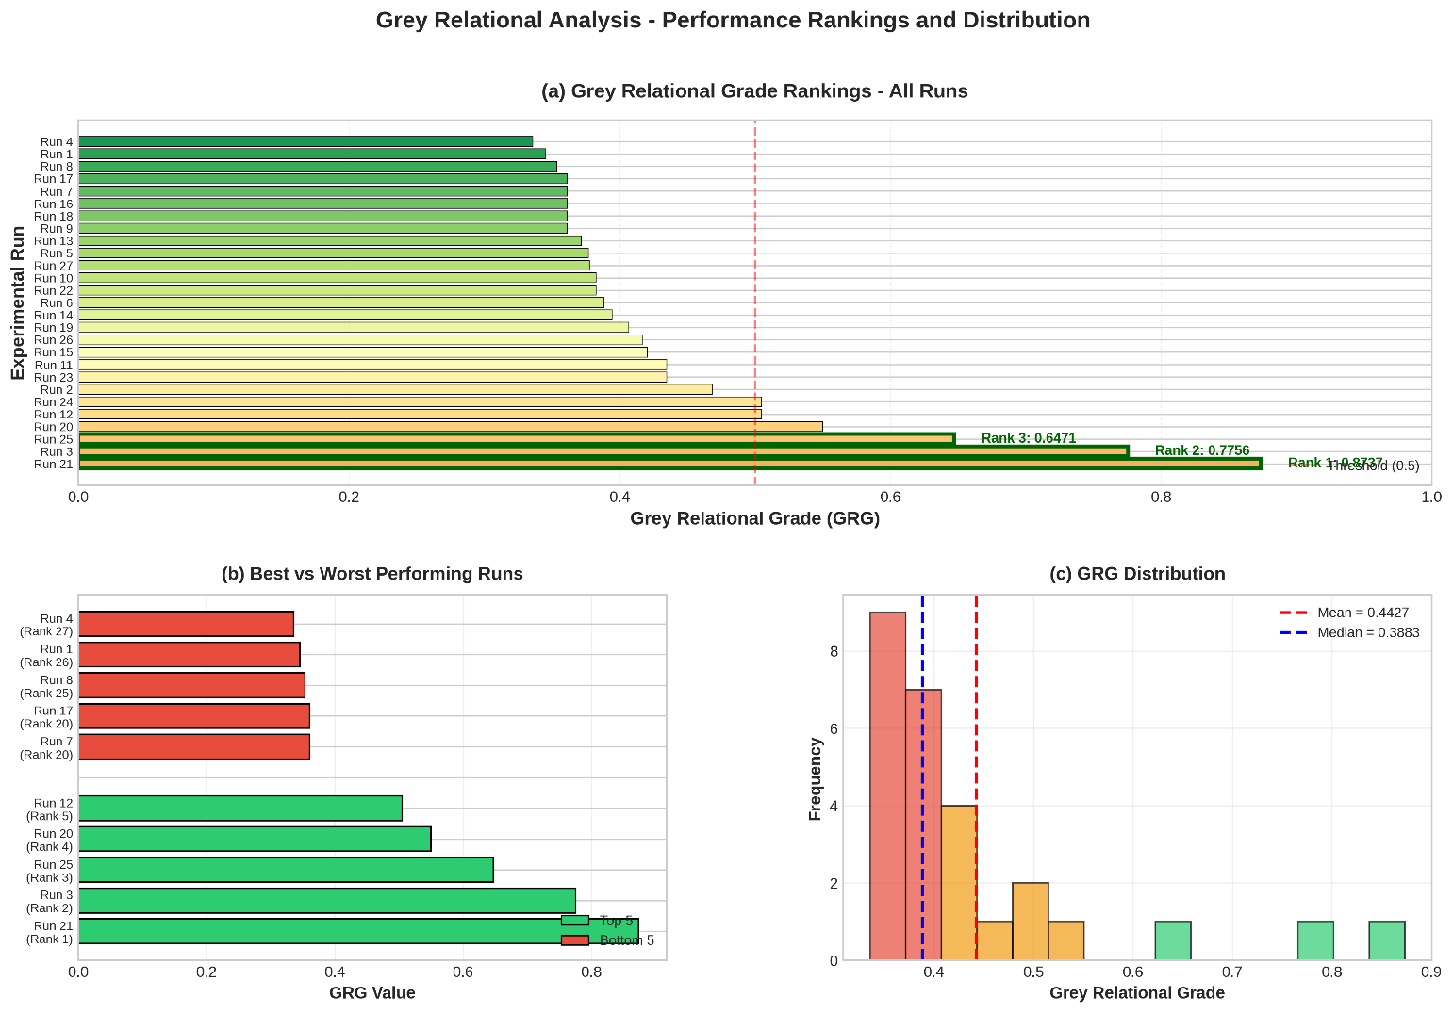

Run | Wire radius (m) |  | Velocity (m/s) | Voltage (KV)
1 | 0.005 |  | 10 | 10
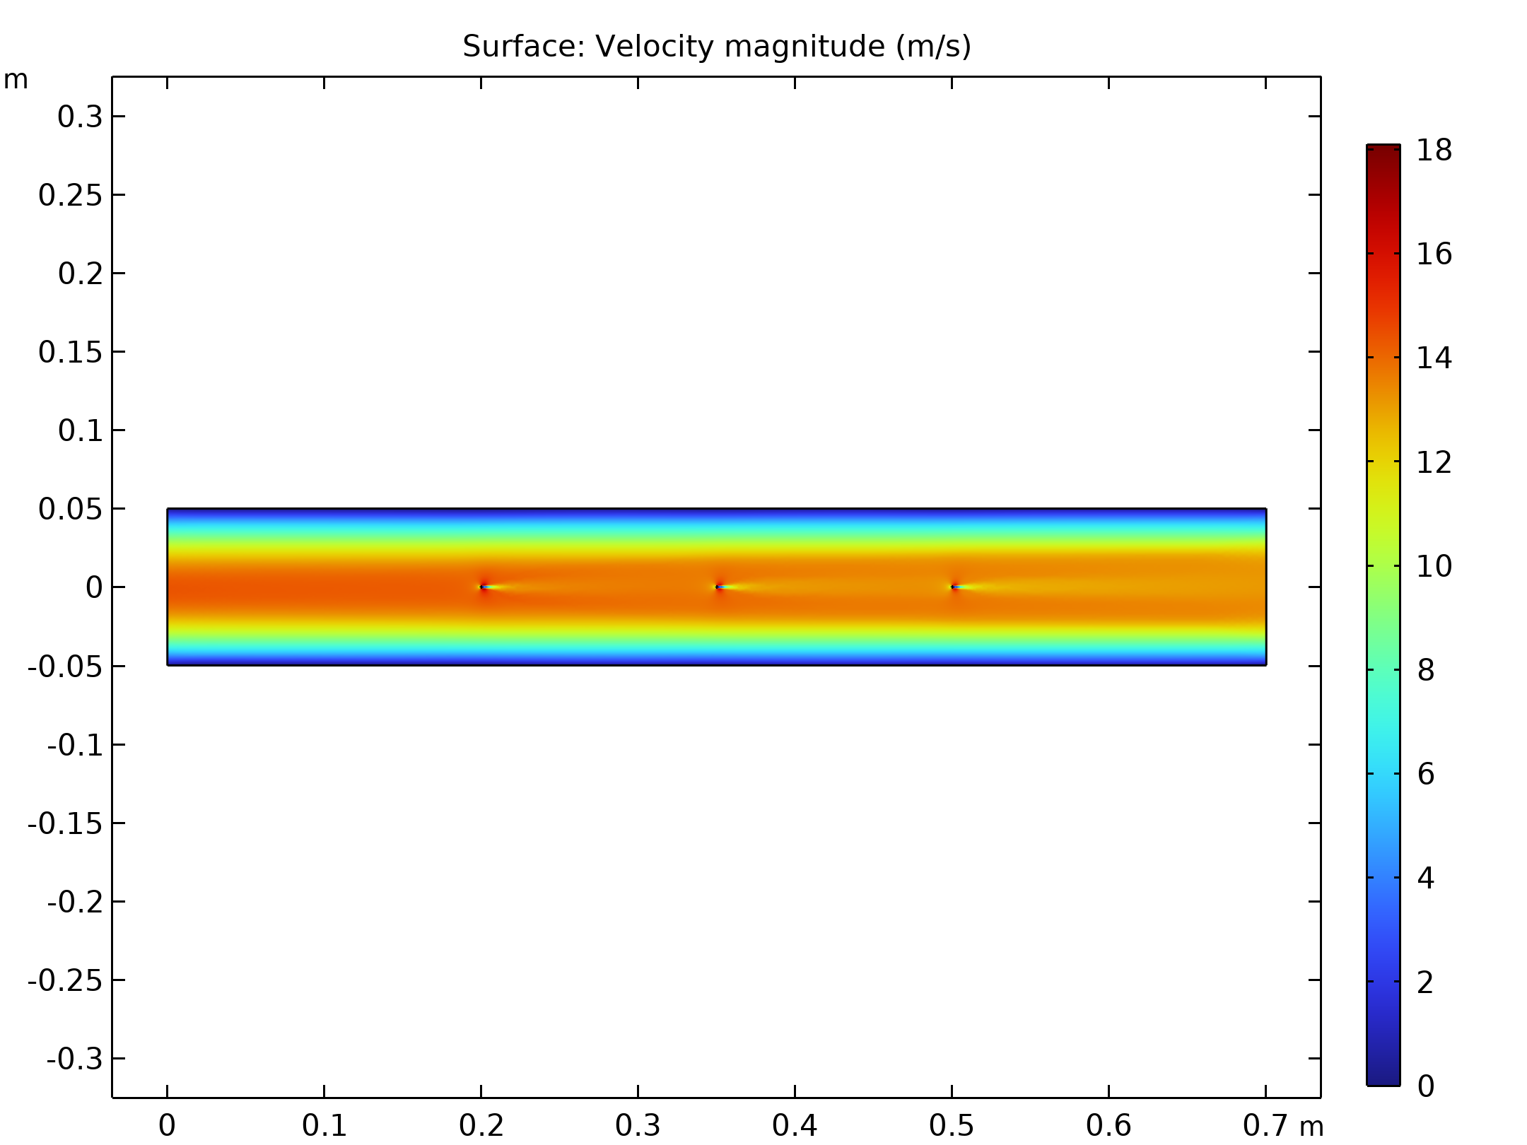  Velocity magnitude of the flow in electrostatic precipitator |  | 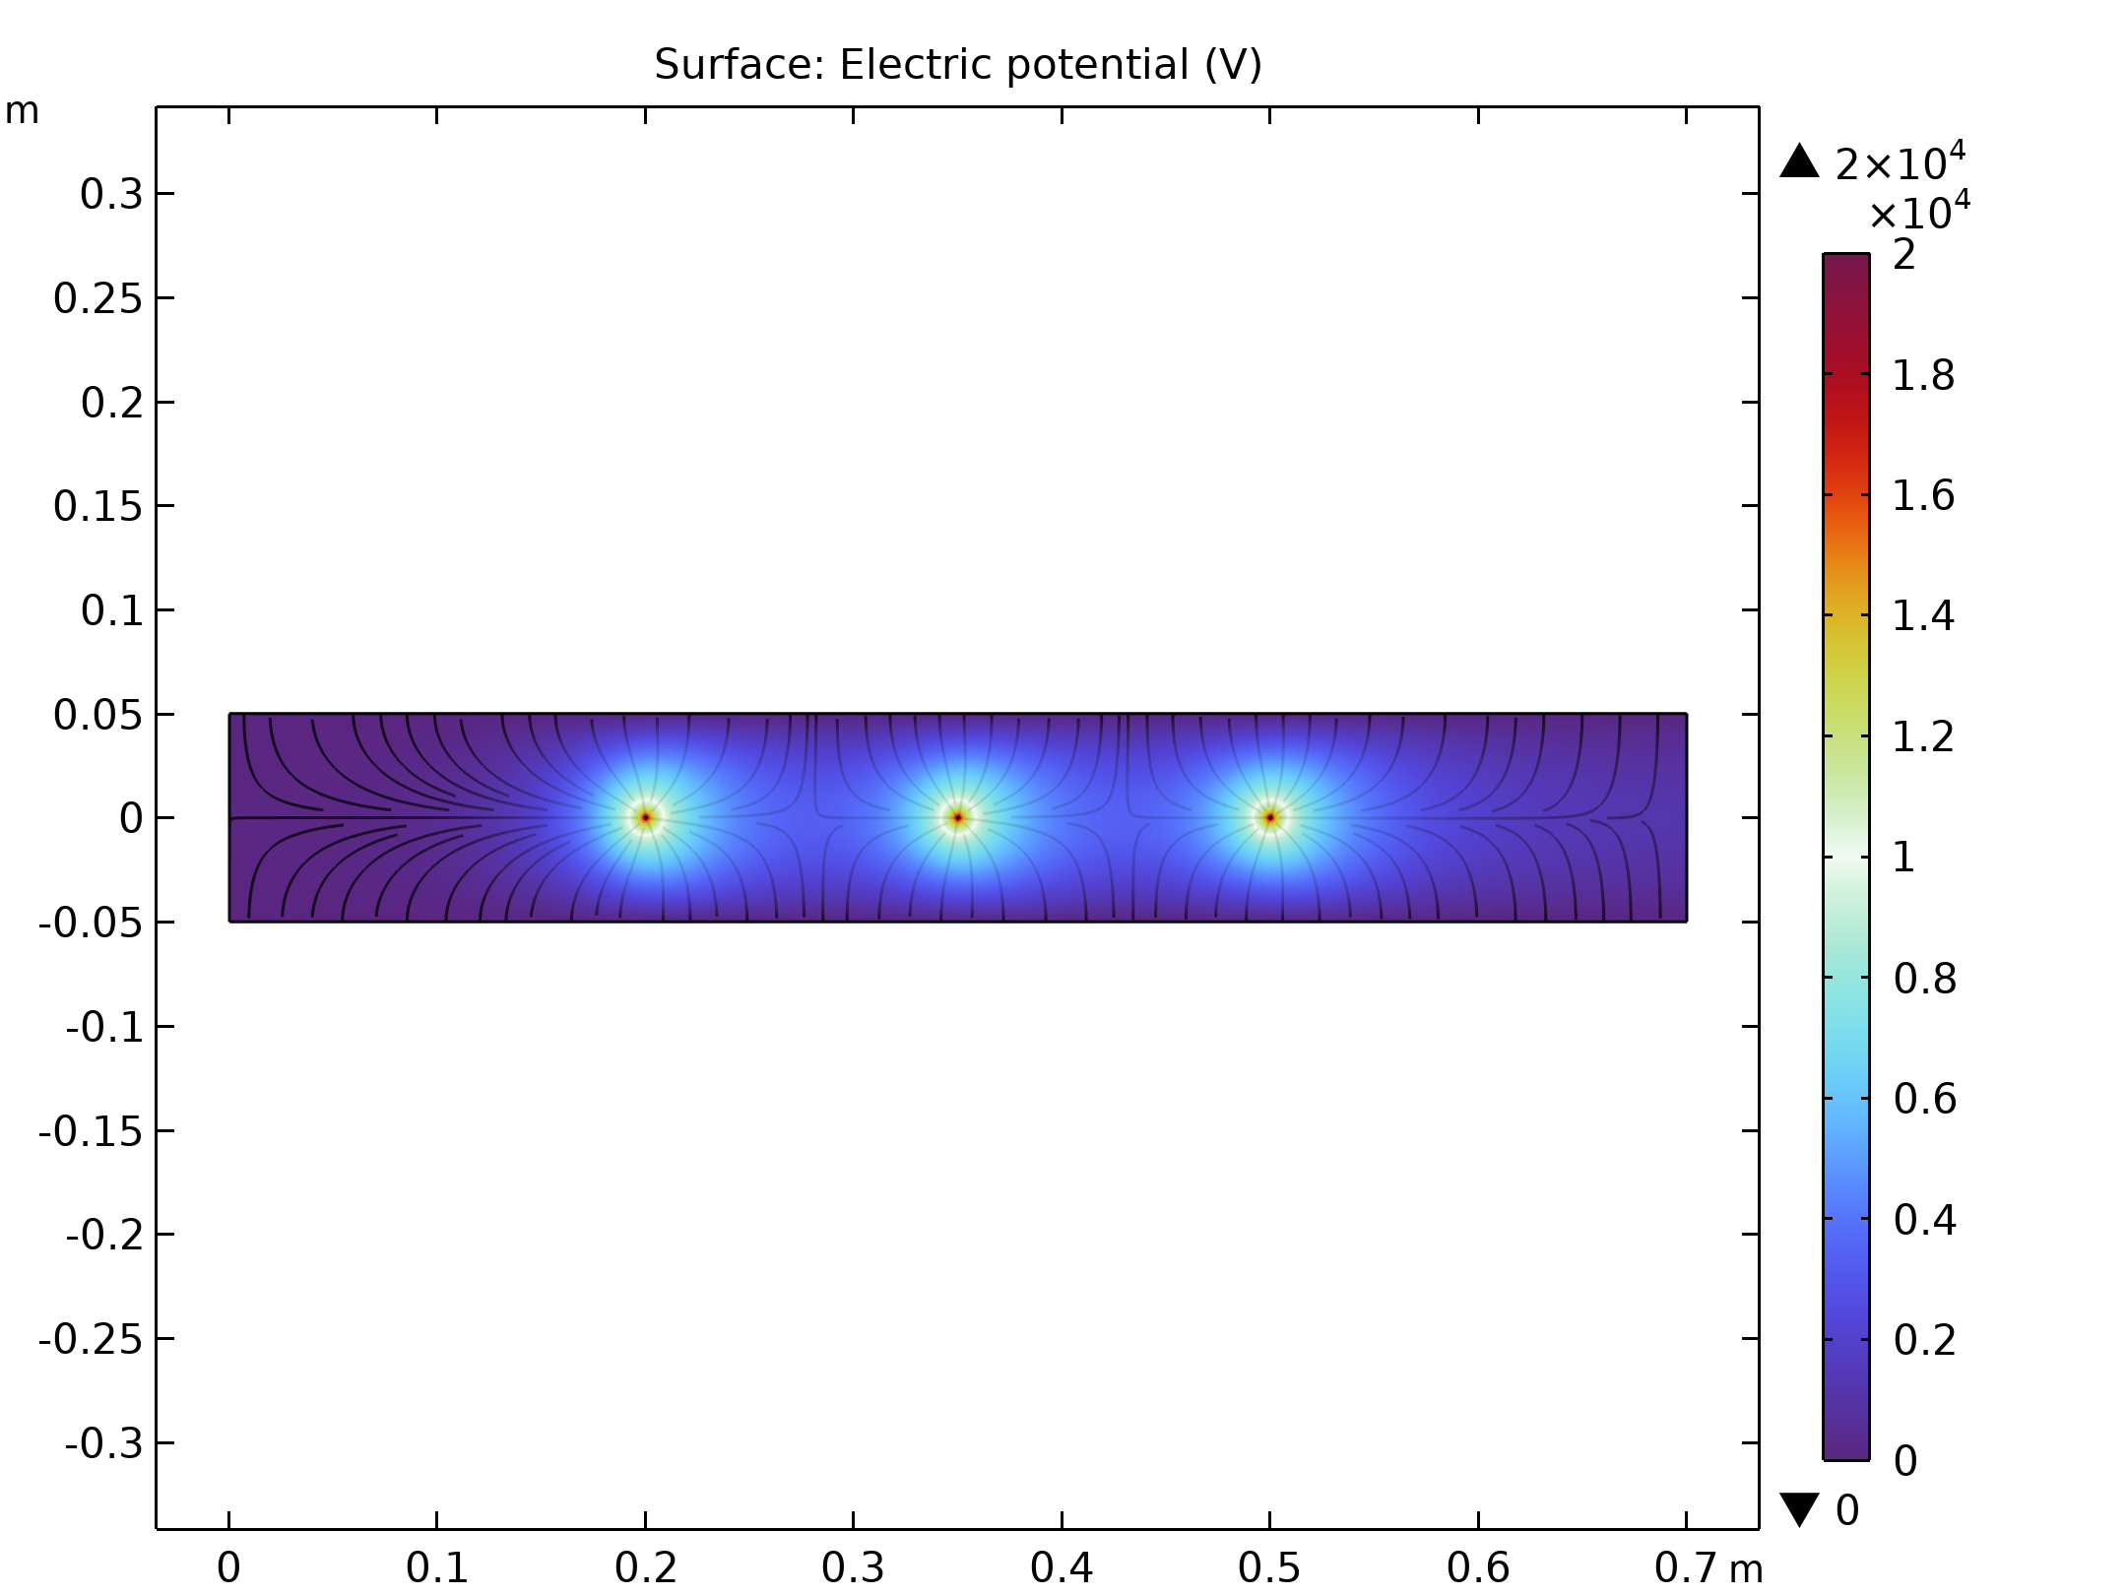  Electric Potential lines around electrodes in Electrostatic Precipitator
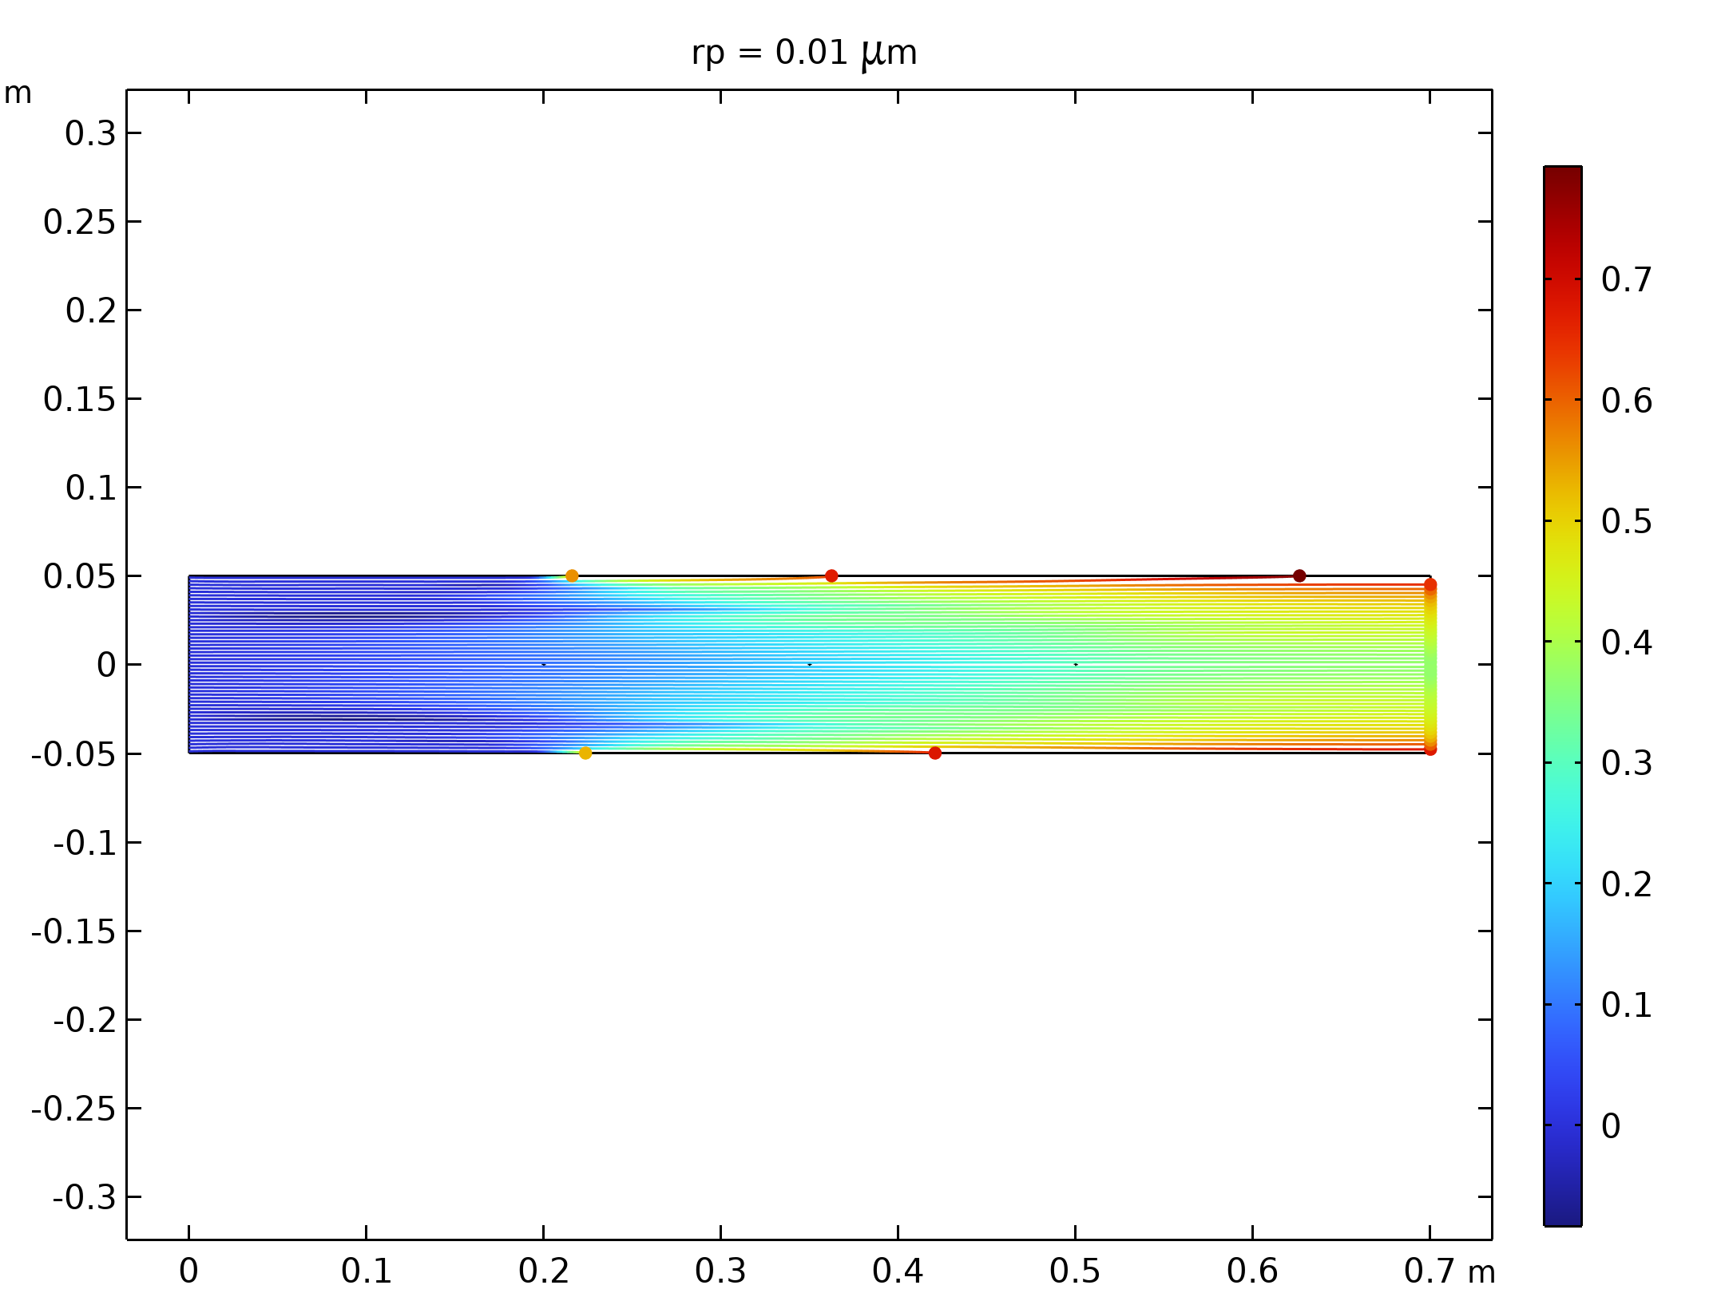  Particle trajectories with the charge number along the trajectory expressed in color for particles with a radius of 0.01 μm |  | 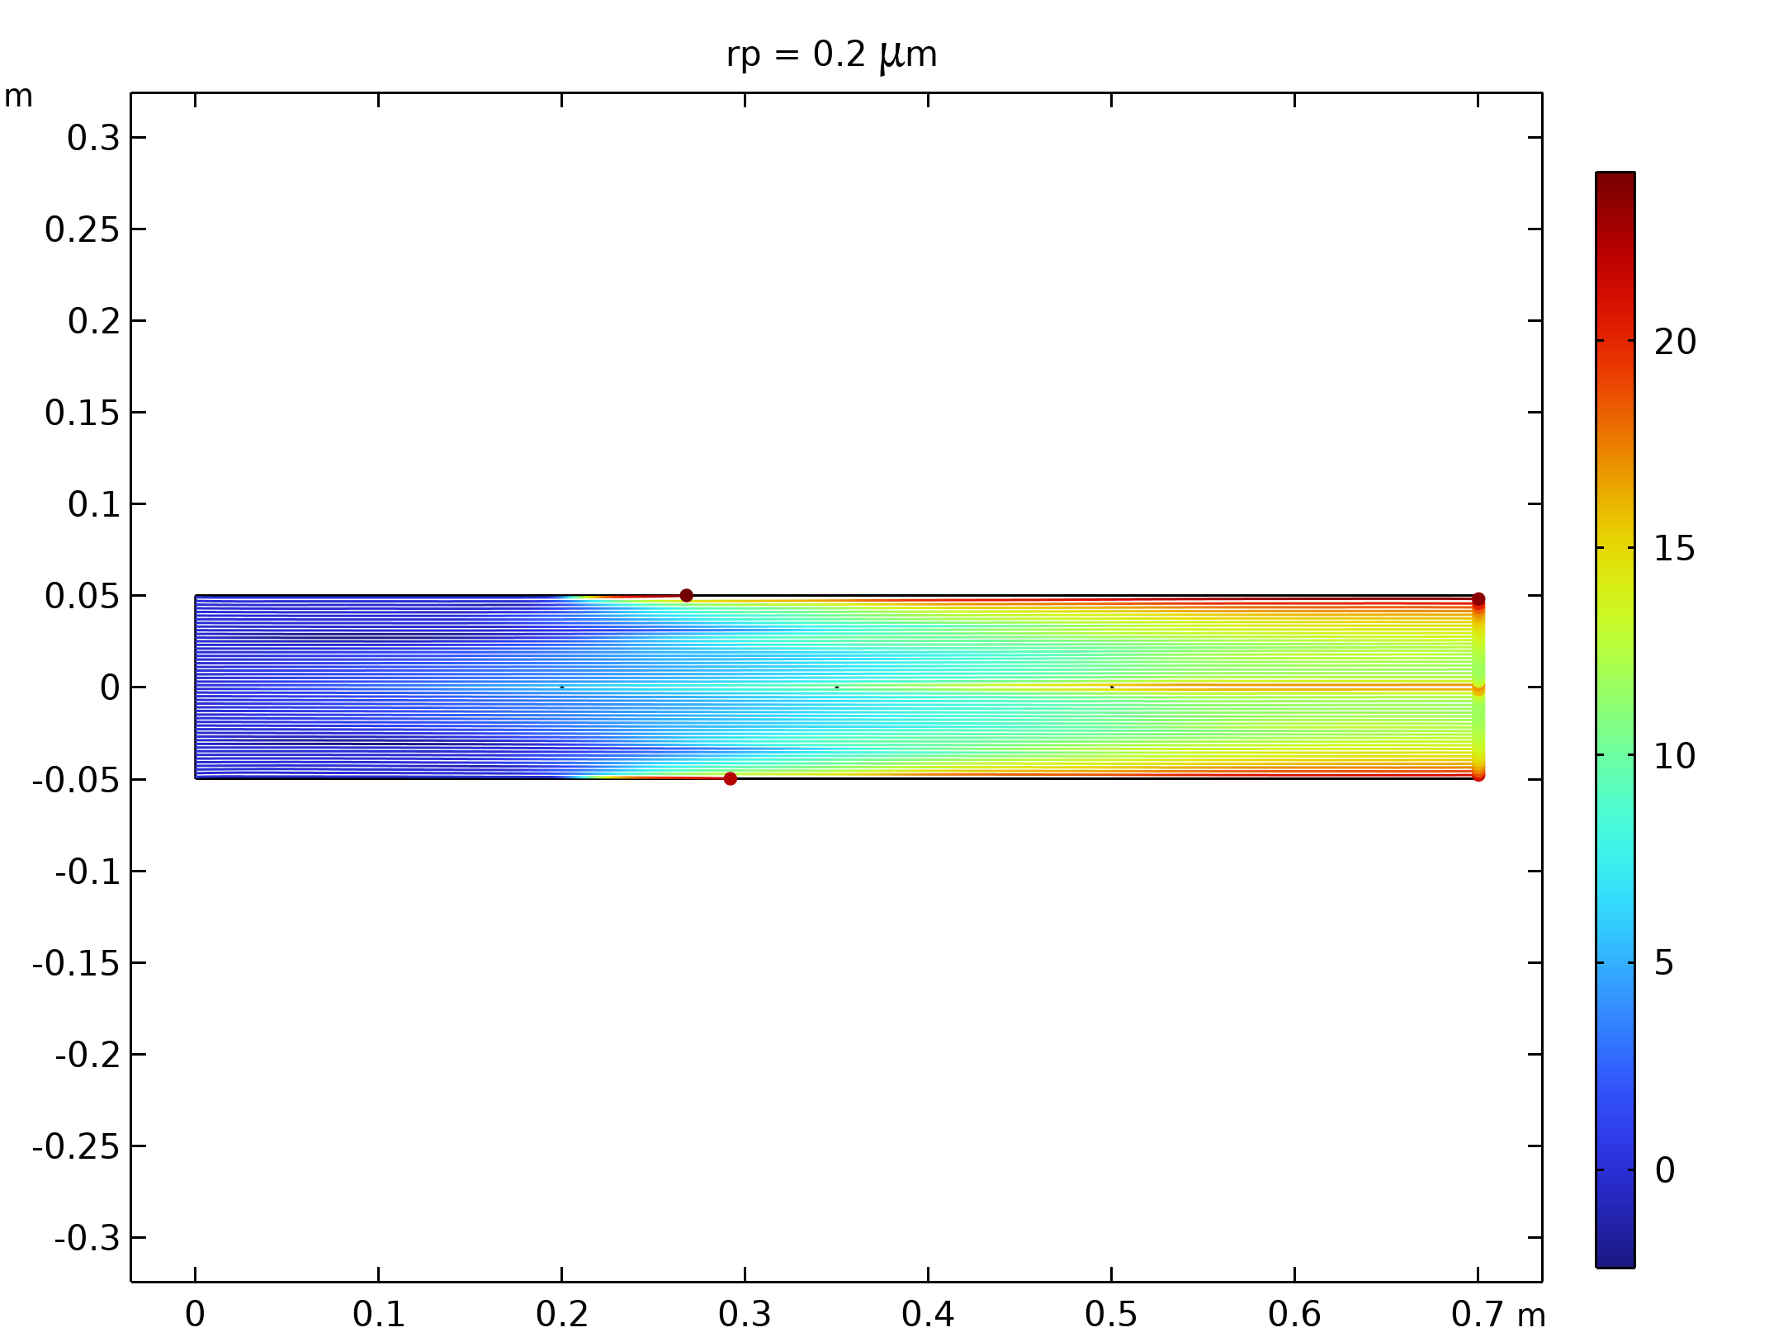  Particle trajectories with the charge number along the trajectory expressed in color for particles with a radius of 0.2 μm.
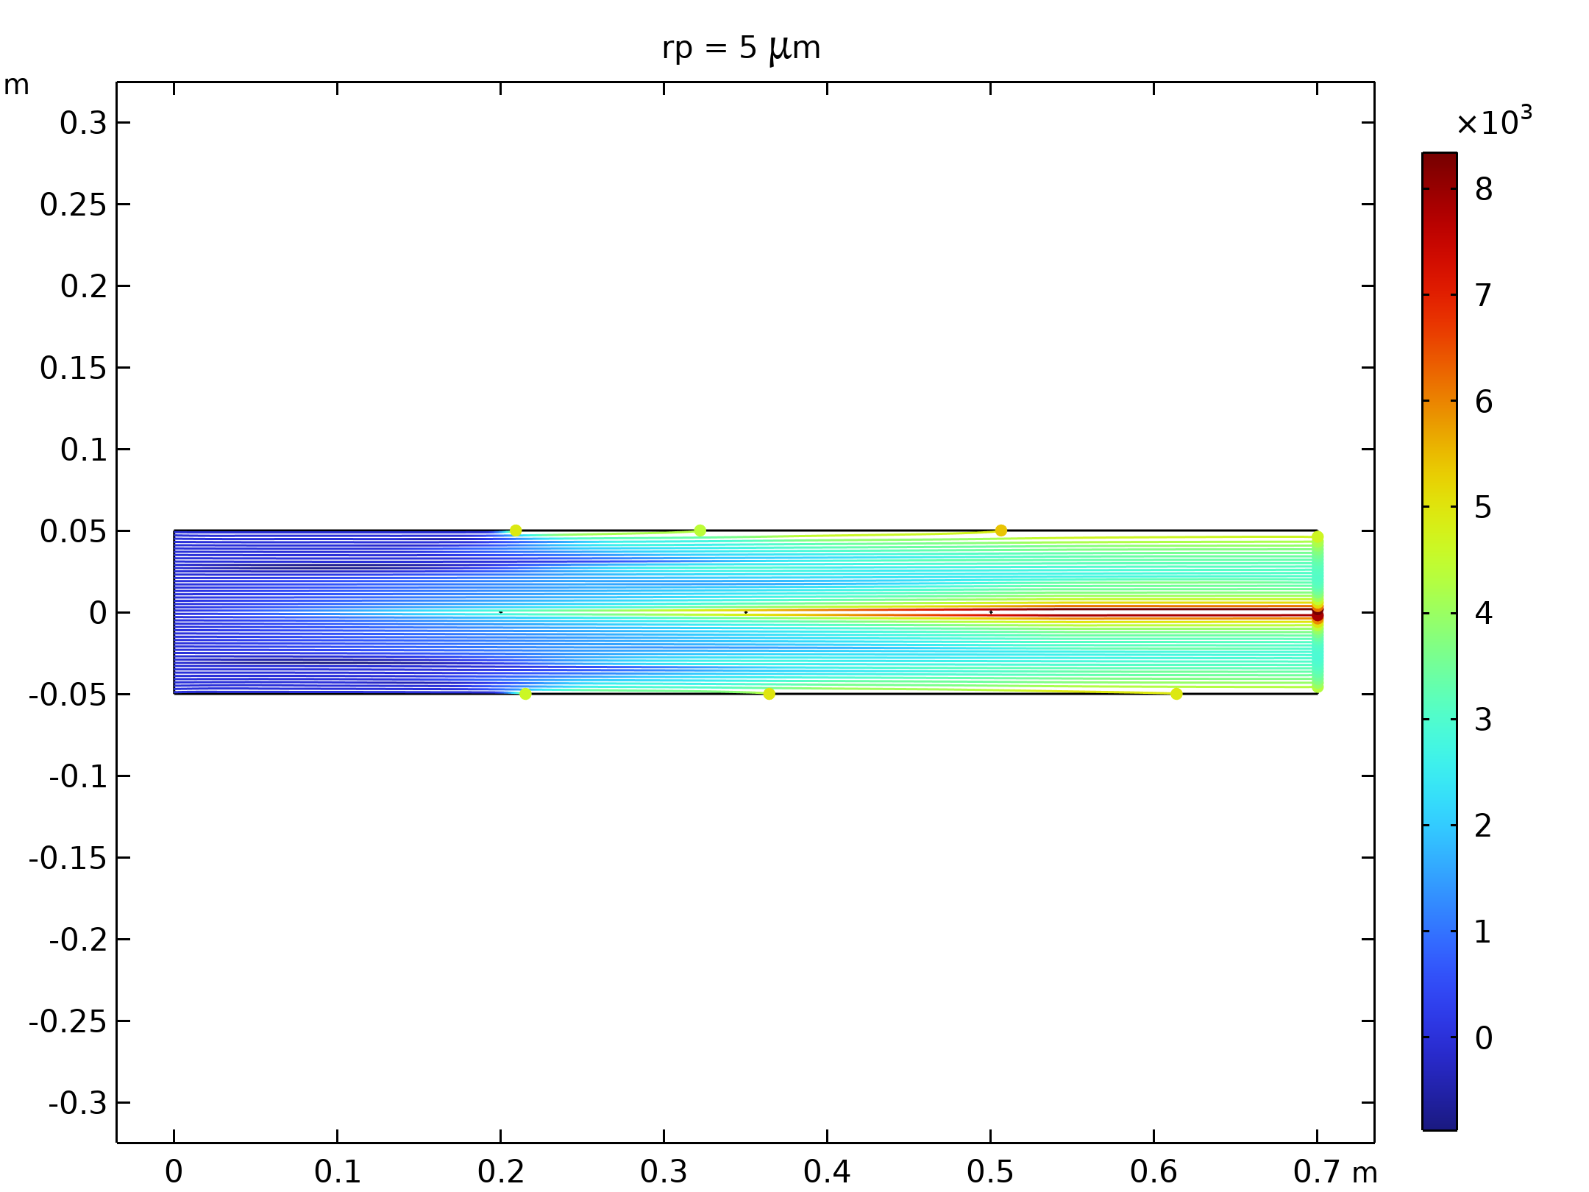  Particle trajectories with the charge number along the trajectory expressed in color for particles with a radius of 5 μm. |  | 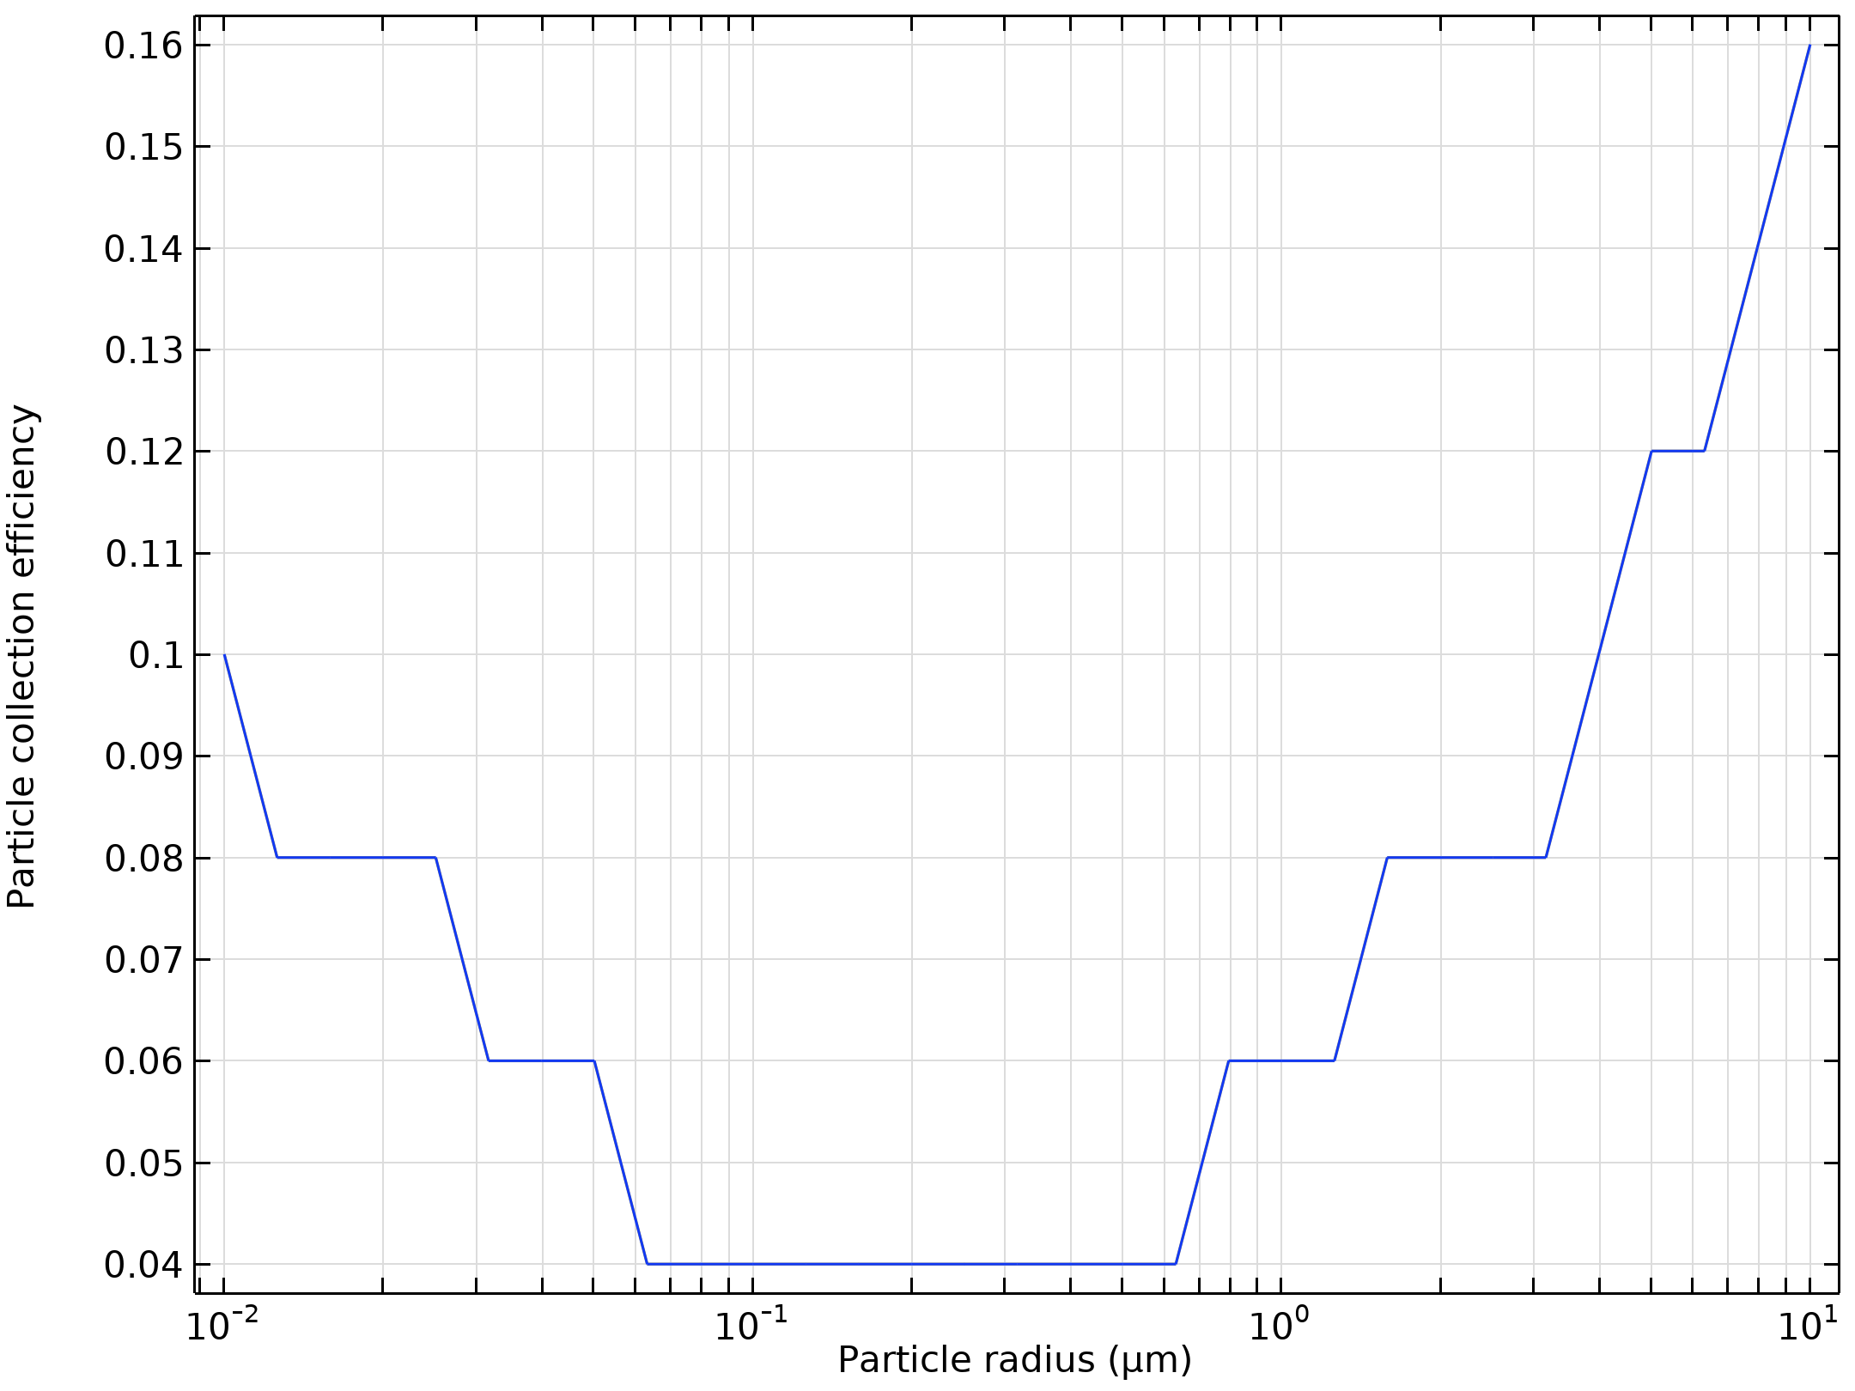  Particle collection efficiency as a function of the particle radius

Run | Wire radius (m) |  | Velocity (m/s) | Voltage (KV)
2 | 0.005 |  | 10 | 30
Velocity magnitude of the flow in electrostatic precipitator |  | 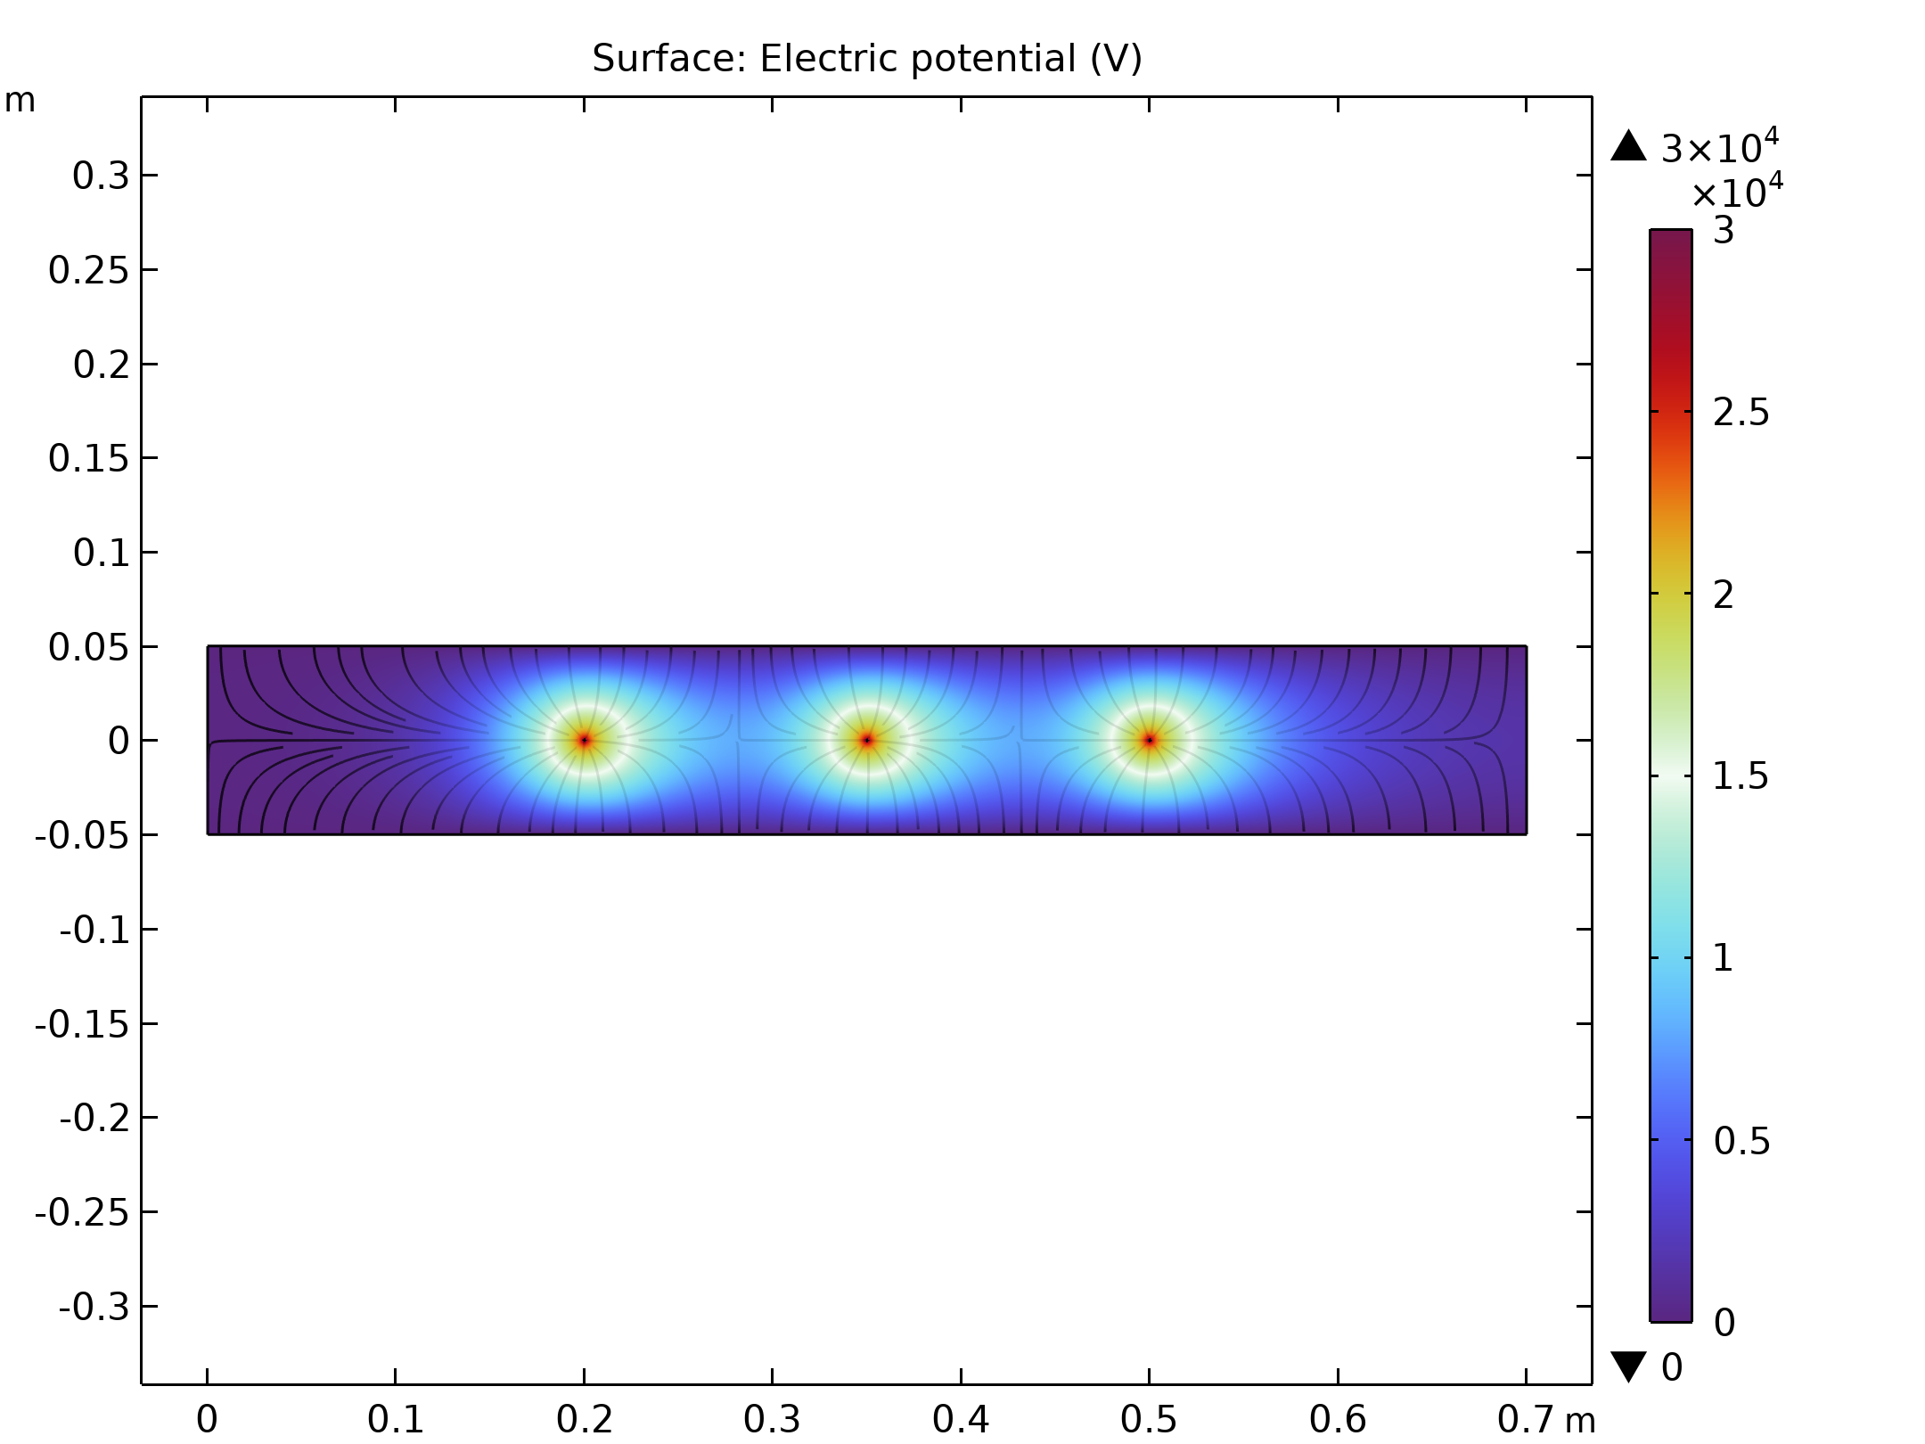  Electric Potential lines around electrodes in Electrostatic Precipitator
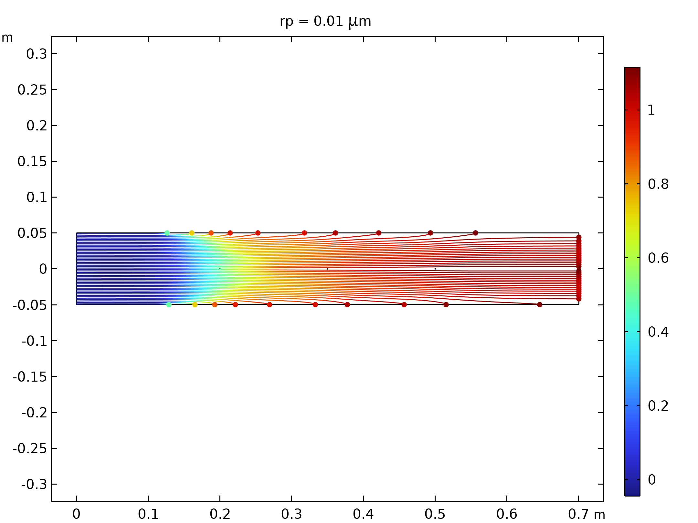  Particle trajectories with the charge number along the trajectory expressed in color for particles with a radius of 0.01 μm |  | 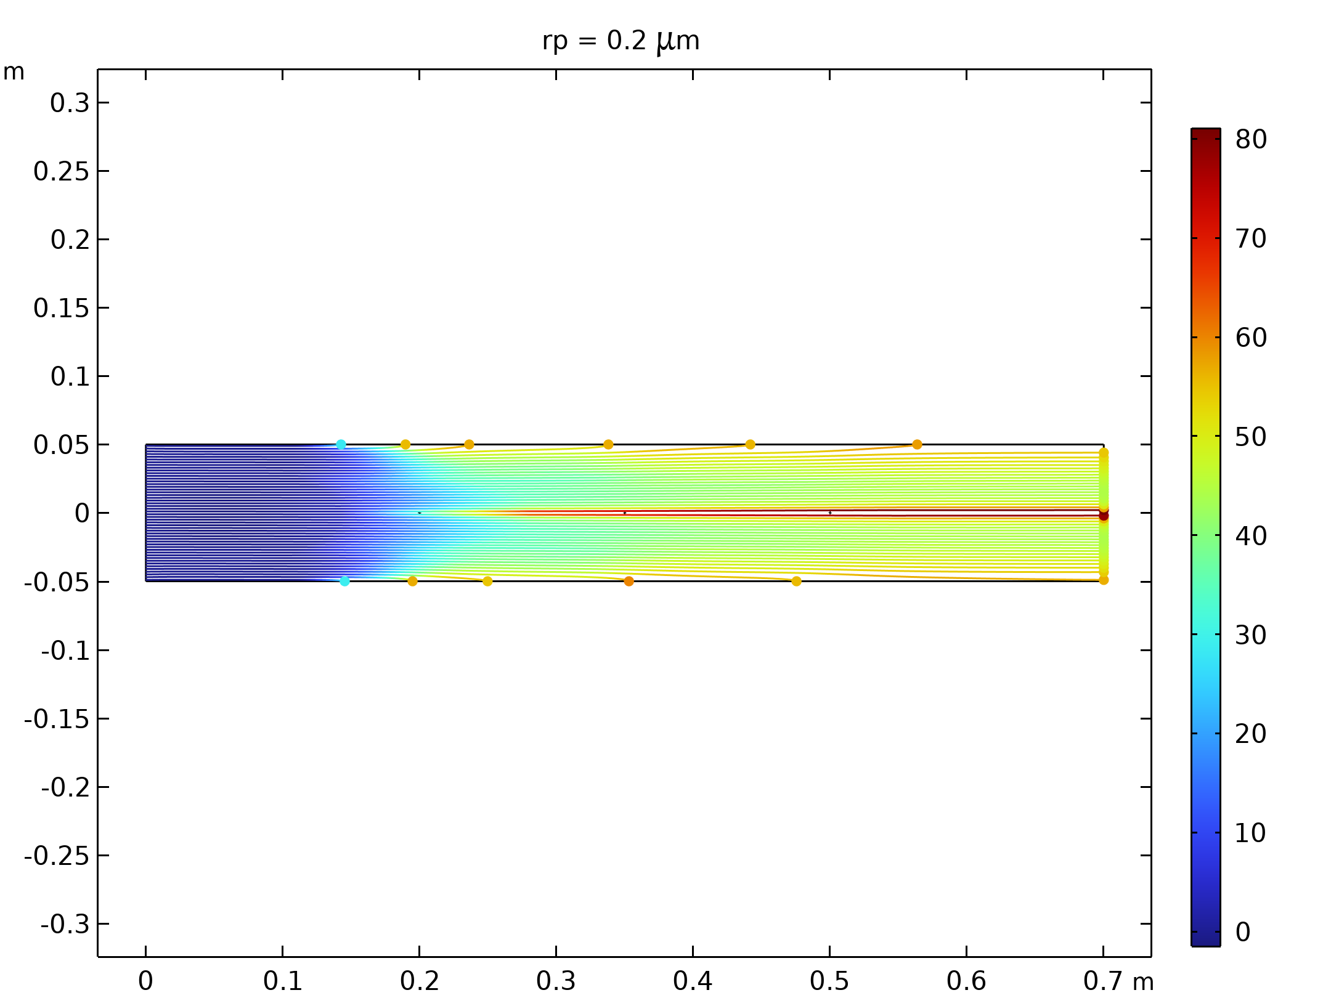  Particle trajectories with the charge number along the trajectory expressed in color for particles with a radius of 0.2 μm.
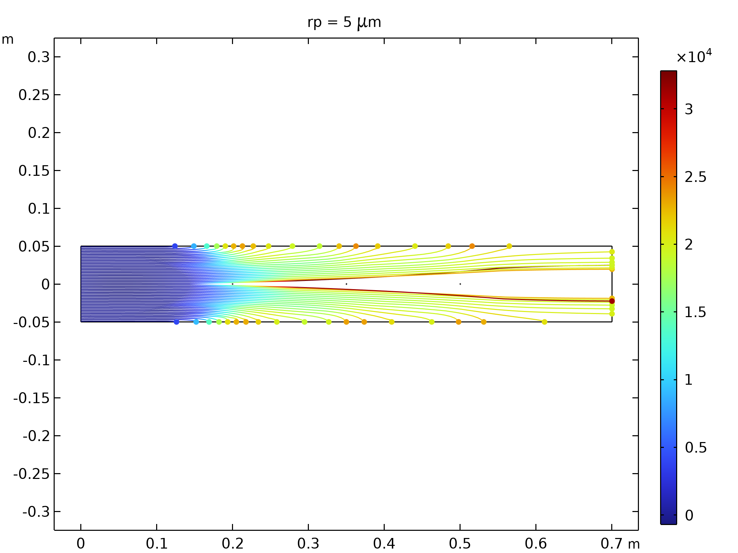  Particle trajectories with the charge number along the trajectory expressed in color for particles with a radius of 5 μm. |  | 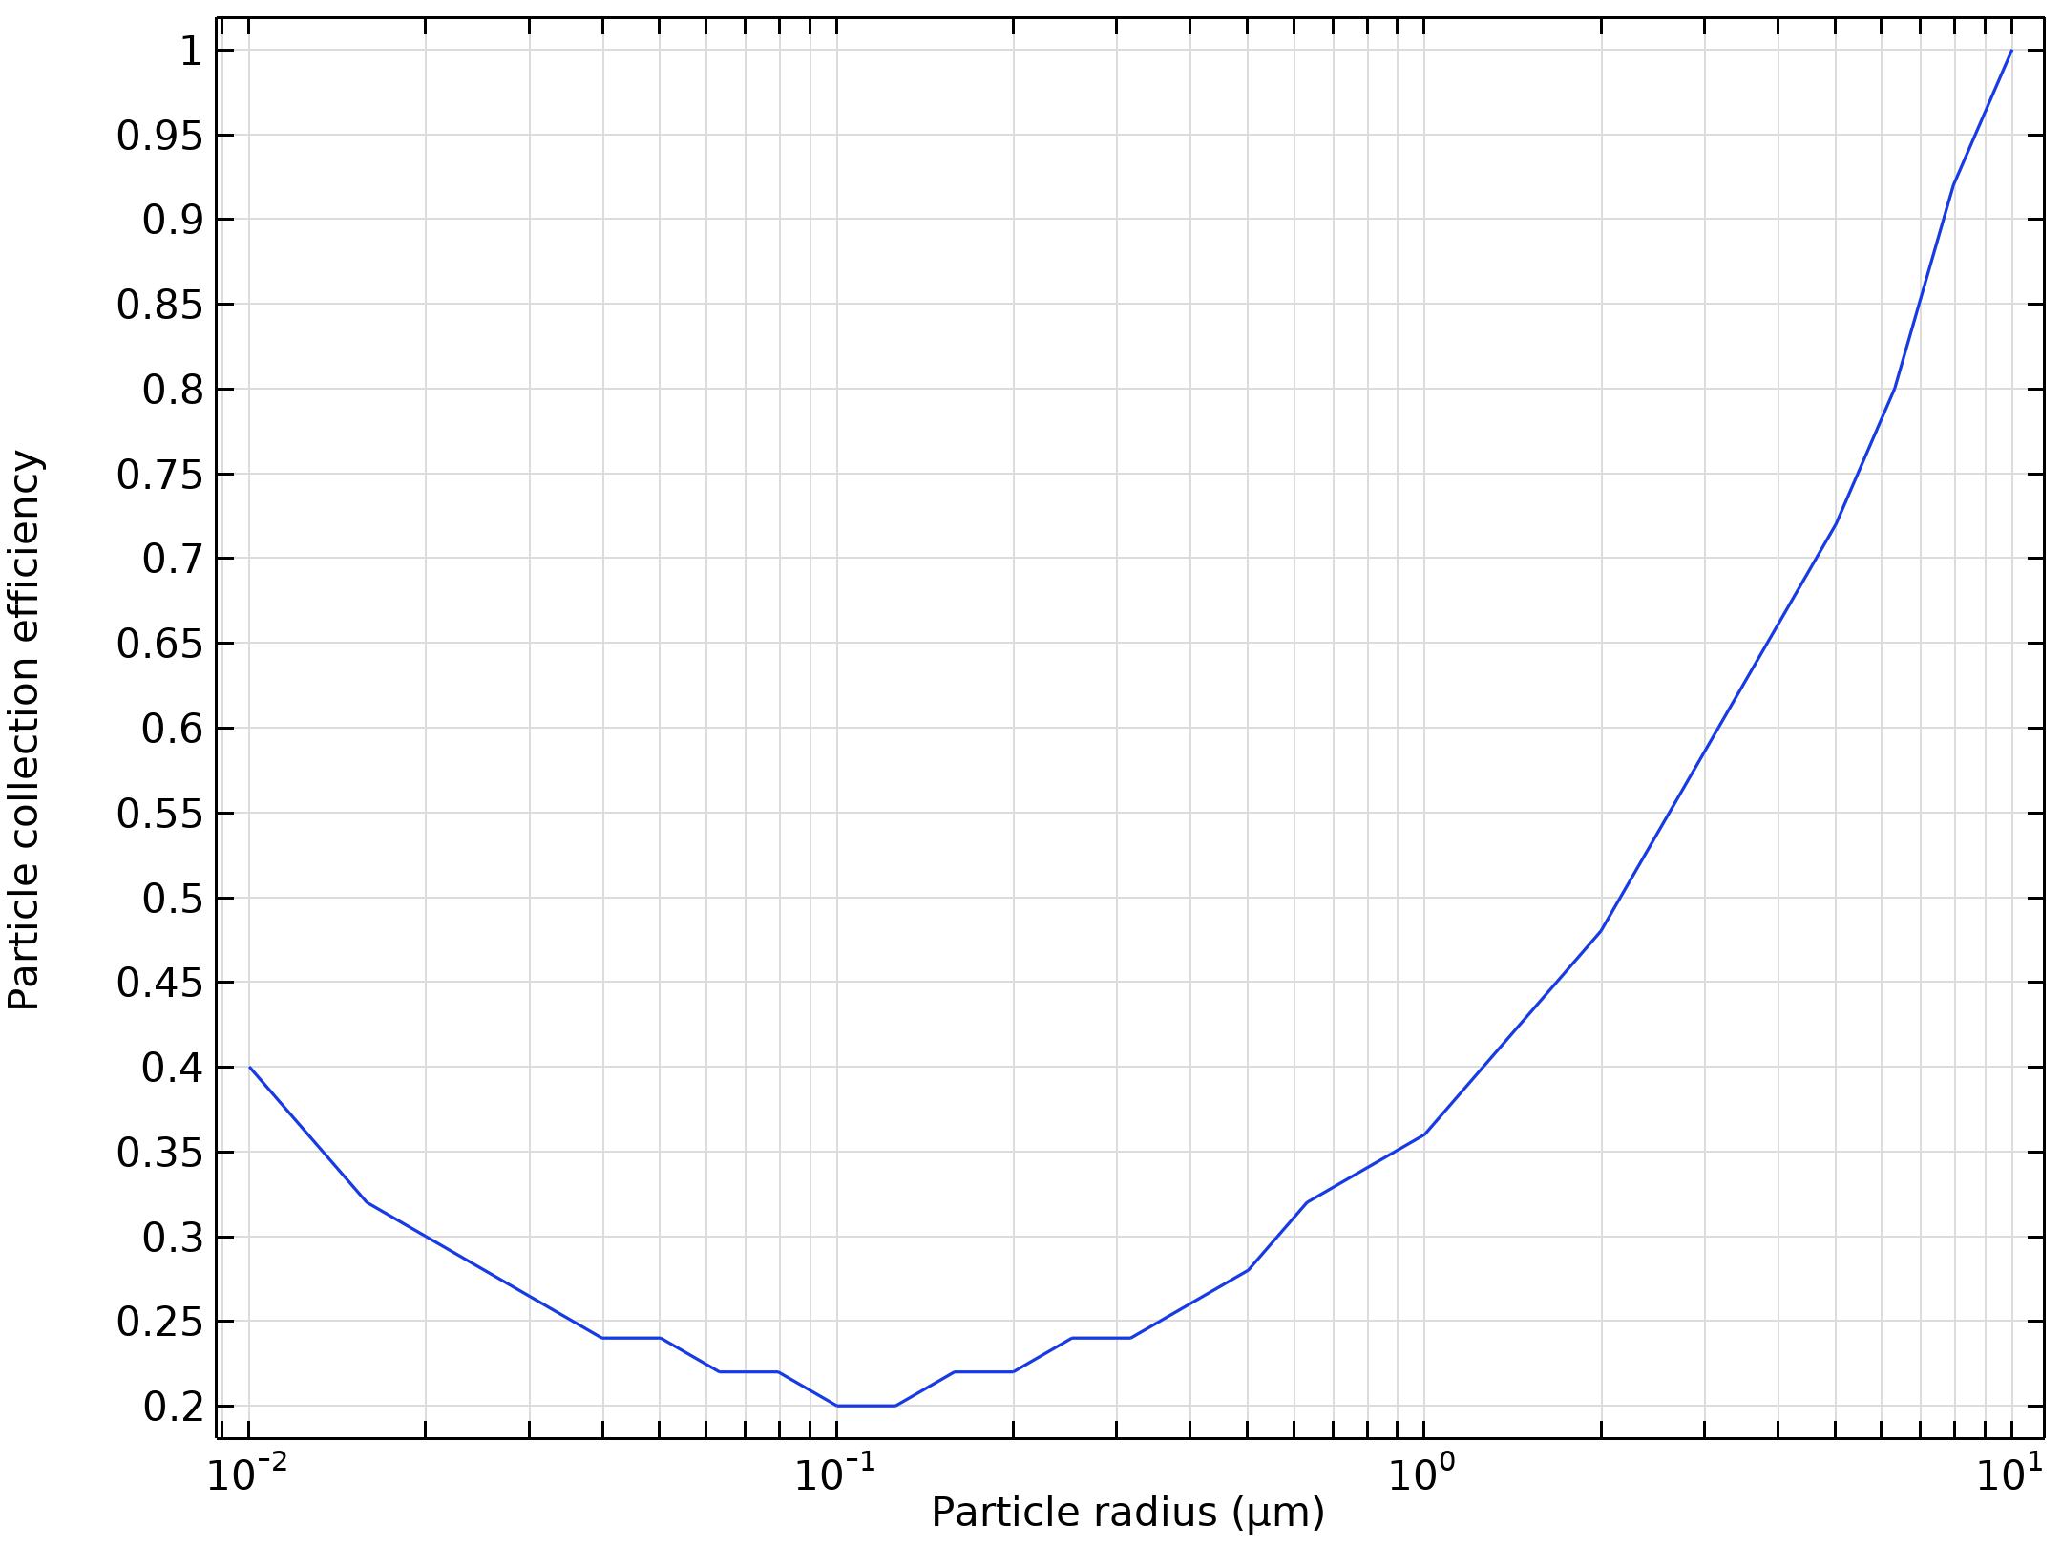  Particle collection efficiency as a function of the particle radius

Run | Wire radius (m) |  | Velocity (m/s) | Voltage (KV)
3 | 0.005 |  | 10 | 50
Velocity magnitude of the flow in electrostatic precipitator |  | 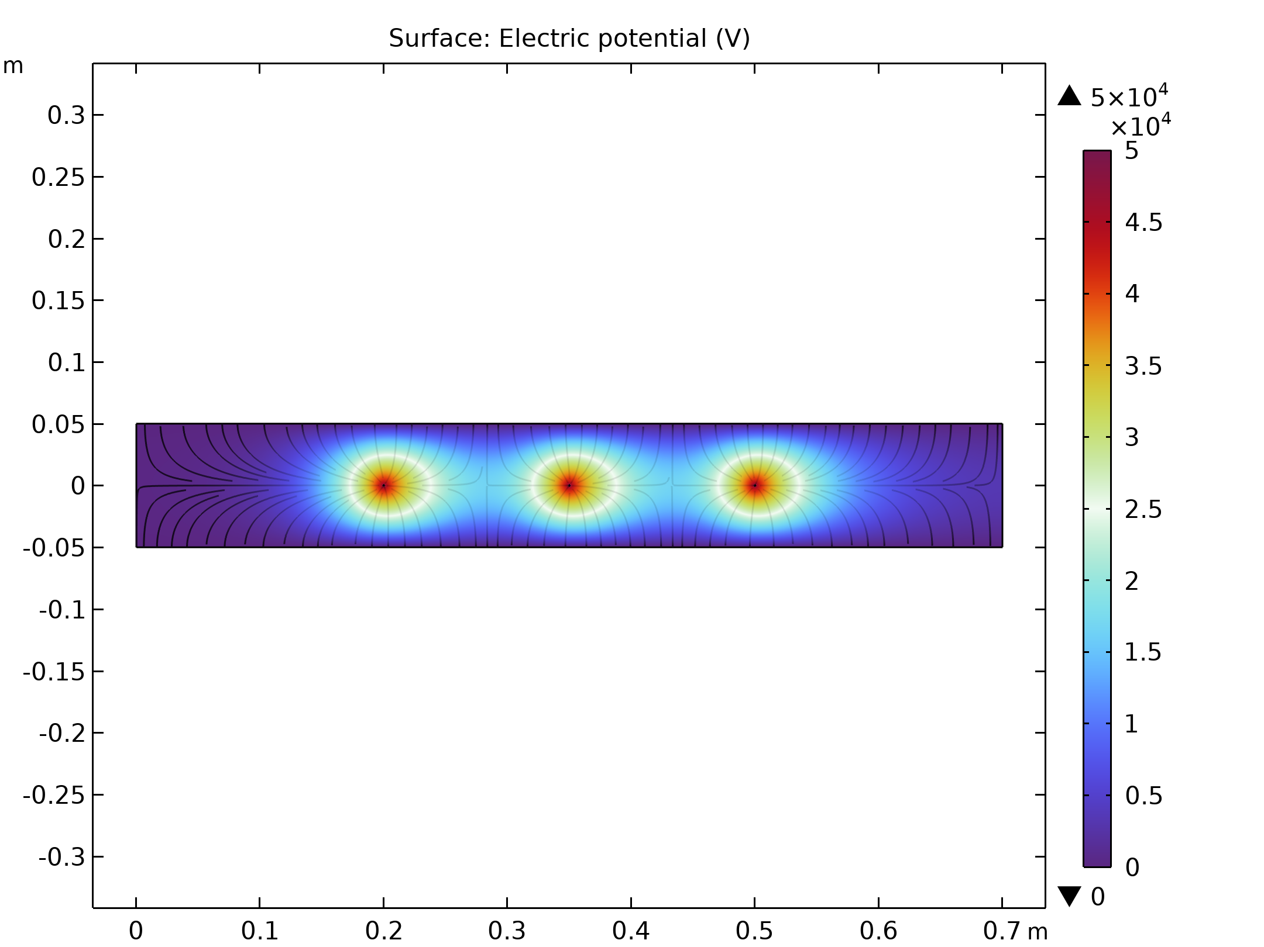  Electric Potential lines around electrodes in Electrostatic Precipitator
Particle trajectories with the charge number along the trajectory expressed in color for particles with a radius of 0.01 μm |  | Particle trajectories with the charge number along the trajectory expressed in color for particles with a radius of 0.2 μm.
Particle trajectories with the charge number along the trajectory expressed in color for particles with a radius of 5 μm. |  | Particle collection efficiency as a function of the particle radius

Run | Wire radius (m) |  | Velocity (m/s) | Voltage (KV)
4 | 0.005 |  | 30 | 10
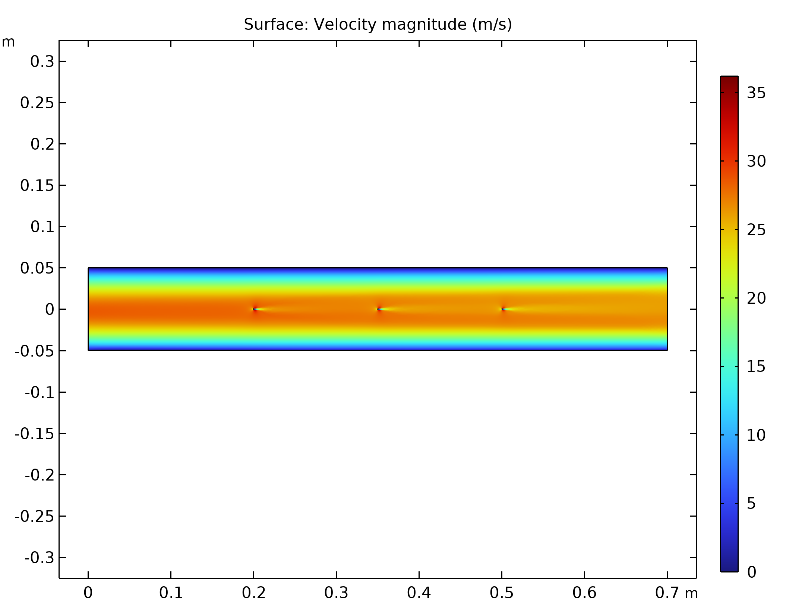  Velocity magnitude of the flow in electrostatic precipitator |  | Electric Potential lines around electrodes in Electrostatic Precipitator
Particle trajectories with the charge number along the trajectory expressed in color for particles with a radius of 0.01 μm |  | Particle trajectories with the charge number along the trajectory expressed in color for particles with a radius of 0.2 μm.
Particle trajectories with the charge number along the trajectory expressed in color for particles with a radius of 5 μm. |  | Particle collection efficiency as a function of the particle radius

Run | Wire radius (m) |  | Velocity (m/s) | Voltage (KV)
5 | 0.005 |  | 30 | 30
Velocity magnitude of the flow in electrostatic precipitator |  | Electric Potential lines around electrodes in Electrostatic Precipitator
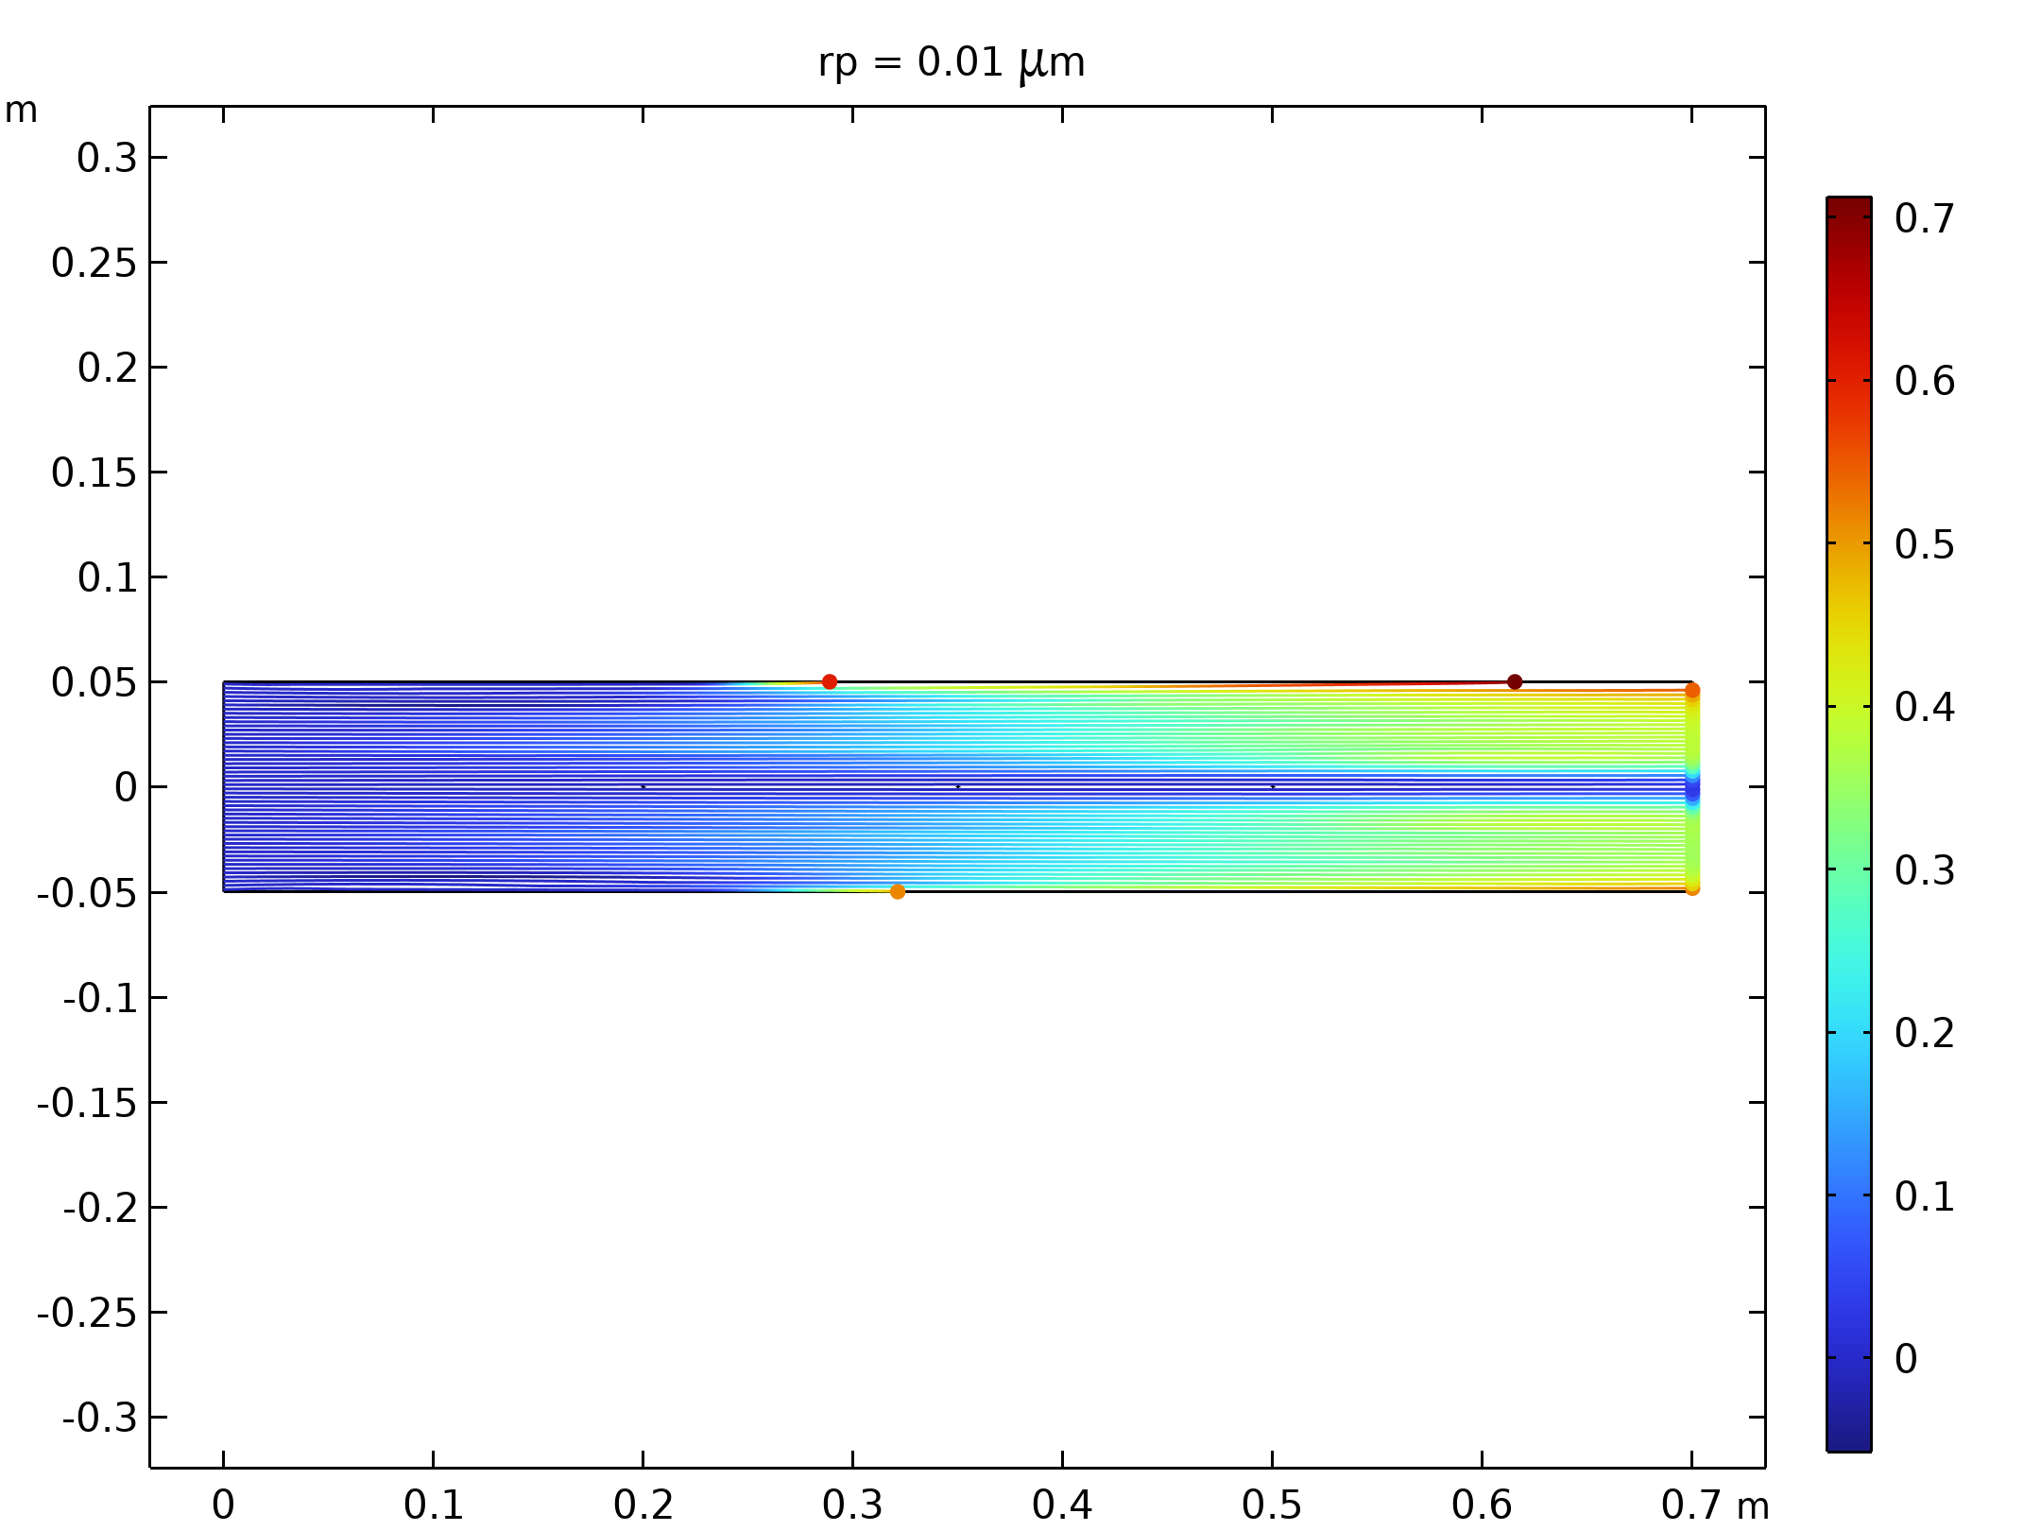  Particle trajectories with the charge number along the trajectory expressed in color for particles with a radius of 0.01 μm |  | 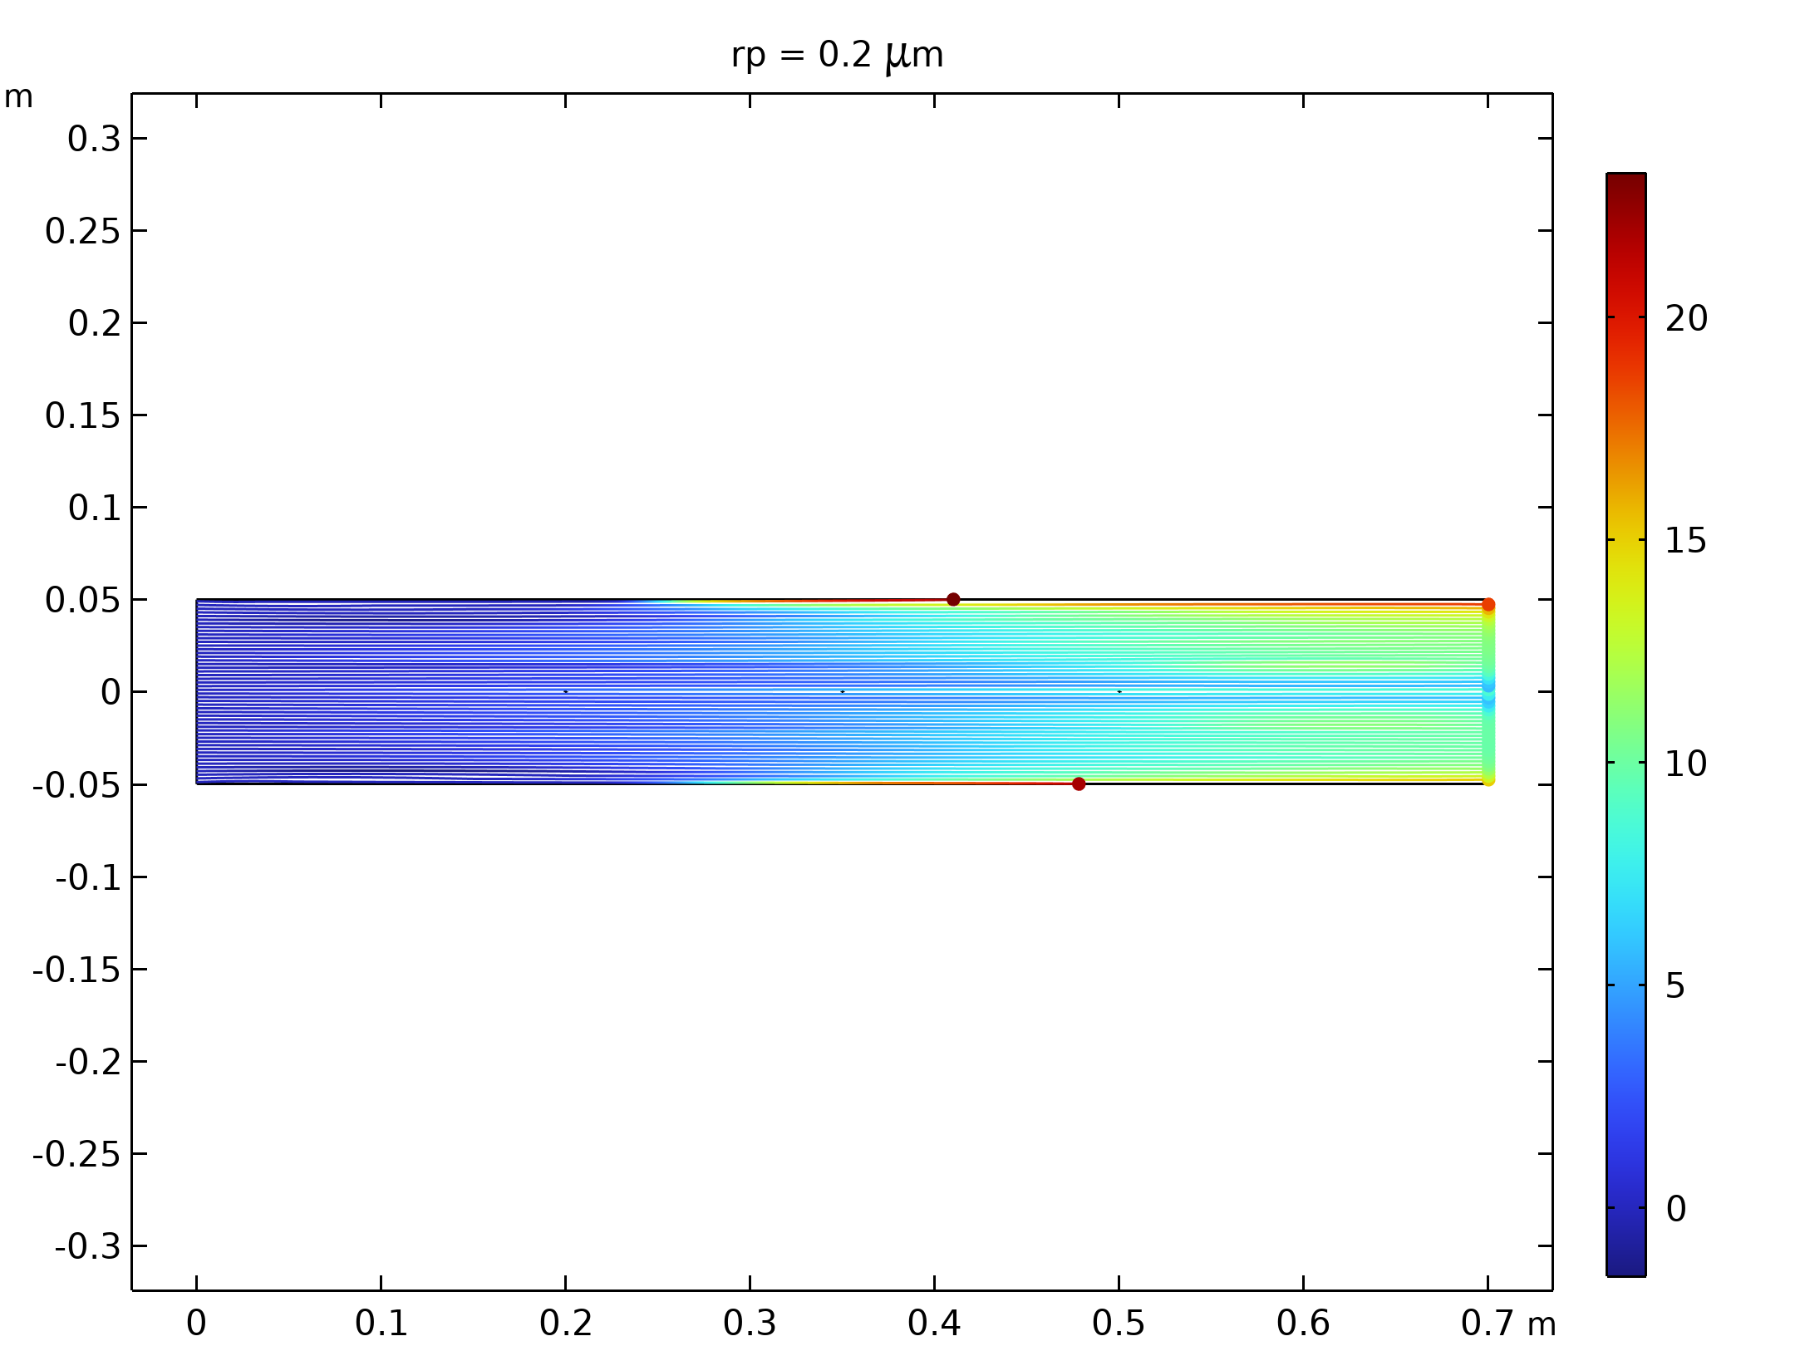  Particle trajectories with the charge number along the trajectory expressed in color for particles with a radius of 0.2 μm.
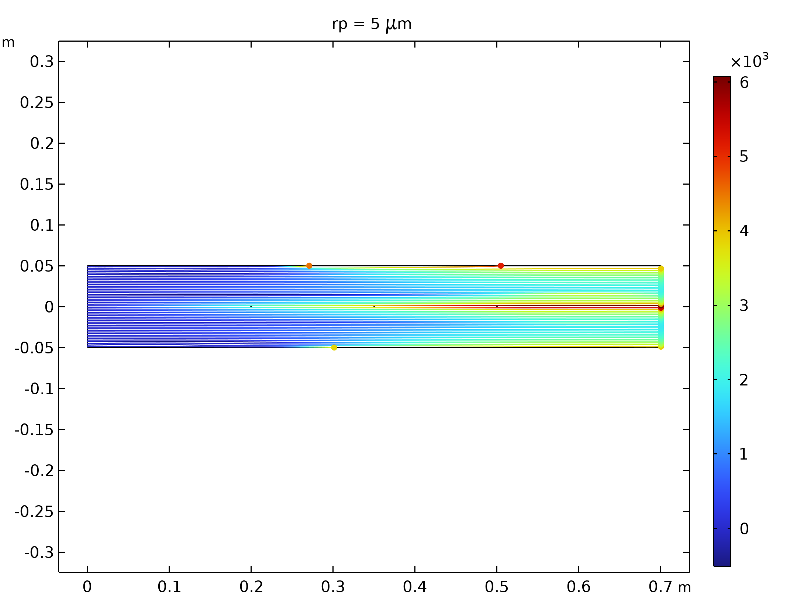  Particle trajectories with the charge number along the trajectory expressed in color for particles with a radius of 5 μm. |  | 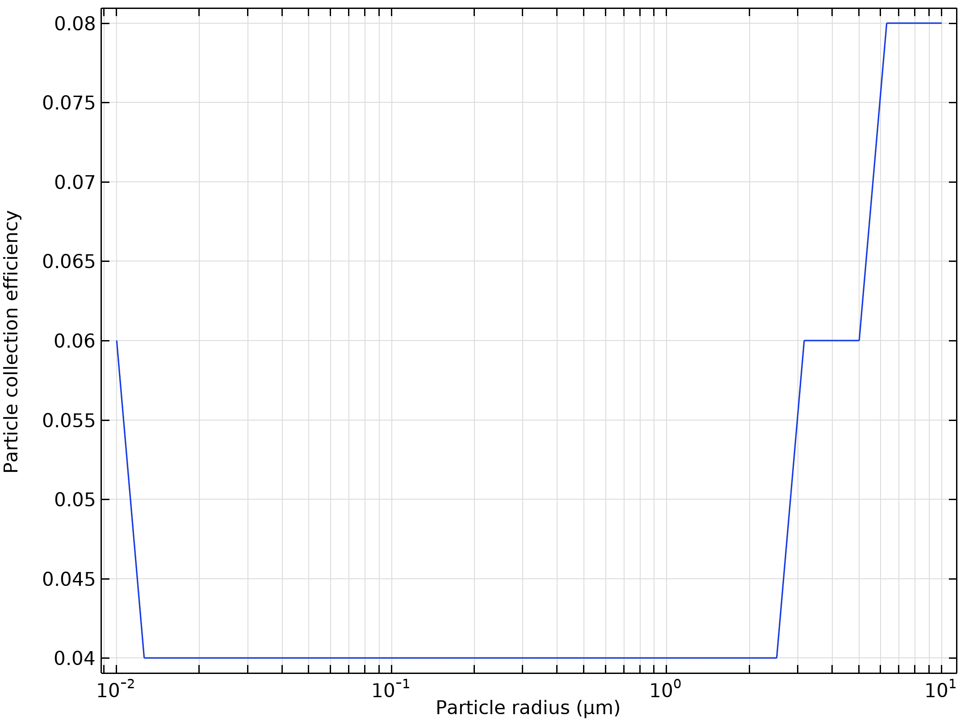  Particle collection efficiency as a function of the particle radius

Run | Wire radius (m) |  | Velocity (m/s) | Voltage (KV)
6 | 0.005 |  | 30 | 50
Velocity magnitude of the flow in electrostatic precipitator |  | Electric Potential lines around electrodes in Electrostatic Precipitator
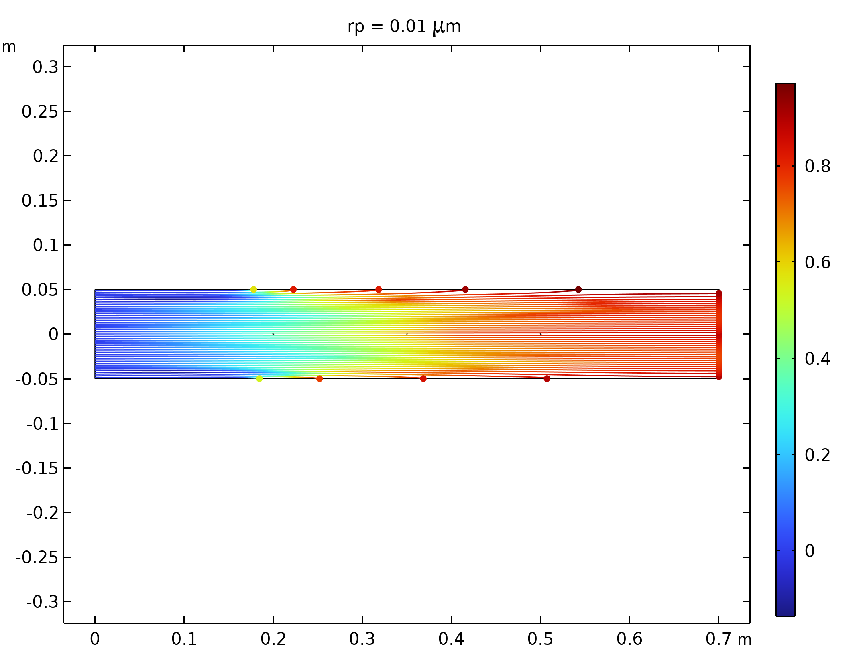  Particle trajectories with the charge number along the trajectory expressed in color for particles with a radius of 0.01 μm |  | 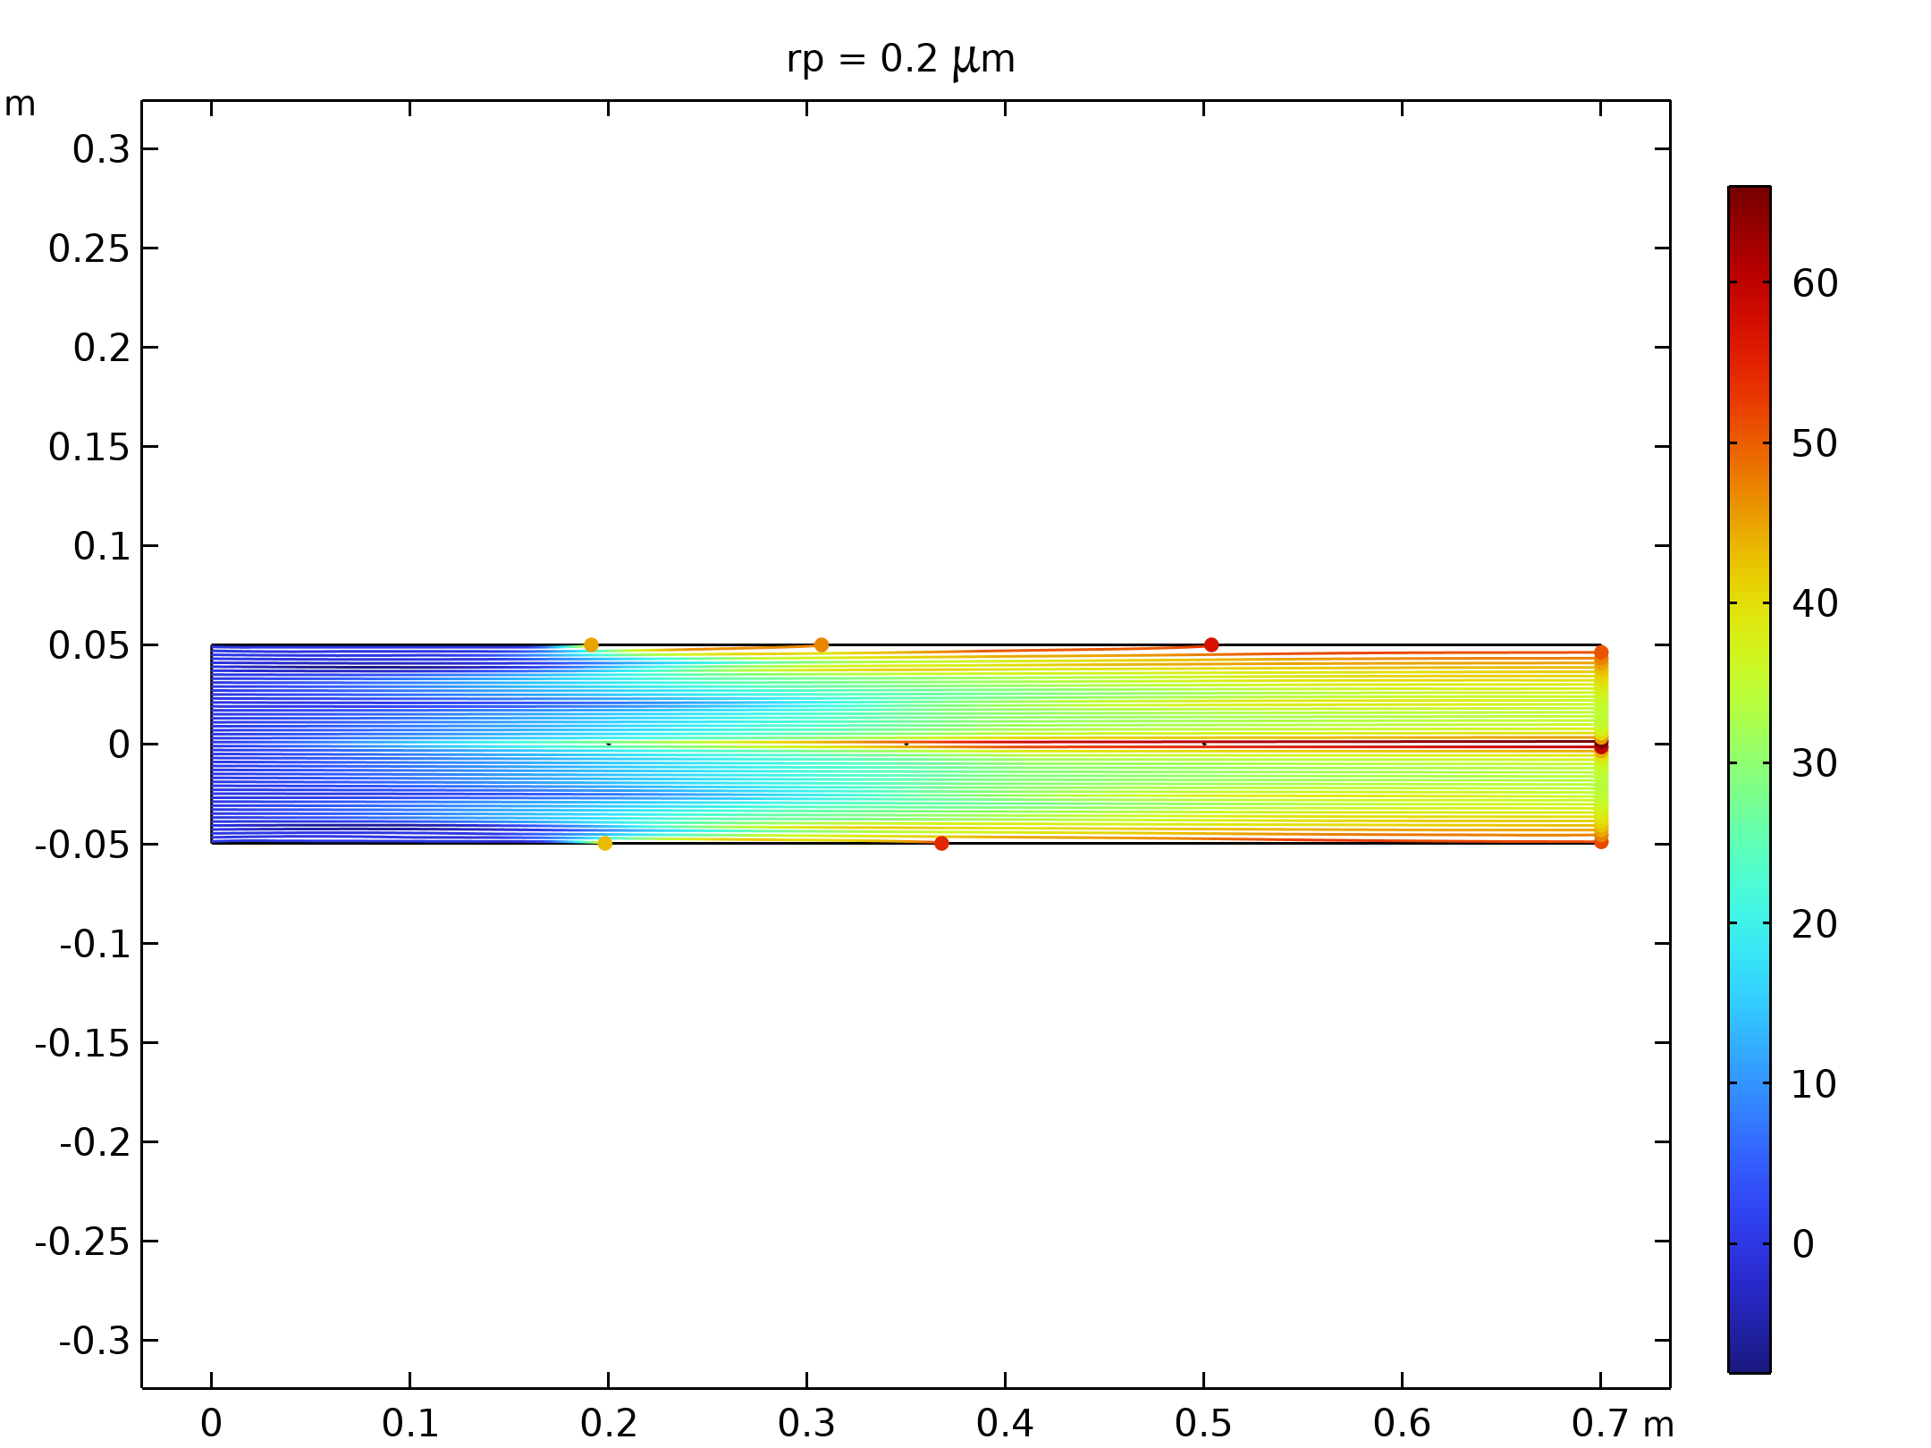  Particle trajectories with the charge number along the trajectory expressed in color for particles with a radius of 0.2 μm.
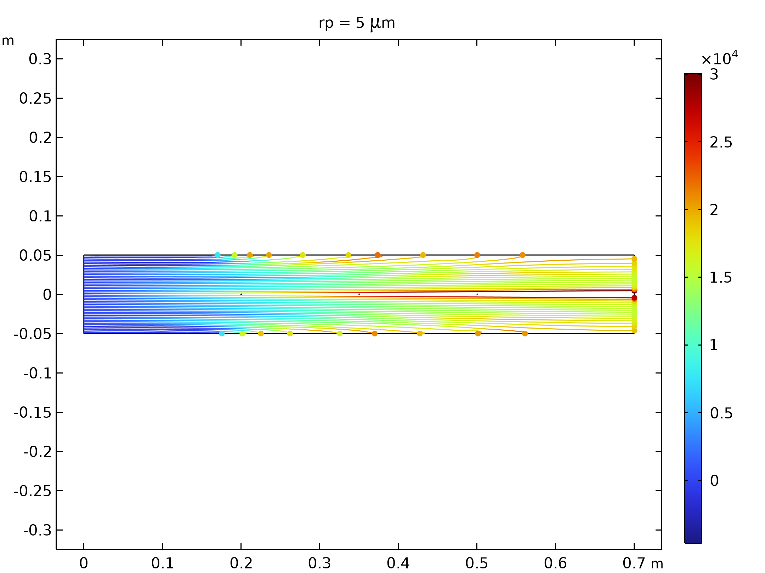  Particle trajectories with the charge number along the trajectory expressed in color for particles with a radius of 5 μm. |  | 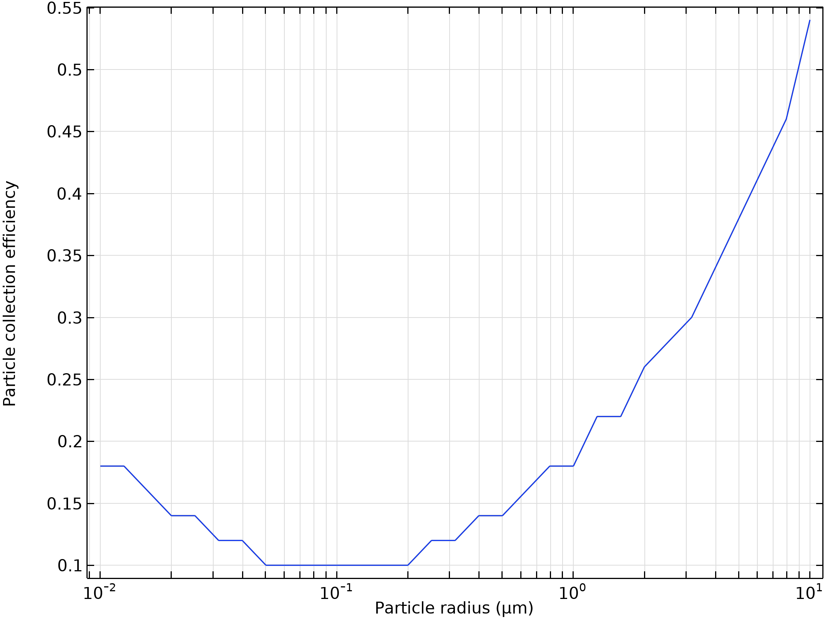  Particle collection efficiency as a function of the particle radius

Run | Wire radius (m) |  | Velocity (m/s) | Voltage (KV)
7 | 0.005 |  | 50 | 10
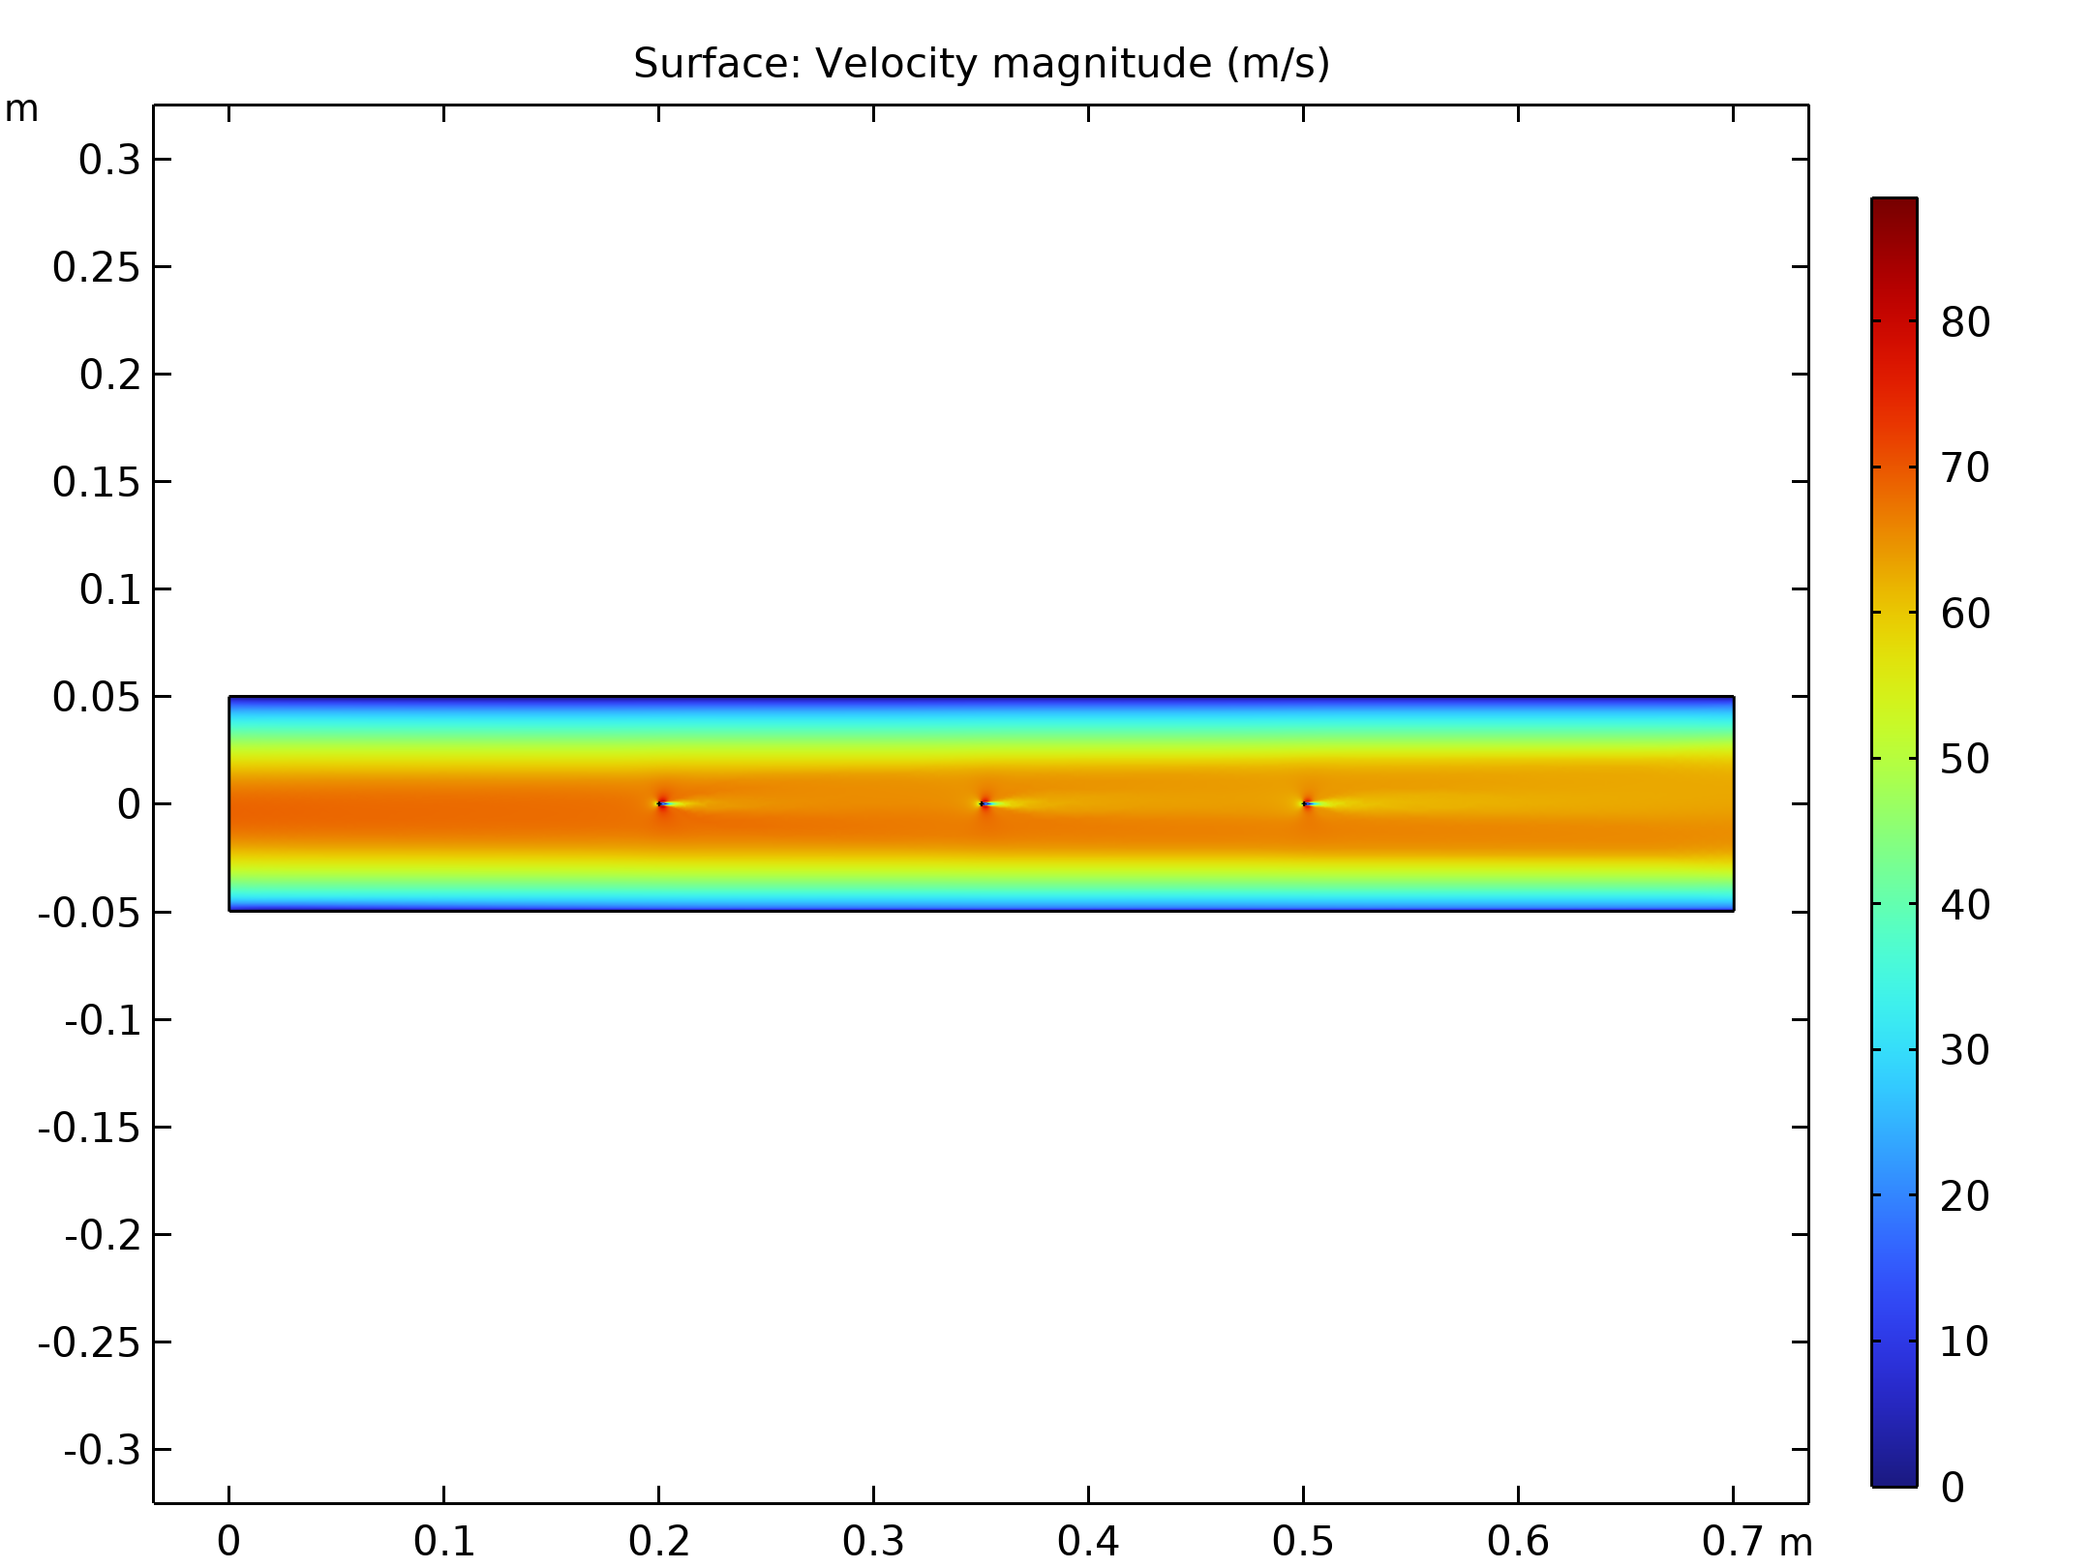  Velocity magnitude of the flow in electrostatic precipitator |  | Electric Potential lines around electrodes in Electrostatic Precipitator
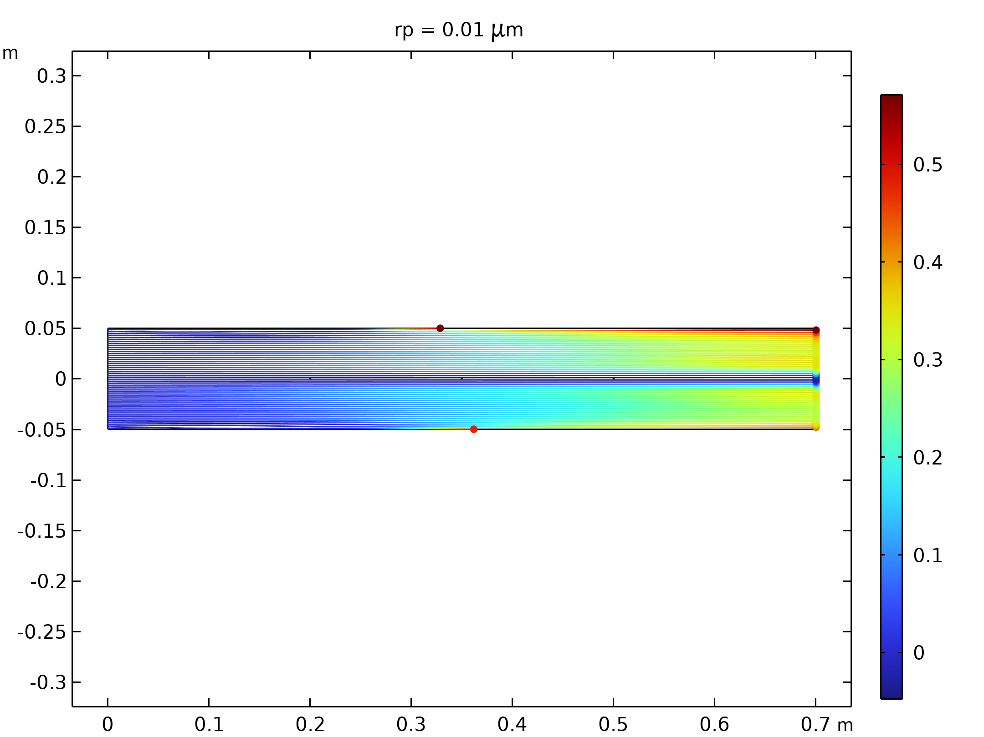  Particle trajectories with the charge number along the trajectory expressed in color for particles with a radius of 0.01 μm |  | 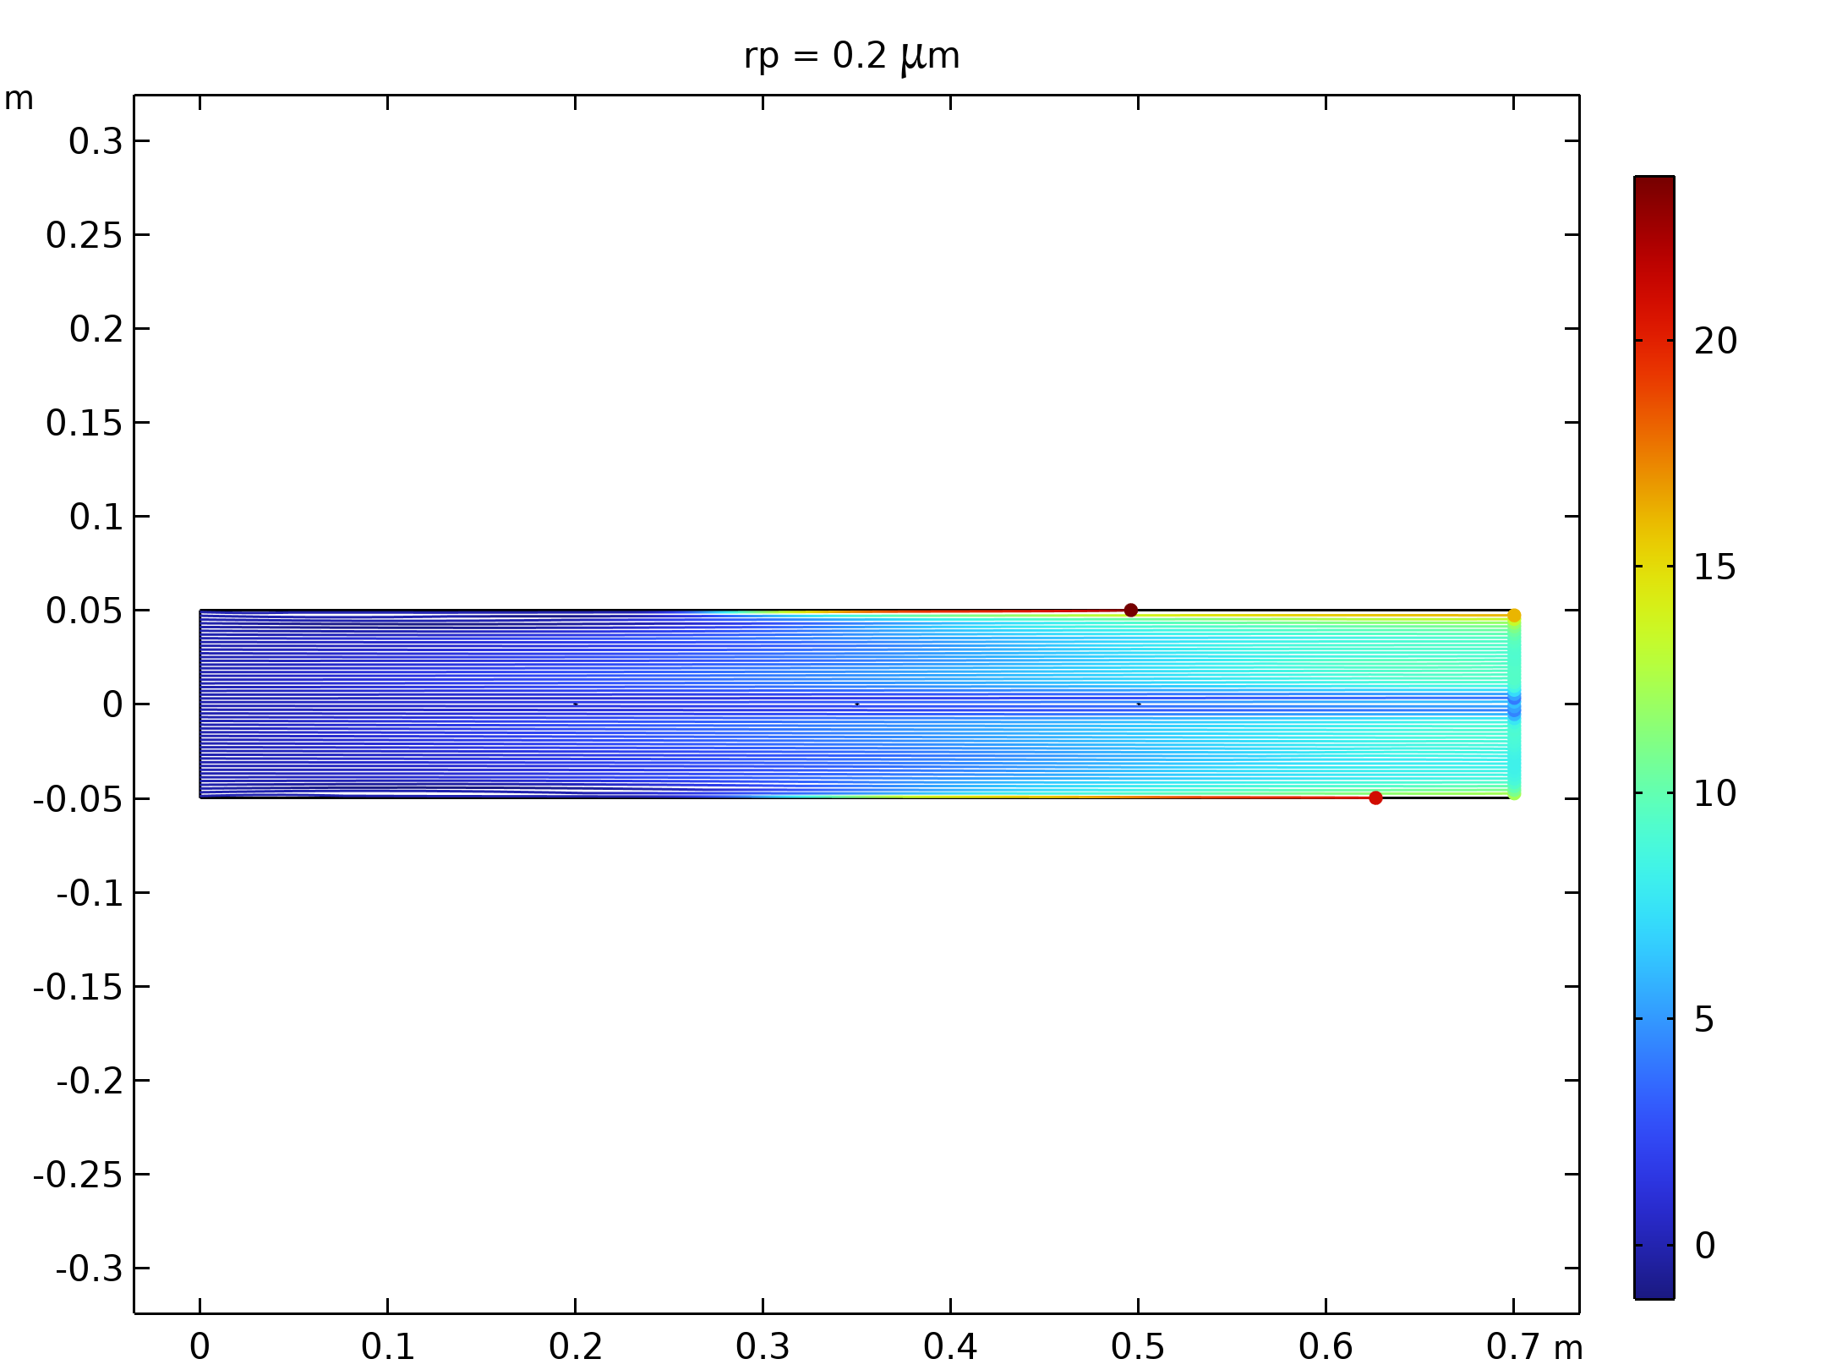  Particle trajectories with the charge number along the trajectory expressed in color for particles with a radius of 0.2 μm.
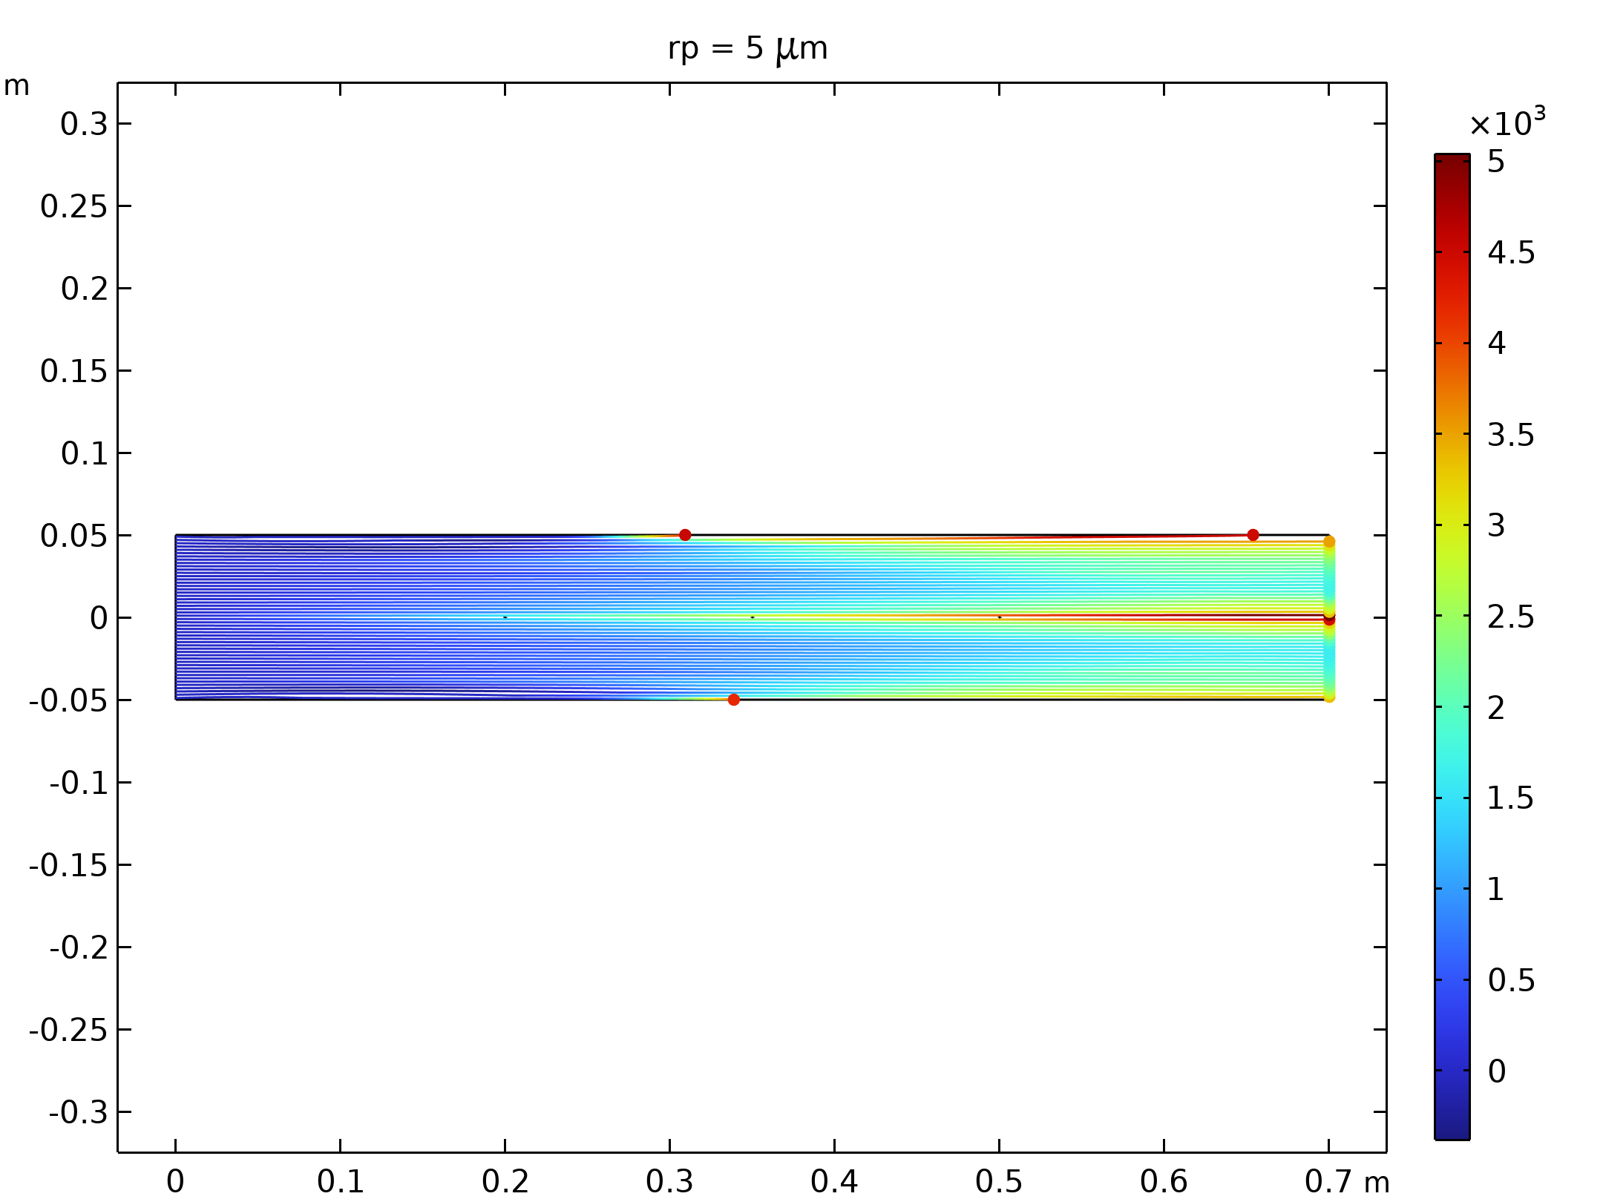  Particle trajectories with the charge number along the trajectory expressed in color for particles with a radius of 5 μm. |  | 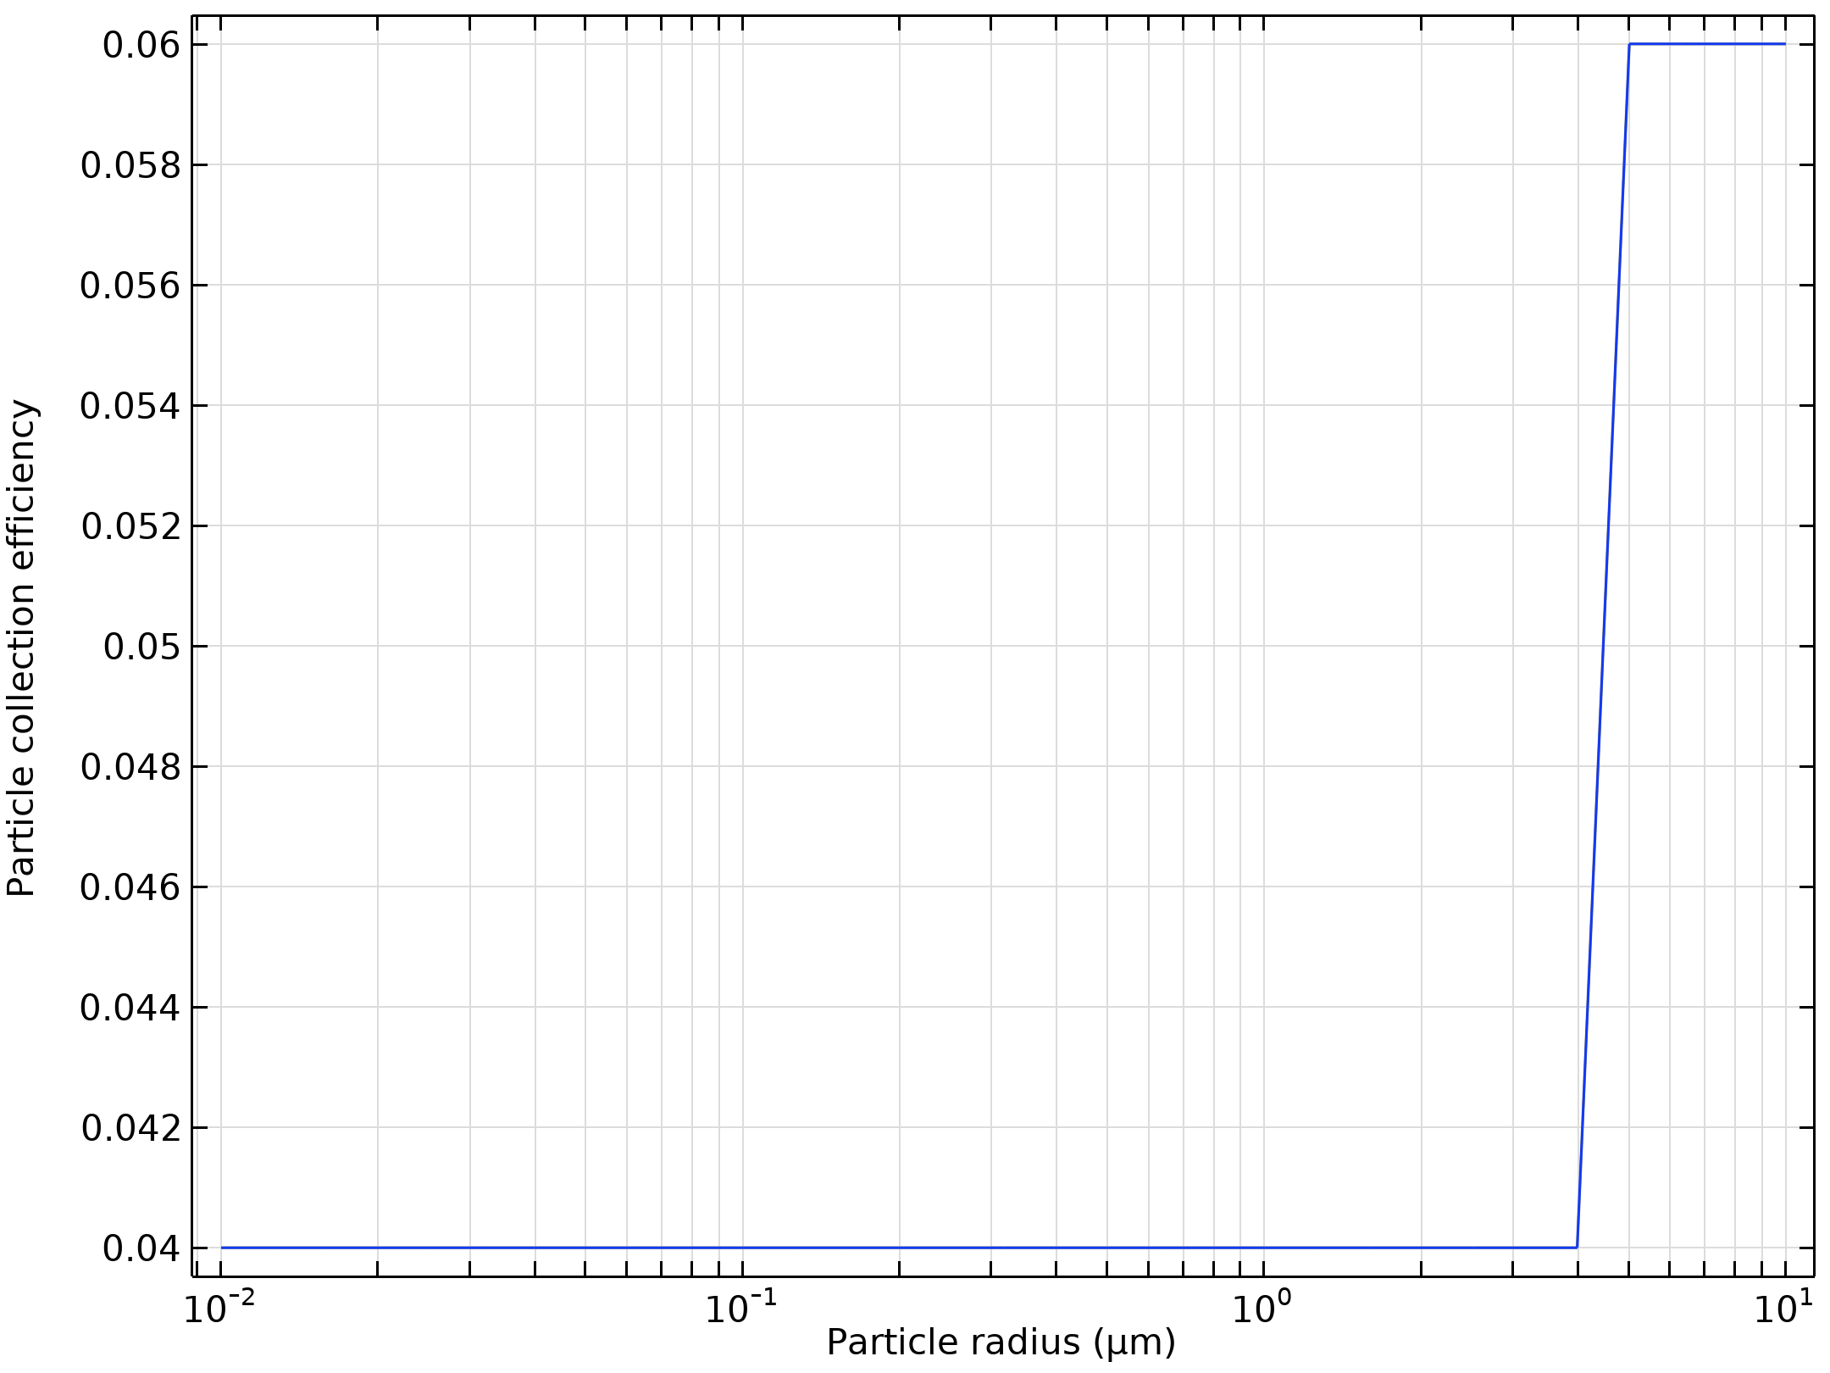  Particle collection efficiency as a function of the particle radius

Run | Wire radius (m) |  | Velocity (m/s) | Voltage (KV)
8 | 0.005 |  | 50 | 30
Velocity magnitude of the flow in electrostatic precipitator |  | Electric Potential lines around electrodes in Electrostatic Precipitator
Particle trajectories with the charge number along the trajectory expressed in color for particles with a radius of 0.01 μm |  | Particle trajectories with the charge number along the trajectory expressed in color for particles with a radius of 0.2 μm.
Particle trajectories with the charge number along the trajectory expressed in color for particles with a radius of 5 μm. |  | Particle collection efficiency as a function of the particle radius

Run | Wire radius (m) |  | Velocity (m/s) | Voltage (KV)
9 | 0.005 |  | 50 | 50
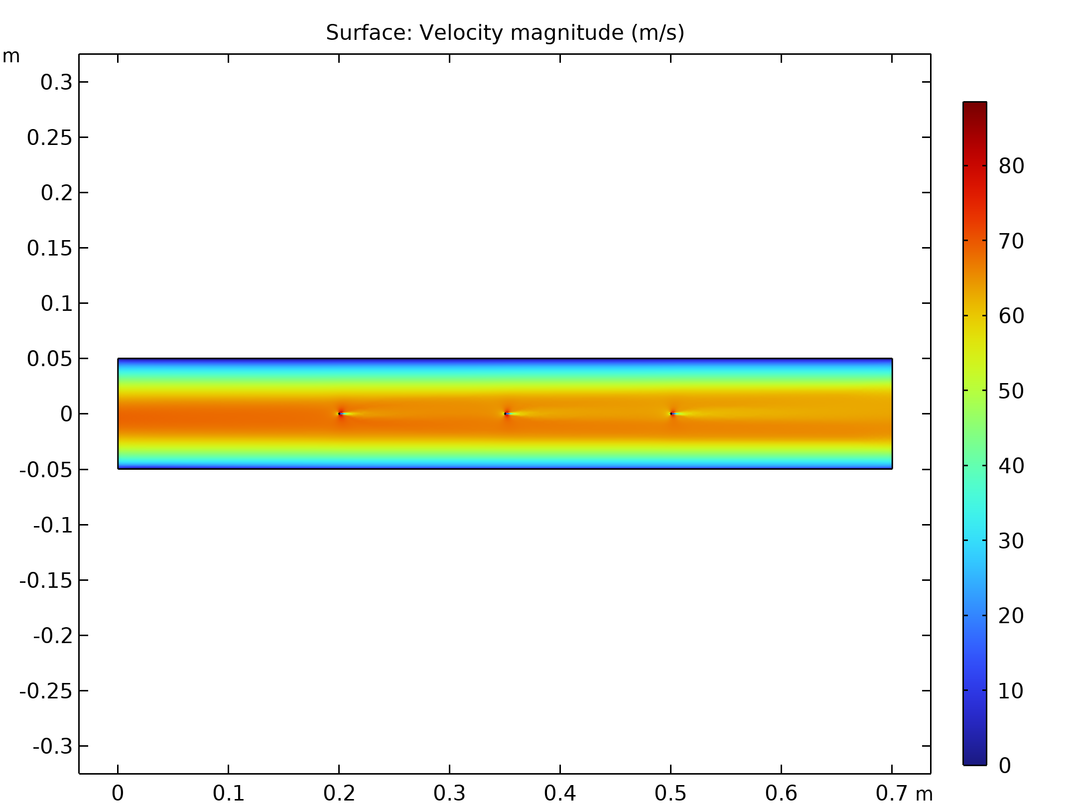  Velocity magnitude of the flow in electrostatic precipitator |  | Electric Potential lines around electrodes in Electrostatic Precipitator
Particle trajectories with the charge number along the trajectory expressed in color for particles with a radius of 0.01 μm |  | Particle trajectories with the charge number along the trajectory expressed in color for particles with a radius of 0.2 μm.
Particle trajectories with the charge number along the trajectory expressed in color for particles with a radius of 5 μm. |  | 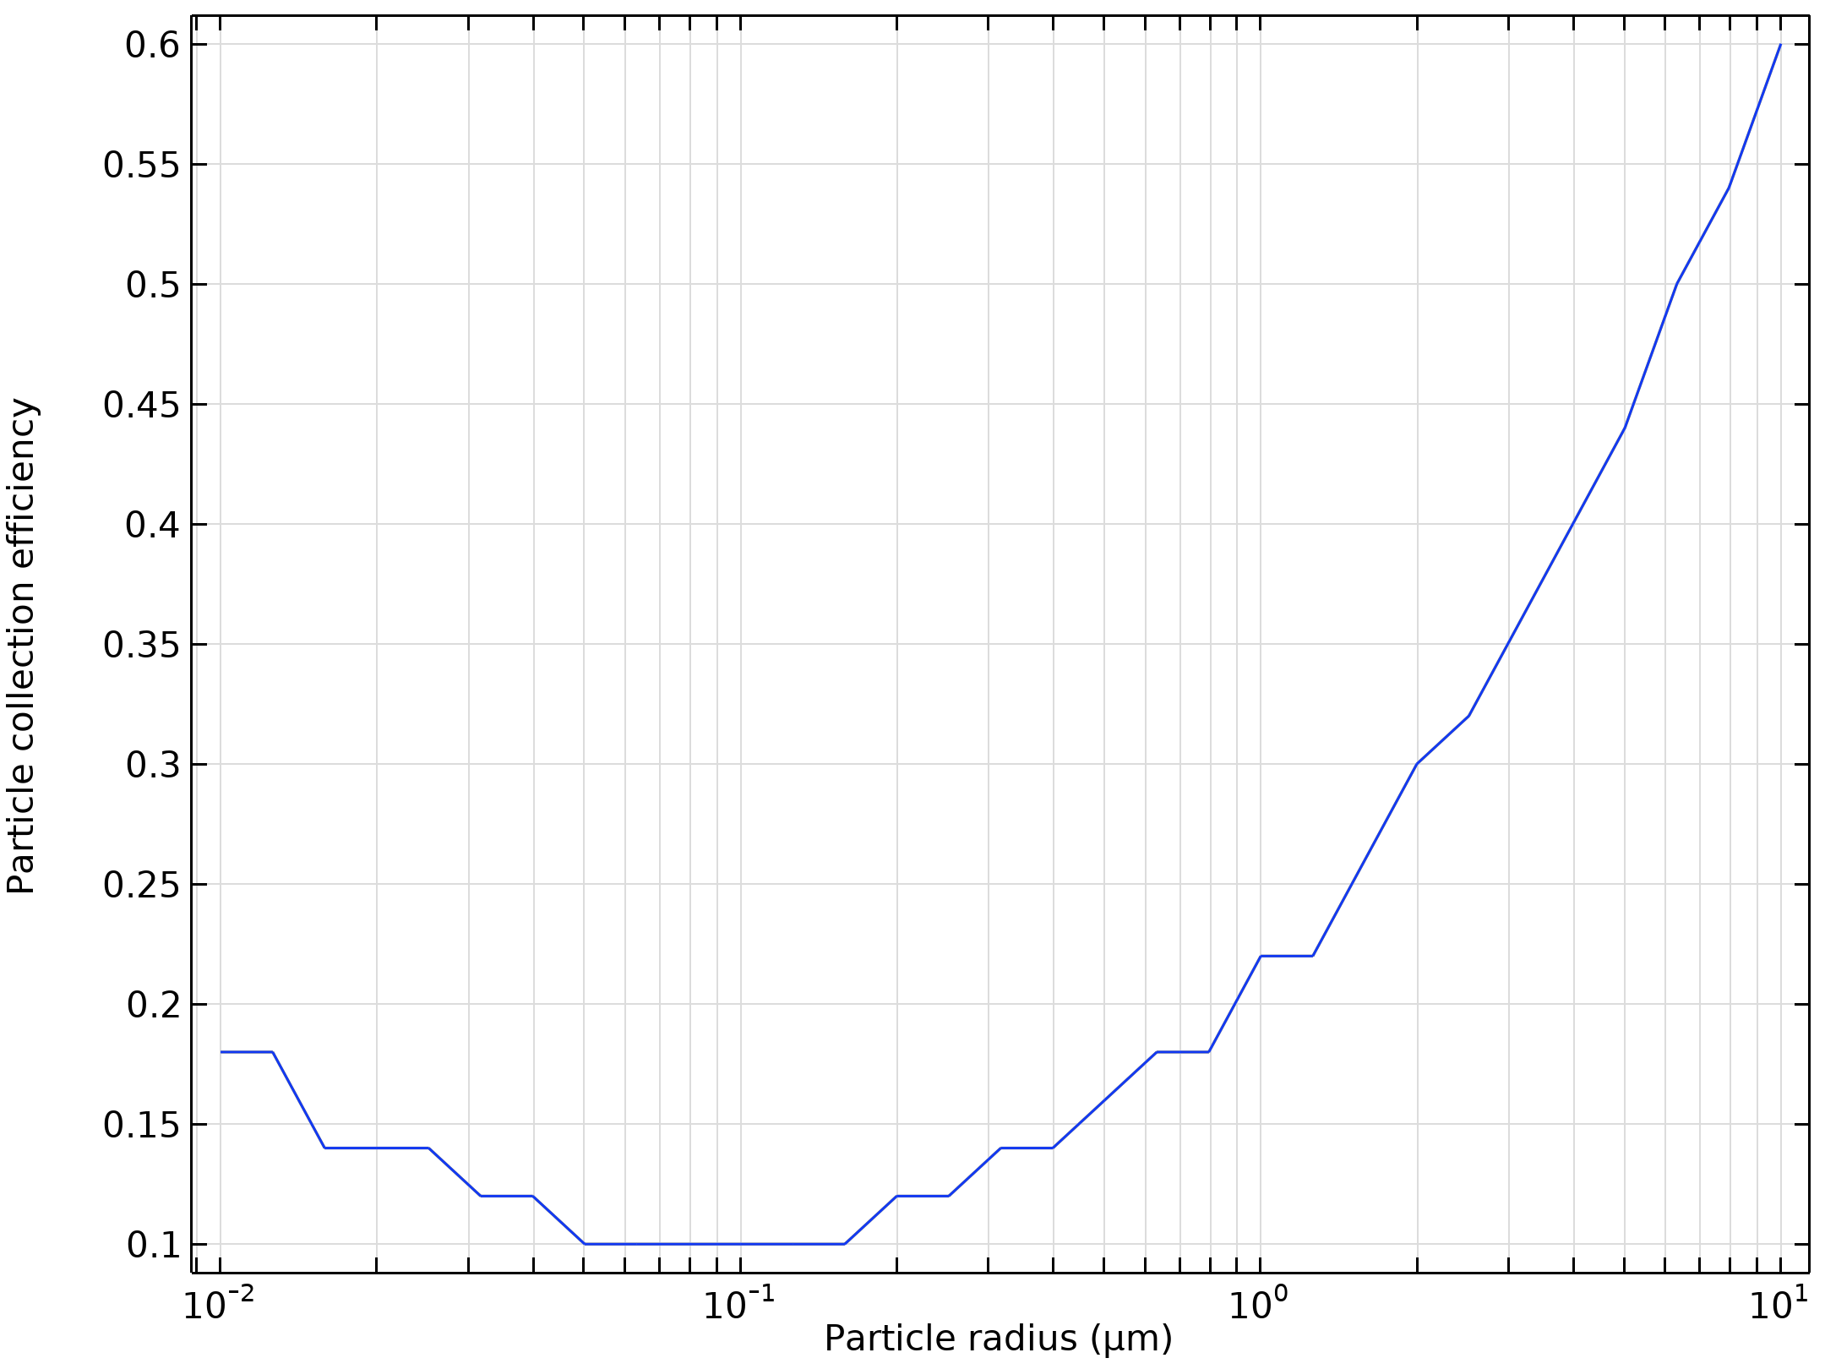  Particle collection efficiency as a function of the particle radius

Run | Wire radius (m) |  | Velocity (m/s) | Voltage (KV)
10 | 0.001 |  | 10 | 10
Velocity magnitude of the flow in electrostatic precipitator |  | Electric Potential lines around electrodes in Electrostatic Precipitator
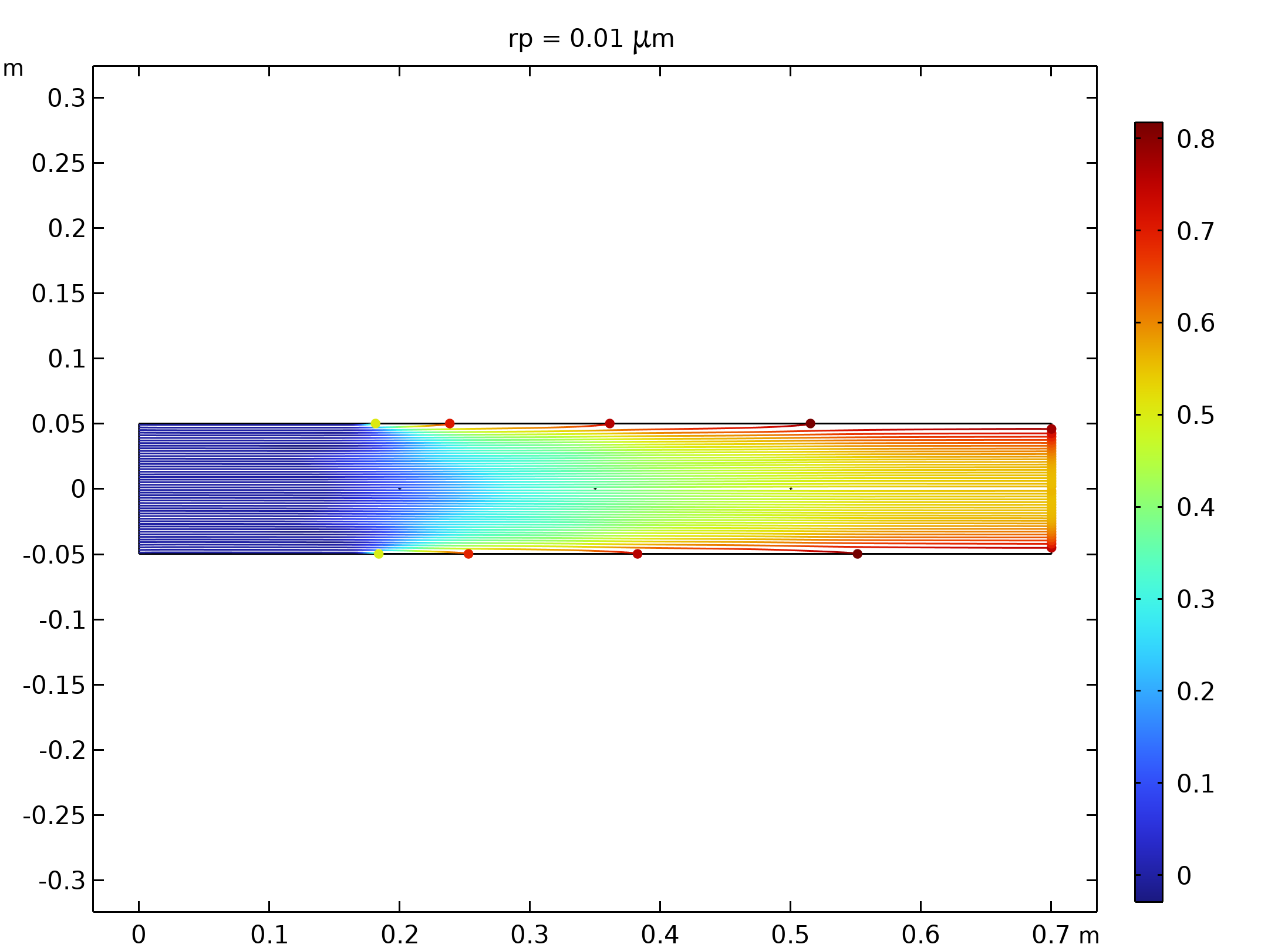  Particle trajectories with the charge number along the trajectory expressed in color for particles with a radius of 0.01 μm |  | 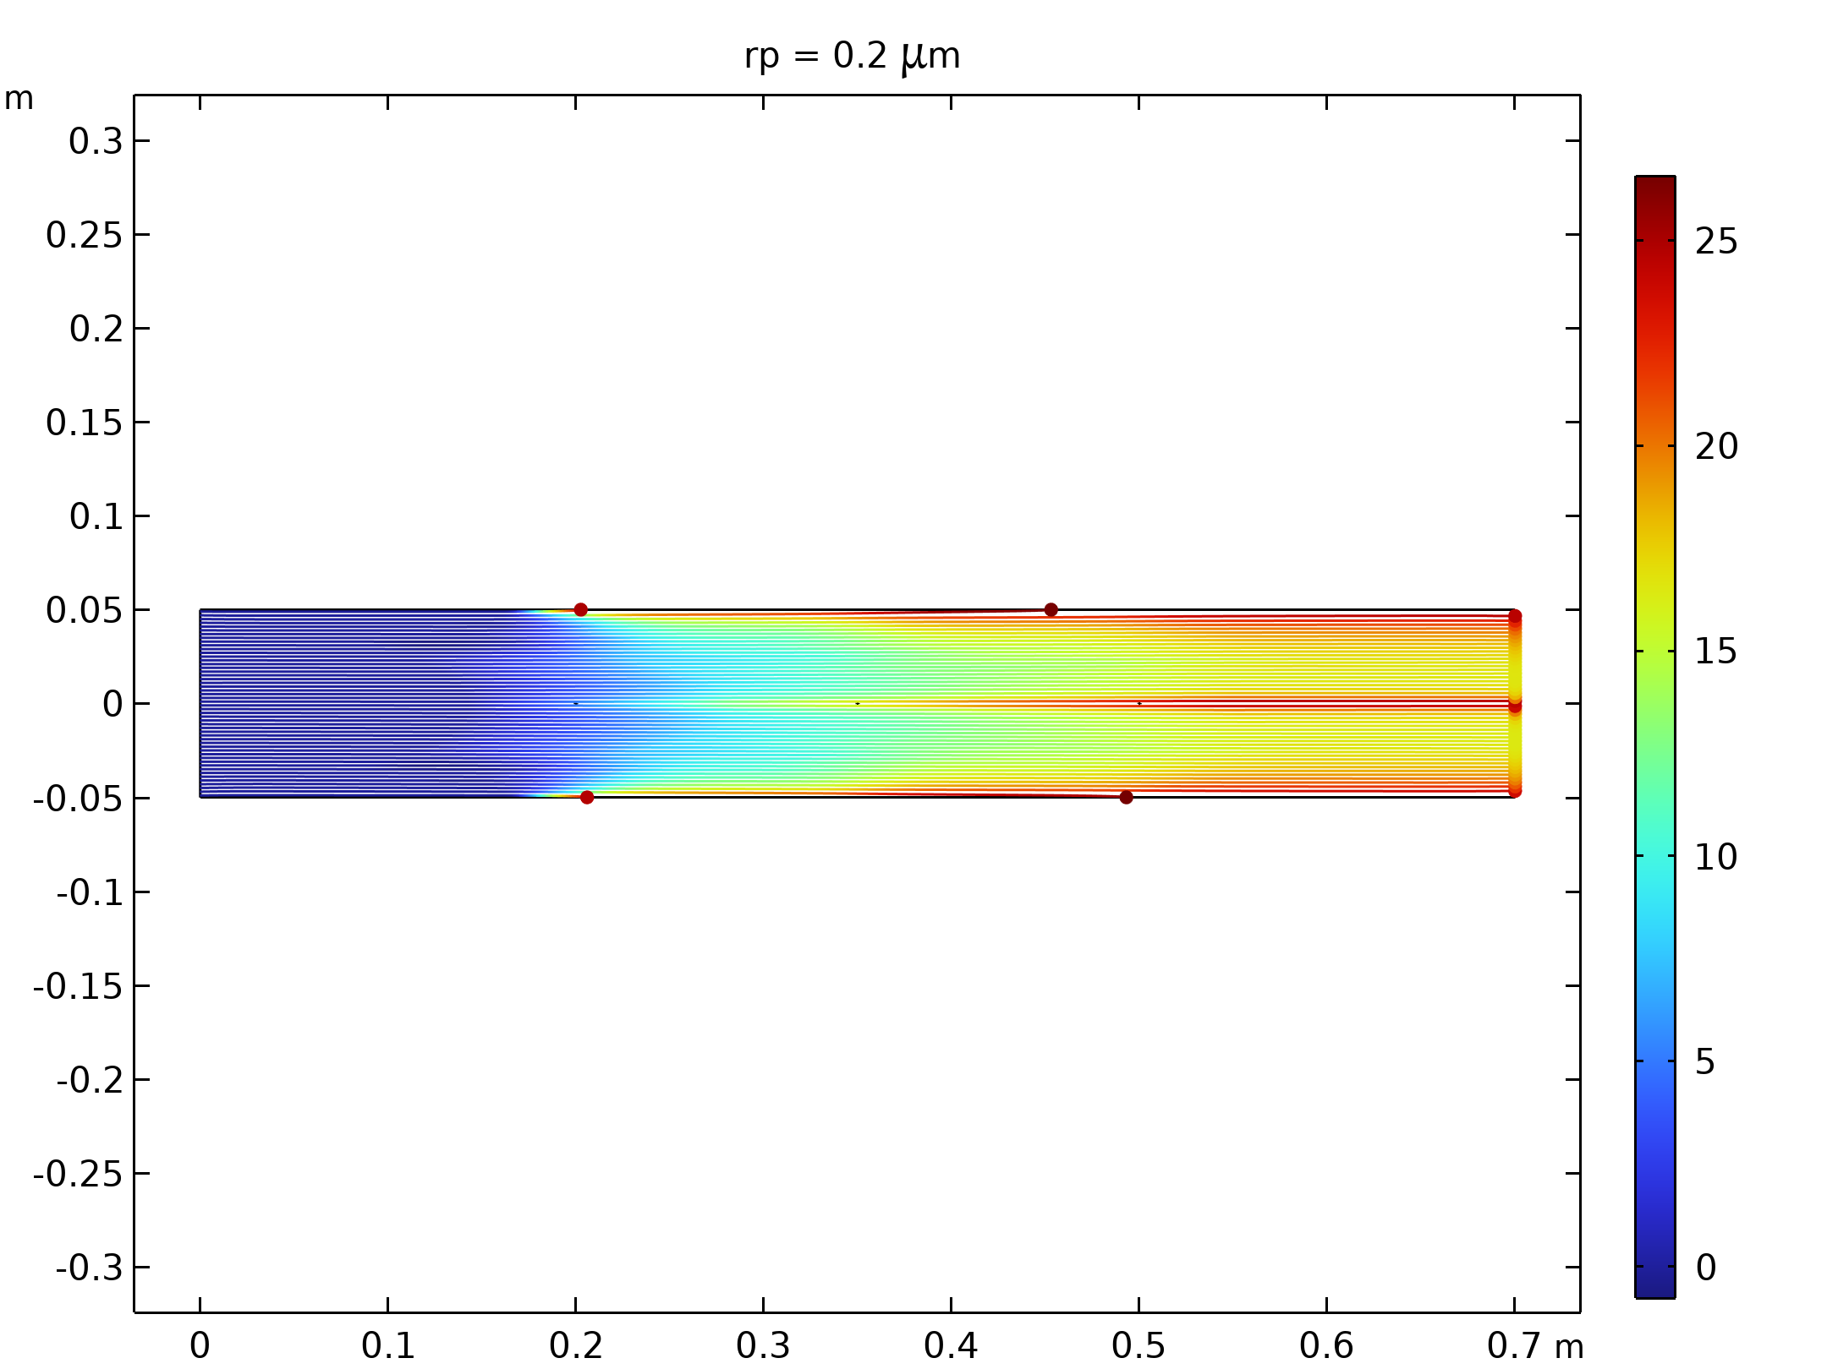  Particle trajectories with the charge number along the trajectory expressed in color for particles with a radius of 0.2 μm.
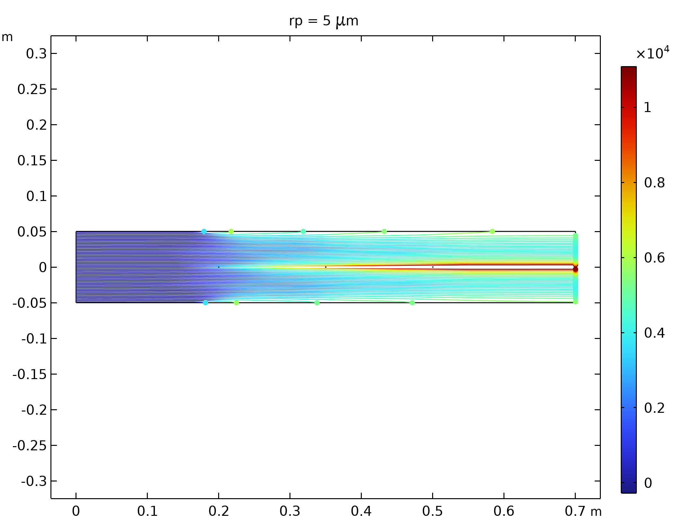  Particle trajectories with the charge number along the trajectory expressed in color for particles with a radius of 5 μm. |  | 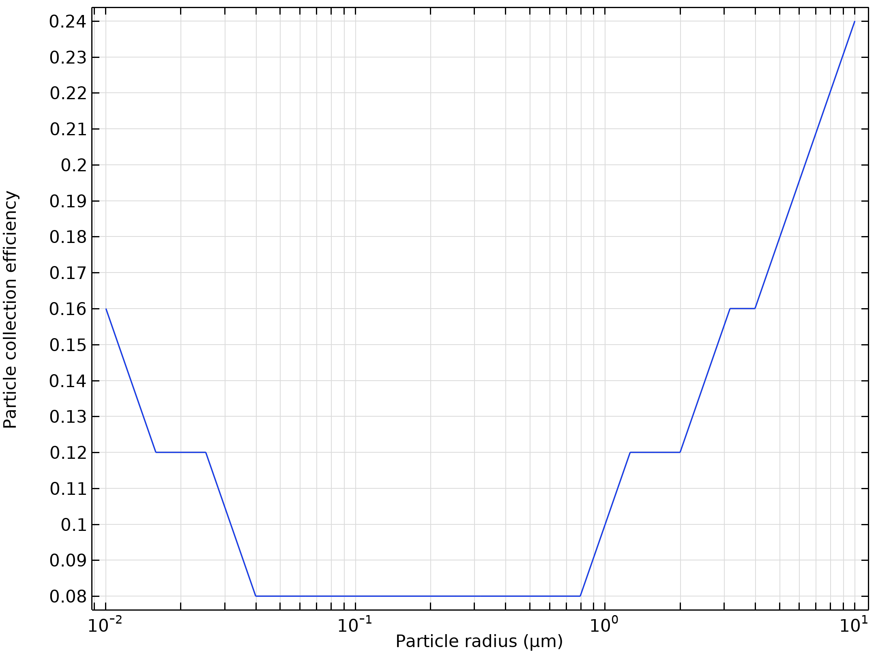  Particle collection efficiency as a function of the particle radius

Run | Wire radius (m) |  | Velocity (m/s) | Voltage (KV)
11 | 0.001 |  | 10 | 30
Velocity magnitude of the flow in electrostatic precipitator |  | Electric Potential lines around electrodes in Electrostatic Precipitator
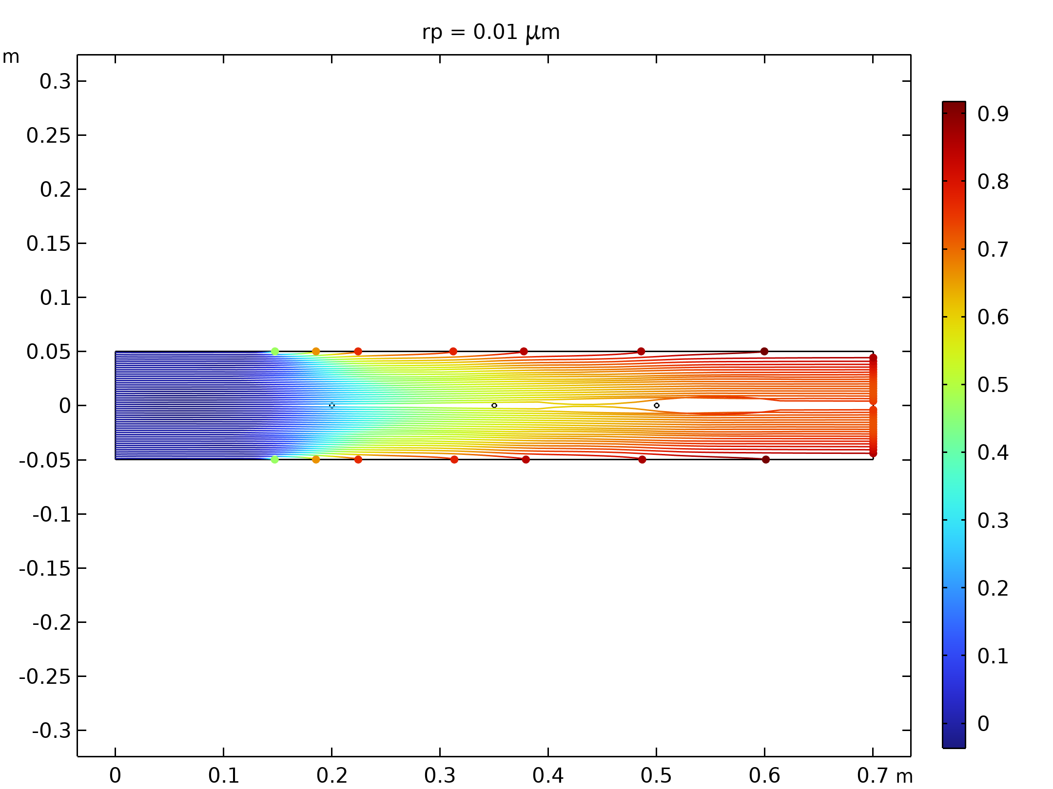  Particle trajectories with the charge number along the trajectory expressed in color for particles with a radius of 0.01 μm |  | 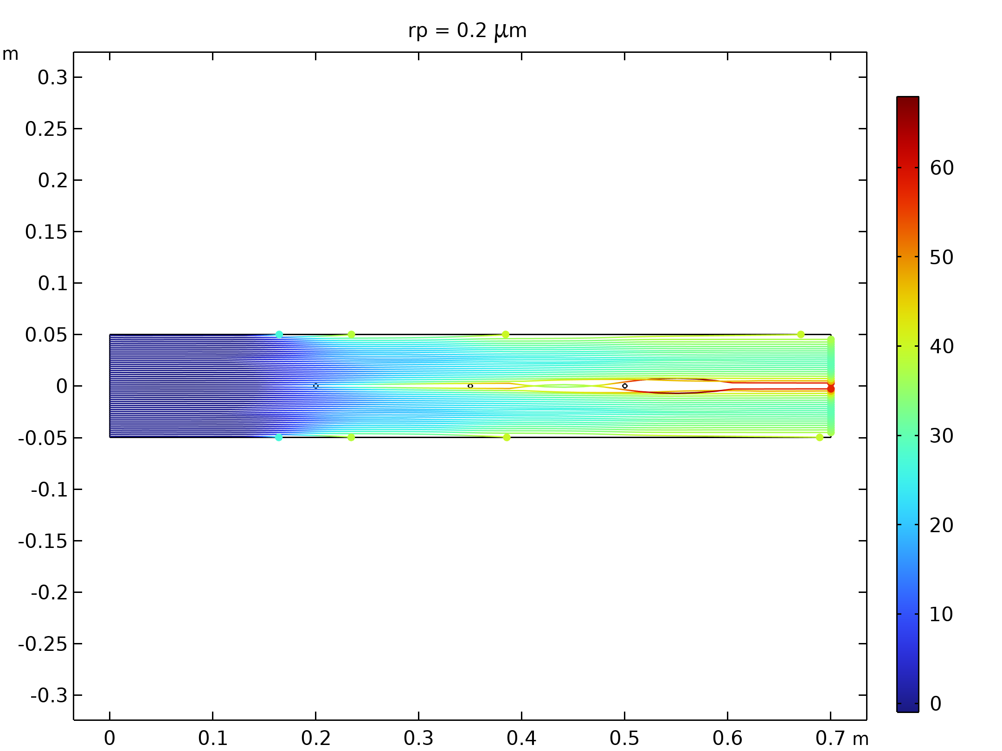  Particle trajectories with the charge number along the trajectory expressed in color for particles with a radius of 0.2 μm.
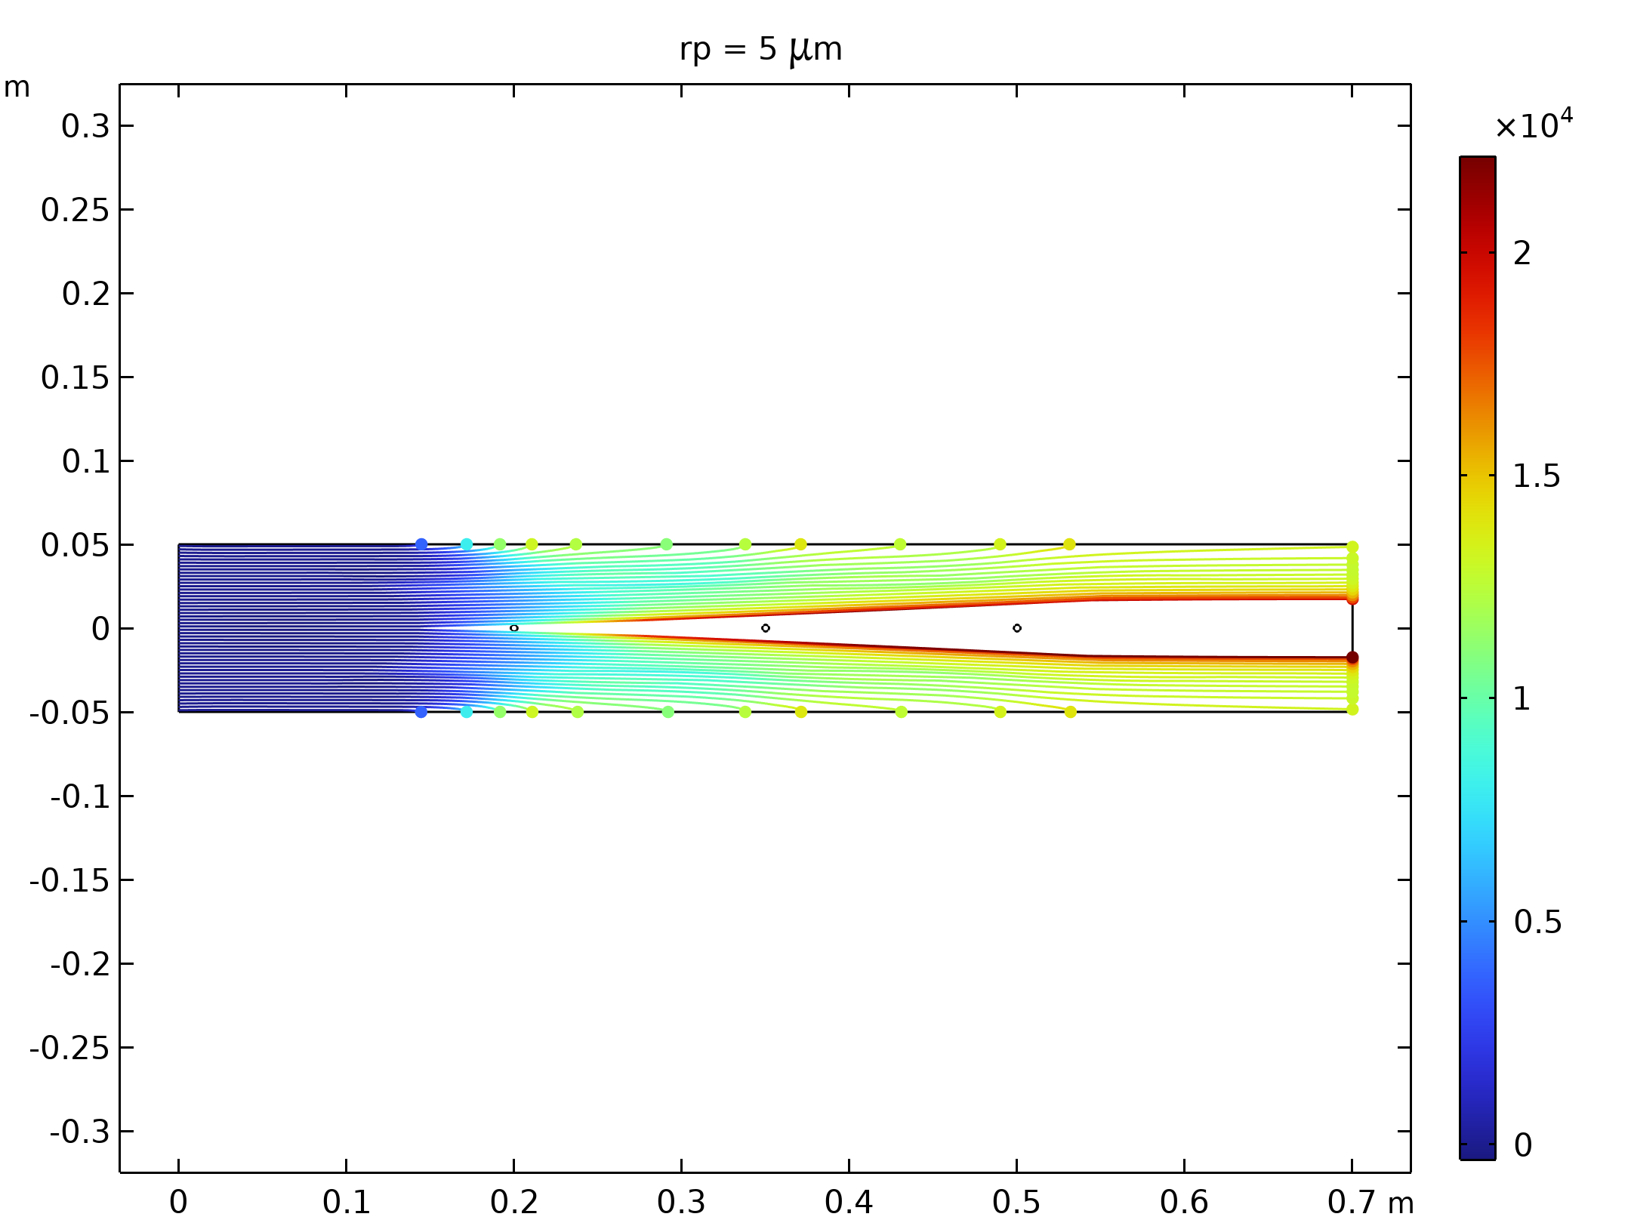  Particle trajectories with the charge number along the trajectory expressed in color for particles with a radius of 5 μm. |  | 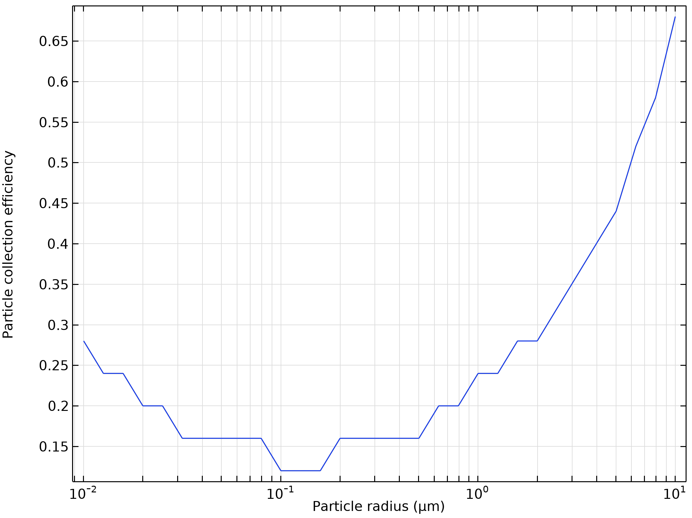  Particle collection efficiency as a function of the particle radius

Run | Wire radius (m) |  | Velocity (m/s) | Voltage (KV)
12 | 0.001 |  | 10 | 50
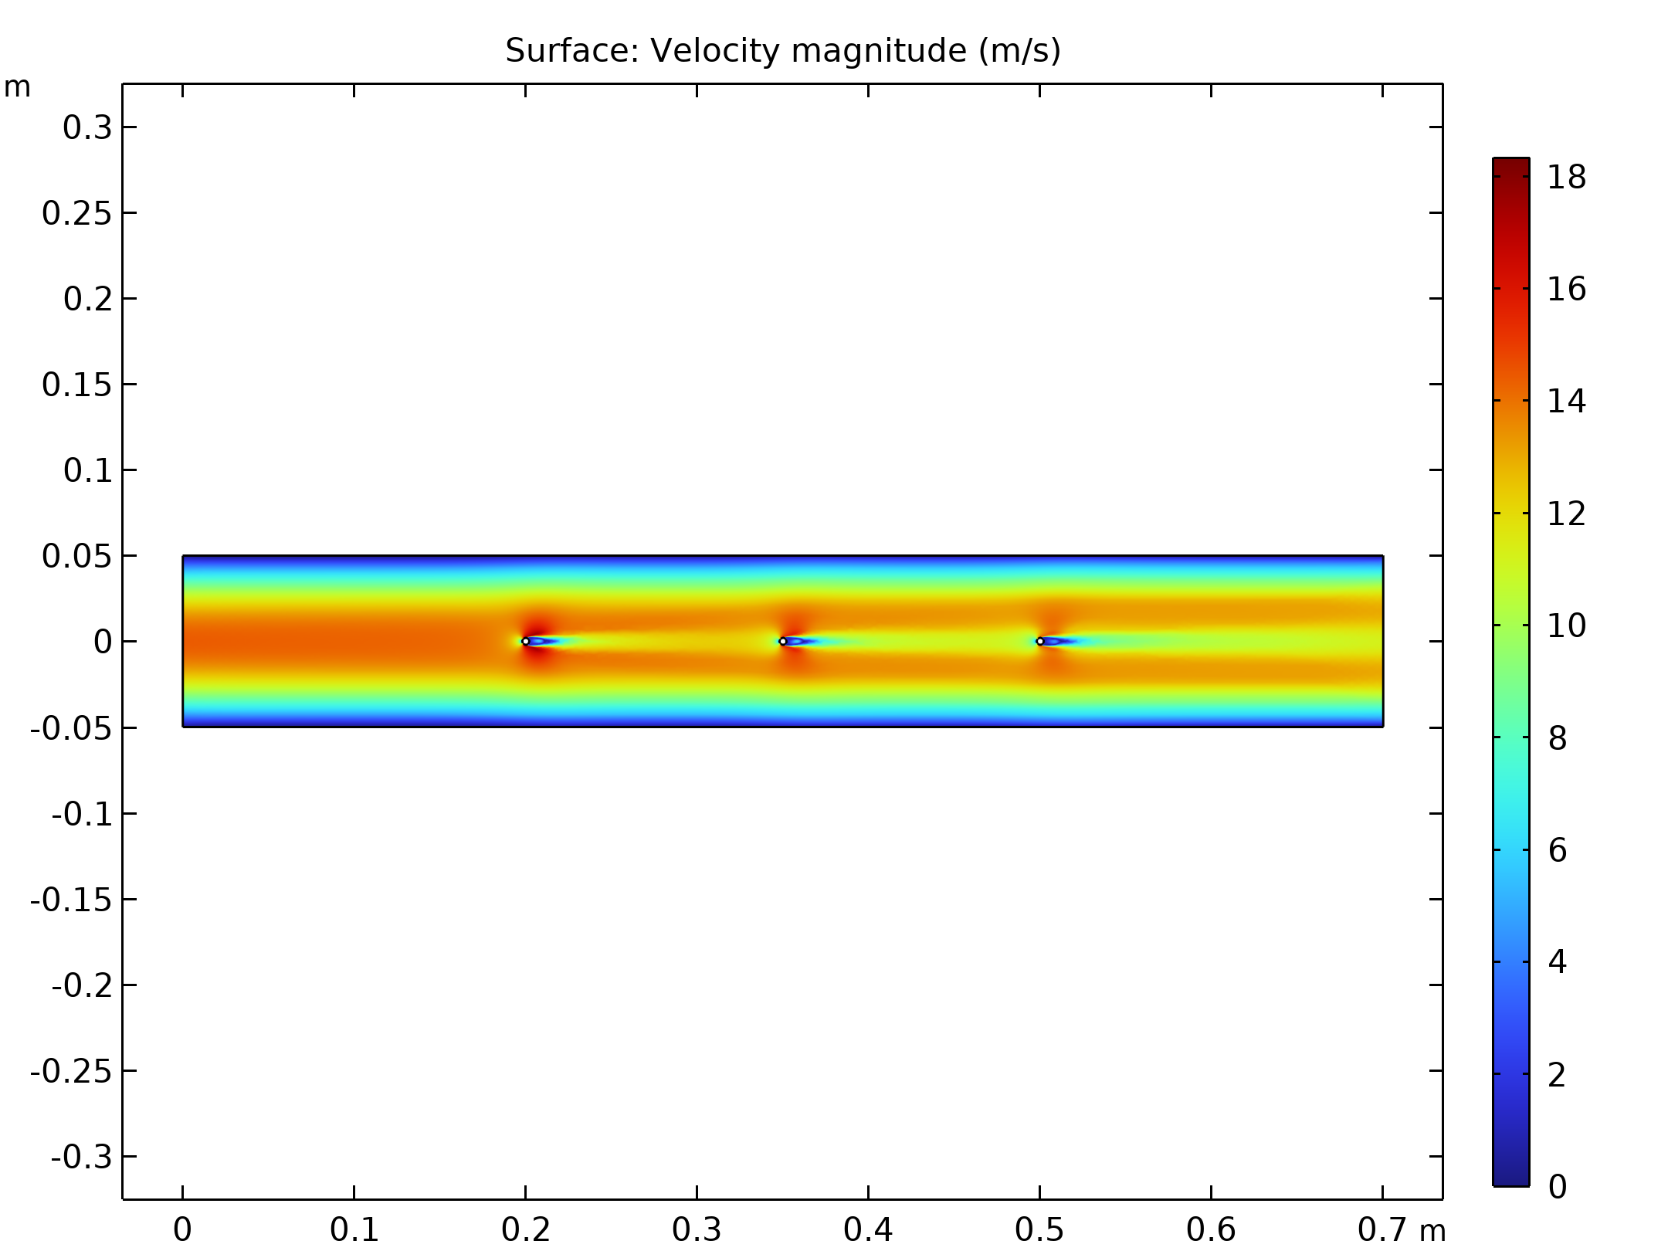  Velocity magnitude of the flow in electrostatic precipitator |  | Electric Potential lines around electrodes in Electrostatic Precipitator
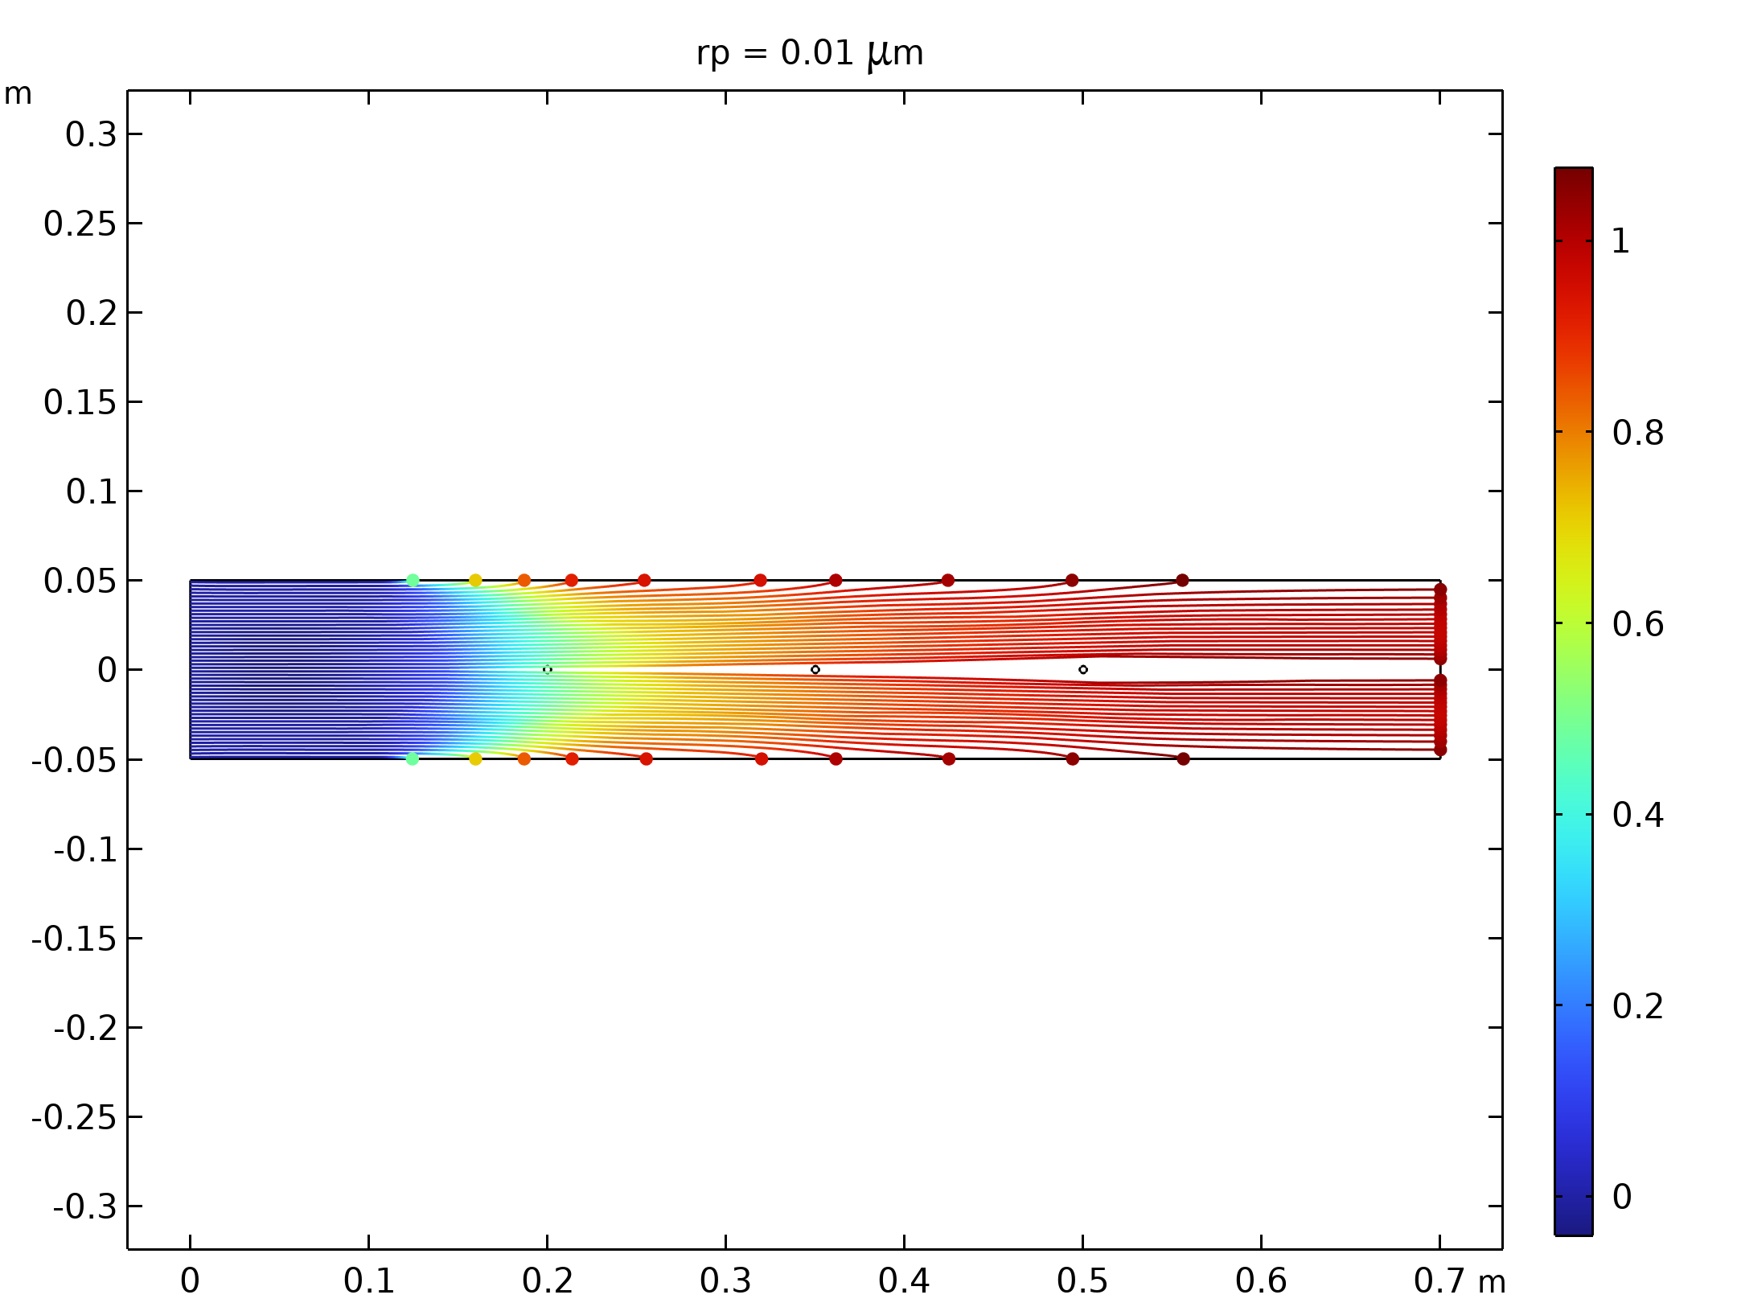  Particle trajectories with the charge number along the trajectory expressed in color for particles with a radius of 0.01 μm |  | 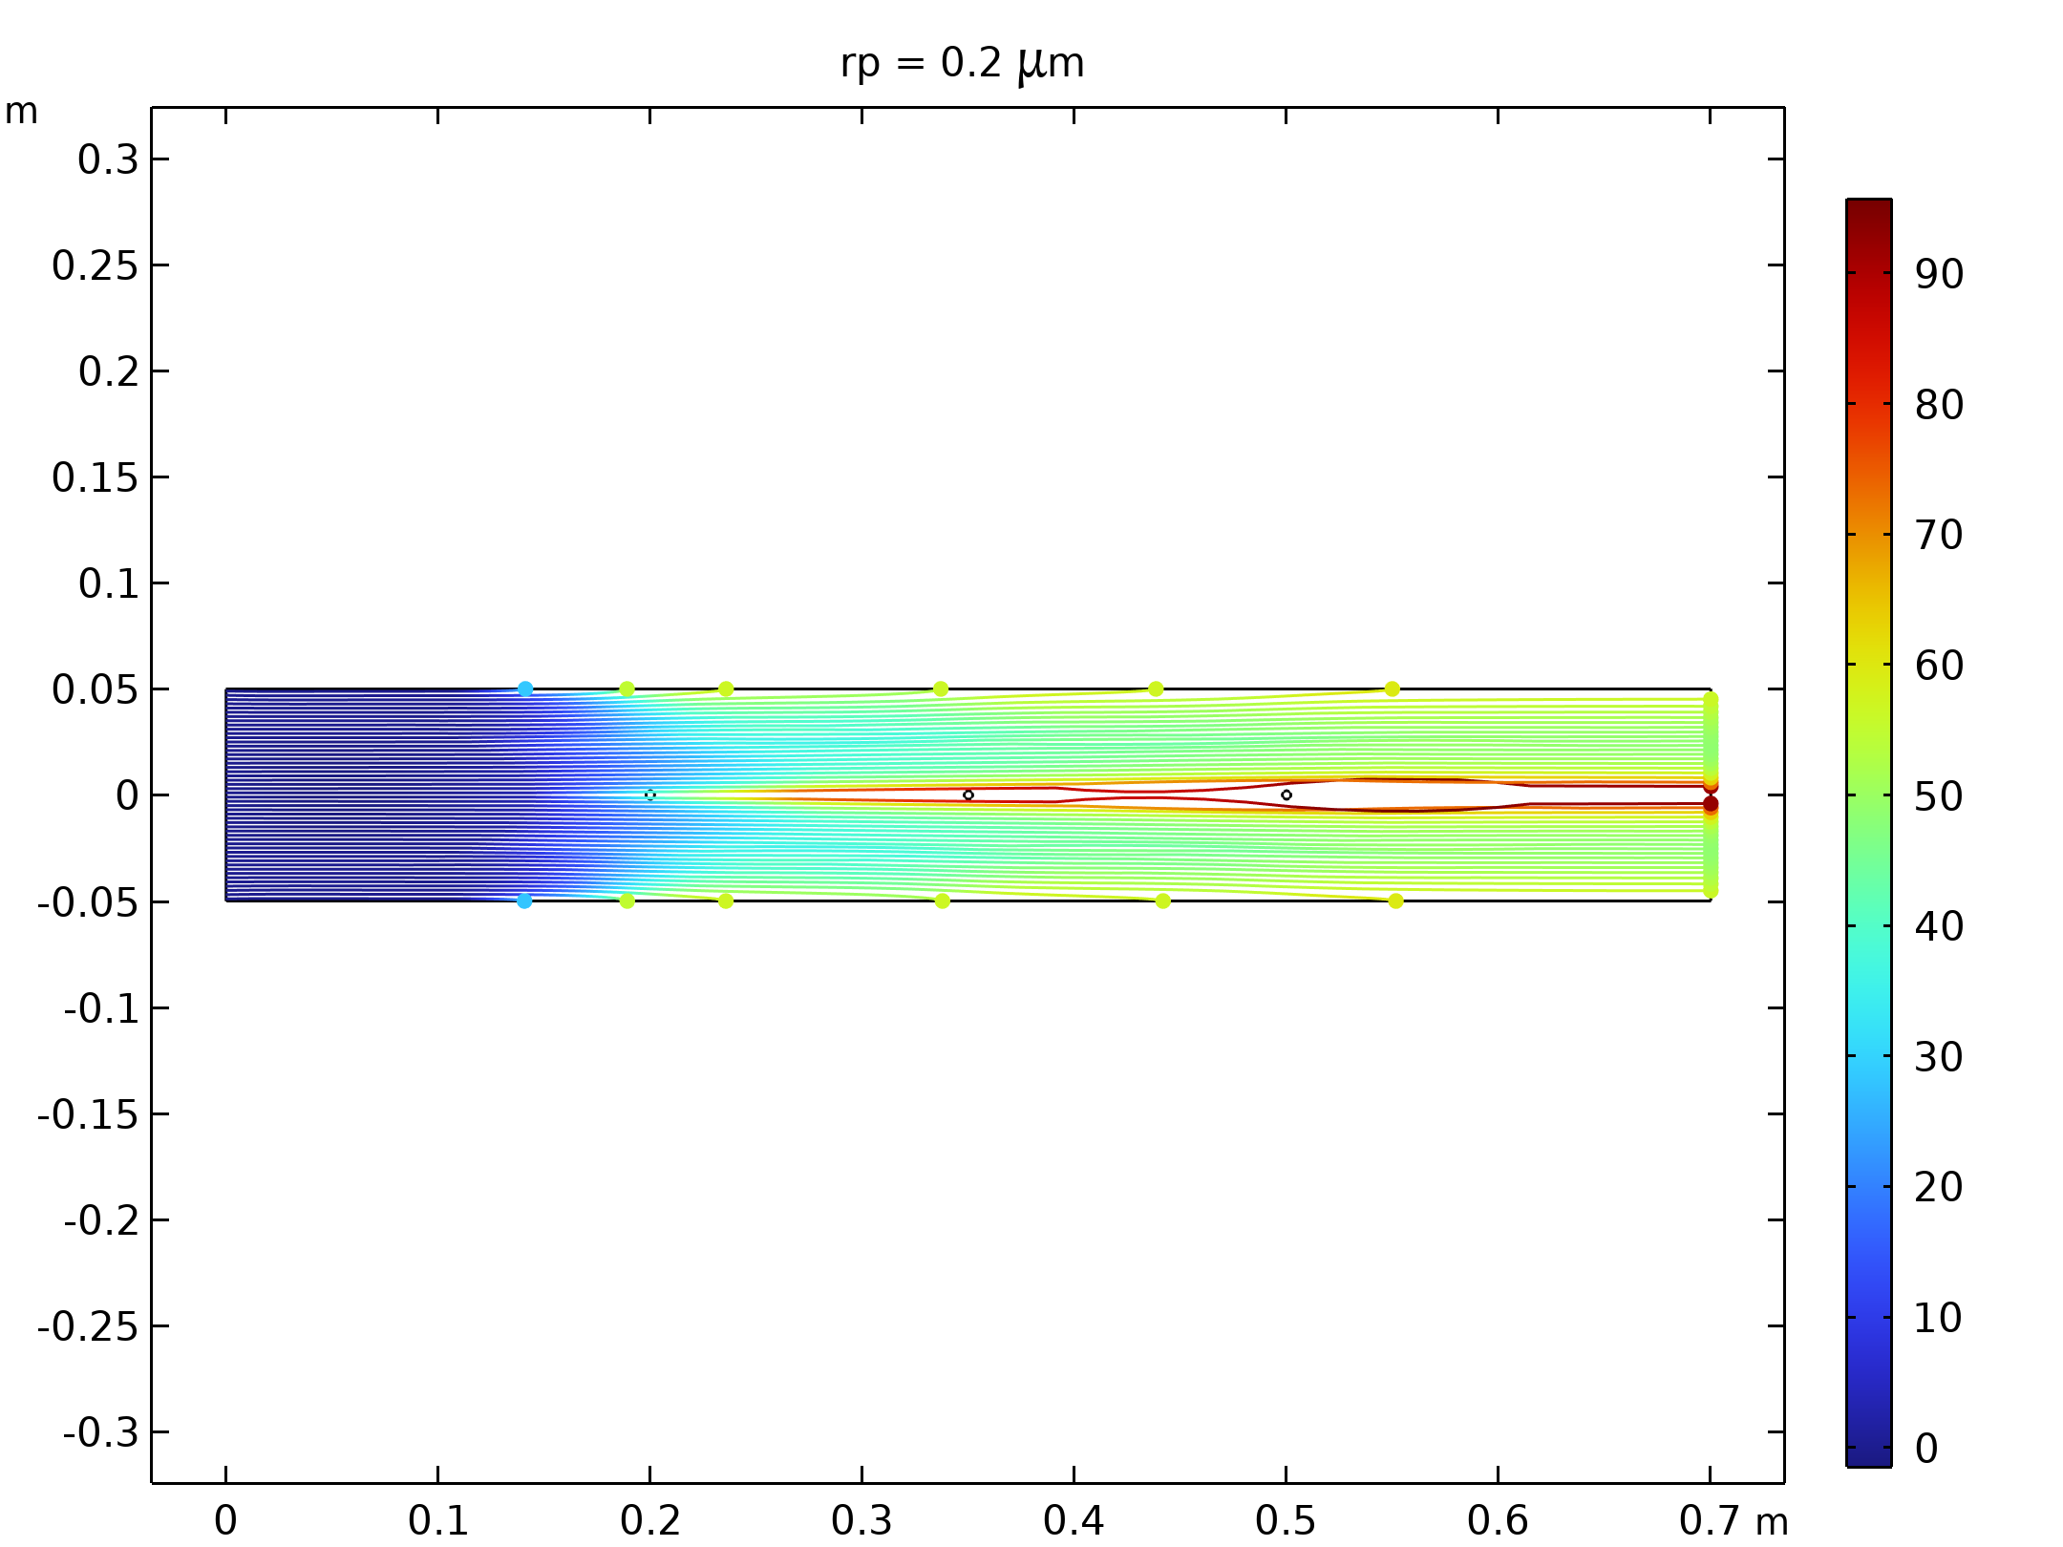  Particle trajectories with the charge number along the trajectory expressed in color for particles with a radius of 0.2 μm.
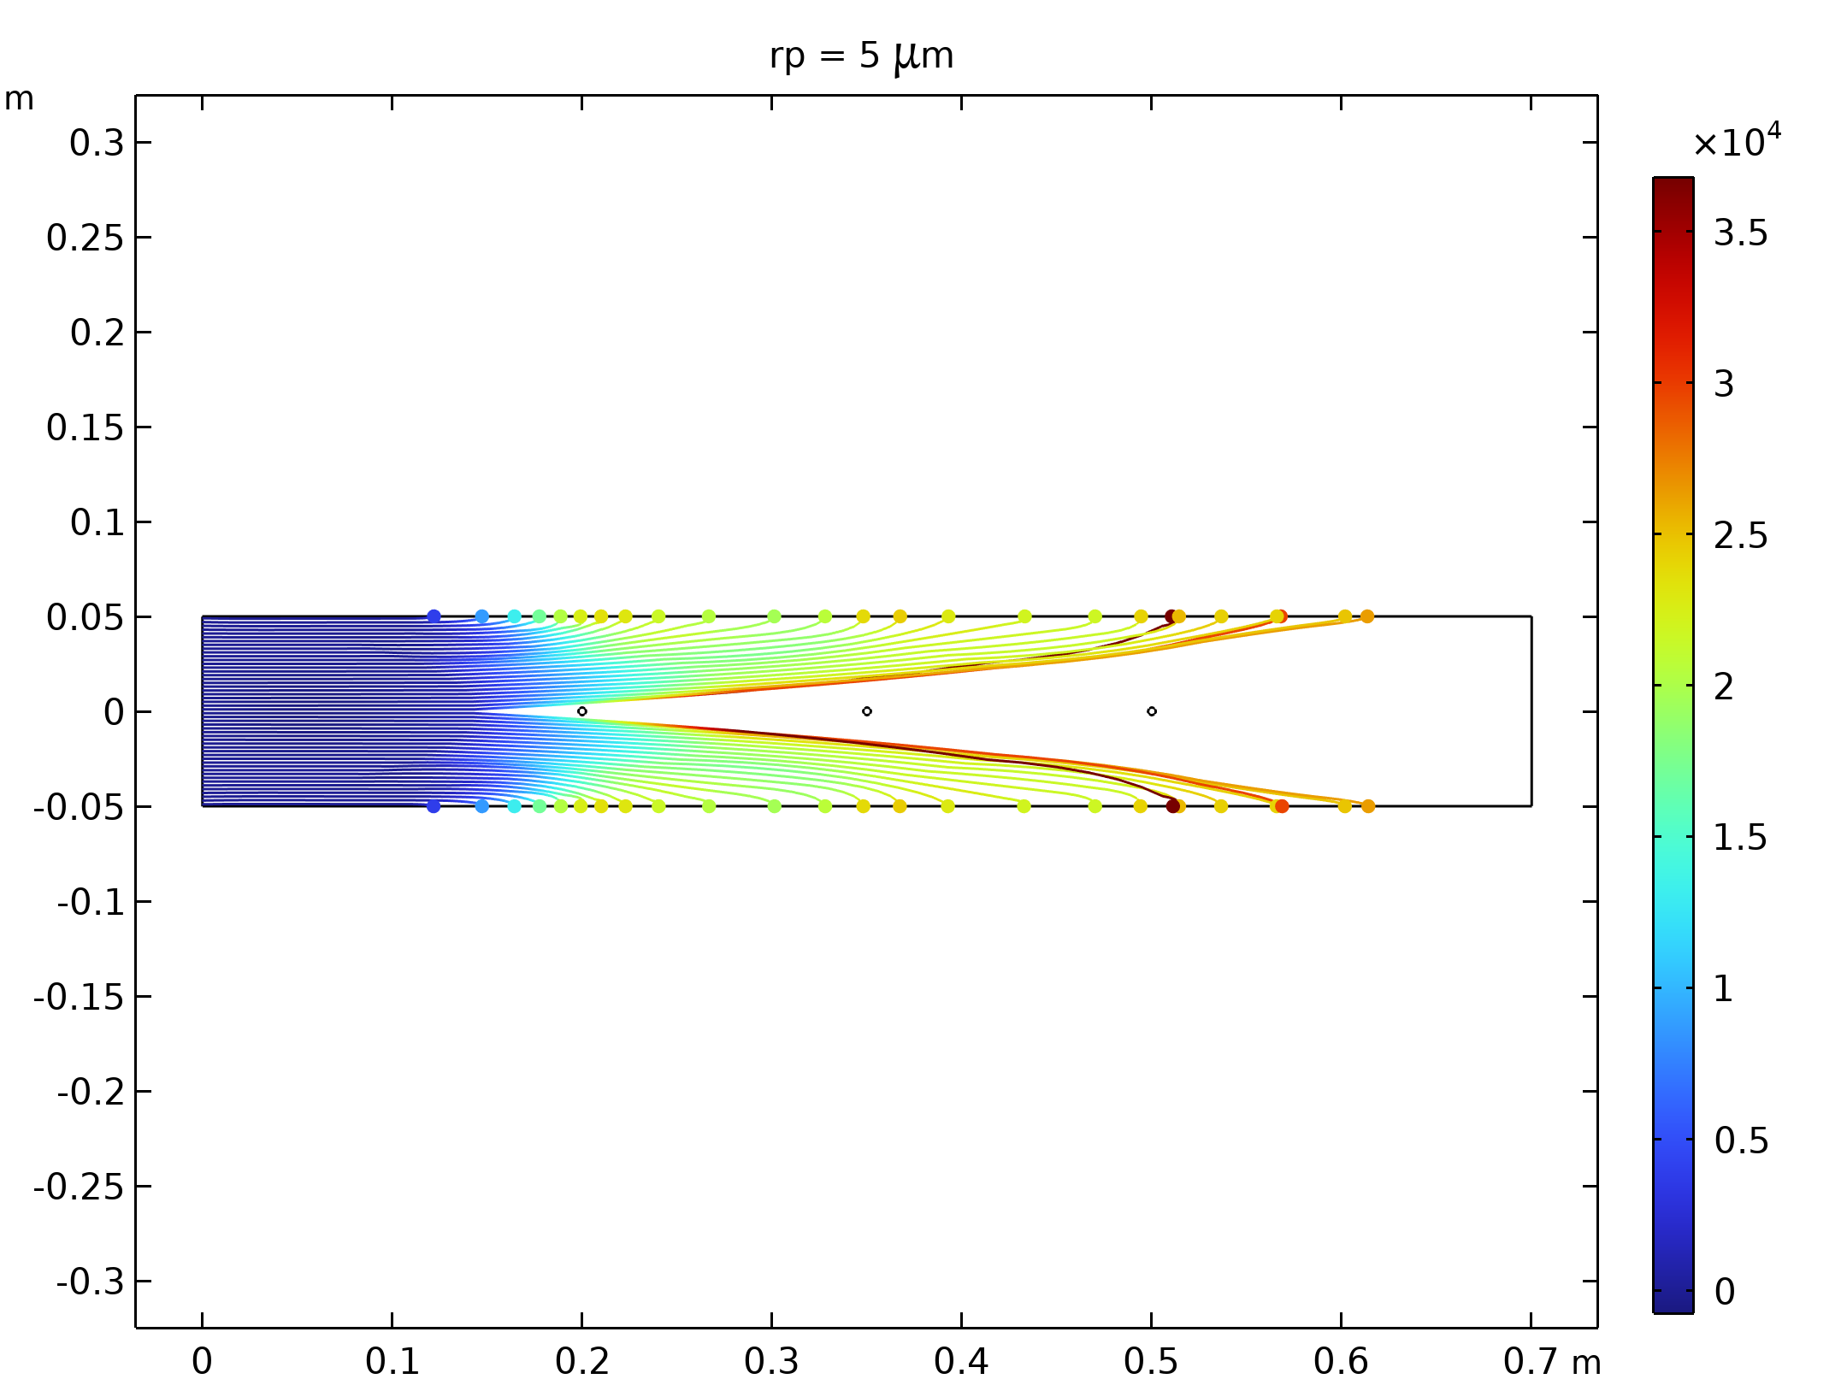  Particle trajectories with the charge number along the trajectory expressed in color for particles with a radius of 5 μm. |  | 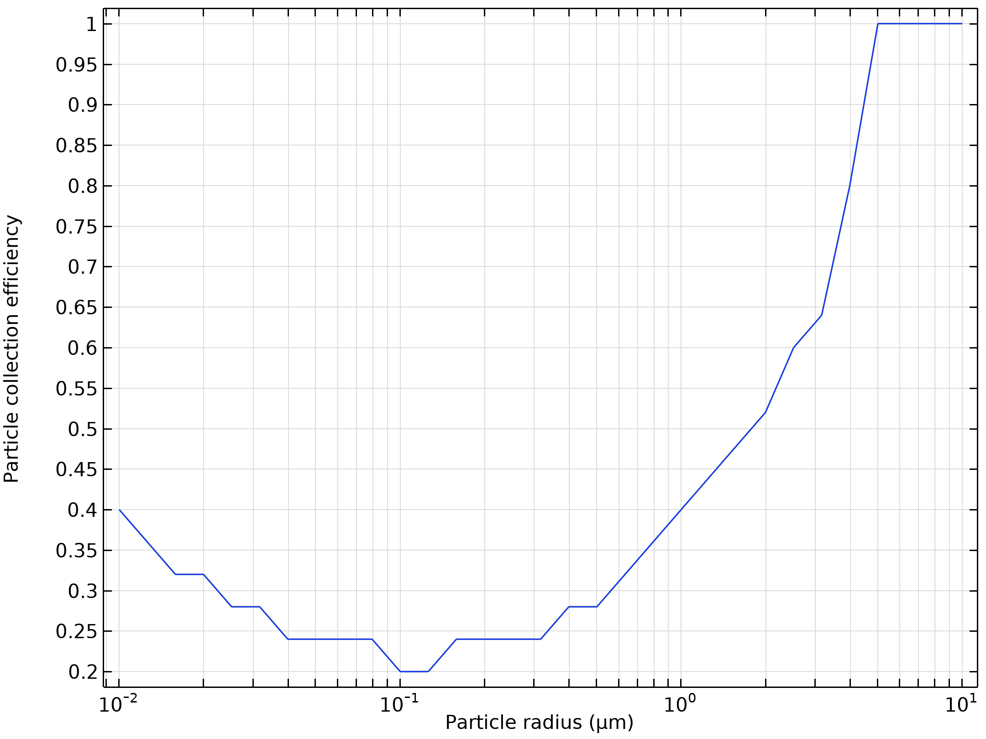  Particle collection efficiency as a function of the particle radius

Run | Wire radius (m) |  | Velocity (m/s) | Voltage (KV)
13 | 0.001 |  | 30 | 10
Velocity magnitude of the flow in electrostatic precipitator |  | Electric Potential lines around electrodes in Electrostatic Precipitator
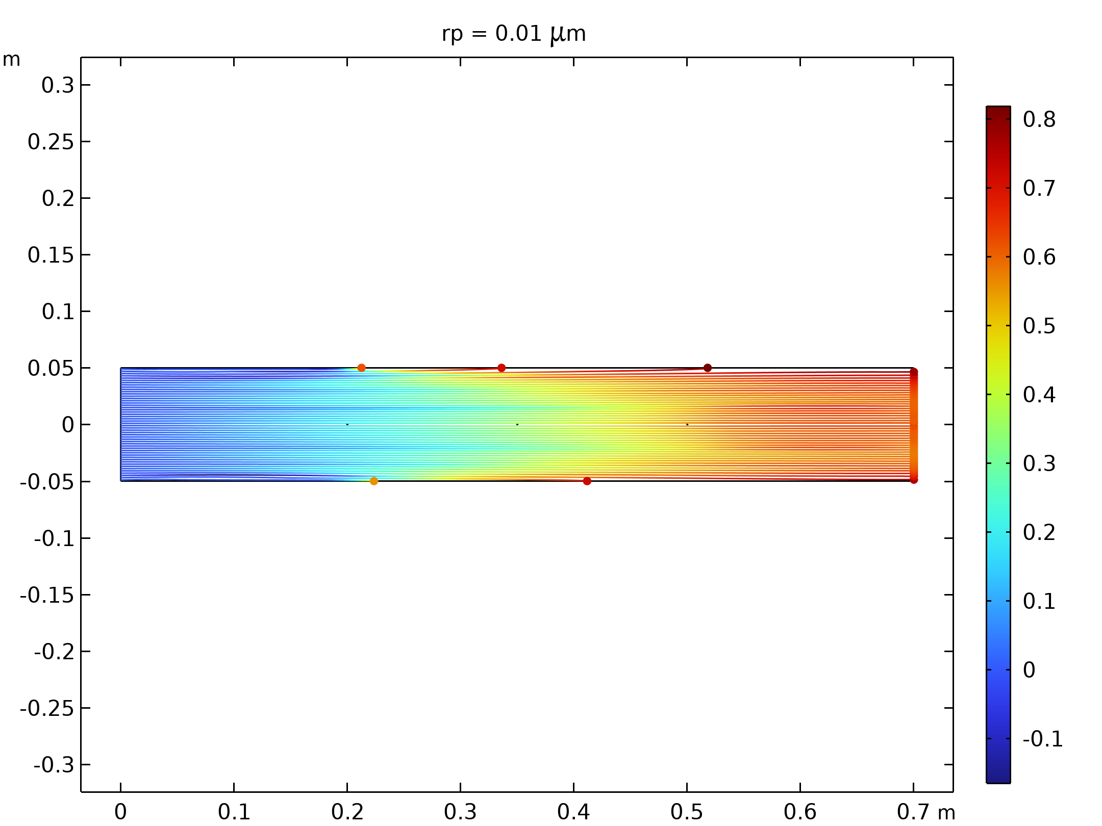  Particle trajectories with the charge number along the trajectory expressed in color for particles with a radius of 0.01 μm |  | 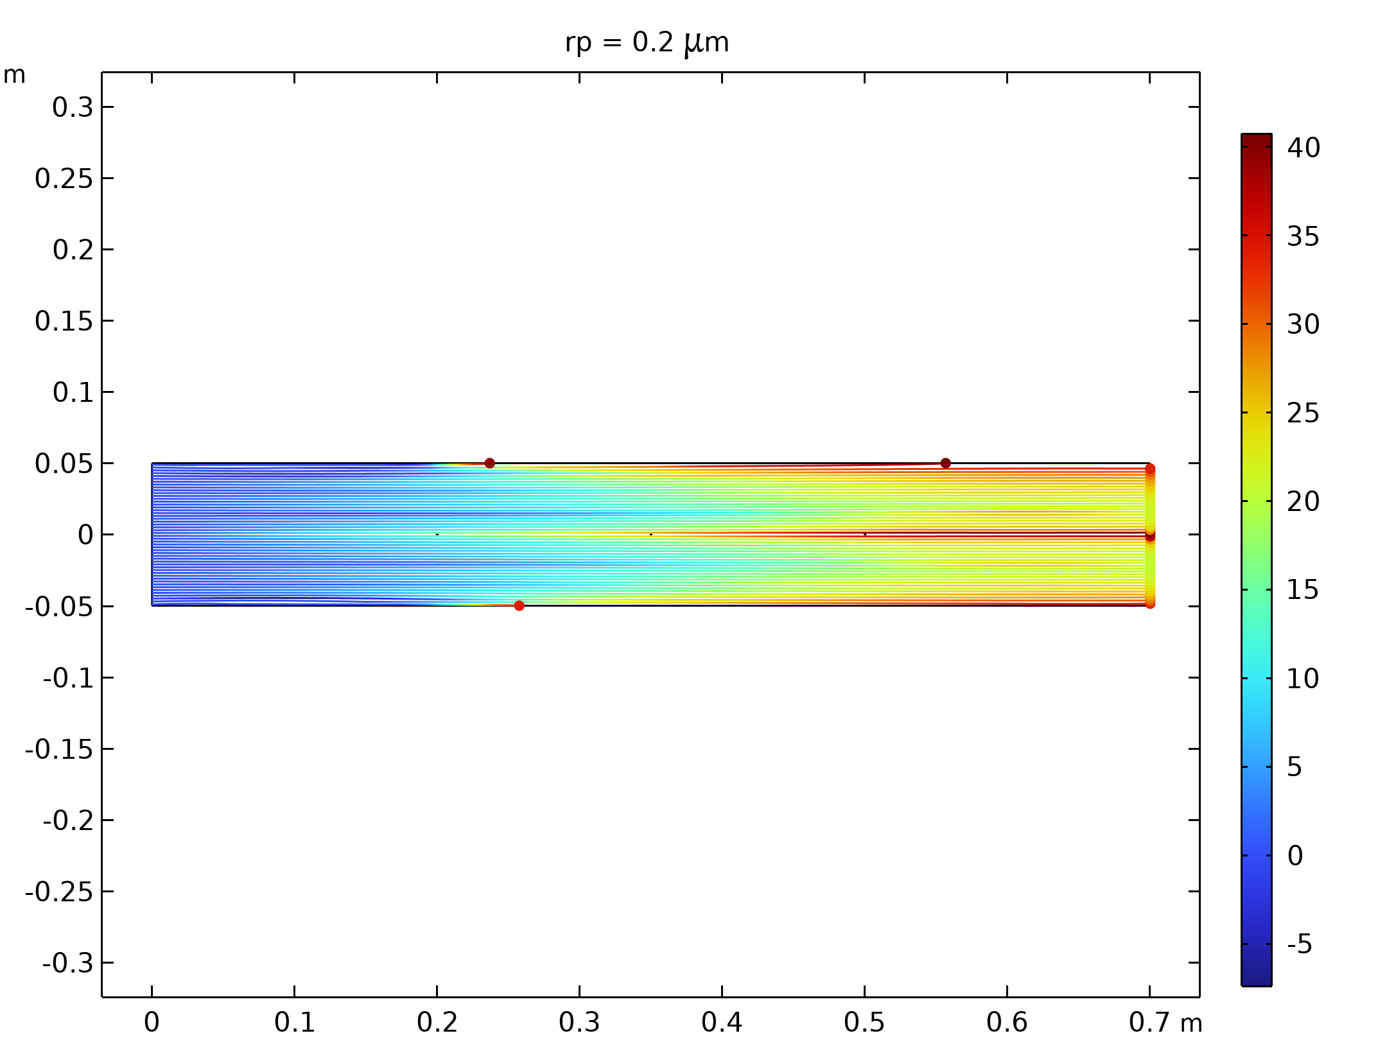  Particle trajectories with the charge number along the trajectory expressed in color for particles with a radius of 0.2 μm.
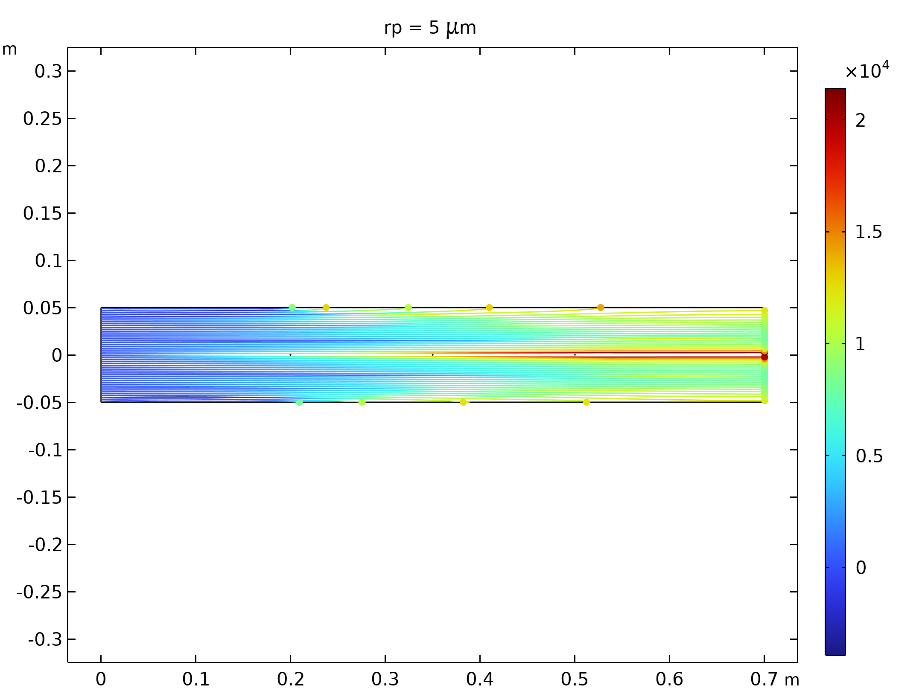  Particle trajectories with the charge number along the trajectory expressed in color for particles with a radius of 5 μm. |  | 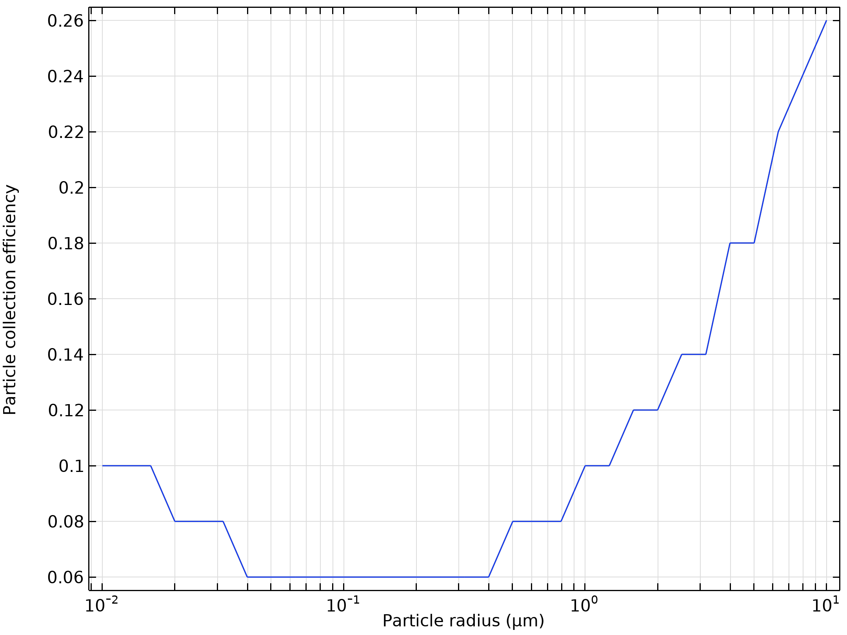  Particle collection efficiency as a function of the particle radius

Run | Wire radius (m) |  | Velocity (m/s) | Voltage (KV)
14 | 0.001 |  | 30 | 30
Velocity magnitude of the flow in electrostatic precipitator |  | Electric Potential lines around electrodes in Electrostatic Precipitator
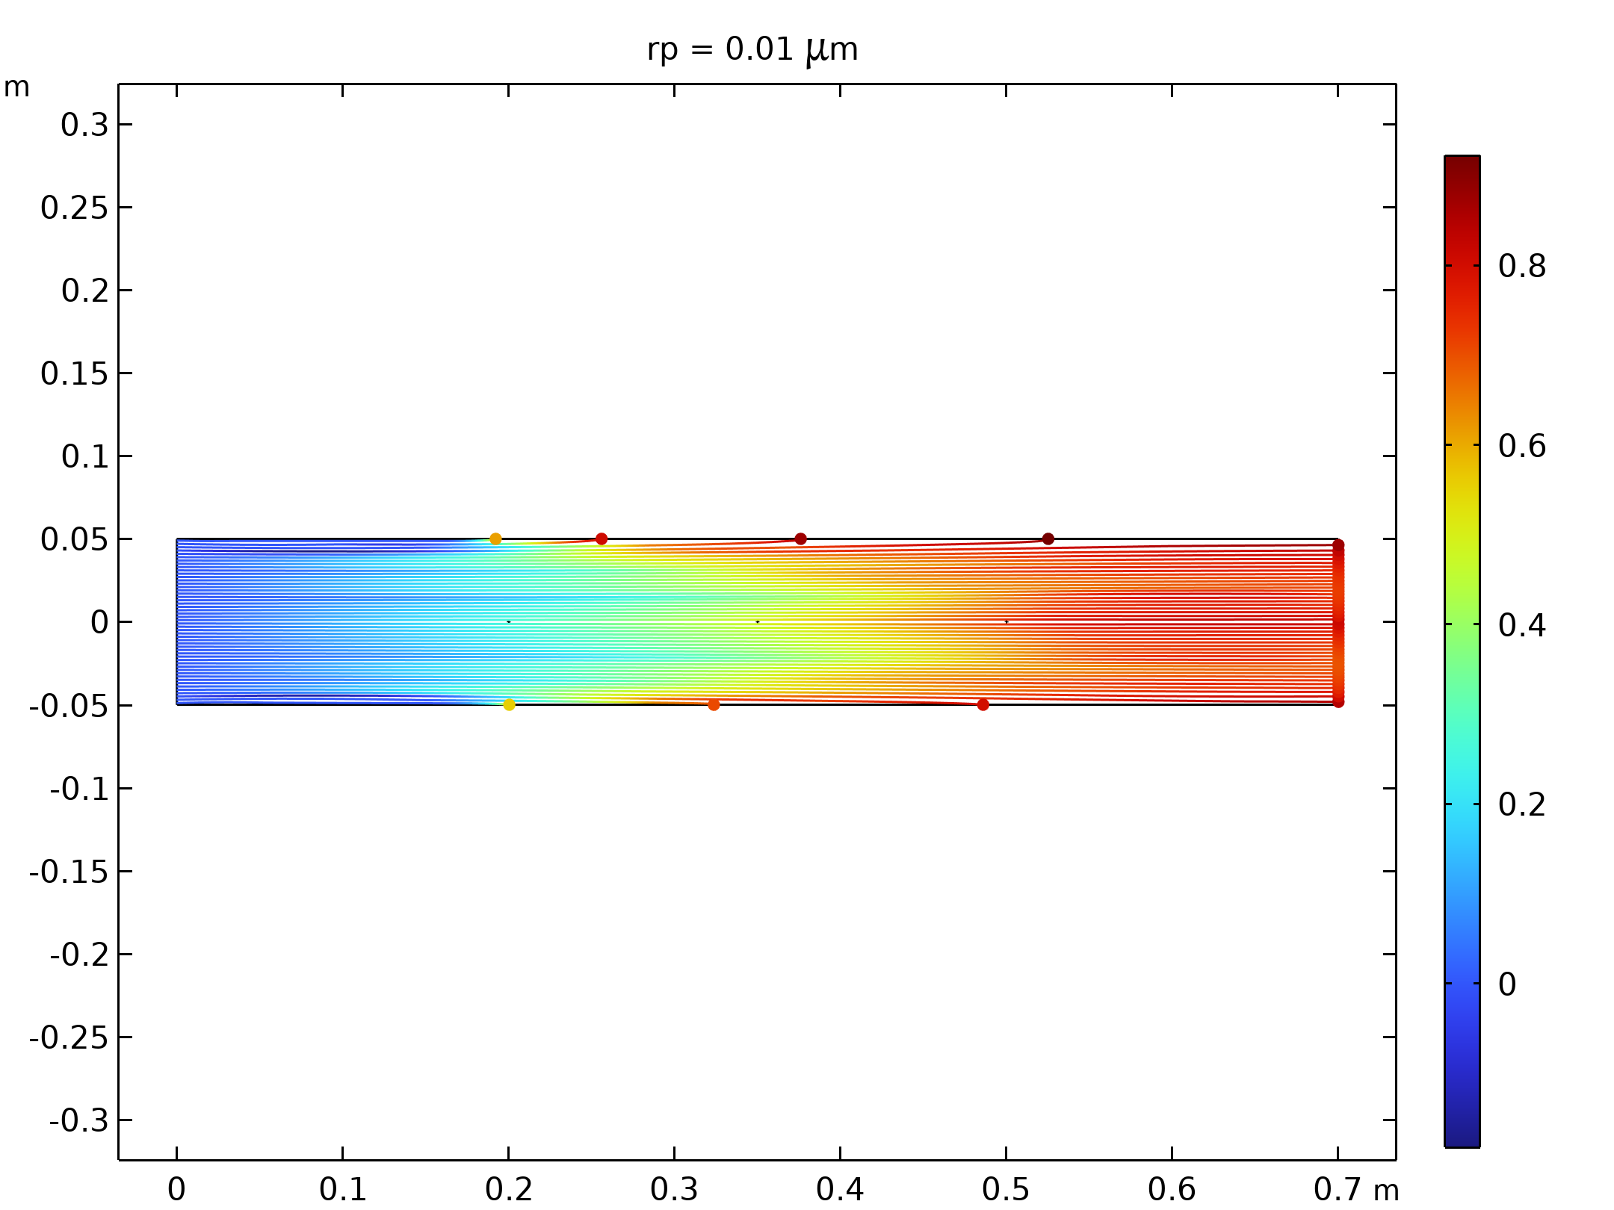  Particle trajectories with the charge number along the trajectory expressed in color for particles with a radius of 0.01 μm |  | 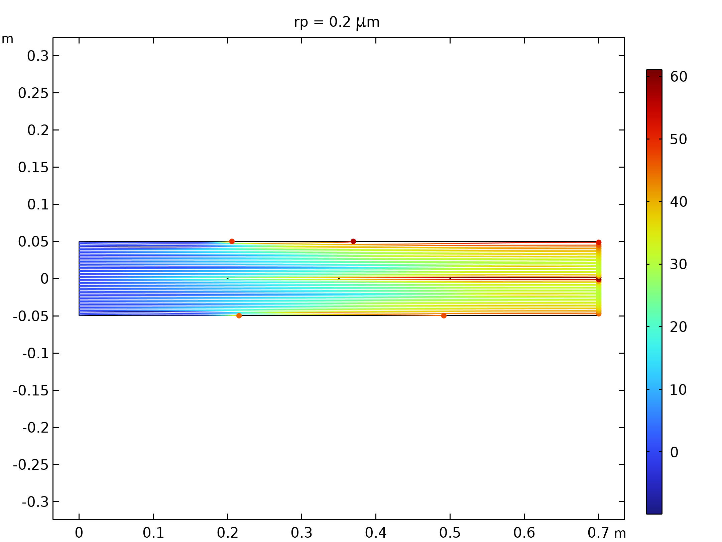  Particle trajectories with the charge number along the trajectory expressed in color for particles with a radius of 0.2 μm.
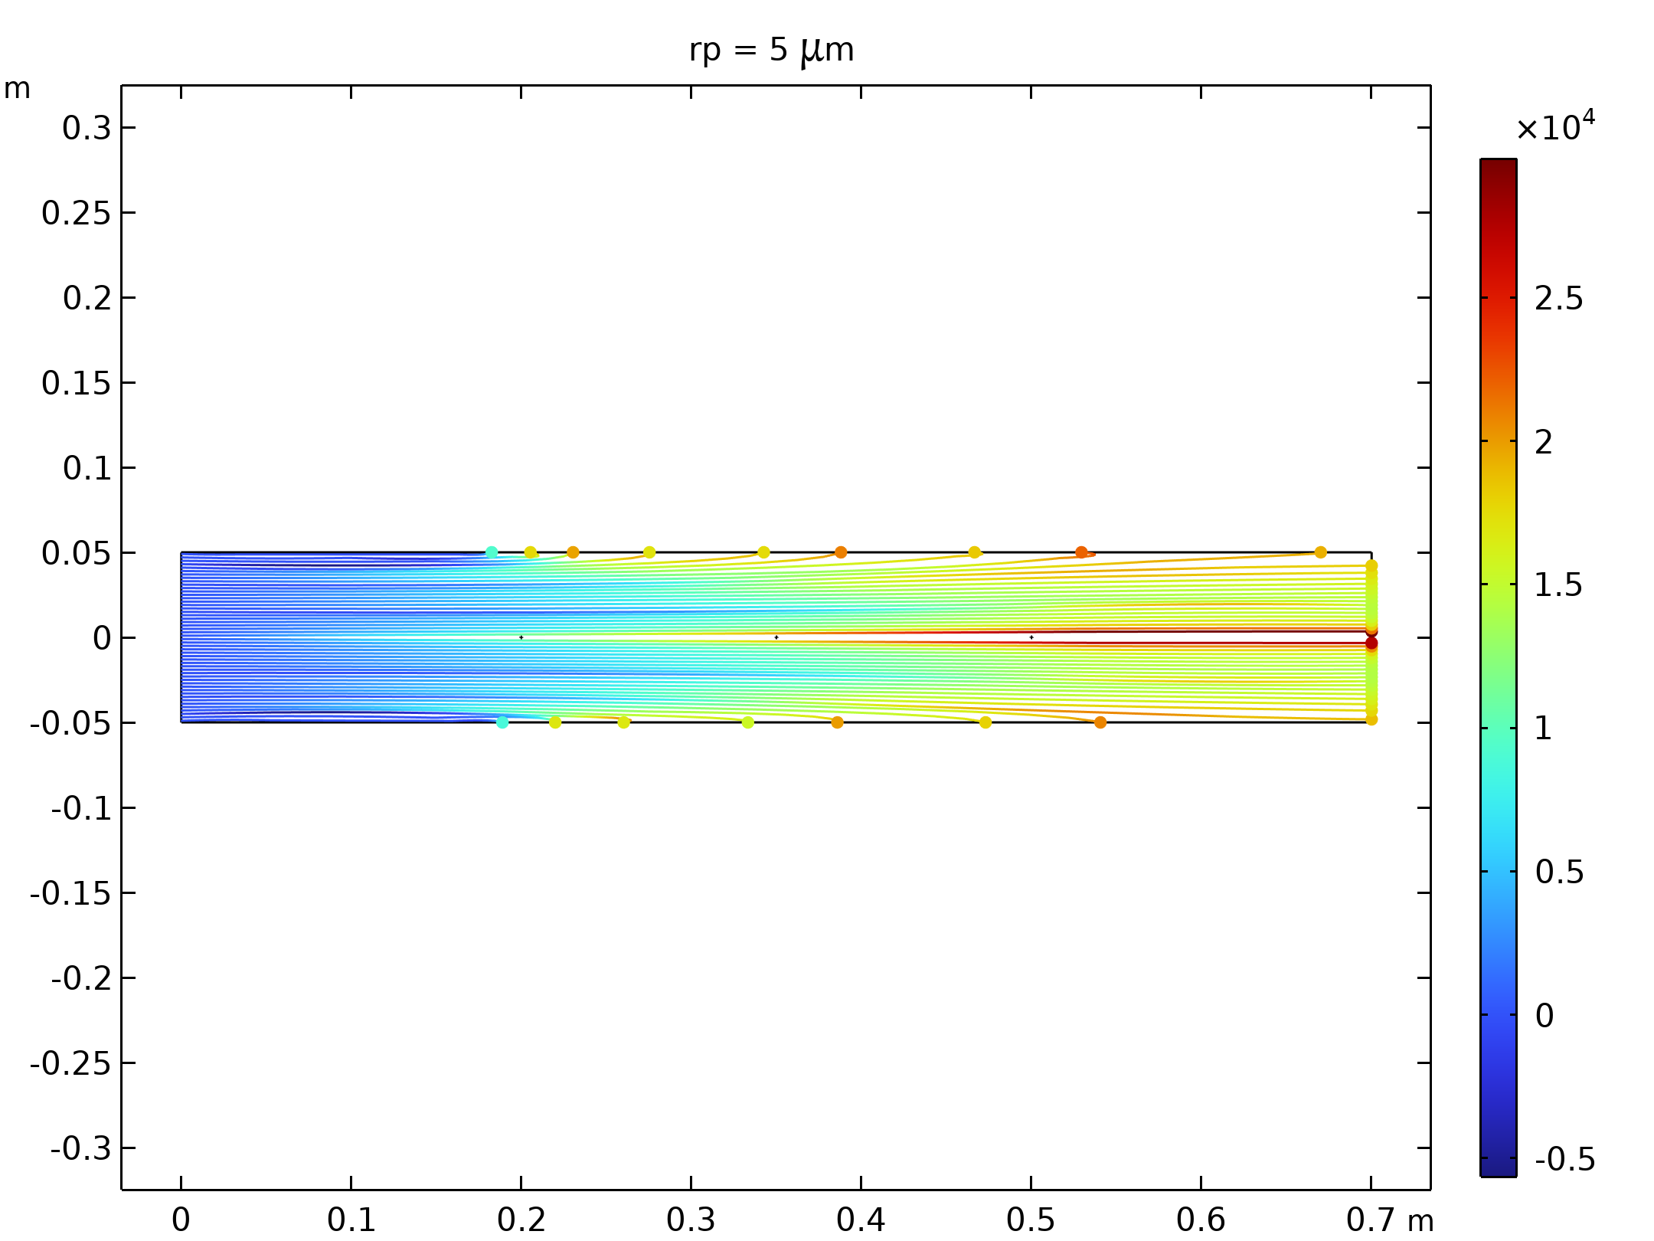  Particle trajectories with the charge number along the trajectory expressed in color for particles with a radius of 5 μm. |  | 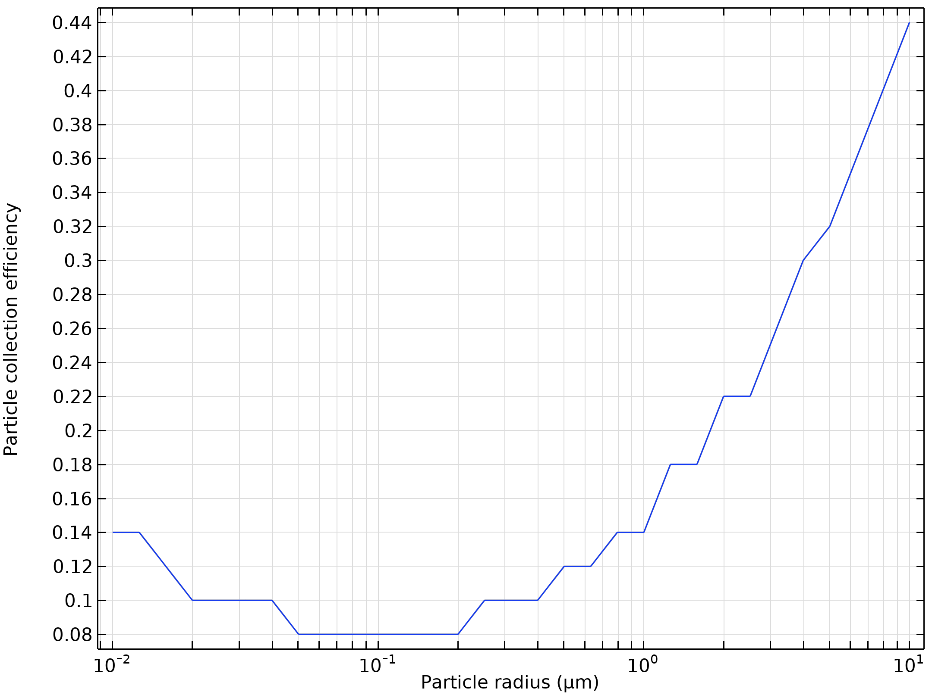  Particle collection efficiency as a function of the particle radius

Run | Wire radius (m) |  | Velocity (m/s) | Voltage (KV)
15 | 0.001 |  | 30 | 50
Velocity magnitude of the flow in electrostatic precipitator |  | Electric Potential lines around electrodes in Electrostatic Precipitator
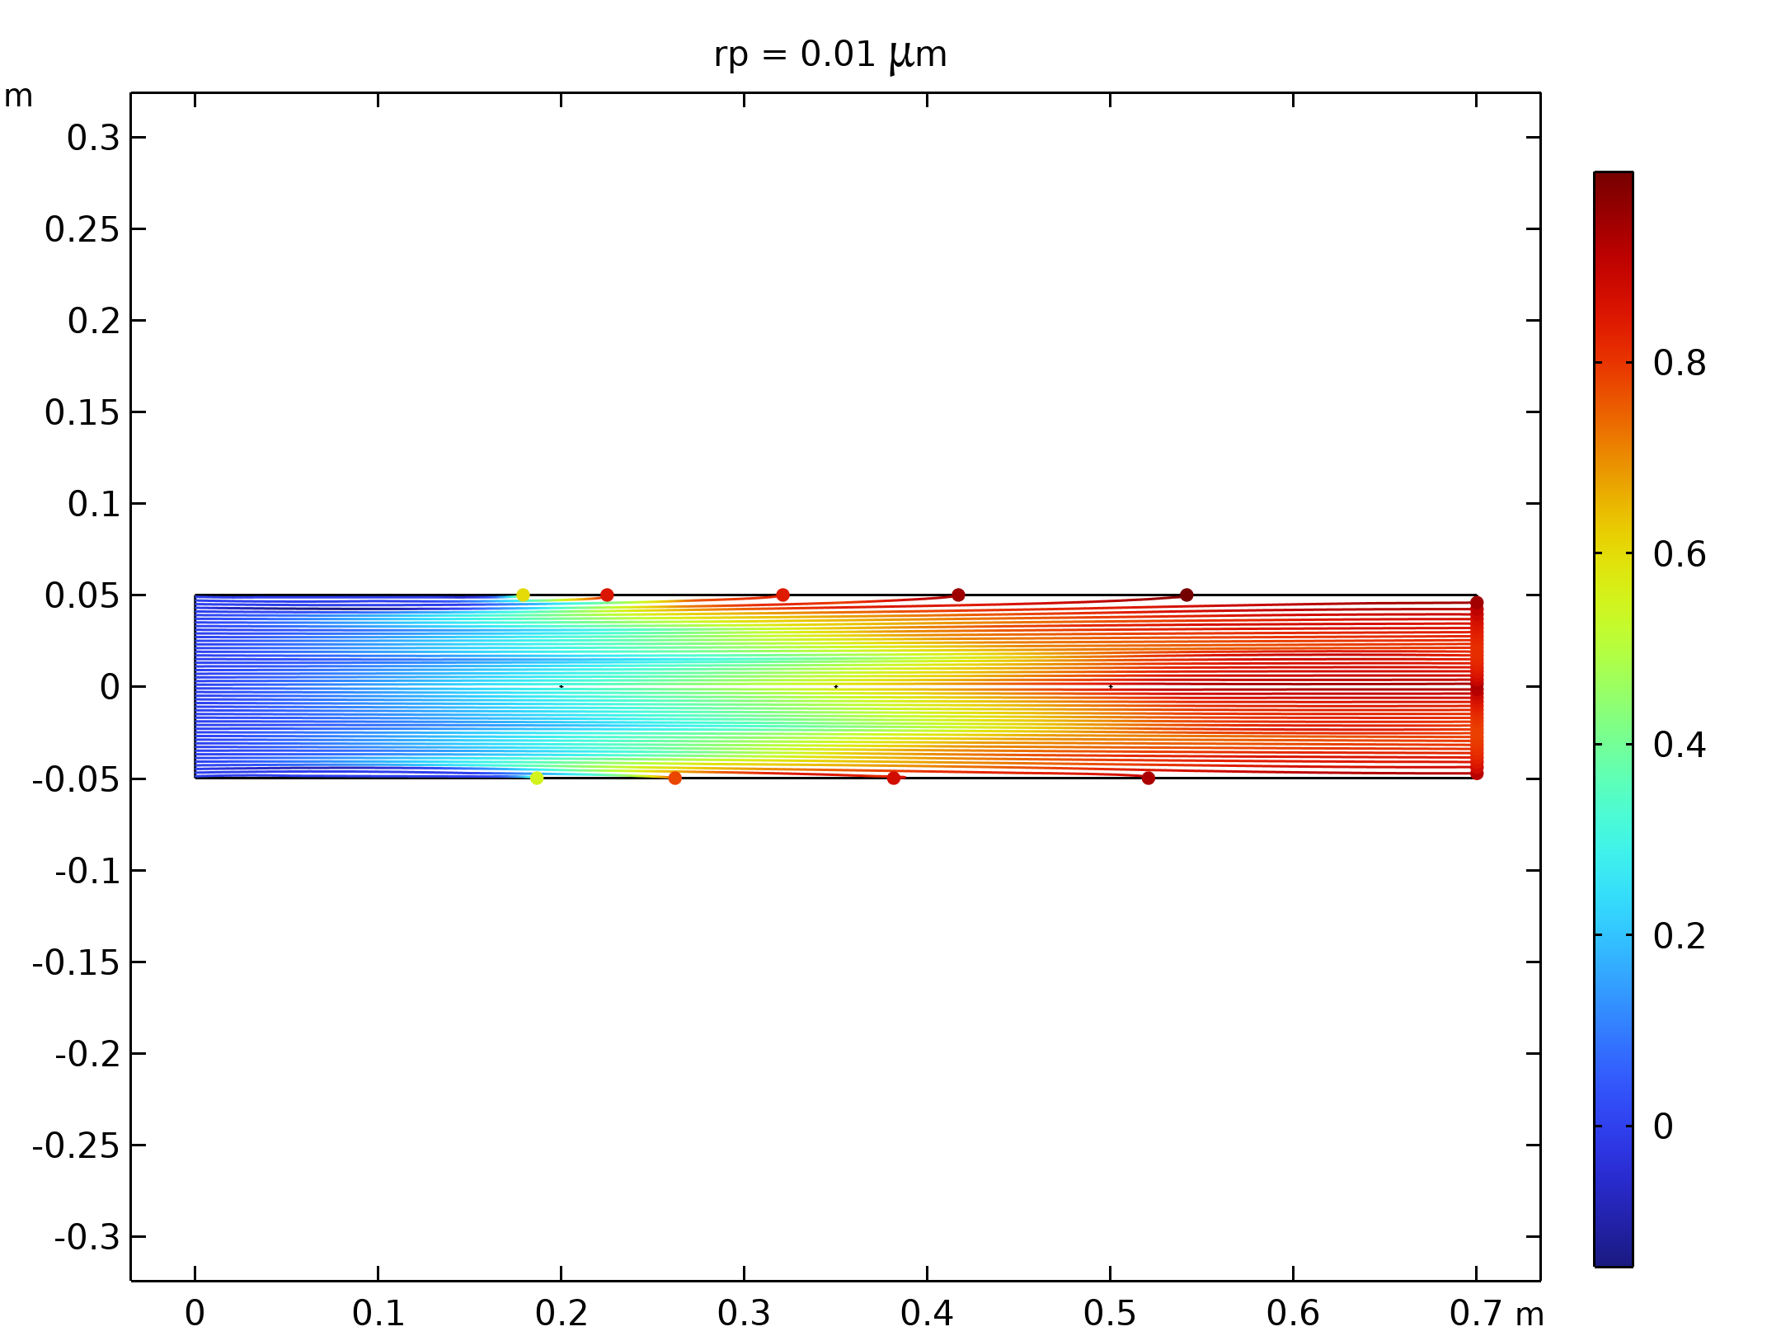  Particle trajectories with the charge number along the trajectory expressed in color for particles with a radius of 0.01 μm |  | 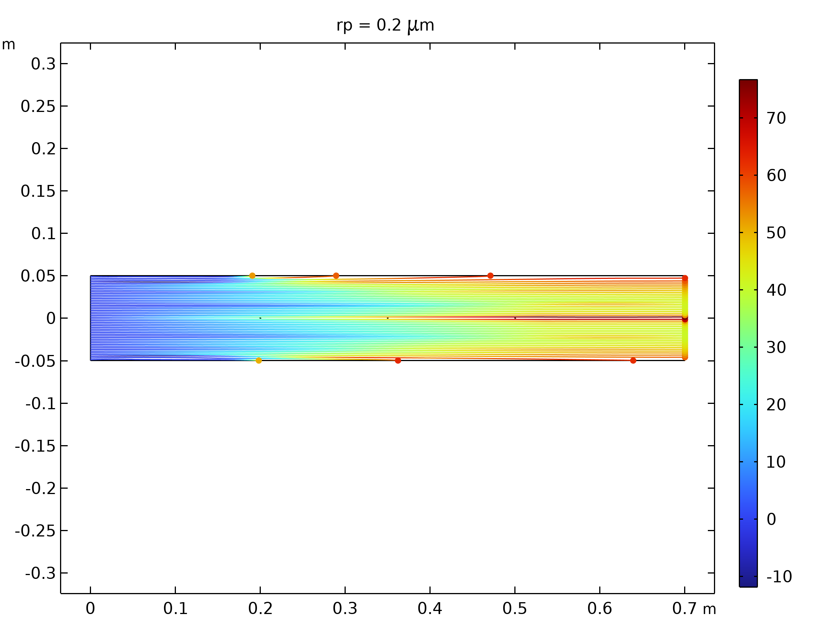  Particle trajectories with the charge number along the trajectory expressed in color for particles with a radius of 0.2 μm.
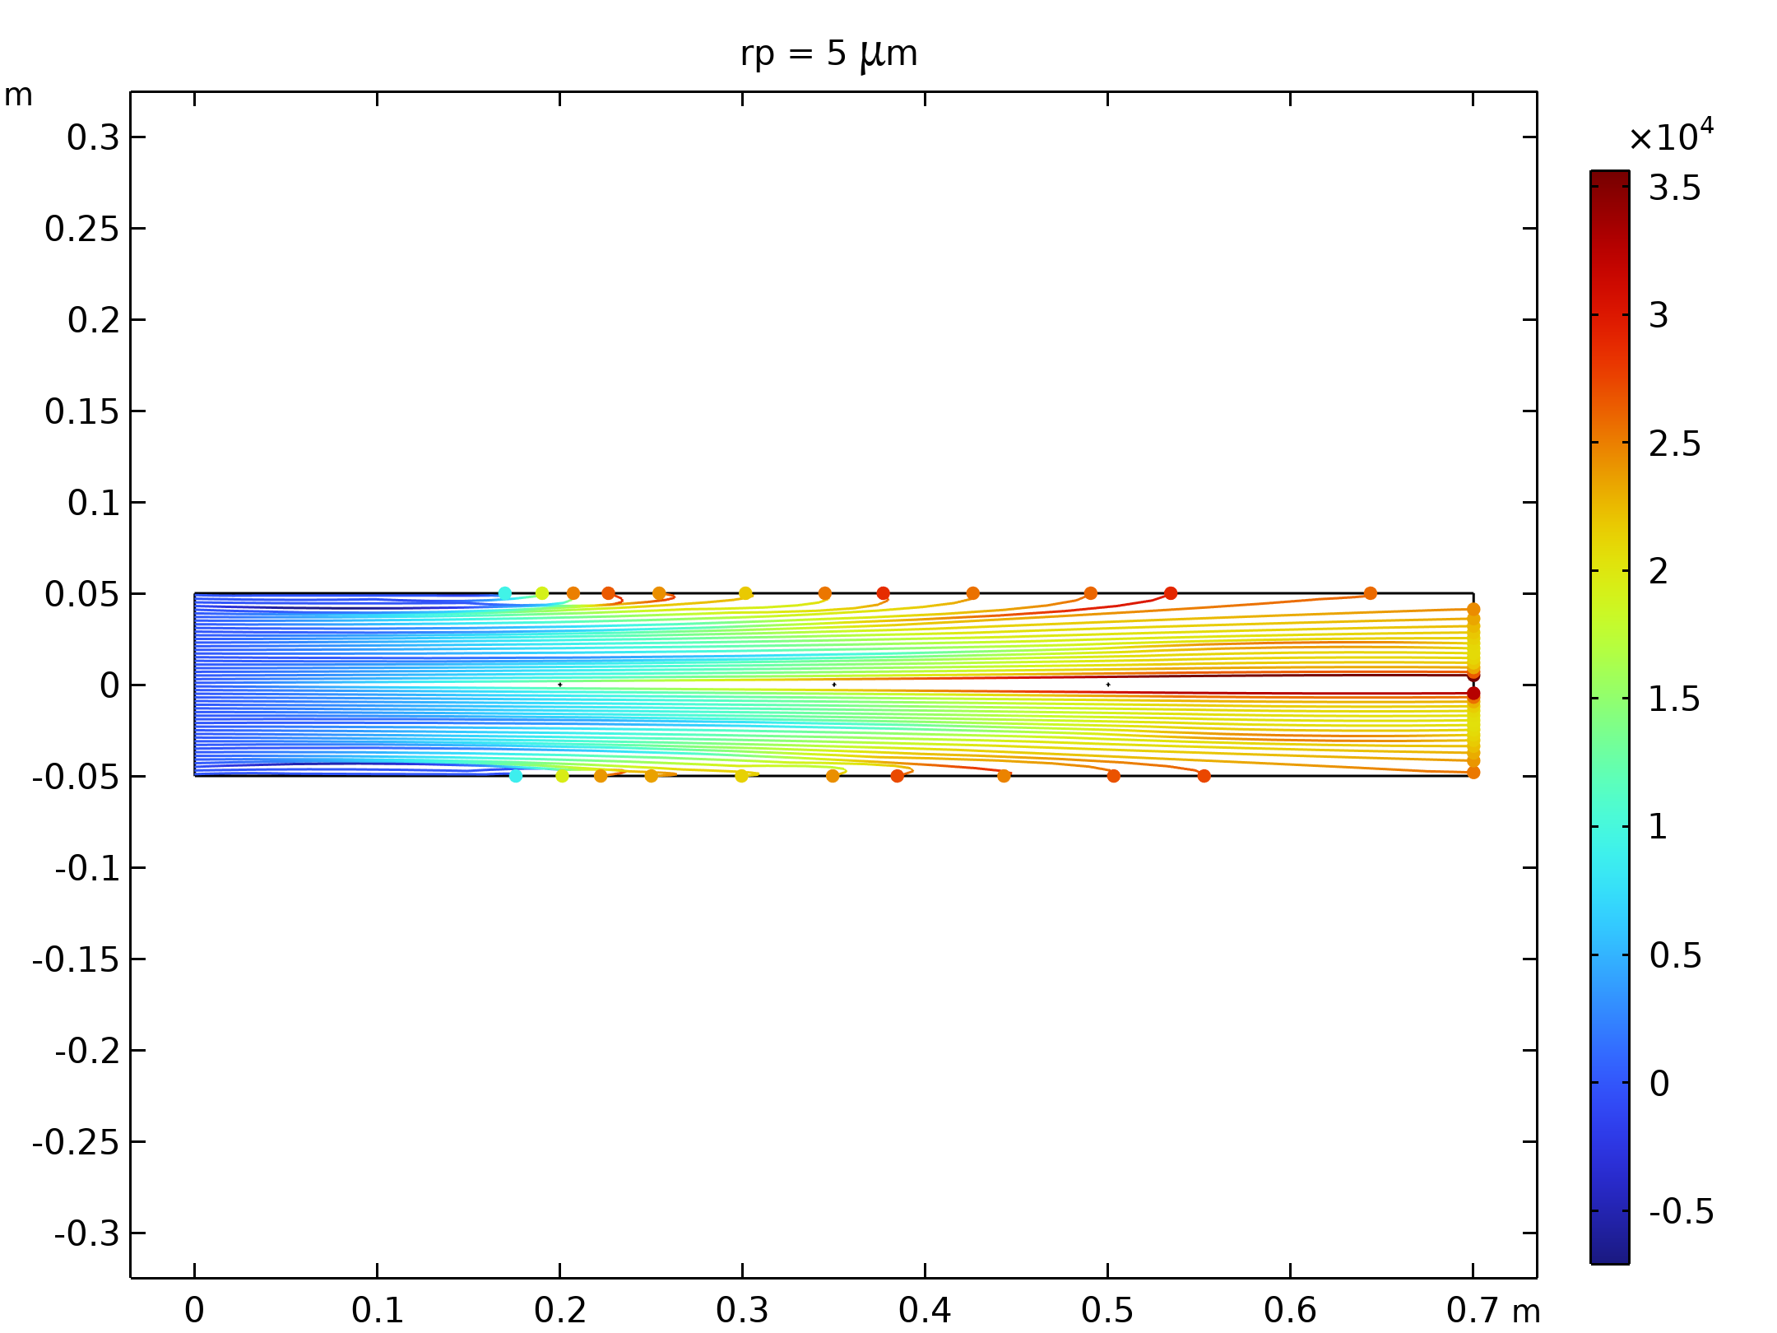  Particle trajectories with the charge number along the trajectory expressed in color for particles with a radius of 5 μm. |  | Particle collection efficiency as a function of the particle radius

Run | Wire radius (m) |  | Velocity (m/s) | Voltage (KV)
16 | 0.001 |  | 50 | 10
Velocity magnitude of the flow in electrostatic precipitator |  | Electric Potential lines around electrodes in Electrostatic Precipitator
Particle trajectories with the charge number along the trajectory expressed in color for particles with a radius of 0.01 μm |  | Particle trajectories with the charge number along the trajectory expressed in color for particles with a radius of 0.2 μm.
Particle trajectories with the charge number along the trajectory expressed in color for particles with a radius of 5 μm. |  | Particle collection efficiency as a function of the particle radius

Run | Wire radius (m) |  | Velocity (m/s) | Voltage (KV)
17 | 0.001 |  | 50 | 30
Velocity magnitude of the flow in electrostatic precipitator |  | Electric Potential lines around electrodes in Electrostatic Precipitator
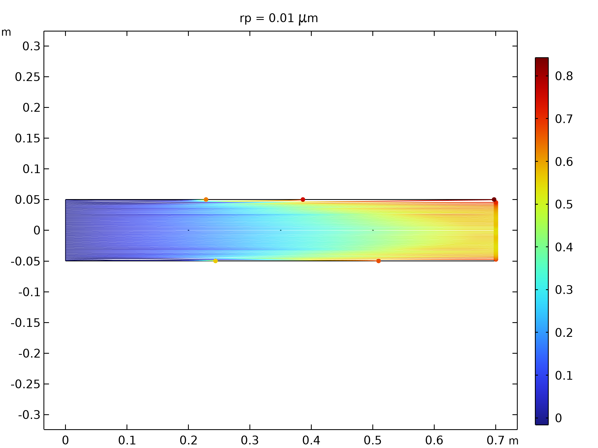  Particle trajectories with the charge number along the trajectory expressed in color for particles with a radius of 0.01 μm |  | 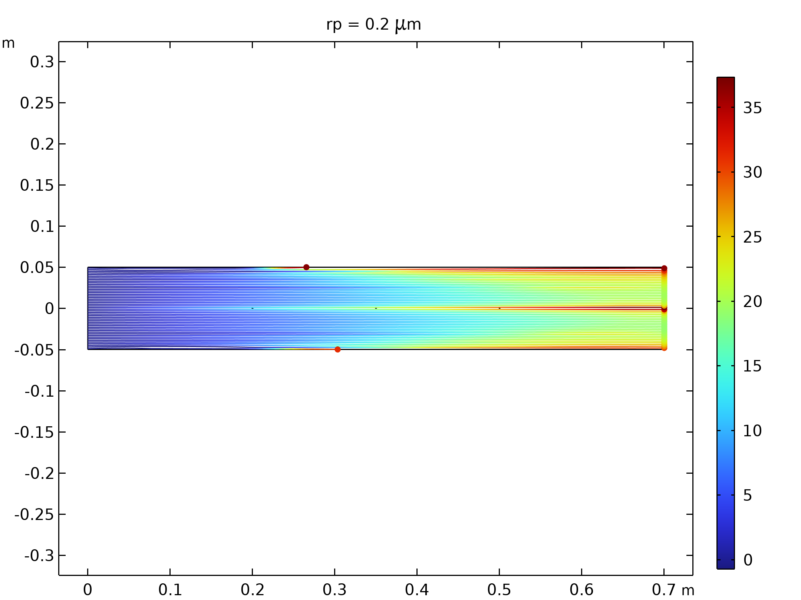  Particle trajectories with the charge number along the trajectory expressed in color for particles with a radius of 0.2 μm.
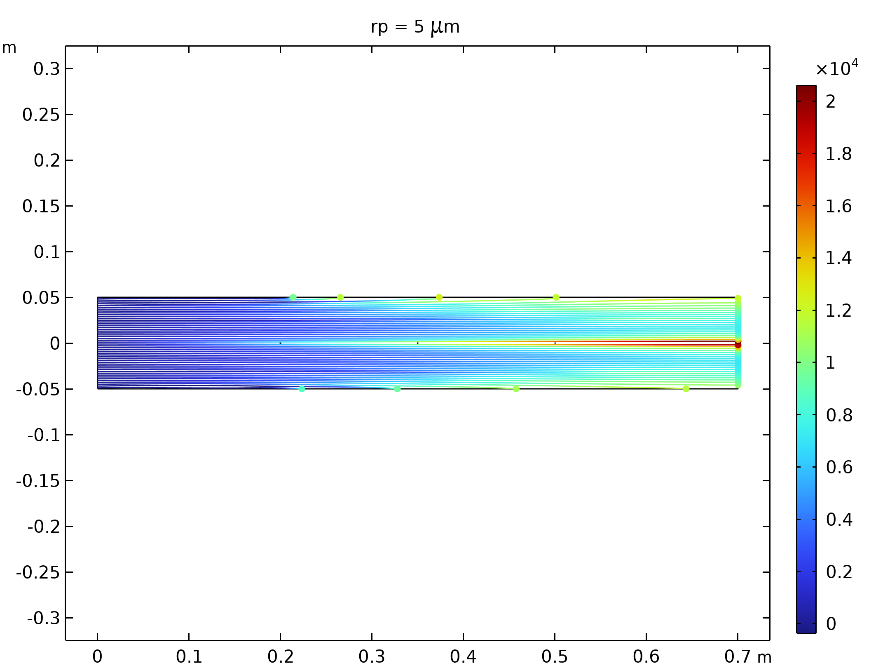  Particle trajectories with the charge number along the trajectory expressed in color for particles with a radius of 5 μm. |  | 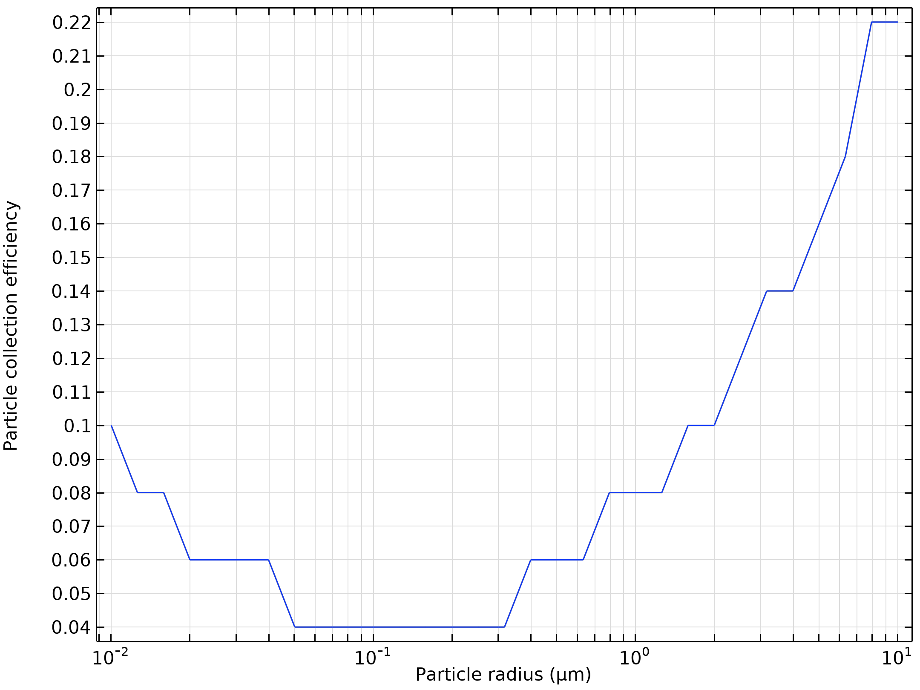  Particle collection efficiency as a function of the particle radius

Run | Wire radius (m) |  | Velocity (m/s) | Voltage (KV)
18 | 0.001 |  | 50 | 50
Velocity magnitude of the flow in electrostatic precipitator |  | Electric Potential lines around electrodes in Electrostatic Precipitator
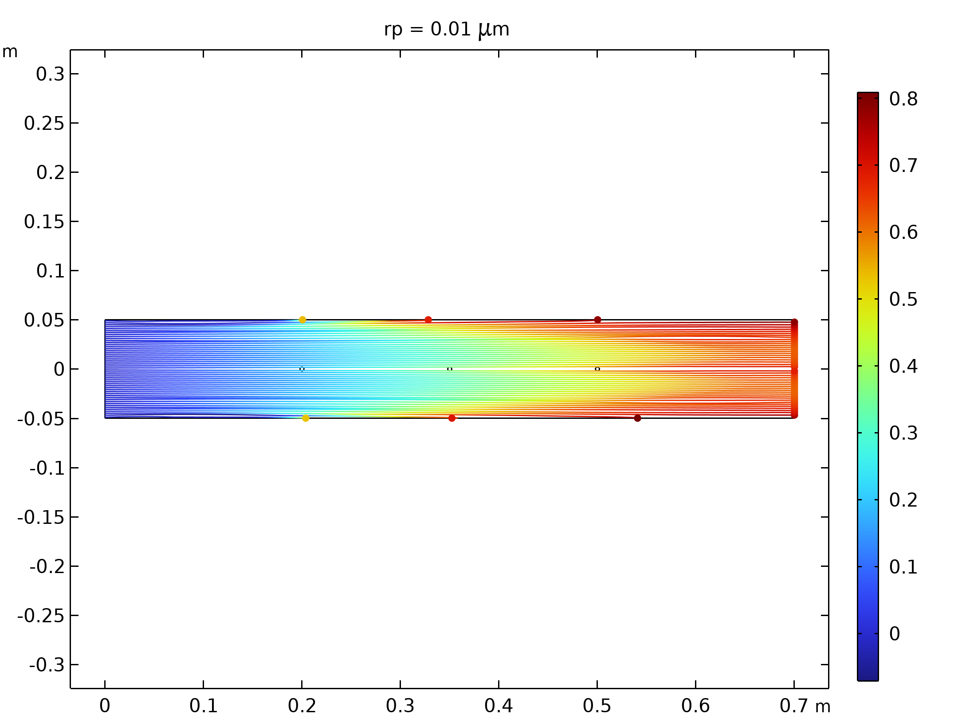  Particle trajectories with the charge number along the trajectory expressed in color for particles with a radius of 0.01 μm |  | 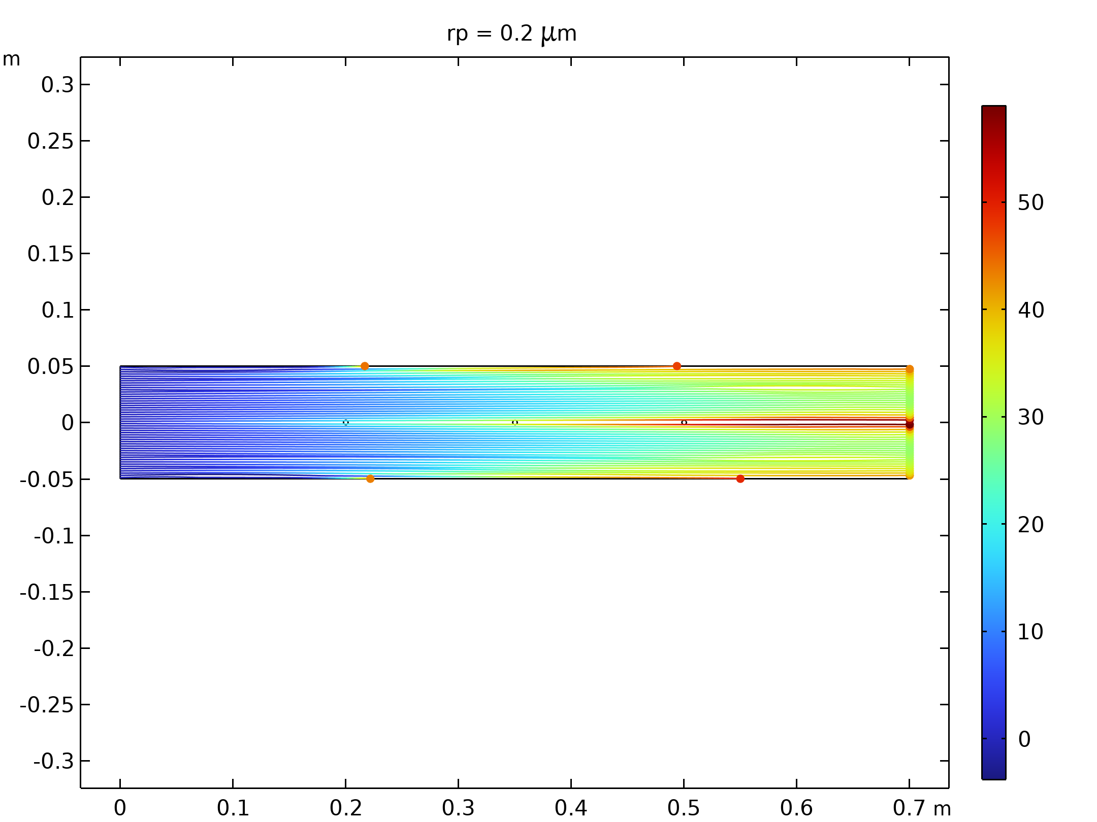  Particle trajectories with the charge number along the trajectory expressed in color for particles with a radius of 0.2 μm.
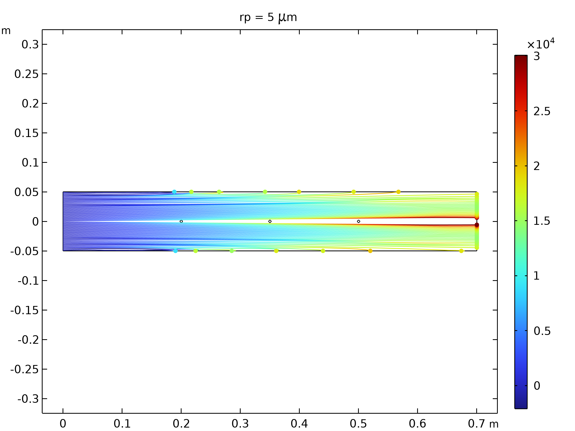  Particle trajectories with the charge number along the trajectory expressed in color for particles with a radius of 5 μm. |  | 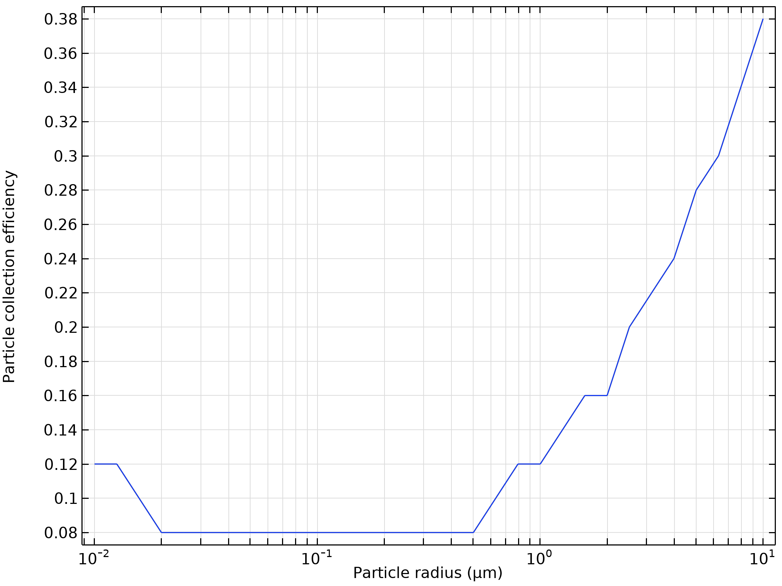  Particle collection efficiency as a function of the particle radius

Run | Wire radius (m) |  | Velocity (m/s) | Voltage (KV)
19 | 0.002 |  | 10 | 10
Velocity magnitude of the flow in electrostatic precipitator |  | Electric Potential lines around electrodes in Electrostatic Precipitator
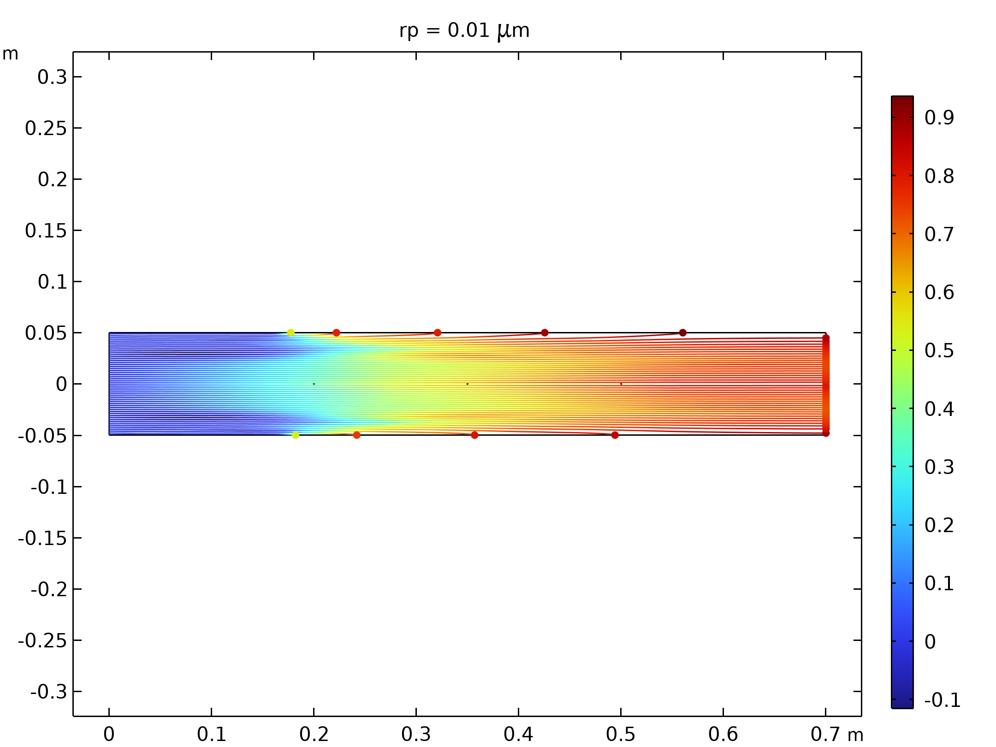  Particle trajectories with the charge number along the trajectory expressed in color for particles with a radius of 0.01 μm |  | 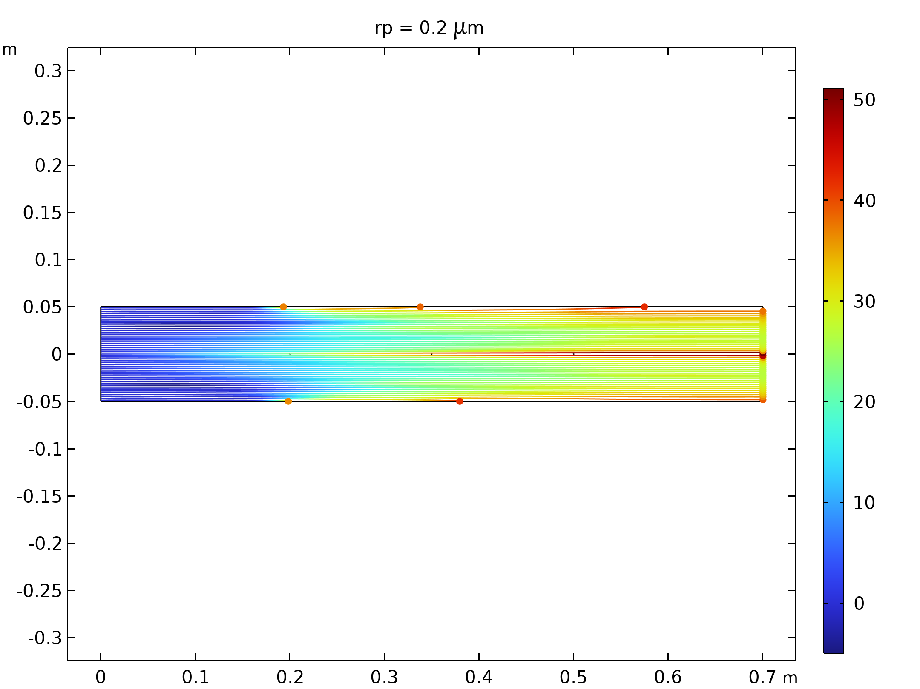  Particle trajectories with the charge number along the trajectory expressed in color for particles with a radius of 0.2 μm.
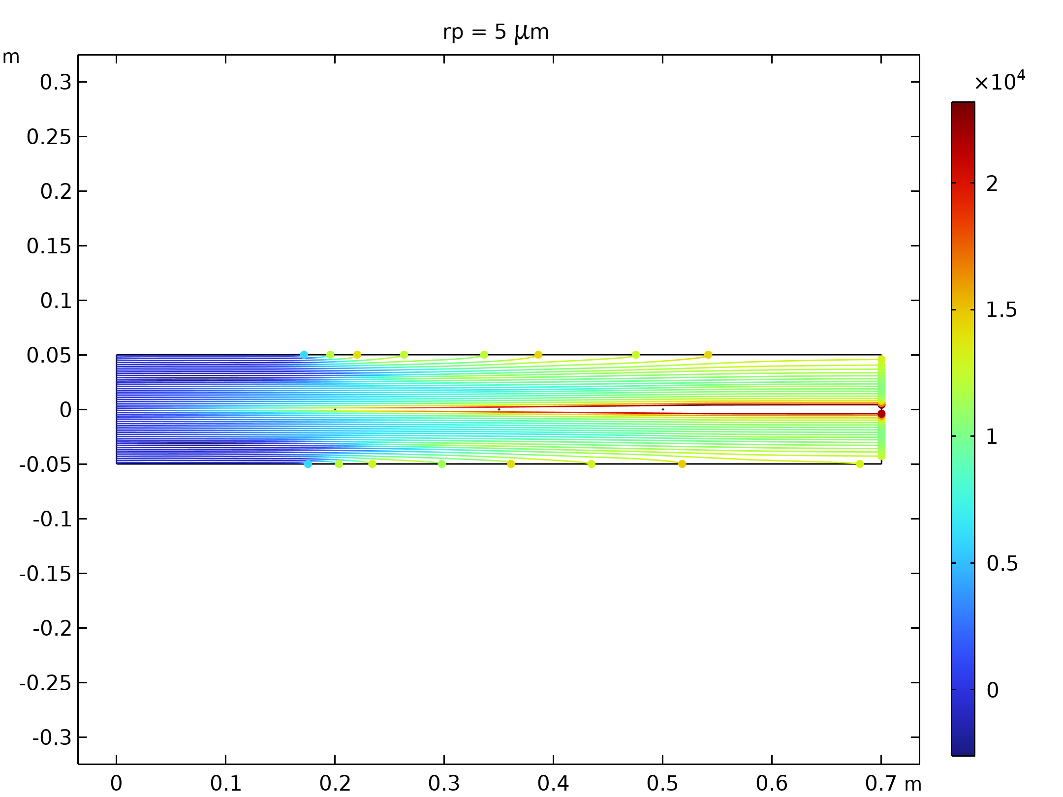  Particle trajectories with the charge number along the trajectory expressed in color for particles with a radius of 5 μm. |  | 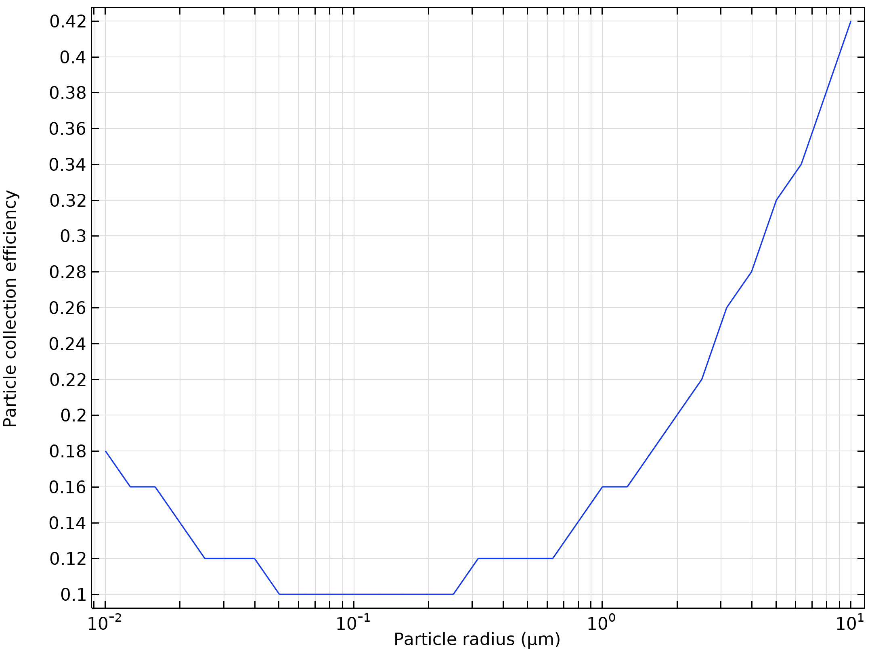  Particle collection efficiency as a function of the particle radius

Run | Wire radius (m) |  | Velocity (m/s) | Voltage (KV)
20 | 0.002 |  | 10 | 30
Velocity magnitude of the flow in electrostatic precipitator |  | Electric Potential lines around electrodes in Electrostatic Precipitator
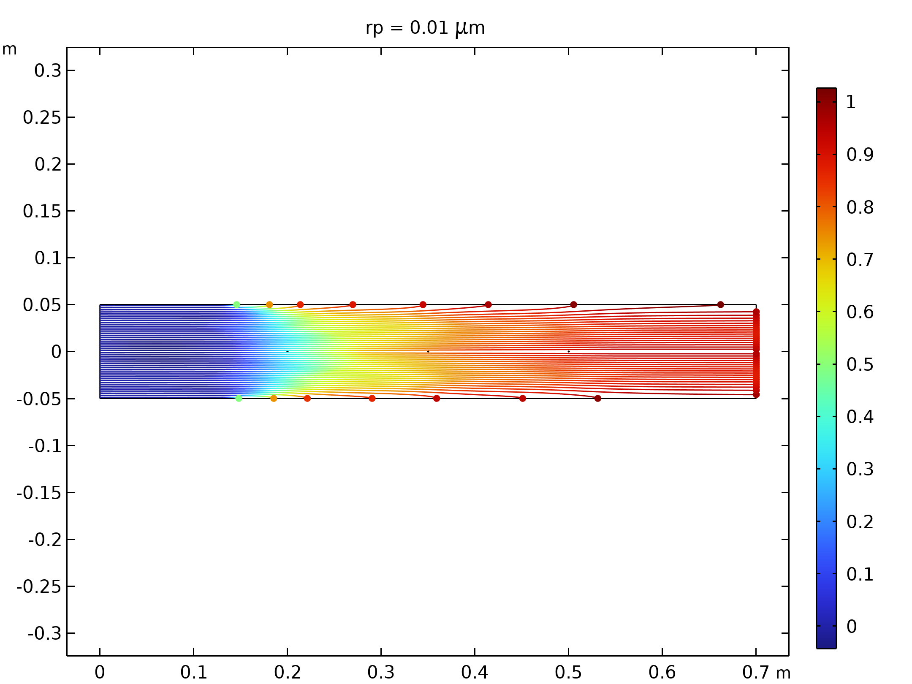  Particle trajectories with the charge number along the trajectory expressed in color for particles with a radius of 0.01 μm |  | 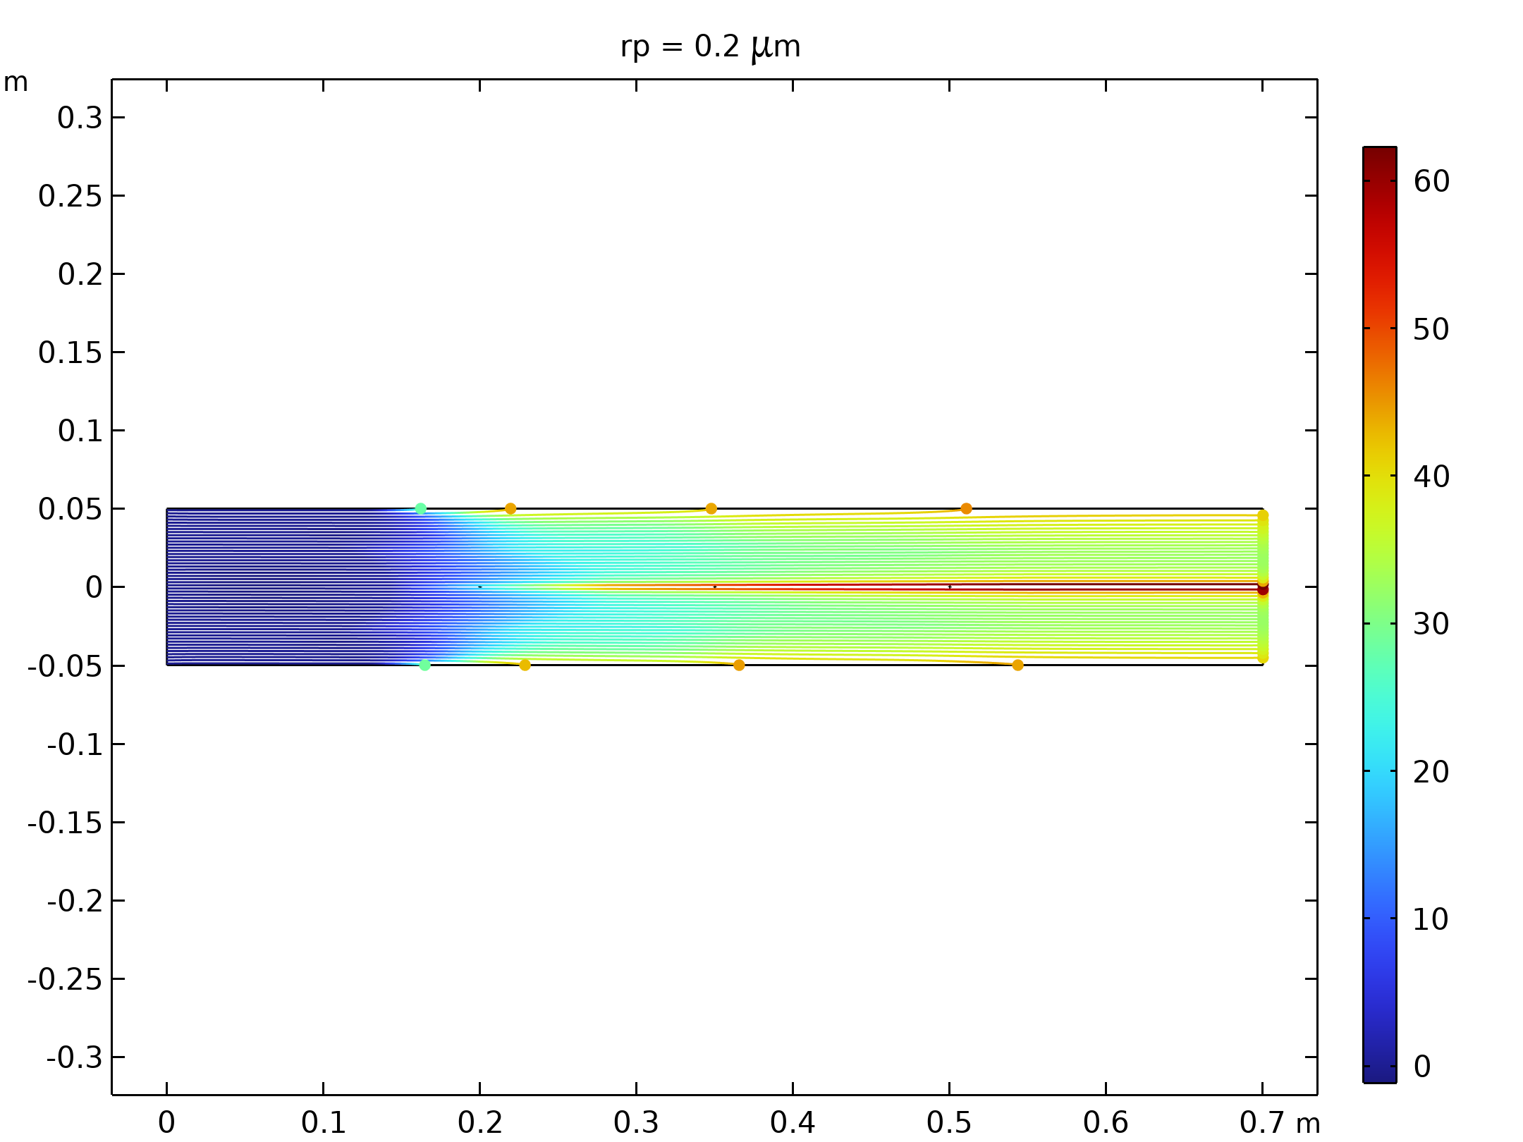  Particle trajectories with the charge number along the trajectory expressed in color for particles with a radius of 0.2 μm.
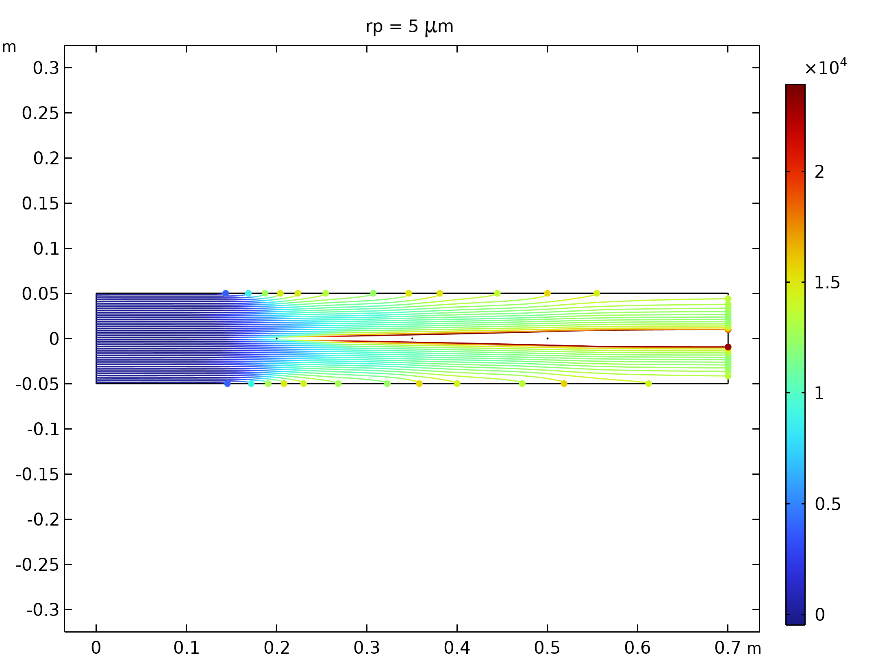  Particle trajectories with the charge number along the trajectory expressed in color for particles with a radius of 5 μm. |  | 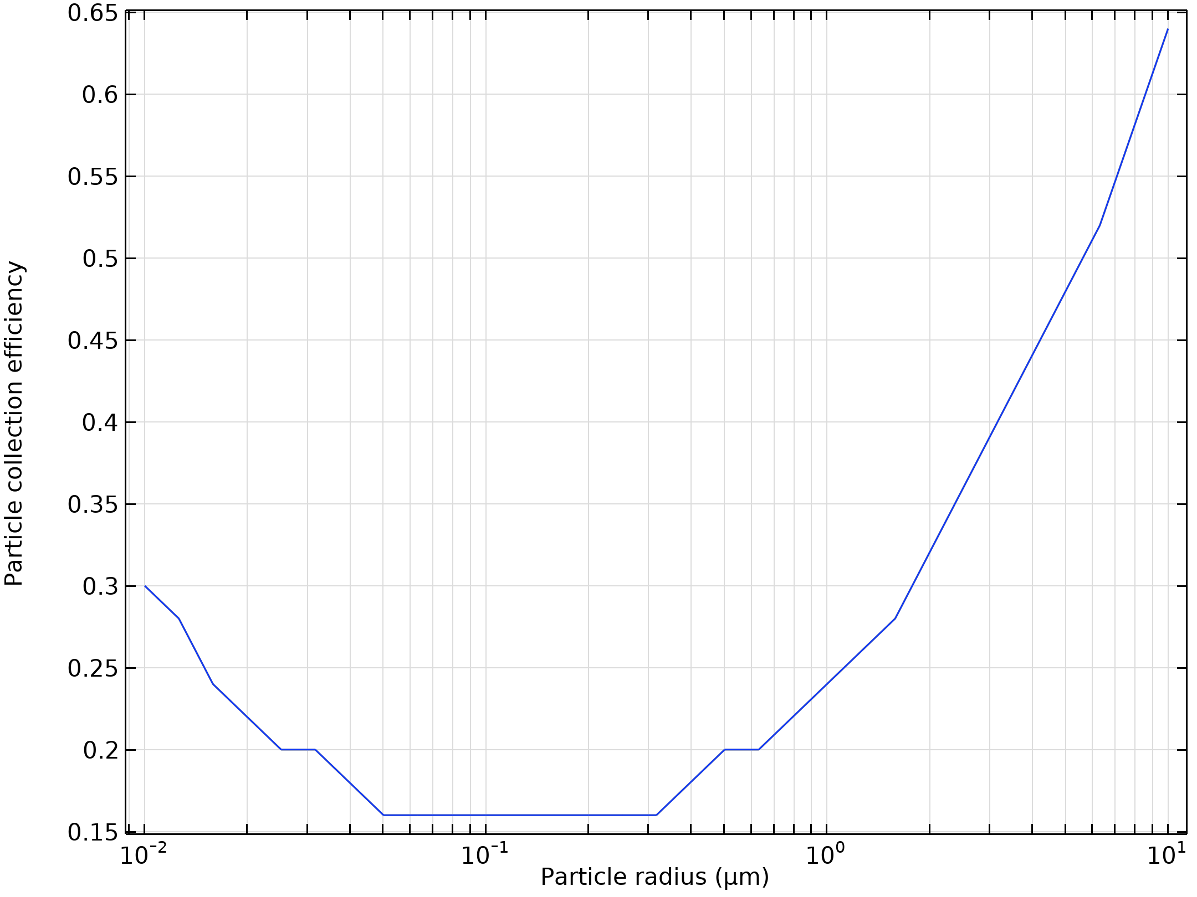  Particle collection efficiency as a function of the particle radius

Run | Wire radius (m) |  | Velocity (m/s) | Voltage (KV)
21 | 0.002 |  | 10 | 50
Velocity magnitude of the flow in electrostatic precipitator |  | Electric Potential lines around electrodes in Electrostatic Precipitator
Particle trajectories with the charge number along the trajectory expressed in color for particles with a radius of 0.01 μm |  | Particle trajectories with the charge number along the trajectory expressed in color for particles with a radius of 0.2 μm.
Particle trajectories with the charge number along the trajectory expressed in color for particles with a radius of 5 μm. |  | Particle collection efficiency as a function of the particle radius

Run | Wire radius (m) |  | Velocity (m/s) | Voltage (KV)
22 | 0.002 |  | 30 | 10
Velocity magnitude of the flow in electrostatic precipitator |  | Electric Potential lines around electrodes in Electrostatic Precipitator
Particle trajectories with the charge number along the trajectory expressed in color for particles with a radius of 0.01 μm |  | Particle trajectories with the charge number along the trajectory expressed in color for particles with a radius of 0.2 μm.
Particle trajectories with the charge number along the trajectory expressed in color for particles with a radius of 5 μm. |  | 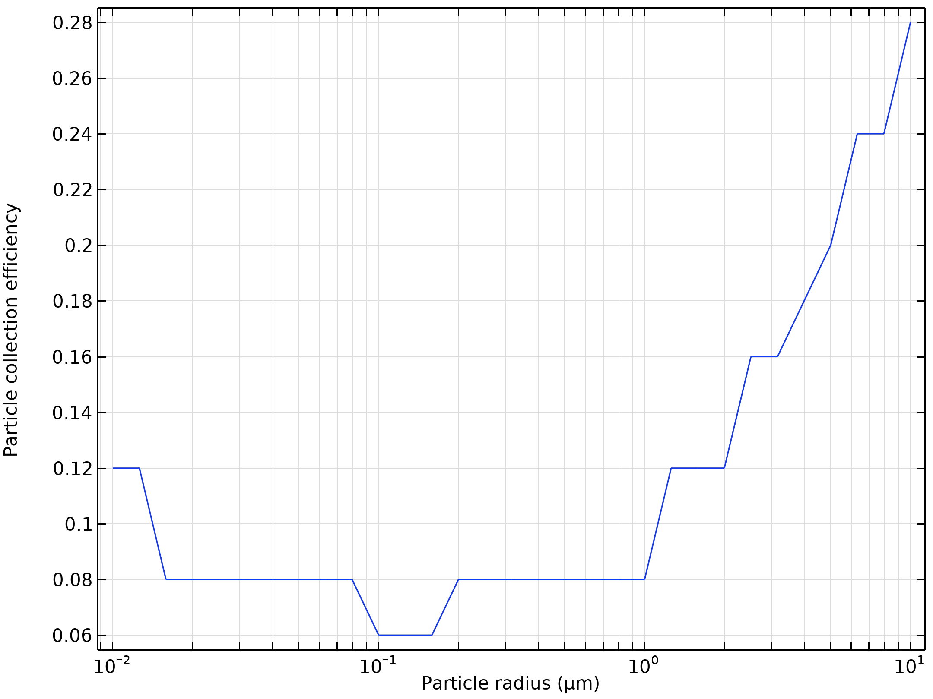  Particle collection efficiency as a function of the particle radius

Run | Wire radius (m) |  | Velocity (m/s) | Voltage (KV)
23 | 0.002 |  | 30 | 30
Velocity magnitude of the flow in electrostatic precipitator |  | Electric Potential lines around electrodes in Electrostatic Precipitator
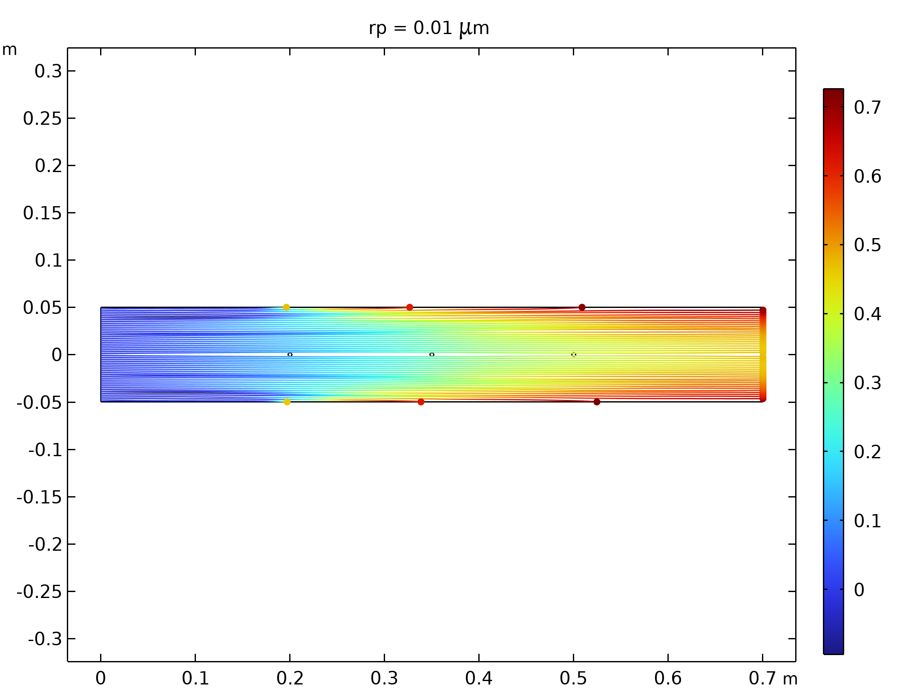  Particle trajectories with the charge number along the trajectory expressed in color for particles with a radius of 0.01 μm |  | 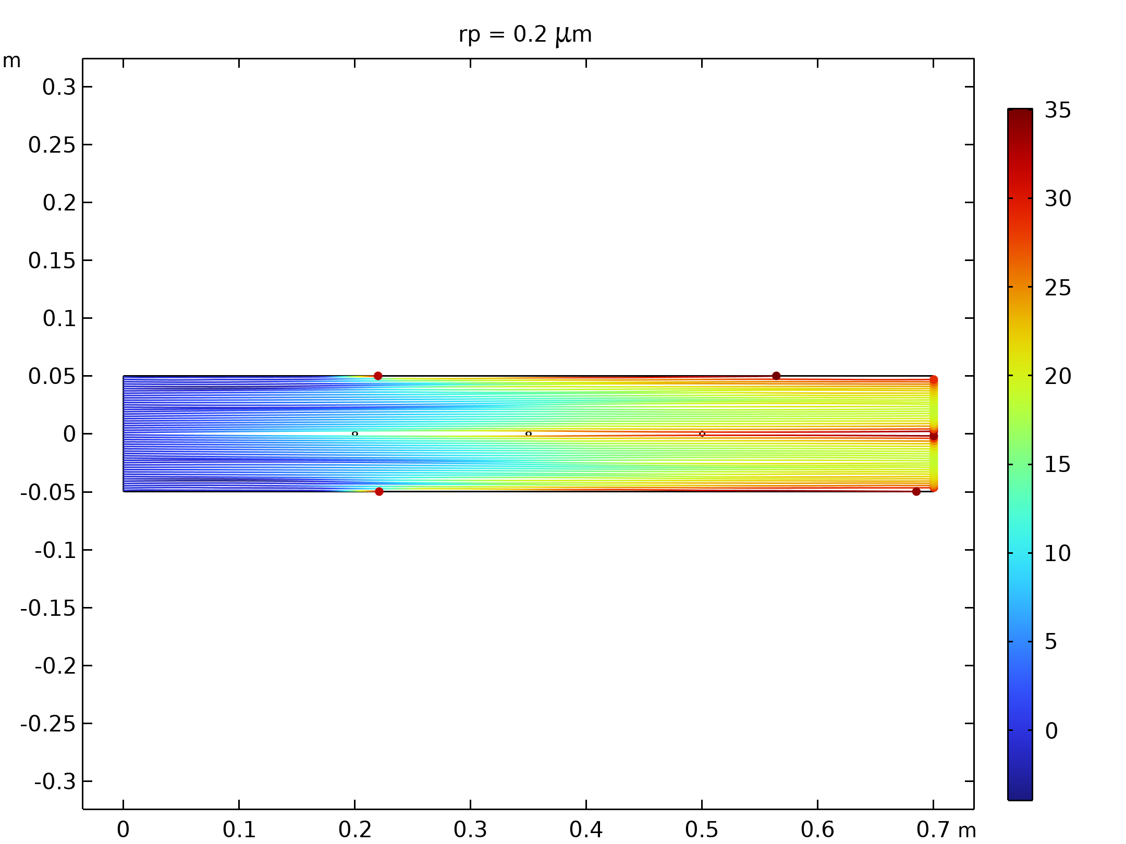  Particle trajectories with the charge number along the trajectory expressed in color for particles with a radius of 0.2 μm.
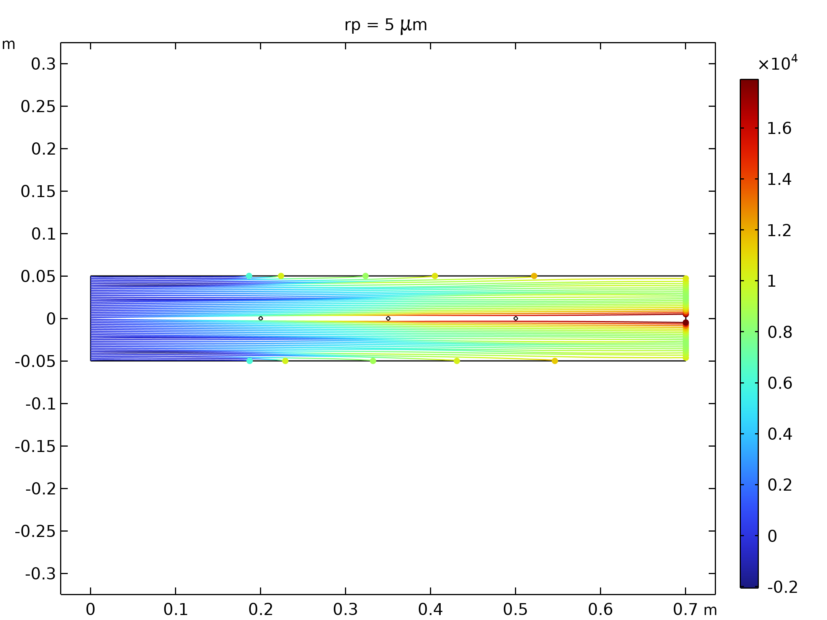  Particle trajectories with the charge number along the trajectory expressed in color for particles with a radius of 5 μm. |  | 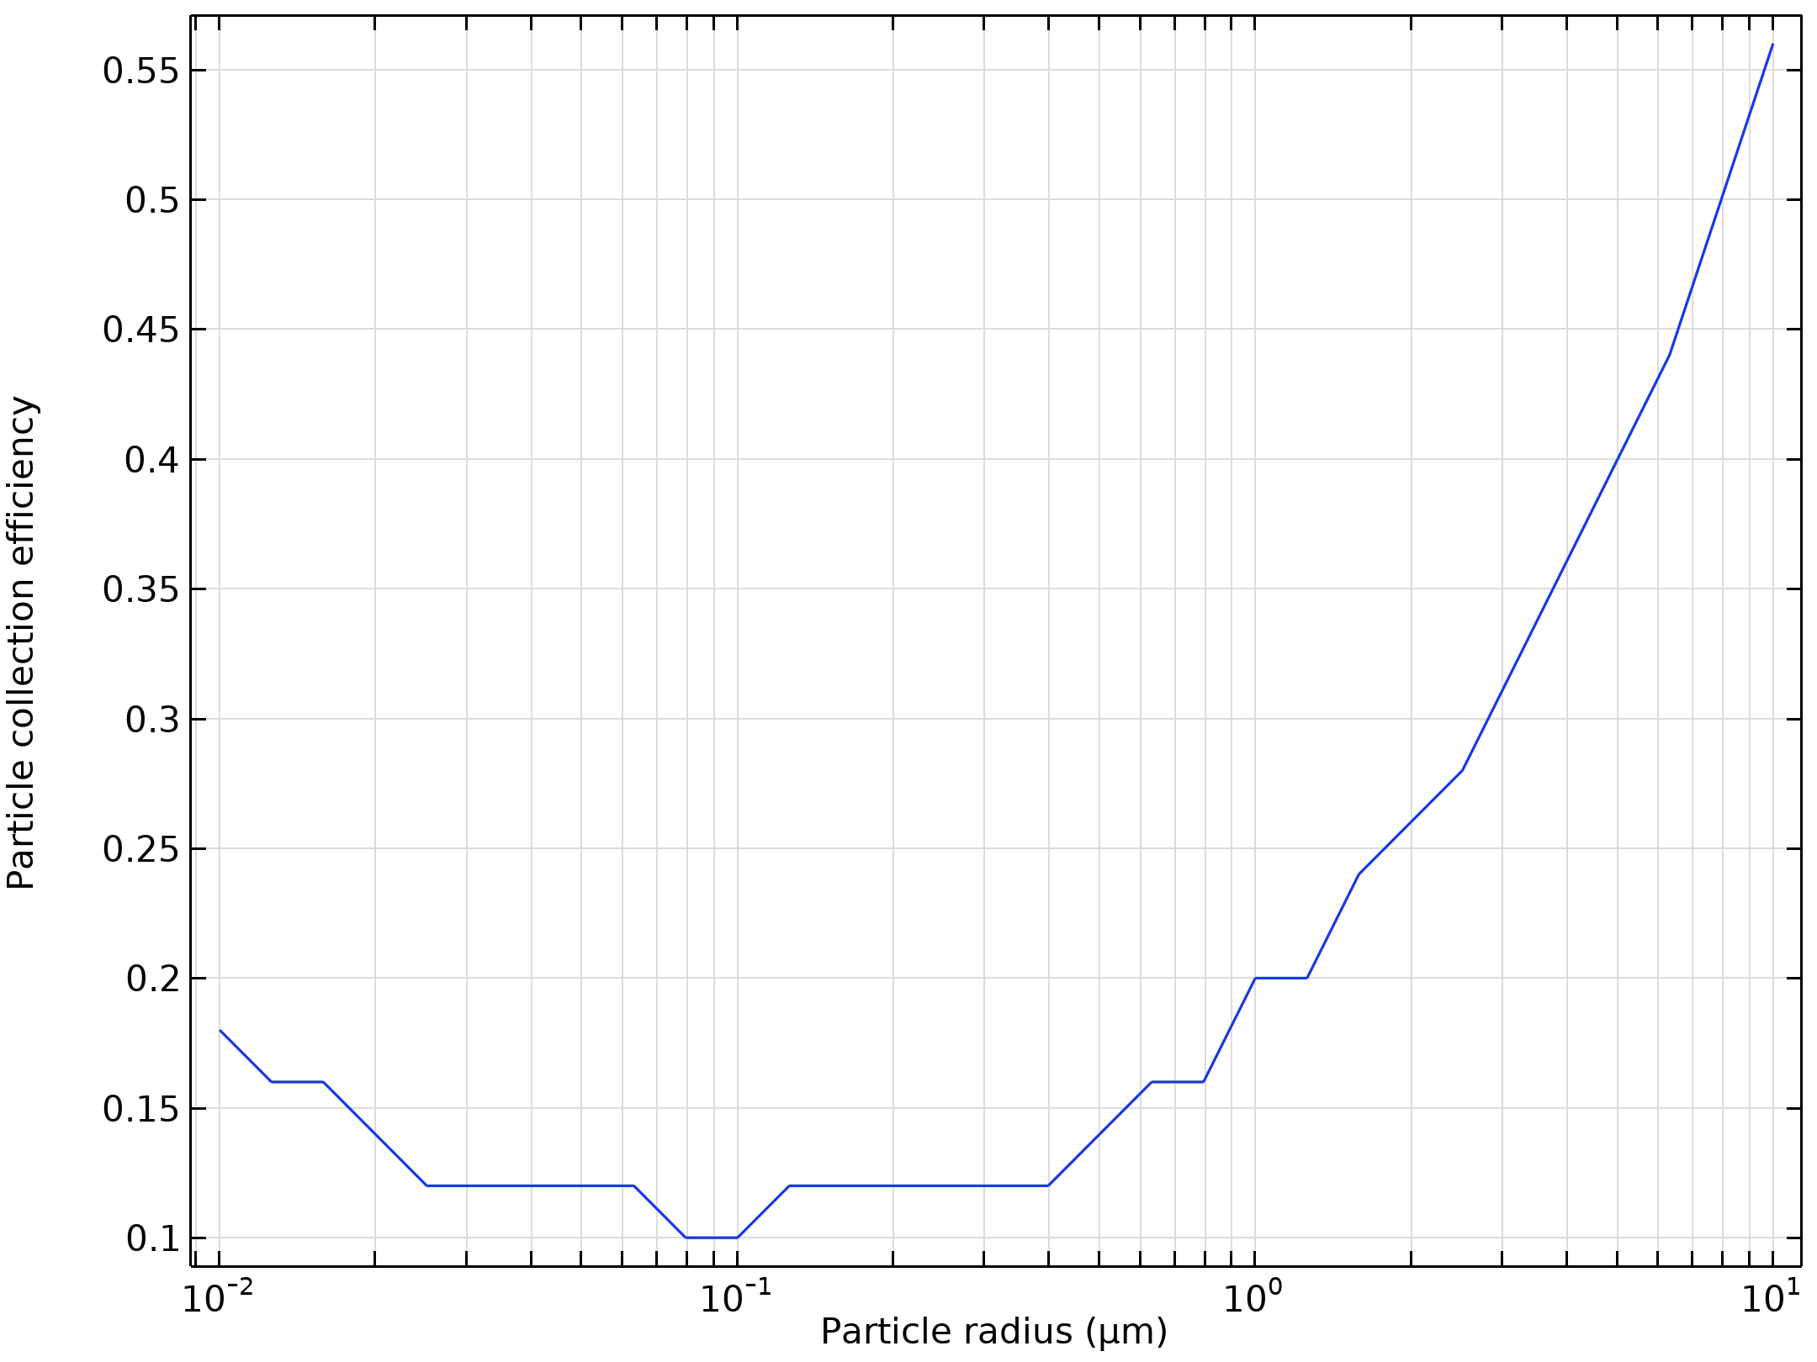  Particle collection efficiency as a function of the particle radius

Run | Wire radius (m) |  | Velocity (m/s) | Voltage (KV)
24 | 0.002 |  | 30 | 50
Velocity magnitude of the flow in electrostatic precipitator |  | Electric Potential lines around electrodes in Electrostatic Precipitator
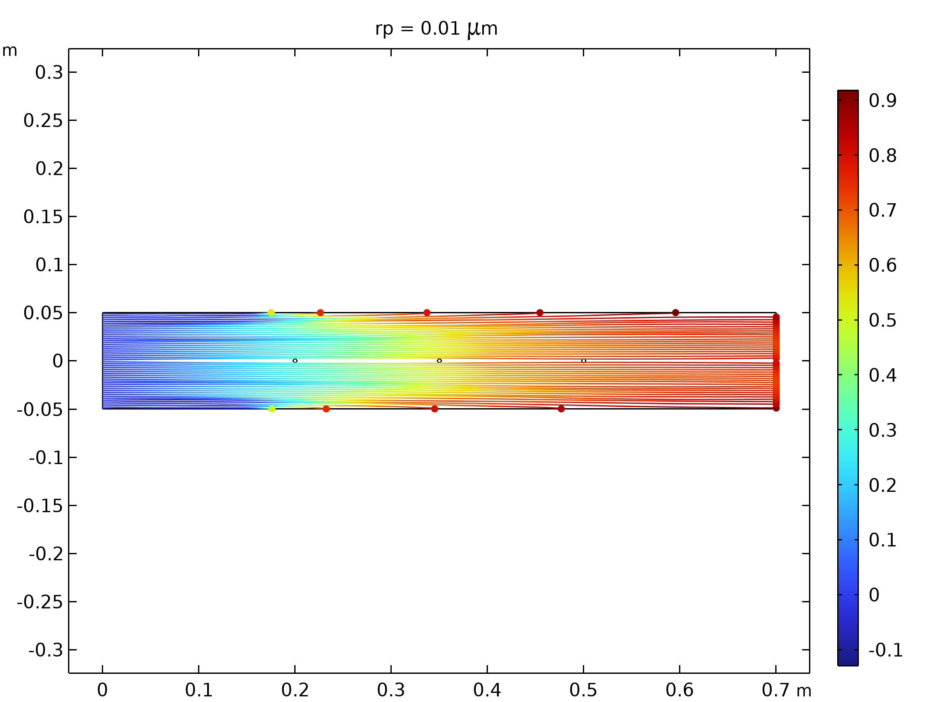  Particle trajectories with the charge number along the trajectory expressed in color for particles with a radius of 0.01 μm |  | 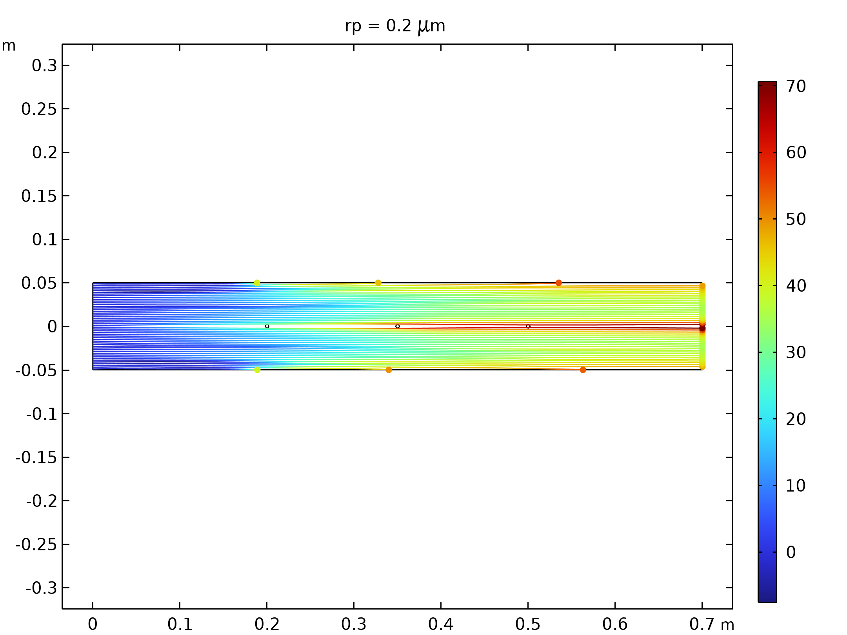  Particle trajectories with the charge number along the trajectory expressed in color for particles with a radius of 0.2 μm.
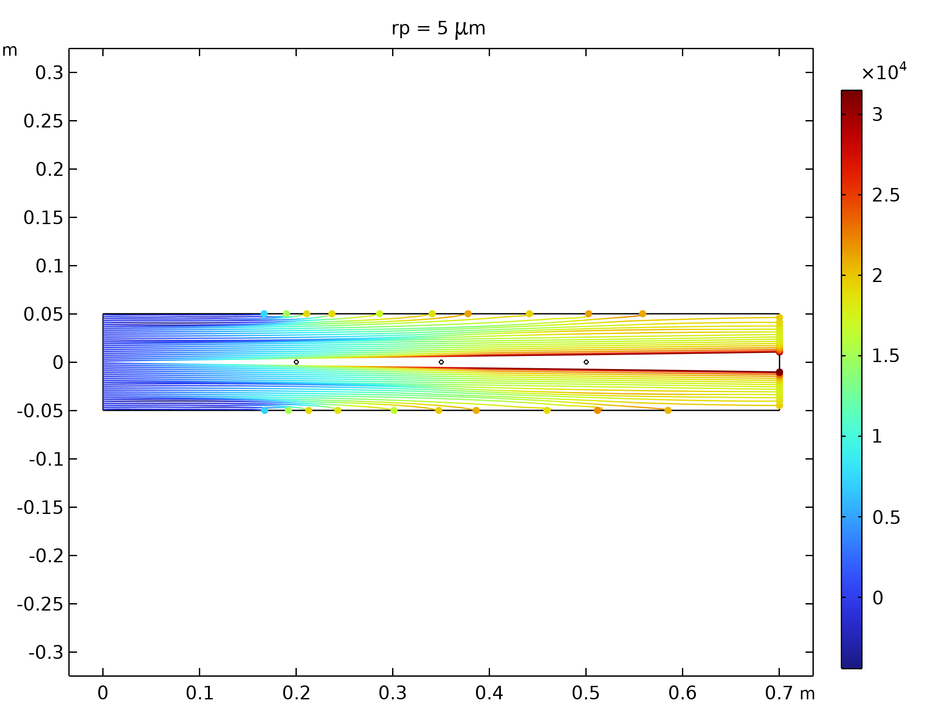  Particle trajectories with the charge number along the trajectory expressed in color for particles with a radius of 5 μm. |  | Particle collection efficiency as a function of the particle radius

Run | Wire radius (m) |  | Velocity (m/s) | Voltage (KV)
25 | 0.002 |  | 50 | 10
Velocity magnitude of the flow in electrostatic precipitator |  | Electric Potential lines around electrodes in Electrostatic Precipitator
Particle trajectories with the charge number along the trajectory expressed in color for particles with a radius of 0.01 μm |  | Particle trajectories with the charge number along the trajectory expressed in color for particles with a radius of 0.2 μm.
Particle trajectories with the charge number along the trajectory expressed in color for particles with a radius of 5 μm. |  | Particle collection efficiency as a function of the particle radius

Run | Wire radius (m) |  | Velocity (m/s) | Voltage (KV)
26 | 0.002 |  | 50 | 30
Velocity magnitude of the flow in electrostatic precipitator |  | Electric Potential lines around electrodes in Electrostatic Precipitator
Particle trajectories with the charge number along the trajectory expressed in color for particles with a radius of 0.01 μm |  | Particle trajectories with the charge number along the trajectory expressed in color for particles with a radius of 0.2 μm.
Particle trajectories with the charge number along the trajectory expressed in color for particles with a radius of 5 μm. |  | Particle collection efficiency as a function of the particle radius

Run | Wire radius (m) |  | Velocity (m/s) | Voltage (KV)
27 | 0.002 |  | 50 | 50
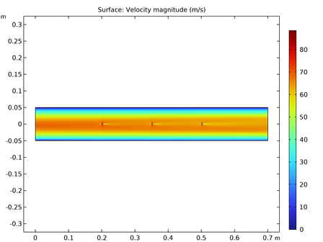  Velocity magnitude of the flow in electrostatic precipitator |  | Electric Potential lines around electrodes in Electrostatic Precipitator
Particle trajectories with the charge number along the trajectory expressed in color for particles with a radius of 0.01 μm |  | Particle trajectories with the charge number along the trajectory expressed in color for particles with a radius of 0.2 μm.
Particle trajectories with the charge number along the trajectory expressed in color for particles with a radius of 5 μm. |  | Particle collection efficiency as a function of the particle radius

