Additional file:
Contents:
Supplementary Table 1. 2
Supplementary Table 2. 3
Supplementary Figure 1. 4
Supplementary Figure 2. 4
Supplementary Figure 3. 5
Supplementary Figure 4. 5
Supplementary Figure 5. 6
Supplementary Figure 6. 6
Supplementary Figure 7. 6

Supplementary Table 1. Search terms
PubMed:
#1 |  | "brain injuries, traumatic"[MeSH Terms]
#2 |  | "Craniocerebral Trauma"[MeSH Terms] OR "head injuries, penetrating"[MeSH Terms]
#3 |  | "cerebrovascular trauma"[MeSH Terms]
#4 |  | "intracranial hemorrhage, traumatic"[MeSH Terms]
#5 |  | "brain hemorrhage, traumatic"[MeSH Terms]
#6 |  | #1 OR #2 OR #3 OR #4 OR #5
#7 |  | traumatic brain injur*[Title/Abstract] OR "brain contusion"[Title/Abstract] OR "craniocerebral trauma"[Title/Abstract] OR "cerebrovascular trauma"[Title/Abstract] OR penetrating head injur*[Title/Abstract] OR "traumatic intracranial hemorrhage"[Title/Abstract] OR "traumatic brain hemorrhage"[Title/Abstract] OR brain trauma*[Title/Abstract] OR traumatic encephalopath*[Title/Abstract] OR "TBI"[Title/Abstract] OR "TBIs"[Title/Abstract] OR concuss*[Title/Abstract]
#8 |  | #6 OR #7
#9 |  | "Erythropoietin"[MeSH Terms] OR "Epoetin Alfa"[MeSH Terms]
#10 |  | "erythropoietin"[Title/Abstract] OR "epoetin alfa"[Title/Abstract] OR "EPO"[Title/Abstract] OR "darbepoetin alfa"[Title/Abstract]
#11 |  | #9 OR #10
#12 |  | #8 AND #11
Cochrane library:
#1 |  | MeSH descriptor: [Erythropoietin] explode all trees
#2 |  | (EPO OR erythropoietin OR Epoetin Alfa OR Darbepoetin alfa):ti,ab,kw
#3 |  | #1 OR #2
#4 |  | MeSH descriptor: [Brain Injuries, Traumatic] explode all trees
#5 |  | MeSH descriptor: [Craniocerebral Trauma] explode all trees
#6 |  | MeSH descriptor: [Cerebrovascular Trauma] explode all trees
#7 |  | MeSH descriptor: [Intracranial Hemorrhage, Traumatic] explode all trees
#8 |  | MeSH descriptor: [Brain Hemorrhage, Traumatic] explode all trees
#9 |  | #4 OR #5 OR #6 OR #7 OR #8
#10 |  | (Traumatic Brain Injur* OR Brain Contusion OR Chronic Traumatic Encephalopathy OR Craniocerebral Trauma OR Cerebrovascular Trauma OR Penetrating head Injuries OR Traumatic Intracranial Hemorrhage OR Traumatic Brain Hemorrhage OR Brain Trauma* OR Traumatic Encephalopath* OR TBI OR TBIs OR concuss*):ti,ab,kw
#11 |  | #9 OR #10
#12 |  | #3 AND #11
Embase:
#1 | 'erythropoietin'/exp
#2 | 'erythropoietin':ab,ti OR 'epoetin alfa':ab,ti OR epo:ab,ti OR 'darbepoetin alfa':ab,ti
#3 | #1 OR #2
#4 | ‘traumatic brain injury'/exp
#5 | ‘traumatic brain injury':ab,ti OR 'traumatic brain injuries':ab,ti OR 'brain contusion':ab,ti OR 'chronic traumatic encephalopathy':ab,ti OR 'craniocerebral trauma':ab,ti OR 'cerebrovascular trauma':ab,ti OR 'penetrating head injury':ab,ti OR 'penetrating head injuries':ab,ti OR 'traumatic intracranial hemorrhage':ab,ti OR 'traumatic brain hemorrhage':ab,ti OR 'brain trauma':ab,ti OR 'brain traumas':ab,ti OR 'traumatic encephalopathy':ab,ti OR 'traumatic encephalopathies':ab,ti OR tbi*:ab,ti OR concuss*:ab,ti
#6 | #4 OR #5
#7 | #3 AND #6

Supplementary Table 2. Effects of different doses of erythropoietin on deep vein thrombosis (lower triangle) and pulmonary embolism (upper triangle) compared with placebo based on network meta-analysis
EPO  (30000u) | 2.05  (0.08, 72.08) | 5.08  (0.17, 312.61) | 1.88  (0.17, 30.16)
0.62  (0.01, 51.04) | EPO  (40000u) | 2.56  (0.12, 91.90) | 0.96  (0.11, 7.41)
0.53  (0.00, 42.37) | 0.93  (0.02, 23.83) | EPO  (80000u) | 0.39  (0.02, 3.67)
0.24  (0.00, 7.43) | 0.42  (0.02, 2.69) | 0.44  (0.03, 6.38) | Placebo
EPO erythropoietin; DVT, deep vein thrombosis; u, unit.

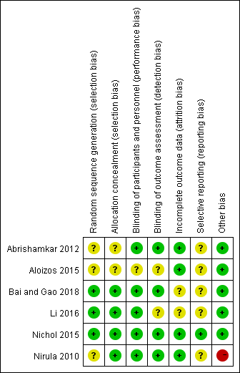
Supplementary Figure 1. Specific risk of bias graph for each study.

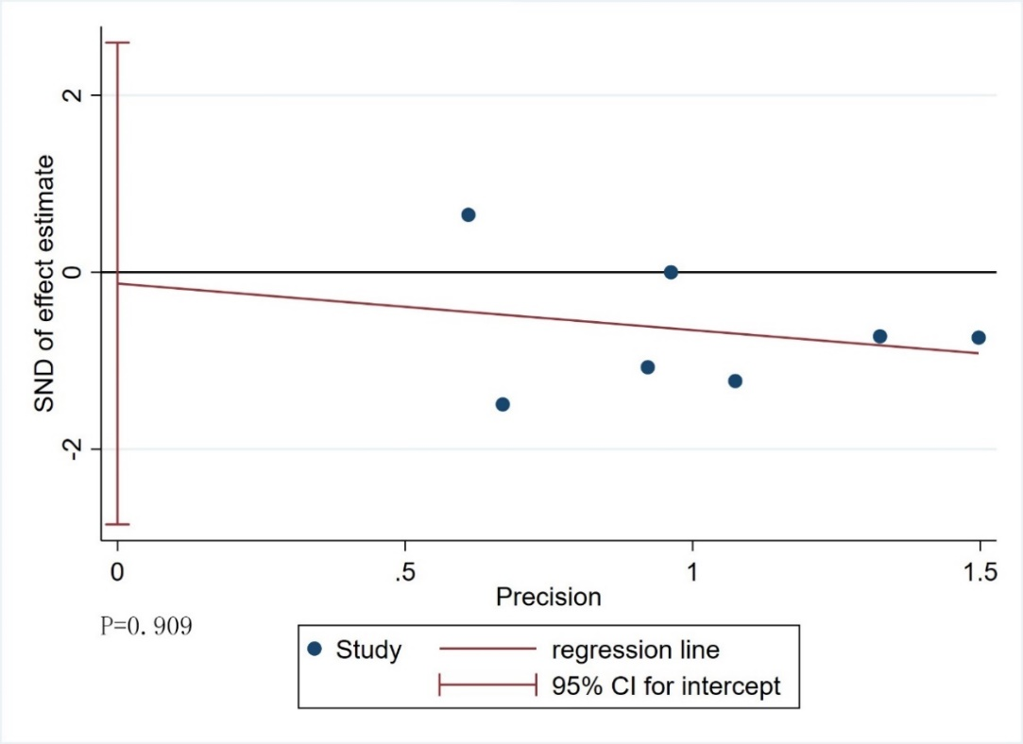
Supplementary Figure 2. Egger test used to assess publication bias in studies reporting mortality.

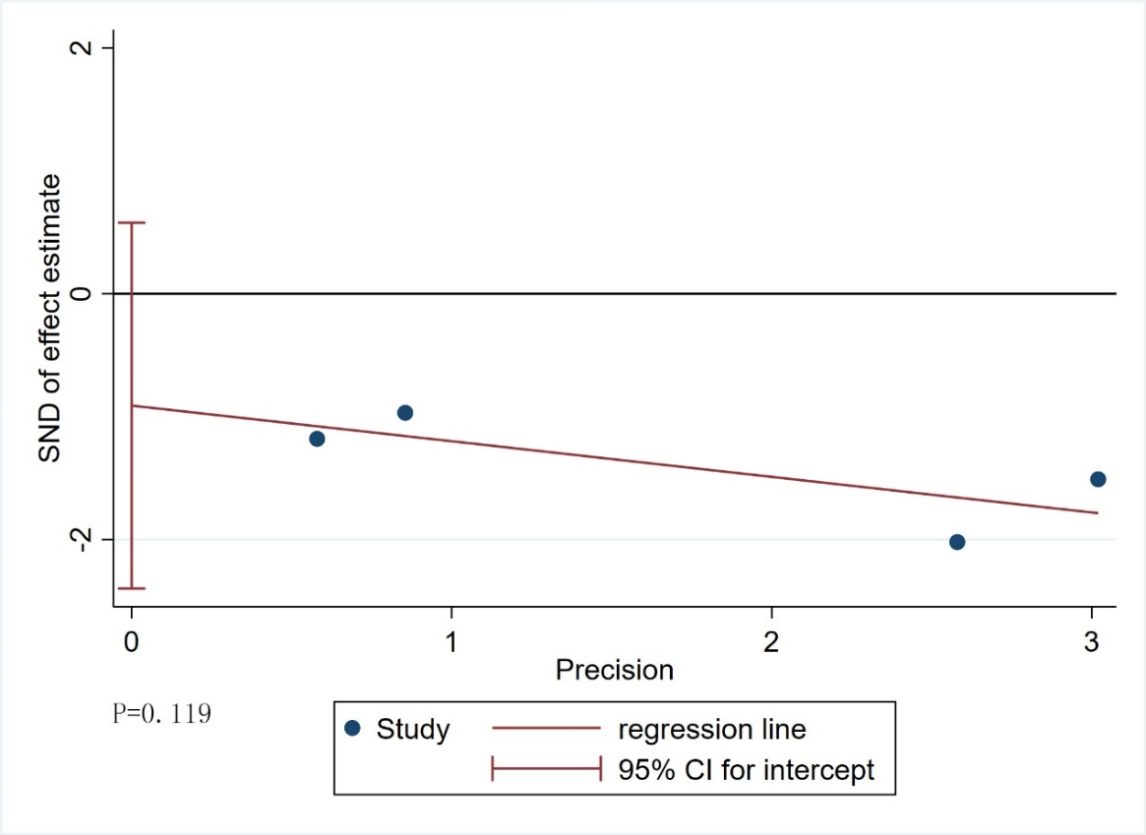
Supplementary Figure 3. Egger test used to assess publication bias in studies reporting the incidence of deep vein thrombosis

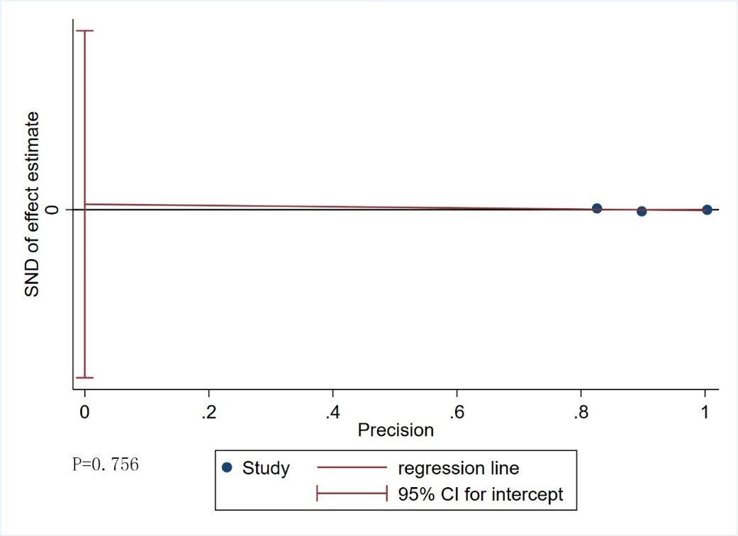
Supplementary Figure 4. Egger test used to assess publication bias in studies reporting the incidence of pulmonary embolism

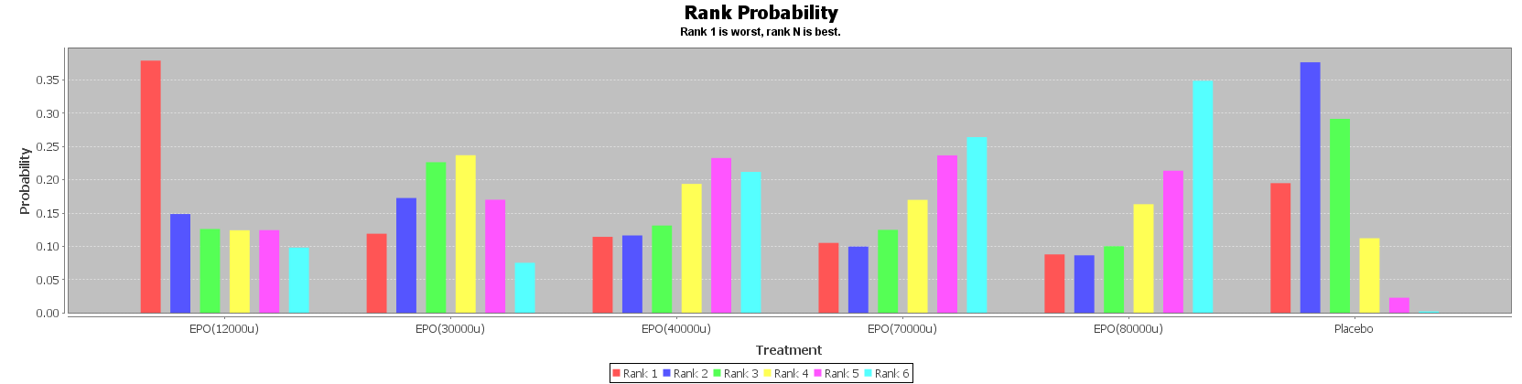
Supplementary Figure 5. Probability ranking of erythropoietin for decreasing mortality in patients with traumatic brain injury. EPO erythropoietin, DVT deep vein thrombosis, u unit, TBI traumatic brain injury

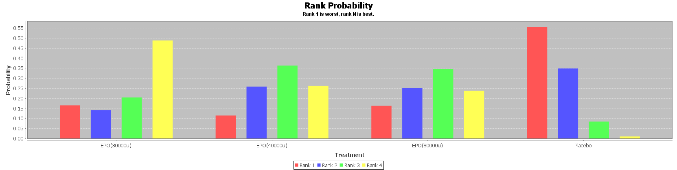
Supplementary Figure 6. Probability ranking of erythropoietin for deep vein thrombosis in patients with TBI. EPO erythropoietin, DVT deep vein thrombosis, u unit, TBI traumatic brain injury
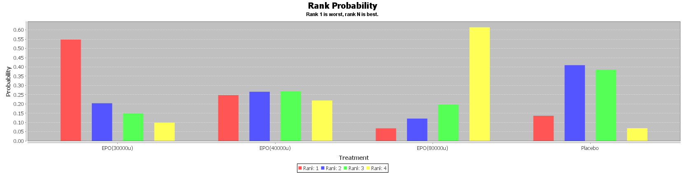
Supplementary Figure 7. Probability ranking of EPO for pulmonary embolism in patients with TBI. EPO erythropoietin, DVT deep vein thrombosis, u unit, TBI traumatic brain injury

