Table 2 Analysis of target-compound docking simulation.
Serial number | Compound | Target | Docked complex of protein and ligand | Affinity  (kcal/mol)
HJT1 | Quercetin | AKT1 | 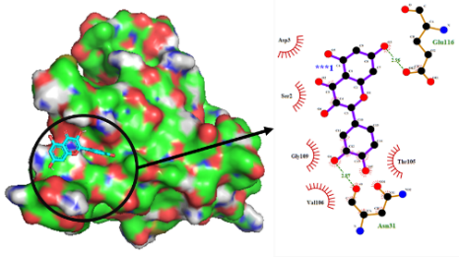 | -6.4
HJT2 | Herbacetin | AKT1 | 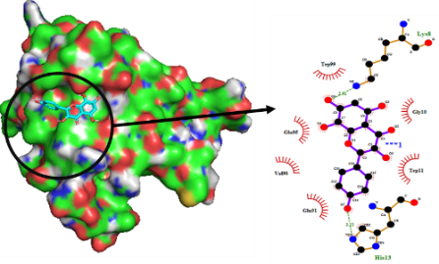 | -6.2
HJT3 | Anthocyanidins | AKT1 | 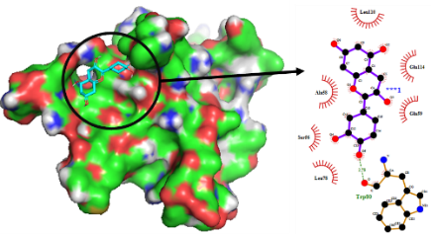 | -5.6
HJT4 | Kaempferol | AKT1 | 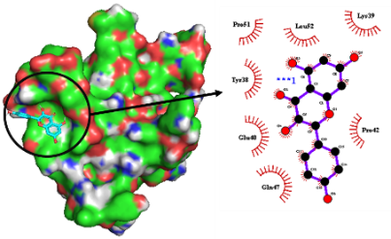 | -6.2
HJT7 | Rosin | TNF | 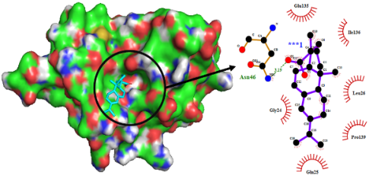 | -6.8
HJT7 | Rosin | TP53 | 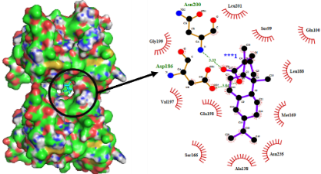 | -8.0
HJT8 | Salidroside | AKT1 | 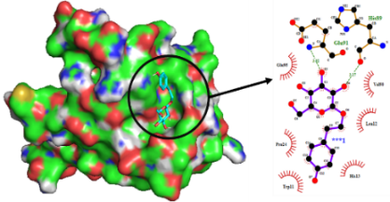 | -5.8
HJT8 | Salidroside | MAPK1 | 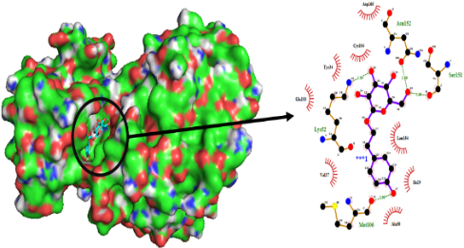 | -7.5
HJT8 | Salidroside | CASP3 | 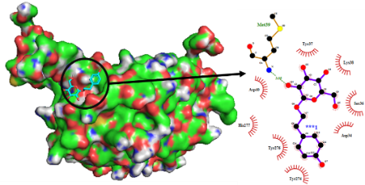 | -6.0
HJT11 | Ferulic acid | STAT3 | 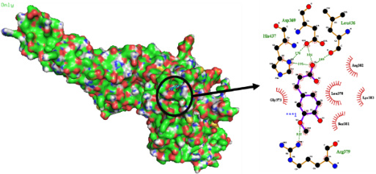 | -5.8
HJT13 | p-hydroxyphenethyl anisate | MAPK1 | 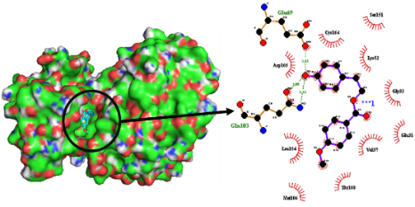 | -6.9
HJT13 | p-hydroxyphenethyl anisate | CASP3 | 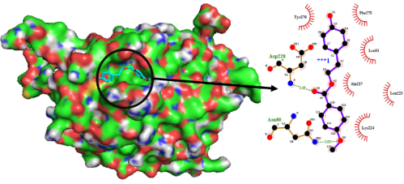 | -6.4
HJT20 | Tricin | AKT1 | 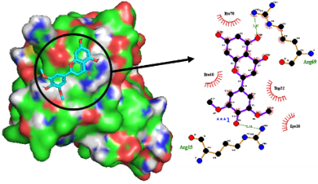 | -5.9
HJT22 | Benzyl alcohol-O-β-D-pyran glycosidase | MAPK1 | 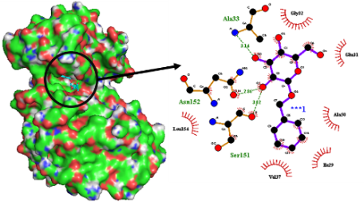 | -5.9
HJT22 | Benzyl alcohol-O-β-D-pyran glycosidase | GAPDH | 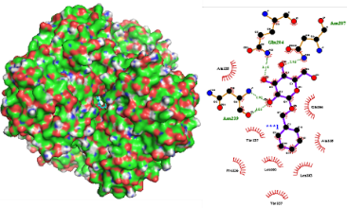 | -7.3
HJT22 | Benzyl alcohol-O-β-D-pyran glycosidase | VEGFA | 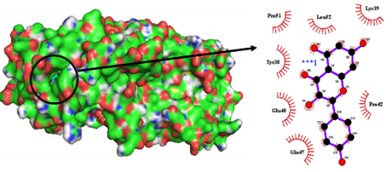 | -6.7
HJT23 | l-picein | MAPK1 | 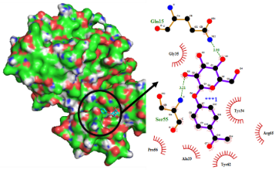 | -6.4
HJT23 | l-picein | GAPDH | 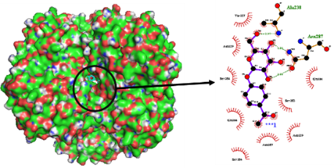 | -7.8
HJT25 | Scaphopetalone | MAPK1 | 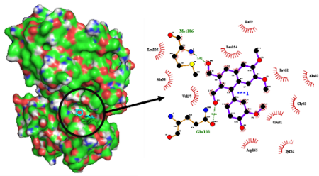 | -7.5
HJT25 | Scaphopetalone | JUN | 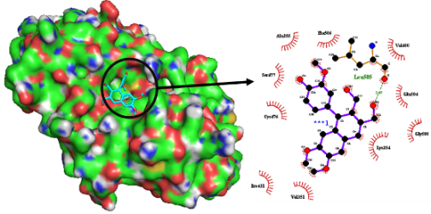 | -5.8
HJT26 | Berchemol | MAPK1 | 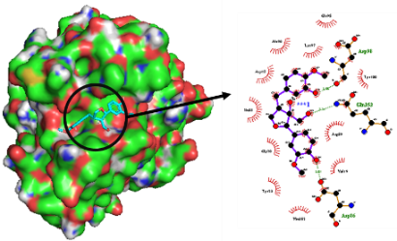 | -7.1

