Table 1 Analysis of the 26 underlying compounds in RW
NO. | Mol ID | Compound | Molecular Formula | Structure
1 | HJT1 | Quercetin | C₁₅H₁₀O₇ | 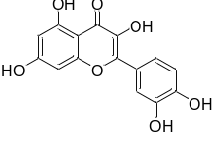
2 | HJT2 | Herbacetin | C₁₅H₁₀O₇ | 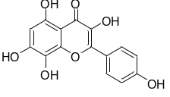
3 | HJT3 | Cyanidin | C₁₅H₁₁O₆⁺ | 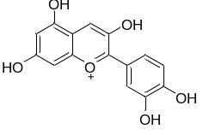
4 | HJT4 | Kaempferol | C₁₅H₁₀O₆ | 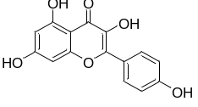
5 | HJT5 | Anthocyanin | C₁₅H₁₁O⁺ | 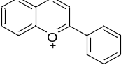
6 | HJT6 | Cinnamic alcohol | C₉H₁₀O | 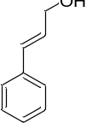
7 | HJT7 | ROSIN | C₁₅H₂₀O₆ | 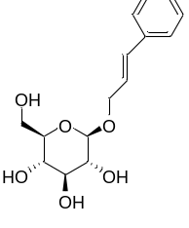
8 | HJT8 | Salidroside | C₁₄H₂₀O₇ | 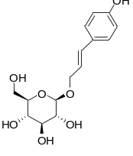
9 | HJT9 | Tyrosol | C₈H₁₀O₂ | 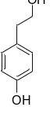
10 | HJT10 | p-Hydroxy-cinnamic acid | C₉H₈O₃ | 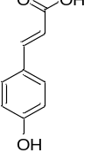
11 | HJT11 | Ferulic acid | C₁₀H₁₀O₄ | 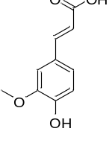
12 | HJT12 | rosiridol | C₁₀H₁₈O₂ | 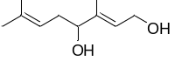
13 | HJT13 | p-hydroxyphenethyl anisate | C₁₆H₁₆O₄ | 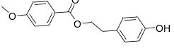
14 | HJT14 | 8-hydroxypinoresinol | C₂₀H₂₂O₇ | 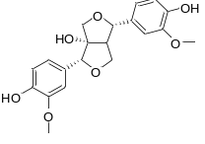
15 | HJT15 | Methyl trans-cinnamate | C₁₀H₁₀O₂ | 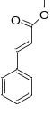
16 | HJT16 | PAEONOL | C₉H₁₀O₃ | 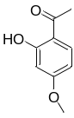
17 | HJT17 | Syringate | C₉H₁₀O₅ | 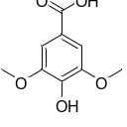
18 | HJT18 | Vanillin | C₈H₈O₃ | 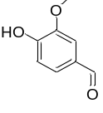
19 | HJT19 | 2-FUROIC ACID | C₅H₄O₃ | 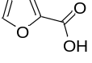
20 | HJT20 | Tricin | C₁₇H₁₄O₇ | 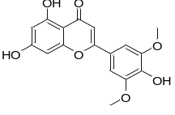
21 | HJT21 | p-Hydroxycinnamic acid | C₉H₈O₃ | 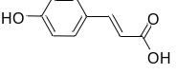
22 | HJT22 | β-D-phenyl glucopyranoside | C₁₂H₁₆O₆ | 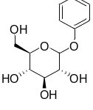
23 | HJT23 | Picein | C₁₄H₁₈O₇ | 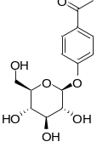
24 | HJT24 | Coniferin | C₁₆H₂₂O₈ | 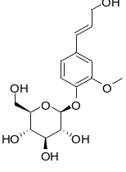
25 | HJT25 | Scaphopetalone | C₂₁H₂₆O₆ | 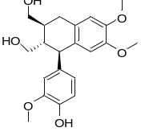
26 | HJT26 | Berchemol | C₂₀H₂₄O₇ | 