Supplementary Material

Title:
Focal adhesion kinase inhibitor TAE226 combined with Sorafenib slows down hepatocellular carcinoma by multiple epigenetics effects

Ilaria Romito¹*, Manuela Porru²*, Maria Rita Braghini¹*, Luca Pompili², Nadia Panera¹, Annalisa Crudele¹, Daniela Gnani³, Cristiano De Stefanis⁴, Marco Scarsella⁴, Silvia Pomella⁵, Stefano Levi Mortera⁶, Emmanuel de Billy⁵, Adrian Libenzio Conti⁴, Valeria Marzano⁶, Lorenza Putignani^{6,7}, Manlio Vinciguerra^{8,9}, Clara Balsano^{10,11}, Anna Pastore¹², Rossella Rota⁵, Marco Tartaglia¹³, Carlo Leonetti², Anna Alisi¹

Supplementary Tables

Table S1. List of antibodies.
Target | Producer | Catalog number | Dilution
FAK | Cell Signaling Technology (Danvers, Massachusetts, USA) | 13009 | Western Blotting: 1:1000 in 2.5% w/v Nonfat Dry Milk, 1X TBS, 0.1% Tween-20.  Immunofluorescence: 1:100 in PBS/BSA 1%.
Phospho-FAK (Tyr397) | Cell Signaling Technology | 8556 | Western Blotting: 1:1000 in 5% w/v BSA, 1X TBS, 0.1% Tween-20.
Phospho-FAK (Tyr397) | Thermo Fisher Scientific Inc. (Waltham, Massachusetts, USA) | 700255 | Immunofluorescence: 1:100 in PBS/BSA 1%.
pTyr1135IGF-I Receptor β | Cell Signaling Technology | 3918 | Western Blotting: 1:1000 in 5% w/v BSA, 1X TBS, 0.1% Tween-20.
Ezh2 | BD Transduction Laboratories (Franklin Lakes, New Jersey, USA) | 612666 | Western Blotting: 1:1000 in 2.5% w/v Nonfat Dry Milk, 1X TBS, 0.1% Tween-20.  Immunofluorescence:  1:100 in PBS/BSA 1%.
α-Tubulin | Novus biologicals (Centennial, Colorado, USA) | NB100-690 | Western Blotting: 1:5000 in 2.5% w/v Nonfat Dry Milk, 1X TBS, 0.1% Tween-20.
PCNA | Cell Signaling Technology | 13110 | Immunofluorescence: 1:300 in PBS/BSA 5%.
HDAC1 | Cell Signaling Technology | 34589 | Western Blotting: 1:1000 in 2.5% w/v Nonfat Dry Milk, 1X TBS, 0.1% Tween-20.  Immunofluorescence:  1:100 in PBS/BSA 1%.
HDAC2 | Cell Signaling Technology | 5113 | Western Blotting: 1:1000 in 2.5% w/v Nonfat Dry Milk, 1X TBS, 0.1% Tween-20.  Immunofluorescence:  1:100 in PBS/BSA 1%.
β-Catenin | Novocastra, Leica Biosystems (Wetzlar, Germany) | NCL-L-B-CAT | Immunofluorescence:  1:100 in PBS/BSA 1%.
Peroxidase-AffiniPure Goat Anti-Rabbit IgG (H+L) | Jackson ImmunoResearch (Ely, Cambridgeshire, UK) | 111-035-144 | Western Blotting: 1:7000 in 2.5% w/v Nonfat Dry Milk, 1X TBS, 0.1% Tween-20.
Peroxidase-AffiniPure Goat Anti-Mouse IgG (H+L) | Jackson ImmunoResearch | 115-035-146 | Western Blotting: 1:7000 in 2.5% w/v Nonfat Dry Milk, 1X TBS, 0.1% Tween-20.
Alexa Fluor 488 conjugate, F(ab’)2-Goat anti-rabbit IgG(H+L) Secondary Antibody | Thermo Fisher Scientific Inc. | A-11070 | Immunofluorescence:  1:500 in PBS/BSA 1%.
Alexa Fluor 555 conjugate, F(ab’)2-Goat anti-Mouse IgG(H+L) Secondary Antibody | Thermo Fisher Scientific Inc. | A-21425 | Immunofluorescence:  1:300 in PBS/BSA 1%.

Table S2. In vivo antitumor efficacy of TAE-226>SOR combination on orthotopic liver tumour.
Treatment groups* | Tumour volume inhibition& | Progression | Stable disease# | Partial response$ | Body weight loss#
TAE226 | 49 | 5/6 | 1/6 | 0/6 | 0
SOR | 50 | 5/6 | 1/6 | 0/6 | 0
TAE226>SOR | 89 | 1/6 | 4/6 | 1/6 | 0
*The mice were treated with TAE226 (per os at 25mg/Kg) for five consecutive days repeated for 2 weeks, SOR (per os at 30 mg/Kg) for five consecutive days or TAE (per os at 25mg/Kg) for five consecutive days repeated for 2 weeks followed by SOR (per os at 30 mg/Kg).
&Tumour volume inhibition was calculated as the nadir of the effect by the following formula: (tumour volume treated mice/tumour volume untreated mice-1) x100.
#Stable disease was defined as the maintenance of tumour volume for at least three weeks after the initiation of treatment.
$ Partial response was defined as the reduction of tumour, after the initiation of treatment, maintained for at least three weeks.
# The percentage of body weight loss was calculated after the initiation of treatment.
Table S3. Common down- and up-regulated genes.

Down-regulated genes | Up-regulated genes
BCL2 | APC
BHLHE40 | CARD17
CA9 | CDK17
CD70 | CGRRF1
CDC42 | ERBB3
CENPA | FBP1
COL1A1 | FOS
COL4A2 | FRZB
DLG3 | LCN2
EGR3 | RIPK1
GRB7 | ROCK1
LCK | SARS
MAP2K2 | TLR3
MARS
MMP1
MMP3
NR4A1
OXCT1
PFKP
PRAME
RAC2
RAD51
RASGRF1
RELA
SLC2A3
TIE1
TLR4

Table S4. Nuclear interactors of FAK (see attached Table S4 Excel file).

Table S5. GO annotations.

 | GO term | Description | Count in Network | Strength | p
1 | GO:0000127 | transcription factor TFIIIC complex | 3 of 6 | 1.93 | 0.00018
2 | GO:0016581 | NuRD complex | 4 of 14 | 1.68 | 5.28e-05
3 | GO:0031595 | nuclear proteasome complex | 2 of 7 | 1.68 | 0.0091
4 | GO:0008540 | proteasome regulatory particle, base subcomplex | 2 of 9 | 1.57 | 0.0126
5 | GO:0030877 | beta-catenin destruction complex | 2 of 10 | 1.53 | 0.0148
6 | GO:0005838 | proteasome regulatory particle | 4 of 21 | 1.51 | 0.00015
7 | GO:0031597 | cytosolic proteasome complex | 2 of 11 | 1.49 | 0.0171
8 | GO:0016580 | Sin3 complex | 2 of 11 | 1.49 | 0.0171
9 | GO:0022627 | cytosolic small ribosomal subunit | 5 of 38 | 1.35 | 6.74e-05
10 | GO:0033276 | transcription factor TFTC complex | 2 of 15 | 1.35 | 0.0270

Supplementary Figures and Legends

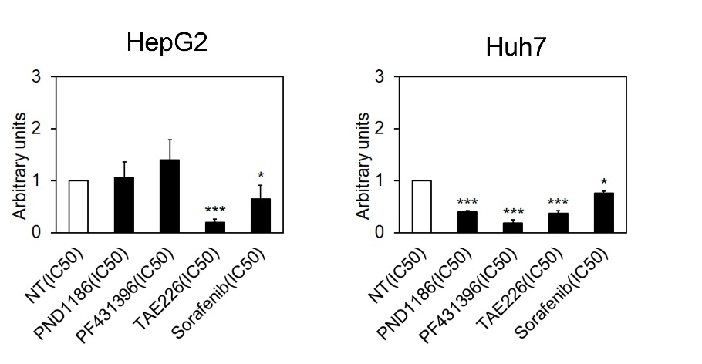
Fig. S1. FAK phosphorylation in HCC cells after IC50 values of treatments. Quantitative analysis of pTyr397FAK expression after 48 hours of treatment with the different drugs, in HepG2 and Huh7 cells. Values are the mean arbitrary units ± SD of at least three independent experiments. Data was analysed by 2-tailed Student's t test. *p < 0.05; ***p < 0.001 vs. Not treated (NT) cells.

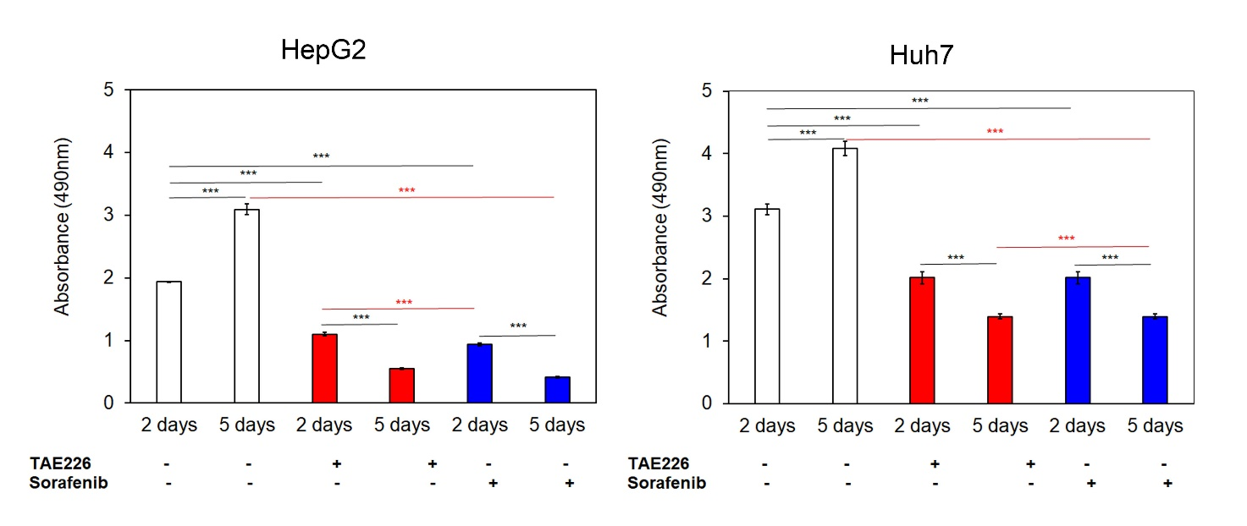

Fig. S2. Evaluation of the IC50 values of TAE226 and SOR on HCC cell viability after 2 and 5 days. Cell viability, measured by XTT assay, after 2 and 5 days from treatment with TAE226 or SOR, in HepG2 and Huh7 cells. Values are the mean OD ± SD of three independent experiments repeated at least in duplicate. Data was analysed by ANOVA. ***p < 0.001.

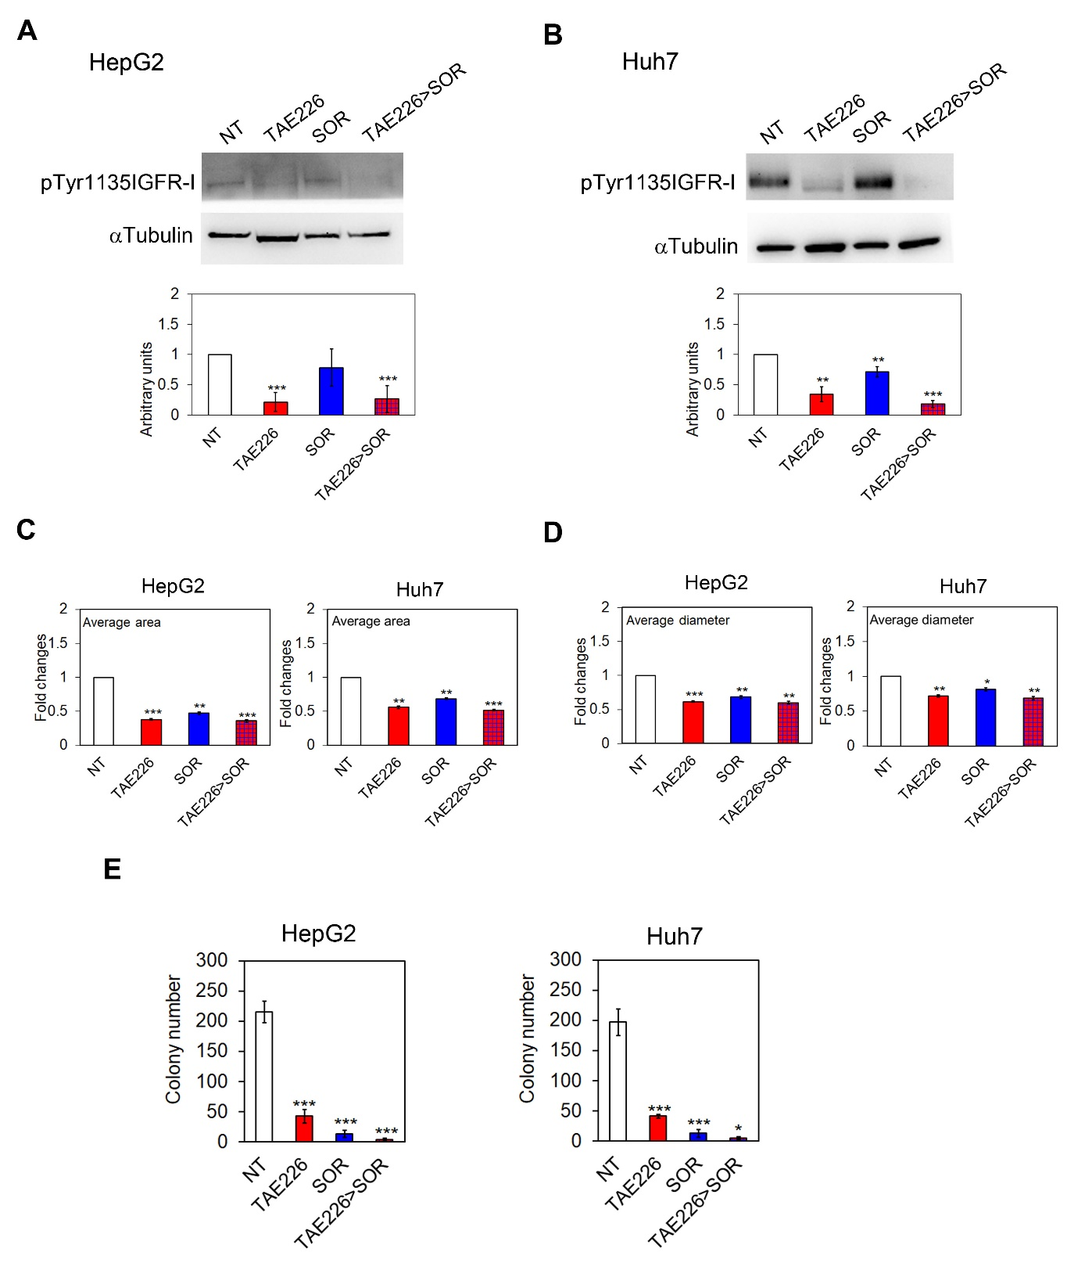
Fig. S3. IGF-1R in HCC cells after treatment with TAE226>SOR compared to single treatments. Representative immunoblot and quantitative analysis of phosphorylated IGF-1R after 48h from treatment with the different drugs, in HepG2 (A) and Huh7 cells (B). Values are the mean arbitrary units ± SD of at least three independent experiments. Data was analysed by 2-tailed Student's t test. **p < 0.01; ***p < 0.001 vs. NT. Endpoints graphs representing average area (C), and diameter (D) of TS after 48 hours of treatment expressed as fold induction. Data are expressed as mean ± SD of two independent experiments repeated in triplicate and was analysed by 2-tailed Student's t test. *p < 0.05; **p < 0.01; ***p < 0.001 vs. NT. (E) Histograms of colony formation assay performed in HCC cells after treatments. Values are the mean ± SD of at least three independent experiments. Data was analysed by 2-tailed Student's t test. *p < 0.05; ***p < 0.001 vs. NT.

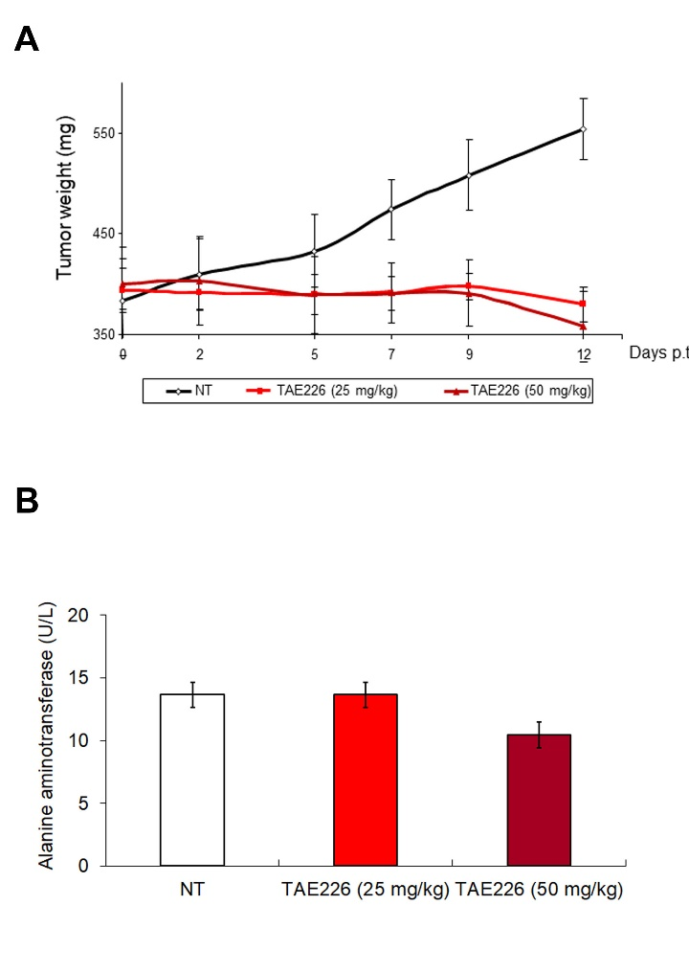

Fig. S4. Pilot study for quantitative setting of TAE226 concentration in a heterotopic HepG2 xenograft model of HCC. (A) Quantitative analysis of tumour weight at various time points in NT animals or after TAE226 treatments. P values were calculated at day 12 using an unpaired two-tailed t-test, between treated and untreated tumours. ****, P ≤ 0.0001 (B) Quantitative analysis of serum liver enzyme alanine aminotransferase (ALT) levels, expressed as U/L, in NT animals or after TAE226 treatments.
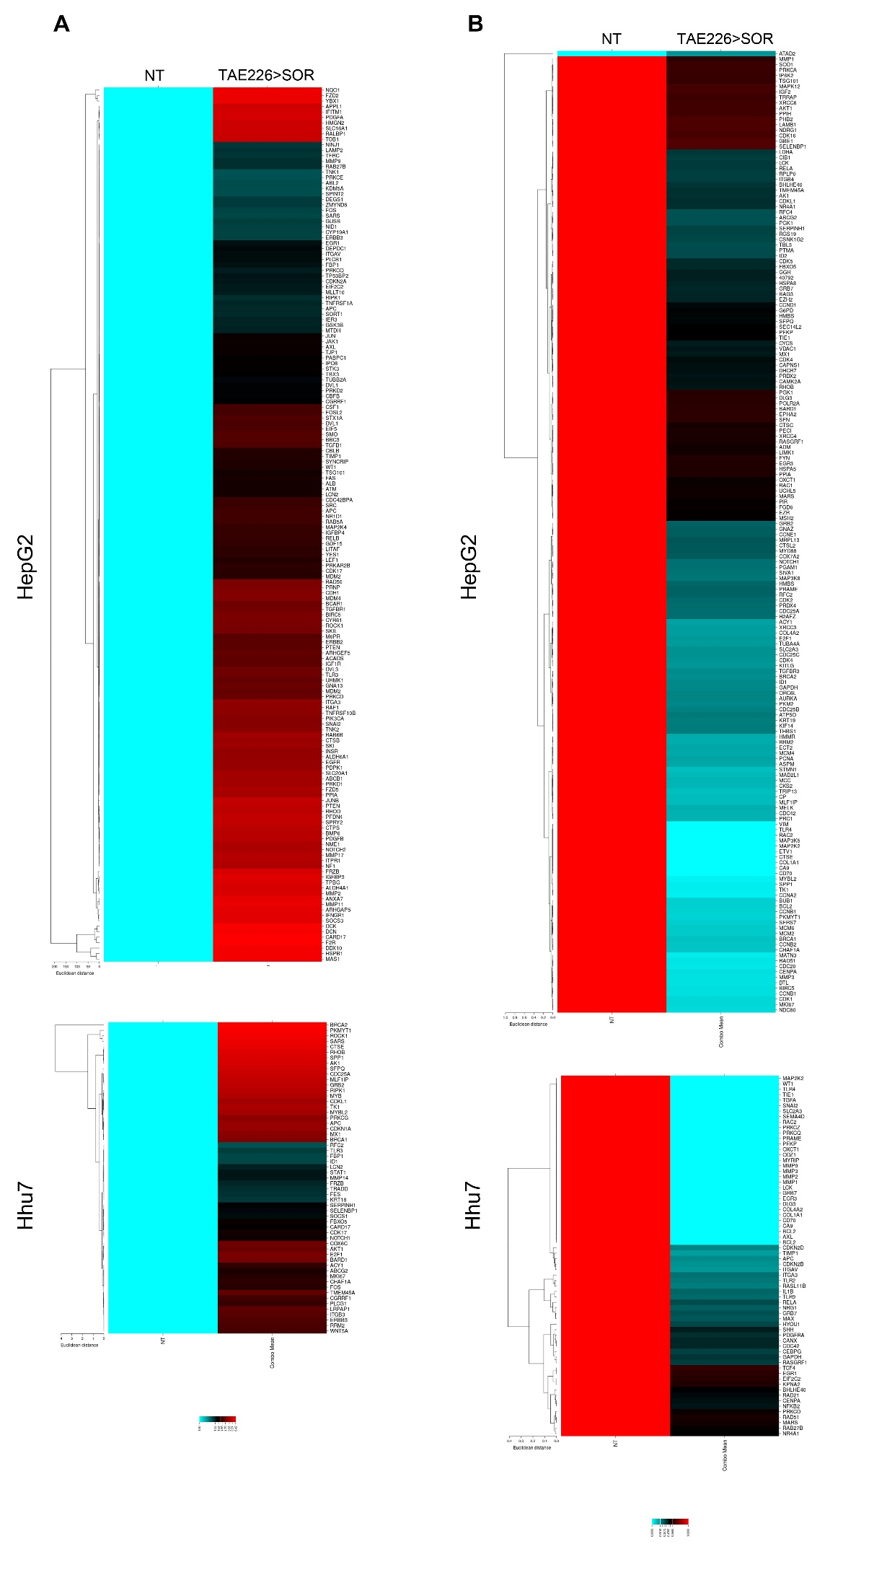

Fig. S5. Effects of FAK inhibition on cancer-related genes. Heatmap representation of the expression of up-regulated (A) and down-regulated (B) cancer-related genes in HepG2 and Huh7 cells in TAE226>SOR compared to NT cells.

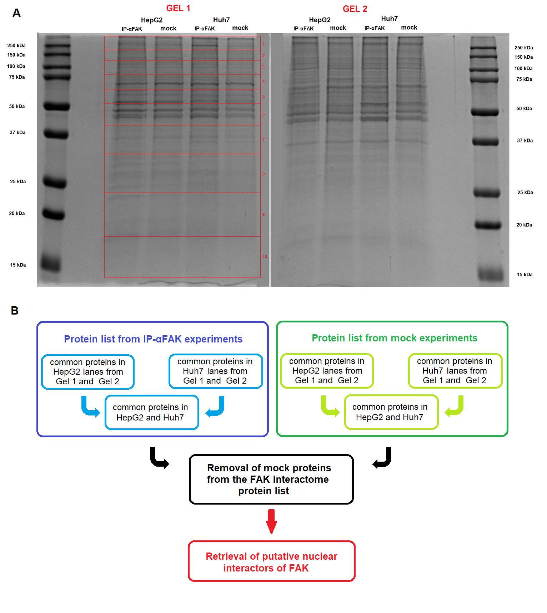
Fig. S6. Analysis of FAK nuclear interaction with specific epigenetics regulators. (A) Coomassie-stained 1D SDS-PAGE gels used for the in-gel digestions of nuclear immunoprecipitates of FAK in HCC cells. The photographs showed gel lanes excision into 10 bands for mass spectrometry characterization of FAK nuclear interactors. (B) Pipeline employed for the analyses of proteomics data.

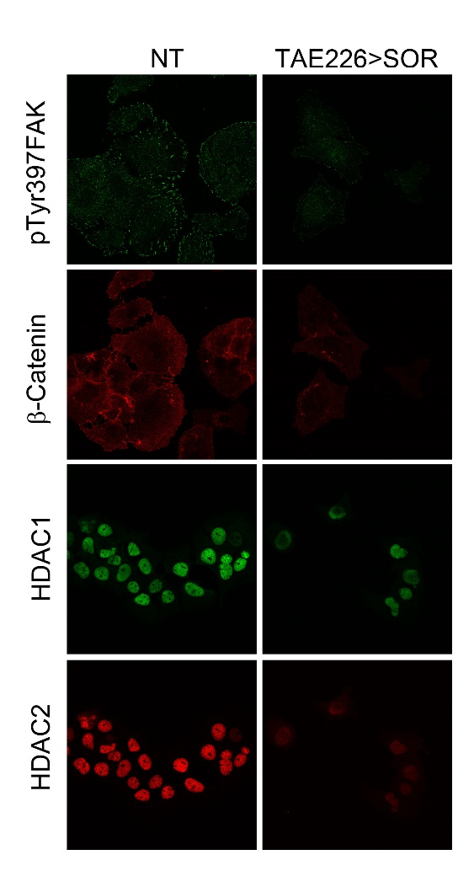

Fig. S7. pTyr397FAK nuclear interactors before and after treatment with TAE226>SOR. Representative images of immunofluorescence for pTyr397FAK, b-Catenin, HDAC1 and HDAC2 in Huh7 cells NT and after TAE226>SOR treatment. 60X Magnification.

