Supplementary Notes
Accountability of livestock multinationals for global environmental impacts
Christina Drotenko
Institute of Environmental Sciences (CML), Leiden University, Leiden, The Netherlands
Oliver Taherzadeh
Institute of Environmental Sciences (CML), Leiden University, Leiden, The Netherlands
Laura Scherer
Institute of Environmental Sciences (CML), Leiden University, Leiden, The Netherlands
Anniek J. Kortleve
Institute of Environmental Sciences (CML), Leiden University, Leiden, The Netherlands
Rutger Hoekstra
Institute of Environmental Sciences (CML), Leiden University, Leiden, The Netherlands
Paul Behrens
Oxford Martin School, Oxford University, Oxford, United Kingdom
Institute of Environmental Sciences (CML), Leiden University, Leiden, The Netherlands

- Key assumptions
Part 1: Livestock company analysis
TNC production data collection
The selection of TNCs included and their corresponding production volumes, are conducted by Profundo, an independent research organisation based in Amsterdam, The Netherlands. As it is difficult to rank largest companies in the livestock product sector due to the lack of transparency, publicly available rankings of company production levels are used to screen for the largest TNCs. Afterwards, data is collected where it is publicly available. Additional limitations include the fact that many TNCs are fragmented and operate globally, making it more difficult to have one clear map of all subsidiary ownership structures and their production volumes.
We exclude the environmental impacts related to live animal trade due to limited traceability of company-level supply chain data that shows where live animals traded end up being processed, including variables such as re-exports. However, meat production is significantly larger than the trade of live animals globally, making it a more relevant area of focus for this research.¹ Additionally, companies that control both the sourcing and processing of animals tend to have better visibility over upstream supply chains compared to those which only import and process live animals. As a result, there is less use that can be derived from company information for each supply chain stage when compared with the overarching firms that control most of the supply chain.
We used regional coefficients, originally from GLEAM² with specific data sources available on our GitHub in ‘TNC production.xlsx’, for animal weights to convert the heads of cattle, pigs, and poultry into their corresponding regional weights. This is calculated to account for weight differences across regions and to align with the scope of the analysis excluding live animals.
FABIO data usage
The FABIO categories for animal products used were based on FAOSTAT definitions and standards.³ The categories for animal products and their corresponding terms in the paper used are ‘Milk - Excluding Butter’ for ‘Dairy’, ‘Pigmeat’ for ‘Pork’, ‘Bovine Meat’ for ‘Beef’, and ‘Poultry Meat’ for ‘Poultry’ found here:
https://www.fao.org/faostat/en/#definitions. Our TNC dataset shows dairy production volumes in tonnes of milk, while FAOSTAT uses raw milk equivalents.

Part 2: Environmental impact analysis
To disaggregate the TNC dataset to be on a country-level which is originally region-level, we apply a weighted average based on the FABIO country-level production to the region-level TNC production.
We apply the trade flows in FABIO to this analysis rather than each TNC’s supply chain flows, as such information is unavailable and/or proprietary. This also means that differences in the types of production processes on the TNC-level are omitted.

- Disaggregated blue and green water use
Blue and green water use are calculated separately in the model, but have been combined for illustrative purposes in the manuscript. The distribution between blue and green water use can be found in the Supplementary Tables within Table 4. Relative to the combined blue and green water use, blue water use makes up an average of 6% of the total, and green water use contributes to an average of 94% of the total.

- Modelling steps and data structure
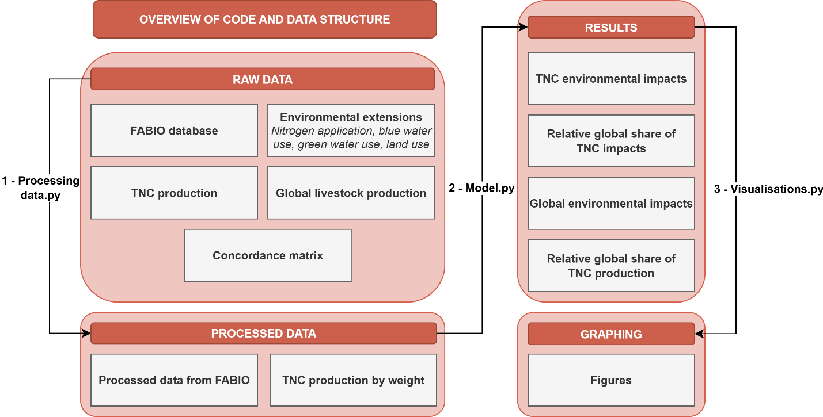

Step 1: Download the raw data
Download the necessary raw data from the following sources:

Description | Source | Availability
FABIO database (2020) | Bruckner et al., 2019⁴ | Can be downloaded here https://zenodo.org/records/2577067
Nitrogen application  Blue water use  Green water use (2020) | Bruckner et al., 2019⁴ | Can be downloaded here https://github.com/fineprint-global/fabio
Land use  (2020) | Baoxiao et al., 2025⁵ | Pre-print can be found here https://www.researchsquare.com/article/rs-5527595/v1 and is still under review, but data can be used once it is published
Global livestock production in heads/tonnes (2022, retrieved June 23, 2025) | Food and Agriculture Organization⁶ | Downloadable from our repository or can be found here https://www.fao.org/faostat/en/#data  File name: Global production.xlsx
TNC production (2022) | Profundo, followed by additional processing from authors | Downloadable from our GitHub repository in the ‘1 – raw data’ folder  File name: TNC production.xlsx
Concordance matrix | Authors | Used to align FABIO countries with GLEAM regions  Downloadable from our GitHub repository in the ‘1 – raw data’ folder  File name: Concordance.xlsx

Step 2: Activate environment
See the included ‘environment.yml’ file for the module requirements.
Step 3: Process the data and calculate the results
Run the ‘1 – Processing data.py’ file to first process the data. Then, run ‘2 – Model.py’ to calculate the necessary results. Beyond the processing completed in the code, some files are processed via Excel for which the files are already in the corresponding folders ‘2 – processed data’ and ‘3 – results’. The other files are created from the ‘1 – Processing data.py’ file. See these file descriptions for both below:
Description | Availability and file name
TNC production by weight | TNC production converted into weight for beef, poultry, and pork  Downloadable from our repository in the ‘2 – processed data’ folder  File name: TNC production by weight.xlsx
Processed data from FABIO | Making the FABIO data ready for our model  Downloadable from our repository in the ‘2 – processed data’ folder  File names:  x_ungrouped.csv  Y_ungrouped.csv  Z_ungrouped.csv  F_ungrouped.csv  blue_water.csv  green_water.csv  N_application.csv
TNC environmental impacts | The results from our model covering all the environmental impacts across the livestock products  Downloadable from our repository in the ‘3 – results’ folder  File name: Results_all_impacts.xlsx  Please note that some additional processing in additional tabs is conducted in Excel before being used for the figures, which is under the file name Results_visualisations.xlsx under tabs ‘All TNC Impacts’, ‘Bovine Meat’, ‘Poultry Meat’, ‘Pigmeat’
Global environmental impacts | Global environmental impacts per livestock product calculated with FABIO, with the code in part of the 2 – Model.py file  Downloadable from our repository in the ‘3 – results’ folder  File name: Results_visualisations.xlsx under tab ‘Global Impacts’
Relative global share of TNC production | Calculations of the TNCs’ production relative to the global production of these livestock products  Downloadable from our repository in the ‘3 – results’ folder  File name: Results_visualisations.xlsx under tab ‘Relative Production’
Relative global share of TNC impacts | Calculations of the TNCs’ environmental impacts relative to the global environmental impacts for these livestock products  Downloadable from our repository in the ‘3 – results’ folder  File name: Results_visualisations.xlsx under tab ‘Relative Impacts’  Note: the code for this is in the 3 – Visualisations.py file.
Summary for Figures | Summary of the relative production and relative impacts of the TNCs to the world for use in the figures

Step 4: Create figures
Run ‘3 – Visualisations.py’. Some minor formatting adjustments such as adding icons are completed using draw.io.

References
1. Chatellier, V. Review: International trade in animal products and the place of the European Union: main trends over the last 20 years. Animal 15, 100289 (2021).
2. Global Livestock Environmental Assessment Model. (2018).
3. FAOSTAT. https://www.fao.org/faostat/en/#definitions.
4. Bruckner, M. et al. FABIO—The Construction of the Food and Agriculture Biomass Input–Output Model. Environ. Sci. Technol. 53, 11302–11312 (2019).
5. Liu, B., Behrens, P., Sun, Z. & Scherer, L. Two-thirds of agricultural carbon and biodiversity loss occurs on one-third of the agricultural area. Preprint at https://doi.org/10.21203/rs.3.rs-5527595/v1 (2025).
6. FAOSTAT. https://www.fao.org/faostat/en/#data.

