Supporting Information

PRMT3-mediated arginine methylation of YBX1 promotes tumorigenesis in glioblastoma

Fig. S1 PRMT3 interacts with YBX1. A, B Co-IP assays in HEK293T cells co-transfected with RMT3-FLAG and YBX1-HA plasmids. Lysates were immunoprecipitated with anti-FLAG (A) or anti-HA (B) beads and analyzed by immunoblotting.
Fig. S2 PRMT3 regulates YBX1 via post-translational modification rather than transcriptional control. A, B PRMT3 and YBX1 mRNA levels were assessed by RT-qPCR in U87 and T98 cells following PRMT3 knockdown (A) or treatment with the PRMT3 inhibitor SGC707 (B). C, D Western blot analysis of total YBX1 and p-YBX1 (Ser102) protein levels in U87 and T98 cells with PRMT3 knockdown (C) or SGC707 treatment (D). E, F PRMT3 and YBX1 mRNA levels (E) and protein levels of p-YBX1 (Ser102) and total YBX1 (F) were measured in U87 cells overexpressing PRMT3. G-I RT‑qPCR analysis of YBX1 and PRMT3 mRNA levels in U87 (G) and T98 (H) cells following YBX1 knockdown, and in U87 cells upon YBX1 overexpression (I). J, K Western blotting analysis of YBX1 and PRMT3 protein levels in U87 and T98 cells with YBX1 knockdown (J) and in U87 cells overexpressing YBX1 (K). Data are presented as mean ± SD. ***P < 0.001, ***P < 0.0001, versus the indicated groups, Student’s t-test.
Fig. S3 PRMT3 modulates global aDMA levels in GBM cells. A, B Western blotting analysis of global aDMA levels in whole-cell lysates from U87 and T98 cells with PRMT3 knockdown (A) or U87 cells with PRMT3 overexpression (B).
Fig. S4 The pan-methyltransferase inhibitor AdOx abolishes YBX1 methylation. A U87 and T98 cells were treated with the general methylation inhibitor AdOx (0 μM, 10 μM, 20 μM) for 48 hours. YBX1 was immunoprecipitated using an anti-YBX1 antibody, and the methylation status was assessed by western blotting with an anti-aDMA antibody.
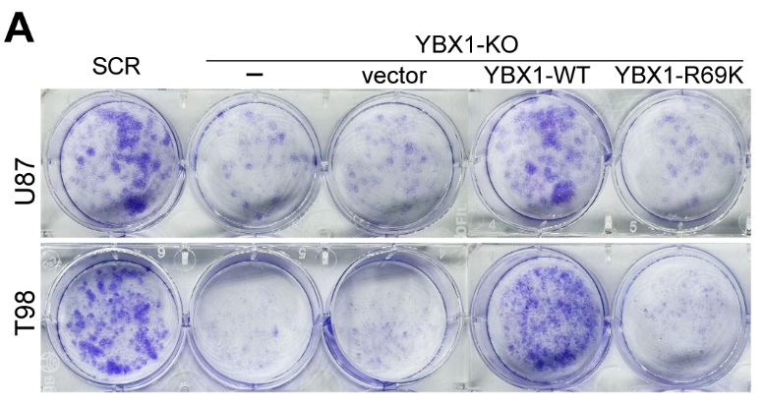
Fig. S5 PRMT3-mediated asymmetric dimethylation of YBX1 at R69 is required for GBM cell proliferation. A Representative images of colony formation in U87 and T98 YBX1‑KO cells reconstituted with vector control, YBX1‑WT or YBX1‑R69K.
Fig. S6 Effects of methylated or nonmethylated peptides on the PRMT3-YBX1 interaction. A, B U87 and T98 cells were untreated or treated with methylated or non-methylated peptides as indicated. Co‑IP assay was performed using anti‑PRMT3 (A) or anti‑YBX1 (B) antibodies, followed by western blotting analysis of PRMT3 and YBX1 in the immunoprecipitates and input samples to assess changes in the PRMT3-YBX1 interaction upon peptide treatment.
Fig. S7 GO enrichment analysis of PRMT3-regulated genes in GBM cells. A GO biological process analysis of differentially expressed genes (DEGs) derived from the GSE200902 dataset (PRMT3 knockdown vs. control). The dot plot displays the top 30 significantly enriched pathways (FDR < 0.05), ranked by gene count.
Fig. S8 Pharmacological inhibition of PRMT3 by SGC707 suppresses E2F1 expression. A, B T98 and U87 cells were treated with SGC707 for 48 hours. E2F1 mRNA levels were quantified by RT‑qPCR (A), and E2F1 protein levels were examined by western blotting (B). Data are presented as mean ± SD. *P < 0.05, **P < 0.01, ***P < 0.0001, versus the indicated groups, Student’s t-test.
Fig. S9 The effect of PRMT3-YBX1 on GBM cell proliferation is dependent on E2F1. A Representative images of colony formation in U87 cells overexpressing PRMT3 with or without YBX1 knockdown. B Representative images of colony formation in U87 and T98 cells silencing PRMT3 with or without E2F1 overexpression. C Representative images of colony formation in U87 cells overexpressing PRMT3 with or without E2F1 knockdown.
Table S1. Sequences of siRNAs and shRNAs.
shRNA/siRNA | Sequence (5'-3')
shRNA_NC | CCGGCAACAAGAT GAAGAGCACAACTCGAGTTGGTGCTCTTCATCTTGTTGTTTTT
shPRMT3 #1 | CCTTGGGAGAAAGAAGAGTATTTCAAGAGAATACTCTTCTTTCTCCCAAGG
shPRMT3 #2 | GATTCTGTCCTTTATGCAAAGTTCAAGAGACTTTGCATAAAGGACAGAATC
shPRMT3 #3 | GTTGAATAATTCAACTCAAACTTCAAGAGAGTTTGAGTTGAATTATTCAAC
siRNA_NC | UUCUCCGAACGUGUCACGUTT
siPRMT3 | GGUCACAGUUCACAAGAAUTT
siYBX1 #1 | GGAACGGAUAUGGUUUCAUTT
siYBX1 #2 | GCAGACCGUAACCAUUAUATT
YBX1 sgRNA | GTAATGGCTTTTGTAGGGTG
siE2F1 | CTACTCAGCCTGGAGCAAGAA
siNSUN2 | CACGTGTTCACTAAACCCTAT

Table S2. Primer sequences for RT-qPCR and RIP-qPCR.
Genes | Sequence (5'-3')
PRMT3 | F: CACTGTCTGCTGAAGCCGCATT
PRMT3 | R: GTAGATGACGAGCAGGTTCTGAC
YBX1 | F: GGGGACAAGAAGGTCATCGC
YBX1 | R: CGAAGGTACTTCCTGGGGTTA
E2F1 | F: GGACCTGGAAACTGACCATCAG
E2F1 | R: CAGTGAGGTCTCATAGCGTGAC
NSUN2 | F: ACCTGGCTCAAAGACCACACAG
NSUN2 | R: TGGCTTGATGGACGAGCAGGTA
β-actin | F: TCCTGTGGCATCCACGAAACT
β-actin | R: GAAGCATTTGCGGTGGACGAT

