Supplementary material
Title: Co-culture of the aerial microalga Coelastrella rubescens KGU-HN001 and the nitrogen fixing-bacterium Rhodobacter sphaeroides under aerial-phase conditions

Nobuhiro Aburai*, Tomoka Koike, Takayuki Tsukagoshi

Department of Chemistry and Life Science, School of Advanced Engineering, Kogakuin University, 2665-1 Nakano-machi, Hachioji, Tokyo 192-0015, Japan

*Corresponding author
E-mail address: bt13347@ns.kogakuin.ac.jp (N. Aburai)
Tel.: +81 42 628 4847
FAX: +81 42 628 5647

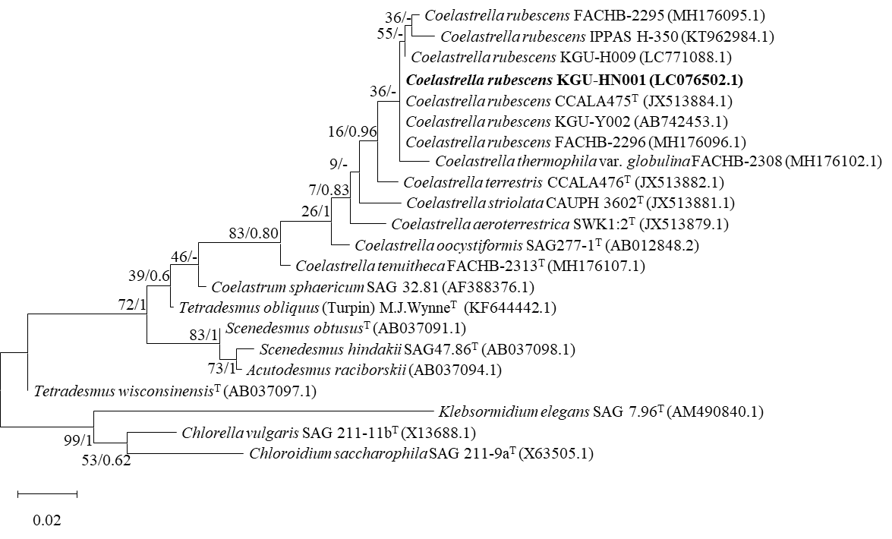

Fig. S1. Phylogenetic tree of isolated bacterium with its known neighbors based on 18S rRNA gene sequences. Tree was constructed using the neighbor-joining method; scale bar represents evolutionary distance (Knuc) of 0.02; and numbers at branch nodes are bootstrap values (1000 replicates) obtained using the maximum-likelihood method. Accession numbers for DNA sequences are indicated in parentheses. ^{T} is type strain.

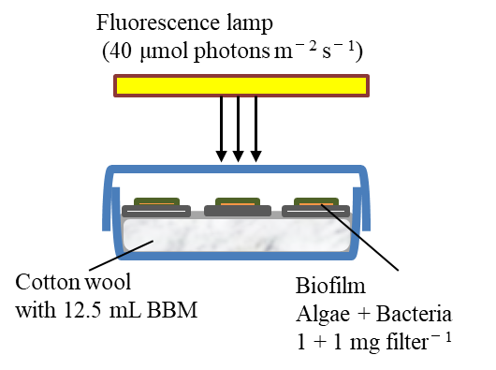

Fig. S2. Diagram of culture method for biofilms under aerial conditions.

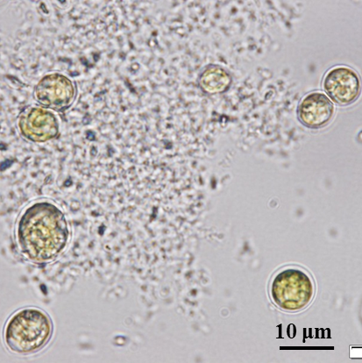

Fig. S3. Image of cells in the mixed biofilm under aerial culture conditions.
(A)
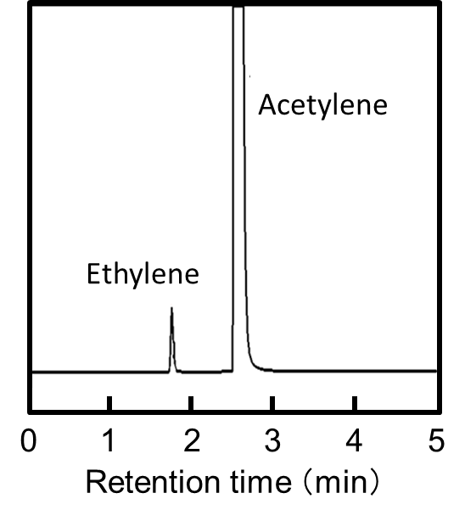

(B)
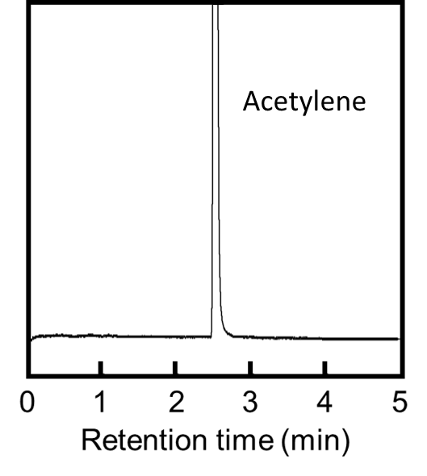

Fig. S4. Chromatogram of substrate and product (ethylene) obtained using the acetylene reduction assay. co-culture of algal and bacterial cells (mixed biofilm) (A) and negative control (only acetylene) (B).
(A)
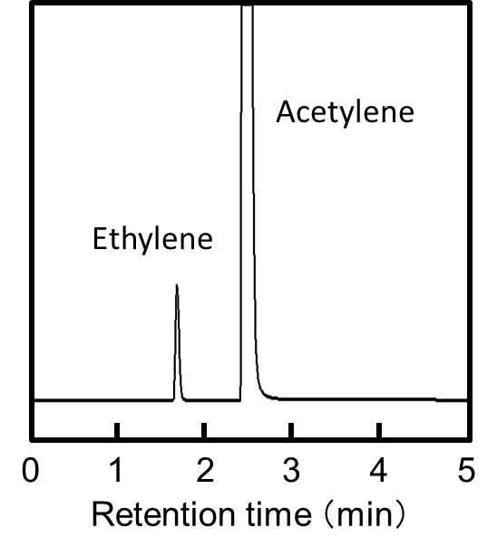

(B)
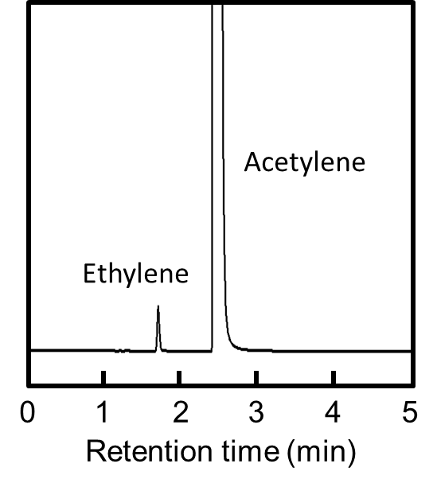

Fig. S5. Acetylene reduction assay. Co-culture of algal and bacterial cells and the biofilms where the two organisms were arranged far apart (A) or as a bilayer (upper layer: microalga, lower layer: bacterium) (B).

