Supplementary file 1. Search terms

Database | Search terms | Date | Numbers of articles
CINAHL Ultimate | (palliative care or terminal care or end of life care) AND (artificial intelligence or ai or a.i.) | 19.9.25 | 174
PubMed | ((Artificial Intelligence[MeSH Terms]) OR (Artificial intelligence[Title/Abstract])) AND (((Palliative care[MeSH Terms]) OR (Hospice and Palliative Care Nursing[MeSH Terms])) OR (Palliative care[Title/Abstract] OR end-of-life care[Title/Abstract] OR terminal care[Title/Abstract])) | 25.9.25 | 282
CENTRAL | 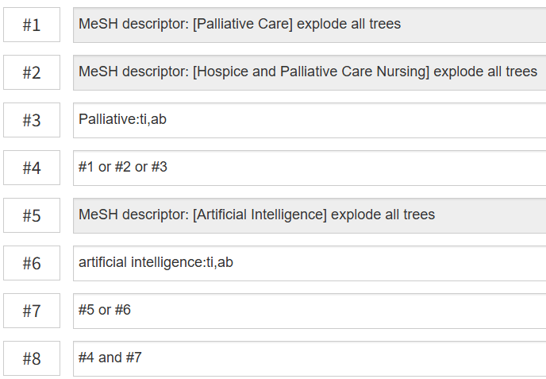 | 22.9.25 | 25
ACM | [Abstract: "artificial intelligence"] AND [Abstract: palliative] | 25.9.25 | 84
Web of Sciences | "artificial intelligence" (Topic) and Palliative care OR end-of-life care OR terminal care (Topic) | 25.9.25 | 249

