Supplementary Information

O-GlcNAcylation stabilizes OCA-B to sustain humoral immunity

Yu Ri Jung ^{1,2,*}, Ki Myeong Na^{1,3,*}, Liu Yue ^{1,2,*}, Junghyun Lim ^{4,*}, Mi-Ran Song¹, Haeun Lee¹, Heeyoun Hwang⁵, Kee K. Kim²*, and Sung-Kyun Park^{1,3}*

¹Infectious Disease Research Center, Korea Research Institute of Bioscience and Biotechnology (KRIBB), Daejeon 34141, Republic of Korea
²Department of Biochemistry, College of Natural Sciences, Chungnam National University, Daejeon 34134, Republic of Korea
³Department of Functional Genomics, KRIBB School of Bioscience, Korea University of Science and Technology (UST), Daejeon 34113, Republic of Korea
⁴Department of Pharmacy, School of Pharmacy, Jeonbuk National University, Jeonju 54896, Republic of Korea
⁵Ochang Bio-Environment Research Center, Korea Basic Science Institute, Cheongju 28119, Republic of Korea
⁶Bio-Analytical School, Korea University of Science and Technology (UST), Daejeon 34113, Republic of Korea

*These authors contributed equally to this work
*Corresponding author.
Lead contact: skpark@kribb.re.kr (S.-K. Park)

Cytokines
Thiamet G
OSMI-1
+
+
+
+
+
-
-
-
-
+
+
+
+
+
-
-
-
-

Fig. S1: Irf4 and Bcl6 transcript levels in cytokine-stimulated B cells under O-GlcNAc–modulating conditions
Real-time RT-qPCR analysis of Irf4 and Bcl6 mRNA expression levels in naive B (CD43⁻CD11b⁻) cells. The cells were stimulated for 72 hours with CD40L, IL-4, and IL-21 in the presence or absence of O-GlcNAcylation inhibitors, including Thiamet G (OGA inhibitor) or OSMI-1 (OGT inhibitor). The results were normalized to Gapdh. Data are presented as mean ± S.D. from three independent experiments. Statistical significance was determined by a two-tailed Student’s t-test (ns: not significant, *: p < 0.05, **: p < 0.01, ***: p < 0.001).

A
B
+
-
OSMI-1
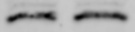
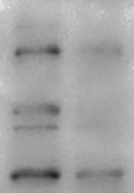
O-GlcNAc
(RL2)
β-Actin
CH12F3-2A
75
100
140
180
+
-
(kDa)
OSMI-1
45

Fig. S2: Inhibition of O-GlcNAcylation by OGT inhibitor impairs the binding affinity of OCT-1 to the IgH gene promoter.
A Representative western blot showing O-GlcNAc levels in CH12F3-2A cells treated with or without OSMI-1(OGT inhibitor). B ChIP-qPCR assay using α-OCT-1 antibody, showing changes in OCT-1 binding to the IgH gene promoter in CH12F3-2A cells. Quantitative data for the enrichment of OCT-1 at the IgH gene promoter are presented as the relative input ratio following normalization against the Actg1 promoter region. Data are presented as mean ± S.D. from three independent experiments. Statistical significance was determined by a two-tailed Student’s t-test (ns: not significant, *: p < 0.05, **: p < 0.01, ***: p < 0.001).

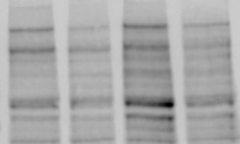
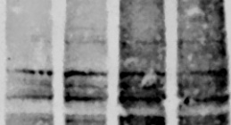
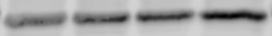
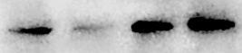
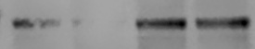
180
O-GlcNAc
(RL2)
β-actin
CH12F3-2A
75
100
+
-
(kDa)
OSMI-1
140
Ubiquitin
OCT1
OCA-B
180
75
100
140
100
35
MG132
+
-
+
+
-
-
45

Fig. S3: Proteasome inhibition prevents O-GlcNAc–dependent loss of OCT-1 and OCA-B in CH12F3-2A cells
Representative immunoblot showing O-GlcNAc, ubiquitin, OCT-1, and OCA-B protein levels in CH12F3-2A cells treated with or without the OGT inhibitor OSMI-1, in the presence or absence of the proteasome inhibitor MG132. Accumulation of ubiquitinated proteins was assessed to verify effective proteasome inhibition by MG132. These data support the involvement of proteasome-dependent degradation in the reduction of OCT-1 and OCA-B under O-GlcNAc–inhibited conditions.

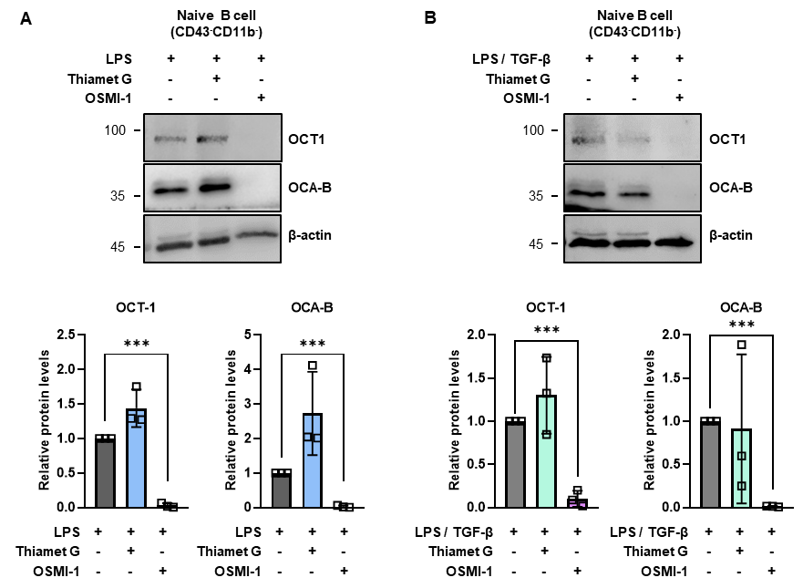

Fig. S4: O-GlcNAcylation maintains OCT-1 and OCA-B protein levels in activated primary B cells
A Representative immunoblot showing OCT-1 and OCA-B protein expression levels in naive splenic B cells (CD43⁻CD11b⁻) stimulated with LPS for 72 h in the presence or absence of O-GlcNAcylation-modulating compounds, including Thiamet G (OGA inhibitor) or OSMI-1 (OGT inhibitor). Quantification of relative band intensities is shown below. B Representative immunoblot showing OCT-1 and OCA-B protein expression levels in naïve splenic B cells stimulated with LPS and TGF-β for 72 h under the same treatment conditions as in (A). Quantification of relative band intensities is shown below. β-actin was used as a loading control for normalization. Data are presented as mean ± S.D. from three independent experiments. Statistical significance was determined by a two-tailed Student’s t-test (ns: not significant, *: p < 0.05, **: p < 0.01, ***: p < 0.001).

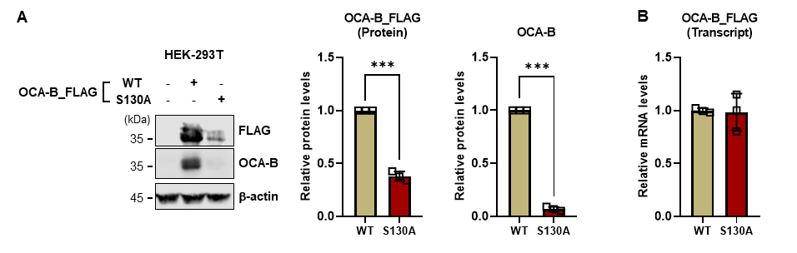

Fig. S5: OCA-B S130A mutation reduces protein abundance without affecting transcript levels in HEK293T cells
A Representative immunoblot showing overexpressed FLAG-tagged OCA-B wild-type (WT) or S130A mutant proteins in HEK293T cells. Quantification of relative band intensities is shown on the right. B Real-time RT–qPCR analysis of FLAG-tagged OCA-B–specific mRNA expression levels in HEK293T cells transfected with WT or S130A constructs. Transcript levels were normalized to Gapdh. All data are presented as mean ± S.D. from three independent experiments. Statistical significance was determined by a two-tailed Student’s t-test (ns: not significant, *: p < 0.05, **: p < 0.01, ***: p < 0.001).

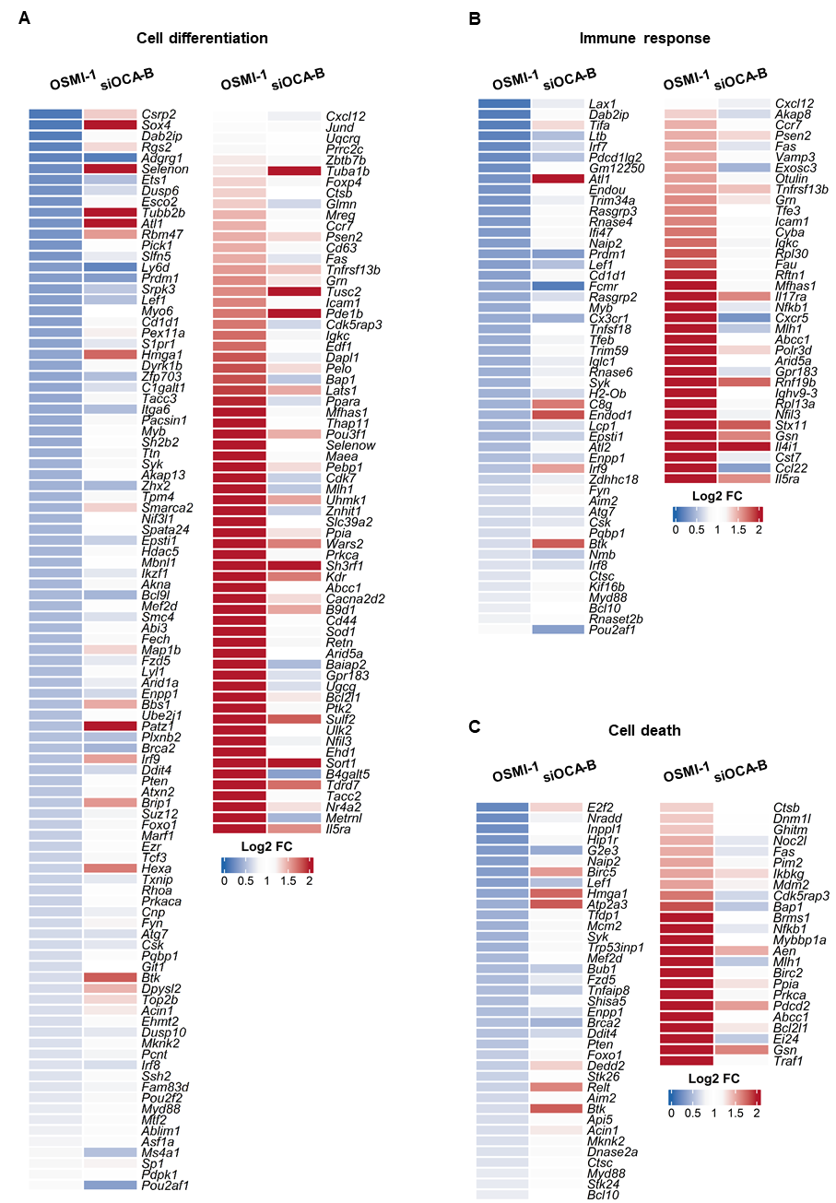

Fig. S6: Shared transcriptional programs downregulated by O-GlcNAc inhibition and OCA-B depletion
A-C Heatmaps showing representative genes across selected biological programs that are commonly regulated in both OSMI-1–treated and siOCA-B–transfected B cells. Relative gene expression levels are displayed as log₂ fold changes (log2 FC) compared with the corresponding control conditions (DMSO or siNC). The color scale indicates relative upregulation (red) or downregulation (blue).

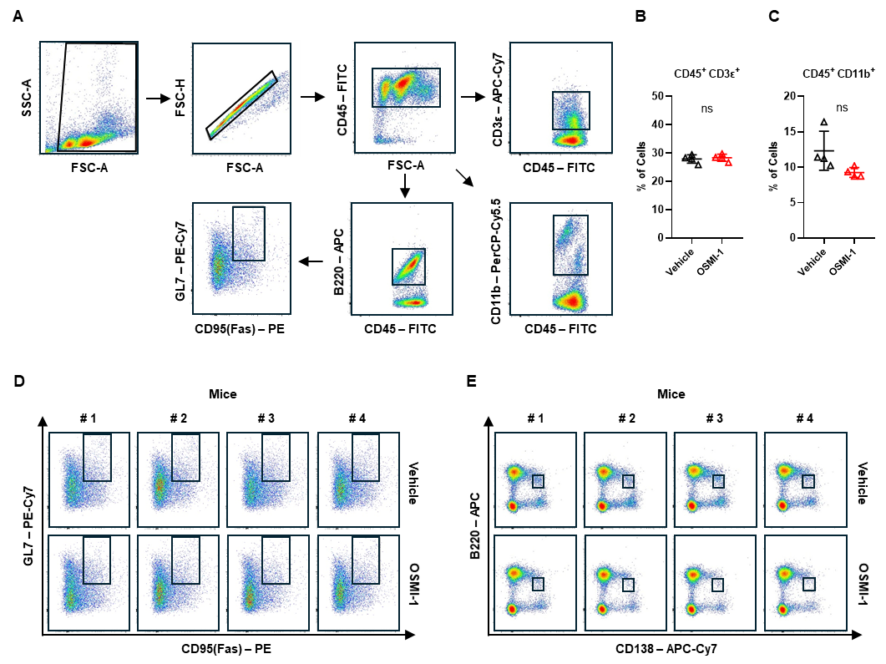

Fig. S7: Flow cytometric gating strategies and representative plots for splenic immune cell subsets
A Gating strategy used to identify major splenic immune cell populations. Total splenocytes were sequentially gated for singlets (FSC-H vs. FSC-A), CD45⁺ leukocytes, and subsequently subdivided into T cells (CD45⁺CD3ε⁺), myeloid-enriched cells (CD45⁺CD11b⁺), and B-cell subsets based on the indicated surface markers. B, C Flow cytometric quantification of major splenic immune populations. Shown are the percentages of CD45⁺CD3ε⁺ T cells (B) and CD45⁺CD11b⁺ myeloid-enriched cells (C) within total splenocytes. Data are presented as mean ± S.D. Statistical significance was determined by a two-tailed Student’s t-test (ns: not significant, *: p < 0.05, **: p < 0.01, ***: p < 0.001). D Representative flow cytometric plots identifying germinal center (GC) B cells. Splenocytes were stained for B220, GL7, and CD95 (Fas), and GC B cells were defined as B220⁺GL7⁺CD95⁺. Individual plots from four representative mice per group (#1–#4) are shown. These data correspond to the quantification presented in Fig. 7J. E Representative flow cytometric plots identifying plasma cells. Splenocytes were stained for B220 and CD138, and plasma cells were defined as B220^{low}CD138⁺. Individual plots from four representative mice per group (#1–#4) are shown. These data correspond to the quantification presented in Fig. 7K.

