Supplemental Information titles and legends

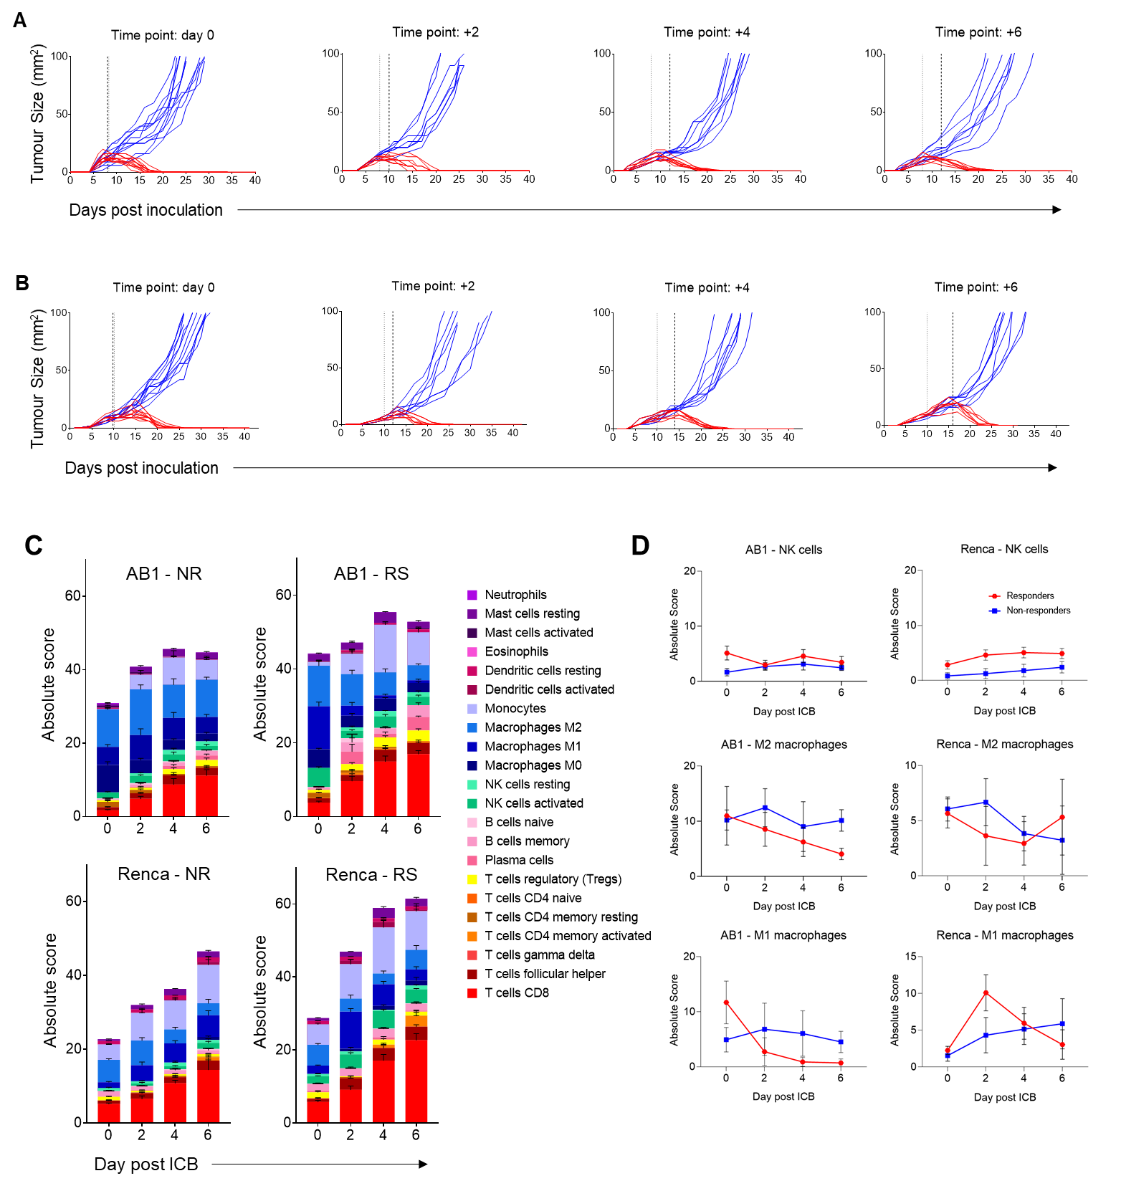
Fig. S1. Growth curves of remaining tumors left in situ after surgical removal of the contralateral AB1 and Renca tumors. Mice bearing contralateral tumors had one tumor removed for RNA sequencing, with the remaining tumor monitored for response to ICB. (A) AB1 tumors were treated with ICB on day 8, and one tumor excised 1 hour, 2, 4, or 6 days after. (B) Renca tumors were treated with ICB on day 10, and one tumor excised 1 hour, 2, 4, or 6 days after. Tumors were categorized as responders (red lines) or non-responders (blue lines). Dotted line = beginning of ICB treatment. Dashed line = day of surgical removal of tumor on right side. (C) CIBERSORTx cell deconvolution analysis of responder (RS) and non-responder (NR) tumors over time, showing all cell subsets. (D) Dynamics of NK cells, M2 macrophages and M1 macrophages in responders (red) and non-responders (blue) over time in the AB1 (left) and Renca (right) models. Bars represent standard deviation.

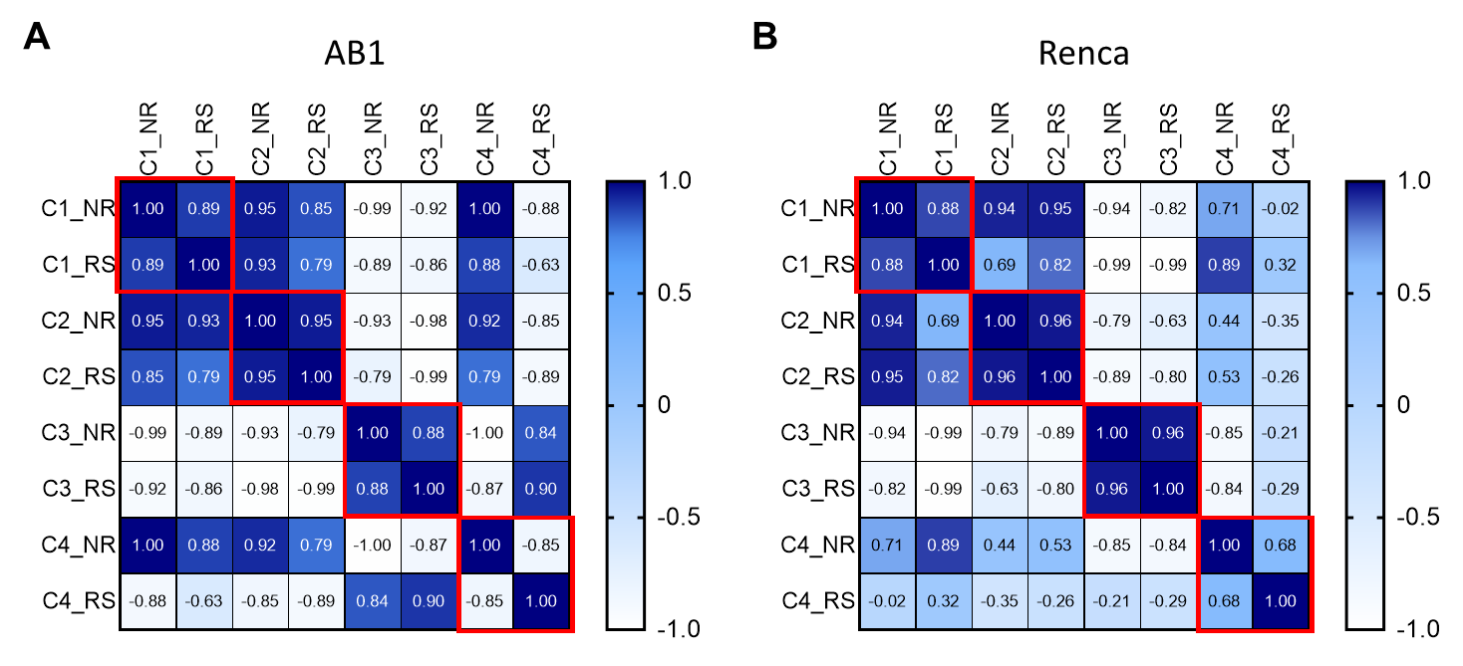

Fig. S2. Correlation analysis of the trendlines between responders and non-responders of each cluster identified by TCseq. (A) AB1 responders and non-responders have a similar trend (r>0.8) in clusters 1-3, but not in cluster 4. (B) Renca responders and non-responders have a similar trend (r>0.8) in clusters 1-3, but not in cluster 4.

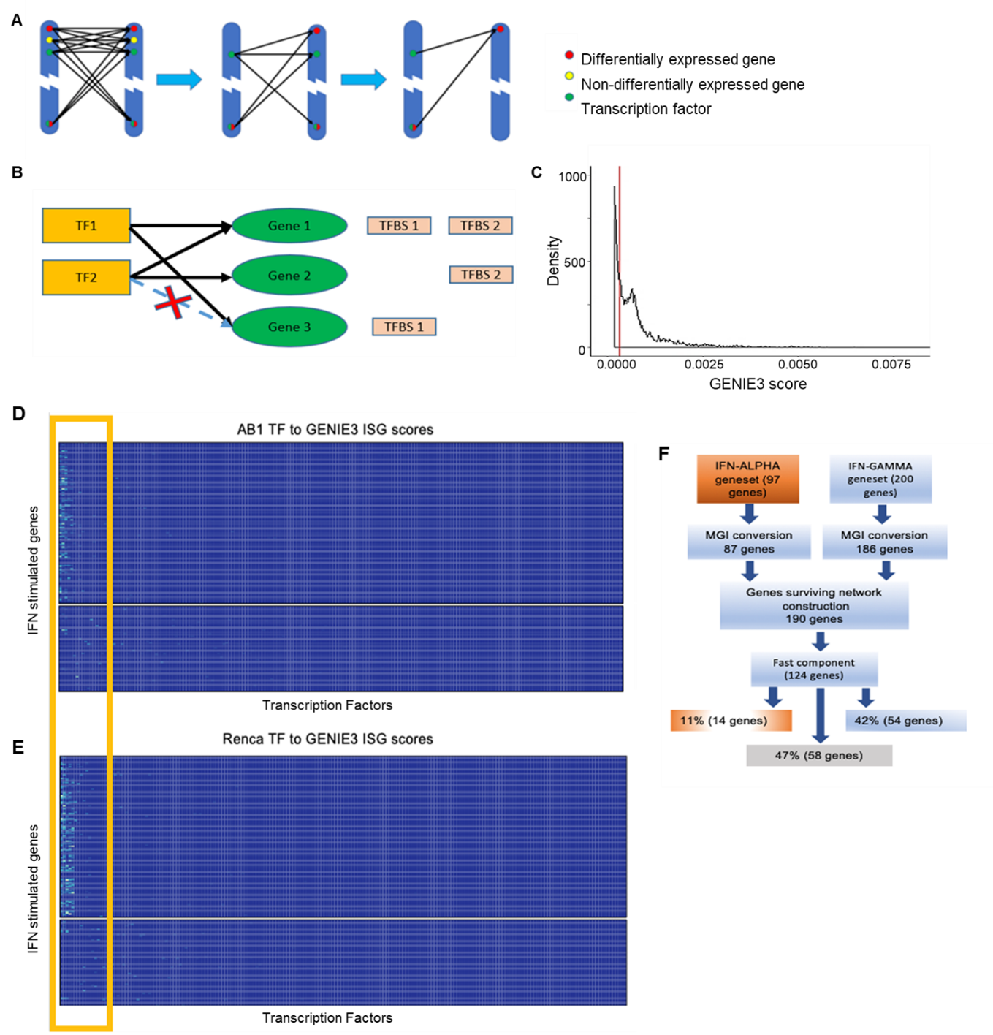
Fig. S3. Network construction approach and analysis on bulk RNA-seq data in AB1 and Renca. We constructed two “direct-interaction networks”, one for AB1 and one for Renca using all responder samples for each strain across four experimental time points. (A and B) Pruning schema used to construct these networks. As illustrated in (B), we eliminate the GENIE3 edge from TF2 to differentially expressed gene 3 because gene 3 does not possess the transcription factor binding site for TF2. (C) Threshold selection after considering the union set of all GENIE3 weights from Renca and AB1 direct networks (red line - 0.0003125). (D and E) Full heatmap of TF to ISGs GENIE3 scores in AB1 (D) and Renca (E) from TFs (x-axis) to ISGs (y-axis). The yellow box across both heatmaps is displayed in Figure 2C, emphasizing that regulation is confined to IFN-related TFs. (F) The on/fast-off component of ISGs is composed of genes stimulated by type I and type II IFN.

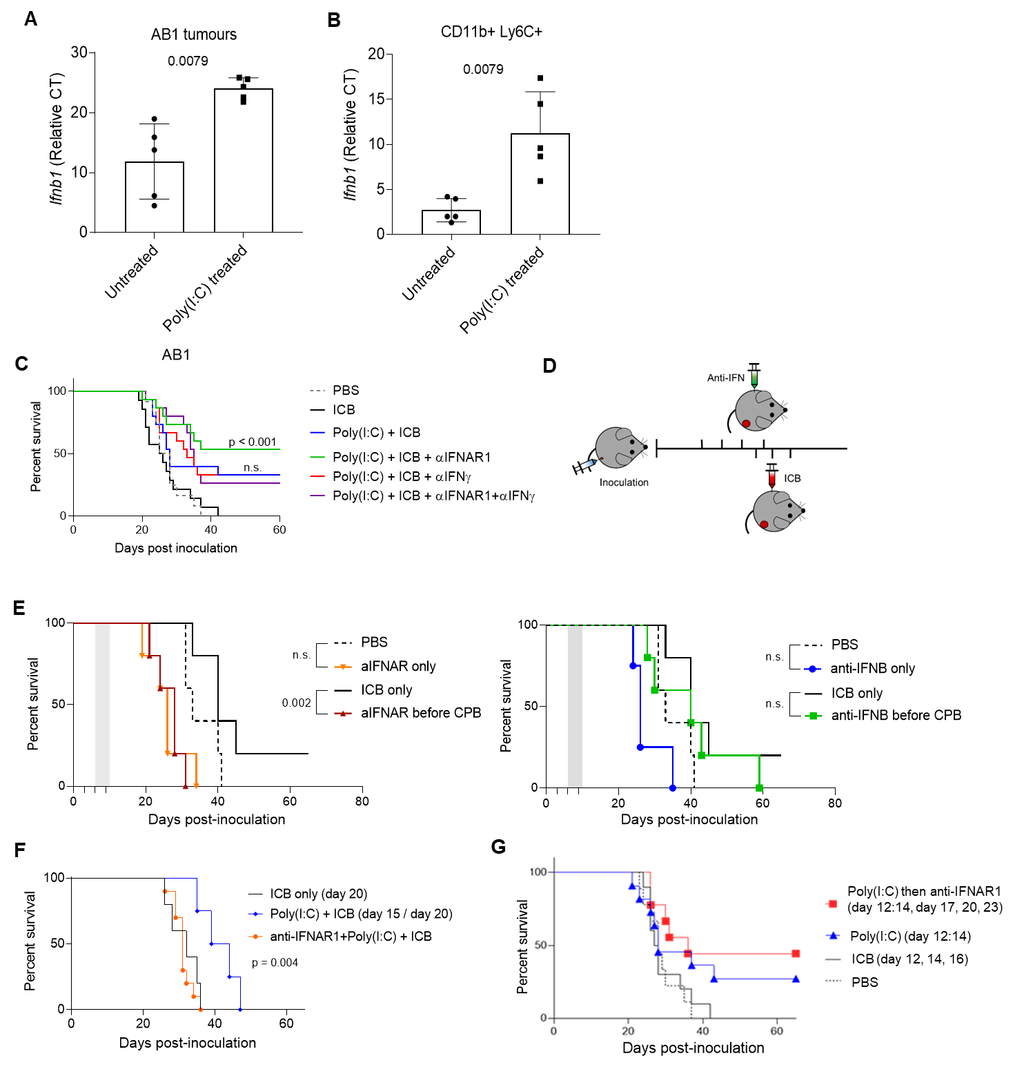
Fig. S4. Therapeutically phenocopying of on/fast-off type I IFN kinetics with poly(I:C) and anti-IFNAR improves response. (A and B) Poly(I:C) induces IFNβ production in Ly6C⁺ monocytes in AB1 tumors. Tumors from AB1 bearing mice were treated with intra-tumoral poly(I:C), harvested, cell sorted, RNA extracted and analyzed for IFNβ expression by RT-PCR. (A) Relative IFNβ RNA expression in untreated compared to poly(I:C) treated tumors. (B) Relative IFNβ RNA expression within the sorted CD11b⁺ Ly6C⁺ monocyte population in untreated compared to poly(I:C) treated tumors. (C) Mice bearing AB1 tumors were treated with poly(I:C) (day 12, 13, 14), followed by ICB (day 17), followed by an antibody against IFNAR1, IFNγ, or both (day 20, 23, 26). Pre-treatment with poly(I:C) increases the number of responders, but does not significantly increase survival (blue line, p= 0.09). Addition of anti-IFNAR significantly improves survival over ICB control (green line, p = <0.001). (D) Schedule of pre-treatment anti-IFNAR followed by ICB. (E) Dosing anti-IFNAR or anti-IFNβ alone is not significant compared to PBS controls. Dosing anti-IFNAR (but not anti-IFNβ) before ICB, rather than after, negates the effect of ICB on AE17 tumors (red line, p = 0.002). (F) Dosing anti-IFNAR concurrently with poly(I:C) (orange line) negates the priming effect of poly(I:C) (p = 0.004). (G) Blocking IFNAR after IFN stimulation with poly(I:C) does not affect response, even when ICB is not involved.

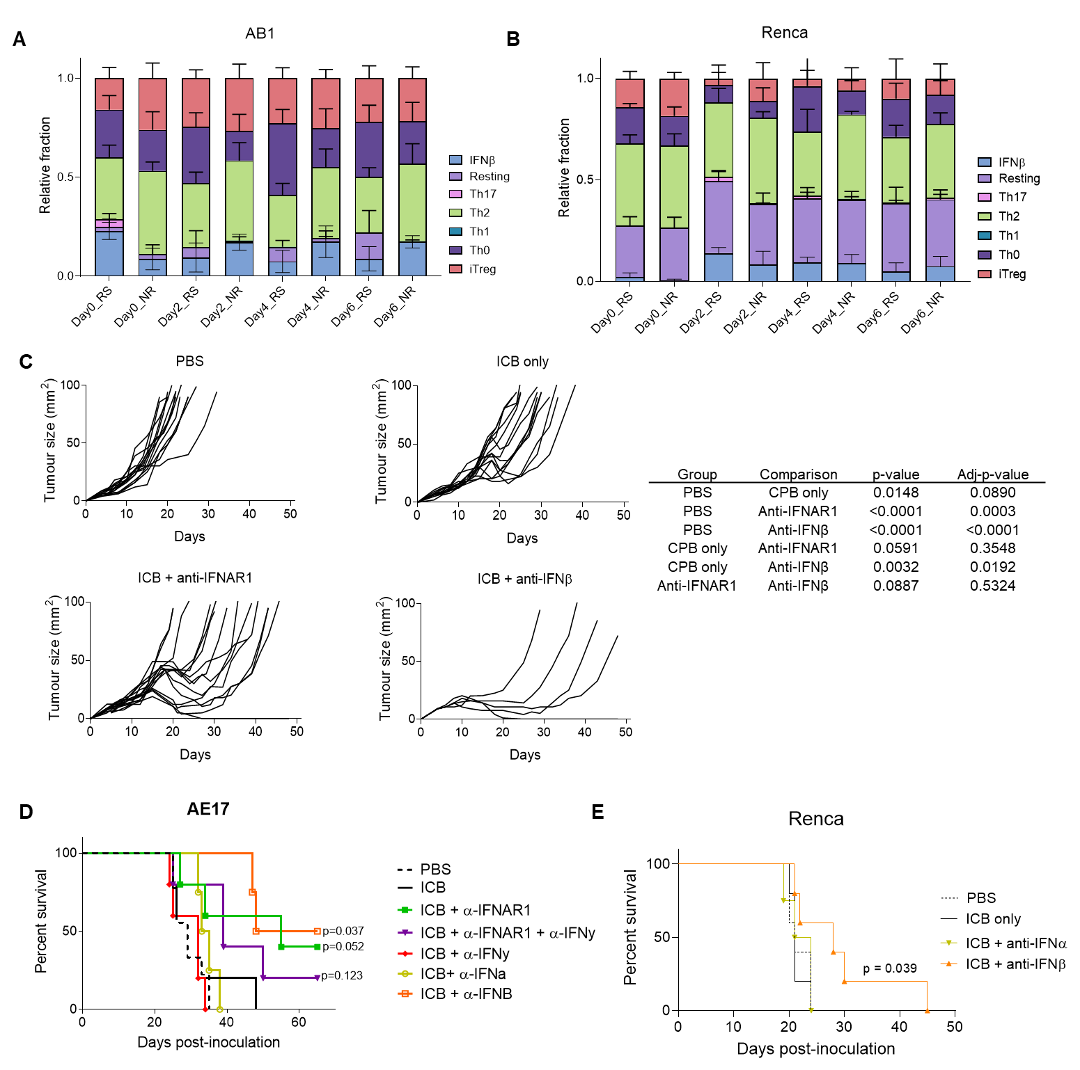
Fig. S5. Mimicking IFN kinetics by blocking IFNβ after ICB improves responses.
(A and B) An IFNβ induced gene signature follows the on/off kinetics in AB1 and Renca tumors. Using a stimulated T cell gene expression signature from a recently published singe cell RNAseq dataset, which was obtained by treating human CD4⁺ T cells with chemokines including IFNβ in vitro ³⁰, we constructed a reference matrix using CIBERSORT. Using this matrix, we used CIBERSORT to deconvolute these populations in our bulk RNAseq data for AB1 (A) and Renca (B). The signature from the IFNβ T cells, but not other stimulated T cells, followed the rapid on/off kinetics in responders, but the increase is delayed in non-responders. (C-E) To more closely recapitulate a clinical scenario, pre-treatment with poly(I:C) was omitted from the schedule. (C) AB1 tumors treated with ICB followed by anti-IFNAR or anti-IFNβ showed a decrease in tumor size and delay in growth when complete response was not achieved. Growth curves were analyzed longitudinally using type II ANOVA and pairwise comparisons across groups with Bonferroni correction for multiple comparisons (lower table ⁸⁵). (D) Blocking IFNβ,, but not IFNα or IFNγ after ICB significantly improved response in the AE17 tumor model. (E) Blocking IFNβ, but not IFNα, after ICB significantly improved response in the Renca tumor model. P-values are compared to ICB control, using Logrank testing.

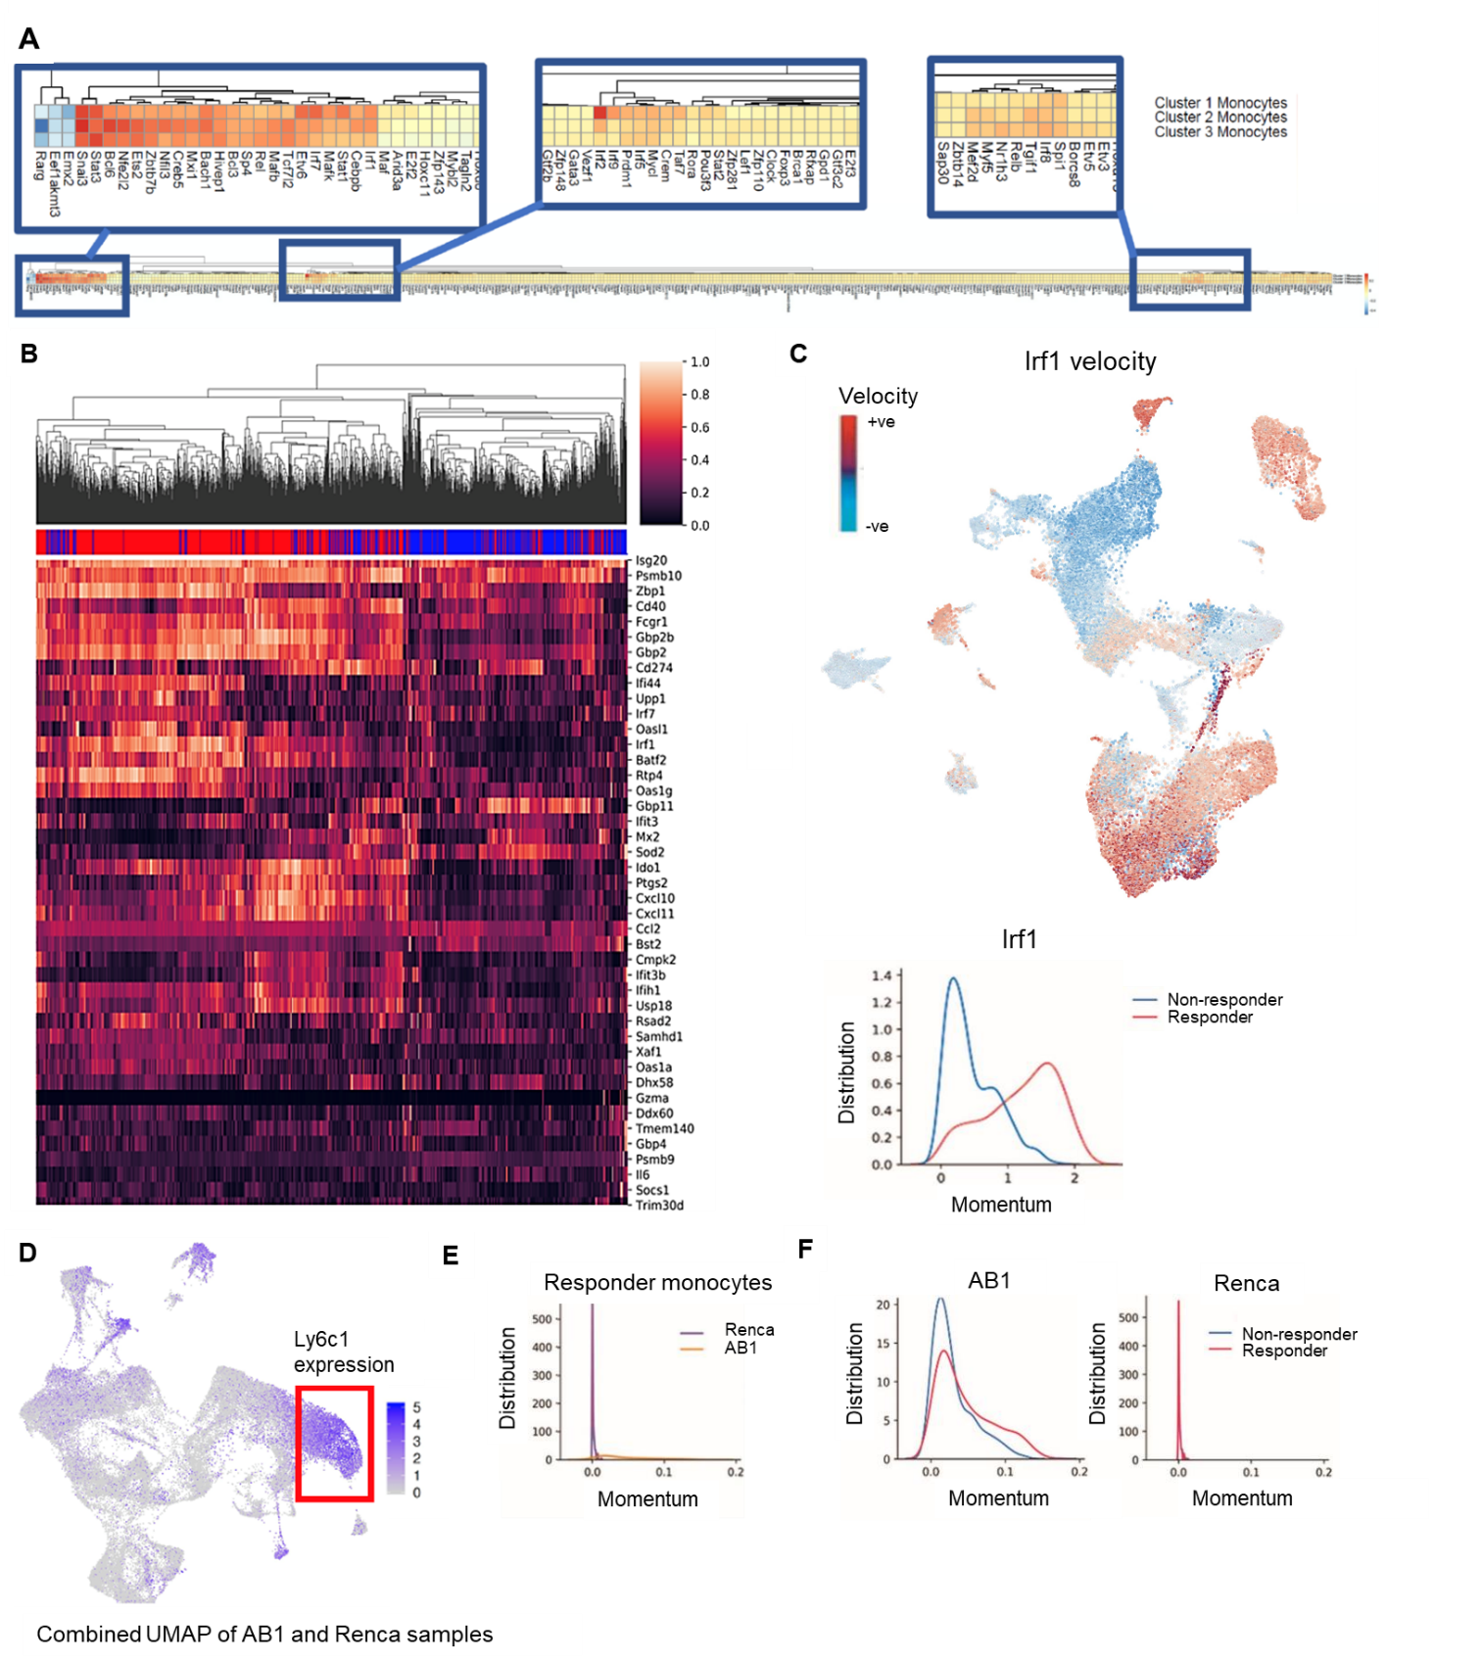
Fig. S6. Increased IFN-related activity in AB1 cluster 1 monocytes in responders, with Renca monocytes existing in an earlier transcriptional state. (A) SCENIC network analysis on single cell AB1 data showed differential transcription factor activation across the 3 monocyte populations. IFN-related TFs were found in all three regions of differential activation and were increased, especially in cluster 1 monocytes. (B) Heatmap of IFN-related gene transcriptional rates (abs(U_measured – U_predicted after gamma fit) for cluster 1 monocytes in responders (red) compared to non-responders (blue). (C) Irf1 transcription in single cells in AB1 tumors shows strong negative regulation in monocytes, and this is also more pronounced in responders than non-responders. (D-F) Since the bulk RNAseq data indicated that the Renca responder samples had a delayed on/fast-off dynamic compared to AB1, we queried whether this delayed dynamic in bulk RNAseq signal in Renca was due to an earlier state of the tumor microenvironment. To investigate this, we examined transcriptional activity of monocytes in AB1 and compared their activity to the same monocyte population in Renca. (D) Combined UMAP of AB1 and Renca samples with cluster 1 monocytes located in the region highlighted by the red box. In this region, Renca responder monocytes have reduced transcriptional momentum compared to AB1 monocytes (E). (F) Both responder and non-responder Renca monocytes have similar transcriptional momentum (right), unlike AB1 (left). Taken together, these data indicate that cluster 1 monocytes diverge over time along two transcriptional trajectories based on ICB response. These separate trajectories are characterised by differences in interferon gene expression, with Renca monocytes at an earlier transcriptional timepoint than AB1.

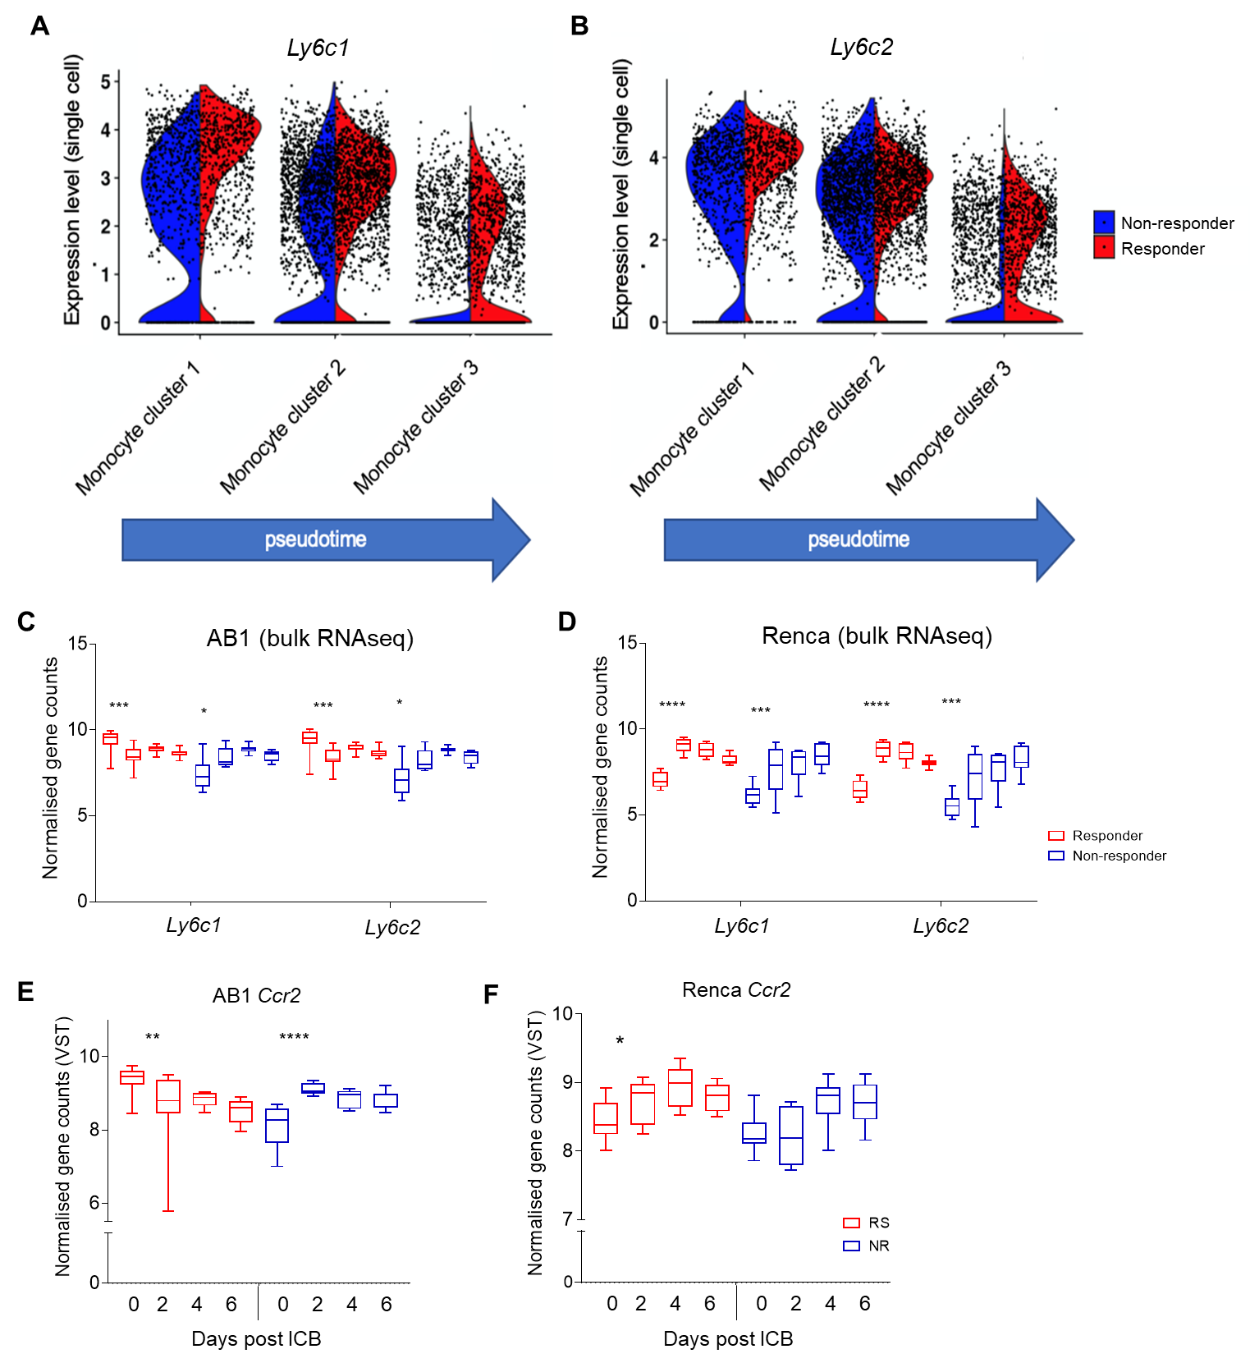Fig. S7. On/off kinetics of Ly6c and CCR2 gene expression in responders over the course of ICB in bulk RNAseq data are compatible with Ly6c gene expression in responder AB1 monocytes along pseudo time axis.
(A and B) The kinetics of expression in Ly6c1 (A) and Ly6c2 (B) in AB1 monocyte clusters across the pseudo time axis (blue arrow, see also Figure 3H). (D and E) Box plot of the normalized expression of the genes Ly6c1 and Ly6c2 in AB1 (D) and Renca (E) bulk RNAseq data. Expression is plotted over time (left to right) in responders (red) and non-responders (blue). (F and G) Box plot of the normalized expression of Ccr2 in AB1 (F) and Renca (G) over time. Comparisons are between day 0 and day 2 within the same group.
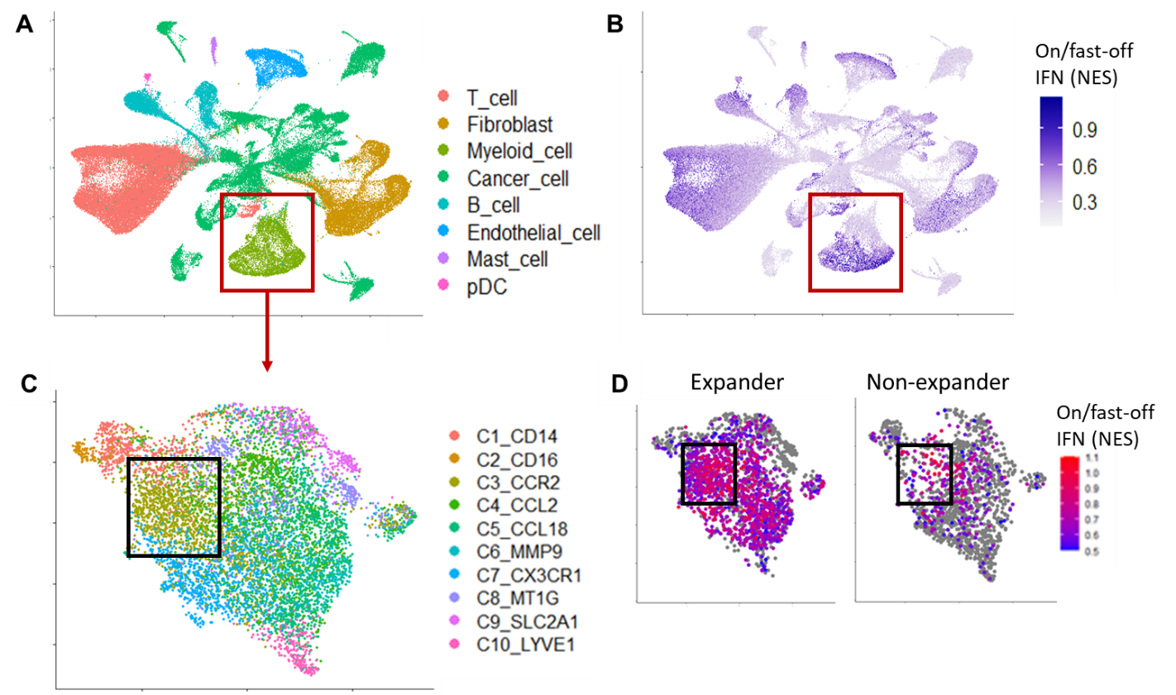

Figure S8. Patients treated with ICB display early enrichment of the on/fast-off IFN signature.
(A) UMAP of single cells from breast cancer patient biopsies taken prior to treatment with anti-PD1. Cluster labels have been provided from the original published analysis ⁴⁵. (B) UMAP showing a highest enrichment of the on/fast-off IFN signature within the myeloid cluster. (C) UMAP of the myeloid cell subset from (A), with cell labels provided from the original published analysis. (D) UMAP of myeloid cells in expander and non-expanders, showing highest enrichment in the CCR2 population.

Supplementary Methods
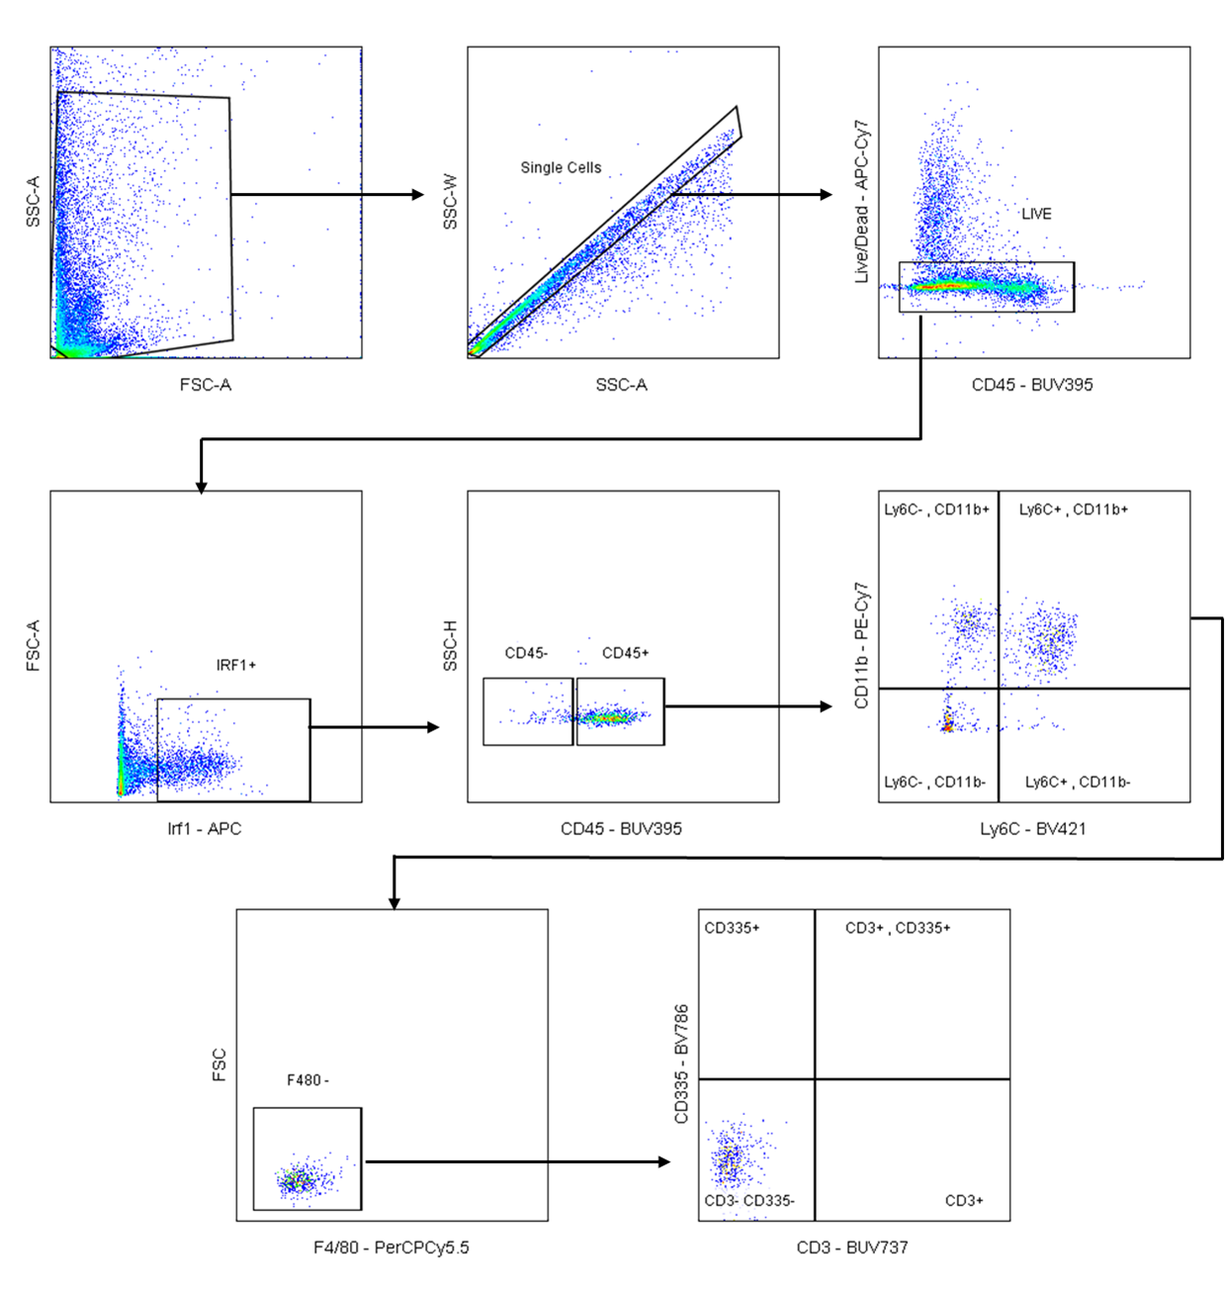
Flow cytometry gating strategy of Irf1⁺ cell markers.
Cells were stained using RNA target probes for Irf1 RNA. Irf1⁺ cells were then gated to determine the phenotype of the cells. CD45 expression was used to distinguish immune cells: CD45⁻ non-immune cells (e.g. tumor cells) and CD45⁺ immune cell populations. Immune cells were analyzed by their expression of CD11b and Ly6C. Ly6C⁺ CD11b⁺ immune cells were F4/80⁻, CD3⁻ and CD335⁻.

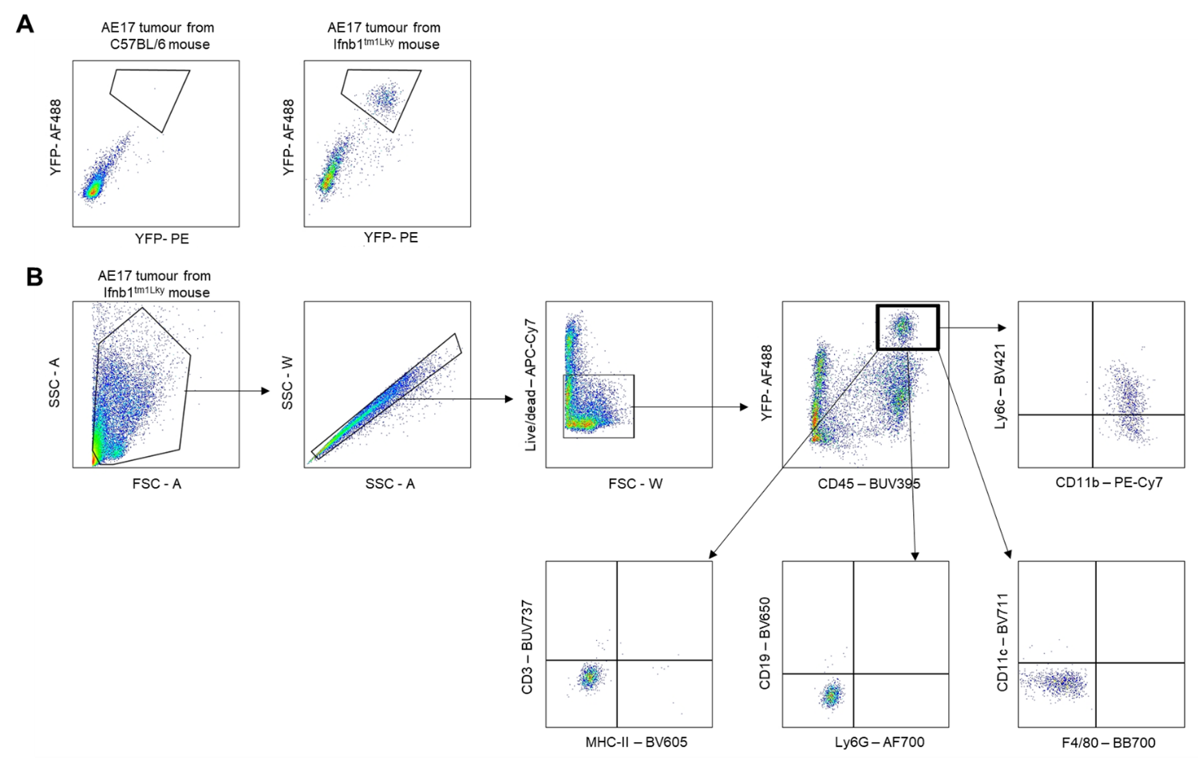
Flow cytometry gating strategy of YFP⁺ cell markers.
(A) Cells were stained using an anti-GFP antibody to detect YFP+ cells. AE17 tumours from C57BL/6 wildtype mice were used as a negative control. (B) Single cells that were negative for our dead cell marker were gated. YFP⁺ cells were exclusively CD45+ (immune cells) and then were gated to determine the phenotype of the cells. YFP+ immune cells were CD11b⁺, Ly6C+/-, MHC-II⁻, CD11c⁻, Ly6G⁻, CD19⁻, CD3⁻ and F4/80⁻

