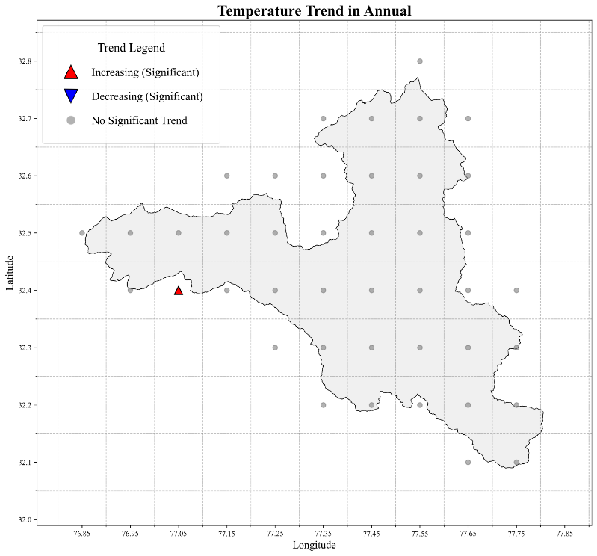
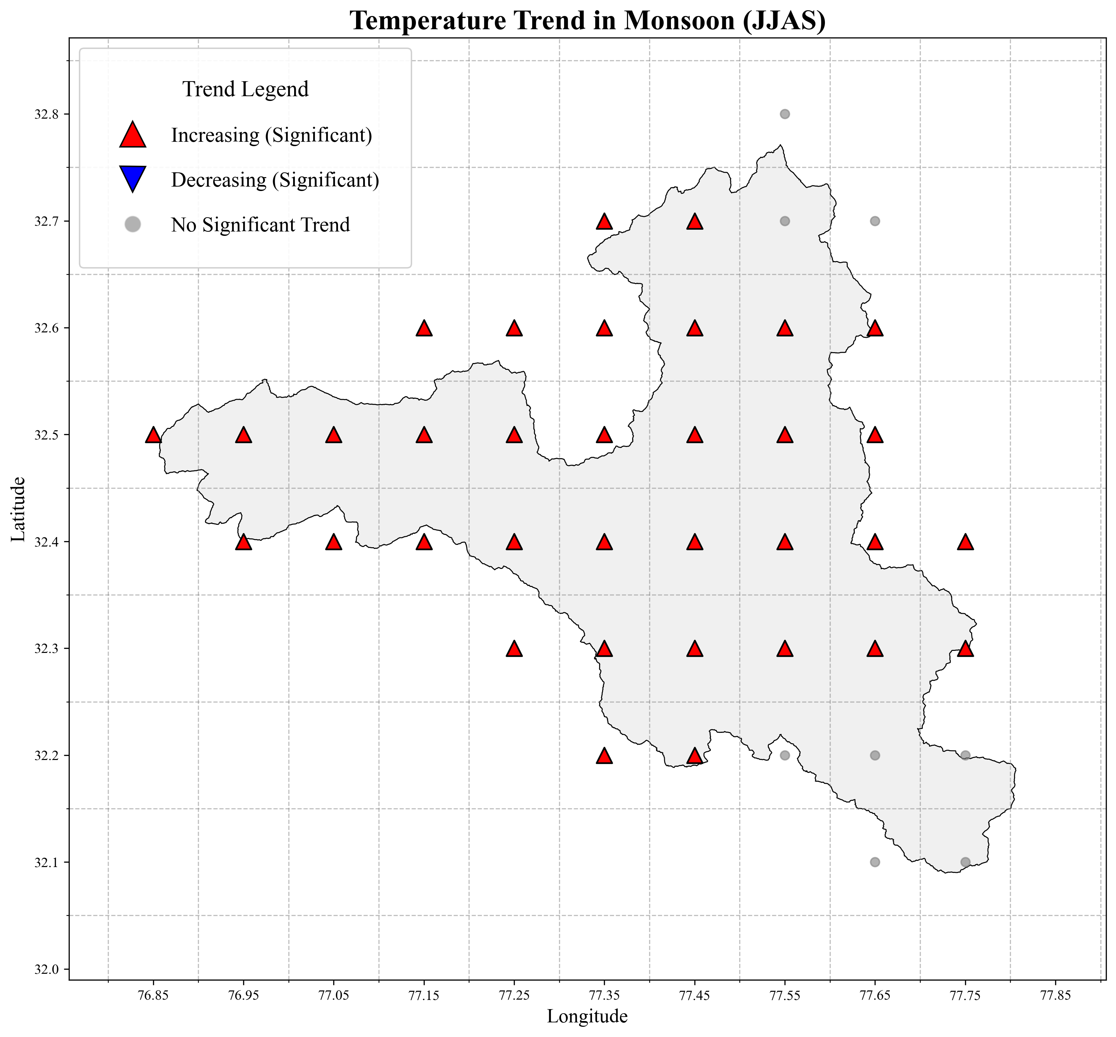
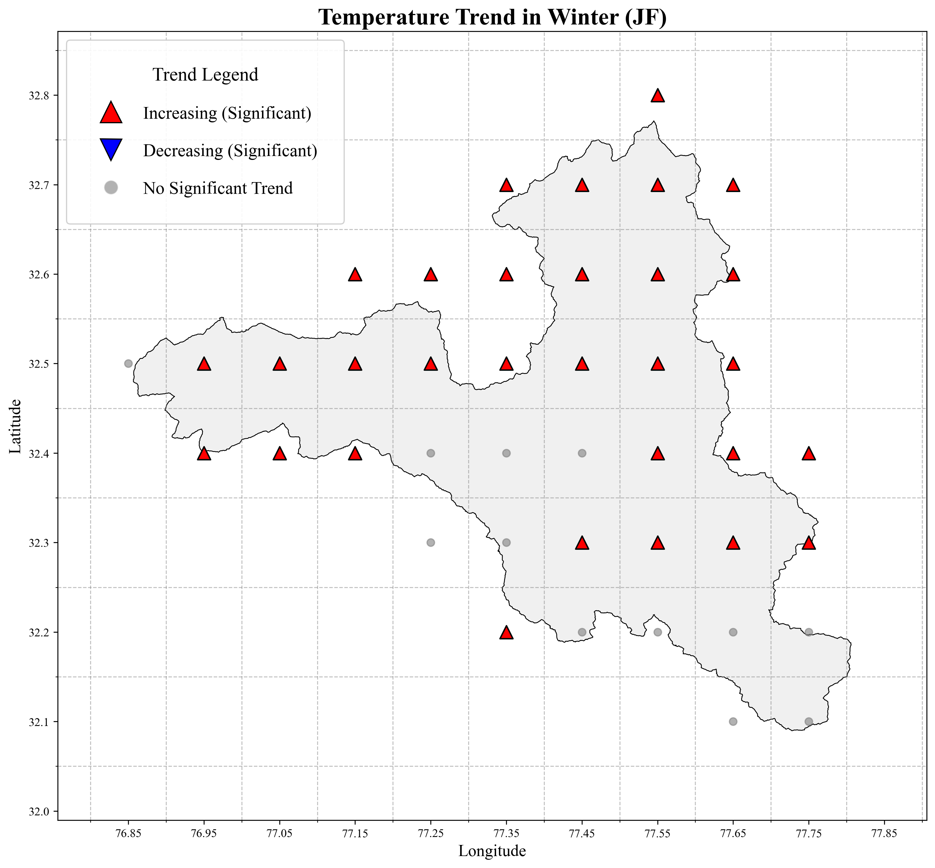
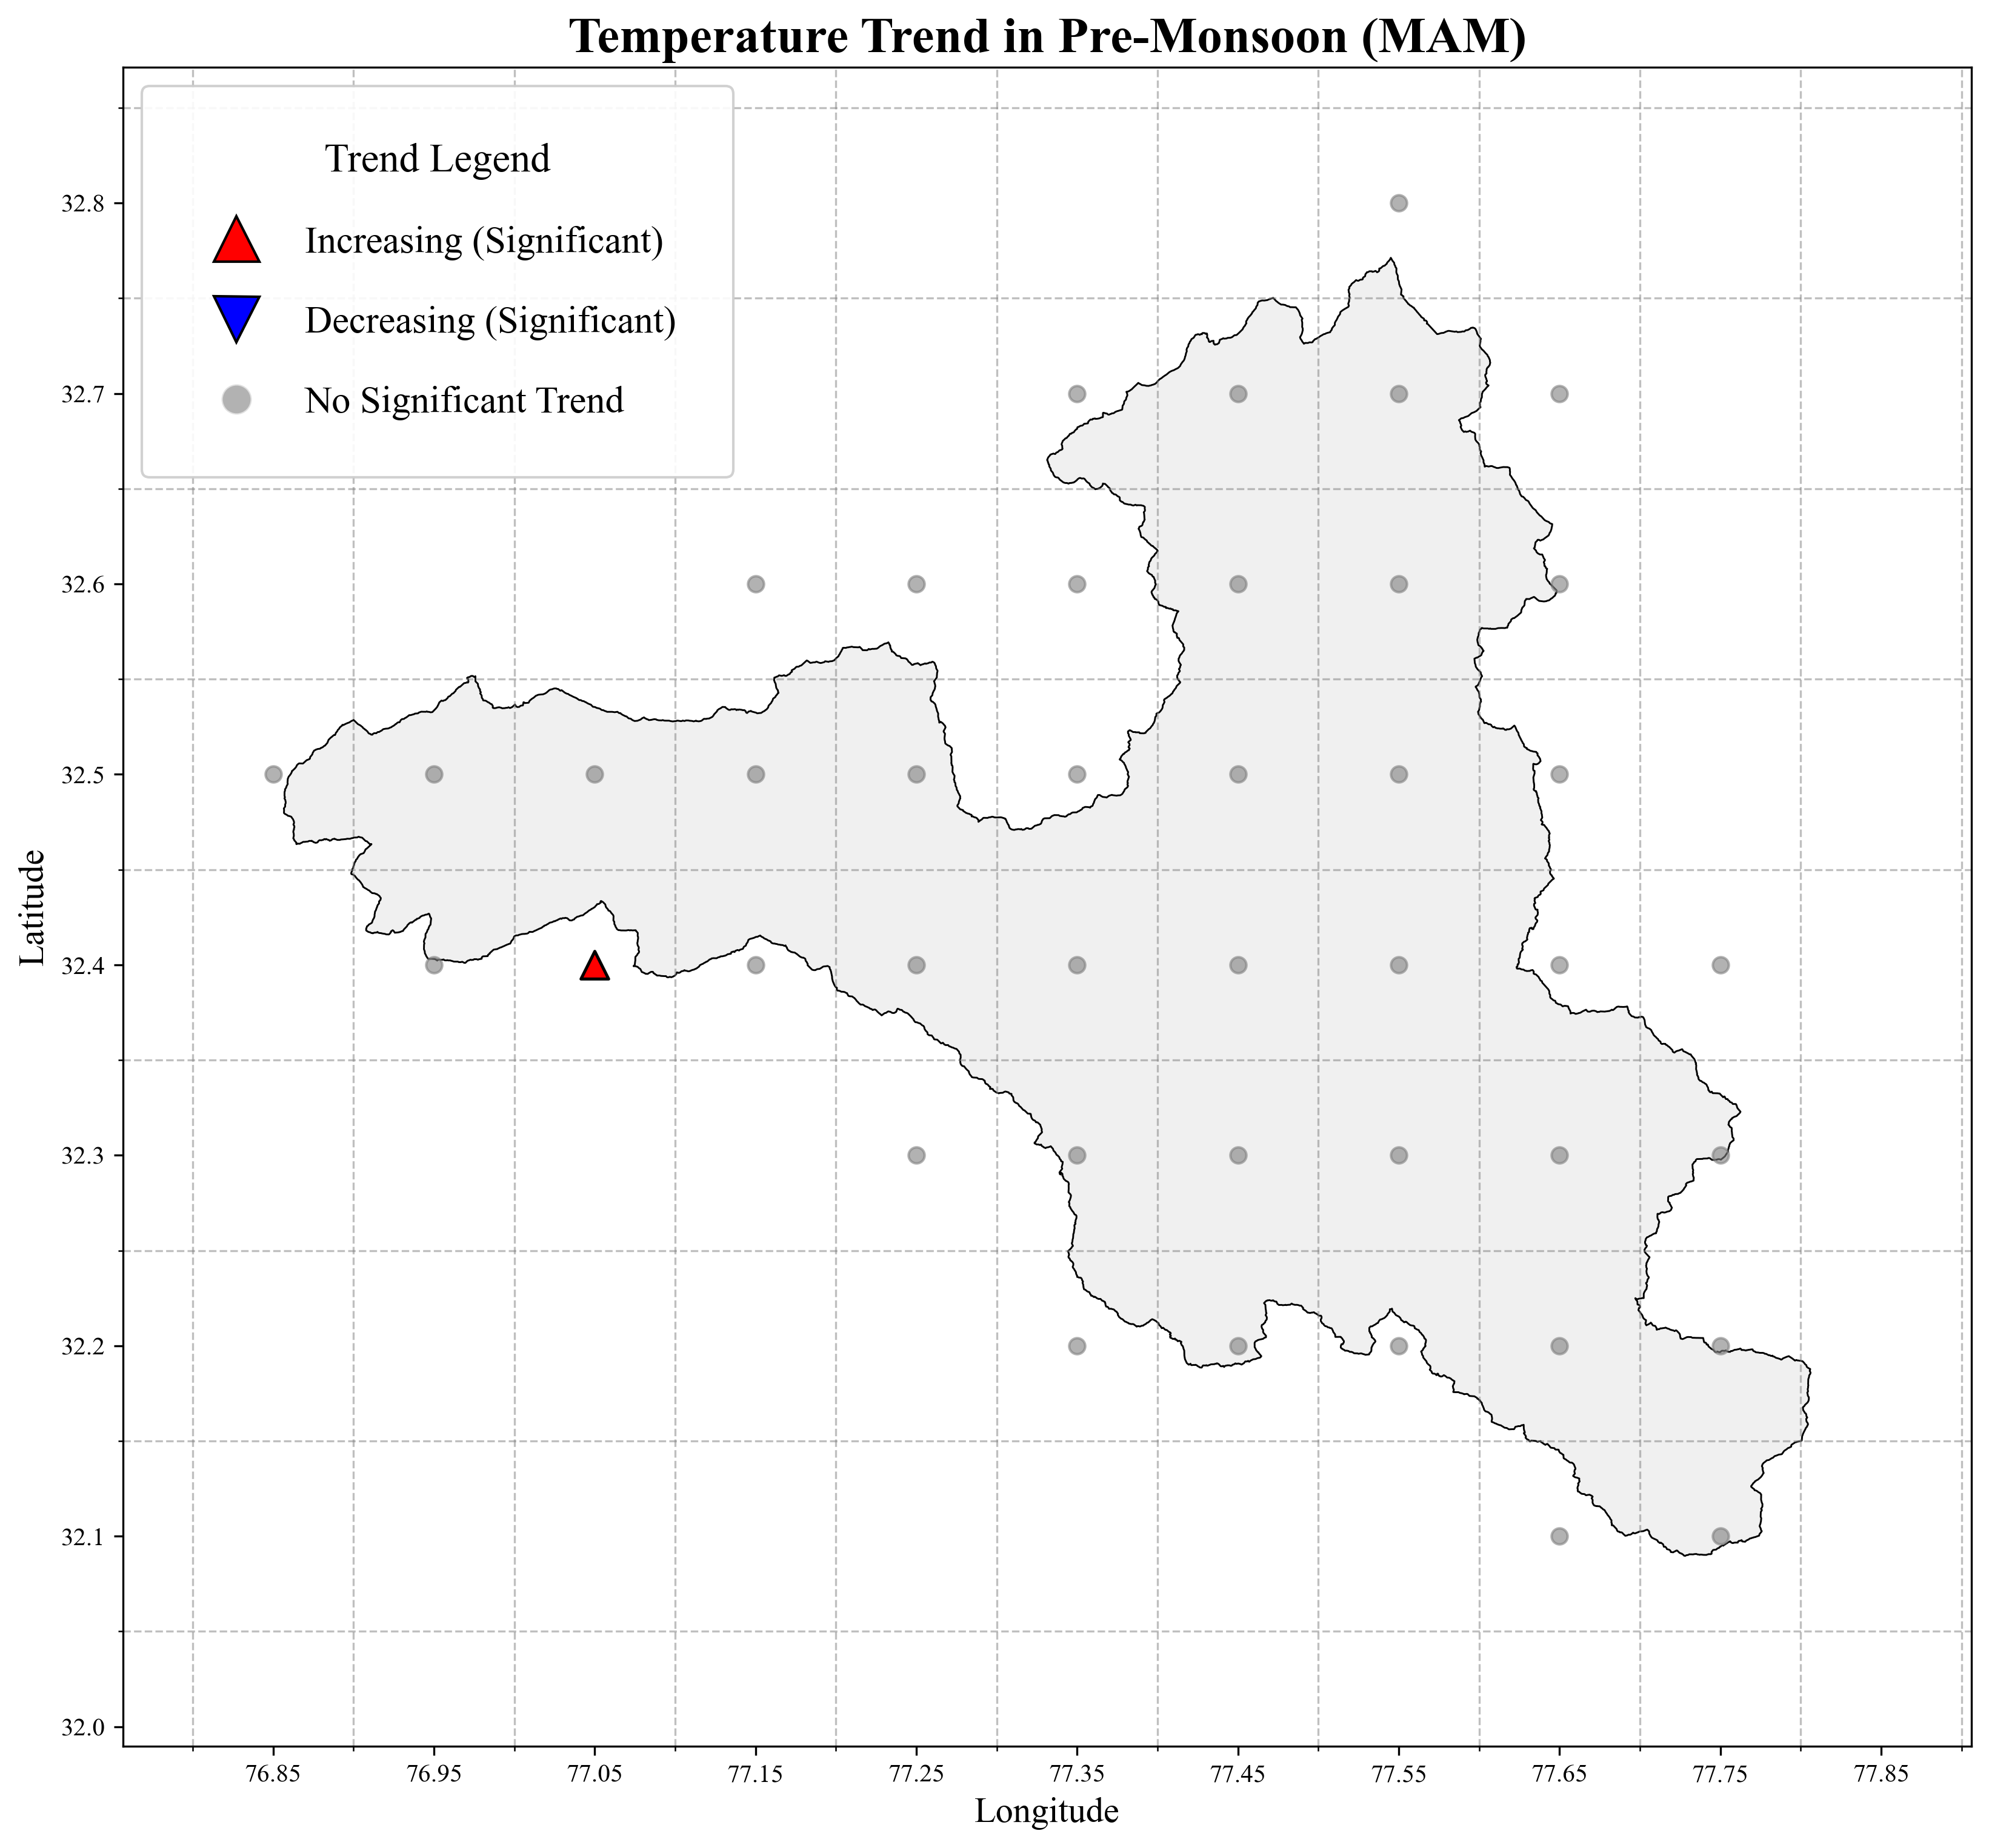
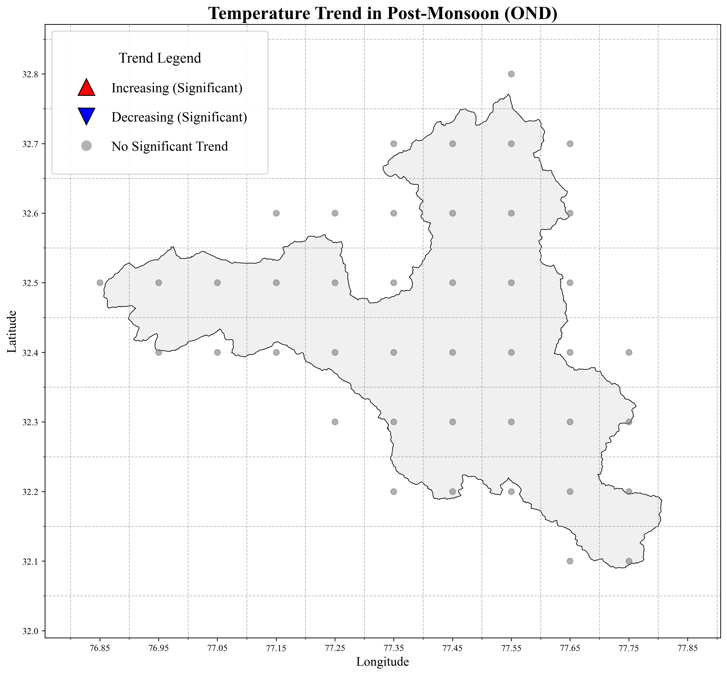
Fig. S1 Spatial Trend Analysis of Temperature S1a – Spatial trend of annual mean Temperature. S1b – Spatial trend of winter temperature S1c – Spatial trend of pre-monsoon temperature. S1d – Spatial trend of monsoon temperature. S1e – Spatial trend of post-monsoon temperature
Spatial Annual and Seasonal M-K Trend Maps of Temperature
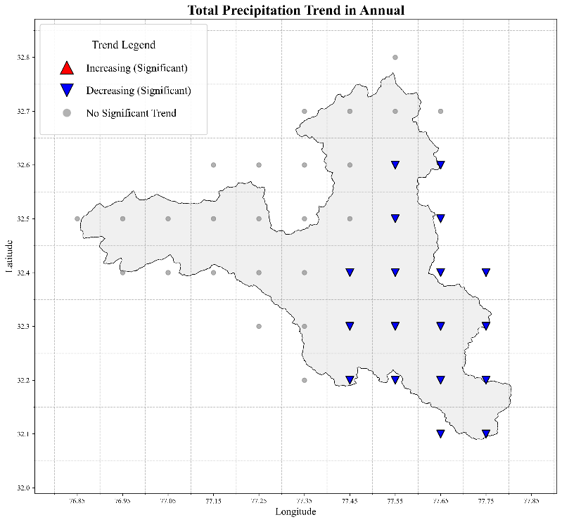
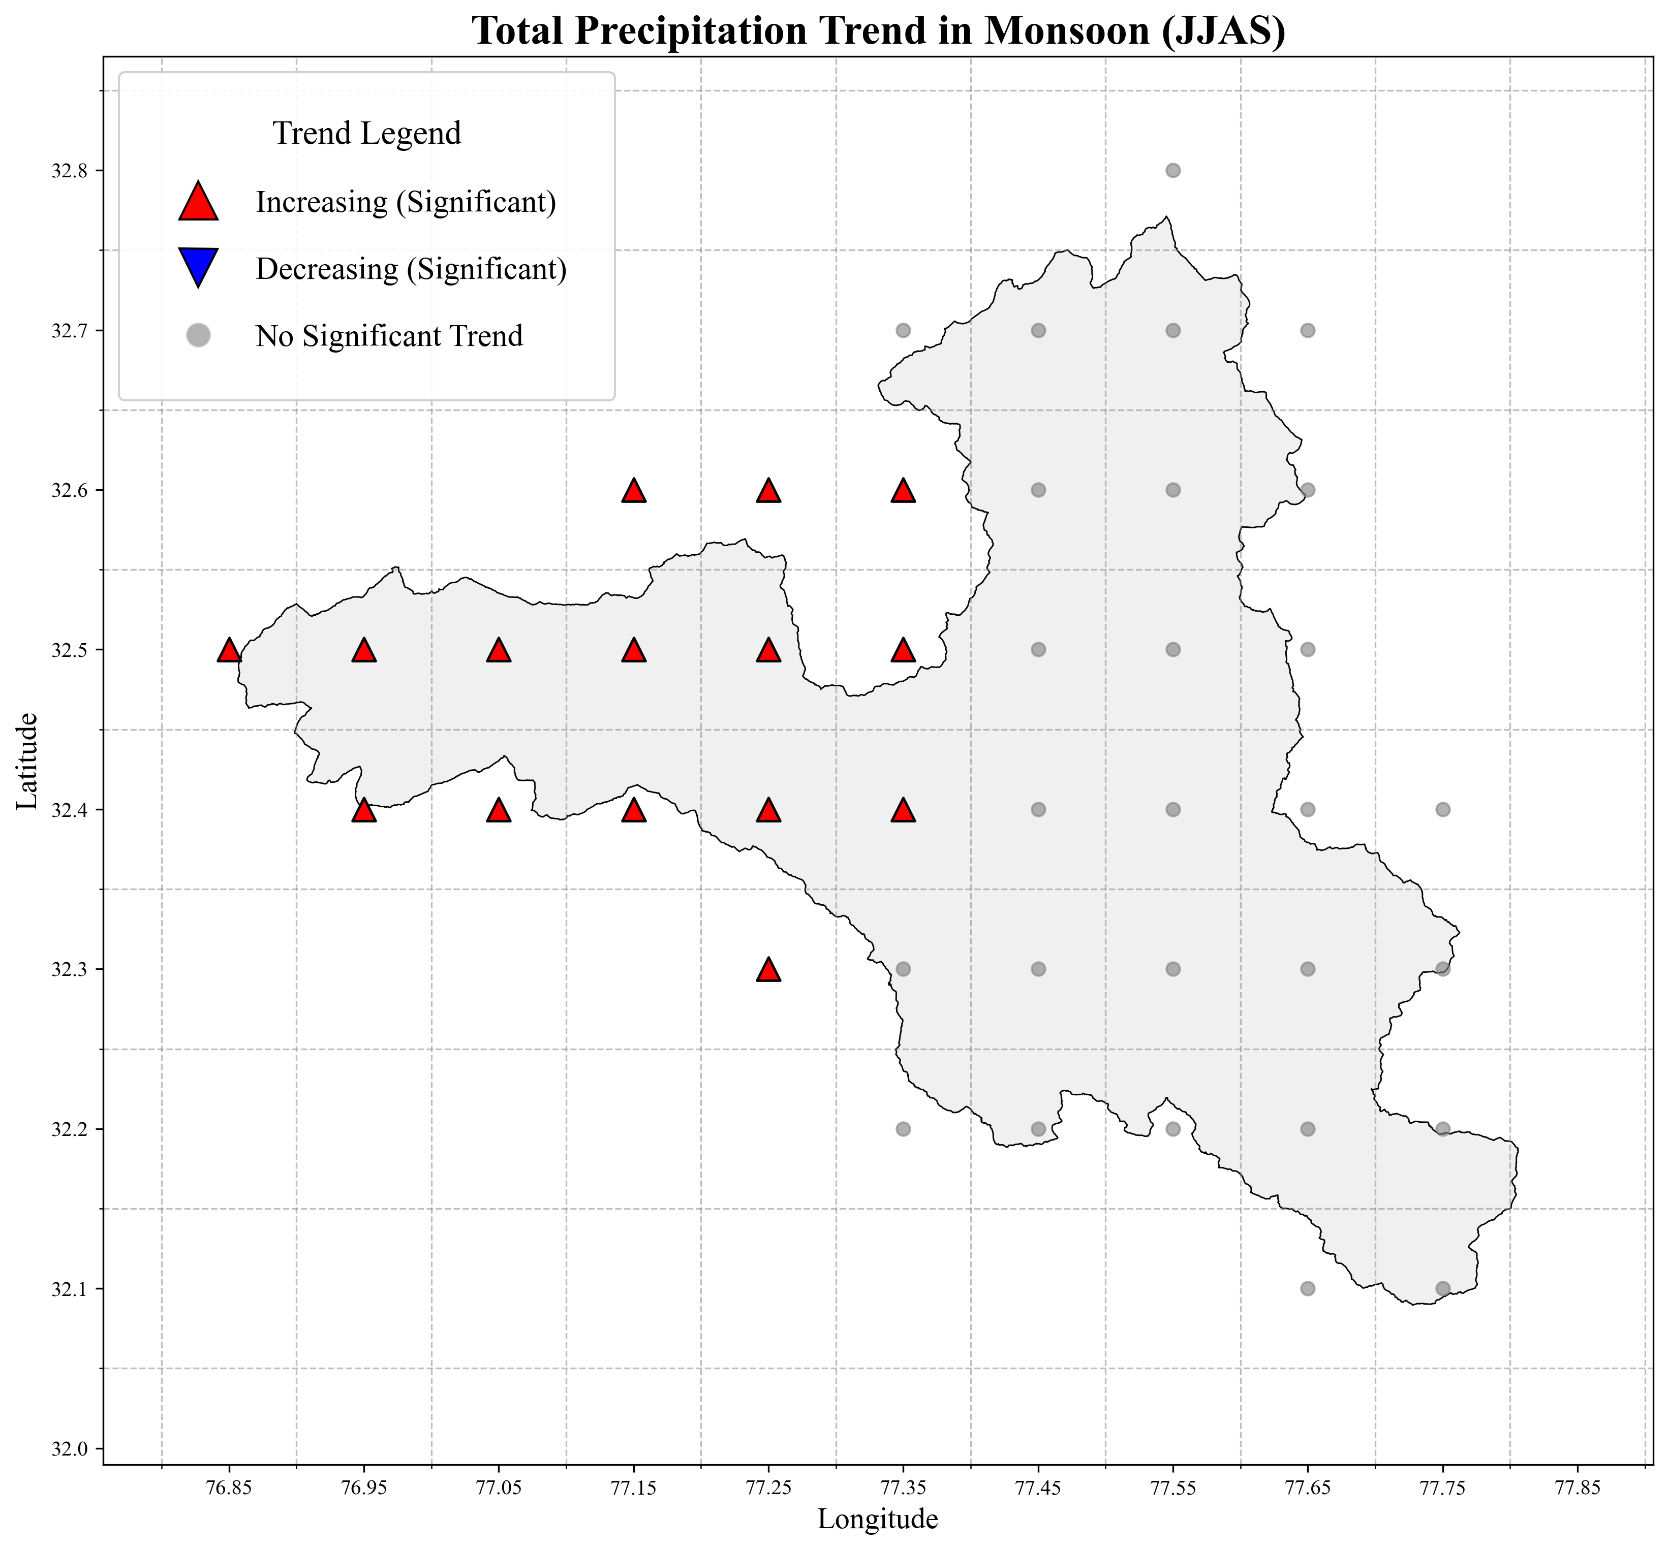
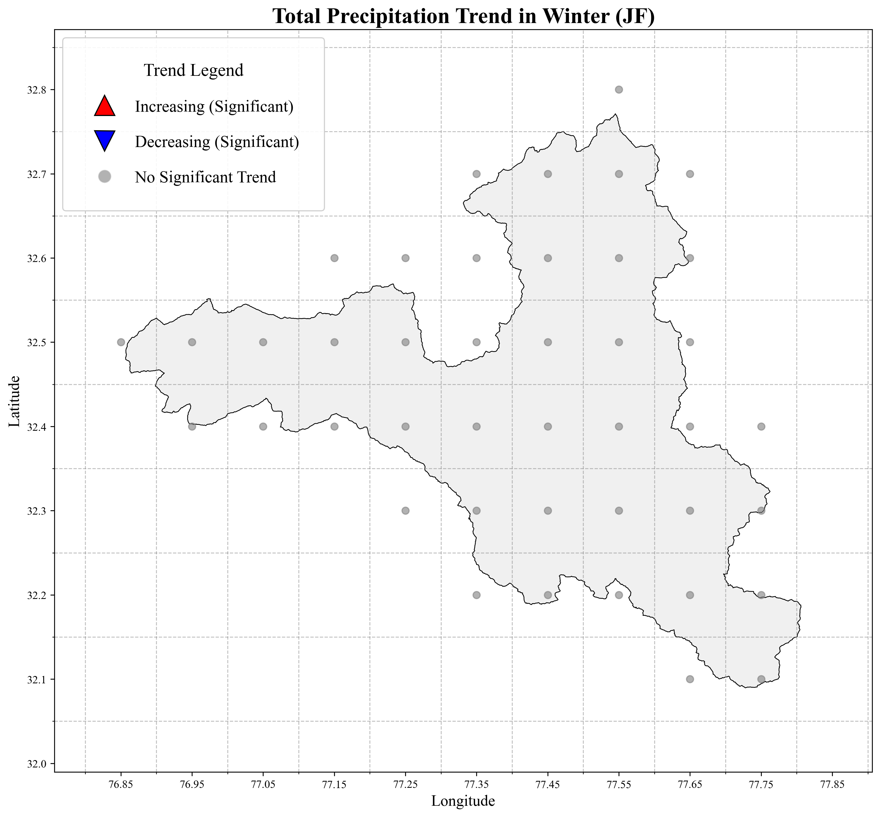
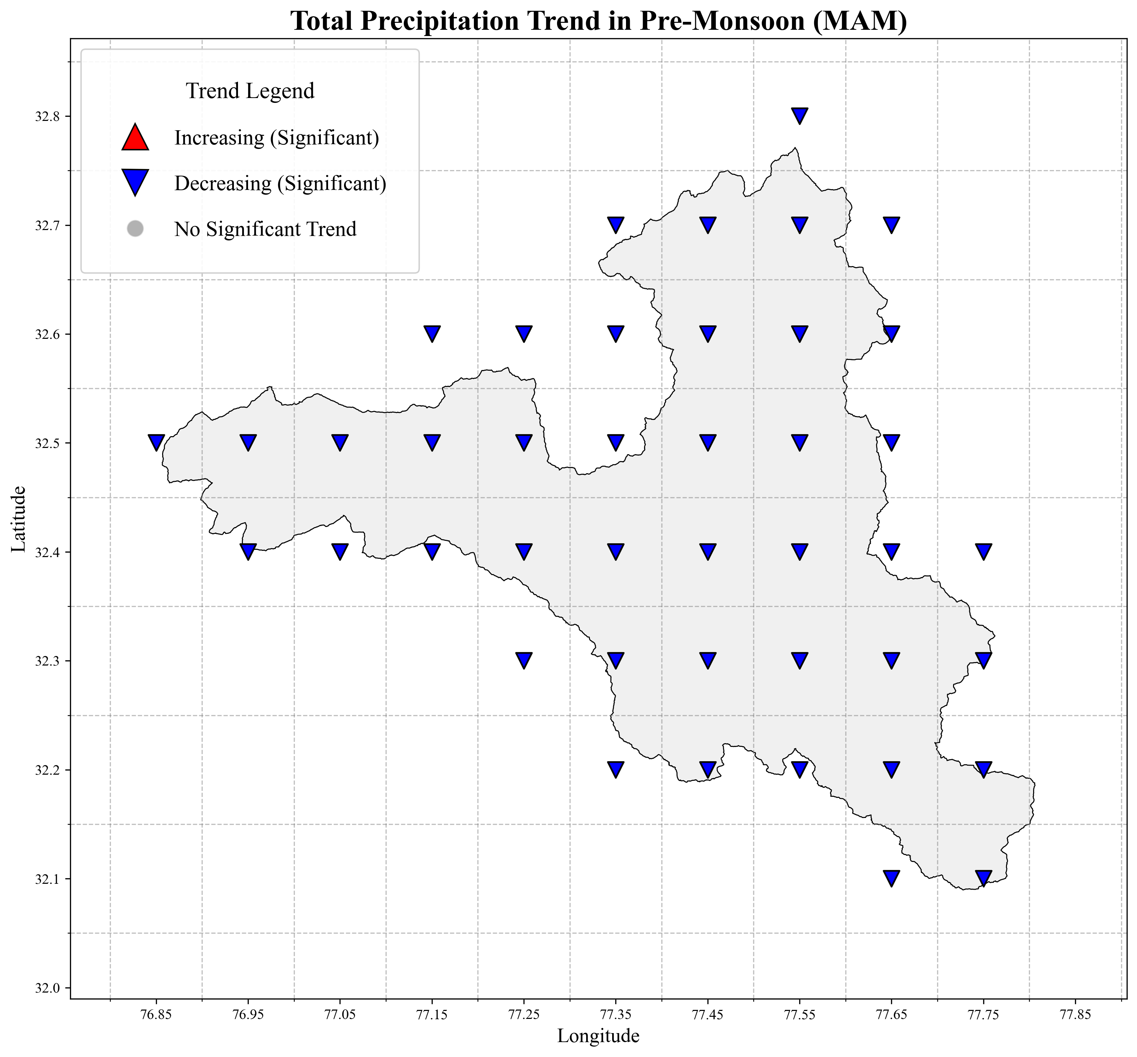
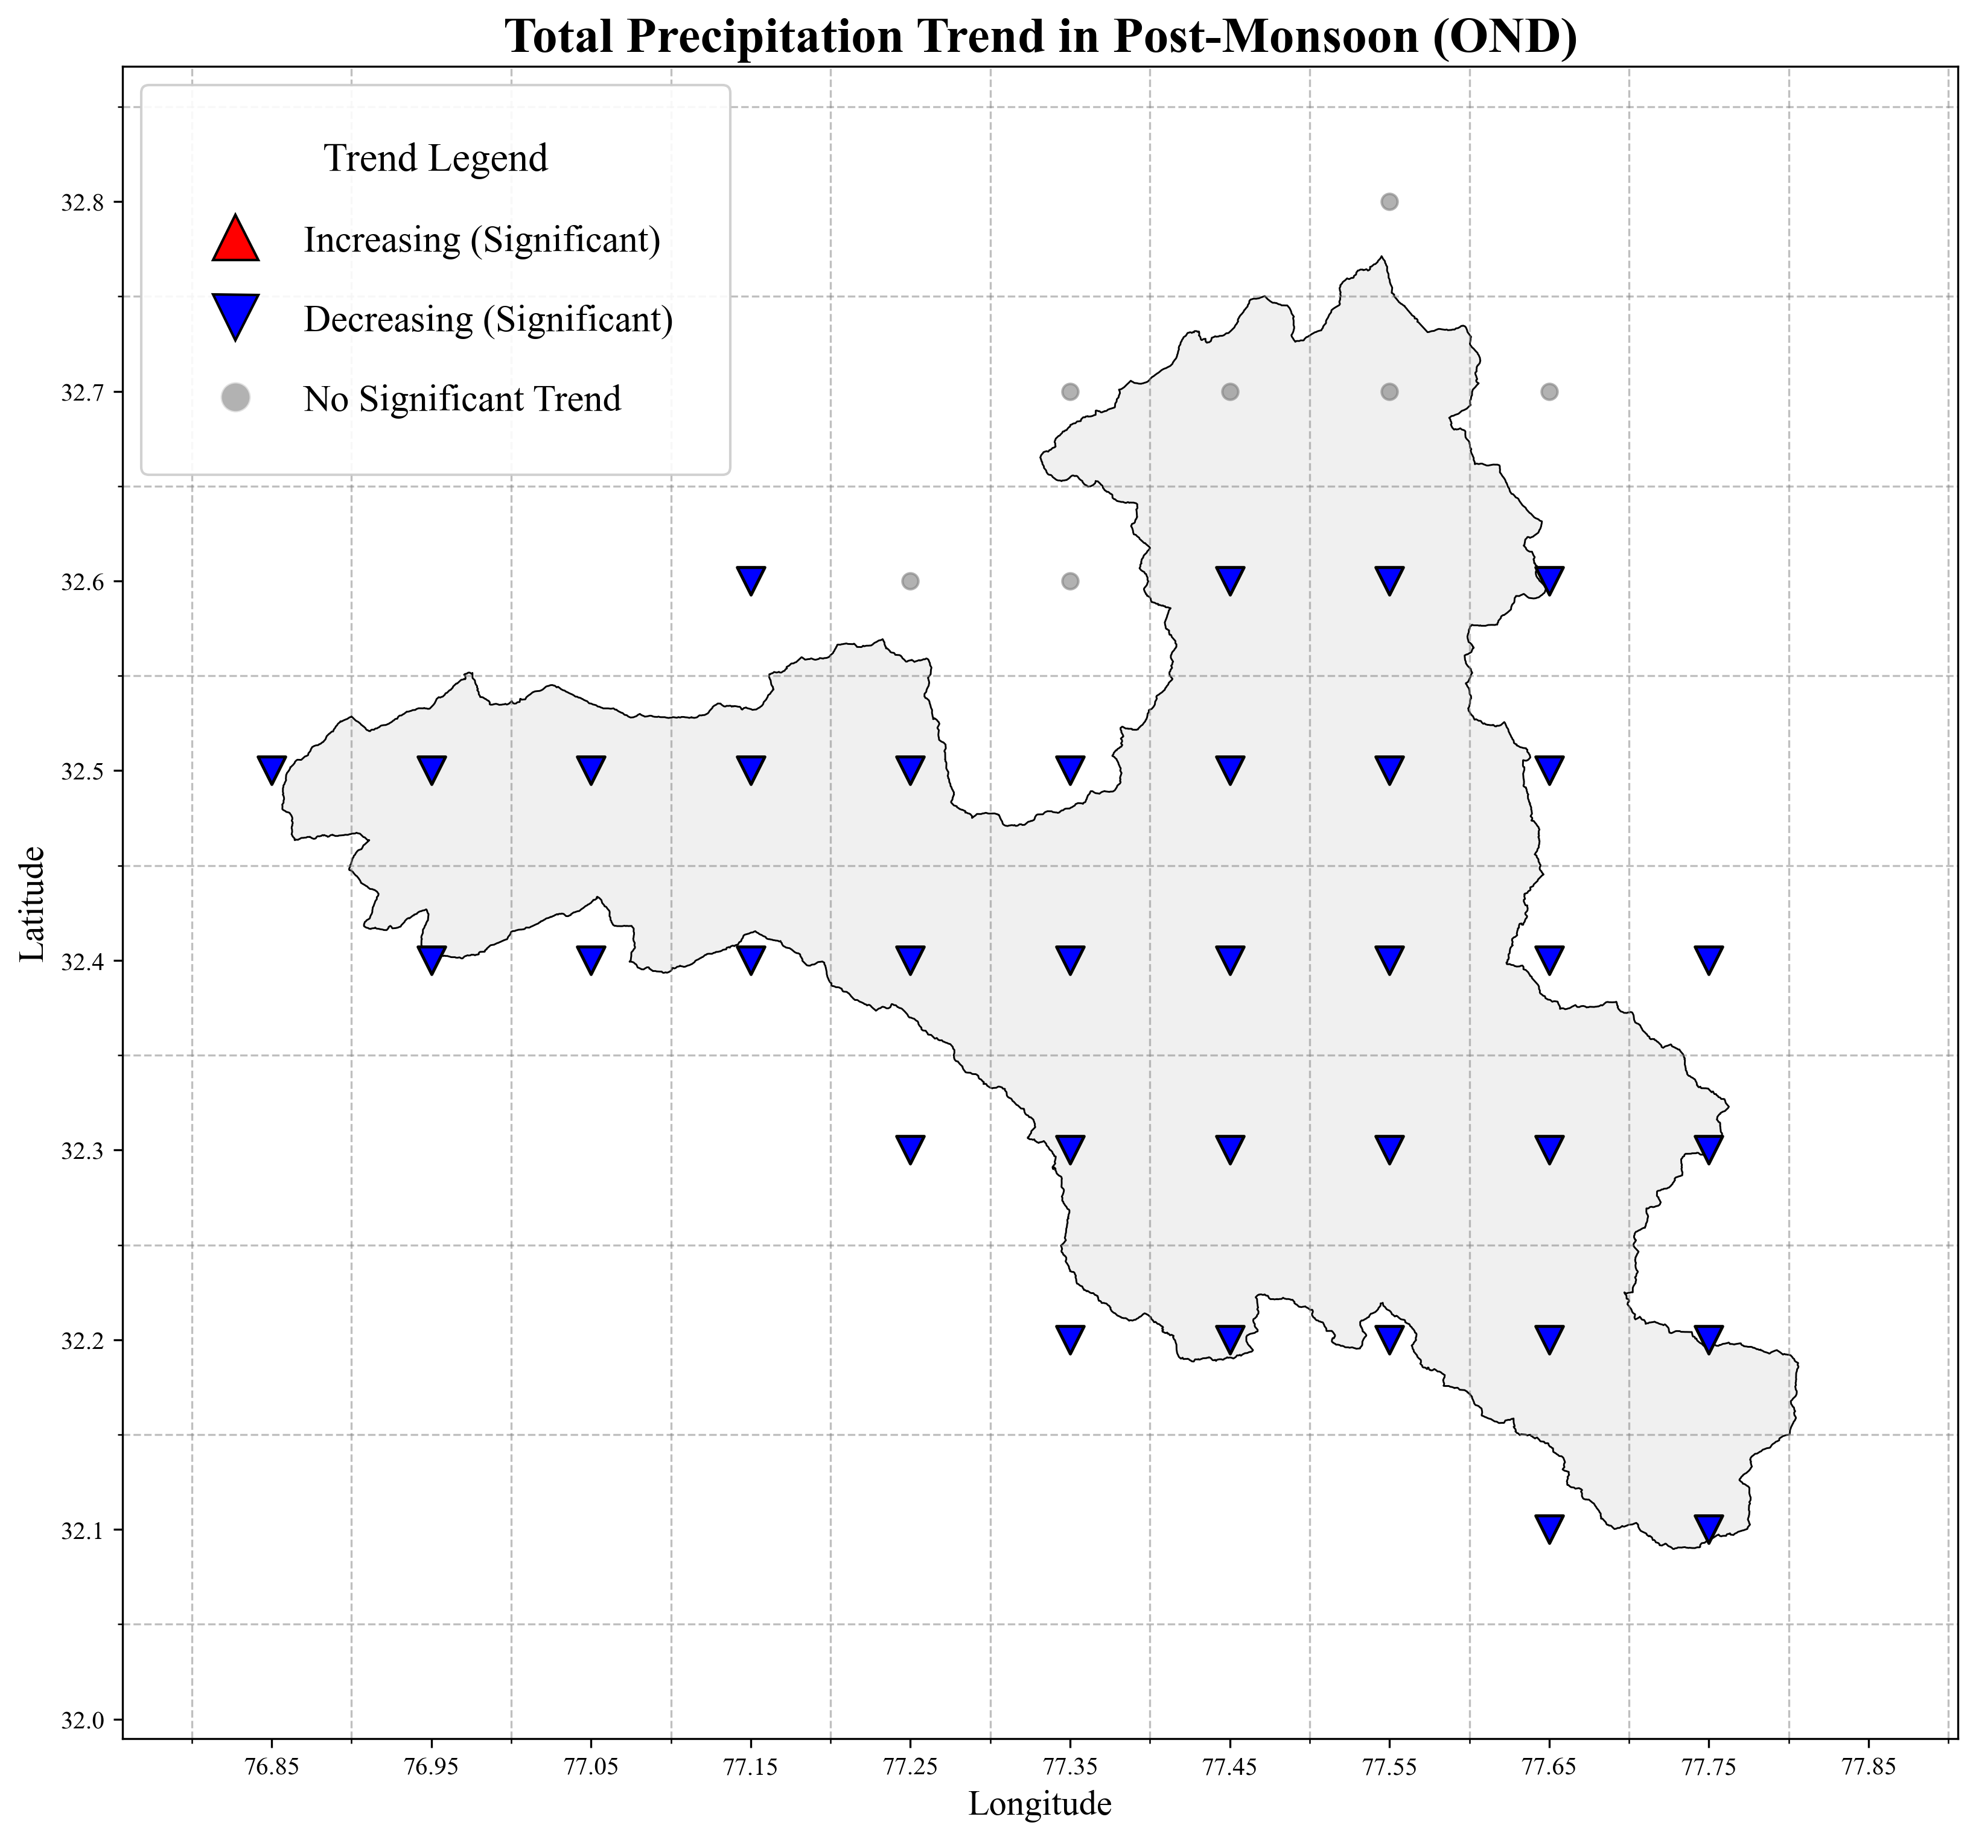
Fig. S2 Spatial Trend Analysis of total precipitation S2a – Spatial trend of annual total precipitation S2b – Spatial trend of winter total precipitation. S2c – Spatial trend of pre-monsoon total precipitation S2d – Spatial trend of monsoon total precipitation. S1e – Spatial trend of post-monsoon total precipitation
Spatial Annual and Seasonal M-K Trend Maps of Total Precipitation
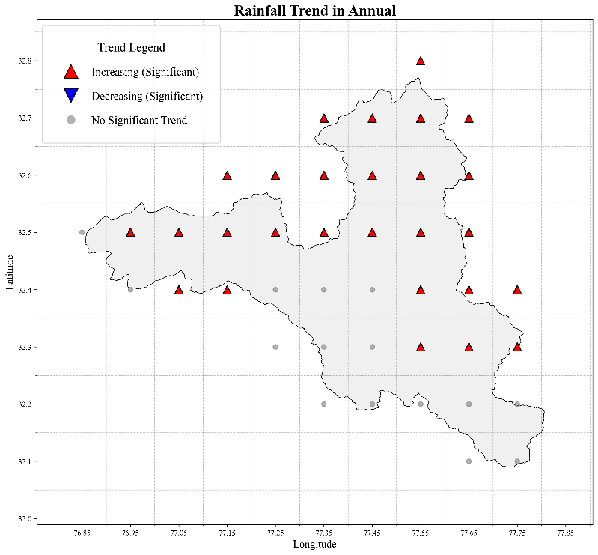
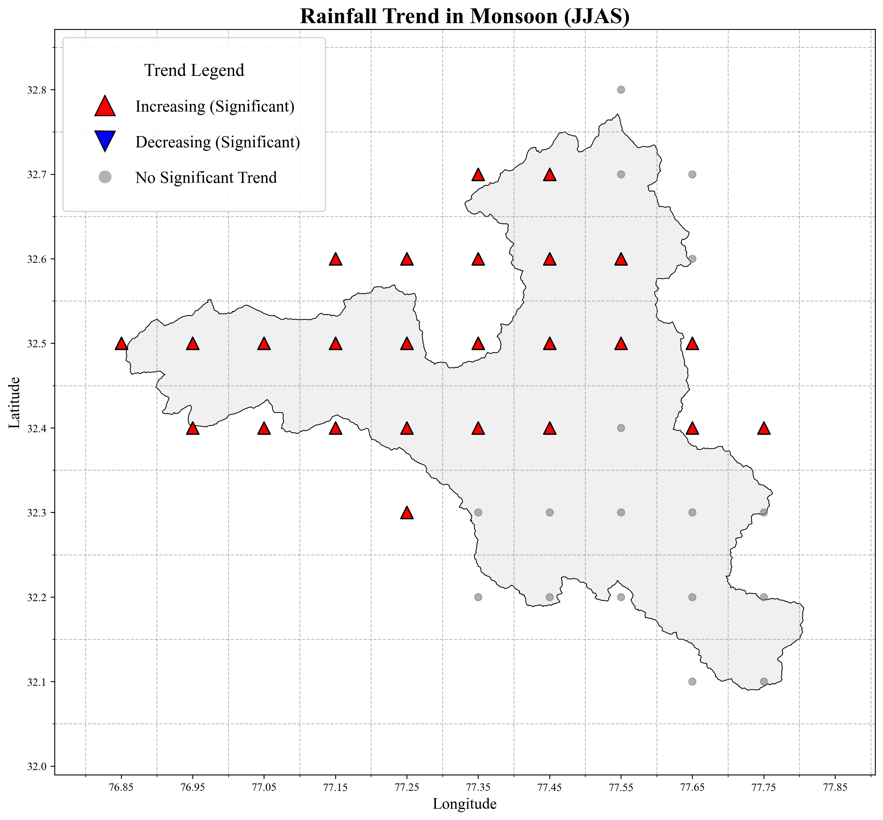
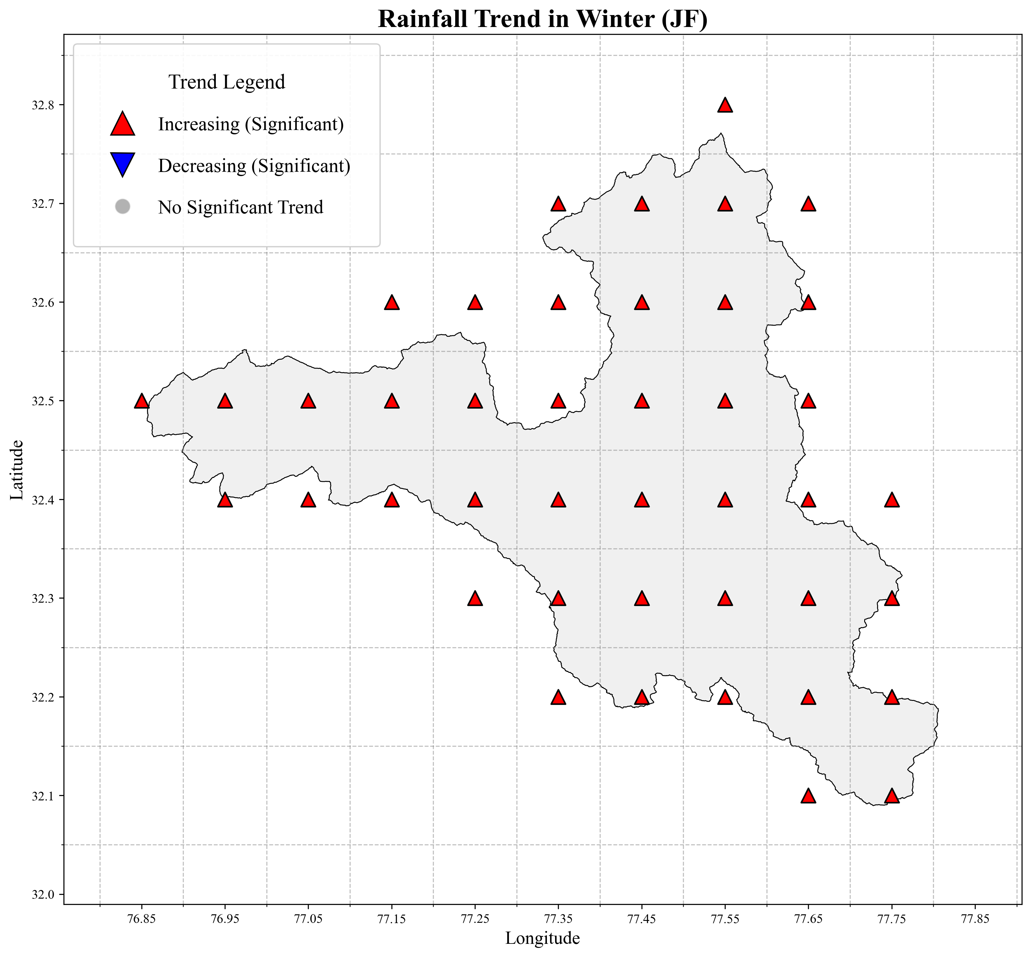
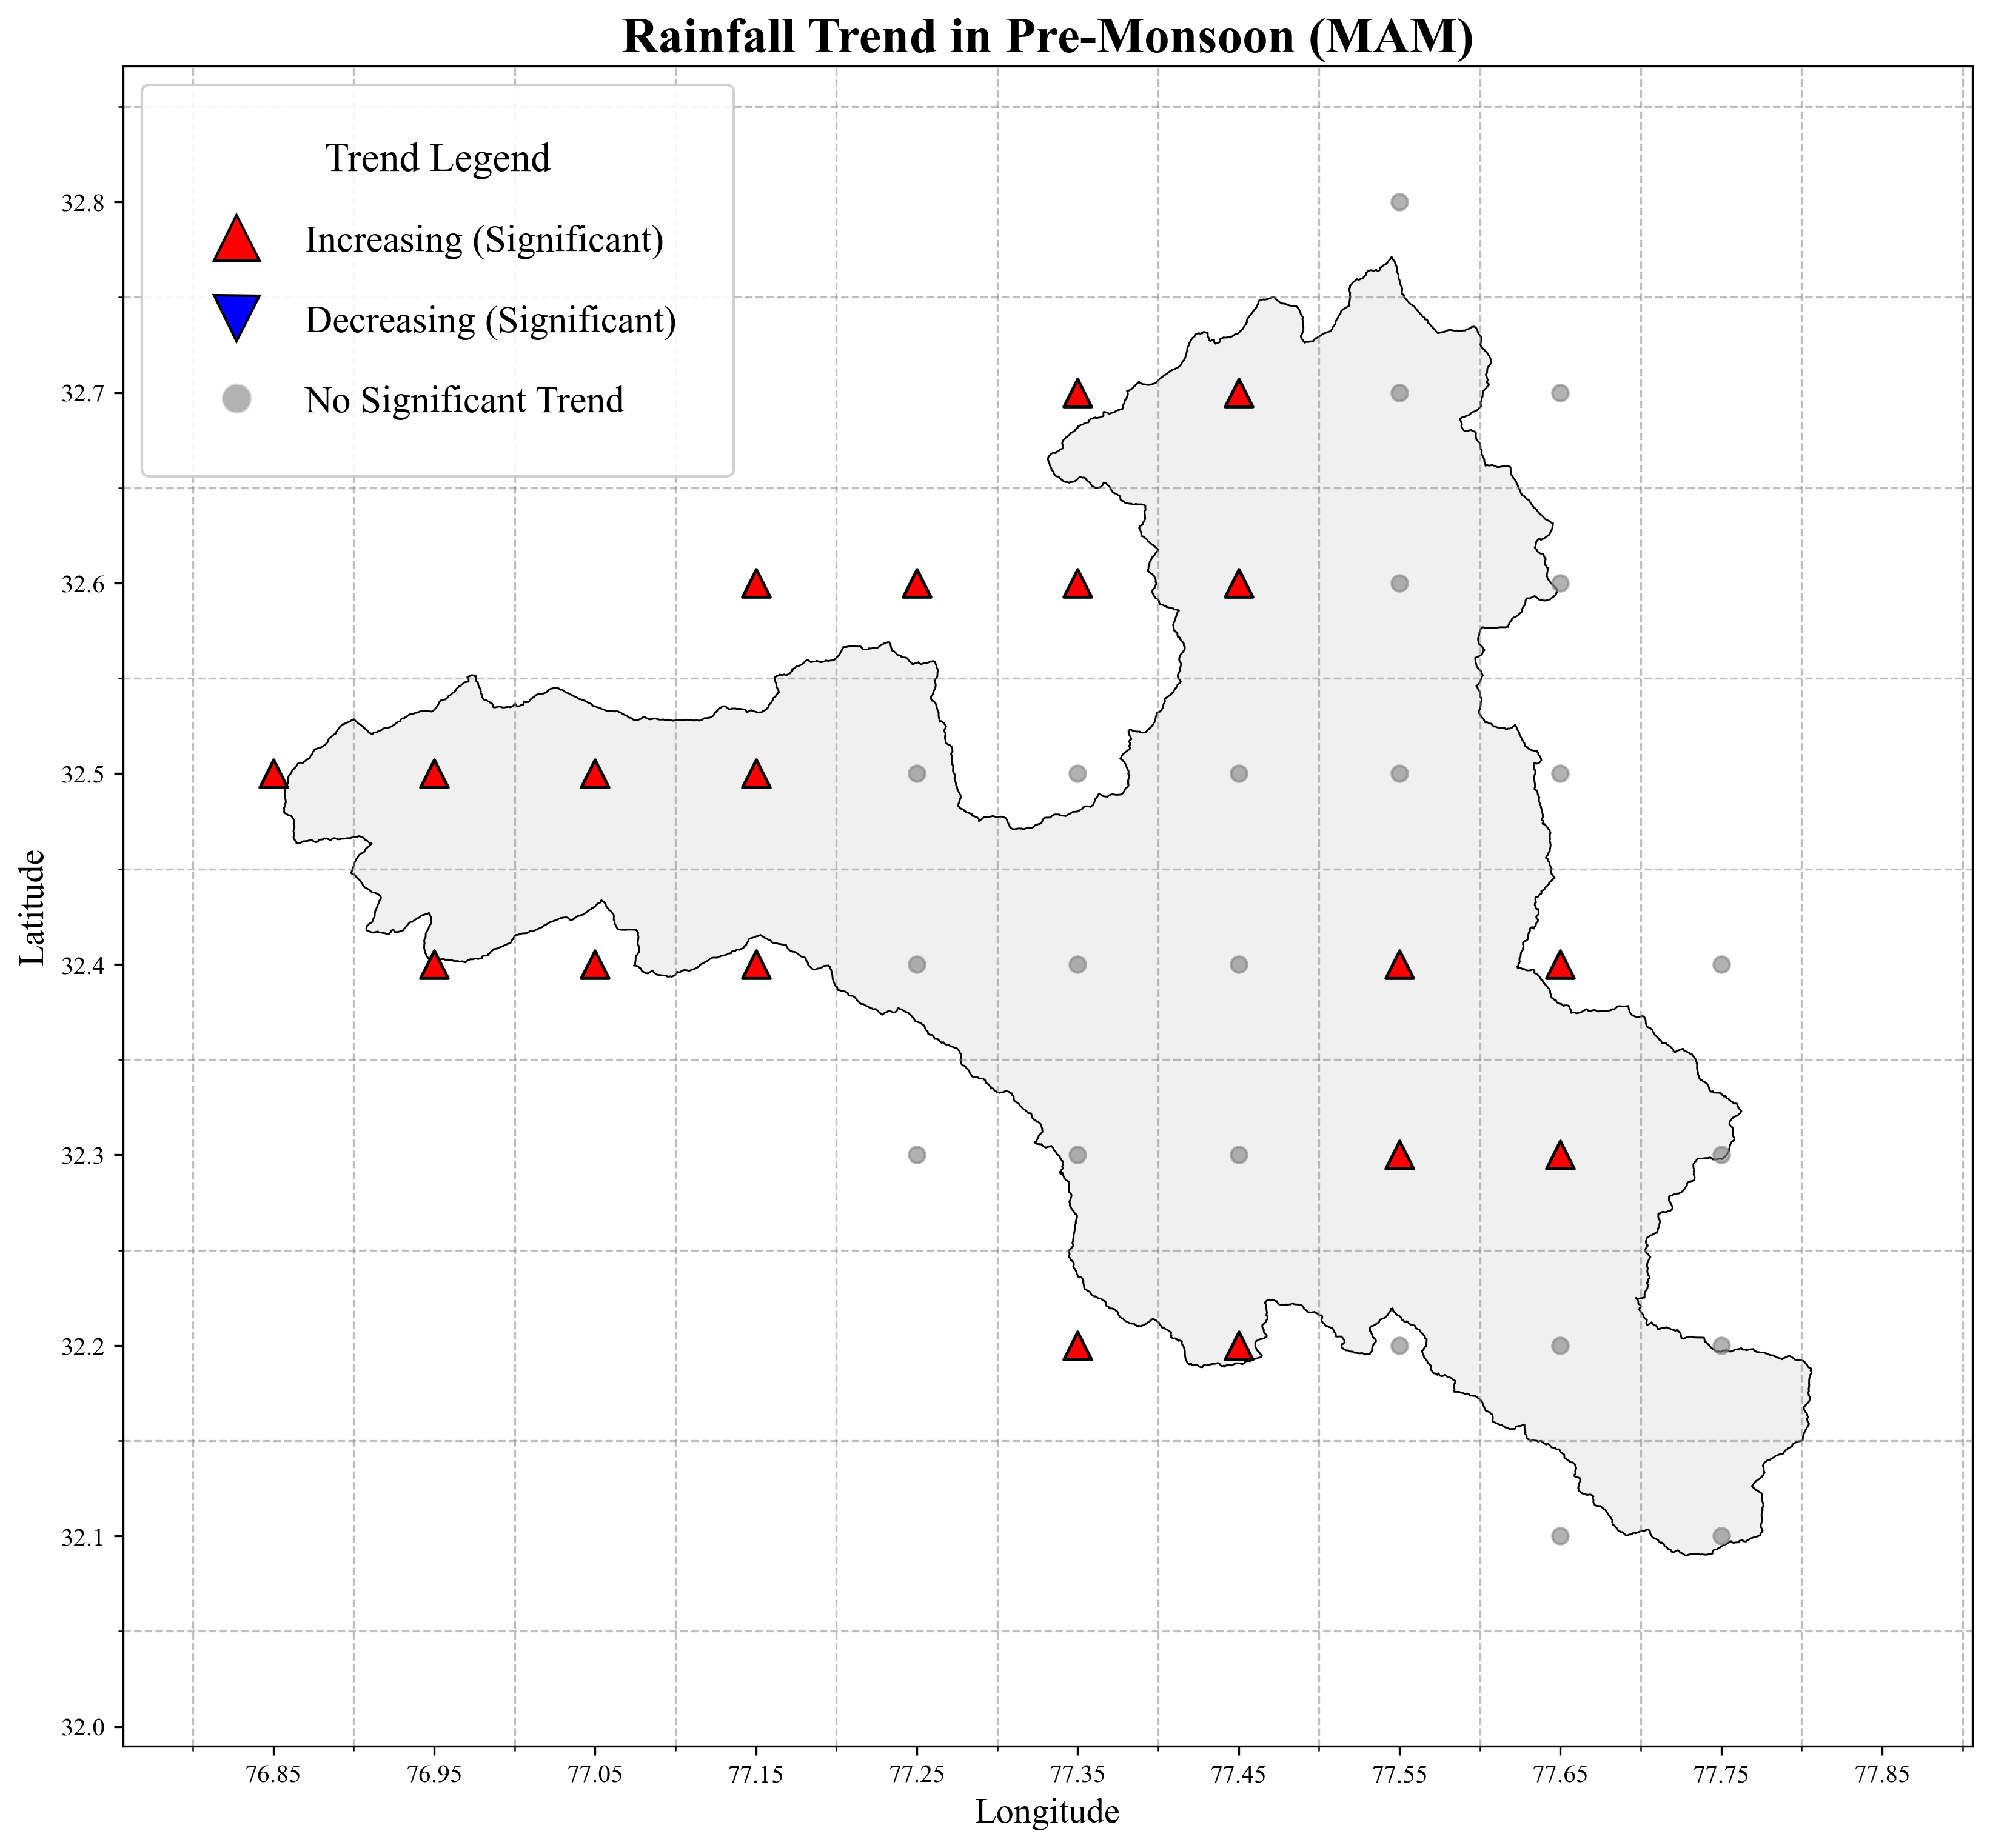
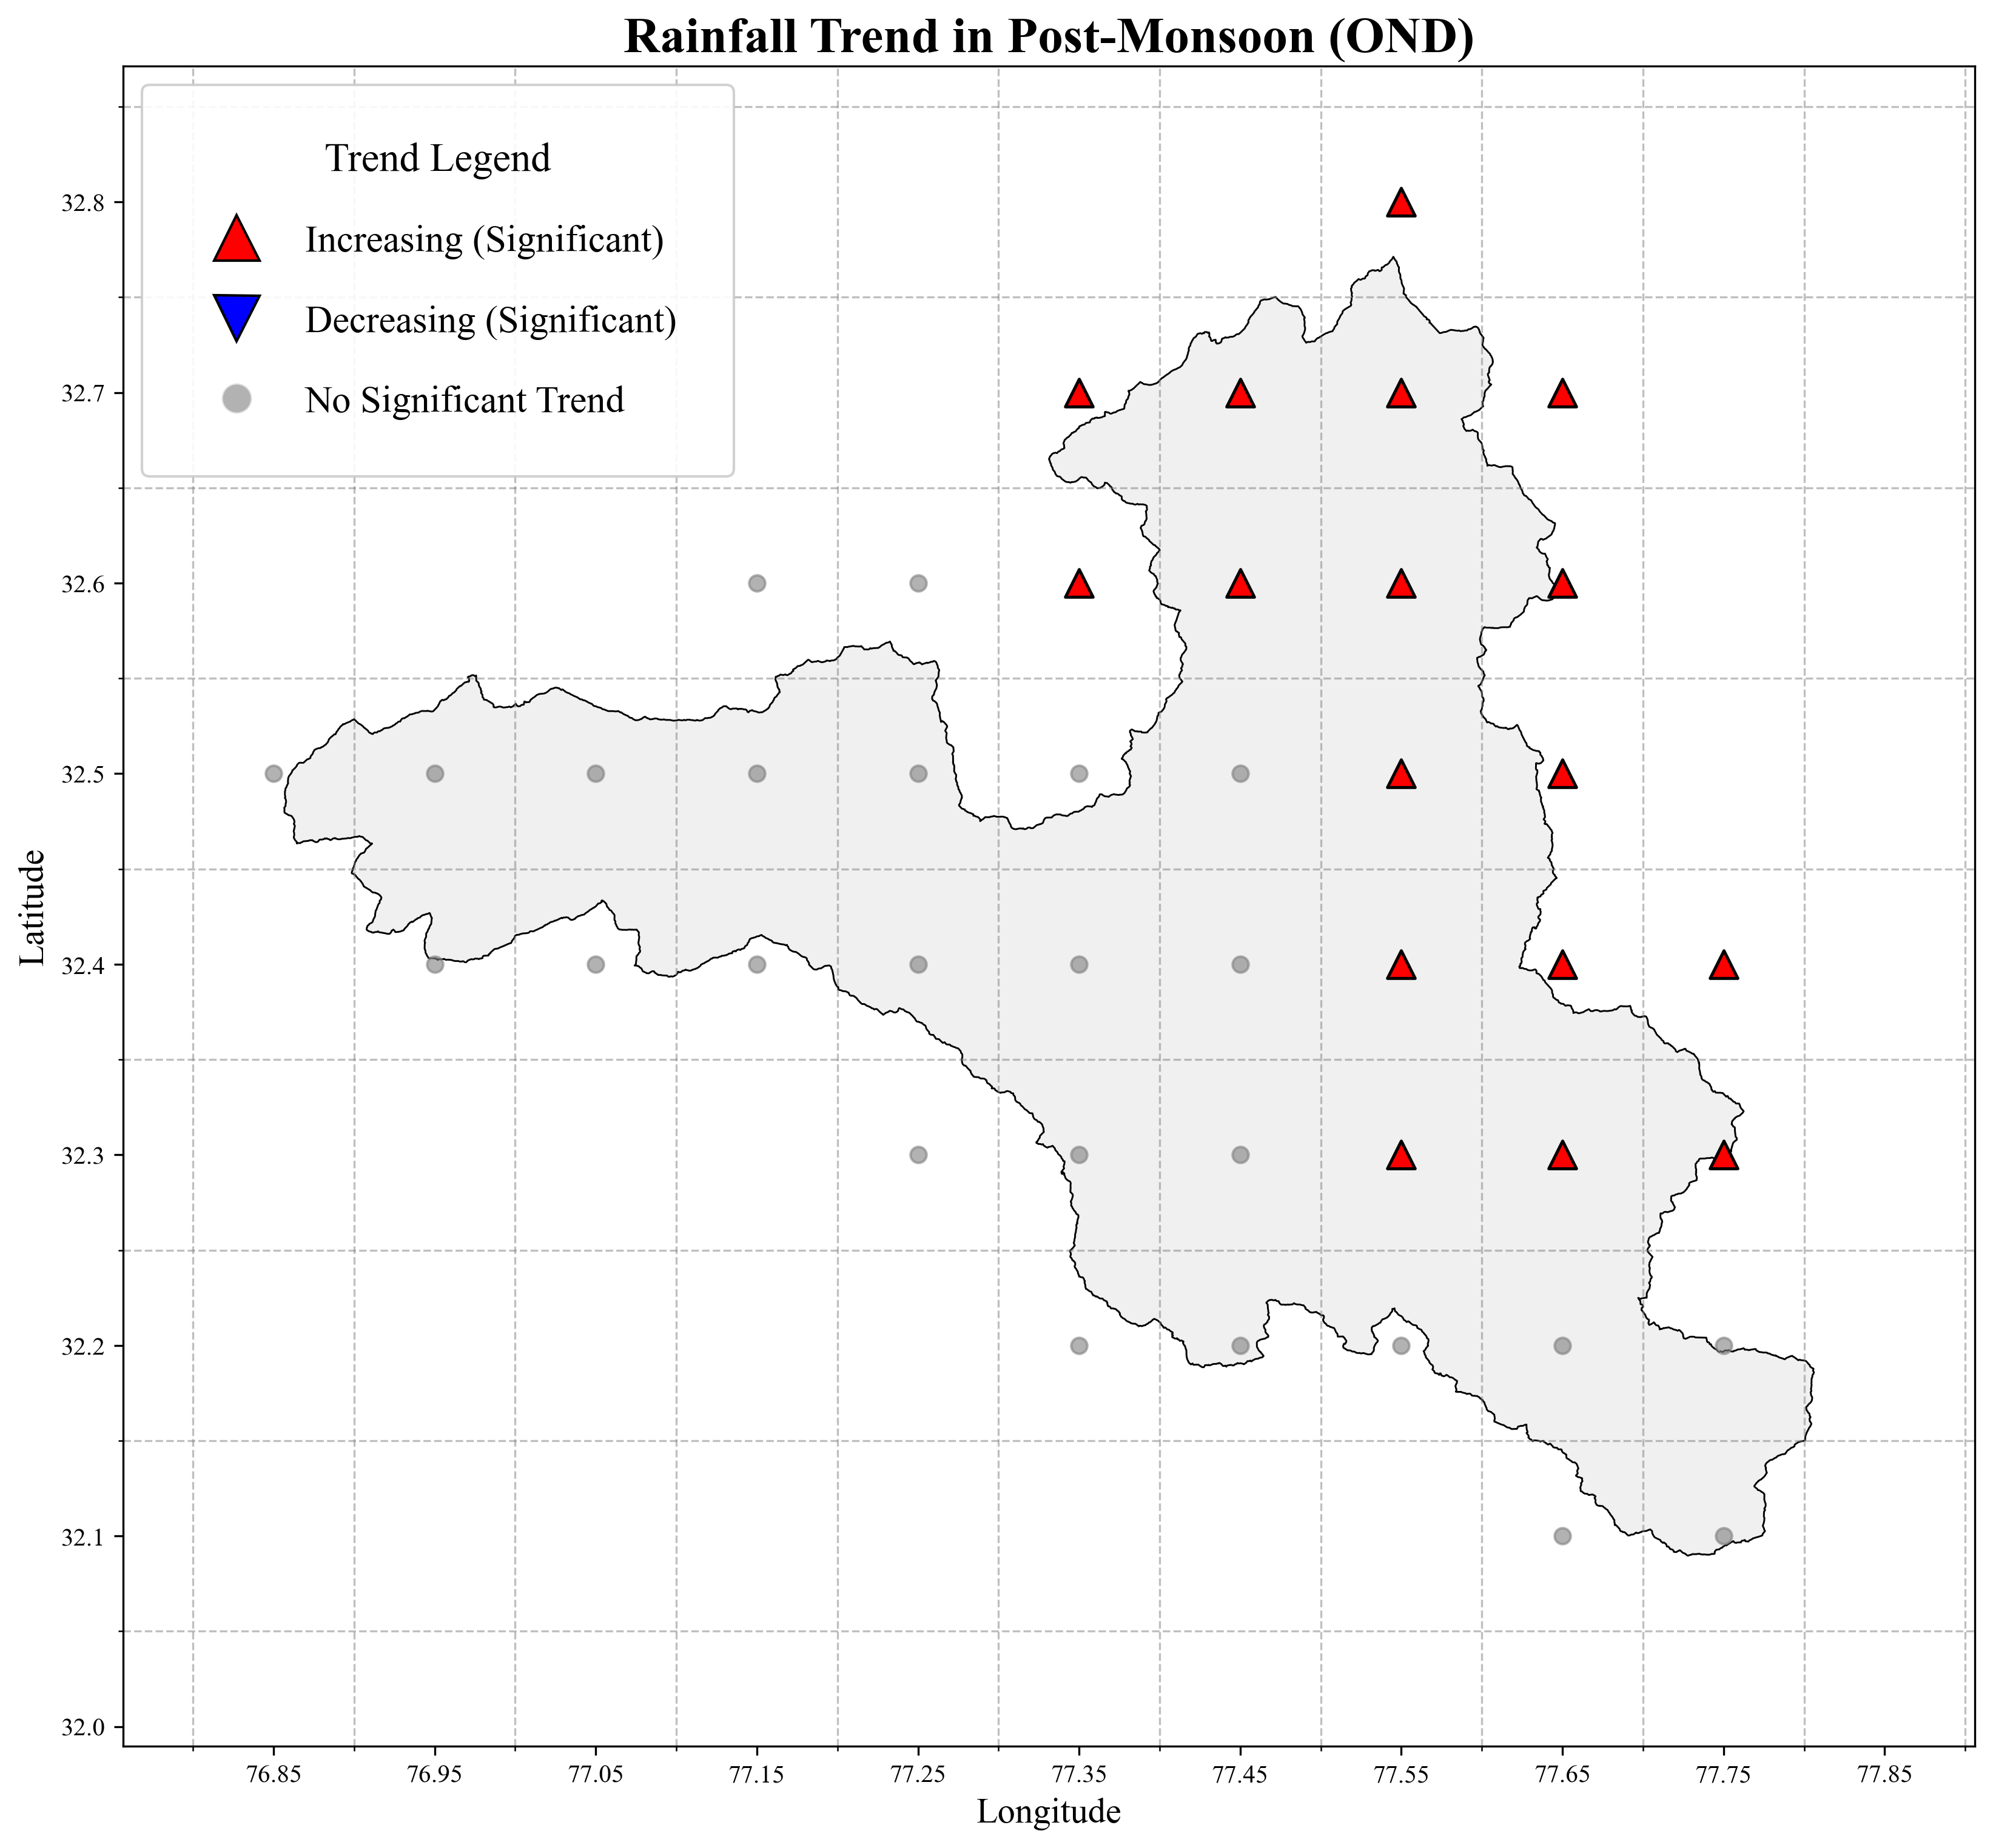
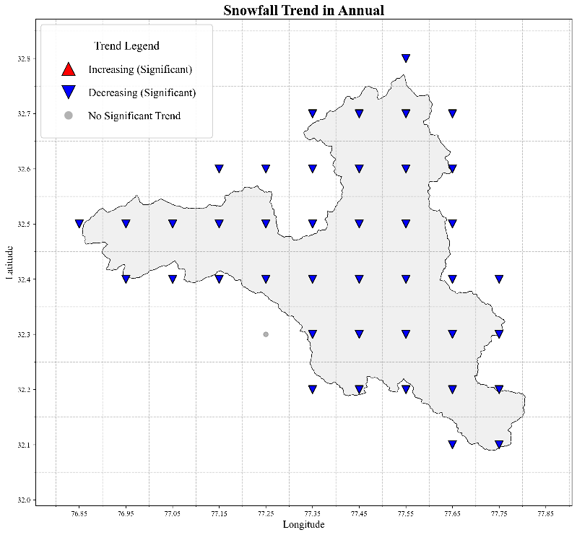
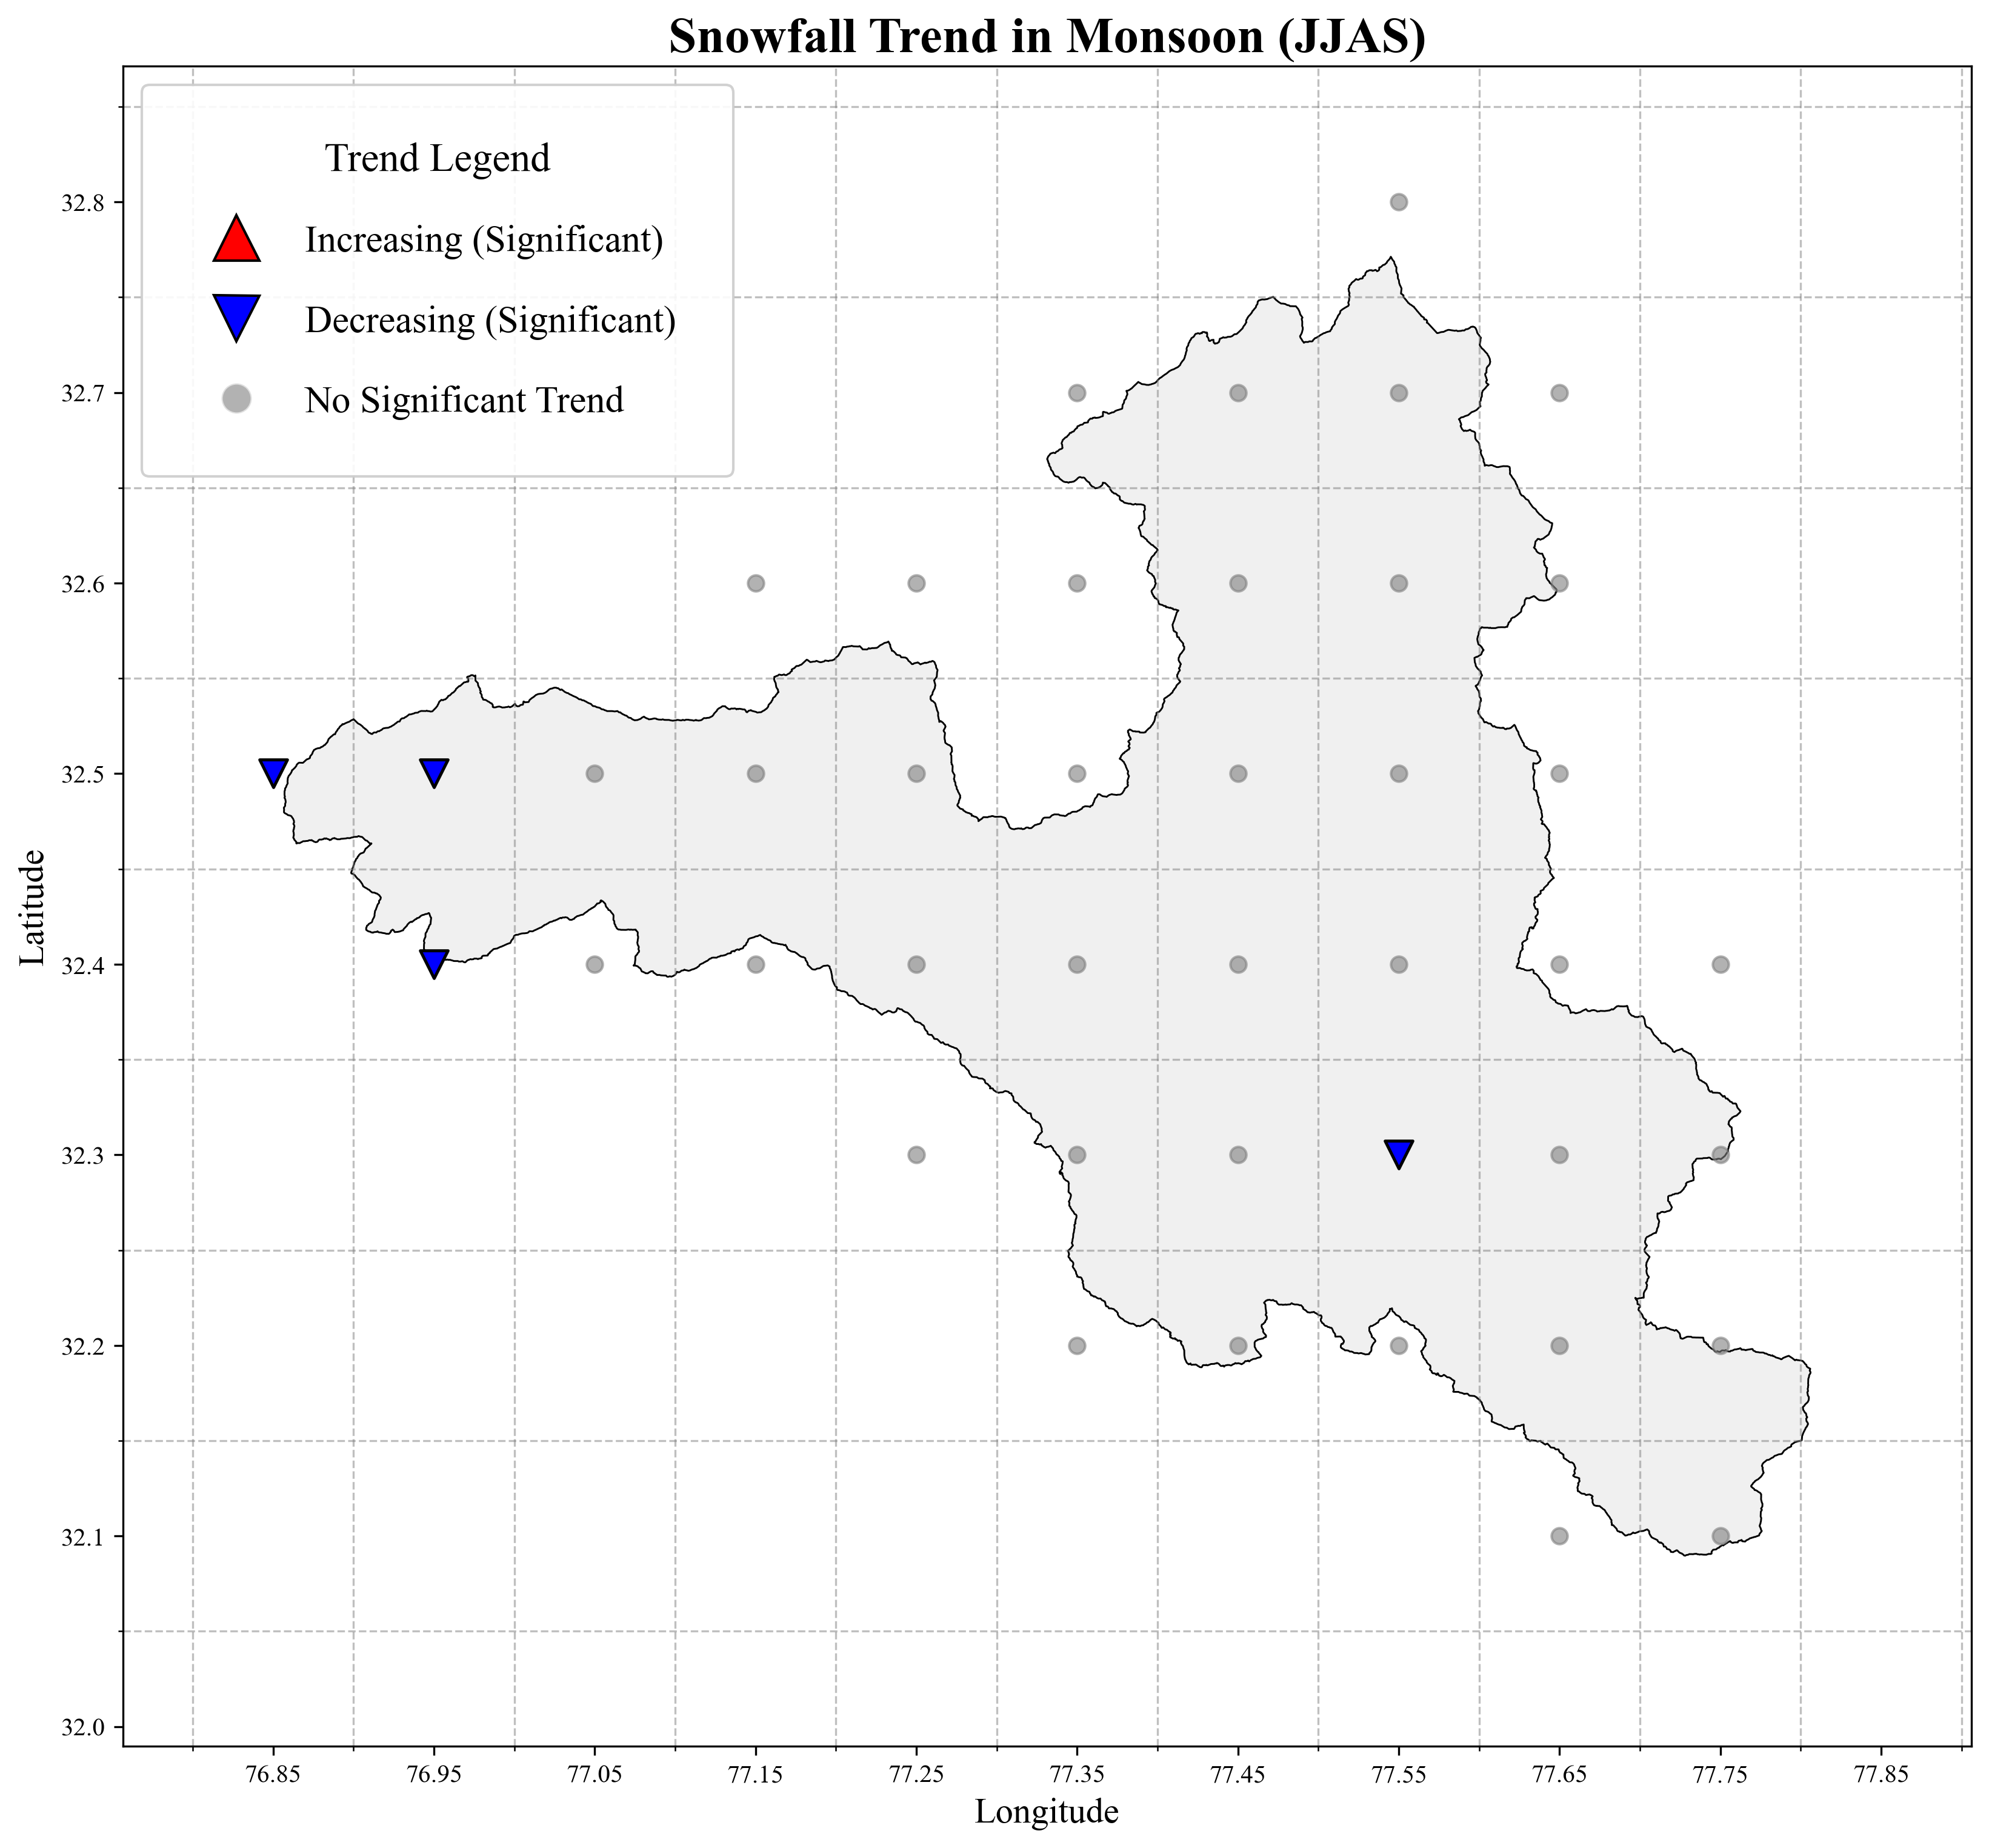
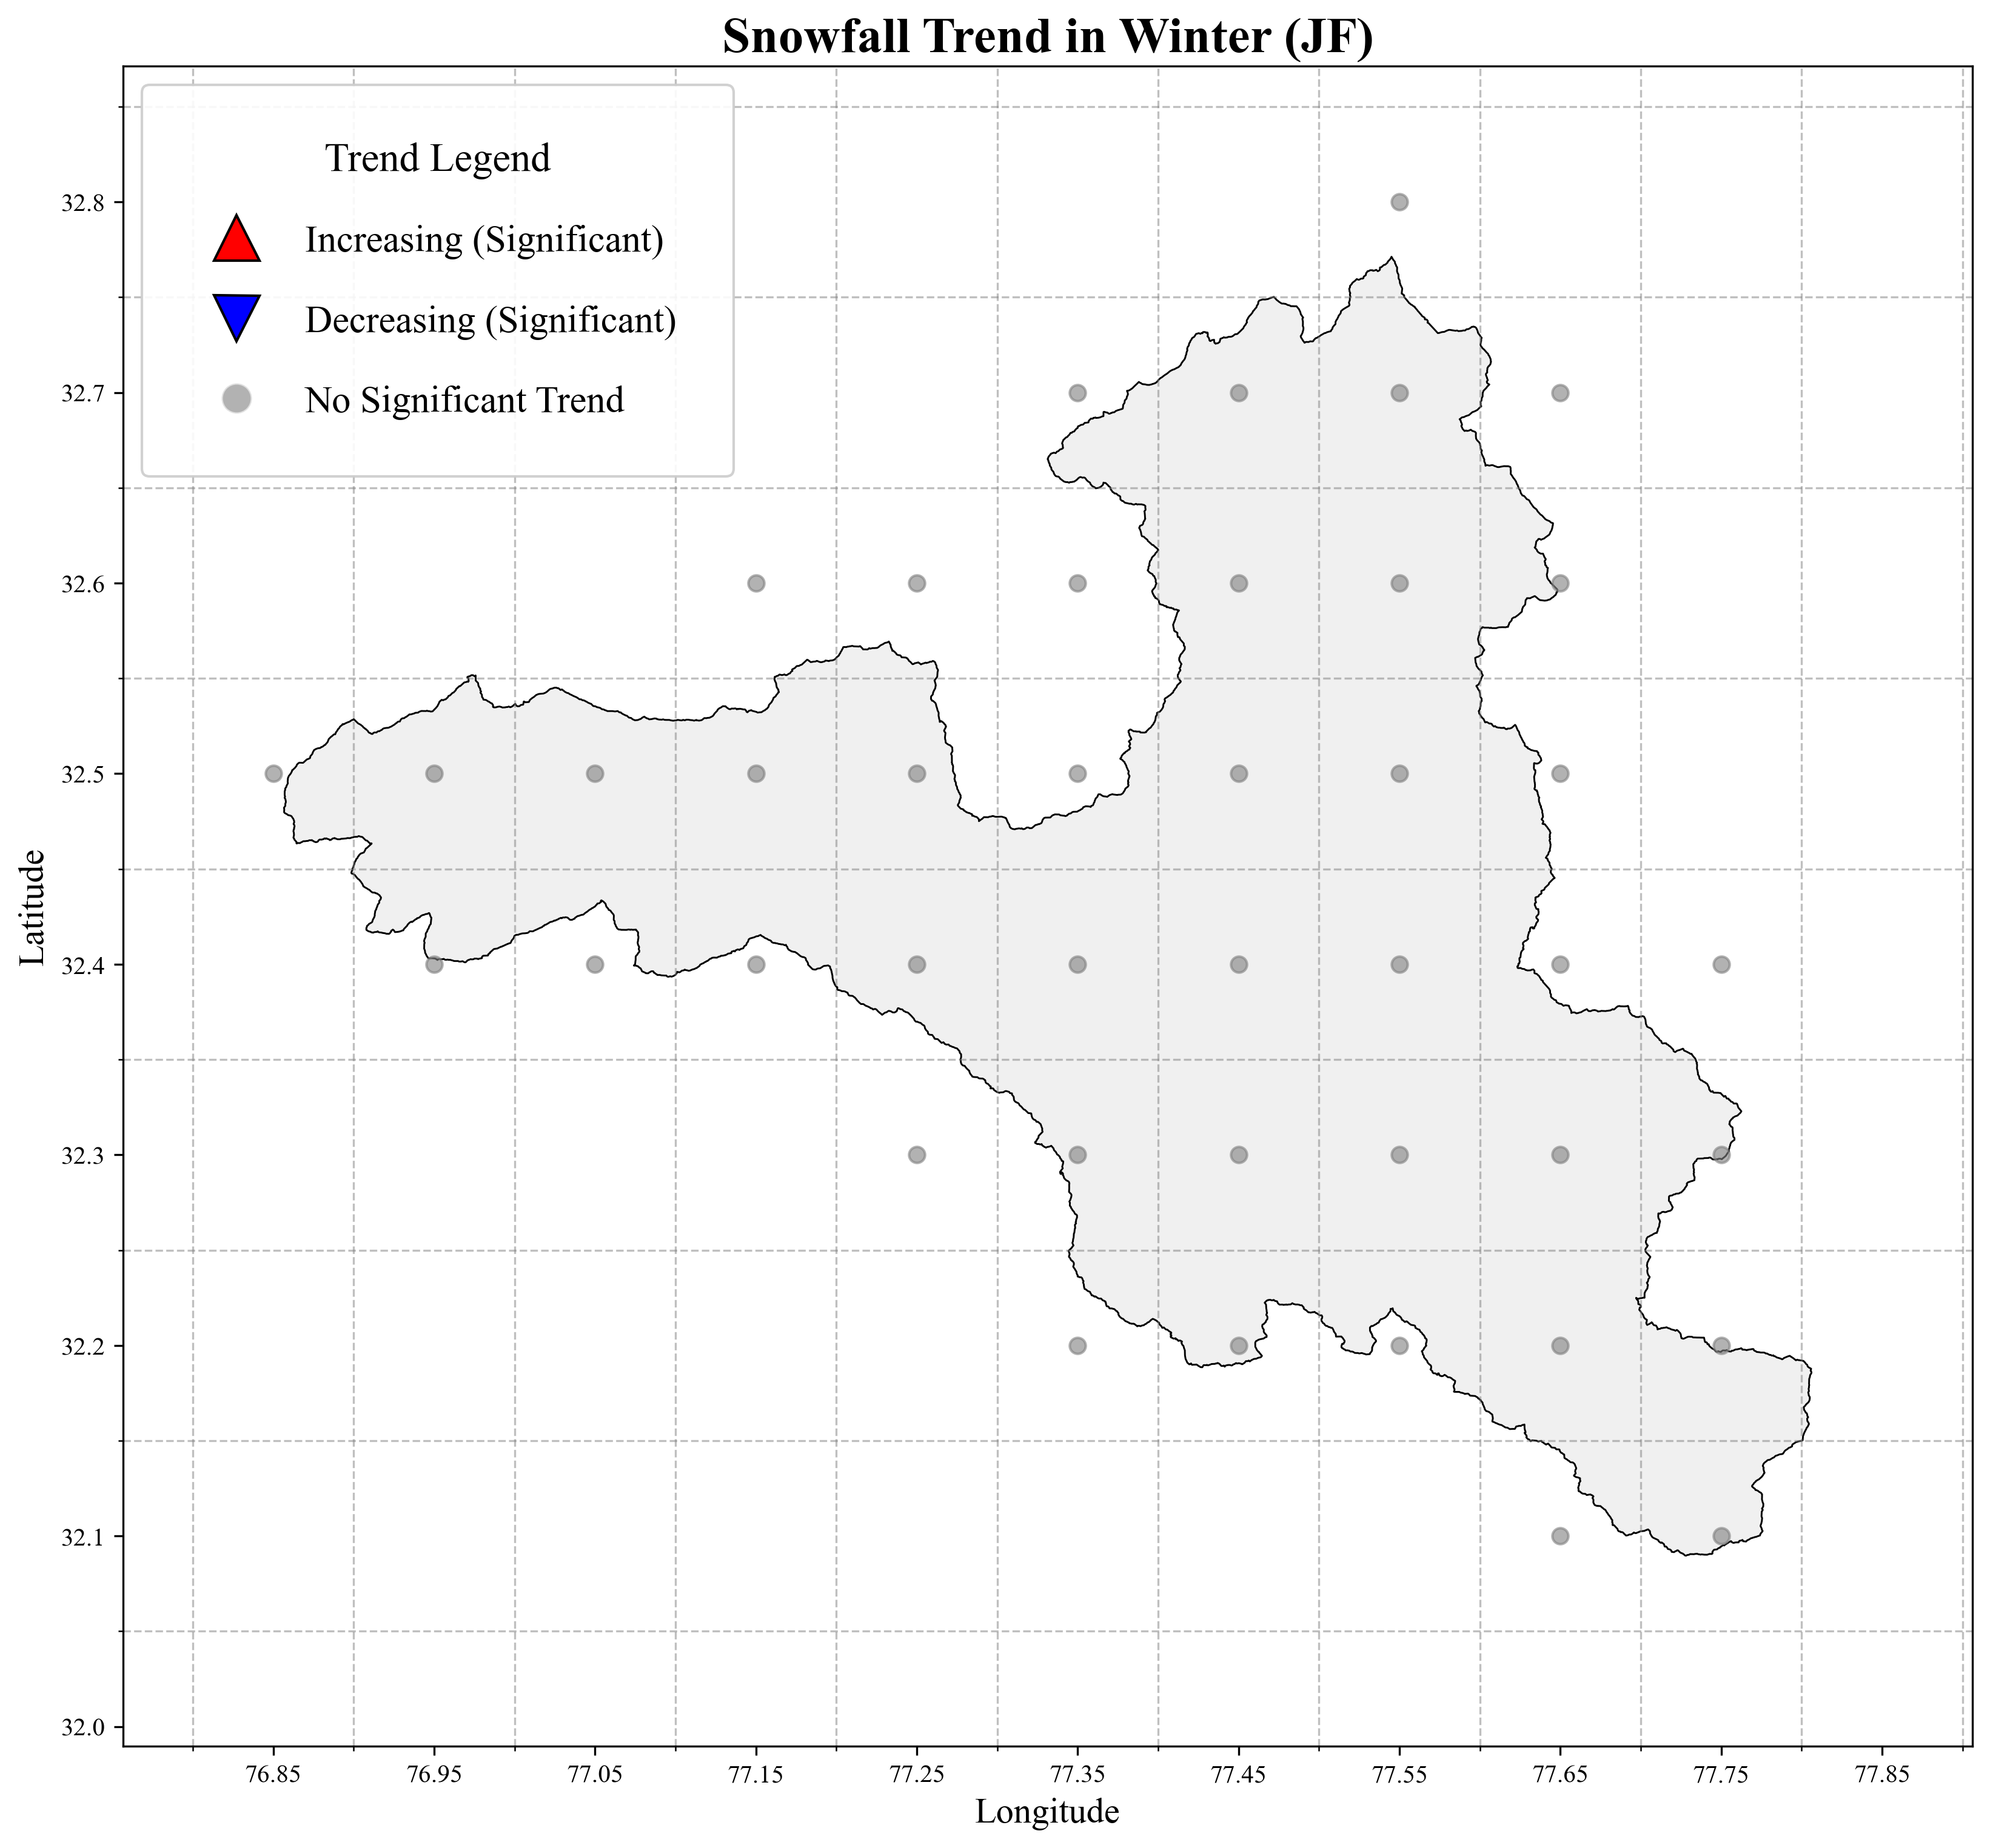
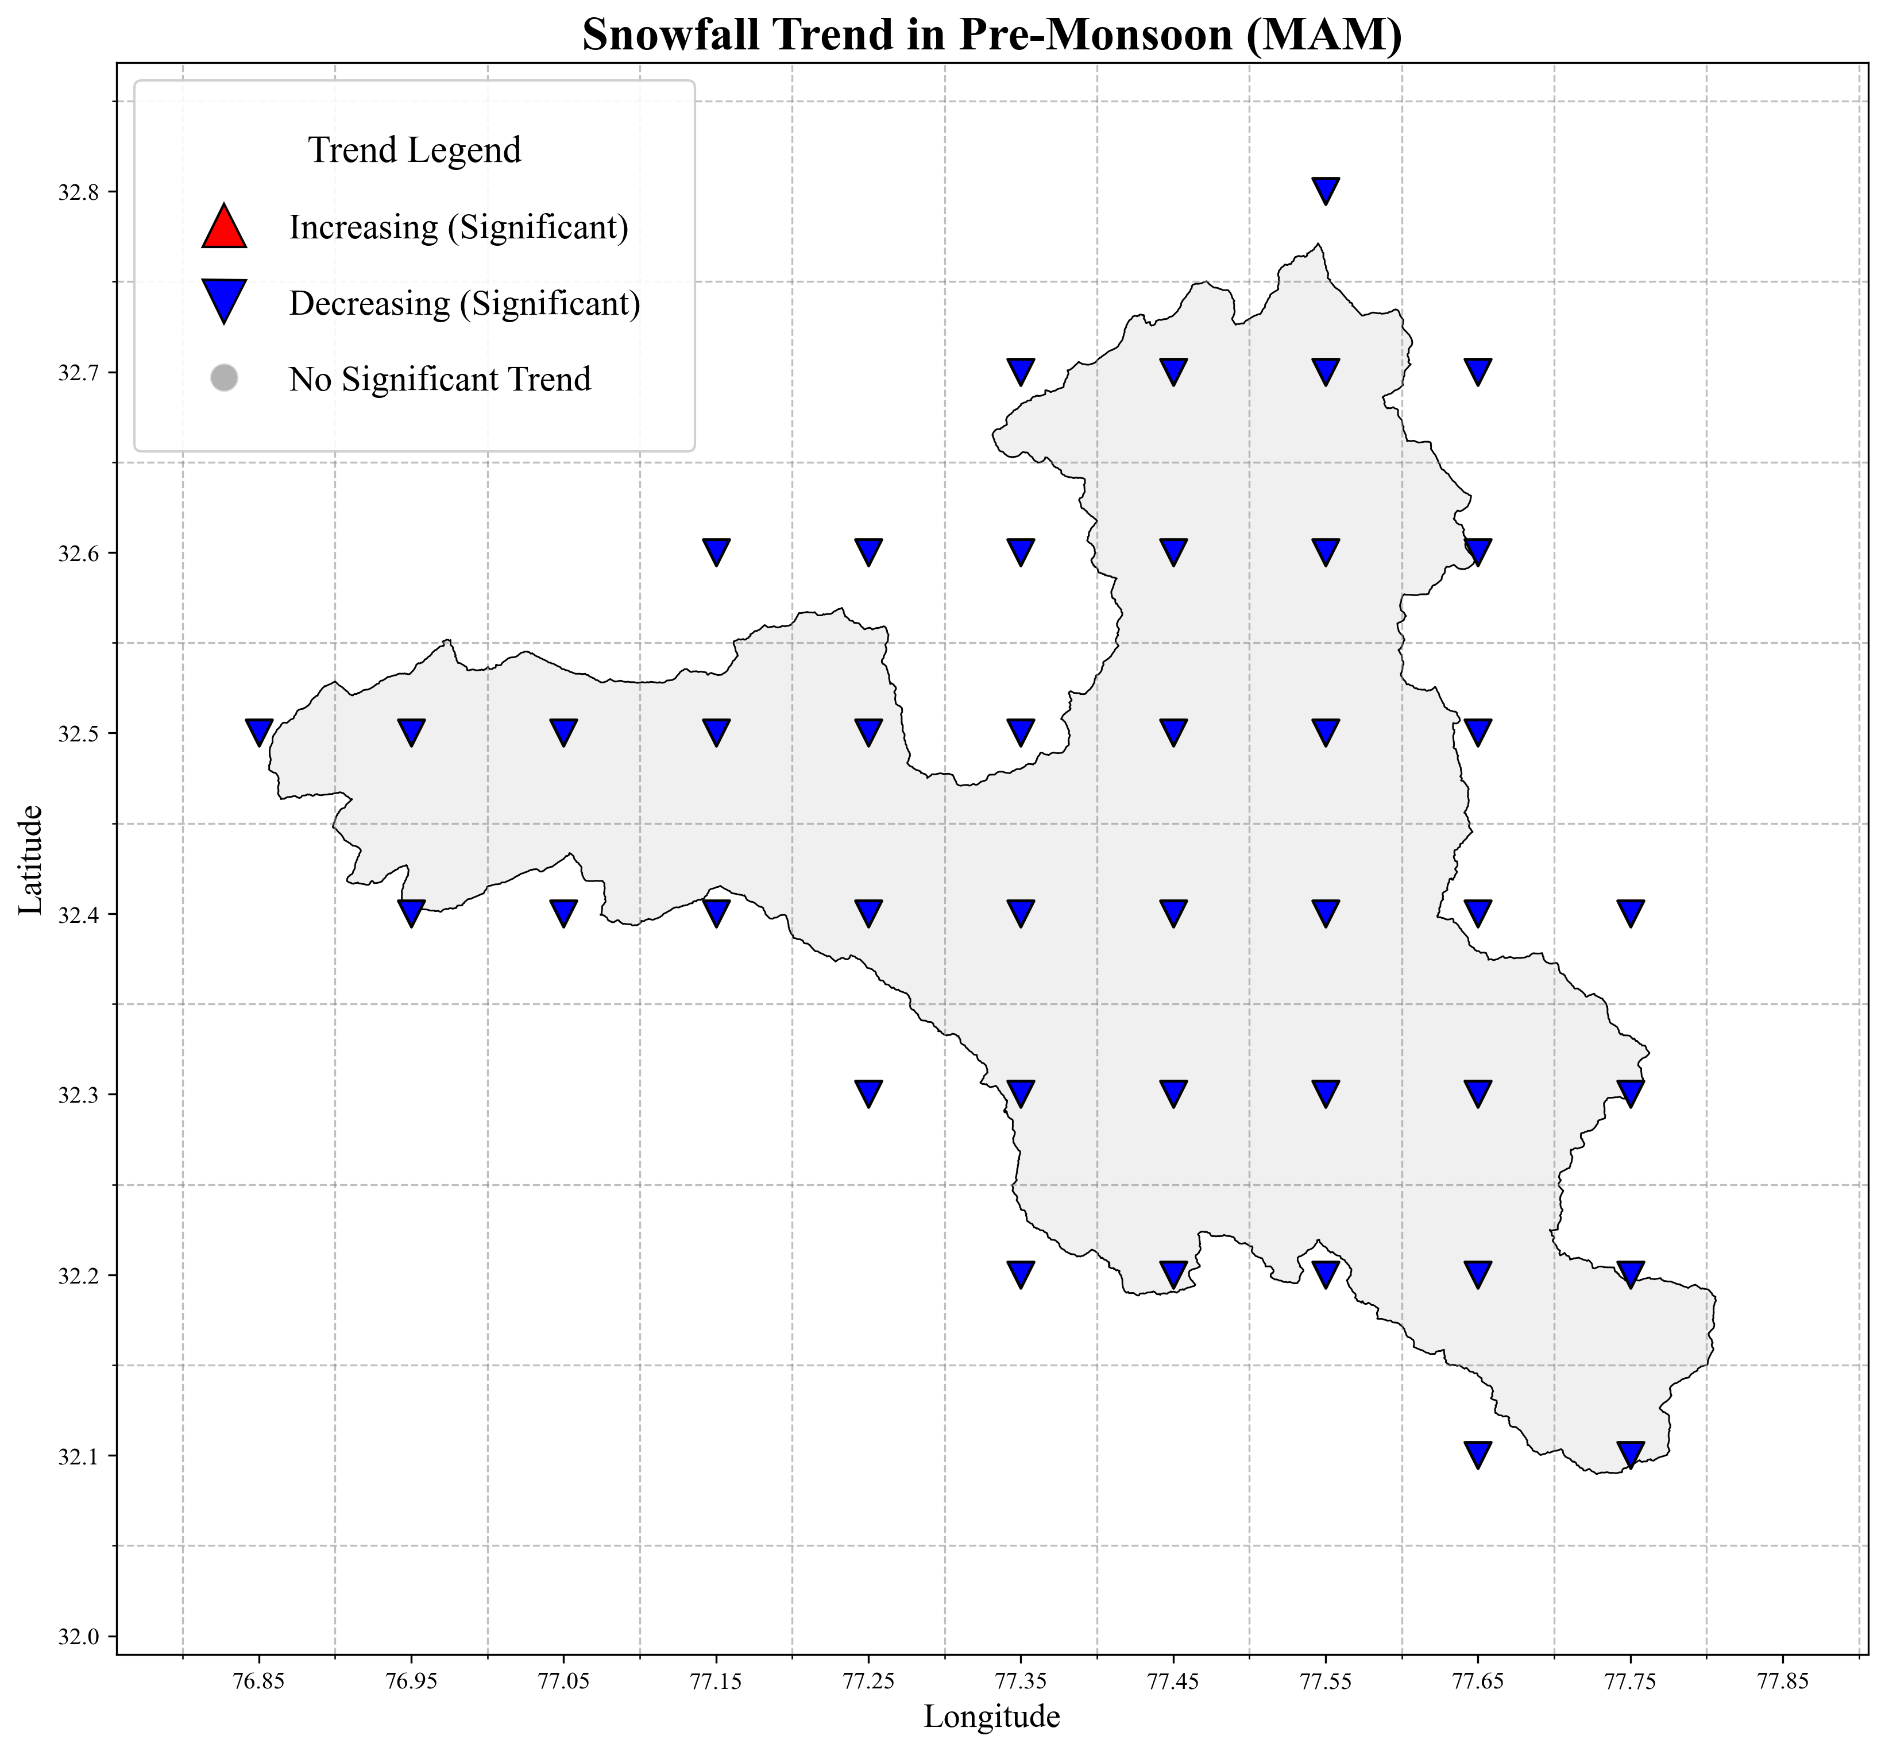
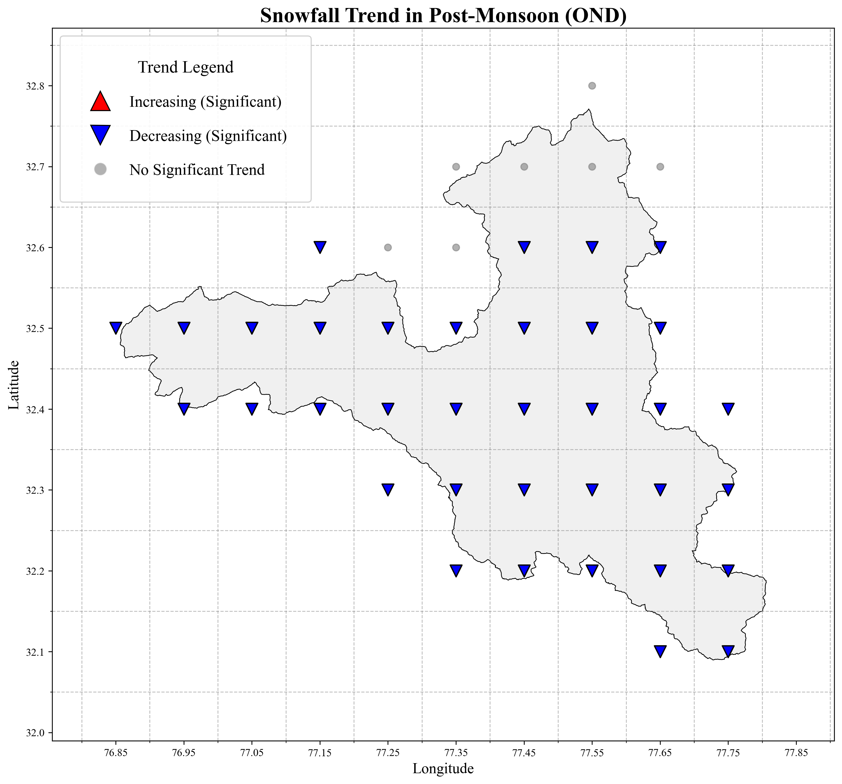
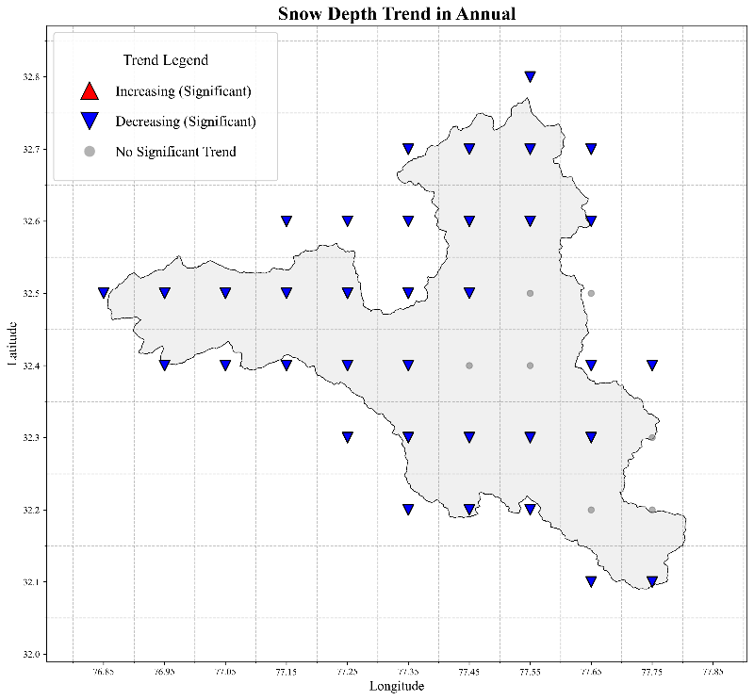
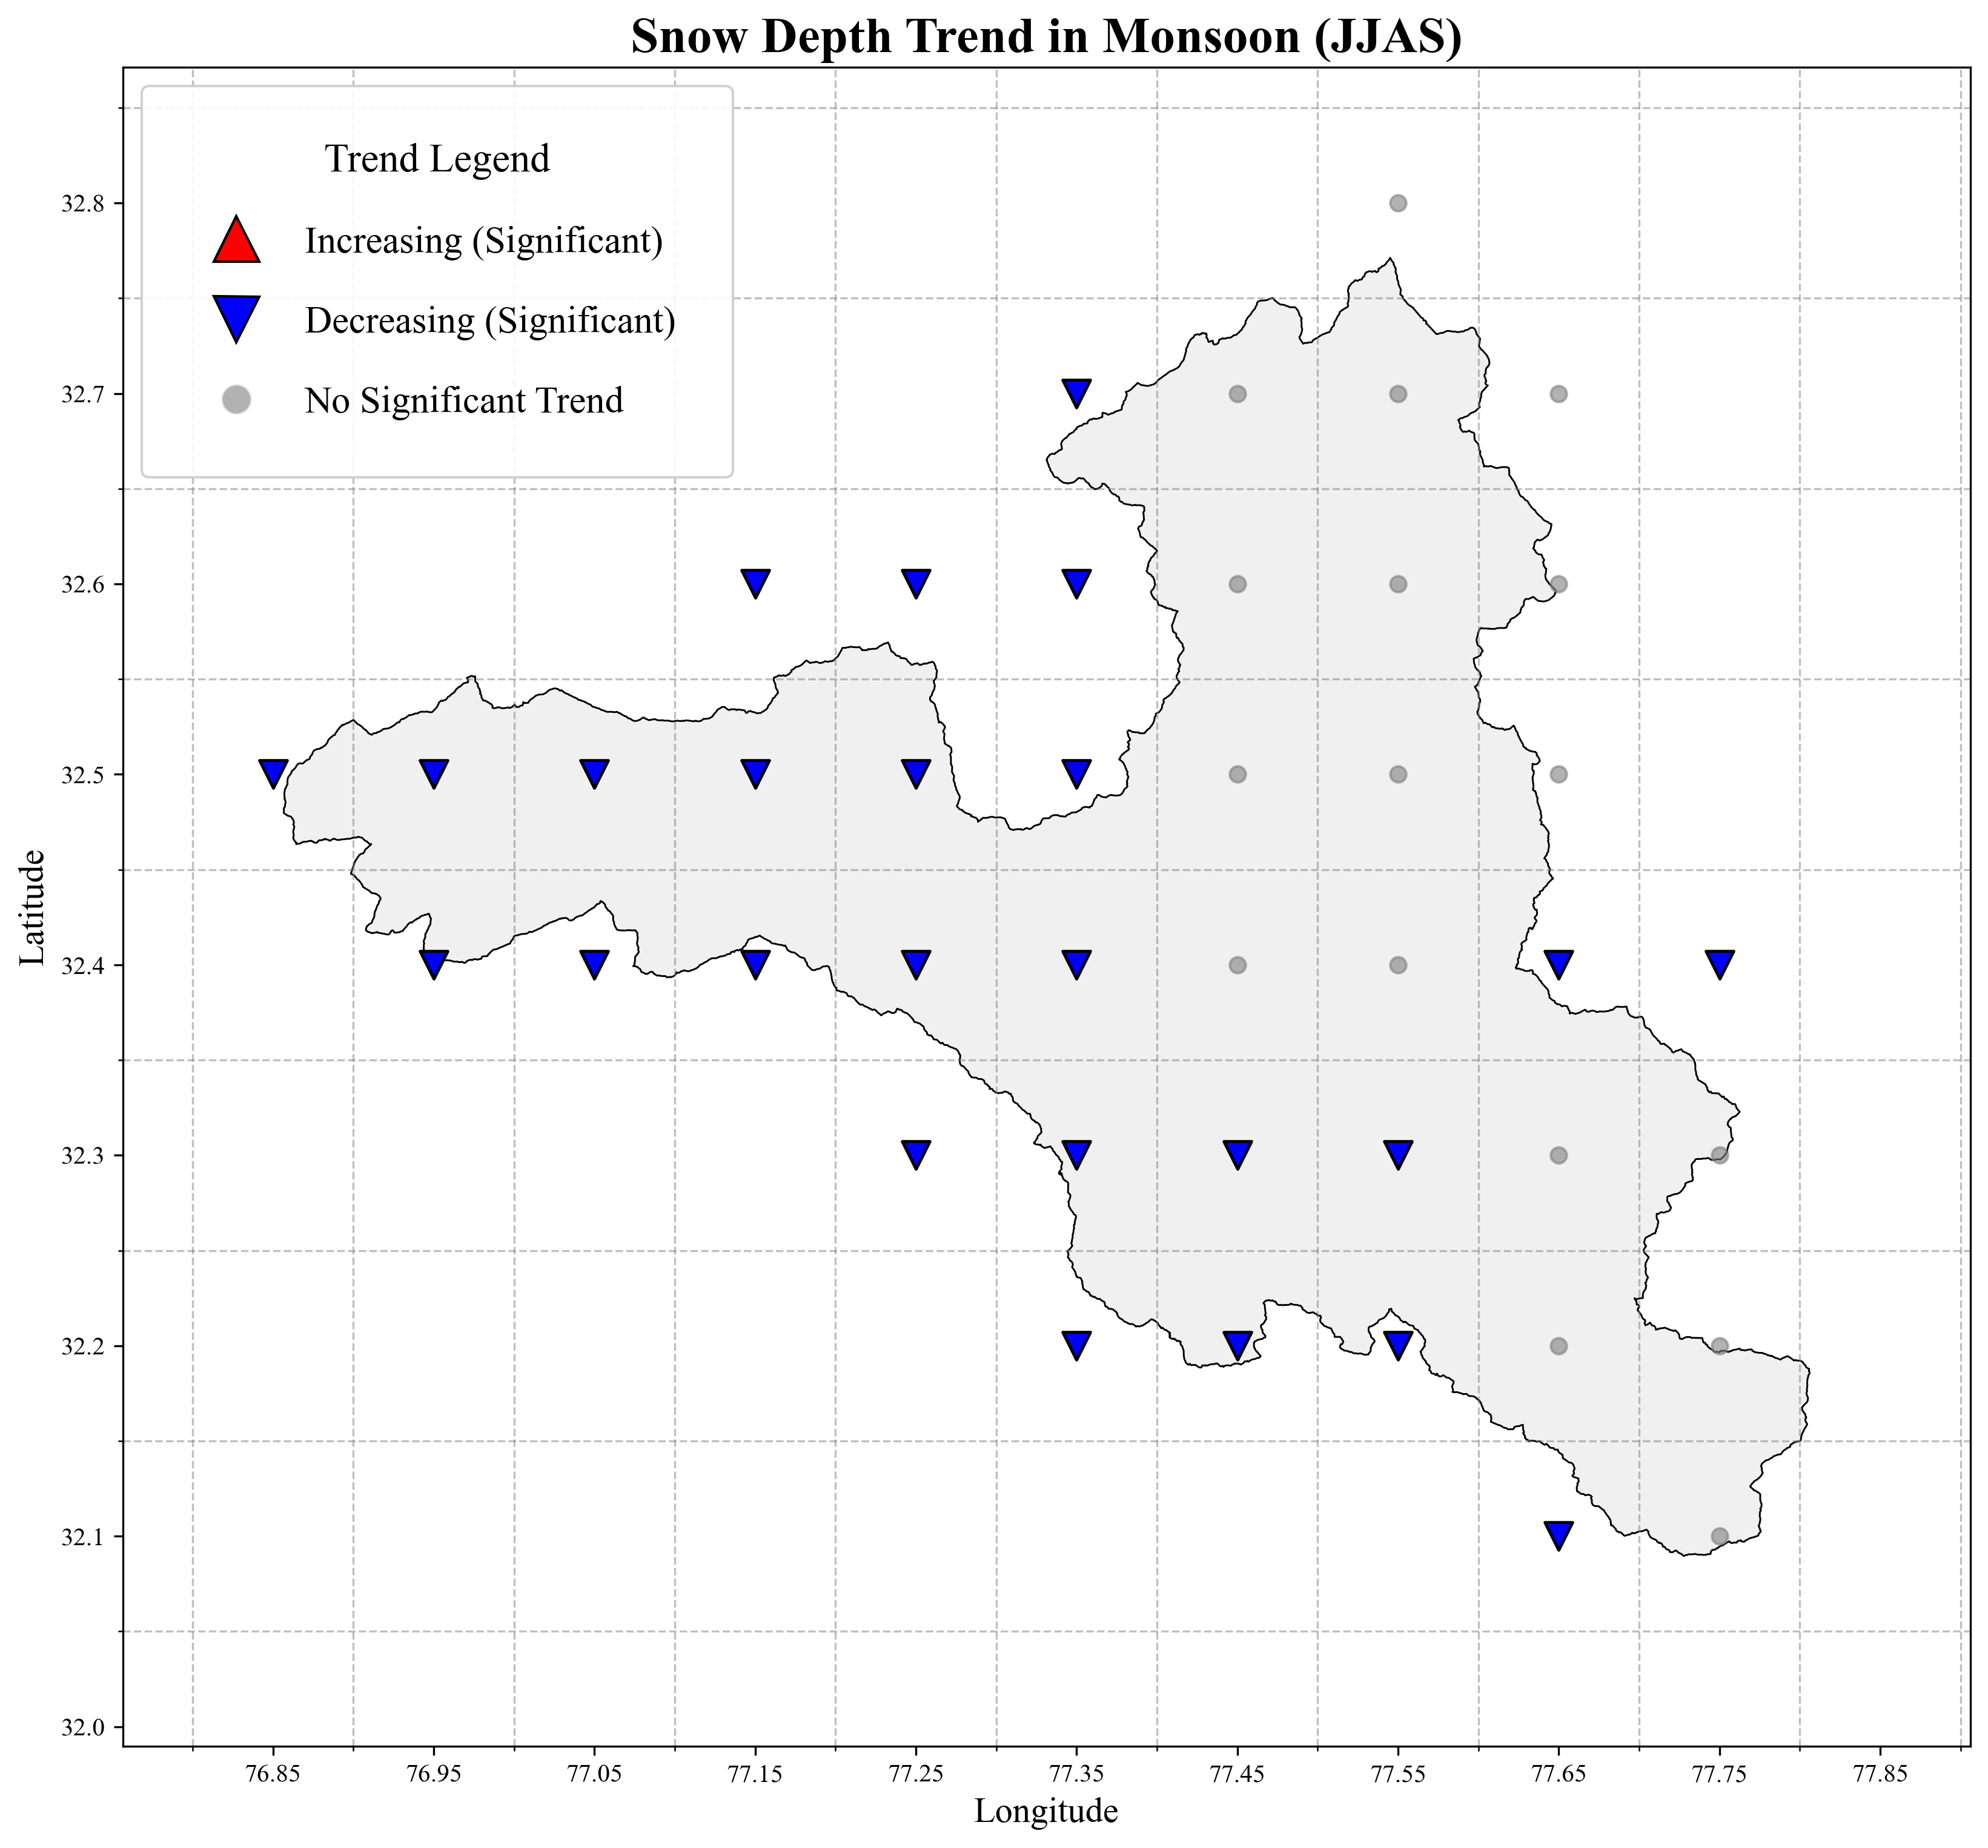
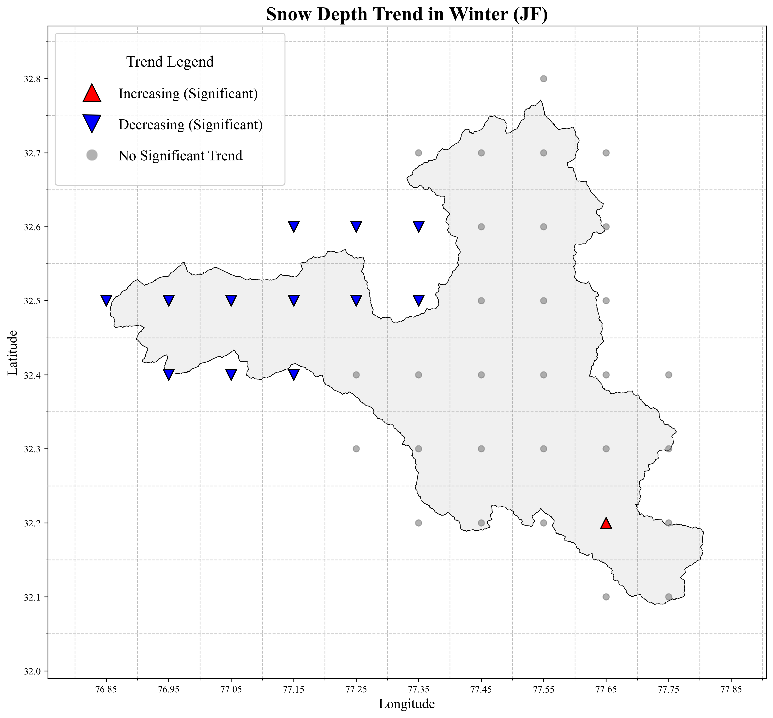
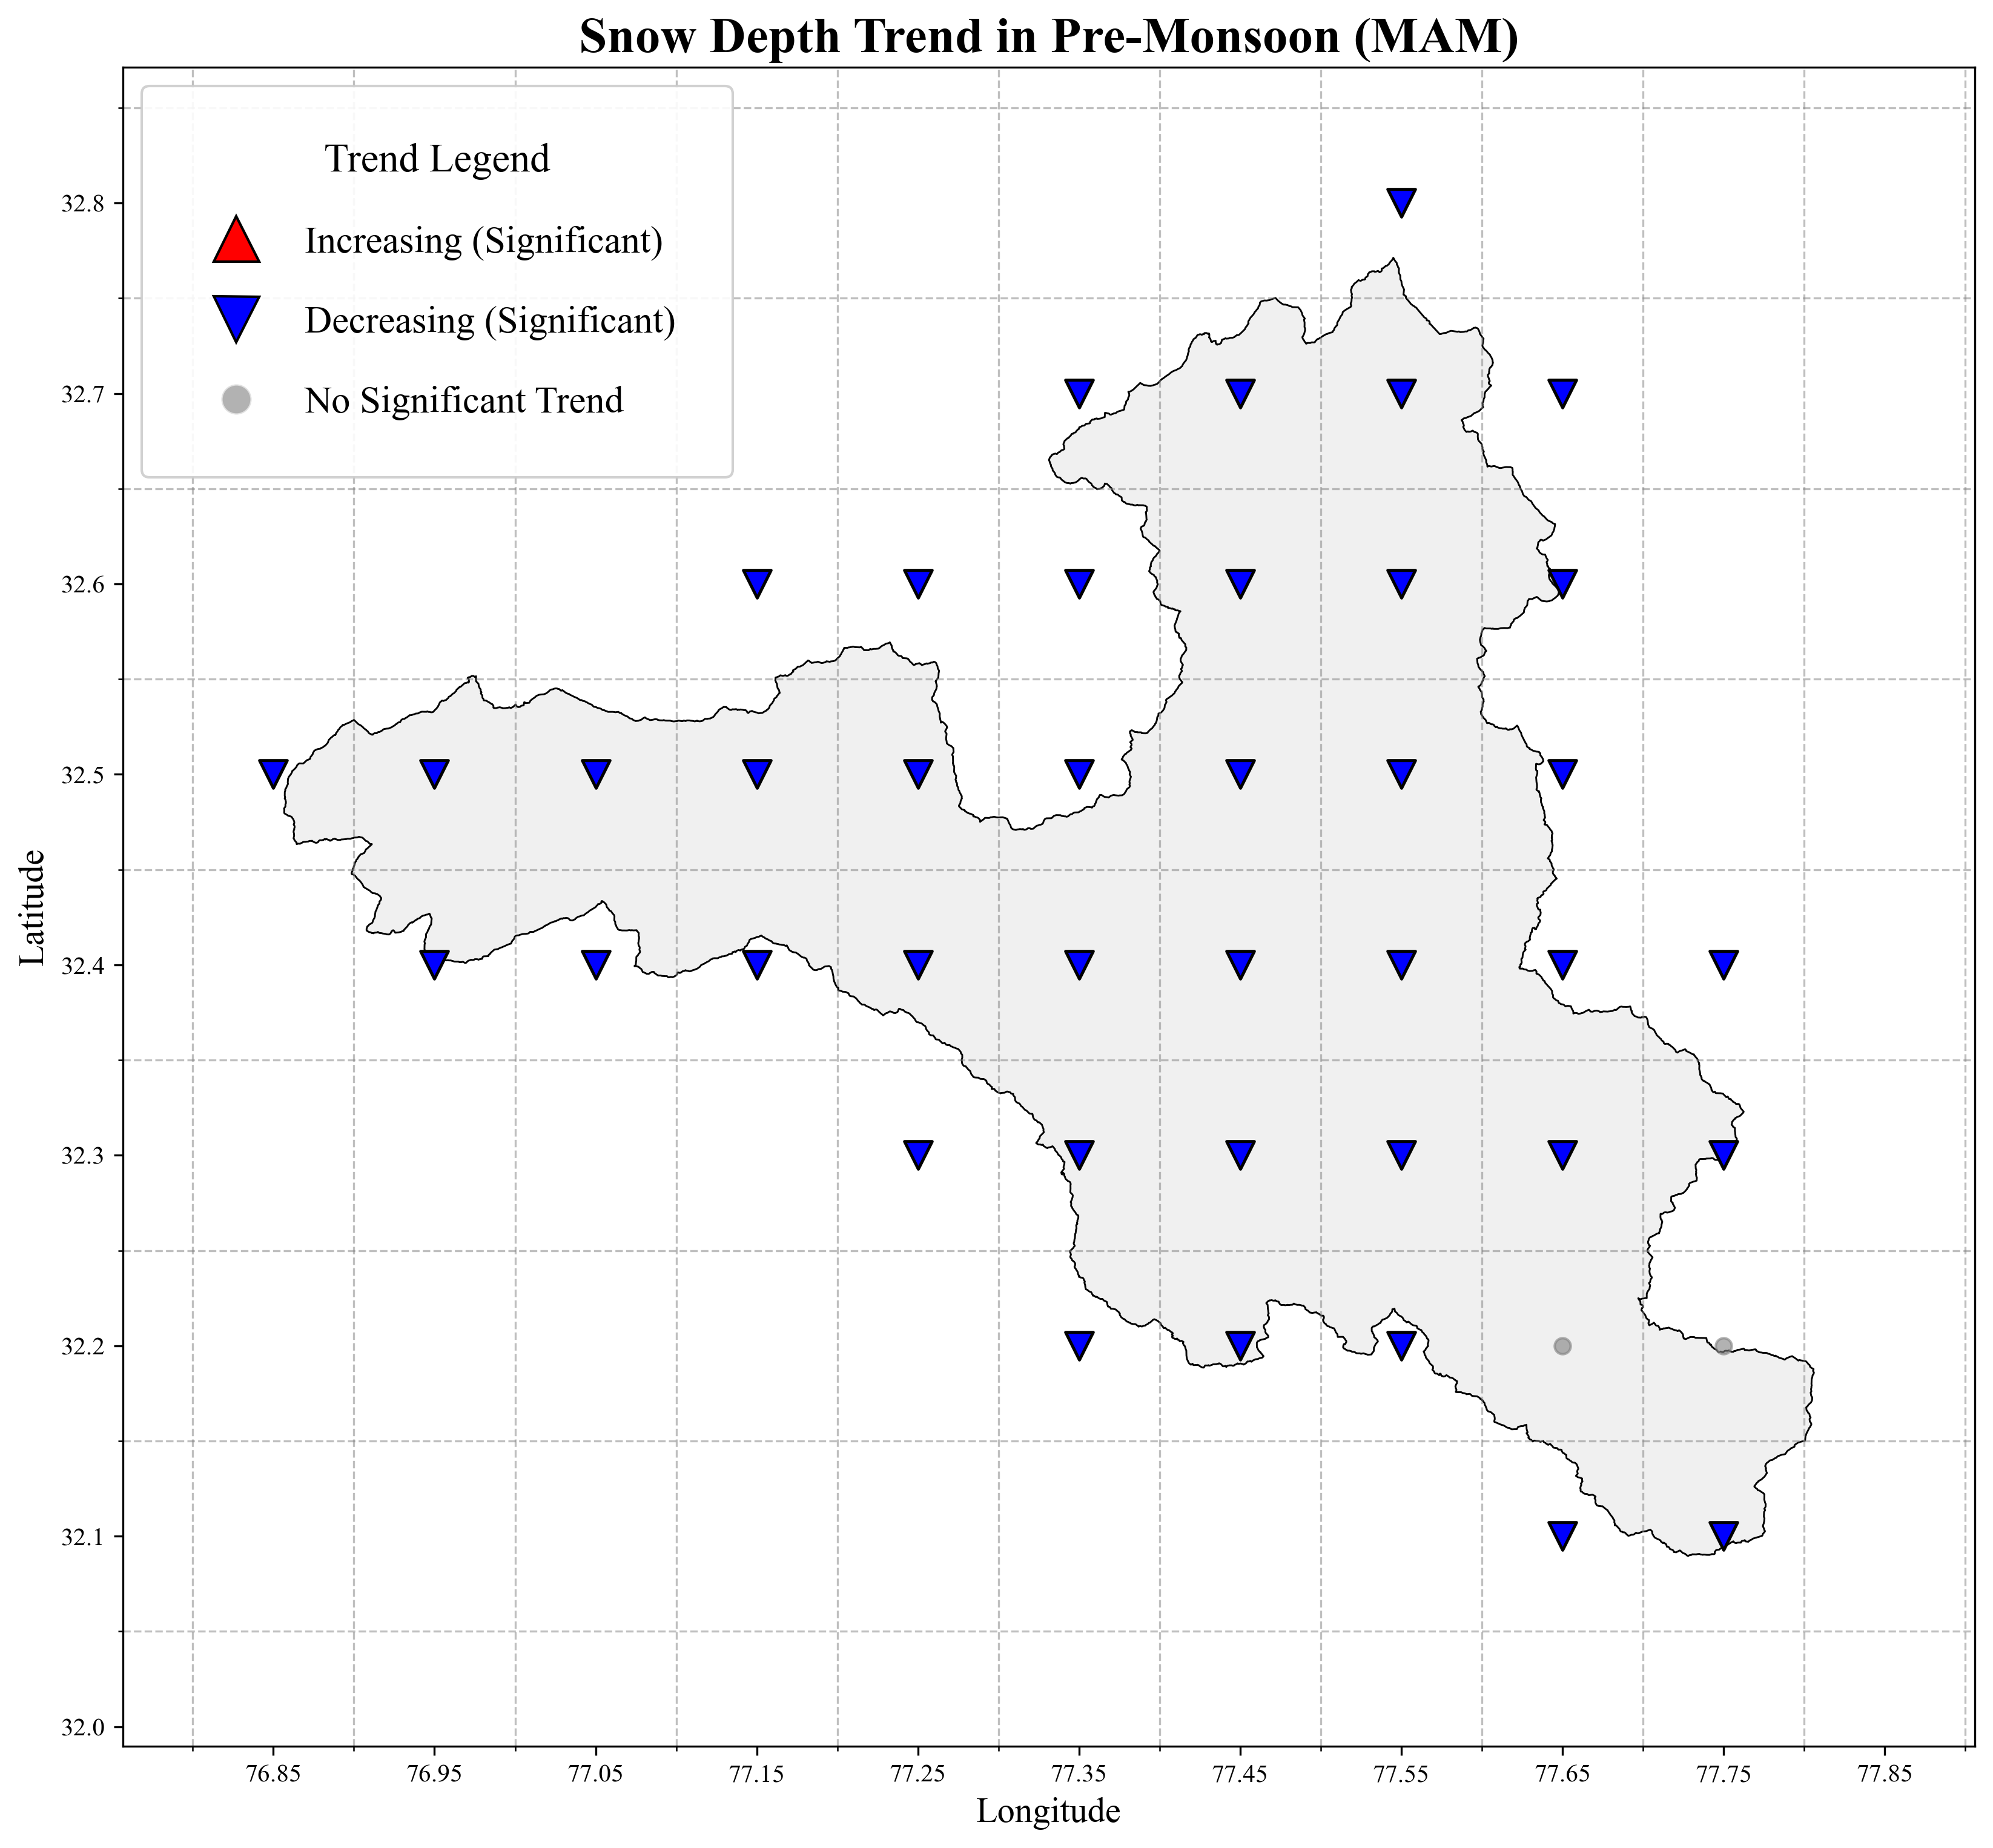
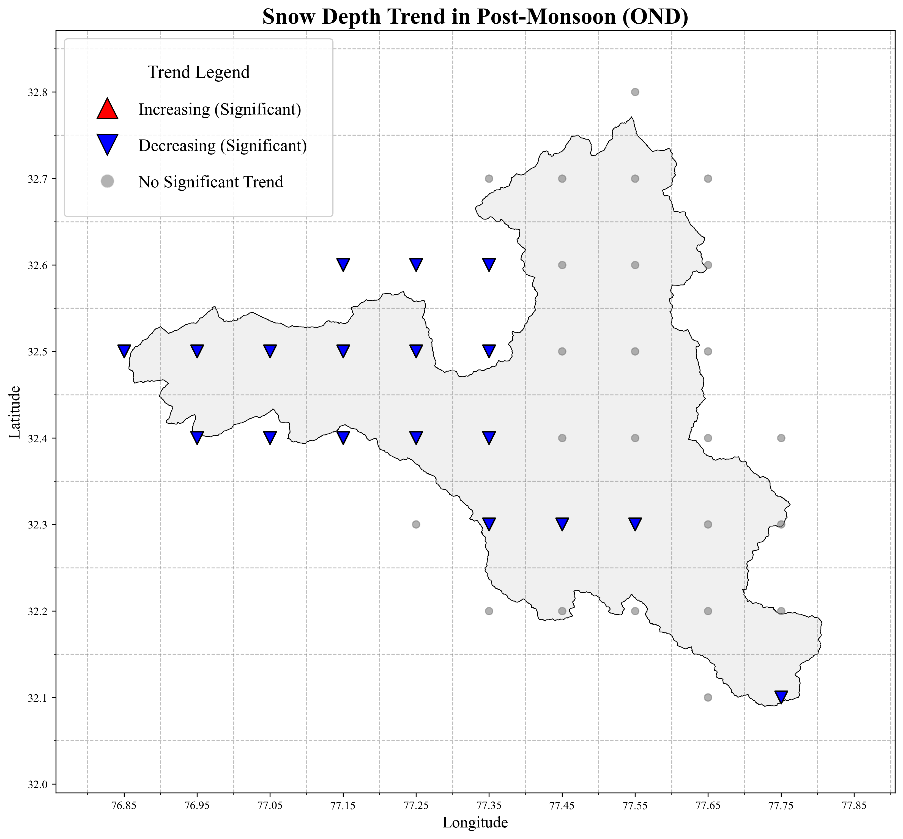
Fig. S3 Spatial Trend Analysis of rainfall. S3a – Spatial trend of annual rainfall S3b – Spatial trend of winter rainfall S3c – Spatial trend of pre-monsoon rainfall. S3d – Spatial trend of monsoon rainfall. S3e – Spatial trend of post-monsoon rainfal
Spatial Annual and Seasonal M-K Trend Maps of Rainfall
Fig. S4 Spatial Trend Analysis of Snowfall. S4a – Spatial trend of annual snowfall S4b – Spatial trend of winter snowfall S4c – Spatial trend of pre-monsoon snowfall S4d – Spatial trend of monsoon snowfall S4e – Spatial trend of post-monsoon snowfall
Spatial Annual and Seasonal M-K Trend Maps of Snowfall
Fig. S5 Spatial Trend Analysis of Snow depth. S5a – Spatial trend of annual snow depth. S5b – Spatial trend of winter snow depth. S5c – Spatial trend of pre-monsoon snow depth. S5d – Spatial trend of monsoon snow depth. S5e – Spatial trend of post-monsoon snow depth
Spatial Annual and Seasonal M-K Trend Maps of Snow Depth
Table S1 Trend Analysis results of monthly, seasonal and annual temperatures
Mann-Kendall and Sen’s Slope Estimator Test Results for Temperature (1950 - 2024)
Variable | Trend | Sens Slope | P-Value | Significant | Kendall Tau | Z Score
Jan | no trend | 0.011799 | 0.107365 | FALSE | 0.127207 | 1.610151
Feb | increasing | 0.013454 | 0.045119 | TRUE | 0.158198 | 2.00354
Mar | no trend | 0.005351 | 0.28035 | FALSE | 0.085405 | 1.079533
Apr | no trend | 0.004123 | 0.475481 | FALSE | 0.056577 | 0.71359
May | increasing | 0.015825 | 0.037827 | TRUE | 0.163964 | 2.076729
Jun | increasing | 0.028908 | 0.001649 | TRUE | 0.248288 | 3.147113
Jul | increasing | 0.040224 | 1.18E-05 | TRUE | 0.345586 | 4.382172
Aug | increasing | 0.01251 | 0.014214 | TRUE | 0.193514 | 2.451821
Sep | no trend | 0.00436 | 0.608427 | FALSE | 0.040721 | 0.512321
Oct | no trend | 0.009802 | 0.453144 | FALSE | 0.059459 | 0.750184
Nov | increasing | 0.032455 | 0.008884 | TRUE | 0.206486 | 2.616495
Dec | no trend | 0.000571 | 0.948938 | FALSE | 0.005405 | 0.06404
Winter | increasing | 0.010892 | 0.022727 | TRUE | 0.17982 | 2.277998
Pre-monsoon | increasing | 0.008066 | 0.033798 | TRUE | 0.167568 | 2.122472
Monsoon | increasing | 0.020242 | 0.000602 | TRUE | 0.270631 | 3.430719
Post-monsoon | no trend | 0.014858 | 0.065935 | FALSE | 0.145225 | 1.838866
Annual Mean | increasing | 0.015467 | 0.000126 | TRUE | 0.302342 | 3.833257

Table S2 Trend Analysis results of monthly, seasonal and annual total precipitation
Mann-Kendall and Sen’s Slope Estimator Test Results for Total Precipitation (1950 - 2024)
Variable | Trend | Sens Slope | P-Value | Significant | Kendall Tau | Z Score
Jan | no trend | -0.236715556 | 0.589358079 | FALSE | -0.042882883 | -0.53976649
Feb | no trend | 0.455866971 | 0.436787353 | FALSE | 0.061621622 | 0.777629689
Mar | no trend | -0.811700625 | 0.06729228 | FALSE | -0.144504505 | -1.829716916
Apr | no trend | -0.438086969 | 0.260472137 | FALSE | -0.089009009 | -1.125275903
May | decreasing | -0.470521556 | 0.035363232 | TRUE | -0.166126126 | -2.104174454
Jun | increasing | 0.530386277 | 0.000121834 | TRUE | 0.303063063 | 3.842405524
Jul | no trend | 0.082281421 | 0.790771468 | FALSE | 0.021261261 | 0.265308953
Aug | no trend | 0.133351086 | 0.492622406 | FALSE | 0.054414414 | 0.686143844
Sep | no trend | 0.002565368 | 0.992700587 | FALSE | 0.001081081 | 0.009148585
Oct | decreasing | -0.259658658 | 0.007762295 | TRUE | -0.21009009 | -2.662238113
Nov | no trend | -0.039029324 | 0.82620915 | FALSE | -0.017657658 | -0.21956603
Dec | no trend | -0.533681773 | 0.070075902 | FALSE | -0.143063063 | -1.811419747
Winter | no trend | 0.25067462 | 0.515983259 | FALSE | 0.051531532 | 0.649549505
Pre-monsoon | decreasing | -0.620048396 | 0.015334765 | TRUE | -0.191351351 | -2.424374914
Monsoon | no trend | 0.197236531 | 0.06729228 | FALSE | 0.144504505 | 1.829716916
Post-monsoon | decreasing | -0.397135833 | 0.027467508 | TRUE | -0.174054054 | -2.204808884
Annual Total Precipitation | no trend | -2.105827741 | 0.16714486 | FALSE | -0.109189189 | -1.381436272

Table S3 Trend Analysis results of monthly, seasonal and annual rainfall
Mann-Kendall and Sen’s Slope Estimator Test Results for Rainfall (1950 - 2024)
Variable | Trend | Sens Slope | P-Value | Significant | Kendall Tau | Z Score
Jan | increasing | 0.000937903 | 0.003317295 | TRUE | 0.231711712 | 2.93669565
Feb | increasing | 0.002199167 | 7.44E-07 | TRUE | 0.39027027 | 4.949384258
Mar | increasing | 0.002920576 | 0.043193174 | TRUE | 0.15963964 | 2.021837192
Apr | no trend | 0.009130304 | 0.070075902 | FALSE | 0.143063063 | 1.811419747
May | increasing | 0.057019667 | 0.000113061 | TRUE | 0.304504505 | 3.860702693
Jun | increasing | 0.265641344 | 1.04E-05 | TRUE | 0.347747748 | 4.409617768
Jul | increasing | 0.431867189 | 0.017812954 | TRUE | 0.187027027 | 2.369483406
Aug | no trend | 0.222245143 | 0.10736492 | FALSE | 0.127207207 | 1.610150886
Sep | no trend | 0.057176354 | 0.453143933 | FALSE | 0.059459459 | 0.750183936
Oct | no trend | -0.002871308 | 0.734988213 | FALSE | -0.027027027 | -0.338497629
Nov | increasing | 0.004514792 | 0.004975504 | TRUE | 0.221621622 | 2.808615466
Dec | no trend | 0.000583524 | 0.080571504 | FALSE | 0.138018018 | 1.747379655
Winter | increasing | 0.001712656 | 1.64E-06 | TRUE | 0.378018018 | 4.79385832
Pre-monsoon | increasing | 0.025803073 | 8.05E-05 | TRUE | 0.310990991 | 3.943039954
Monsoon | increasing | 0.276550396 | 0.001548644 | TRUE | 0.24972973 | 3.165410265
Post-monsoon | no trend | 0.000575073 | 0.862004484 | FALSE | 0.014054054 | 0.173823107
Annual Rainfall | increasing | 1.156449732 | 0.002245903 | TRUE | 0.241081081 | 3.05562725

Table S4 Trend Analysis results of monthly, seasonal and annual snowfall
Mann-Kendall and Sen’s Slope Estimator Test Results for Snowfall (1950 - 2024)
Variable | Trend | Sens Slope | P-Value | Significant | Kendall Tau | Z Score
Jan | no trend | -0.237059926 | 0.589358079 | FALSE | -0.042882883 | -0.53976649
Feb | no trend | 0.455229797 | 0.436787353 | FALSE | 0.061621622 | 0.777629689
Mar | no trend | -0.80983 | 0.06729228 | FALSE | -0.144504505 | -1.829716916
Apr | no trend | -0.440204687 | 0.237933638 | FALSE | -0.093333333 | -1.180167411
May | decreasing | -0.555567162 | 0.014578977 | TRUE | -0.192792793 | -2.442672083
Jun | increasing | 0.208906525 | 0.027467508 | TRUE | 0.174054054 | 2.204808884
Jul | decreasing | -0.358688174 | 0.0008401 | TRUE | -0.263423423 | -3.339233372
Aug | no trend | -0.083804231 | 0.14577312 | FALSE | -0.114954955 | -1.454624948
Sep | no trend | -0.049829452 | 0.680569363 | FALSE | -0.032792793 | -0.411686306
Oct | decreasing | -0.24262149 | 0.011271792 | TRUE | -0.2 | -2.534157929
Nov | no trend | -0.042472714 | 0.797827009 | FALSE | -0.020540541 | -0.256160368
Dec | no trend | -0.535568318 | 0.070075902 | FALSE | -0.143063063 | -1.811419747
Winter | no trend | 0.24934014 | 0.527875547 | FALSE | 0.05009009 | 0.631252336
Pre-monsoon | decreasing | -0.651986333 | 0.011569521 | TRUE | -0.199279279 | -2.525009344
Monsoon | no trend | -0.082887051 | 0.301234321 | FALSE | -0.081801802 | -1.033790058
Post-monsoon | decreasing | -0.387537596 | 0.030142367 | TRUE | -0.171171171 | -2.168214546
Annual Snowfall | decreasing | -2.955239484 | 0.041336945 | TRUE | -0.161081081 | -2.040134361

Table S5 Trend Analysis results of monthly, seasonal and annual snow depth
Mann-Kendall and Sen’s Slope Estimator Test Results for Snow depth (1950 - 2024)
Variable | Trend | Sens Slope | P-Value | Significant | Kendall Tau | Z Score
Jan | no trend | -0.003162956 | 0.148324127 | FALSE | -0.114234234 | -1.445476364
Feb | no trend | -0.001992636 | 0.360265941 | FALSE | -0.072432432 | -0.914858458
Mar | no trend | -0.002692746 | 0.156181828 | FALSE | -0.112072072 | -1.41803061
Apr | decreasing | -0.004806488 | 0.008418877 | TRUE | -0.207927928 | -2.634792359
May | decreasing | -0.005504798 | 0.003840759 | TRUE | -0.228108108 | -2.890952727
Jun | decreasing | -0.005139162 | 0.042256437 | TRUE | -0.16036036 | -2.030985777
Jul | decreasing | -0.00404896 | 0.024999968 | TRUE | -0.176936937 | -2.241403222
Aug | decreasing | -0.000961225 | 0.003840759 | TRUE | -0.228108108 | -2.890952727
Sep | no trend | -9.71E-05 | 0.22023242 | FALSE | -0.096936937 | -1.225910334
Oct | decreasing | -0.00081343 | 0.004699915 | TRUE | -0.223063063 | -2.826912635
Nov | decreasing | -0.00195874 | 0.033038081 | TRUE | -0.168288288 | -2.131620207
Dec | decreasing | -0.00289695 | 0.044147399 | TRUE | -0.158918919 | -2.012688608
Winter | no trend | -0.002385298 | 0.197067871 | FALSE | -0.101981982 | -1.289950426
Pre-monsoon | decreasing | -0.004496381 | 0.017812954 | TRUE | -0.187027027 | -2.369483406
Monsoon | decreasing | -0.002870029 | 0.033038081 | TRUE | -0.168288288 | -2.131620207
Post-monsoon | decreasing | -0.001911543 | 0.024999968 | TRUE | -0.176936937 | -2.241403222
Annual Mean | decreasing | -0.003449461 | 0.006585081 | TRUE | -0.214414414 | -2.71712962

