Supplementary Information
Informative alignment patterns between chemical structure and clinical signals support context-aware toxicity assessment
Hiroto Asano¹, Yu-Shi Tian ^{1, *}, Asuka Hatabu ¹, Kaori Fukuzawa ¹, Daisuke Takaya¹, Kenji Ikeda ¹
¹Graduate School of Pharmaceutical Sciences, The University of Osaka, 1-6 Yamadaoka, Suita, Osaka 565-0871, Japan

ORCIDs:
Hiroto Asano: 0000-0002-0973-6773; Yu-Shi Tian: 0000-0002-8988-9453
Asuka Hatabu: 0000-0001-9886-1447; Kaori Fukuzawa: 0000-0001-5357-8250
Daisuke Takaya: 0000-0001-6020-8151; Kenji Ikeda: 0000-0001-8299-4464

*Corresponding author: Yu-Shi Tian, Graduate School of Pharmaceutical Sciences, The University of Osaka, 1-6 Yamadaoka, Suita City, Osaka 565-0871, Japan; Phone: +81-6-6879-8242; Fax.: +81-6-6879-8242; Email: yushi-tian@phs.osaka-u.ac.jp

Supplementary Note 1. Details of AEST, a web-based signal detection platform
We developed the Adverse Events Signal-detection Tool (AEST), a web application that performs drug safety signal detection using FAERS data¹ directly through a browser. AEST is based on the FAERS resource covering 2004 Q1 to 2025 Q2 and conducts signal detection for drug–Preferred Term (PT) combinations while visualizing relevant background information.
AEST serves as the analytical infrastructure for this study and is publicly available to facilitate its reuse in safety research. Because FAERS is updated quarterly, the analysis period covered by AEST is continuously updated to maintain its utility for research purposes. This section describes the data used in the AEST, system architecture, drug name search functionality, user interface, distributed processing, and performance evaluation.

Overview of AEST data
The AEST dataset comprises drug names and PT combinations derived from FAERS, and contains a total of 575,452,020 records. The mean number of records per quarter was 6,691,302 with a standard deviation of 6,094,644 records, showing an increasing trend over time (Supplementary Table 5, Supplementary Fig. 1). Completeness rates for key fields showed that the drug name and PT were present in 100% of the reports. In contrast, some fields, such as start date and event date, had relatively lower completeness rates, reflecting the known limitations of spontaneous reporting systems.

Supplementary Table 5. Summary of data completeness for key fields in the AEST
Data total: 575,452,020 records (mean per file 6,691,302; SD ± 6,094,644)
 | Filling rate (number/total)
Drug name | 100.0% (575,452,020/575,452,020)
PT | 100.0% (575,452,020/575,452,020)
Indication PT | 99.9% (575,451,928/575,452,020)
Start date | 14.7% (84,453,152/575,452,020)
Event date | 40.7% (234,136,717/575,452,020)
End date | 85.0% (489,402,120/575,452,020)
Age | 71.8% (413,091,651/575,452,020)
Sex | 88.8% (510,802,519/575,452,020)
Reporter country | 96.3% (553,877,001/575,452,020)

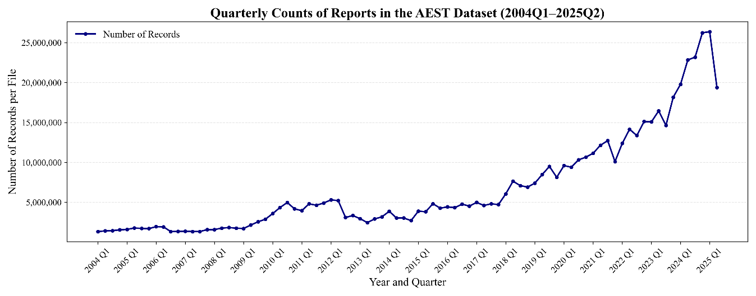
Supplementary Fig. 1. Quarterly trends in record counts. Quarterly counts of reports in the AEST from 2004 Q1 to 2025 Q2 show a continuous increase in report volume, with accelerated growth in recent years.

System architecture
The AEST was implemented using Python software. The user interface was built using Streamlit² and data aggregation and processing were performed using Ray³, a distributed computing framework (Supplementary Fig. 2). When users input a drug name and analysis conditions, the server executes FAERS aggregation in parallel across the segmented datasets using Ray, followed by signal detection. The results are automatically displayed on the screen as tables and graphs.

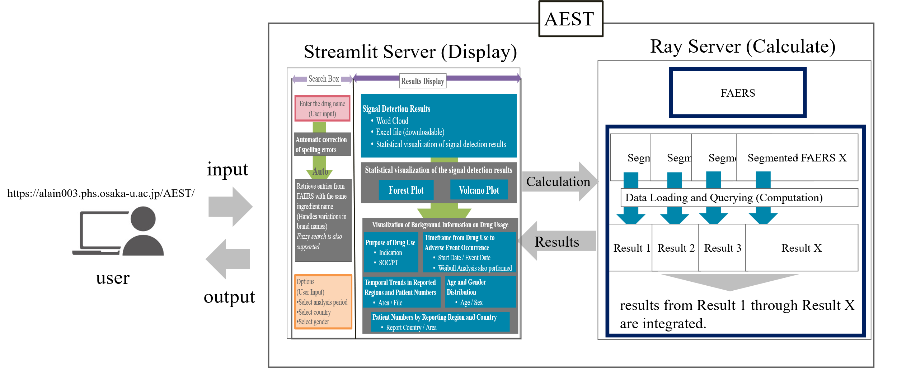
Supplementary Fig. 2. Workflow of AEST, including input handling and visualization via Streamlit, parallel aggregation over segmented data using Ray with integration of intermediate results, and final result presentation.

Drug name search (fuzzy matching) function and evaluation
FAERS contains diverse drug name notations, including generic names, brand names, and abbreviations, and user inputs may contain spelling errors. Consequently, exact string matching alone may lead to insufficient search accuracy⁴. To address this issue, AEST calculates the string similarity between the user input and drug names registered in its internal dictionary using the Jaro–Winkler metric and returns the candidate with the highest similarity score. Because the Jaro–Winkler distance emphasizes matching at the beginning of strings, it is expected to provide robustness against typing errors⁵. This function also maps the user input to internally managed normalized drug names.
To quantitatively evaluate the robustness of this fuzzy-matching approach, simulated typing errors were generated based on the QWERTY keyboard layout using the Keyboard August function from nlpaug⁶ for all 5,721 compound names available for signal detection in the AEST. The character error rate (aug_char_p) was varied from 0% to 50% in 5% increments, and the matching rate after the search was calculated for each condition, with augmentation applied to all strings (min_char = 1). All other parameters were set to their default values.
The results showed that when aug_char_p was 0.25 or less, the average matching rate remained around 90% (Supplementary Fig. 3). However, when aug_char_p exceeded 0.3, the matching rate declined significantly, reaching 36.7% at 0.5. This decline was particularly pronounced for drugs with relatively short string lengths (generally less than 15 characters).
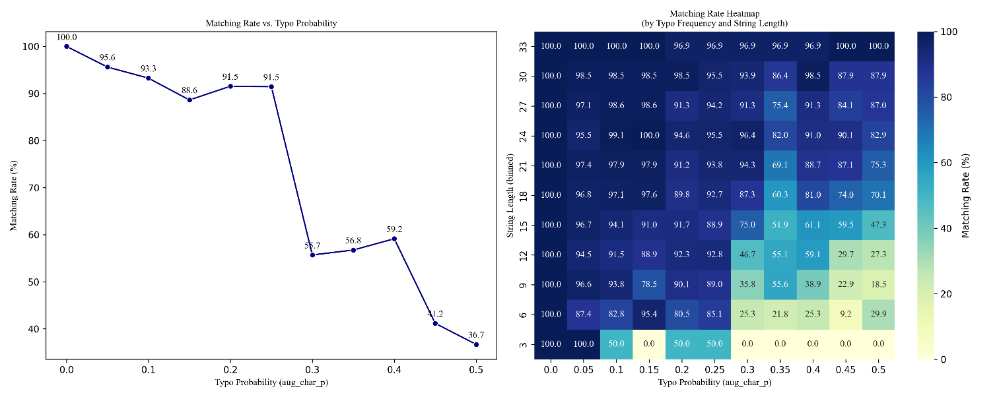

Supplementary Fig. 3. Matching rate according to typo probability and string length.
a) Line plot showing the decrease in matching rate as typo probability increases.
b) Heatmap illustrating matching rates by typo frequency and string length. Matching accuracy remains high for low typo probabilities, while shorter strings and higher typo probabilities result in decreased matching performance.

User interface
The AEST automatically executes signal detection and visualization of the results upon drug name input (Supplementary Fig. 4). The drug name input incorporates fuzzy matching based on the Jaro–Winkler distance to accommodate typing errors and other input inconsistencies. The analysis outputs included signal detection results and background information visualized through graphs, such as drug usage patterns, time-to-onset distributions, and patient demographic characteristics. Users can also flexibly configure analysis conditions, including the time period, country, and age group, through graphical user interface operations.
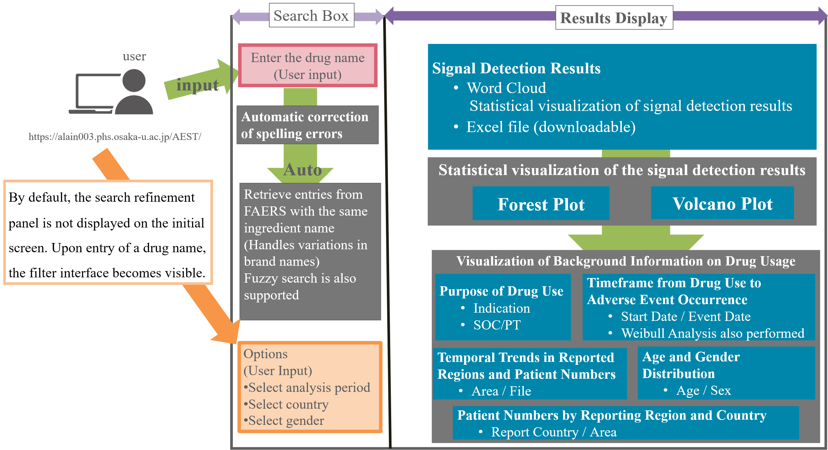
Supplementary Fig. 4. Overview of the AEST interface. The AEST integrates automated spelling correction, brand name harmonization, and an interactive search panel triggered by drug name inputs. It generates word clouds, statistical plots (forest and volcano plots), and detailed summaries of drug usage patterns, time-to-onset profiles, and patient demographics to support in-depth pharmacovigilance analysis.

Distributed processing and performance evaluation
Given the high computational cost associated with the FAERS analysis, AEST employs distributed parallel processing using Ray. The FAERS data were divided into multiple segments and each segment was asynchronously aggregated as an independent task. A performance evaluation was conducted in an environment with 20 vCPUs and 30 GiB of memory.
First, the processing time for signal detection was evaluated for all 5,721 compounds available for analysis. The average processing time was 6 s (SD = 5), with individual calculations ranging from 2 s to 21 s. (Supplementary Fig. 5). The processing time tended to increase for compounds associated with a larger number of reports or multiple name variants, such as the coexistence of generic and brand names.
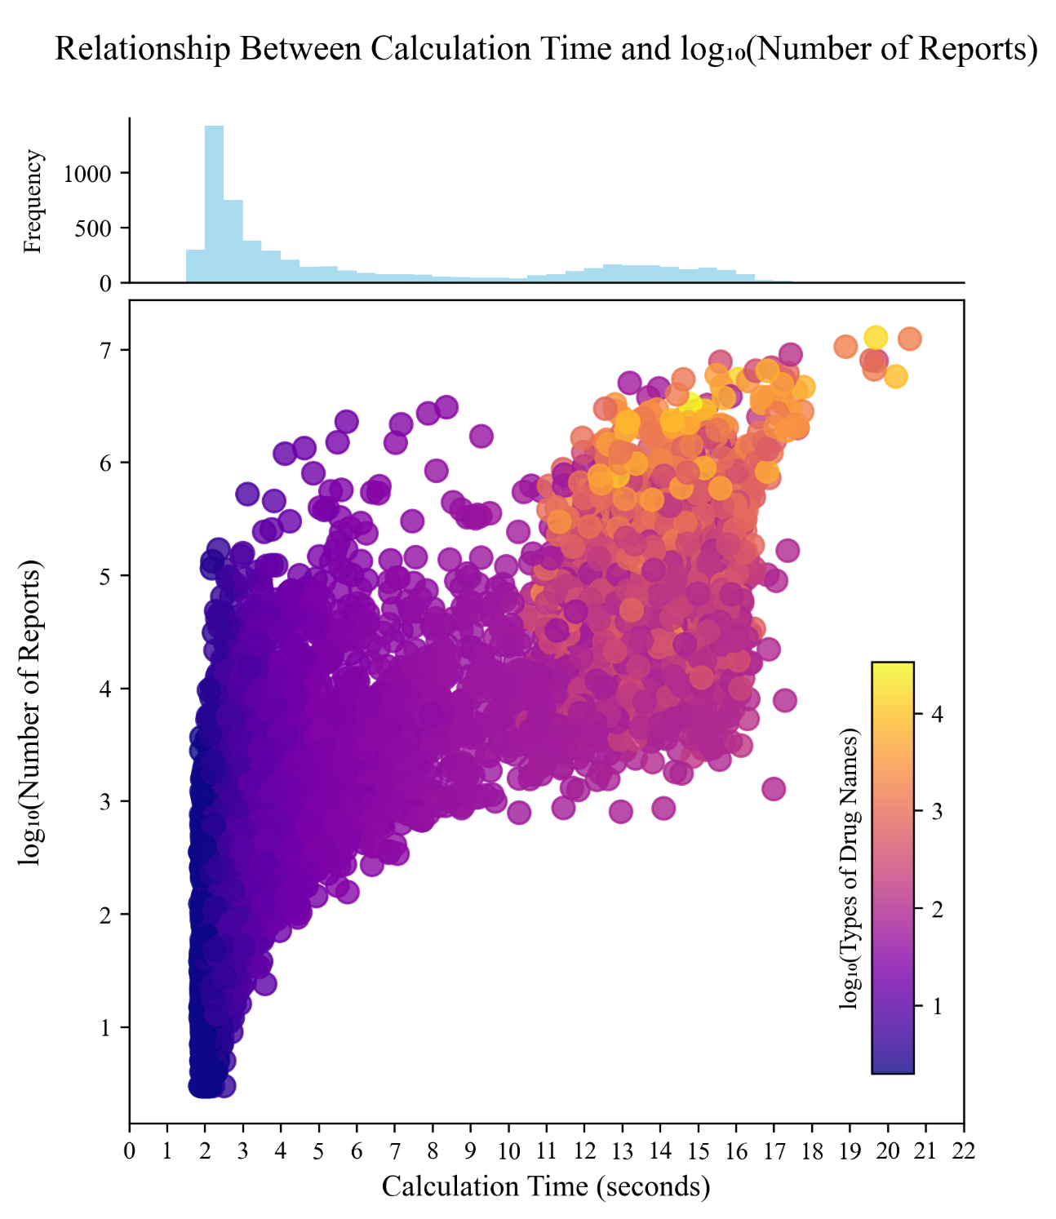
Supplementary Fig. 5. Relationship between calculation time and log₁₀ (number of reports). Scatter plot showing the correlation between computation time (x-axis) and the logarithmic number of reports analyzed (y-axis), with points colored by log₁₀ (types of drug names). The histogram at the top shows the frequency distribution of the calculation times. The plot demonstrates that computation time increases with the number of reports and that drug name diversity also influences calculation complexity.

Next, load testing was conducted to assess the tolerance to concurrent access. Search requests were issued via automated browser operations using Playwright⁷, and the number of parallel threads was increased stepwise to 1, 6, 12, and 24. The evaluation metrics included the response time until completion of signal detection and background information visualization as well as the error rate for failed responses.
During load testing, AEST successfully generated background information for 5,693 of the 5,721 compounds (99.5%). The concurrent access response times were evaluated using these 5,693 compounds (Supplementary Fig. 6). Under single-thread conditions, the 95th and 99th percentile response times were approximately 34 and 76 s, respectively. As the number of parallel threads increased, the response times increased, and a small proportion of requests remained unresolved. For six parallel threads, the 95th percentile response time was approximately 131 s, with no unresolved requests observed. At 12 threads, the 95th percentile increased to approximately 252 s, with unresolved requests accounting for 0.4% of the cases (23/5,693). At the highest concurrency level (24 threads), the 95th percentile response time reached approximately 450 s, the 99th percentile approached 548 s, and the proportion of unresolved requests increased to 1.5% (85/5,693).

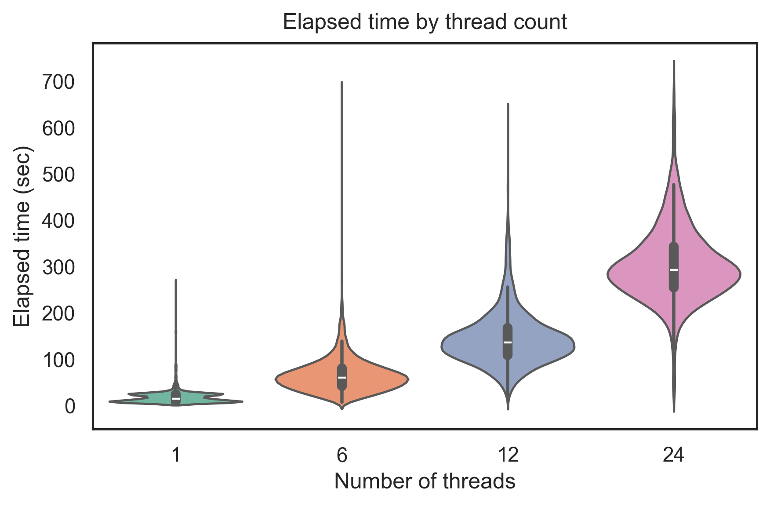
Supplementary Fig. 6. Distribution of elapsed time by number of threads. Violin plots display the distribution of elapsed processing times (seconds) for different numbers of threads (1, 6, 12, and 24). The results show that increasing the number of threads tends to result in longer processing times.

Public availability, comparison with existing tools, and limitations
The AEST is available online (https://alain003.phs.osaka-u.ac.jp/AEST). The platform can be accessed through any web browser, regardless of the device or operating system, without the need to install dedicated software. The system is designed to automatically reflect the latest FAERS updates, thereby reducing the burden of data and software maintenance on users. User registration and login are not required, and the system does not store search queries or user input information, thereby ensuring the protection of user privacy.
Several FAERS mining platforms, including FDAble, AERS Spider, OpenVigil, and AERSMine, have been reported. However, as of January 2026, differences remain in their operational status and available functionalities (Supplementary Table 6)^{8–11}. AEST is distinguished by its integrated provision of drug name input correction, flexible filtering of analysis conditions, signal detection output, and visualization of related background information within a single interactive web interface.

Supplementary Table 6. Feature comparison between AEST and existing FAERS analysis tools.
Features | FDAble | AERS Spider | OpenVigil 2.0 | AERSMine | AEST  (ours)
FAERS Data Mining | ○ | ○ | ○ | ○ | ○
Drug Name Normalization |  |  |  | ○ | ○
Handling of Drug Name Variations and Typos |  |  |  |  | ○
Signal Detection with Custom Filters |  |  |  |  | ○
Visualization of Signal Detection Results |  |  | ○ |  | ○
Exporting Signal Detection Results |  |  | ○ | ○ | ○
Visualization of Background Data |  |  |  |  | ○
Operational Status (as of Sep 2025) | ○ |  | ○ | ○ | ○
Pricing | $350 | free | free | free | free
URL | https://www.fdable.com/ | http://www.chemoprofiling.org/AERS | https://openvigil.sourceforge.net/ | https://research.cchmc.org/aers/home | https://alain003.phs.osaka-u.ac.jp/AEST

Nevertheless, the AEST has limitations inherent to both FAERS and technical constraints. FAERS is subject to reporting biases, and the detected signals do not directly imply causality; therefore, careful clinical interpretation is required. In addition, the responsibility for the final risk assessment and any clinical application of the results generated by AEST rests solely with the user. The system is intended to be used as a supportive tool for hypothesis generation, rather than as a definitive decision-making system. The direct application of AEST outputs to regulatory decision-making or clinical judgment requires additional evidence and comprehensive evaluation by qualified experts. Furthermore, response delays and increased error rates may occur with high concurrent access rates. However, AEST is designed with distributed parallel processing, which allows performance improvements through the augmentation of computational resources. In this study, performance was evaluated using 20 vCPUs and 30 GiB of memory.
Future work will include further enhancement of the graphical user interface, development of manuals and tutorials, and the provision of specific use cases to support the appropriate interpretation and application of results. Additional efforts will focus on the quantitative evaluation of the contribution of input correction in reducing analysis errors and incorporating user feedback into stepwise system improvements.

Supplementary Note 2. Performance of QSAR Models in Stratified Drug Groups
We conducted an exploratory QSAR analysis to determine whether stratifying drugs according to the proposed safety patterns improved the predictive performance for adverse events. QSAR models were constructed separately for each safety pattern and compared with models trained without stratification to evaluate the changes in classification performance.

Methods
The QSAR performance was evaluated using the benchmark safety dataset curated by Ryan et al¹². This dataset consists of 399 approved drugs (165 positives and 234 negatives) associated with four acute clinical outcomes: acute liver injury (ALI), acute kidney injury (AKI), acute myocardial infarction (AMI), and upper gastrointestinal bleeding (GI bleed).
For each adverse event, independent QSAR models were constructed for compound sets classified as Pattern 1 (information convergence) and Pattern 2 (individual biology–driven risk), with performance benchmarked against size- and ratio-matched random subsets. Patterns 3 (treatment environment) and 4 (hidden risk) were not independently modeled because their small sample sizes limited the feasibility of the QSAR analysis. Two-dimensional molecular descriptors calculated using Mordreds were employed as explanatory variables consistent with those used in this analysis. Random Forest classifiers were used as the learning algorithms with a maximum tree depth of 8. Class weights were adjusted to account for class imbalance.
The predictive performance was evaluated using stratified five-fold cross-validation, which was repeated five times, and the mean area under the receiver operating characteristic curve (AUC) was calculated for each condition. To assess whether the observed performance improvements were attributable to pattern-based stratification, null distributions were constructed based on random sampling that ignored pattern information. Specifically, random compound sets preserving the original sample sizes and positive-to-negative ratios were generated and the same QSAR modeling procedure was applied.
Differences in the AUC between the pattern-stratified models and corresponding random baselines were evaluated using a randomization test with 999 iterations to estimate the empirical p-values. To account for multiple testing across patterns within each adverse event, p-values were adjusted using the Benjamini–Hochberg procedure. Given the exploratory nature of this analysis, a false discovery rate (q) threshold of 0.10 was adopted.

Results and Discussion
When the predictive performance (AUC) of the QSAR models trained on pattern-stratified compound sets was compared with the null distributions derived from random sampling of equal size, significant improvements in classification performance were observed for three of the four adverse events examined (Supplementary Table 7).
Specifically, for AKI and AMI, compounds classified as Pattern 1 showed higher predictive performance, with mean AUC values of 0.92 (Δ = 0.17) and 0.77 (Δ = 0.25), respectively. In contrast, for GI bleeding, the highest predictive performance was observed for compounds classified as Pattern 2, with a mean AUC of 0.91 (Δ = 0.22).
For these three conditions (AKI Pattern 1, AMI Pattern 1, and GI bleeding pattern 2), the unadjusted p-values were approximately 0.03, and the corresponding Benjamini–Hochberg–adjusted q-values were 0.09. All values were below the predefined exploratory significance threshold (q < 0.10), indicating that QSAR models trained on selected safety-pattern–stratified compound sets tended to achieve improved predictive performance compared with models trained without stratification.
The observed increase in AUC following pattern-based stratification suggests that separating drugs according to shared safety characteristics may reduce noise arising from a mixture of heterogeneous mechanisms of action and toxicity, thereby improving the QSAR model performance. In particular, the strong performance observed for pattern 1 compounds against AKI and AMI supports the hypothesis that these drug groups share relatively consistent structural features and physicochemical properties associated with their toxicity profiles. These characteristics may be useful in identifying high-risk compounds in the early stages of drug discovery.
In contrast, for GI bleeding, a marked improvement in predictive performance was observed only for compounds classified as pattern 2. Although GI bleeding is generally considered a clinically heterogeneous outcome and is difficult to predict, this result suggests that within specific subsets of drugs associated with individual biology–driven risks, common structural features reflecting more predictable biological pathways may remain detectable. This finding highlights the importance of evaluating the effectiveness of stratification on an AE-specific basis.
In comparison, no significant improvement in predictive performance was observed for acute liver injury (ALI) in either pattern. This may reflect the complex and multifactorial nature of ALI, which may not have been adequately captured by a single pattern-based stratification scheme. Additionally, the relatively limited sample size available for this outcome may have resulted in insufficient statistical power to detect subtle effects.
Nevertheless, the observation that pattern-based stratification improved the predictive performance for three of the four major adverse events examined supports the utility of the proposed safety-pattern framework. By focusing on groups of compounds with shared safety characteristics, this approach may enable the construction of more robust and interpretable QSAR models, and providing a foundation for more precise toxicity assessments.

Supplementary Table 7. QSAR performance in pattern-stratified subsets and matched random baselines.
Algorithm | Outcome | Pattern | Nª | n_{pos} | Observed AUC | Random-baseline AUC | Δ AUC | Empirical p-value | BH-adjusted q-value
Random forest | Acute kidney injury | Pattern 1 | 29 | 8 | 0.9235 | 0.7489 | 0.1746 | 0.032 | 0.088
Random forest | Acute kidney injury | Pattern 2 | 32 | 9 | 0.6565 | 0.7619 | -0.1054 | 0.891 | 1.000
Random forest | Acute liver injury | Pattern 1 | 41 | 30 | 0.6150 | 0.6404 | -0.0254 | 0.610 | 0.8307
Random forest | Acute liver injury | Pattern 2 | 39 | 31 | 0.1264 | 0.6310 | -0.5046 | 1.000 | 1.000
Random forest | Acute myocardial infarction | Pattern 1 | 31 | 11 | 0.7667 | 0.5202 | 0.2465 | 0.031 | 0.088
Random forest | Acute myocardial infarction | Pattern 2 | 35 | 15 | 0.5500 | 0.5413 | 0.0087 | 0.466 | 0.8307
Random forest | Upper gastrointestinal bleeding | Pattern 1 | 34 | 9 | 0.6580 | 0.6909 | -0.0329 | 0.623 | 0.8307
Random forest | Upper gastrointestinal bleeding | Pattern 2 | 26 | 9 | 0.9083 | 0.6844 | 0.2239 | 0.033 | 0.088
ªN denotes the number of compounds in each pattern-defined subset and n_{pos} denotes the number of positive compounds. “Random-baseline AUC (pooled)” indicates the mean AUC from randomly sampled compound sets matched for N and class balance.ΔAUC was calculated as observed AUC minus pooled random-baseline AUC. Empirical p-values were obtained from a permutation test with 999 iterations, and q-values were adjusted using the Benjamini–Hochberg procedure.

Supplementary Note 3. Efficiency of Pattern-Based Candidate Stratification for Literature-Supported Drug Repositioning
Drug repositioning (DR) is a promising approach in drug development, but evaluating all approved drugs is impractical due to time and resource constraints. Therefore, it is important to identify subsets of drugs for prioritized evaluation. Candidate groups can be prioritized if they show both broad coverage of therapeutic areas and hit rates comparable to or higher than the overall set.
We assessed approved drug groups using two metrics: the diversity of disease areas indicated in the literature and the hit rate derived from literature-supported drug repositioning (DR) evidence. Using an established four-pattern risk framework, we classified approved drugs and focused our analysis on Pattern 2, which may reflect host-related biological influences. The performance of this group was then compared with that of the non-stratified global drug set.

Methods
The analysis used the Literature module of DrugRepoBank,¹³ a curated database comprising drugs with experimentally or analytically supported evidence for drug repositioning. The reference dataset comprised 169 drugs reported in 134 publications. Drug names were normalized and assigned to one of four risk patterns. For each DR case, the associated disease area was classified using the first-level anatomical therapeutic chemical (ATC) code.
Therapeutic breadth was quantified by counting the number of distinct ATC classes covered by Pattern 2 drugs and comparing this coverage with that of the full dataset. Statistical significance was evaluated using a hypergeometric test to determine whether the observed coverage exceeded that expected by chance, given the size of the global drug set.
As a secondary analysis, hit rates were evaluated. Let n denote the number of drugs in each set and z the number with literature-supported DR evidence. The hit rate was modeled as a Bernoulli probability parameter θ. Assuming a Beta prior distribution,
$$θ∼Beta(α_{\text{prior}},β_{\text{prior}}),$$
the posterior distribution after observing the data is given by
$$θ∣\text{data}∼Beta(α_{\text{prior}}+z, β_{\text{prior}}+n-z).$$
To assess sensitivity to prior assumptions, four priors were examined: a uniform prior, Jeffreys prior, a weakly informative prior, and a skeptical prior. Posterior distributions were estimated using 1,000,000 Monte Carlo samples. From these distributions, the posterior probability that the Pattern 2 hit rate exceeded the global hit rate was calculated, along with the posterior distribution of the hit-rate ratio $θ_{\text{Pattern2}}/θ_{\text{Global}}$.

Results
Across the full dataset, 93 drugs were associated with DR evidence spanning 8 distinct ATC classes. Although Pattern 2 accounted for only 41% (30/74) of all drugs with reported DR evidence, it covered 75% (6/8) of the observed therapeutic classes. This degree of coverage was significantly greater than expected by chance (p = 0.035, hypergeometric test).

The hit rate of literature-supported DR for the global drug set was 8.46% (74/875), compared with 8.93% (30/336) for Pattern 2 (Supplementary Table 8). Bayesian analysis indicated that the posterior probability of the Pattern 2 hit rate exceeding the global rate ranged from 0.61 to 0.73 across all prior specifications. Although the 95% credible interval of the hit-rate ratio (posterior mean 1.09–1.15) included unity, both the direction and magnitude of the effect were consistent across prior assumptions.

Discussion
Pattern 2 represents a subset of approved drugs, yet it captures a substantial portion of the therapeutic diversity highlighted in literature-reported drug repositioning cases. This suggests that drugs identified through such a pattern are likely to include a relatively high proportion of candidates with repositioning potential, making Pattern 2 a practical starting point for prioritization in early-stage DR, especially when resources are limited. From a resource-allocation perspective, this finding suggests that restricting initial DR screening to Pattern 2 may reduce the number of candidate drugs while largely preserving therapeutic coverage, potentially improving search efficiency without markedly compromising domain diversity.
Importantly, this pattern-based stratification does not compromise the hit rate. Across all prior assumptions, the hit rate for Pattern 2 was consistently or slightly higher than that of the global drug set. Although this analysis is constrained by its reliance on curated literature and coarse disease classification based on first-level ATC codes, it provides exploratory support for the potential use of pattern-guided prioritization in early-stage DR research.

Supplementary Table 8. Prior sensitivity analysis of Bayesian comparison between Pattern 2 and the global drug set
Prior distribution | Posterior probability that Pattern 2 outperforms the global set, P (ªp₂ > ^{b}p_{all}) | Posterior mean of hit-rate ratio, E [p₂ / p_{all}] | 95% credible interval (p₂ / p_{all})
Uniform Beta (1,1) | 0.624 | 1.086 | 0.704–1.574
Jeffreys Beta (0.5,0.5) | 0.609 | 1.078 | 0.696–1.565
Weak Beta (2,2) | 0.653 | 1.102 | 0.719–1.590
Skeptical Beta (5,5) | 0.732 | 1.146 | 0.762–1.632
ª p₂ ,Pattern 2; ^{b} p_{all}, global (unstratified) drug set.

Supplementary Note 4. Considerations for Interpretation and Practical Use
The AEST platform and the associated framework analyses are intended to support hypothesis generation regarding drug–adverse event relationships and the broader structure–side effect landscape. Simultaneously, several aspects related to data sources, representation choices, and validation strategies should be considered when interpreting the observed patterns and when applying the system in practice.
First, as the FAERS is a spontaneous reporting database, the signals identified in this study should be interpreted as statistical associations rather than direct evidence of causality. Even when disproportionality metrics indicate elevated reporting, residual confounders owing to concomitant medications, comorbidities, disease severity, and other patient-level factors may persist. This consideration is particularly important in settings where reported adverse events may overlap with the natural clinical course of the treated condition itself and may also contribute to an apparently higher divergence in therapeutic areas characterized by complex symptoms and reporting behaviors, such as neurological and psychiatric disorders.
Second, clinical and prescription contexts can shape safety profiles in ways that are not fully captured by chemical structure similarity alone. Indication bias and prescription patterns may differ substantially even within the same therapeutic class; for example, when later-line therapies are preferentially prescribed to patients with more severe or treatment-resistant diseases. Consequently, when structurally similar drugs exhibit different adverse event profiles, these differences may reflect not only intrinsic pharmacological properties, but also systematic differences in patient populations and treatment contexts.
Third, the generalizability across regions should be approached with caution. The FAERS is largely centered on the United States, and reporting practices, healthcare systems, and population characteristics vary internationally. In addition, population-level differences in the prevalence of functional polymorphisms in drug-metabolizing enzymes, such as CYP2C19 and CYP2D6, may further influence drug exposure and the risk of adverse events. Extending this analytical framework to additional pharmacovigilance resources, including JADER, EudraVigilance, and VigiBase, is important for assessing the consistency and robustness of the observed patterns across settings.
From a methodological perspective, dimensionality reduction provides an interpretable representation of high-dimensional data but inevitably involves information compression. The trustworthiness of the two-dimensional projections indicates that local neighborhood relationships are not perfectly preserved, and the interpretation of relative distances, particularly for drugs located near apparent boundaries in the embedded space, should therefore remain conservative. Future studies may explore alternative embedding strategies or parameterizations that better balance interpretability while preserving the local structure.

In addition, the use of two-dimensional chemical descriptors enables broad compound coverage and computational scalability, but does not capture stereochemistry, conformational flexibility, or dynamic molecular behavior that may be relevant to toxicity. Accordingly, some instances of structure–side effect divergence may reflect limitations of representation rather than true biological dissociation, motivating the future integration of three-dimensional descriptors or complementary molecular representations where feasible.
Finally, external benchmarking of label-derived resources require careful framing. Although OnSIDES provides standardized mappings based on regulatory documents, it does not necessarily reflect the full reasoning underlying regulatory decisions, nor does it always capture the most up-to-date labeling information. Therefore, limited concordance with label-derived references should not be interpreted solely as a high false positive rate; it may also reflect the identification of emerging, incompletely characterized, or context-dependent risks.
More broadly, AEST is positioned as a hypothesis generation tool for drug safety research and pharmaceutical development. Its outputs should be interpreted independent of regulatory decision-making processes and spontaneous reporting systems, and any clinical or regulatory conclusions should be drawn in conjunction with expert reviews and additional lines of evidence.
Supplementary References
1. FDA Adverse Event Reporting System (FAERS): Latest Quarterly Data Files. FDA (2019) https://www.fda.gov/drugs/fdas-adverse-event-reporting-system-faers/fda-adverse-event-reporting-system-faers-latest-quarterly-data-files.
2. Streamlit • A faster way to build and share data apps. (2021) https://streamlit.io/.
3. Moritz, P. et al. Ray: a distributed framework for emerging AI applications. in Proceedings of the 13th USENIX conference on Operating Systems Design and Implementation 561–577 (USENIX Association, USA, 2018).
4. Senger, C., Kaltschmidt, J., Schmitt, S. P. W., Pruszydlo, M. G. & Haefeli, W. E. Misspellings in drug information system queries: characteristics of drug name spelling errors and strategies for their prevention. Int J Med Inform 79, 832–839 (2010) https://doi.org/10.1016/j.ijmedinf.2010.09.005.
5. Waruru, A. et al. Where No Universal Health Care Identifier Exists: Comparison and Determination of the Utility of Score-Based Persons Matching Algorithms Using Demographic Data. JMIR Public Health and Surveillance 4, e10436 (2018) https://doi.org/10.2196/10436.
6. Ma, E. makcedward/nlpaug. (2026).
7. Fast and reliable end-to-end testing for modern web apps | Playwright. https://playwright.dev/.
8. Search FDA FAERS and MAUDE databases (drug and medical-device adverse events). https://www.fdable.com/.
9. Grigoriev, I., zu Castell, W., Tsvetkov, P. & Antonov, A. V. AERS spider: an online interactive tool to mine statistical associations in Adverse Event Reporting System. Pharmacoepidemiology and Drug Safety 23, 795–801 (2014) https://doi.org/10.1002/pds.3561.
10. Böhm, R. et al. OpenVigil FDA - Inspection of U.S. American Adverse Drug Events Pharmacovigilance Data and Novel Clinical Applications. PLoS One 11, e0157753 (2016) https://doi.org/10.1371/journal.pone.0157753.
11. Sarangdhar, M. et al. Data mining differential clinical outcomes associated with drug regimens using adverse event reporting data. Nat Biotechnol 34, 697–700 (2016) https://doi.org/10.1038/nbt.3623.
12. Ryan, P. B. et al. Defining a reference set to support methodological research in drug safety. Drug Saf 36 Suppl 1, S33-47 (2013) https://doi.org/10.1007/s40264-013-0097-8.
13. Huang, Y. et al. DrugRepoBank: a comprehensive database and discovery platform for accelerating drug repositioning. Database (Oxford) 2024, baae051 (2024) https://doi.org/10.1093/database/baae051.

