Supplemental figure 1
PRISMA flow diagram
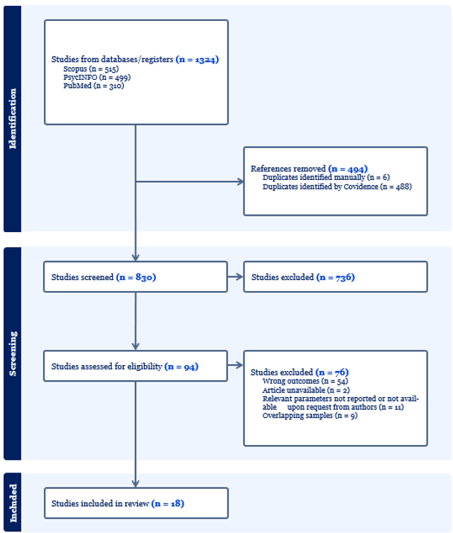

Supplemental table 1
Study overview
Author (year) | Patient population | Therapist backgroundª | CBT therapists or novices | Rater backgroundª | Rating material | Interrater reliability^{c} | Quality score (0-7) | Quality classification^{b}
Goldberg et al. (2020) | Not reported | Master-level therapists (90.1%), PhD/PsyD (4%), MD (2.8%), bachelor-level therapists (3.1%) | CBT therapists | Doctoral-level CBT experts | Audio | ICC = .84 | 4 | Medium quality
Karlin et al. (2019) | Depression | Doctoral-level psychologists 66.7%, master's-level social workers 33.3% | Both | Expert CBT training consultant | Audio | Not reported | 3 | Low quality
Karlin et al. (2012) | Veterans with depression | Social workers (51%), psychologists (41%), nurses (5%), psychiatrists (3%) | Both | CBT experts | Audio | Not reported | 3 | Low quality
Crits-Cristoph et al. (2021) | Depression | Master's degree or above | CBT therapists | Graduate students in clinical psychology | Audio | ICC = .87 | 5 | High quality
Lopez et al. (2011) | Depression | Master's degree or above | CBT therapists | Clinical psychologists | Audio | ICC = .83 | 5 | High quality
Bryant et al. (1991) | Depression | Two doctoral-level clinical psychologists, two master's level psychiatric nurses | CBT therapists | Doctoral candidate in clinical psychology | Audio and video | Not reported | 4 | Medium quality
Rollinson et al. (2008) | Non-affective psychosis | Clinical psychologists and therapists | CBT therapists | Doctoral clinical psychologists | Audio | Not reported | 4 | Medium quality
Serfaty et al. (2009) | Depression in older adults | Accredited therapists | CBT therapists | Accredited therapists | Audio | Not reported | 3 | Low quality
Strunk et al. (2010) | Depression | Five licensed doctoral-level psychologists, one psychiatric nurse | CBT therapists | Doctoral-level researchers | Video | ICC = .77 | 6 | High quality
Westra et al. (2012) | General axienty disorder | Psychologists | CBT therapists | Four graduate students in clinical psychology | Video | ICC = .78 | 6 | High quality
Williams et al. (1991) | Not reported | Psychologists | Both | Doctoral-level researchers | Audio | r = .992 | 2 | Low quality
Yew et al. (2021) | Depression | Therapists | CBT therapists | Doctoral level psychology researcher-practitioners | Audio | r = 0.92 - 0.95 | 5 | High quality
Rozek et al. (2018) | Depression or anxiety | Trainee therapists | CBT novices | One doctoral student and two bachelor students. | Video | Not reported | 6 | High quality
Shah et al. (2013) | Low quality of life in older adults | Licensed clinical social workers | CBT therapists | Doctoral students | Audio | r = .92 | 5 | High quality
Rashkovic (2016)^{d} | Patients in clinical practice | Psychologists (80%)  Psychiatrists (8%)  Psychiatrists/psychotherapists (12%) | CBT therapists | Doctoral-level researchers | Audio | ICC = .85 | 4 | Medium quality
Rashkovic (2016) | Patients in clinical practice |  | CBT therapists | Doctoral-level researchers | Audio | ICC = .85 | 3 | Low quality
Rashkovic (2016) | Patients in clinical practice |  | CBT novices | Doctoral-level researchers | Audio | ICC = .85 | 4 | Medium quality
McManus et al. (2010) | Anxiety or depression | Clinical psychologists (52.2%)  Nurses (20.1%)  Psychiatrists (11.9%)  Counsellors (5.0%)  Other (7.9%) | Both | Doctoral-level CBT experts | Audio or video | ICC = .47 | 2 | Low quality
Shaw et al. (1999) | Depression | Six psychologists, two psychiatrists | CBT therapists | Doctoral-level CBT experts | Audio | Not reported | 4 | Medium quality
Notes. a) Information on therapist and rater backgrounds is reported verbatim. b) Study quality was classified as low, medium, or high using quartiles, which defined the medium-quality category: low quality ≤ 3; medium quality = 4; high quality ≥ 5. c) If more than one interrater reliability score was reported in a record, the score for CBT therapists (i.e., therapists with CBT training or experience) is reported here. d) Each row for Rashkovic et al. (2016) represents distinct therapist groups reported in the record, with row one and two representing distinct experimental conditions, and row three representing the total sample before CBT training.

