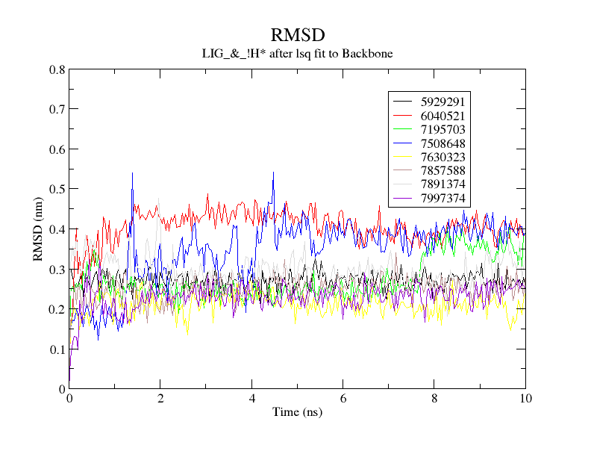
Fig. S1: Ligand RMSD of compounds selected by secondary screening

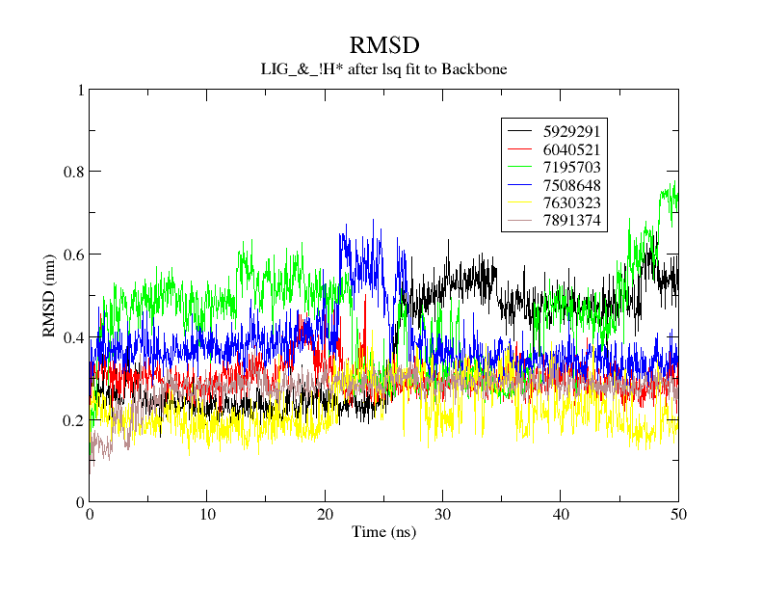
Fig. S2: Ligand RMSD of compounds selected by tertiary screening

Table S1: Mean binding free energy (ΔG_{mean}) and max binding free energy (ΔG_{max}) of each compound (kcal/mol)
ID | ΔG_{mean} | ΔG_{max}
7891374 | -12.95 | -0.62
5929291 | -18.25 | 4.86
6040521 | 0.57 | 16.61
7195703 | -14.20 | -1.13
7630323 | -9.18 | 8.9
7508648 | -5.49 | 10.95

Table S2: Average ligand RMSD (nm) of final candidate compounds
ID | run 1 | run 2 | run 3
7891374 | 0.2733 | 1.3792 | 0.7193
7195703 | 0.3665 | 0.4711 | 0.2507

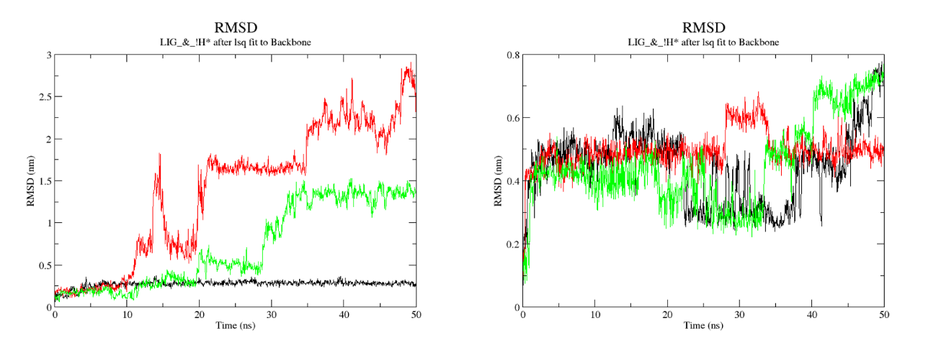
Fig. S3: Average ligand RMSD of 7891374 (left) and 7195703 (right)

Table S3: Selected compounds
name | ID | IUPAC
Compound 1 | 7195703 | N-(3-chloro-4-methoxyphenyl)-2-  [(5-methoxy-1H-benzimidazol-2-  yl)thio]acetamide

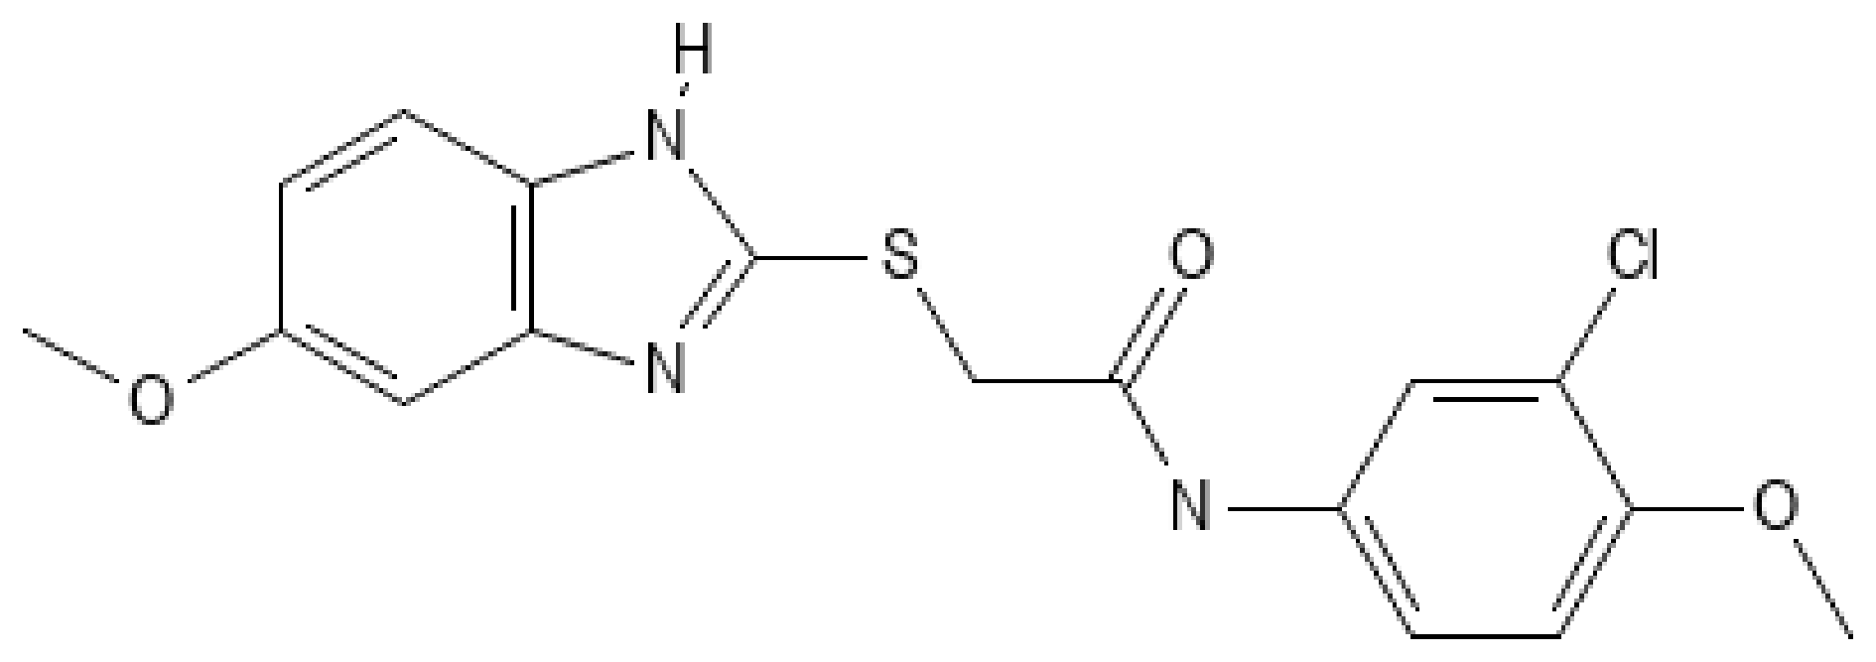
Fig. S4: Structure of Compound 1

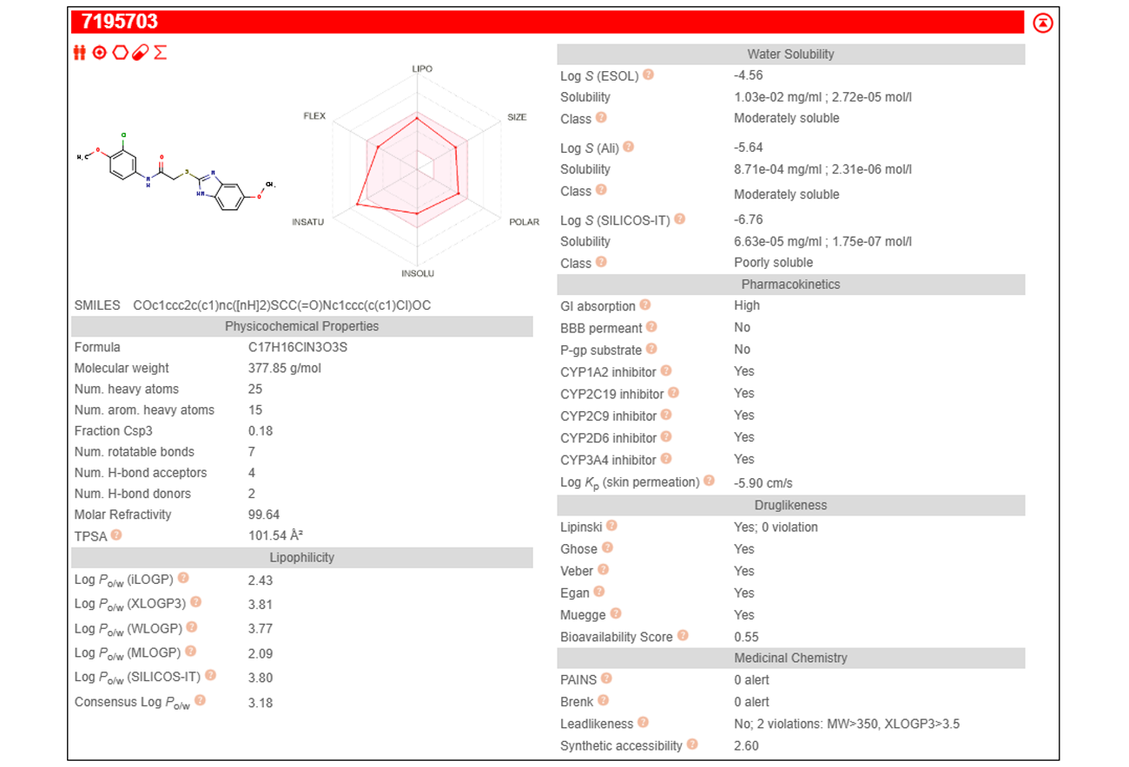
Fig. S5: Drug-likeness analysis of 7195703

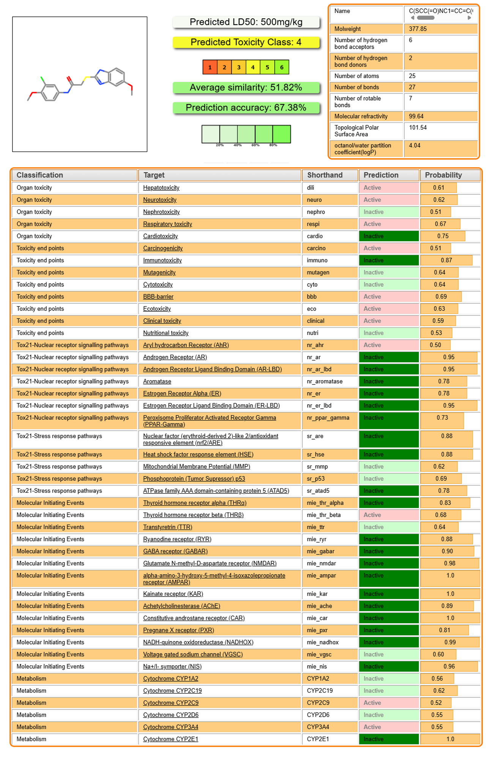
Fig. S6: Toxicity Prediction of 7195703
Table S4: Chemical Structures of 7195703 Analogues
PubChem CID | Structure
135476455 | 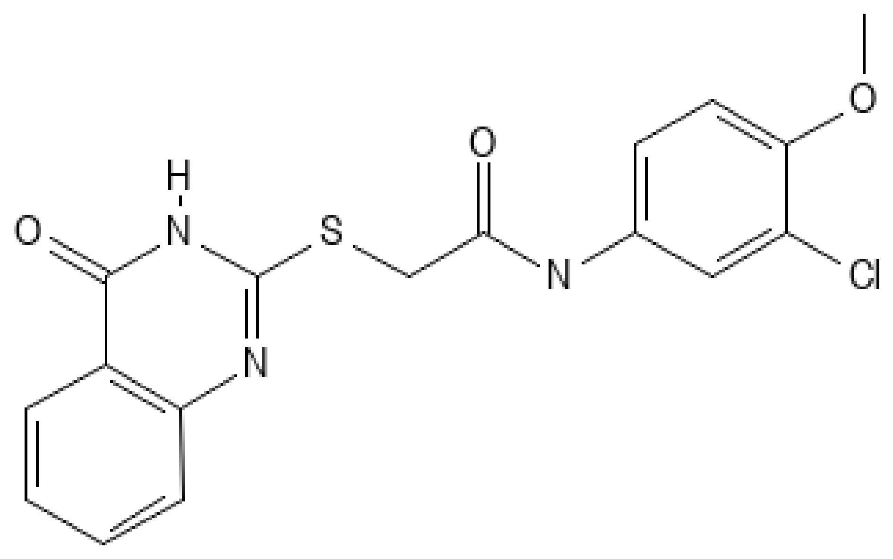
2166318 | 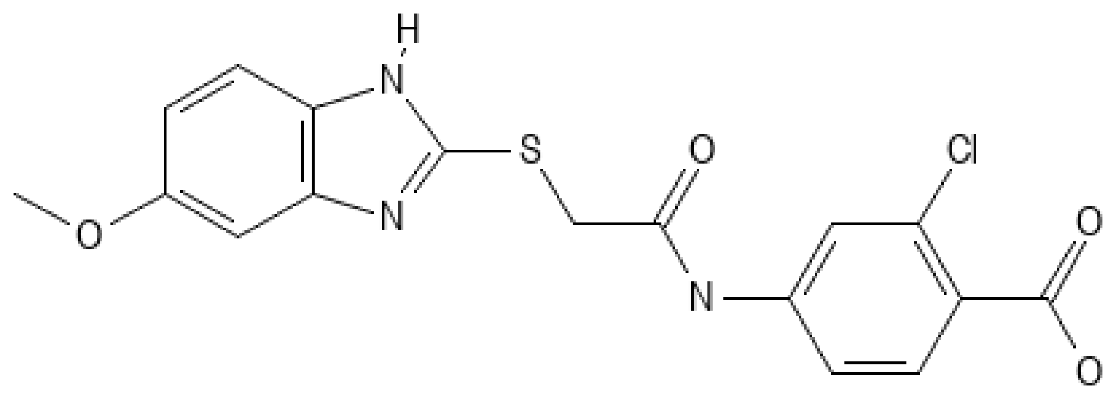
2987305 | 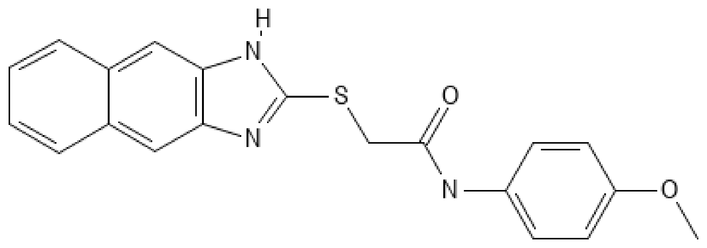
2274941 | 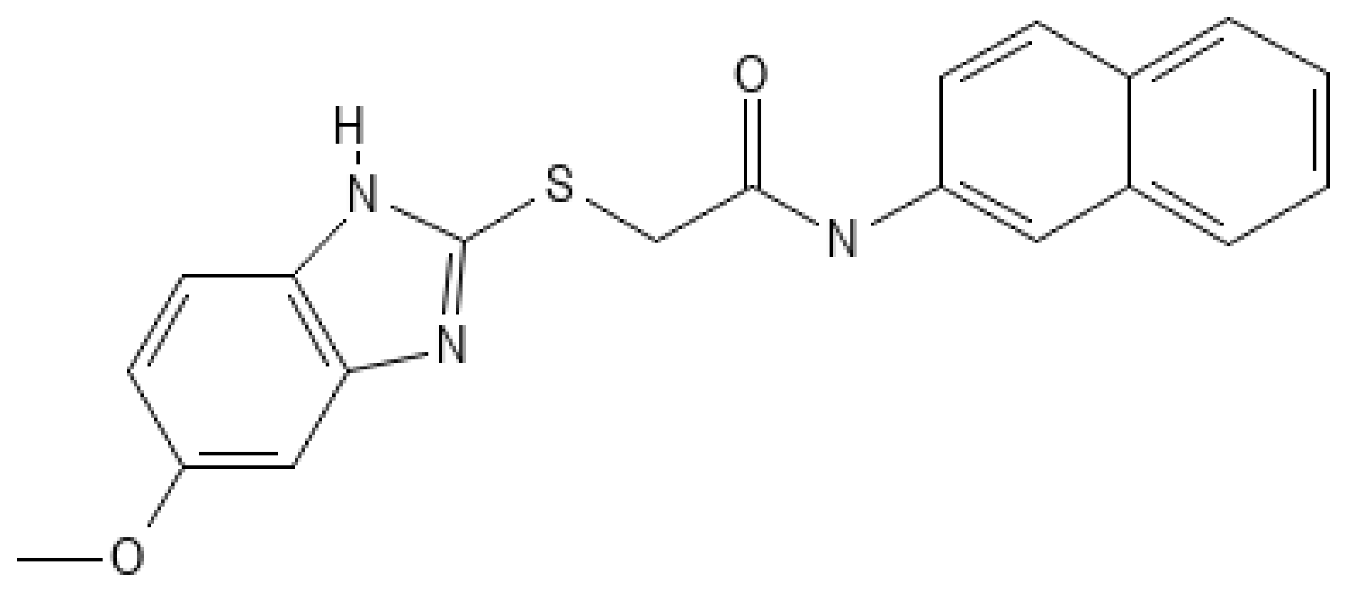
2302155 | 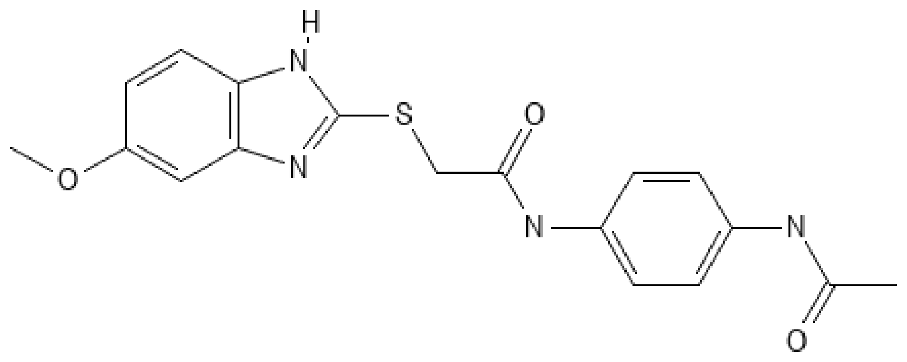

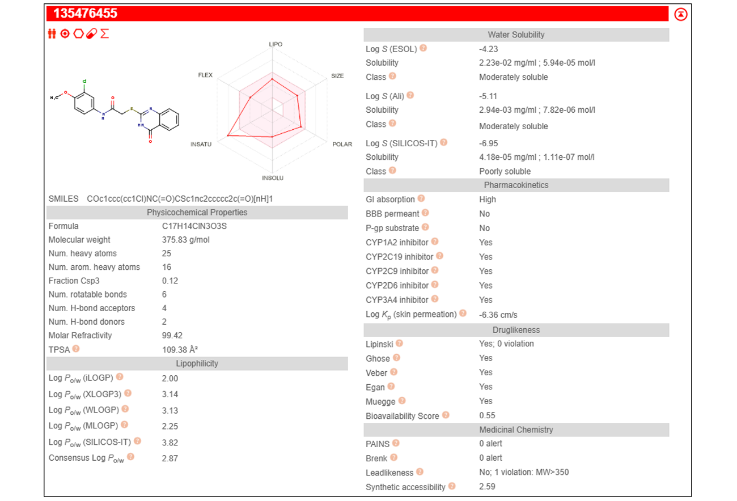
Fig. S7: Drug-likeness analysis of 135476455

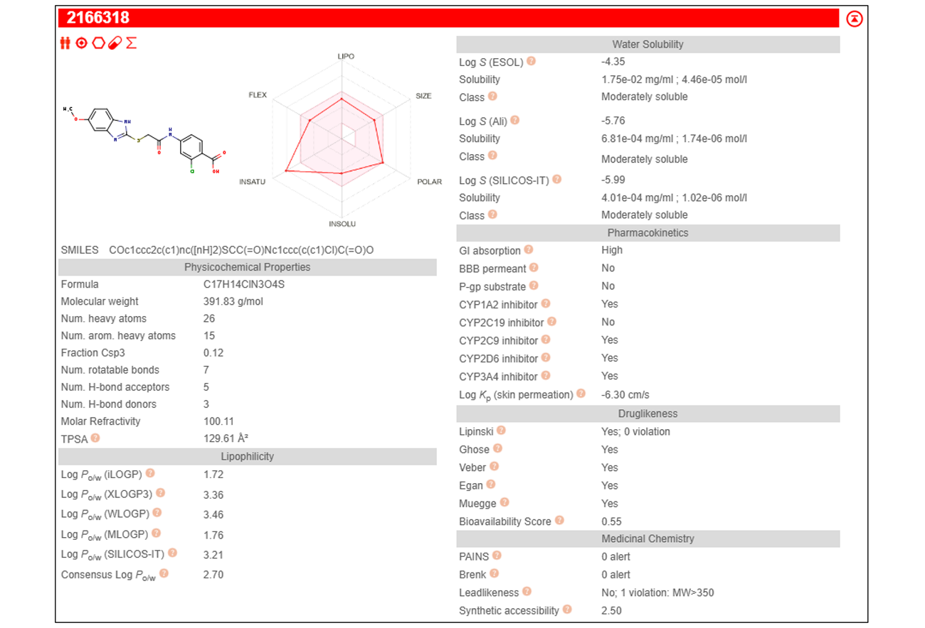
Fig. S8: Drug-likeness analysis of 2166318

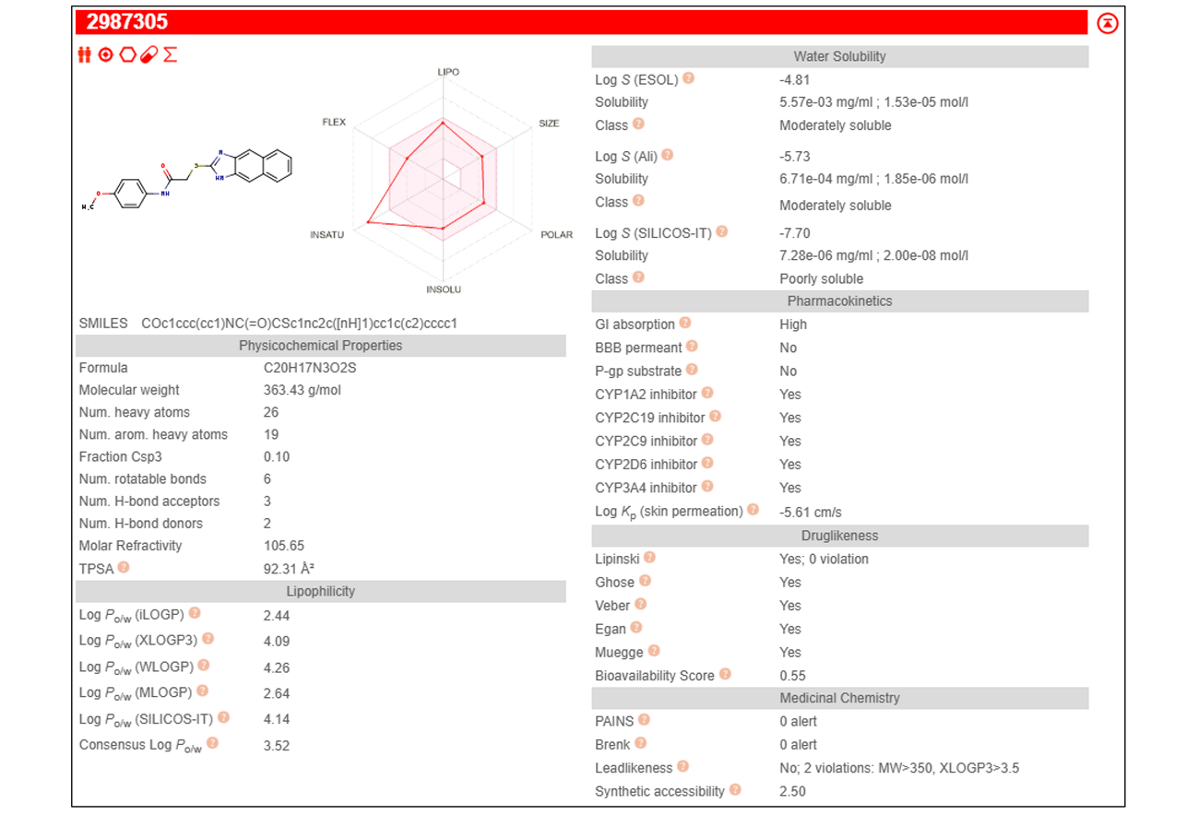
Fig. S9: Drug-likeness analysis of 2987305

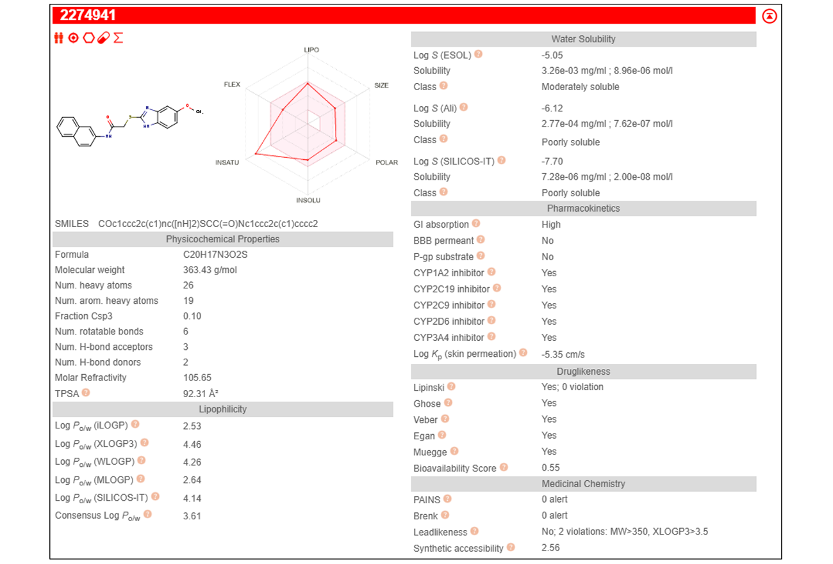
Fig. S10: Drug-likeness analysis of 2274941

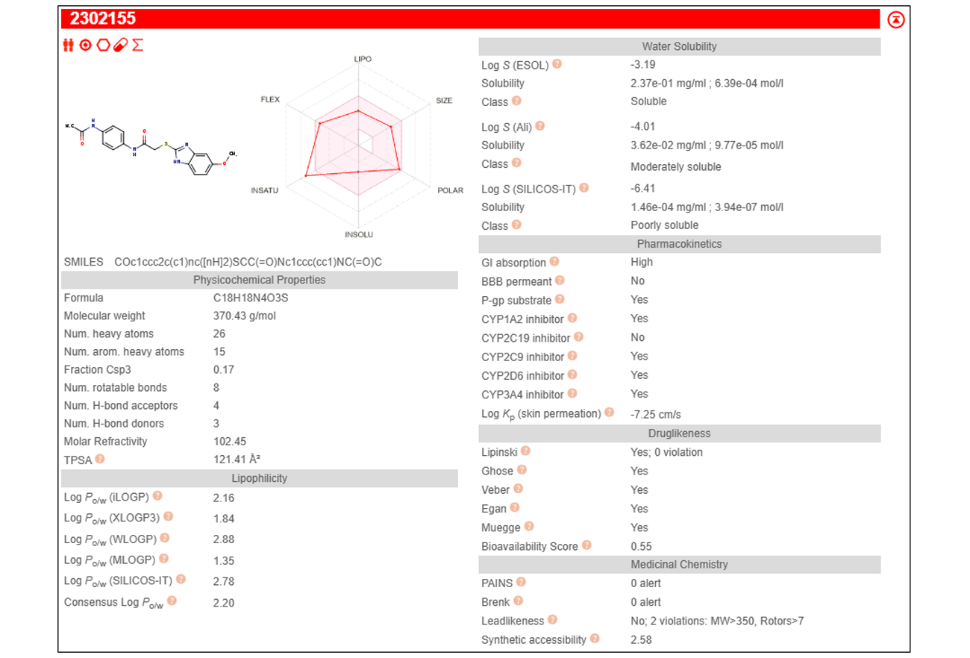
Fig. S11: Drug-likeness analysis of 2302155

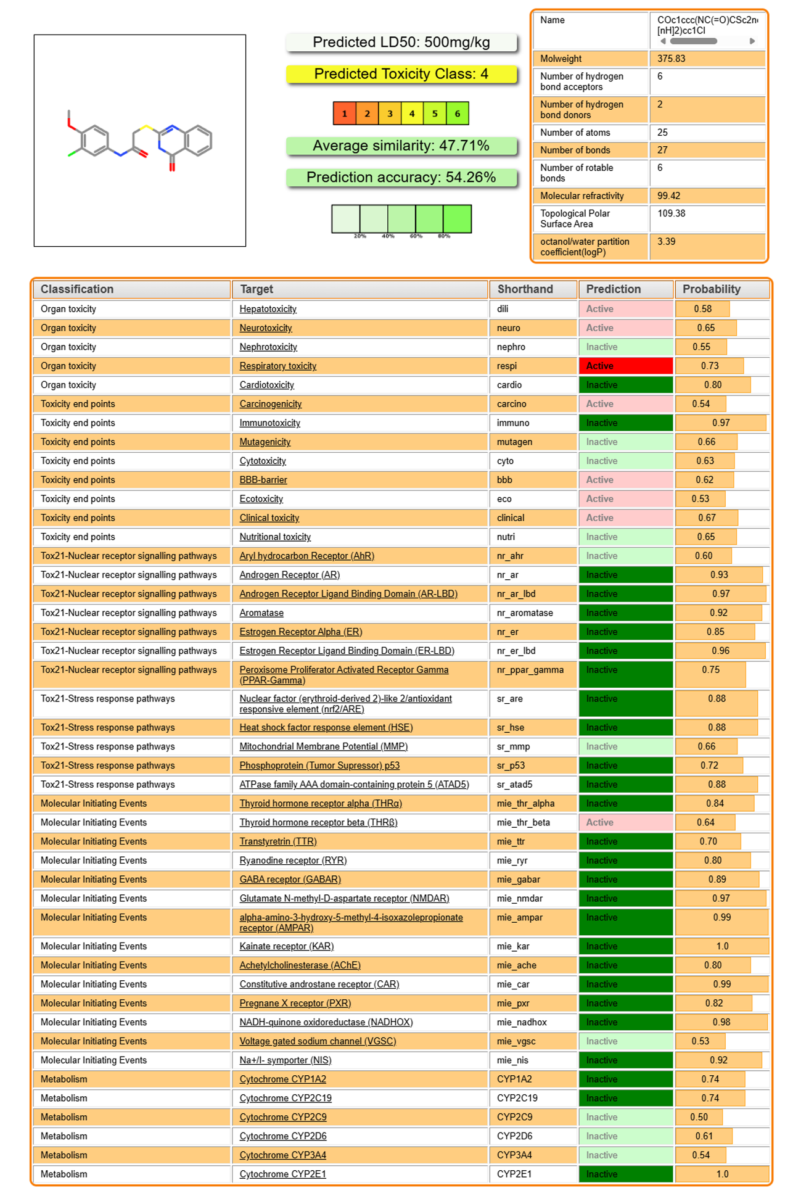
Fig. S12: Toxicity Prediction of 135476455

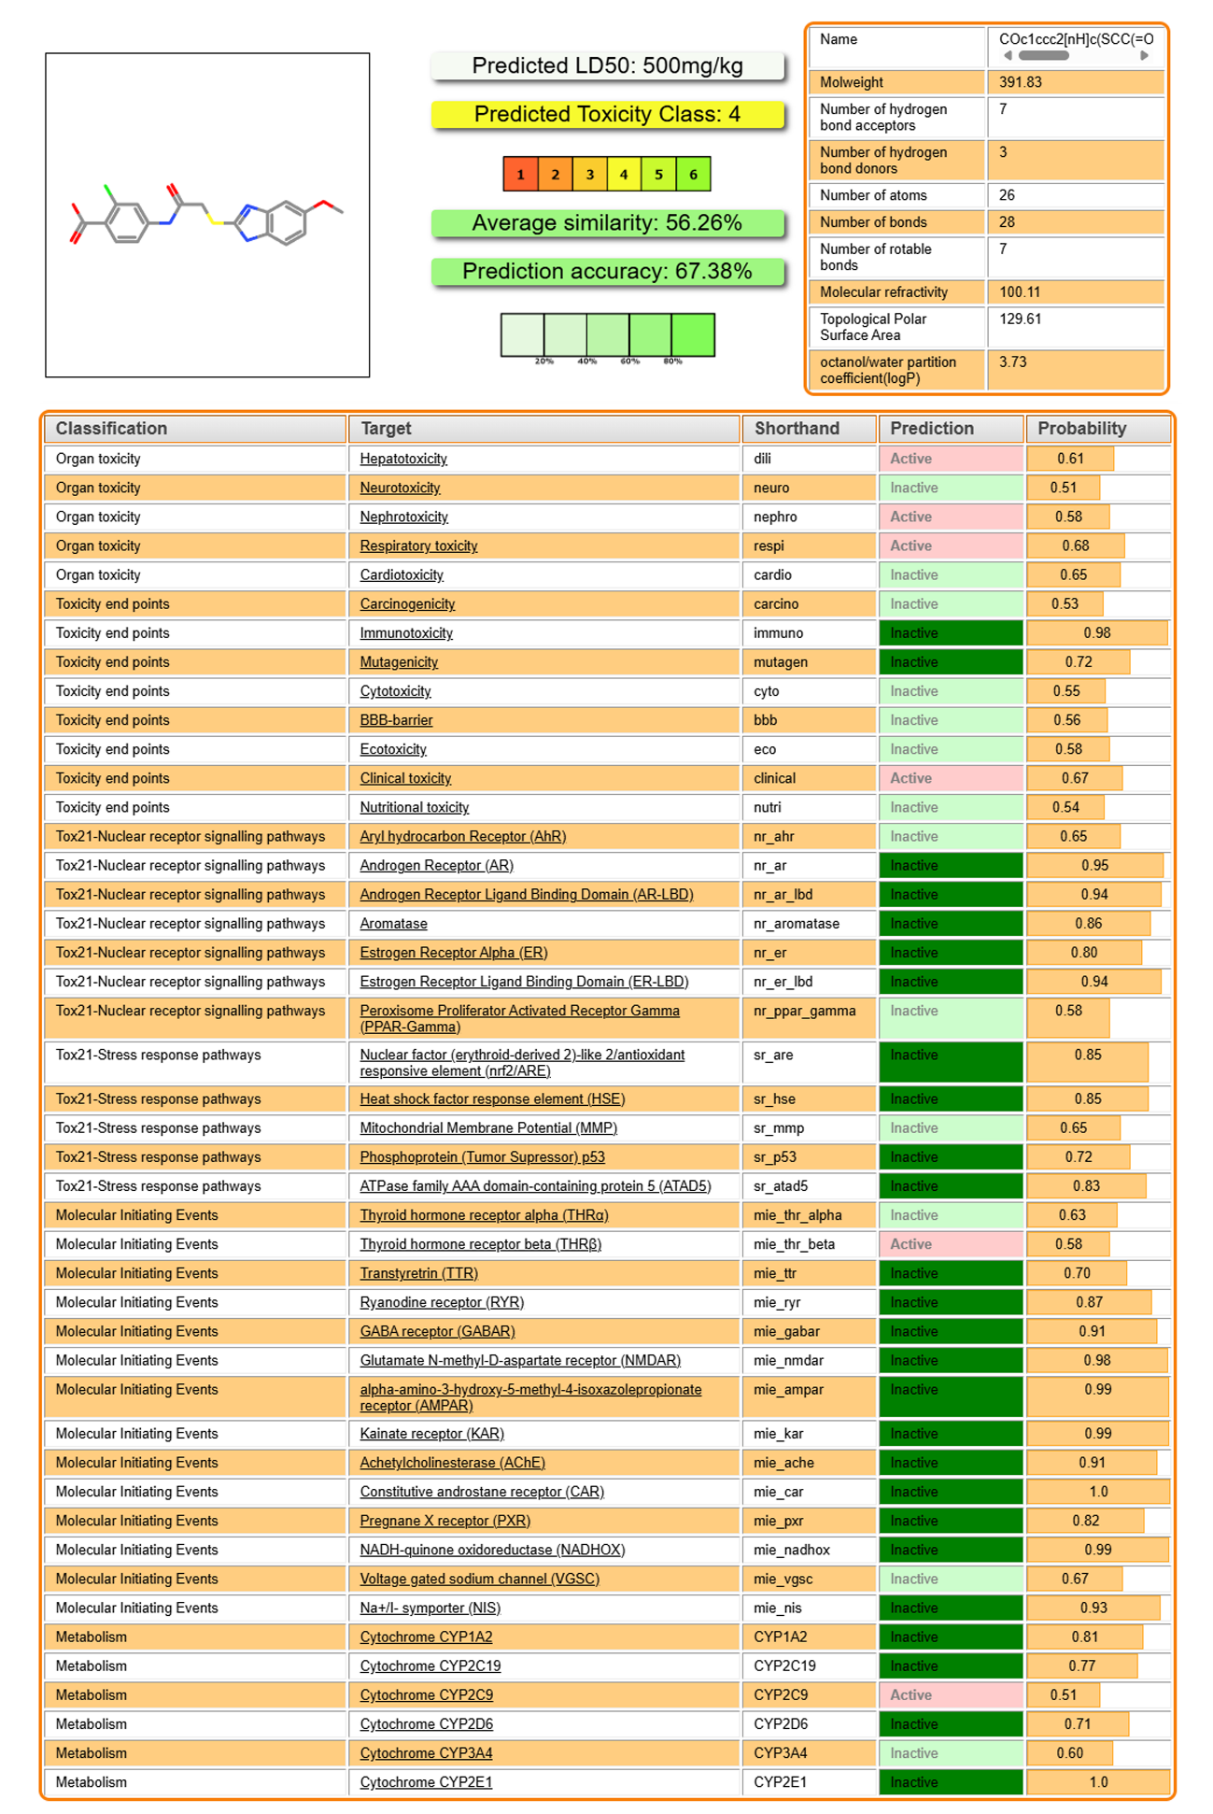
Fig. S13: Toxicity Prediction of 2166318

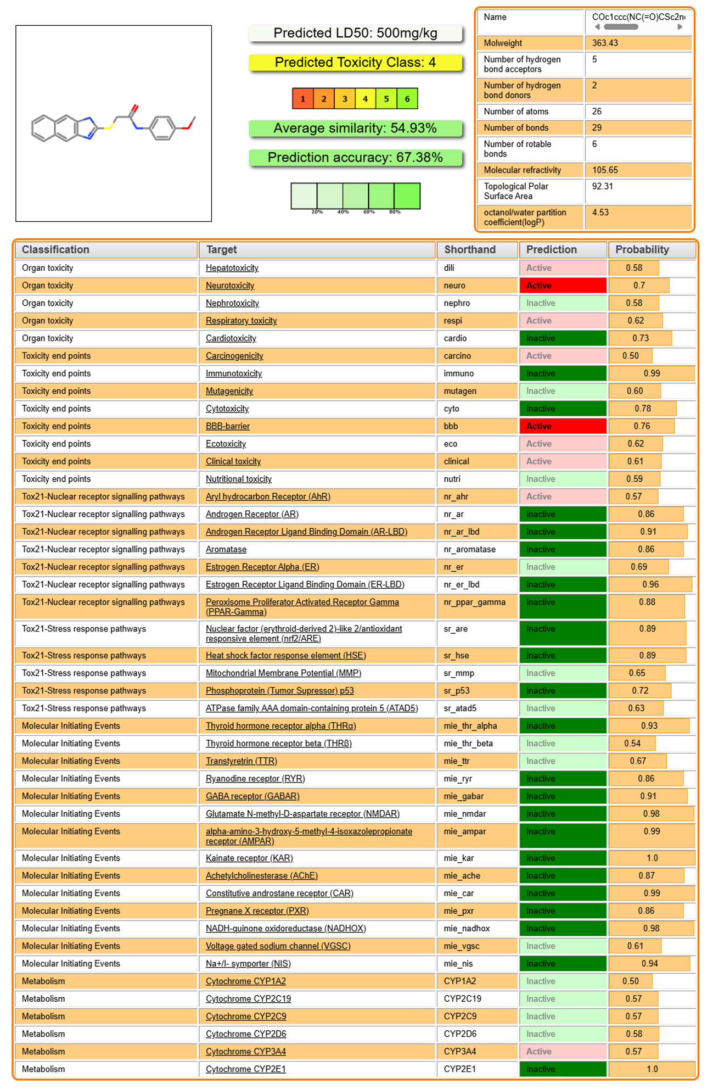
Fig. S14: Toxicity Prediction of 2987305
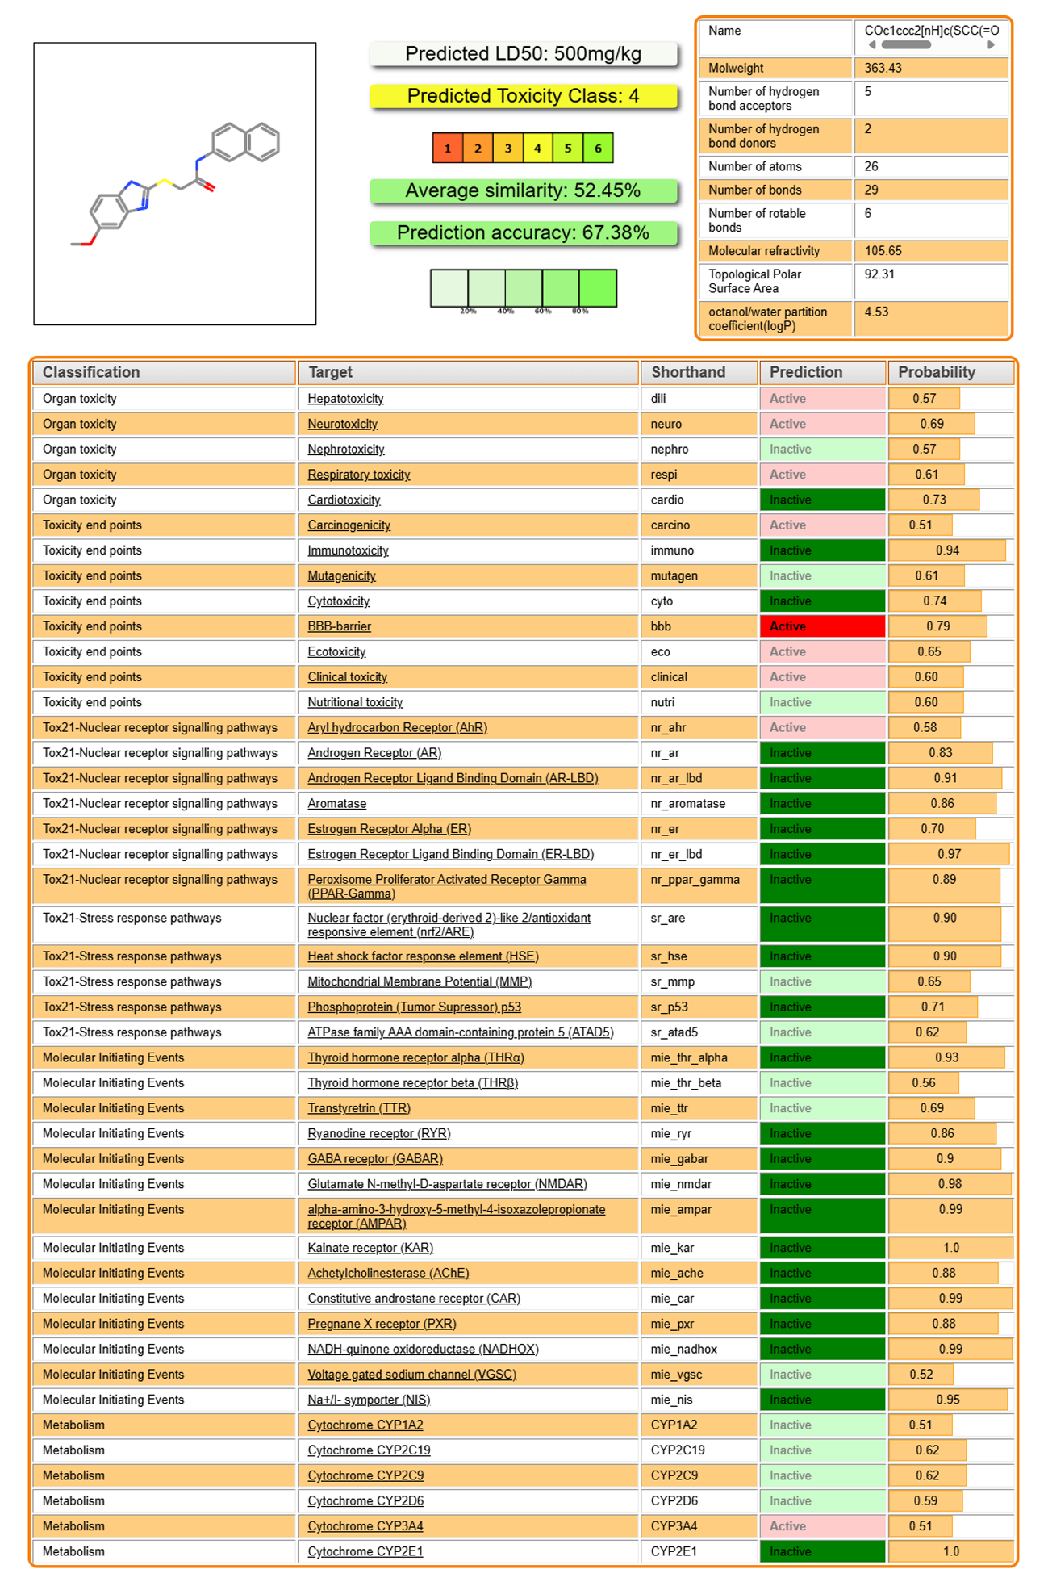
Fig. S15: Toxicity Prediction of 2274941

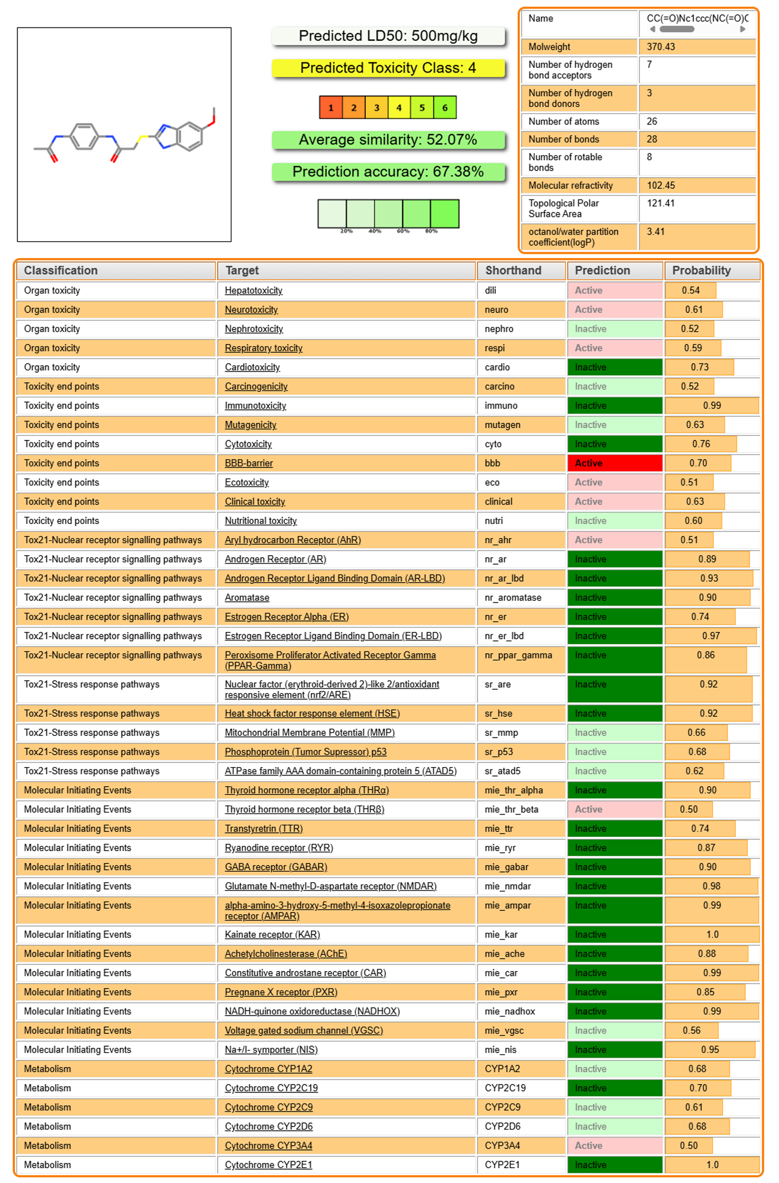
Fig. S16: Toxicity Prediction of 2302155

