Methods
Data collection
Using the ISI Web of Science, peer-reviewed journal articles (1950-2020) related to plant biomass under experimental warming were searched with specific keywords (See Text S1). To avoid bias in publication selection, the following criteria were conducted to select the studies compiled in our database (Text S2): (i) Warming treatments conducted in terrestrial biomes and at least one of our considered variables [including plant total biomass (TB), aboveground biomass (AGB), belowground biomass (or root biomass, BGB), and root: shoot ratio (R/S)] were recorded. (ii) The experimental temperature, warming method (e.g., open top chamber, infrared heater, or soil heating cable) and dominant plant species were indicated clearly in both warming and control groups. (iii) Apart from the difference in experimental temperature, other initial environmental condition and plant species compositions were the same in the control and warming. (iv) Warming duration was at least longer than one growing season. (v) The mean, standard deviations/errors, and sample sizes of these variables could be extracted from the figures, tables or context directly.
Using the five above selection criteria, 322 papers (Text S2 and PRISMA diagram in Text S3) were selected, the observations [e.g., TB, AGB, BGB, or R/S, and soil moisture, water use efficiency (WUE), soil inorganic nitrogen (SIN), soil NH₄⁺, soil NO₃⁻, microbial biomass (MB), and/or microbial biomass C/N (MB C/N)] in both control and warming groups were extracted as well as treatment and environmental information [e.g., warming duration (DUR) and magnitude (WM), latitude (LAT), mean annual precipitation (MAP) and temperature (MAT)]. If the local climate condition was not reported in paper, the WorldClim dataset (http://www.worldclim.org/) was used to obtain climate variables based on latitude and longitude ¹. The soil properties, i.e., bulk density (BD), clay content (CLAY), and soil organic carbon (SOC) in each sites were extracted from the Harmonized Word Soil Database (https://daac.ornl.gov/SOILS/guides/HWSD.html, Tables S3 and S4). In order to analyze the effects of climate and treatment variable, we divided MAP, MAT, DUR and WM into six classes according to the method in Lin et al. 2010 (Table S1)².
Mycorrhizal fungi types (MFTs) and plant functional types (PFTs, including woody vs herb, tree vs shrub, grass vs forb, Figs. 1 and S1, Table S2) of dominant plants in each biome were confirmed by the latest FungalRoot database according to Soudzilovskaia et al. (2019)³ and the original publications. The MFTs of biomes were labeled as AMF, EMF, or AMF-EMF if the root symbiosis of dominant plants were arbuscular mycorrhizal fungi (AMF) or ecto- mycorrhizal fungi (EMF), or both AMF and EMF (AM-EMF). Most analyses in this study were focused on AMF, EMF and AMF-EMF, as biomes with non-mycorrhizal fungi (NMF) were too few for allowing us to conduct any analyses on them (Fig. S1).
Data analysis
In this study, we employed response ratio [RR, natural log (ln) of the ratio of the mean value in warming treatment ($\overline{X_{t}}$) to that in control ($\overline{X_{c}}$), Eq. 1] to reflect warming effect on the concerned variables^{4,5}. The method of testing frequency distribution of individual RR to warming was supplemented in Text S4.
$RR=ln\left(\frac{\overline{X_{t}}}{\overline{X_{c}}}\right)=\ln\left(\overline{X_{t}}\right)-ln⁡(\overline{X_{c}})$ (1)
The weighted mean response ratio (RR₊₊, Eq. 2), and the standard error of RR₊₊ [s(RR₊₊), Eq. 3] in each subgroups [e.g., different MFTs (AMF, EMF or AM-EMF) or PFTs (woody plants or herbs)] was calculated using individual RR (RR_{ij}) and its weight (w_{ij}), which is the reciprocal of the variance (v_{ij}, Eq.4)
${RR}_{++}=\frac{\sum_{i=1}^{m}{\sum_{j=1}^{k}{w_{ij}{RR}_{ij}}}}{\sum_{i=1}^{m}{\sum_{j=1}^{k}{W_{ij}}}}$ (2)
$s\left({RR}_{++}\right)=\sqrt{\frac{1}{\sum_{i=1}^{m}{\sum_{j=1}^{k}{w_{ij}}}}}$ (3)
where m is the number of subgroups, and k is the number of RR in the ith subgroup (i = 1, 2, …, m; j = 1, 2, …, k).
$w_{ij}=\frac{1}{V_{ij}}$,$v=\frac{{S_{t}}^{2}}{n_{t}{{\overline{X}}_{t}}^{2}}+ \frac{{S_{c}}^{2}}{n_{c}{{\overline{X}}_{c}}^{2}}$ (4)
The $n_{t}$, $n_{c}$, and $S_{t}$, $S_{c}$are the number of replication and standard deviation for concerned variable in warming and control groups, respectively. A significant warming effect on a given response variable was considered only when the 95% CI did not overlap with zero. The percentage change of a response variable under warmed condition was estimated by [exp (RR₊₊)-1] ×100%. Stepwise linear regression was used to analyzed the impacts of environmental conditions on the effect size of root: shoot ratio [RR (R/S)] (Tables S2 and S3). The importance of each predictors was expressed as the sum of Akaike weights derived from model selection using the “glmulti” package in R (www.metafor-project.org/doku.php/tips:model_selection_with_glmulti, Fig. 2). The linear regression between MAP and RR (R/S) was examined by meta-regression using the “metafor” package in R (Fig. 1). Structural equation model (SEM) was performed using the “lavaan” package in R to examine the effect of PFTs, MFTs, background climate (MAT, MAP), and warming treatment (WM and DUR) on RR (R/S) through related changes of AGB and BGB under warming (Fig. S8). The figures for variable correlation were conducted in SigmaPlot 12.5 (Systat Software, San Jose, CA, Fig. S12).

1 Fick, S. E. & Hijmans, R. J. WorldClim 2: new 1-km spatial resolution climate surfaces for global land areas. International Journal of Climatology 37, 4302-4315 (2017).
2 Lin, D., Xia, J. & Wan, S. Climate warming and biomass accumulation of terrestrial plants: a meta-analysis. New Phytol. 188, 187-198, doi:10.1111/j.1469-8137.2010.03347.x (2010).
3 Soudzilovskaia, N. A. et al. Global mycorrhizal plant distribution linked to terrestrial carbon stocks. Nature Communications 10, 5077, doi:10.1038/s41467-019-13019-2 (2019).
4 Hedges, L. V., Gurevitch, J. & Curtis, P. S. The meta-analysis of response ratios in experimental ecology. Ecology 80, 1150-1156, doi:10.2307/177062 (1999).
5 Luo, Y. Q., Hui, D. F. & Zhang, D. Q. Elevated CO₂ stimulates net accumulations of carbon and nitrogen in land ecosystems: A meta-analysis. Ecology 87, 53-63, doi:10.1890/04-1724 (2006).

Acknowledgments: This research was financially supported by the National Natural Science Foundation of China (Grant No. 32071593, 31930072, 31600352), National key Research and Development Program of China (Grant No. 2020YFA0608403) and the Fundamental Research Funds for the Central Universities.
Author Contributions: L.Y.Z collected and analyzed the data, and wrote the manuscript. X.H.Z. conceived, designed and oversaw the study. L.Y.Z. and Y.H.H. did the statistical analysis. M.P.T., L.Y.Z, and X.H.Z. discussed, wrote and revised the manuscript together. Y.H.H., Y.L.F., Z.G.D., M.L., X.Y.S., C.H.L, C.Y.L., R.Q.L., G.Y.Z., and S.H.B. commented on the manuscript.
Competing Interest Declaration: Authors declare that they have no competing interests.
Author Information: Supplementary Information is available for this paper. Correspondence and requests for materials should be addressed to X.H. Zhou (xhzhou@des.ecnu.edu.cn). Reprints and permissions information is available at www.nature.com/reprints.

Table S1-S4
Table S1 Levels of subgroups according to mean annual precipitation (MAP), temperature (MAT), warming magnitude (WM), and experimental duration (DUR) of selected studies in the meta-analysis.
Variables | Levels of subgroups
MAP (mm) | < 300 | 300 ~ 450 | 450 ~ 600 | 600 ~ 750 | - ~ 900 | > 900
MAT (ºC) | < -2 | -2 ~ 3 | 3 ~ 8 | 8 ~ 13 | 13 ~ 18 | > 18
WM (ºC) | < 1 | 1 ~ 2 | 2 ~ 3 | 3 ~ 4 | 4 ~ 5 | > 5
DUR (year) | <1 | 1 ~ 2 | 2 ~ 3 | 3 ~ 4 | 4 ~ 5 | > 5

Table S2 Stepwise linear regression of response ratio of root: shoot [RR (R/S)] with the environmental conditions, including soil clay content (CLAY, %), bulk density (BD, g/cm³), organic carbon (SOC, %), latitude (LAT), mean annual temperature (MAT, ºC) and precipitation (MAP, mm), and warming treatments, including experimental duration (DUR, year), and warming magnitude (WM, ºC), for biomes dominated by root symbiosis of AMF, EMF, and for biomes dominated by herbs and woody plants, without weights.
Groups | Equation | R² | P-Value
AMF | RR (R/S) = -0.001MAP + 0.591 | 0.353 | <0.001
AMF | RR (R/S) = -0.001MAP - 0.033MAT + 0.803 | 0.481 | <0.001
EMF | RR (R/S) = -0.032MAT + 0.284 | 0.328 | 0.003
EMF | RR (R/S)= -0.029MAT - 0.067WM + 0.419 | 0.450 | 0.002
Herbs | RR (R/S) = 0.030DUR -0.174 | 0.171 | 0.003
Herbs | RR (R/S) = 0.028DUR+0.000MAP+0.110 | 0.312 | <0.001
Herbs | RR (R/S) = 0.029DUR-0.001MAP+0.016MAT +0.187 | 0.386 | <0.001
Woody plants | RR (R/S) = -0.001MAP +0.517 | 0.304 | <0.001
Woody plants | RR (R/S) = -0.001MAP -0.044DUR+0.667 | 0.408 | <0.001

Table S3 Stepwise linear regression of response ratio of root: shoot [RR (R/S)] with the environmental conditions, including soil clay content (CLAY, %), bulk density (BD, g/cm³), organic carbon (SOC, %), latitude (LAT), mean annual temperature (MAT) and precipitation (MAP), and warming treatments, including experimental duration (DUR), and warming magnitude (WM), for forbs, shrubs and trees, respectively. There was no variable selected for grasses.
Groups | Equation | R² | P-Value
Forbs | RR (R/S) = -0.001MAP +0.178 | 0.805 | <0.001
Shrubs | RR (R/S) = -0.059MAT + 0.539 | 0.632 | 0.006
Shrubs | RR (R/S) = -0.077MAT -4.884BD+ 7.286 | 0.966 | <0.001
Trees | RR (R/S) = -0.001MAP +0.508 | 0.271 | 0.003
Trees | RR (R/S) = -0.001MAP +0.008ClAY+0.666 | 0.382 | 0.002

Table S4 Heterogeneity (Q_{b}) of response ratio (RR) of total biomass (TB), above-, below-ground biomass (AGB and BGB), and root: shoot (R/S) between monoculture vs. mixed, angiosperm (Ang.) vs. gymnosperm (Gym.), and woody vs. herb.
Variables | Group 1 | Group 2 | Q_{b} | Sig.
RR (TB) | Monoculture | Mixed | 9.014 | 0.634
RR (TB) | Ang. | Gym. | 58.264 | 0.216
RR (TB) | Woody | Herb | 176.932 | 0.026*
RR (AGB) | Monoculture | Mixed | 425.553 | 0.147
RR (AGB) | Ang. | Gym. | 527.885 | 0.058
RR (AGB) | Woody | Herb | 557.971 | 0.062
RR (BGB) | Monoculture | Mixed | 21.417 | 0.486
RR (BGB) | Ang. | Gym. | 2.249 | 0.830
RR (BGB) | Woody | Herb | 5.349 | 0.729
RR (R/S) | Monoculture | Mixed | 35.914 | 0.538
RR (R/S) | Ang. | Gym. | 96.787 | 0.269
RR (R/S) | Woody | Herb | 274.324 | 0.076
* indicated the significant difference at p < 0.05.

Figs. S1-S12
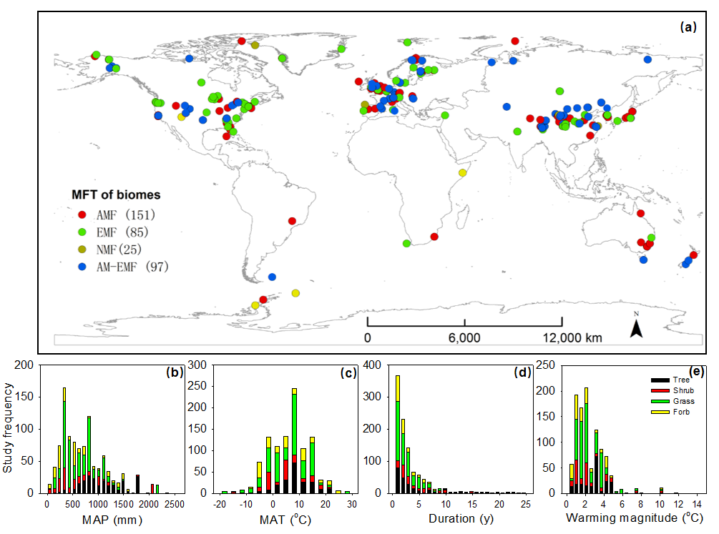
Figure S1 Site location (a) and frequency of warming studies (b-e) included in this meta-analysis. Study frequency were analyzed based on the mean annual precipitation (MAP, mm, b) and temperature (MAT, ºC, c) in sites as well as warming duration (y, d) and magnitude (ºC, e). The abbreviations AMF, EMF and NMF indicated biomes with dominant root symbiosis of arbuscular mycorrhizal, ecto-mycorrhizal and non-mycorrhizal fungi (AMF, EMF and NMF), respectively. Mixed indicated biomes with mixed arbuscular and/or ecto-mycorrhizal, and/or non-mycorrhizal fungi.

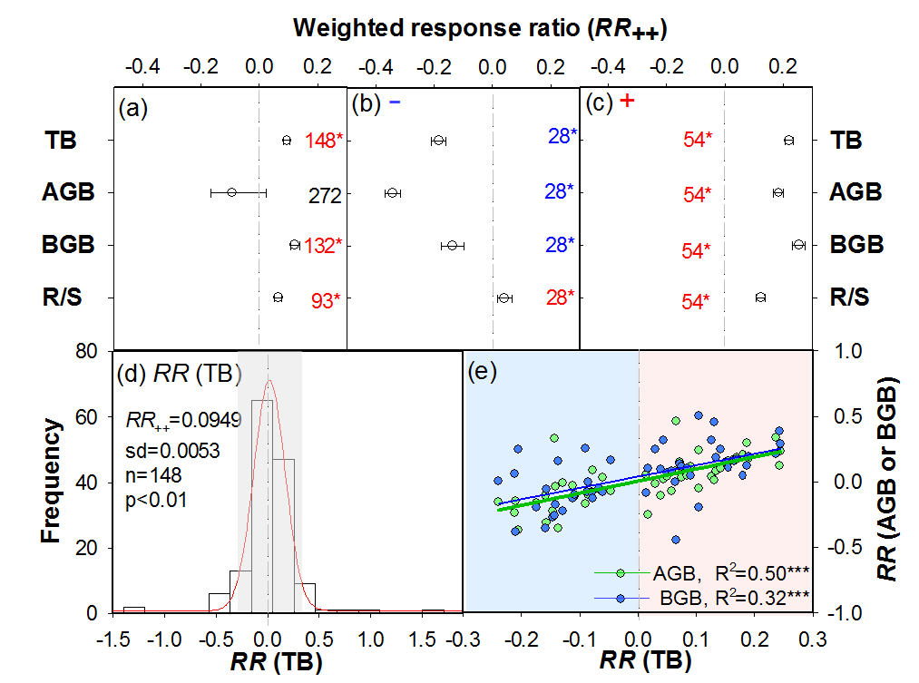
Figure S2 Weighted response ratios (RR++) of biomass and biomass allocation to warming (a, b, c), and the frequency distribution of response ratio (RR) of total biomass (d), and response relationships between above- and below-ground biomass with total biomass (e). TB, AGB, BGB and R/S were total biomass, above-, below-ground biomass, and root/shoot ratio, respectively. The data in plots b and c were come from the studies with all records about four variables, i.e., TB, AGB, BGB, and R/S (c and d).The P value of normal distribution test of RR (TB) in the plot d was 0.0896. The numbers in plots of a, b and c were the sample sizes, and the symbols * indicated statistical significance (P<0.05). The relationships between RR (TB) vs RR (AGB) and RR (BGB, e) were based on studies within 95% confidence interval for the Gaussian distribution of RR (TB, R²=0.9930, P<0.0001) in grey shadow of plot d (e).

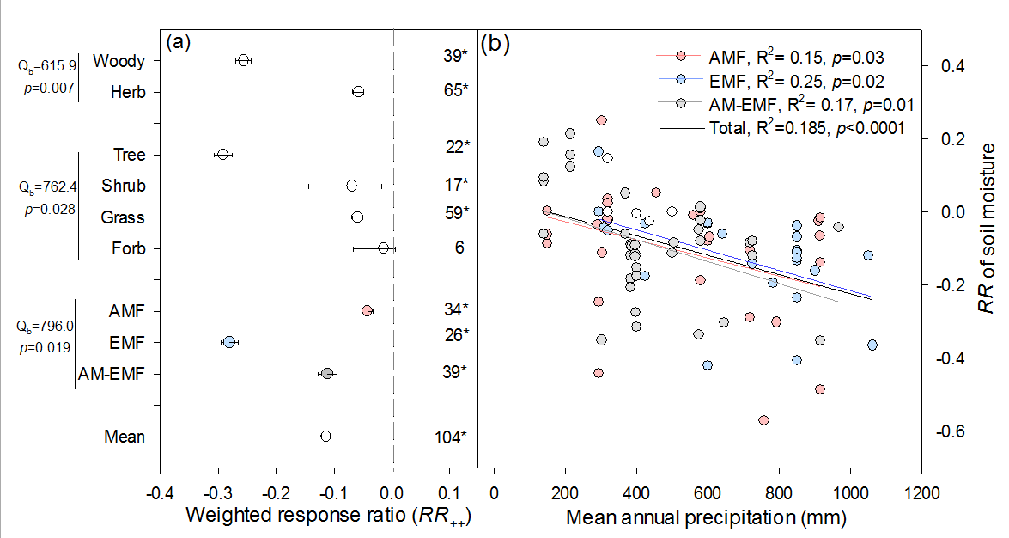
Figure S3 Weighted response ratio (RR₊₊) of soil moisture for different biomes (a), and the correlation between mean annual precipitation (mm) and response ratio of soil moisture (b). Tree, Shrub, Grass, and Forb were biomes dominated by trees, shrubs, grasses and forbs; AMF, EMF and Mixed were biomes with dominant root symbiosis of arbuscular mycorrhizal (AMF), ecto-mycorrhizal fungi (EMF), and biomes with mixed root symbiosis of mycorrhizal fungi (Mixed). The numbers in plot a were the sample sizes; the error bars indicated 95% CI; the symbols * indicated a significant warming-induced response (P < 0.05).

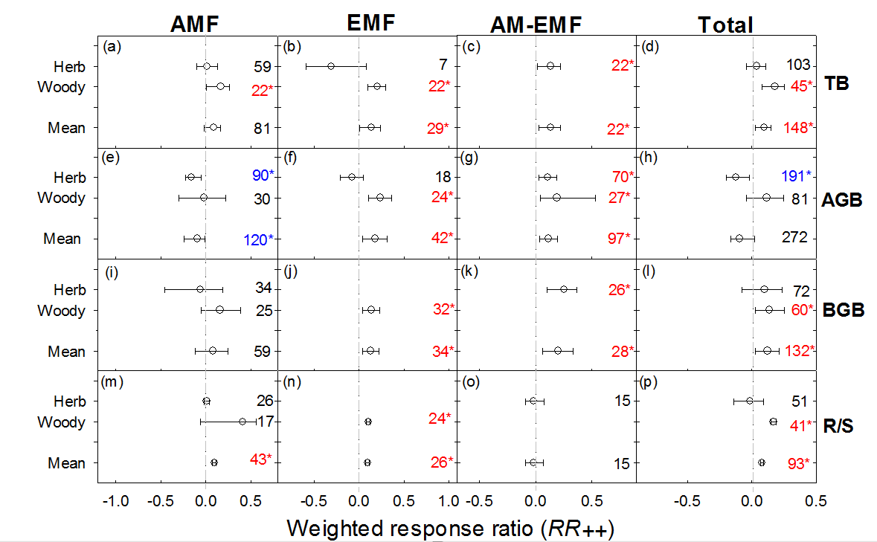
Figure S4 Weighted response ratio (RR₊₊) of total biomass (TB, a-d), above- and belowground biomass (AGB and BGB, e-h and i-l) and root: shoot ratio (R/S, m-p) in biomes with dominant root symbiosis of arbuscular mycorrhizal (AMF, a, e, i, and m), ecto-mycorrhizal fungi (EMF, b, f, j, and n), and biomes with arbuscular and ecto-mycorrhizal fungi (AM-EMF, c, g, k and o), and in total studies (Total, d, h, l, and p). Only the subgroups with more than 5 sample size were used in the analysis, and if the number of data points is lower than 20, we calculated CI based on (RR₊₊) and [S (RR₊₊)]. The error bars indicated 95% CI. If it did not overlap with zero, a significant warming-induced response was considered. The numbers in plots were the sample sizes, and the symbols * indicated statistical significance (P < 0.05).

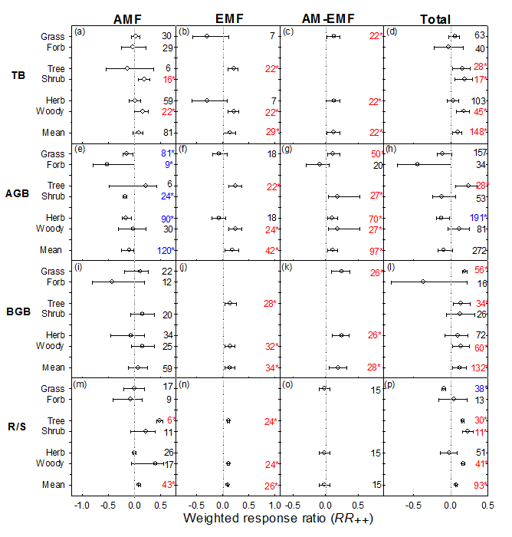
Figure S5 Weighted response ratio (RR₊₊) of total biomass (TB, a-d), above- and below-ground biomass (AGB and BGB, e-h and i-l) and root: shoot (R/S, m-p) in biomes with dominant root symbiosis of arbuscular mycorrhizal (AMF, a, e, i, and m), ecto-mycorrhizal fungi (EMF, b, f, j, and n), and biomes with mixed root symbiosis of mycorrhizal fungi (Mixed, c, g, k and o), and in total studies (Total, d, h, l, and p). Only the subgroups with more than 5 sample size were exhibited, and if the number of data points is lower than 20, we calculated CI based on (RR₊₊) and [S (RR₊₊)]. The error bars indicated 95% CI. If it did not overlap with zero, a significant warming-induced response was considered. The numbers in plots were the sample sizes, and the symbols * indicated statistical significance (P < 0.05).

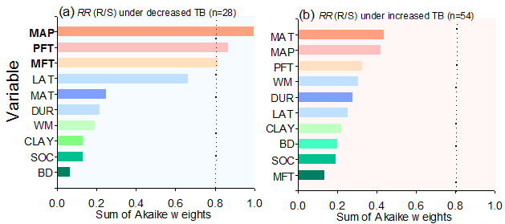
Figure S6 Model-averaged importance of the predictors for warming effects on root: shoot [RR (R/S)] based on studies with decreased and increased total biomass (TB, a and b) respectively. The variables with importance value >0.8 were consider as essential predictors. The important value is based on the sum of Akaike weights derived from model selection using corrected Akaike’s information criteria. PFT, plant functional types; MT, mycorrhizal fungi types; MAP, mean annual precipitation; MAT, mean annual temperature; LAT, latitude; CLAY, the proportion of clay in soil; BD, bulk density; SOC, soil organic carbon; WM, warming magnitude; DUR, warming duration.

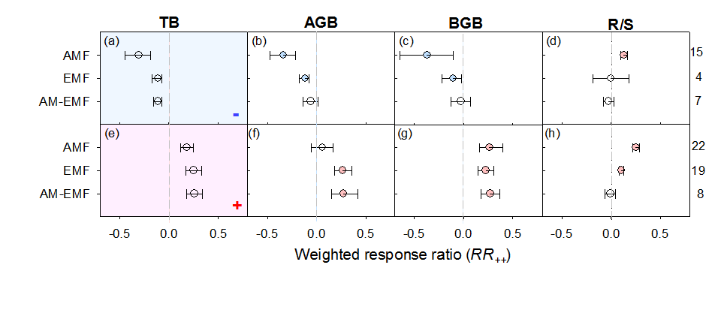
Figure S7 Weighted response ratio (RR₊₊) of total biomass (TB, a,e), above- and below-ground biomass (AGB and BGB, b,f and c,g) and root: shoot (R/S, m-p) in biomes with dominant root symbiosis of arbuscular mycorrhizal (AMF), ecto-mycorrhizal fungi (EMF), and biomes with mixed root symbiosis of mycorrhizal fungi (Mixed) in studies with increased and decreased TB, respectively. The error bars indicated 95% CI. If it did not overlap with zero, a significant warming-induced response was considered. The numbers on the right of plots d and h were the sample sizes.

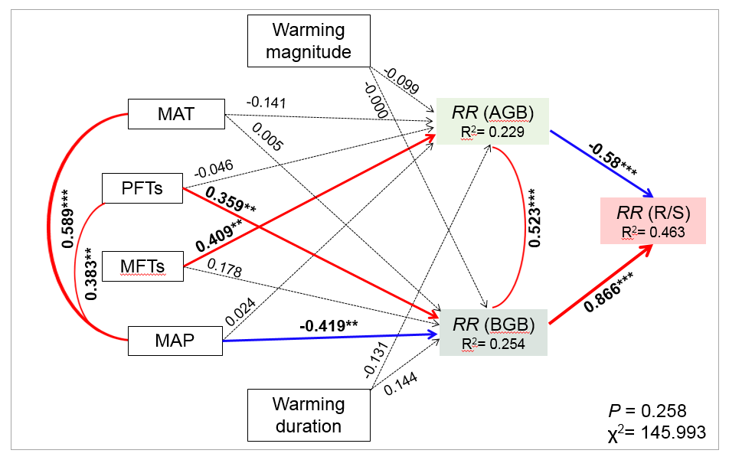
Figure S8 Path analysis examining the effects of plant functional types (PFTs, e.g., herbs or woody plants), dominant mycorrhizal types in root symbiosis (MFTs, e.g., AMF, AM-EMF or EMF), background climate condition (MAT and MAP) and warming treatment (warming magnitude and duration) on response of root: shoot ratio (R/S) through changes in AGB and BGB under warming condition. The solid and dashed lines indicated the significant (p<0.05) and non-significant effects (p>0.05), and the red and blue solid arrows indicated positive and negative effects (p<0.05), respectively. We assigned ‘0’ and ‘1’ for herbs and woody plants, respectively; ‘0’, ‘0.5’, ‘1’ to AMF, AM-EMF and EMF, respectively in this analysis.

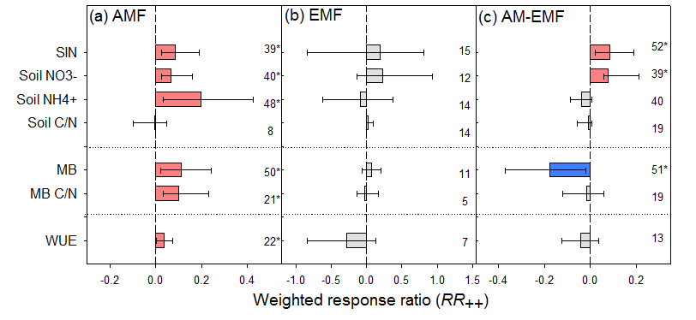
Figure S9 Weighted response ratio (RR₊₊) of soil inorganic nitrogen (SIN), soil NO₃⁻, soil NH₄⁺, soil C/N, microbial biomass (MB), microbial C/N (MB C/N), and water use efficiency (WUE) for different biomes. AMF, EMF, Mixed, and Total indicated the biomes dominated with root symbioses of arbuscular mycorrhizal (AMF, a), ecto-mycorrhizal fungi (EMF, b), mixture of AMF and EMF (c). The numbers in plots were the sample sizes; the error bars indicated 95% CI; the symbols * indicated a significant warming-induced response (P < 0.05).

Figure S10 Weighted response ratio (RR₊₊) of soil inorganic nitrogen (SIN), soil NO₃⁻, soil NH₄⁺, soil C/N, microbial biomass (MB), microbial C/N (MB C/N), and water use efficiency (WUE) for different biomes dominated by woody (a) and herb plants (b). The numbers in plots were the sample sizes; the error bars indicated 95% CI; the symbols * indicated a significant warming-induced response (P < 0.05).

Figure S11 Weighted response ratio (RR₊₊) of soil inorganic nitrogen (SIN), soil NO₃⁻, soil NH₄⁺, soil C/N, microbial biomass (MB), microbial C/N (MB C/N), and water use efficiency (WUE) for different biomes dominated by grasses (a), forbs (b), trees (c), and shrubs(d). The numbers in plots were the sample sizes; the error bars indicated 95% CI; the symbols * indicated a significant warming-induced response (P < 0.05).

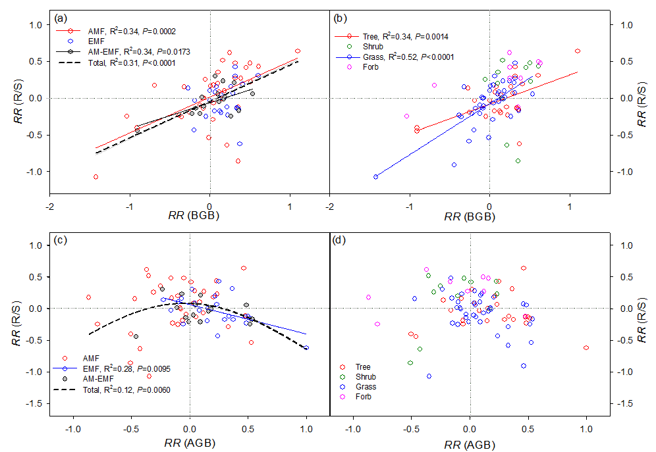

Figure S12 The relationship between response ratio (RR) of below- (BGB, a and b) and above-ground biomass (AGB, c and d) vs. root: shoot (R/S). AMF, EMF, Mixed, and total indicated biomes with dominant root symbiosis of arbuscular mycorrhizal (AMF), ecto-mycorrhizal fungi (EMF), and biomes with mixed root symbiosis of mycorrhizal fungi (Mixed), and in total studies (Total), respectively.

